Session 9 booklet (part 1) – Visual and Literary Evidence for Neronian Buildings

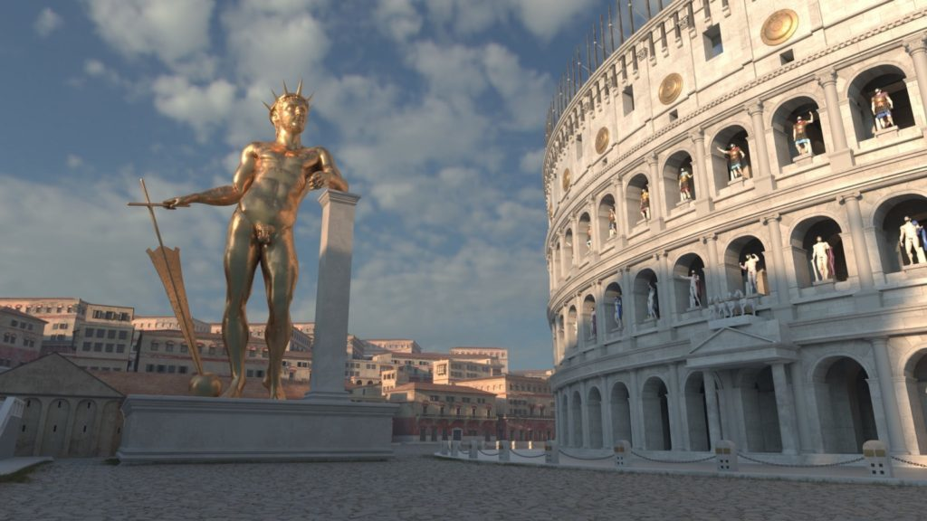

In the second workshop of this session we will examine artistic (particularly coin iconography), reconstructive outlines (where archaeology or early modern records allow), and literary descriptions of buildings in Neronian Rome. We will consider what these types of evidence can tell us and how we might go about reconstructing these edifices. A set of images and literary excerpts have been given below. You should try and answer the following questions:

Questions:
1) What features of the harbour of Portus can we learn about from Neronian coinage that we might not otherwise glean from the literary sources?
2) If we have limited ancient literary or artistic depictions of structures, what other evidence may we potentially be able to draw upon (consider this in relation to the Baths and the Circus)?
3) What architectural features pertaining to Nero’s amphitheatre can you clean from Calpurnius Siculus’ Eclogues?
4) What can learn about the structure of Nero’s Macellum Magnum (Great Market Place) from his coinage?
5) What features stand out on Nero’s triumphal arch and who do you think the figures represent?
6) Which reconstruction of the Colossus do you find most plausible based on the literary and iconographic evidence?

Julio-Claudian Rome
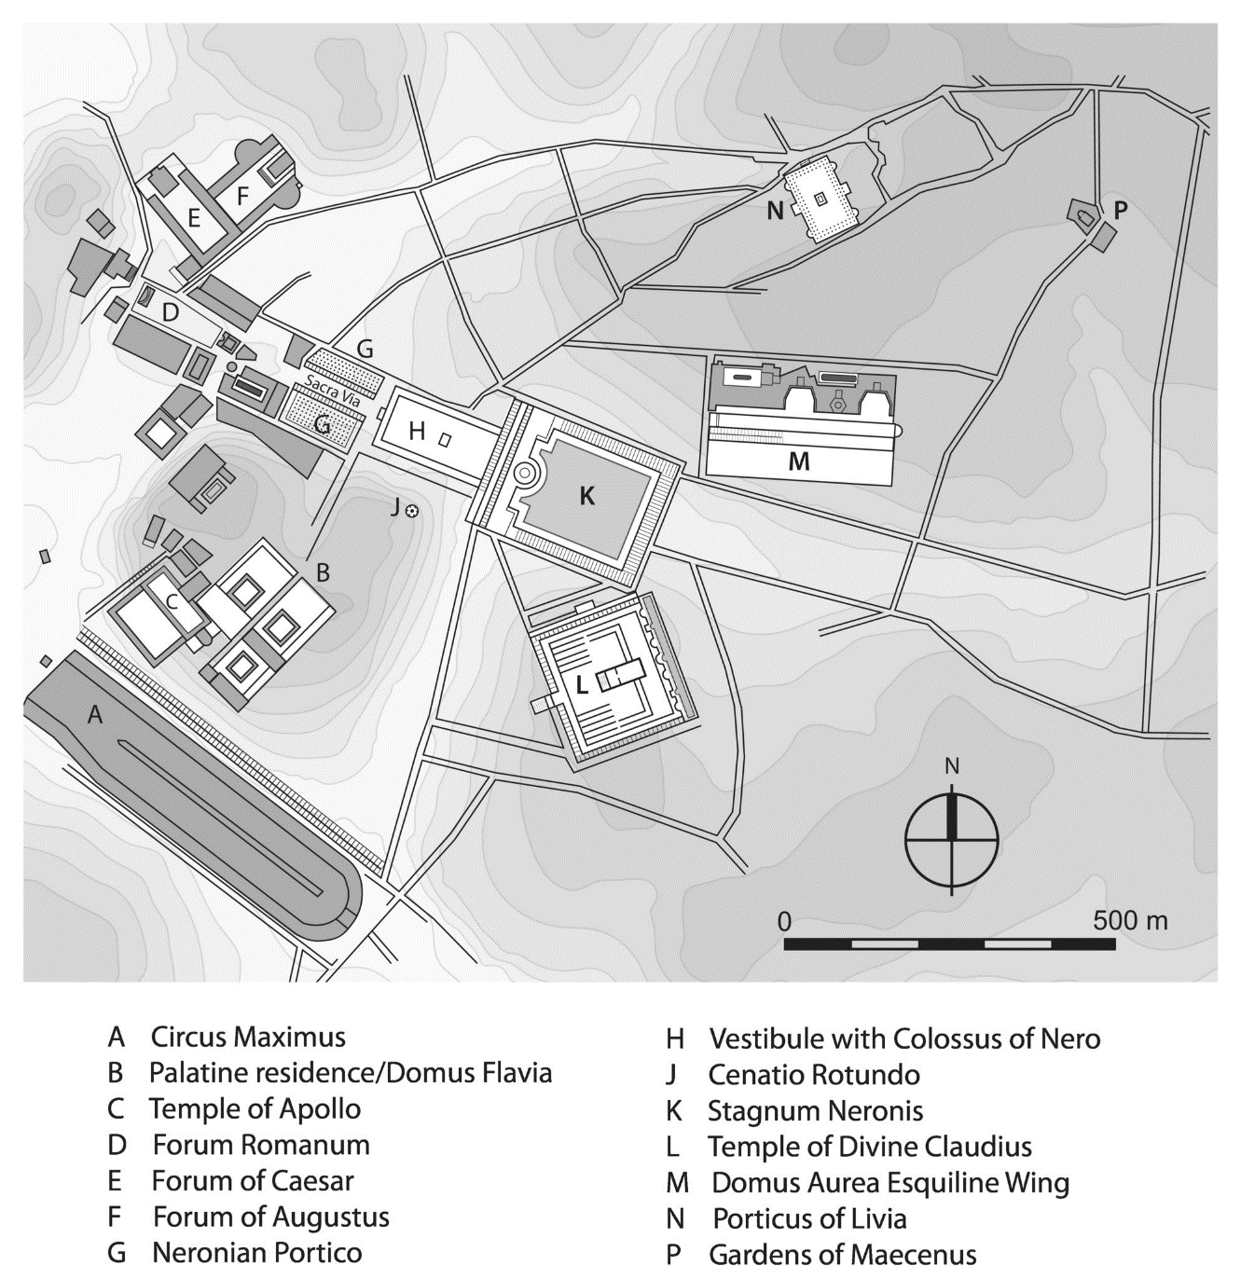

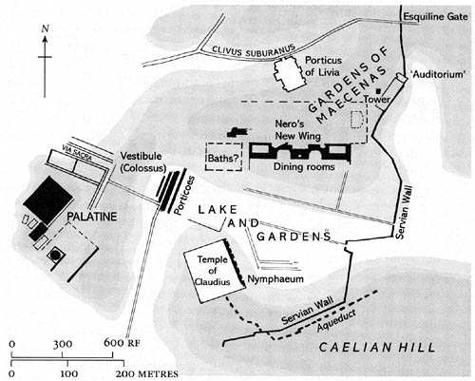

Nero and Portus
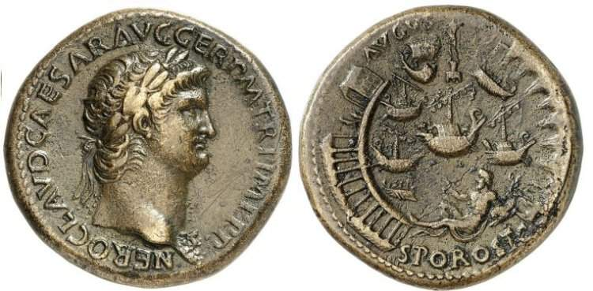
Nero AE Sestertius. Rome mint, AD 64 - AVGVSTI POR(tus) OST(iensis), S(enatus) C(onsultu), the Ostian port of Augustus, by senatorial decree

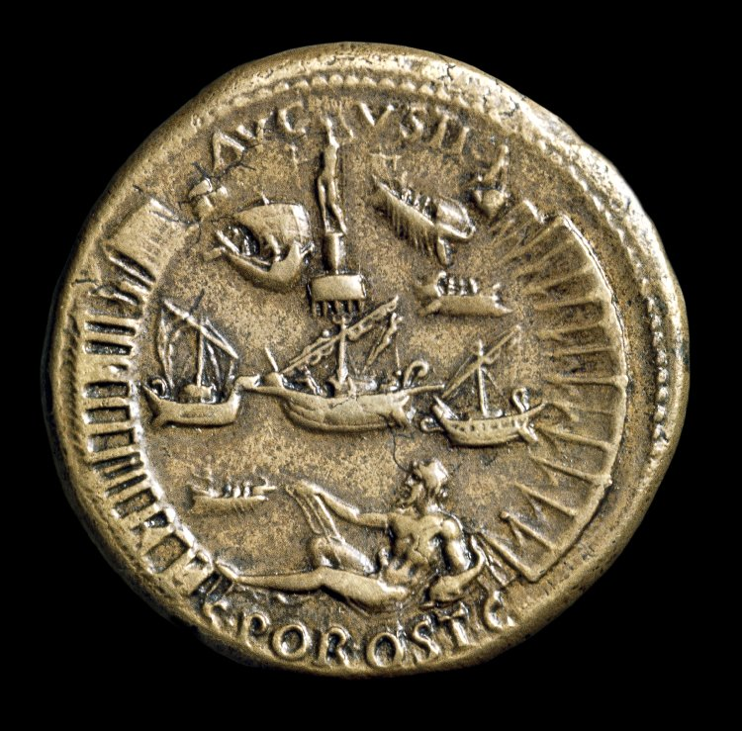
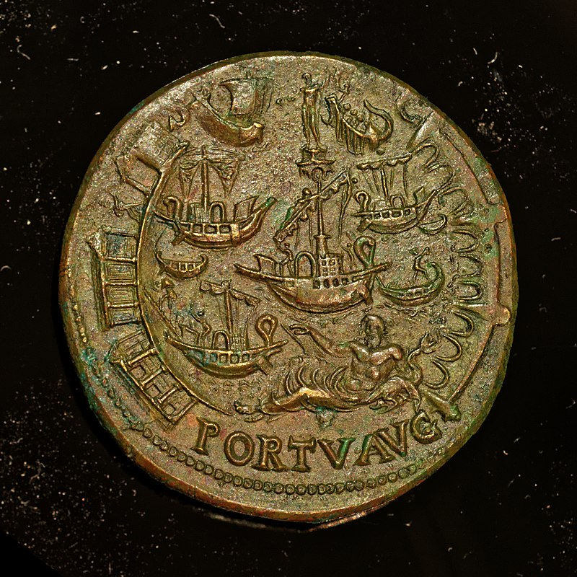

Tacitus Annals 15.18
“Nero had the grain for the populace — which had been spoilt by age — thrown into the Tiber, as proof that the corn-supply was not a matter for anxiety. The price was not raised, though some two hundred vessels actually in port [Portus Claudii / Portus Augustii] had been destroyed by a raging tempest, and a hundred more, which had made their way up the Tiber, by a chance outbreak of fire.”

15.43.
[Reconstruction efforts post Great Fire] “These colonnades Nero offered to erect at his own expense, and also to hand over the building-sites, clear of rubbish, to the owners. ... As the receptacle of the refuse he settled upon the Ostian Marshes, and gave orders that vessels which had carried grain up the Tiber must run down-stream laden with debris.”
Suetonius Nero 16.1
“He had also planned to extend the walls as far as Ostia and to bring the sea from there to Rome by a canal.”

31.3-4
“He also began a pool, extending from Misenum to the lake of Avernus, roofed over and enclosed in colonnades, into which he planned to turn all the hot springs in every part of Baiae; a canal from Avernus all the way to Ostia, to enable the journey to be made by ship yet not by sea; its length was to be a hundred and sixty miles and its breadth sufficient to allows ships with five banks of oars to pass each other. For the execution of these projects he had given orders that the prisoners all over the empire should be transported to Italy, and that those who were convicted even of capital crimes should be punished in no other way than by sentence to this work. He was led to such mad extravagance, in addition to his confidence in the resources of the empire, by the hope of a vast hidden treasure [Dido’s treasure]...”

Suetonius Divus Claudius 20.3
“He [Claudius] constructed the harbour at Ostia by building curving breakwaters on the right and left, while before the entrance he placed a mole in deep water. To give this mole a firmer foundation, he first sank the ship in which the great obelisk had been brought from Egypt, and then securing it by piles, built upon it a very lofty tower after the model of the Pharos at Alexandria, to be lighted at night and guide the course of ships.”

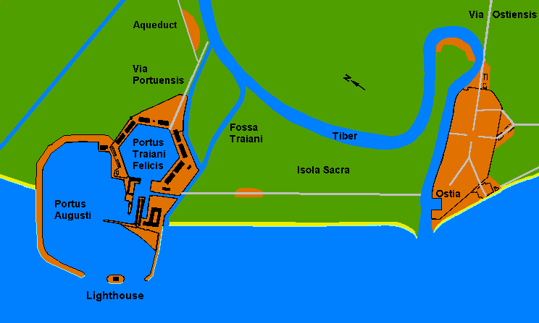

Baths of Nero
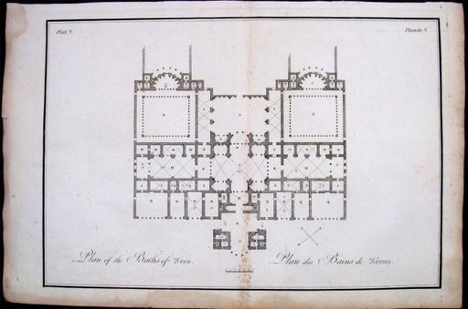
Plan / reconstruction of the Baths of Nero, 1775

ILS 5173 = CIL 6.9797
“My name is Ursus, and I was first among the Romans to play with grace the glass-ball game with my companions. Cheered on (I tell the truth) by large applauding crowds in the Baths of Trajan, Titus, Agrippa, and often Nero.”

Suetonius Nero 12.3
“[establishes Greek style games]… which he called the Neronia; and he simultaneously opened his baths, which had a gymnasium attached, and provided free oil for the knights and senators.”

Martial Epigrams 2.48
“… keep to yourselves Nero’s warm baths”

Statius Silvae 1.5.62
“… if I may compare great things with small, would one who had bathed of late in Nero’s baths refuse to sweat here once more…”

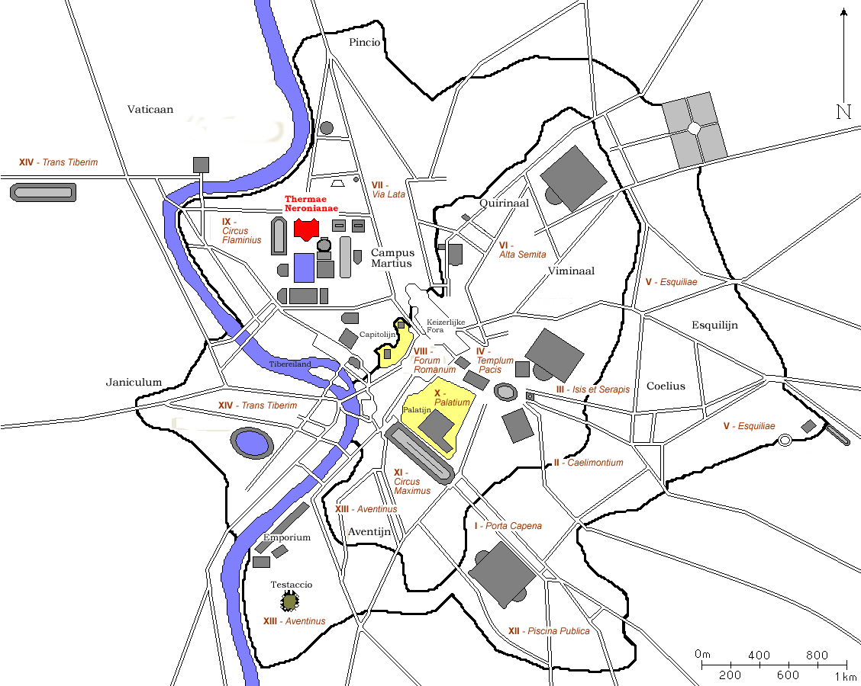

Circus of Gaius and Nero
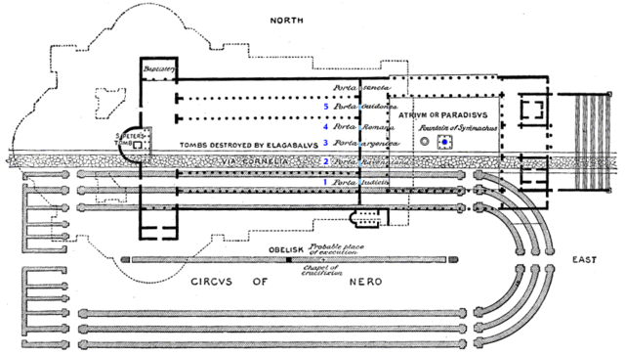
Reconstruction of the area / outline of the circus of Gaius and Nero

Tacitus Annals 14.14
“It was an old desire of his to drive a chariot and team of four, and an equally repulsive ambition to sing to the lyre in the stage manner. "Racing with horses," he used to observe, "was a royal accomplishment... Seneca and Burrus decided to concede one of his points rather than allow him to carry both; and an enclosure was made in the Vatican valley, where he could manoeuvre his horses without the spectacle being public. Before long, the Roman people received an invitation...”

15.44
“Nero had offered his Gardens for the spectacle [punishing Christians], and gave an exhibition in his Circus, mixing with the crowd in the habit of a charioteer, or mounted on his chariot.”

Eusebius Church History 25.5-7
“Thus publicly announcing himself as the first among God's chief enemies, he was led on to the slaughter of the apostles. It is, therefore, recorded that Paul was beheaded in Rome itself, and that Peter likewise was crucified under Nero. This account of Peter and Paul is substantiated by the fact that their names are preserved in the cemeteries of that place even to the present day. It is confirmed likewise by Caius, a member of the Church, who arose under Zephyrinus, bishop of Rome. He, in a published disputation with Proclus, the leader of the Phrygian heresy, speaks as follows concerning the places where the sacred corpses of the aforesaid apostles are laid:
‘But I can show the trophies of the apostles. For if you will go to the Vatican or to the Ostian way, you will find the trophies of those who laid the foundations of this church.’”

Nero’s Amphitheatre

Suetonius Nero 12.1
“At the gladiatorial show, which he gave in a wooden amphitheatre, erected in the district of the Campus Martius within the space of a single year, he had no one put to death, not even criminals. But he compelled four hundred senators and six hundred Roman knights, some of whom were well to do and of unblemished reputation, to fight in the arena. Even those who fought with the wild beasts and performed the various services in the arena were of the same orders.”

Tacitus Annals 13.31
“In the consulate of Nero, for the second time [AD 57], and of Lucius Piso, little occurred that deserves remembrance, unless the chronicler is pleased to fill his rolls with panegyrics of the foundations and the beams1 on which the Caesar reared his vast amphitheatre in the Campus Martius; although, in accordance with the dignity of the Roman people, it has been held fitting to consign great events to the page of history and details such as these to the urban gazette.”

Calpurnius Siculus Eclogues 7
L [Lycotas]. You are slow, Corydon, in coming back from Rome. For twenty nights past, of a truth, have our woods longed to see you, and the saddened bulls waited for your yodellings.

C [Corydon]. O you slow-coach, no more unbending than a tough axle, Lycotas, you prefer to see old beech-trees rather than the new sights exhibited by our youthful god in the spacious arena.
...
C. I saw a theatre that rose skyward on interwoven beams and almost looked down on the summit of the Capitoline. Passing up the steps and slopes of gentle incline, we came to the seats, where in dingy garments the baser sort viewed the show close to the women's benches. For the uncovered parts, exposed beneath the open sky, were thronged by knights or white-robed tribunes. Just as the valley here expands into a wide circuit, and, winding at the side, with sloping forest background all around, stretches its concave curve amid the unbroken chain of hills, so there the sweep of the amphitheatre encircles the level ground, and the oval in the middle is bound by twin piles of building. Why should I now relate to you things which I myself could scarcely see in their several details? So dazzling was the glitter everywhere. Rooted to the spot, I stood with mouth agape and marvelled at all, nor yet had I grasped every single attraction, when a man advanced in years, next me as it chanced on my left, said to me: "Why wonder, country-cousin, that you are spellbound in face of such magnificence? you are a stranger to gold and only know the cottages and huts which are your humble homes. Look, even I, now paralysed with age, now hoary-headed, grown old in the city there, nevertheless am amazed at it all. Certes, we rate all cheap we saw in former years, and shabby every show we one day watched."

Look, the partition-belt and the gilded arcade vie in brilliancy; and withal just where the end of the arena presents the seats closest to the marble wall, wondrous ivory is inlaid on connected beams and unites into a cylinder which, gliding smoothly on well-shaped axle, could by a sudden turn balk any claws set upon it and shake off the beasts. Bright too is the gleam from the nets of gold wire which project into the arena hung on solid tusks, tusks of equal size; and (believe me, Lycotas, if you have any trust in me) every tusk was longer than our plough. Why narrate each sight in order? Beasts of every kind I saw; here I saw snow-white hares and horned boars, here I saw the elk, rare even in the forests which produce it. Bulls too I saw, either those of heightened nape, with an unsightly hump rising from the shoulder-blades, or those with shaggy mane tossed across the neck, with rugged beard covering the chin, and quivering bristles upon their stiff dewlaps. Nor was it my lot only to see monsters of the forest: sea calves also I beheld with bears pitted against them and the unshapely herd by the name of horses, bred in that river whose waters, with spring-like renewal, irrigate the crops upon its banks. Oh, how we flinched, whenever we saw the arena part asunder and its soil upturned and beasts plunged out from the chasm cleft in the earth; yet often from those same rifts the golden arbutes sprang amid a sudden fountain spray (of saffron).

L. O lucky Corydon, unhampered by old age; lucky in that by the grace of heaven it was your lot to set your early years in this age! Now if fortune has vouchsafed to you close sight of our worshipful Emperor-god, if there and then you marked his countenance and mien, tell me, come, tell me, Corydon, what I may deem to be the features of the gods.

C. O would that I had not been clad in peasant garb! Else should I have gained a nearer sight of my deity: but humble dress and dingy poverty and brooch with but a crooked clasp prevented me; still, in a way, I looked upon his very self some distance off, and, unless my sight played me a trick, I thought in that one face the looks of Mars and of Apollo were combined.

Macellum Magnum
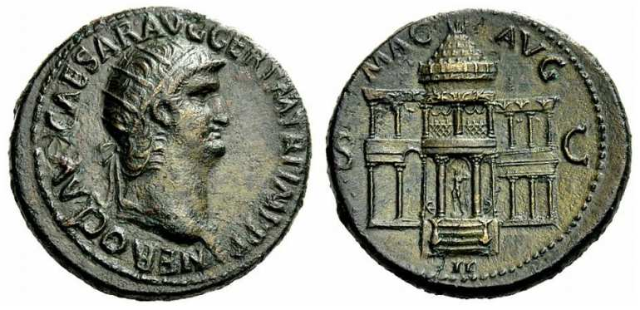
Nero AE Dupondius. NERO CLAVD CAESAR AVG GER P M TR P IMP P P, radiate head right / MAC AVG S-C

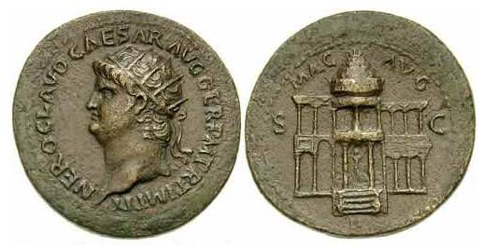
Nero, AE dupondius, AD 63. Rome. NERO CLAVD CAESAR AVG GER P M TR P IMP P P, radiate head left / MAC AVG, II in ex, S-C across fields, frontal view of the domed Macellum Magnum

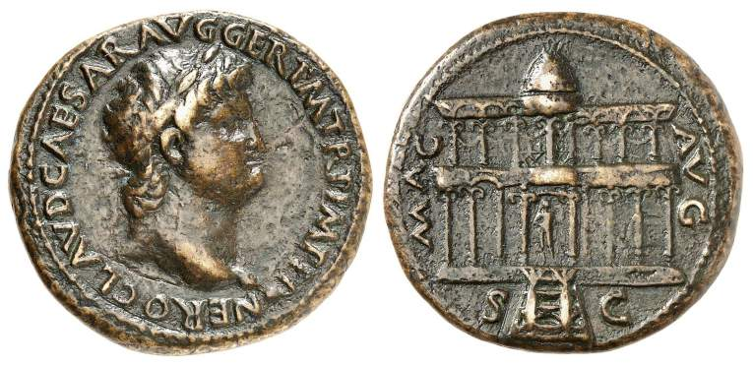
Nero AE Dupondius. Lyons mint. NERO CLAVD CAESAR AVG GER P M TR P IMP P P, laureate head left, globe at point of bust / MAC AVG, S-C on either side of steps, frontal view of the Macellum

Cassius Dio 32.18.3
“It was at this time that he celebrated so many sacrifices for his preservation, as he expressed it, and dedicated the provision market called the Macellum.”

Notitia regionum urbis Reg. II - located in the Caelian area of Rome.

Triumphal Arch
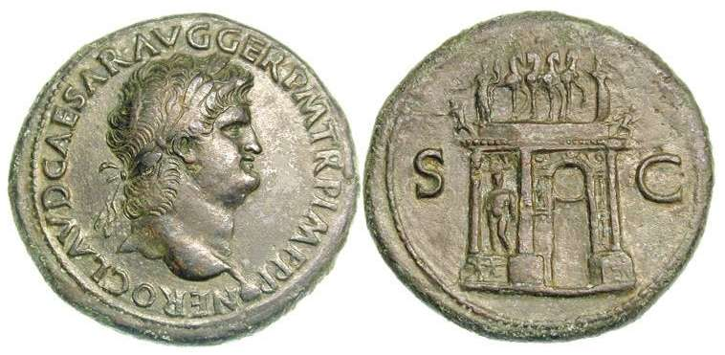
Nero AE Sestertius. AD 65, Lyon mint. – RIC 432

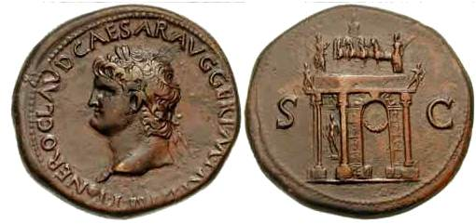
Nero AE Sestertius. AD 65, Lyon mint. – RIC 433

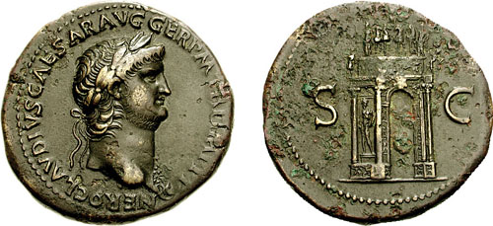
Nero AE Sestertius. AD 64, Rome mint. – RIC 147
Tacitus Annals 13.41
“...for all this [capture of Artaxata], Nero was hailed as Imperator, and in obedience to a senatorial decree, thanksgivings were held; statues and arches, and successive consulates were voted to the sovereign; and the days on which the victory was achieved, on which it was announced, on which the resolution concerning it was put, were to be included among the national festivals.”
15.18
“But at Rome trophies over the Parthians and arches were being erected in the middle of the Capitoline Hill: they had been voted by the senate while the issue of the war was still open, and now they were not abandoned — appearances being consulted, though known truth had to be ignored.”

Colossus of Nero
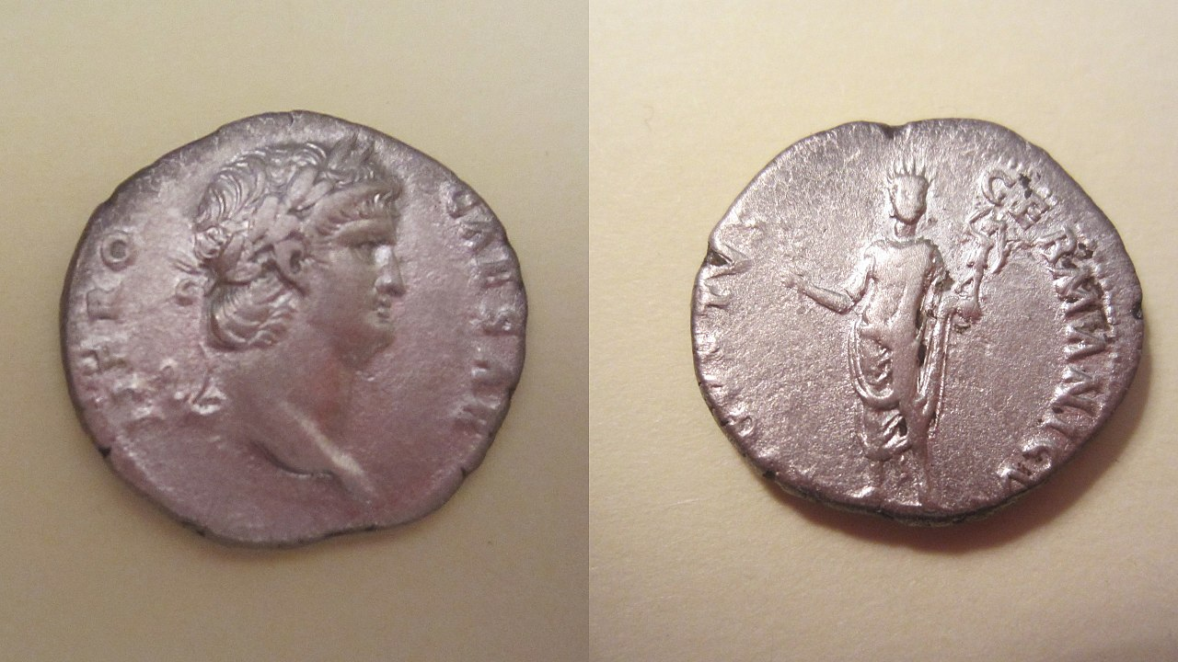
Possible representation of the Colossus on a Neronian denarius?

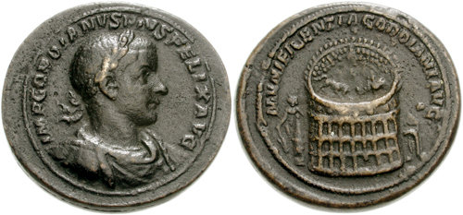
Medallion of Gordian III

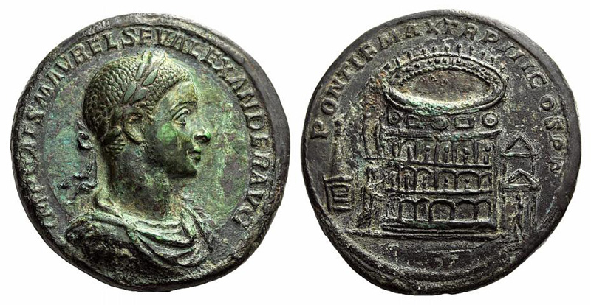
Medallion of Severus Alexander
Artistic reconstruction of the Colossus
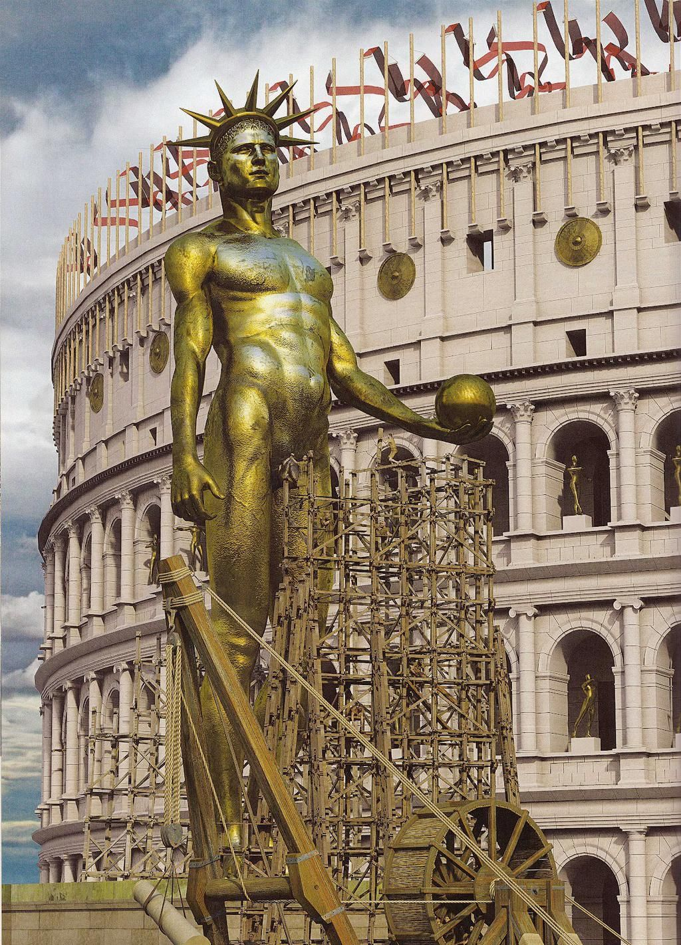
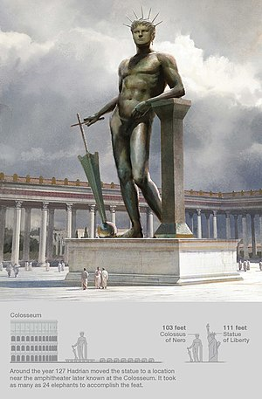
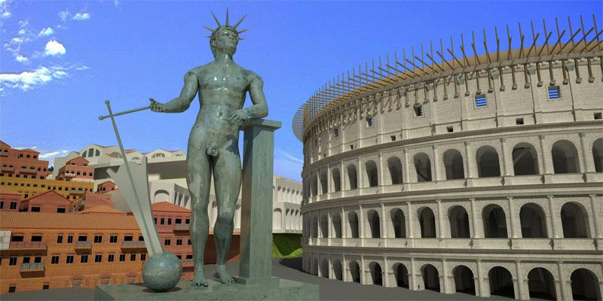
Literary descriptions of the Colossus

Suetonius Nero 31.1
“Its vestibule [the Domus Aurea] was large enough to contain a colossal statue of the emperor a hundred and twenty feet high...”

Pliny Natural History 34.18.45-47
“But all these gigantic statues of this kind have been surpassed in our own age by that of Mercury, made by Zenodotus for the city of the Arverni in Gaul, which was ten years in being completed, and the making of which cost four hundred thousand sesterces. Having given sufficient proof there of his artistic skill, he was sent for by Nero to Rome, where he made a colossal statue intended to represent that prince, one hundred and ten feet in height. In consequence, however, of the public detestation of Nero's crimes, this statue was consecrated to the Sun. We used to admire in his studio, not only the accurate likeness in the model of clay, but in the small sketches also, which served as the first foundation of the work. This statue proves that the art of fusing [precious] brass was then lost, for Nero was prepared to furnish the requisite gold and silver, and Zenodotus was inferior to none of the ancients, either as a designer or as an engraver.”

Cassius Dio 65.15.1
“In the sixth consulship of Vespasian and the fourth of Titus [AD 75] the precinct of Pax was dedicated and the "Colossus" was set up on the Sacred Way. This statue is said to have been one hundred feet in height and to have borne the features of Nero, according to some, or those of Titus, according to others.”

