Entrepernurial Innovation - BMBM4011

  - Assignment 1 – Aqua water filtration system pitch

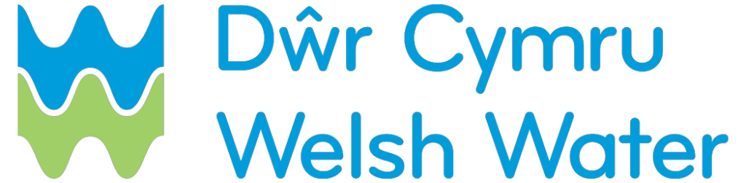
Ali Al-Kassab – 2101361
Ben Williams – 2223458
Louis Summerfield – 2309645
Nathan Barlow – 2318300
Matthew Evans – 2317129
Corey Valente - 2310254
Contents
Video Link 2
References 3
Statement of contribution 5

Video Link
https://youtu.be/iFFmMM2D1Lg

References
Anthony Jr, B., (2023). The role of community engagement in urban innovation towards the co-creation of smart sustainable cities. Journal of the Knowledge Economy

Attarbachi, T., Kingsley, M.D. and Spallina, V. (2023). New trends on crude glycerol purification: A review. Fuel

D, Christian Wahl. (2017). Making the Sustainable Development Goals work for local communities everywhere. Available at: https://designforsustainability.medium.com/making-the-sustainable-development-goals-work-for-local-communities-everywhere-3f00bd5db31 (Accessed: 20th of March 2024).

Dharminder, R.K.S., Kumar, V., Devedee, A.K., Mruthyunjaya, M. and Bhardwaj, R., 2019. The clean water: The basic need of human and agriculture. IJCS, 7(2), pp.1994-1998.

Doyle, M.W. and Havlick, D.G., (2009). ‘Infrastructure and the environment. Annual Review of Environment and Resources’, 34, pp.349-373.

Dwr Cymru (2024) Water quality alerts. Available at: https://inyourarea.digdat.co.uk/dwrcymru?loc=CF14+1NX (Accessed: 20th March 2024)

Dwr Cymru (2024). Our plan Available at: https://corporate.dwrcymru.com/en/about-us/our-plans (Accessed: 20th March 2024)

Edwards, A.M.C., Martin, D. and Mitchell, G.N., (1987). ‘Coloured runoff in the Yorkshire Pennines and its consequences for water supply’. ‘Colour in upland waters.’
Holzer, J.K., Ellis, L. and Merritt, M.W., (2014). ‘Why we need community engagement in medical research’. ‘Journal of Investigative Medicine’

Khalifa, M. and Bidaisee, S., 2018. The importance of clean water. Sch J Appl Sci Res, 1(7), pp.17-20.

Matthews, A.K., Newman, S., Anderson, E.E., Castillo, A., Willis, M. and Choure, W., (2018). ‘Development, implementation, and evaluation of a Community Engagement Advisory Board: strategies for maximizing success’. ‘Journal of Clinical and Translational Science’

Supply chain sustainability school (2024). Welsh water. Available at: https://www.supplychainschool.co.uk/partners/welsh-water/ (Accessed: 20th of March 2024).

Statement of contribution
My contribution to this group assignment includes creating this portfolio, talking about engaging community in our initiative, doing the conclusion and editing the video.

