Neve Evans
2000119
DATA mining project: morgan & morgan office supplies
Digital Intelligence & Analytics BMBM5006

Executive Summary

The purpose of this report is to assist Morgan & Morgan Office Supplies to interpret their data and analyse it so that I can draw patterns and conclusions from it as to be able to do a health check on their business performance.
By analysing the data I will be able to give recommendations on how to improve their performance, if necessary.
In order to analyse the data I will be using Microsoft Excel, the performance of such tool will be evaluated as well for the business.
Recommendations given are to monitor unnecessary extra costs such as manufacturing or stock purchase costs, discounts and shipping methods.
Table of Contents
Executive Summary 1
`Introduction 3
Main Findings 4
IF Function 4
SUM Function 5
Formatting Cells: Currency 6
VLOOKUP Function 7
Pivot Table Function 9
Bar Graph Visualisation 11
Conclusion 14
Recommendations 14
References 15

`Introduction

In this report I will be analysing a large data set from Morgan & Morgan Office Supplies Swansea in order to assist in giving recommendations on the health of their business. It’s extremely important to analyse data in a business “because it helps businesses optimize their performances. Implementing [data analytics] into the business model means companies can help reduce costs by identifying more efficient ways of doing business and by storing large amounts of data.” (Investopedia, 2022) Hopefully by analysing this data set I will be able to help Morgan & Morgan Office Supplies improve their performance and find the most efficient techniques in order to succeed.
To be able to analyse this data I will be using Microsoft Excel, which according to TechTarget (2022), is a spreadsheet program that allows users to format, organise and calculate data. By organising the data using Excel, data analysts, like myself, can make information easier to view and can also manipulate this data using mathematical functions, or visualise the data using graphs or pivot tables.
Excel is incredibly useful for data analytics in a business as it works well for teams since “makes it easy to collaborate and work on spreadsheets together” (helpsystems, 2020), it also is quite simple for individual, beginner users to grasp since “Excel doesn’t have a learning curve, so time to insight is usually fast. You can choose your path to data analysis. You can work through rows and columns. Or you can click to display the data in a pivot table for deeper analysis. You can even create visualizations in charts or graphs in just a few clicks.” (helpsystems, 2020) Excel truly is one of the best applications for data analytics, no matter the skill and it can all be done very efficiently which is key in business.

Main Findings

IF Function

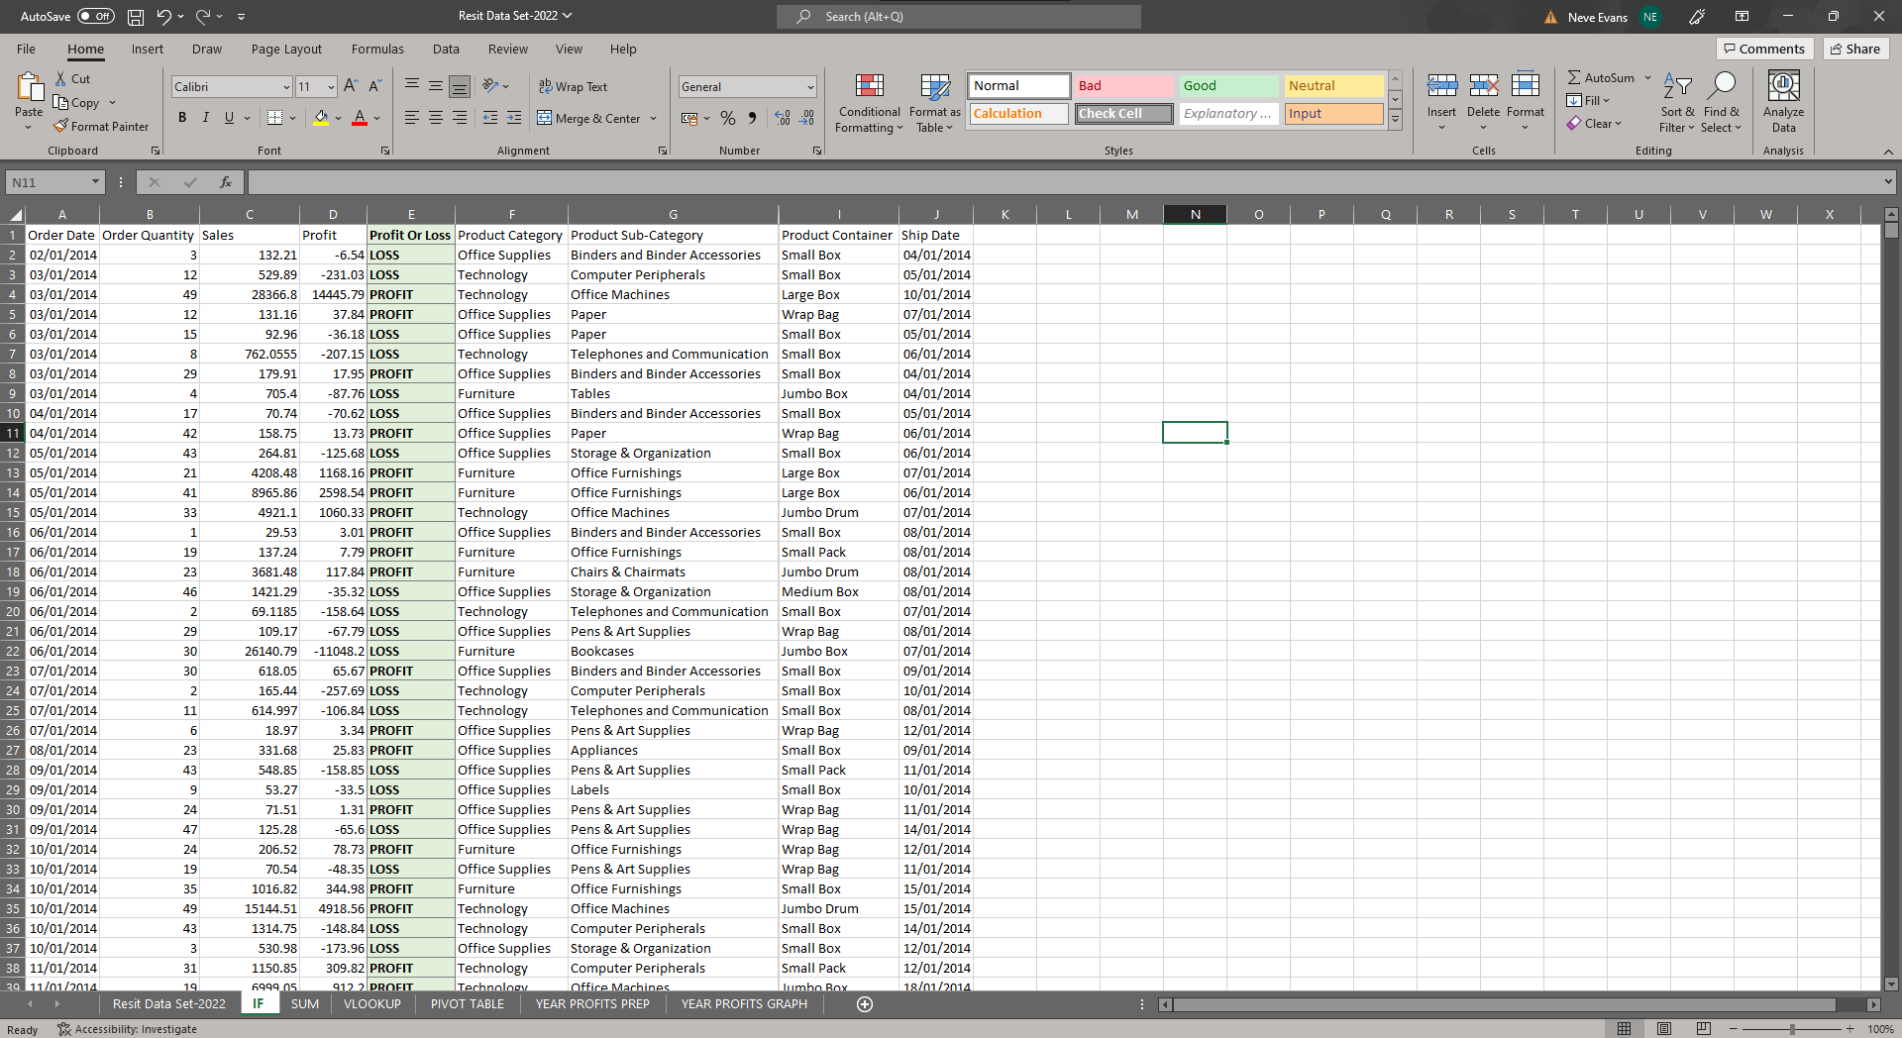
Fig 1: Profit & Loss IF Function
Using Excel’s IF function I was able to show whether a product was a profit or a loss. This was achieved by using the formula =IF(D2>0,”PROFIT”,”LOSS”). This made it very easy to see what was a profit and what was a loss without having to look at the figures. By using this formula you can now easily discover what items aren’t achieving a profit and then use further analytic tools to narrow this down further. The only drawback with this function is it still considers even 1 pence as a profit which in business isn’t a significant profit, this is where you would apply further formulas.
The IF function is very useful as it easily “allows you to make logical comparisons between a value and what you expect” (Microsoft Support, 2022)

SUM Function

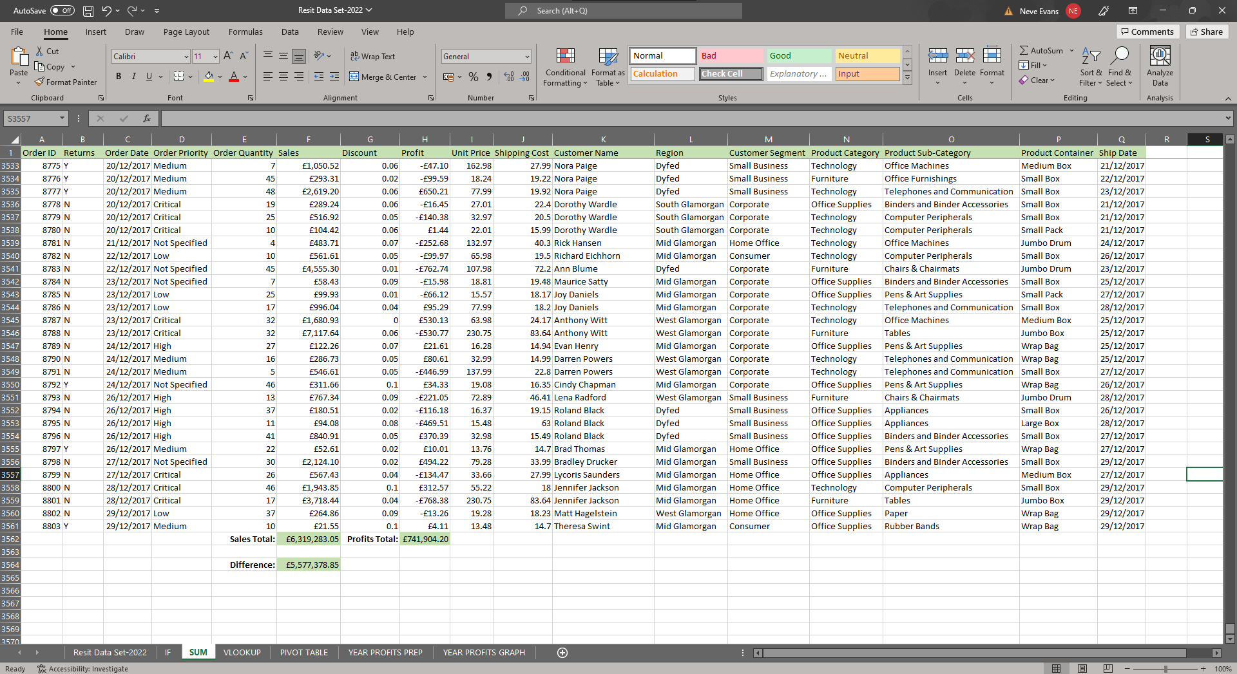
Fig 2: Sales & Profit Totals using SUM function
Using the SUM function, =SUM(F2:F3561) and =SUM(H2:H3561) I was able to calculate the sum of the sales and sum of the profits. This meant instead of spending hours on a calculator working out the grand totals it was done with one simple formula. This helps me to analyse and compare the figures, since £6.6M sales is fantastic but only £742K profits isn’t that great and could be higher. The SUM function has allowed me to see an issue with profits and now I am able to analyse further to see what is causing this issue. Seeing the total sales and profits also allowed me to calculate the difference using =F3562-H3562 which calculated to £5.5M, this figure is how much the business has spent for the product whether that is manufacturing costs, stock purchasing, discounts, or mailing costs. This is quite a high figure and so potentially reducing these costs could lead to a higher profit figure.
The SUM function is incredibly useful in data analytics as it “helps obtain the totals of ranges irrespective of whether the cells are contiguous or non-contiguous, it automatically updates to include the addition of a row or a column, … [and] it eliminates the difficulty associated with typing manual entries.” (WallStreetMojo, n.d)

Formatting Cells: Currency

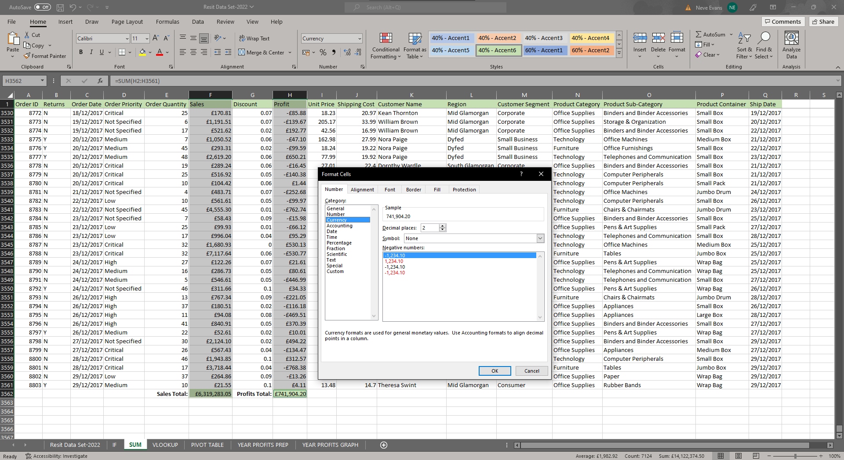
Fig 3: Formatting Currency on Sales & Profit Totals
After calculating the sales and profit totals I believed it important to format the cells to show the ‘£’ symbol as I was dealing with currency specifically. It was straightforward to select both columns and format them with the ‘format cells’ button and from there I could change the number of figures after the decimal point but I left it as 2 since that is the maximum for dealing with currency.
It’s important to format currency in Excel when appropriate, as Excel in XL (2020) explains “a rupee without the currency symbol is just a number [and] Excel makes it easy for us to format numbers as currency so that one can distinguish between the amounts and numbers.” It’s something small that just makes reading the data clearer.

VLOOKUP Function

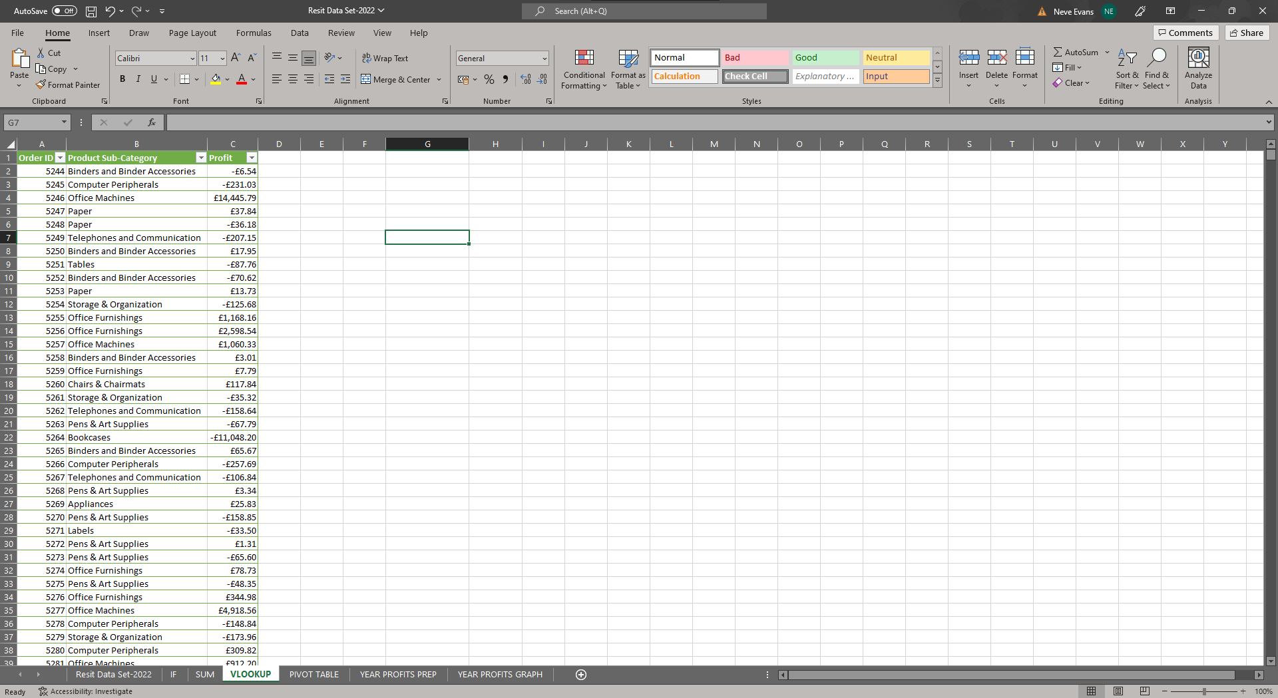
Fig 4: Preparing data for VLOOKUP
Before starting the VLOOKUP function I had to prepare the data so I selected the order ID column, product subcategory column and the profits column. I intended to use VLOOKUP so that by looking up a product you could easily retrieve the profit data for it. I encountered some issues here as VLOOKUP does not like using duplicate data which there were a few in the product subcategory column. I couldn’t remove duplicates, for example, the two ‘paper’ entries as they had different profit so they were sold to different customers. I considered trying to use VLOOKUP to retrieve multiple entries but it was not possible, this is when I decided to use the order ID but include the product subcategory as a key anyways. To solve this problem each item could have a specific code instead. However, in the end this still worked for me and gave me what I needed.
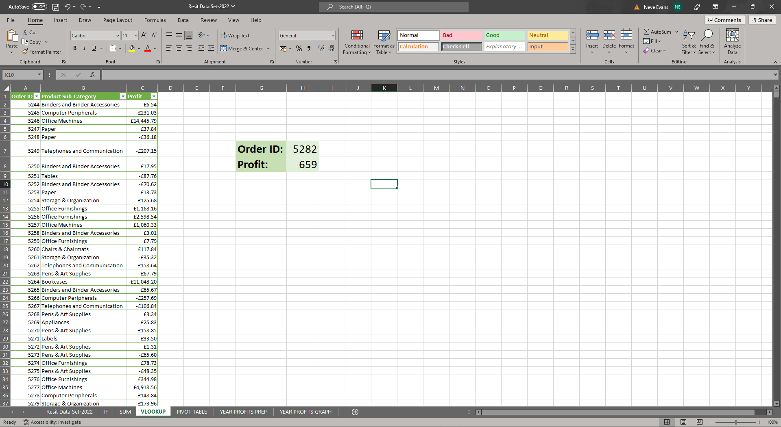
Fig 5: VLOOKUP Function in action
In the screenshot above you can see the VLOOKUP function in action, to achieve this function I used the formula =VLOOKUP(H7,table,3,FALSE) so that when you enter the order ID in the indicated cell it will return you, in the indicated profit cell, the profit for that order. This allows me to quickly look at individual orders and see the profit for it rather than inefficiently scanning manually through all the data. VLOOKUP is useful when needing “to find information in a large spreadsheet, or [when] you are always looking for the same kind of information.” (Microsoft Support, 2022)

Pivot Table Function
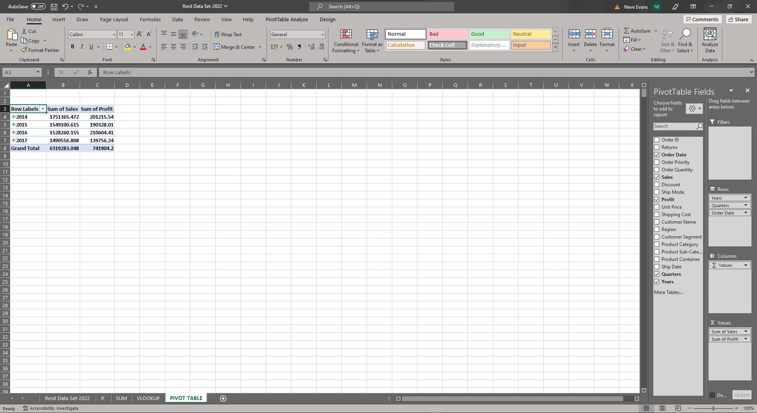
Fig 6: Creating a pivot table
For my next function I decided to create a pivot table, this was incredibly easy to make as you can see in the screenshot above. Whilst on my selected data sheet I used the pivot table button which created a new sheet and asked me to select on the right-hand side what data I wanted to put in the table. For this function I decided to look at the sum of the sales and profits throughout the years. This felt like a sensible analysis to make at this point. My pivot table broke each year down into 4 quarters which is great since a lot of business works on the 4 quarters of the year often stylised as Q1, Q2, Q3 and Q4.
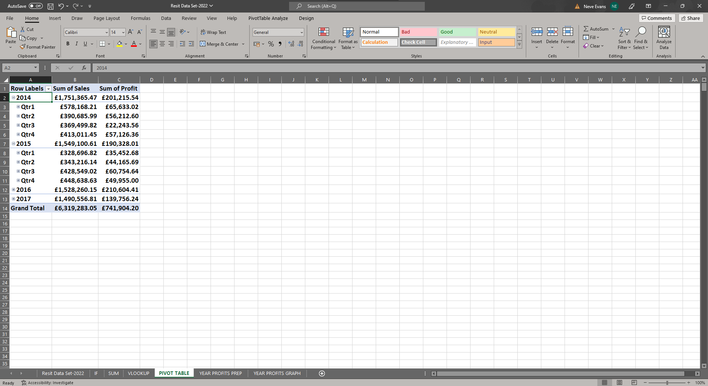
Fig 7: Pivot table
Using the pivot table I was able to analyse each year and quarter in detail which allowed me to see that 2014 had the highest sales but 2016 had the highest profits although 2016 did have the second lowest sales which indicates the items it sold were highly profitable despite not making many sales that year. As for the quarters 2016 Q4 had the highest profits overall which means with some further analysis we could look further into what made 2016 Q4 so profitable. 2017 had the least amount of sales and profits as a whole and Q3 was the most underperforming in that year, with some further analysis we could discover why this is and that would be a good place to start for improvements. Overall, however, 2014 Q3 had the lowest profits, so analysing that quarter is also another area to investigate.
I found the pivot table to be one of the most useful functions as it narrowed down healthy and unhealthy areas within the business very easily and quickly. It’s certainly something that any beginner could use as a tool to improve their business analytics. According to the Association of Business Training (2013), pivot tables are beneficial as they are easy to use, it’s an easy way to analyse and summarise large amounts of data, it helps find data patterns, it enables a business to create quick data reports and all these benefits help in quick decision making which is key in business.

Bar Graph Visualisation

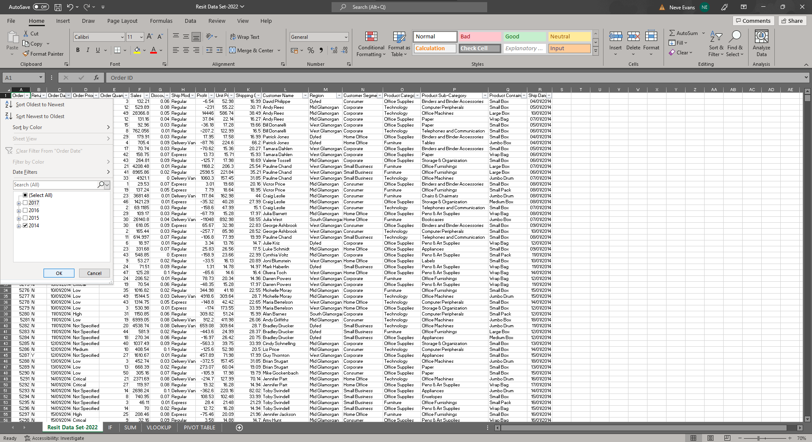
Fig 8: Using the sort & filter function for bar graph preparation
In order to prepare for my bar graph I first had to use Excel’s sort and filter function to filter each year since my graph is going to be showing profits for each year. This function is really easy to use as it shows me the check boxes for the order date column and I only had to untick every year except the one I needed. Once I had filtered the year I copied the profits column into a new sheet which you will see below.
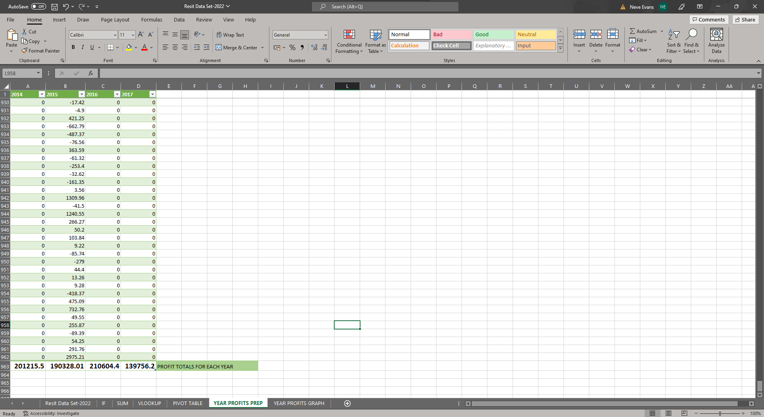
Fig 9: Prepared profit data for each year and the totals
Once I had filtered the data I put it all into a new sheet and here I could use the SUM function again to get the profit totals for each year, this was all straightforward to do in minutes and I could then copy the totals across to a new sheet for my graph.
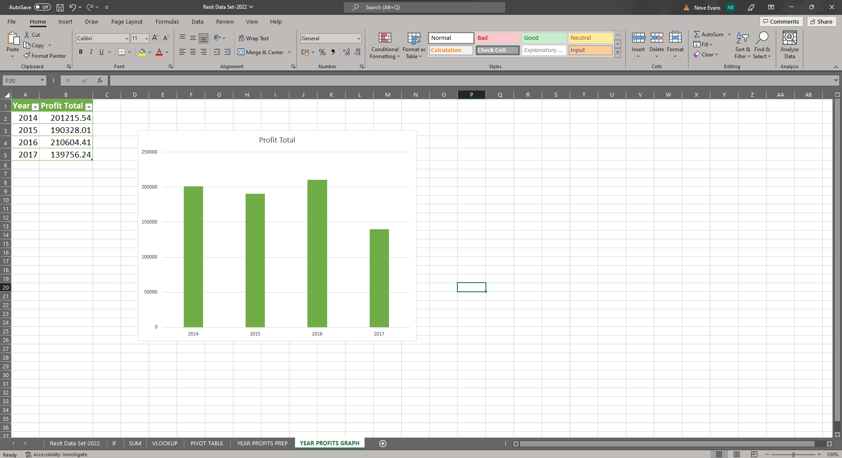
Fig 10: Graph of total profits by year
Using the profit totals I was then able to create a bar graph which showed the profit totals by year, this was again very simple to do since Excel has an automatic graph function.
Having this graph allows me to visualise the data easily and analyse it. The graph showed me that 2017 was the least profitable year, this is backed up by the pivot table as well. It also shows that 2016 was the most profitable year although it is almost on par with 2014 and 2015. Now I have this information I know it would be sensible to further analyse 2017 to see why it wasn’t a very profitable year.
Excel’s column charts “are useful for showing data changes over a period of time or for illustrating comparisons among items.” (Microsoft Support, 2022) Just like pivot tables, column charts are straightforward to create and it’s another fantastic way to visualise data.

Conclusion

My data analysis shows that profits could have been higher and that 2017 underperformed compared to other years. 2016 was a profitable year despite the sales which I have already identified as being a positive thing, low sales but high profits indicates that the products sold give the best profit per sale than anything else.
In conclusion of using Excel as a data analysis tool, I have found it to be incredibly useful and would absolutely recommend it for all data analysing. Excel is quick, easy, efficient and beginner friendly. There are many tools online to help learn more complicated uses of Excel and it’s easy to grasp these after a few tries. A lot of the functions are straightforward as they are automatic buttons along the home bar, it is also possible to do step-by-step formulas as well for those who may not understand how to use it.
I have found Excel to be the most useful tool in this task since I am an example of someone who is not well versed in the application and yet I was able to use it to it’s full extent in order to analyse the data exactly how I needed to and it was an extremely efficient tool to use.

Recommendations

Some recommendations I would make is to consider cutting down manufacturing costs or stock purchasing costs, reducing high discounts and find cheaper alternatives for the expensive shipping methods so that there is a high profit per sale like 2016. It would be good as well to further investigate what went wrong in 2017 and to improve based on those mistakes.

References

Association of Business Training (2013) What is a Pivot Table and what are the Benefits of Utilizing Them in Excel?. Available at: https://www.associationofbusinesstraining.org/articles/view.php?article_id=11022 (Accessed: 13 July 2022)
Excel in XL (2020) How to Format Numbers as Currency in Excel. Available at: https://excelinexcel.in/ms-excel/formulas/format-numbers-as-currency/ (Accessed: 13 July 2022)
helpsystems (2020) What’s So Great About Analyzing Data in Microsoft Excel?. Available at: https://www.helpsystems.com/blog/whats-so-great-about-analyzing-data-microsoft-excel (Accessed: 13 July 2022)
Investopedia (2022) Data Analytics. Available at: https://www.investopedia.com/terms/d/data-analytics.asp (Accessed: 13 July 2022)
Microsoft Support (2022) IF Function. Available at: https://support.microsoft.com/en-us/office/if-function-69aed7c9-4e8a-4755-a9bc-aa8bbff73be2 (Accessed: 13 July 2022)
Microsoft Support (2022) Present your data in a column chart. Available at: https://support.microsoft.com/en-us/office/present-your-data-in-a-column-chart-d89050ba-e6b6-47de-b090-e9ab353c4c00 (Accessed: 13 July 2022)
Microsoft Support (2022) VLOOKUP. Available at: https://support.microsoft.com/en-us/office/video-vlookup-when-and-how-to-use-it-9a86157a-5542-4148-a536-724823014785#ID0EBBD=Transcript (Accessed: 13 July 2022)
TechTarget (2022) Excel. Available at: https://www.techtarget.com/searchenterprisedesktop/definition/Excel (Accessed: 13 July 2022)
WallStreetMojo (no date) SUM Function in Excel. Available at: https://www.wallstreetmojo.com/sum-function-in-excel/ (Accessed: 13 July 2022)

