

Task 1 – Reading Task Template
Upload your photo of your A3 in-class notes here:
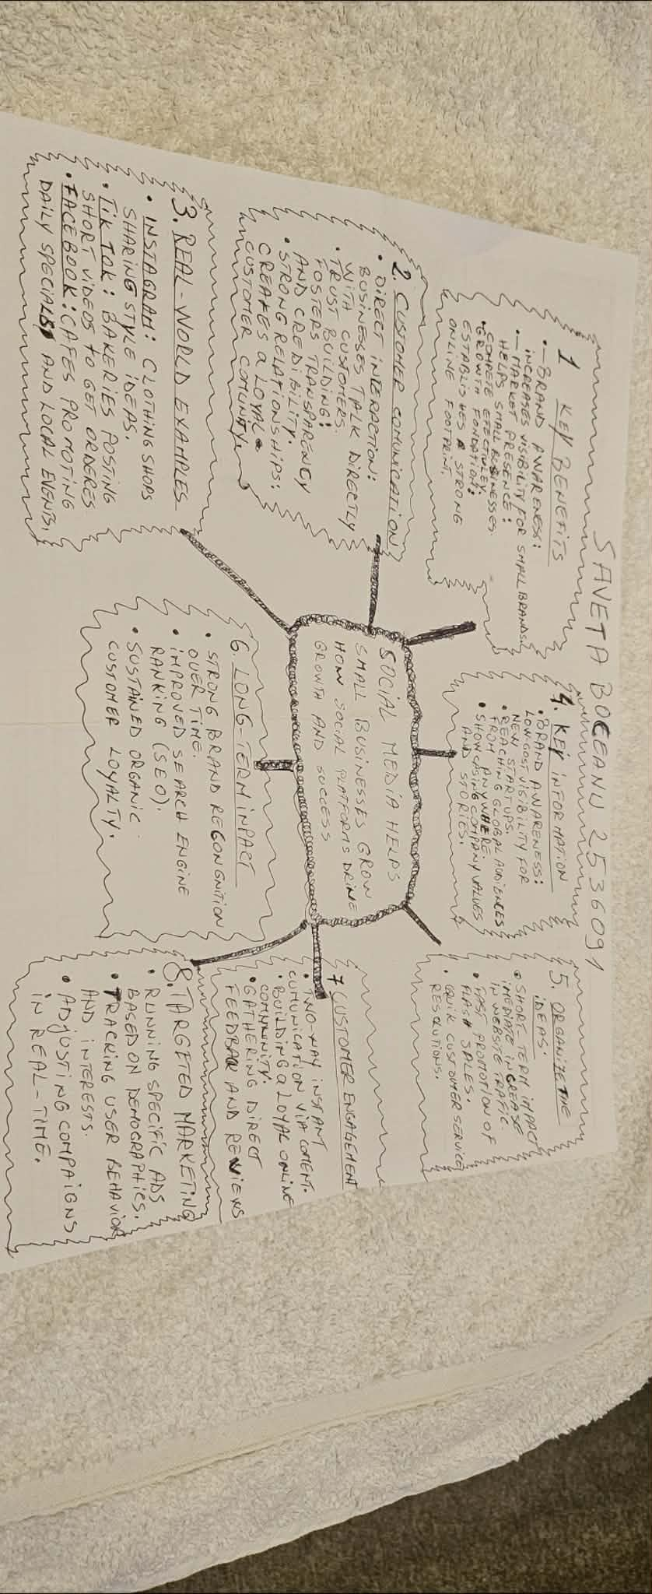

1. Answer these questions using the sentence starters below
a. What is the main idea of the text?
The main idea is that social media helps small business grow how social platforms drive growths and success
b. What are two key points?
One key point is: brand awareness increases visibility for small brand .
Another key point is: market presence helps small businesses compete effectively
c. What part of the text did you find most important? Why?
The most important part is: organising and understanding the text
d. Was anything unclear or difficult to understand?
I was not sure about how to make the mind map and how to figure out the text
e. How did your group help you understand the text better?
My group helped me by understand the text and how to make a mind map in class and how to make the point on the mind map
3. One sentence reflection
Question: What did you find challenging about this task?
The hardest part was submitting my work and the home work I did not know how to submit

