Marketing fundamentals
Assessment 1- Blogging to communicate

Table of Contents
Introduction: 3
“As part of an individual assignment you are required to choose a well-known company of your choice and use blogs as part of the communication activities for your chosen project” 4
Conclusion: 12
References: 13

Introduction:
Marketing fundamentals are the process implemented by the various organizations to develop more of their features in the competitive market. An organization needs proper management and strategies which helps them more in creating the proper and correct footprints in the business market. The whole blog will discuss the marketing fundamentals of an organization named Asda.

“As part of an individual assignment you are required to choose a well-known company of your choice and use blogs as part of the communication activities for your chosen project”

Marketing Strategy

Image no. 1: Marketing strategy
Source: (Crick et al., 2020)
Marketing strategy is the process implemented by an organization like ASDA to function the business more smoothly in the business market. It is also referred to as a plan of action which determines organizations like ASDA to promote more on selling their products in the competitive market. Marketing strategy of ASDA covers long term development goals which help the organization to provide the quality goods as to increase more revenue in the organization. Marketing strategy of the organization like ASDA refers to goals achieved by organization by understanding and providing customer needs and wants by establishing distinct and sustainable competitive advantage (Tong et al., 2020). Action of planning is created on implementing such strategies in the organization.
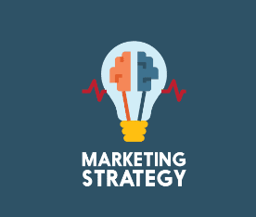
Image no. 2: Marketing strategy
Source: (Tong et al., 2020)
This process also helps organizations to reach the customers goals by creating different channels in the organization. It also helps in determining the value of a single customer in an organization. Marketing strategies of an organization like ASDA also helps in determining the position of organization in the competitive market. Marketing strategies in the organization also creates a positive influence to know the key stakeholders of an organization, partners made by organization in initial days and helps by mentioning more on advertising and promoting in the different business market (Morgan et al., 2019). A marketing strategy in an organization also helps in setting the direction to sell the products in the individual market. Marketing strategy in the organization also helps in tracking the business operation and activities of the organization in a competitive market. This process also helps organizations like ASDA to connect more and establish renowned relationships with the valuable customers. Forcing to create more strong relationships with the customers also helps in changing the revenue structure in organization.

Image No. 3: marketing Strategy
Source: (Morgan et al., 2019)

Product Range
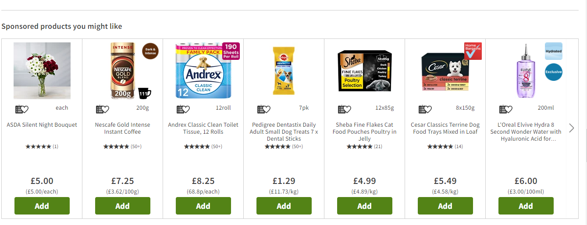
Image no 04: product range
Source: (Gilardi et al., 2018)
ASDA being a responsible retail organization offers a large variety of products which helps customers to satisfy their needs and wants. The product developed by the organization is most unique and valuable to price. Organization also holds strong brand positioning in the global market by offering different kinds of products which are most used daily by every customer. Being a recognized and renowned organization launched in the year 1960 in Yorkshire, the United Kingdom managed to develop their products which are more benefits to customers on using the products (Li et al., 2021).

Image no 05: product range
Source: (Li et al., 2021)
The main products developed by the ASDA are groceries items used daily in the kitchen of every residential and merchandise for the kids, women and men at a valued price, and toys for the children. ASDA also offers Gift cards which help organizations to retain more customers in the organization. Organization also offers corporate gift cards which helps in benefitting more in satisfying the needs of customers. The main motive of the ASDA after launching its initiative is offering the proper services of food items which help customers to satisfy their needs in terms of requirements. ADA has launched different initiatives to benefit the customers and they are gas station and online doctor appointments (Ferell et al.,2021). This initiative was taken majorly by the management of ASDA too implement the major changes in the organization as well as helps organization in gaining more revenue by investing less.

Image No. 06: Product Range
Source: (Ferrell et al., 2021)
The main reason for developing the products in the huge range was because the organization had gained a huge brand impression and valuable customers in the short period of time. Asda also focuses more on developing their products rather than focusing more on collecting more revenues. Implementing this process by the organization also makes it more unique among the different organizations present in terms of competing ASDA.

Role of marketing Manager

Image no 07: role of marketing manager
Source: (Hanson et al., 2020)
Marketing manager of an organization plays an important role in functioning the business smoothly in the business market. The role of m marketing manager is considered as the most important role in benefitting the organization like ASDA. Marketing managers in organizations like ASDA have many roles and responsibilities in terms of taking the organization to higher heights (Mothersbaugh et al., 2020). Marketing managers in the organization like ASDA research more in the competition and gathers more information and reports to the organization. Using this process by the organization also helps more in changing the products ranges and quality.

Image No.08: Role of Marketing manager
Source: (Mothersbaugh et al., 2020)
Marketing manager of an organization like ASDA also learns more about the trending culture in the business market and creates more marketing strategies which helps the organization to develop more growth in the competitive market. Marketing manager of an organization like ASDA also helps in developing the products by researching more in the competitive market. Promotion of the product which is developed by the organization as an innovation is done more responsibly by the marketing manager of ASDA. Branding of products in the different markets is also the assigned role of the marketing manager (Kingsnorth, 2022). The main duties and responsibilities of a marketing manager is to increase the organization revenue by selling the products more in the competitive market.

Image No. 09: Role of Marketing manager
Source: (Kingsnorth, 2022)
Marketing manager of an organization like ASDA also creates new strategies which help the organization to function and operate more smoothly in the business market. Marketing manager of an organization like Asda also collects more information as required to the organization to develop more in the competitive market.
Identifying values and Goals

Image no.10: Identifying values and goals
Source :(Kumar et al., 2020)

The second step for organizations like ASDA is to identify the values and goals of the organization after conducting business in the competitive market. Marketing strategy of an organization like ASDA must be aligned and matched with the moral values and goals of an organization. Identifying the goals and objectives in the business market also requires more researching skills of human resource management professionals. Management must observe what organization is focusing on and must visualize the goals and the targets to be more determined on the target (Chaffey et al., 2019). Management in the organization is determined to know the competitors in the competitive market. Targeting the more valuable customers during researching the market also helps organizations to build a strong empire in the business market. Establishing valuable customers in the business market requires the good quality of products developed by organizations in balancing price. Committing more on retaining the valuable customers in the organization also enables more to settle permanent customers in the organization. Knowing the valuable customers who are more interested in buying and purchasing is more important for the organization when developing a proper and correct marketing strategy.

Image no 11: Identifying goals
Source: (Chaffey and Chadwick, 2019)

Setting objectives of goals and targets also helps organizations in improving the performance in the business market. Identification of goals and objectives also requires good professionals of management who helps in reaching more on the other organization and receive more ideas and information which also helps the organization in setting targets and achieving it (Olson et al., 2018). It is more important for the organization like ASDA to implement the changes in the management and hire more professionals in the organization to reach the objectives and targets.

Marketing Segmentations
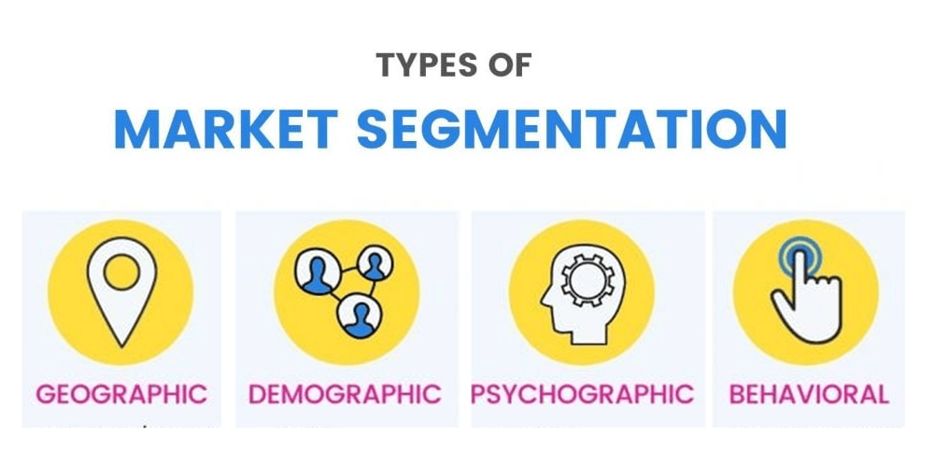

Image no.12: Marketing segmentation.
Source: (Schyvinck and Willem, 2019)
ASDA not only sells food, but it also helps deliver different outfits and products. Implementing the market segmentation in the correct process also helps ASDA to perform more smoothly in the business market. Marketing segment is the process which helps in dividing customers which are identified by the organization like ASDA as valuable customers. It is also a process used by an organization like ASDA to increase the revenue in the organization by using different approaches (Pelsmacker et al., 2018). This process also helps organizations in differentiating in less valuable and more valuable customers in the organization. It also helps organizations like ASDA to divide the brands total addressable market by dividing into smaller and compact groups. Results of using the marketing segmentation process by the organization also helps in creating more effective results in the organization.
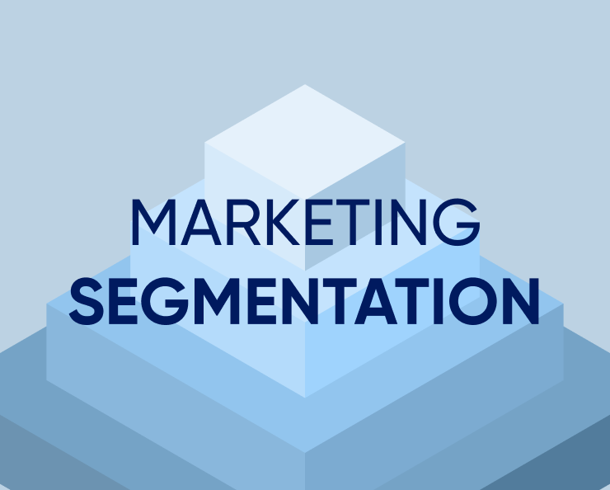
Image no 13: Marketing Segmentation
Source: (Olson et al., 2018)
Organization also functions well in the business market. It also helps organizations like ASDA to increase more sales by using the correct approaches. This process also helps organizations by conveying the meaningful messages in the grip rather than conveying individuals. After the segmentation of the market is done, the organization is developed more in terms of developing products required by the different segments. Marketing segments in the organization are done to value the customers as well as providing more facilities and services to the customers in the different levels. The common example of marketing segments implemented by the organization like ASDA is geographic segments, demographic segments, psychographic segments, and behavioral segments. Those different segments in the organization offer different kinds of products required by the valuable customers of an organization.

E-commerce Website
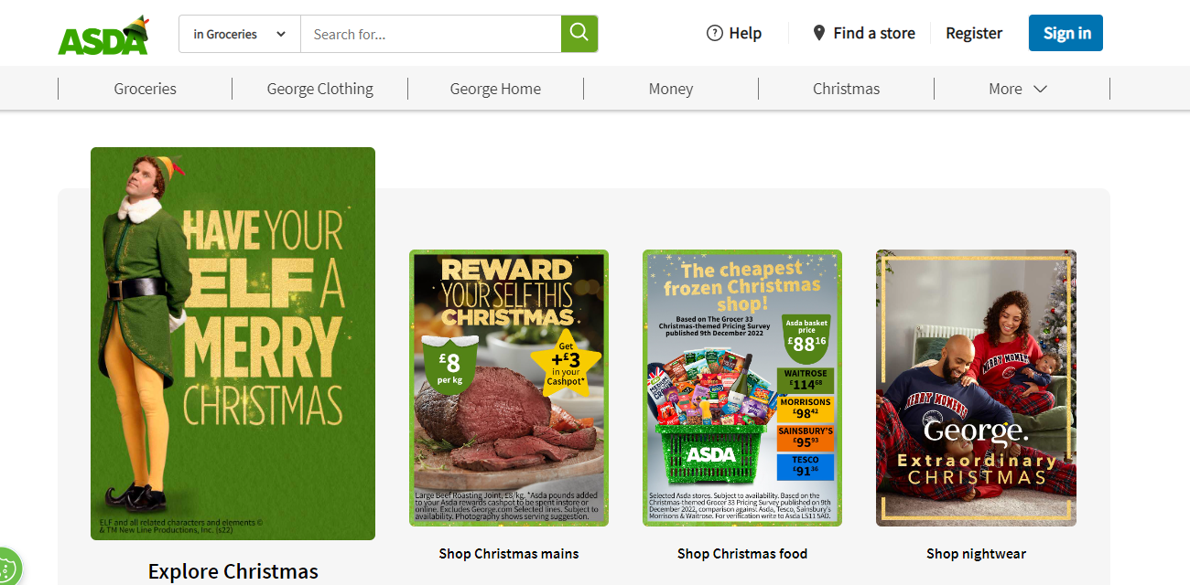
Image no 14. E-commerce website
Source: (Adams et al., 2019)
It is the process and methods implemented by the organization like ASDA which is created for the benefit of the consumers. After great research in the market, management of ASDA thought of launching the e-commerce website. Launching an e-commerce website in the first initial stage also gained more than one million users in the organization website. The main principles of initiating the process of e-commerce by the organization are to make more changes in the revenue structure of an organization. Laughing e-commerce website also helps customers deliver their required resources in the individual residential. This process also helps organizations to make more developments on the e-platform. Organization is also able to compete against the strong competitors in the market. The main competitors of the organization in the business market are Marks and Spencer who hold their business in both platform online and offline mode (Yousaf and Xicheng, 2018).
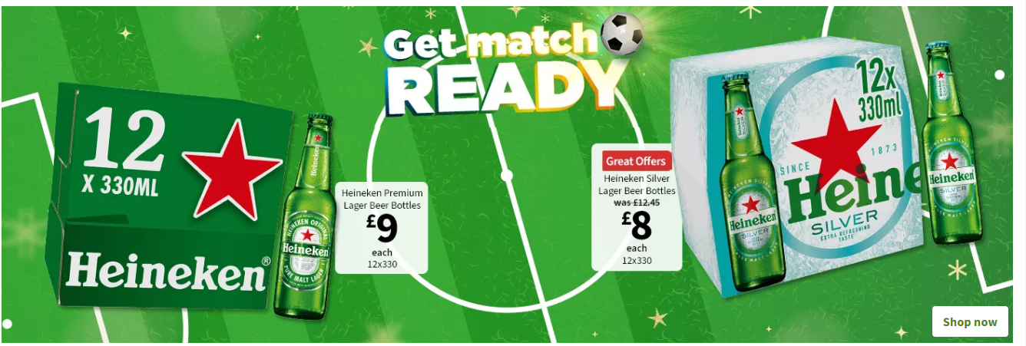
Image No 15: E commerce website
Source: (Paley, 2021)
Customers are requested to order their products which are more essential and satisfy their needs by sitting on their own residential. The process of delivering the items ordered by the customer is faster as compared to other organizations. Launching e-commerce websites and developing more on the products manufactured by them also helps ASDA in recovering the financial strengths invested by them before. The main motive behind developing the e-commerce website was due to the recent pandemic faced by the world. ASDA being a responsible organization dealing with fresh food, grocery items and other products managed to launch their ecommerce website to help customers to lower the risk of getting infected by deadly coronavirus in the situation.

Improved digitalization
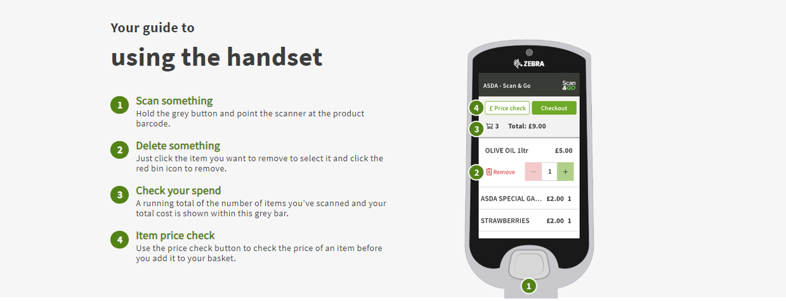
Image no 16. Automated self-checkout counter
Source:(Wang et al., 2020)
Improving the technology in the organization like Asada a slow help in contributing to the hassle-free shopping while physically in the outlets. The main motive behind developing more automated technology in the organization also helps reduce the cost of employees in the organization. This process also helps customers in shopping hassle free and without standing in long queues. This process also helps the organization in retaining more customers in the organization. ASDA being a huge organization offering huge amounts of products at retail prices tends to have a huge crowd in the outlets. A monitored by the many professionals in the organization thought of implementing the automated machines in the checkout process which also helps organization to reduce the crowdedness among the customers, many customers in the organization also feel calmer in shopping in a silent environment which also helps organization to retain new and valuable customers in the organization (Setiawan et al., 2020). After the implementation of this process in every outlet ASDA sale were increased by 5% of total sales as compared before.

Images No 17: Improved Digitization
Source: (Pelsmacker et al., 2018)
ASDA being a responsible organization also contributed more in reducing the risks of getting transmitted from the various diseases after successful implementation of technology in the organization. ASDA also set an example of implementing the technology changes in the organization. It was renowned and recalled as the first organization among every organization to develop modern techniques in the organization. By implementing the technology successfully in the organization ASDA was also able to set the examples of digitalization to every organization who was in need of those technologies.

Conclusion:
As discussed above, business fundamentals play an important role in developing a particular organization in the business market. The whole blog has been focused more briefly on discussing the role of business fundamentals in organizations like ASDA.

References:
Adams, M., Upreti, V. and Chen, J., 2019. Product-market strategy and underwriting performance in the United Kingdom’s property–casualty insurance market. The European Journal of Finance, 25(11), pp.1012-1031.
Chaffey, D. and Ellis-Chadwick, F., 2019. Digital marketing: strategy, implementation & practice. Pearson uk.
Chaffey, D. and Ellis-Chadwick, F., 2019. Digital marketing: strategy, implementation & practice. Pearson uk.
Crick, J.M. and Crick, D., 2020. Coopetition and COVID-19: Collaborative business-to-business marketing strategies in a pandemic crisis. Industrial Marketing Management, 88, pp.206-213.
De Pelsmacker, P., Van Tilburg, S. and Holthof, C., 2018. Digital marketing strategies, online reviews and hotel performance. International Journal of Hospitality Management, 72, pp.47-55.
De Pelsmacker, P., Van Tilburg, S. and Holthof, C., 2018. Digital marketing strategies, online reviews and hotel performance. International Journal of Hospitality Management, 72, pp.47-55.
Ferrell, O.C., Hartline, M. and Hochstein, B.W., 2021. Marketing strategy. Cengage Learning.
Ferrell, O.C., Hartline, M. and Hochstein, B.W., 2021. Marketing strategy. Cengage Learning.
Gilardi, F., Lam, C., Tan, K.C., White, A., Cheng, S. and Zhao, Y., 2018. International TV series distribution on Chinese digital platforms: Marketing strategies and audience engagement. Global Media and China, 3(3), pp.213-230.
Hanson, W.A. and Kalyanam, K., 2020. Internet marketing and e-commerce. (Student ed.). Thomson/South-Western.
Kingsnorth, S., 2022. Digital marketing strategy: an integrated approach to online marketing. Kogan Page Publishers.
Kumar, A., Paul, J. and Unnithan, A.B., 2020. ‘Masstige ‘marketing: A review, synthesis and research agenda. Journal of Business Research, 113, pp.384-398.
Li, F., Larimo, J. and Leonidou, L.C., 2021. Social media marketing strategy: definition, conceptualization, taxonomy, validation, and future agenda. Journal of the Academy of Marketing Science, 49(1), pp.51-70.
Li, F., Larimo, J. and Leonidou, L.C., 2021. Social media marketing strategy: definition, conceptualization, taxonomy, validation, and future agenda. Journal of the Academy of Marketing Science, 49(1), pp.51-70.
Morgan, N.A., Whitler, K.A., Feng, H. and Chari, S., 2019. Research in marketing strategy. Journal of the Academy of Marketing Science, 47(1), pp.4-29.
Morgan, N.A., Whitler, K.A., Feng, H. and Chari, S., 2019. Research in marketing strategy. Journal of the Academy of Marketing Science, 47(1), pp.4-29.
Mothersbaugh, D.L., Hawkins, D.I., Kleiser, S.B., Mothersbaugh, L.L. and Watson, C.F., 2020. Consumer behavior: Building marketing strategy. New York, NY, USA: McGraw-Hill Education.
Mothersbaugh, D.L., Hawkins, D.I., Kleiser, S.B., Mothersbaugh, L.L. and Watson, C.F., 2020. Consumer behavior: Building marketing strategy. New York, NY, USA: McGraw-Hill Education.
Olson, E.M., Slater, S.F., Hult, G.T.M. and Olson, K.M., 2018. The application of human resource management policies within the marketing organization: The impact on business and marketing strategy implementation. Industrial Marketing Management, 69, pp.62-73.
Olson, E.M., Slater, S.F., Hult, G.T.M. and Olson, K.M., 2018. The application of human resource management policies within the marketing organization: The impact on business and marketing strategy implementation. Industrial Marketing Management, 69, pp.62-73.
Paley, N., 2021. The manager's guide to competitive marketing strategies. Routledge.
Schyvinck, C. and Willem, A., 2019. From cause-related marketing strategy to implementation in professional basketball organizations: A matter of alignment. European Sport Management Quarterly, 19(1), pp.58-79.
Setiawan, A., Rini, E.S., Sadalia, I. and Daulay, M.T., 2019. Analysis of Murabahah Financing Marketing Strategy at PT BPRS Amanah Insan Cita, Medan, North Sumatra, Indonesia.
Tong, S., Luo, X. and Xu, B., 2020. Personalized mobile marketing strategies. Journal of the Academy of Marketing Science, 48(1), pp.64-78.
Wang, Y., Hong, A., Li, X. and Gao, J., 2020. Marketing innovations during a global crisis: A study of China firms’ response to COVID-19. Journal of business research, 116, pp.214-220.
Yousaf, S. and Xiucheng, F., 2018. Halal culinary and tourism marketing strategies on government websites: A preliminary analysis. Tourism Management, 68, pp.423-443.
Tong, S., Luo, X. and Xu, B., 2020. Personalized mobile marketing strategies. Journal of the Academy of Marketing Science, 48(1), pp.64-78.

