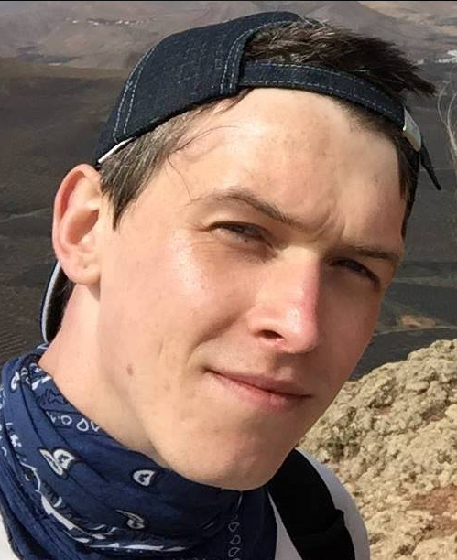

Name: Ross David Dallimore

Student number: 1700010

Student email address: 1700010@student.uwtsd.ac.uk

Contact number: 01646 693989

Please use the remaining space to give a brief outline of why you have chosen your course of study and any relevant special interests or experiences:

I have always enjoyed the outdoors, climbing, mountaineering, camping and travelling. I feel like my course gives me a chance to get a career doing something I enjoy.

