14/08/2026
UNIVERSITY OF WALES TRINITY SAINT DAVID
LONDON CAMPUS
Assignment 2
Learning in the Digital Era
Video Link: video Presentation.pptx
Module Name: Learning in the Digital Era
Module Code: ACCA 4025

Student Name: Rajeep Maharjan
Student ID: 2538568
Group: 1

Lecturer’s Name: Koushik Modak

Table of Contents
Introduction 2
Main Body 2
Conclusion 16
References 17

Introduction

This report supports the presentation on Self-Evaluation, Professional Development Plan and Assigned Topic Summary. The purpose of this assignment is to demonstrate self-awareness, reflective practice, and planning for personal and professional development using established theoretical models. The report applies Gibbs Reflective Cycle (1988) [1] as the primary reflective framework, complemented by Schön's reflective practitioner concept [2], Boud et al.'s emphasis on emotions in learning [3], and Kolb's experiential learning cycle [4].

It covers three main tasks:
Task 1 – Self-Evaluation using SWOT analysis,
Task 2 – Professional Development Plan with SMART goals [6], and
Task 3 – Unit 4 Topic Summary on Unpacking Experiences.

All sources are cited using IEEE style with corresponding references listed at the end.

Main Body

I have attached here the link of my presentation explaining Self -Evaluation, Personal Development Plan and Summary of Unpacking Experiences.

Video Link: video Presentation.pptx

Slide 1 COVER PAGE
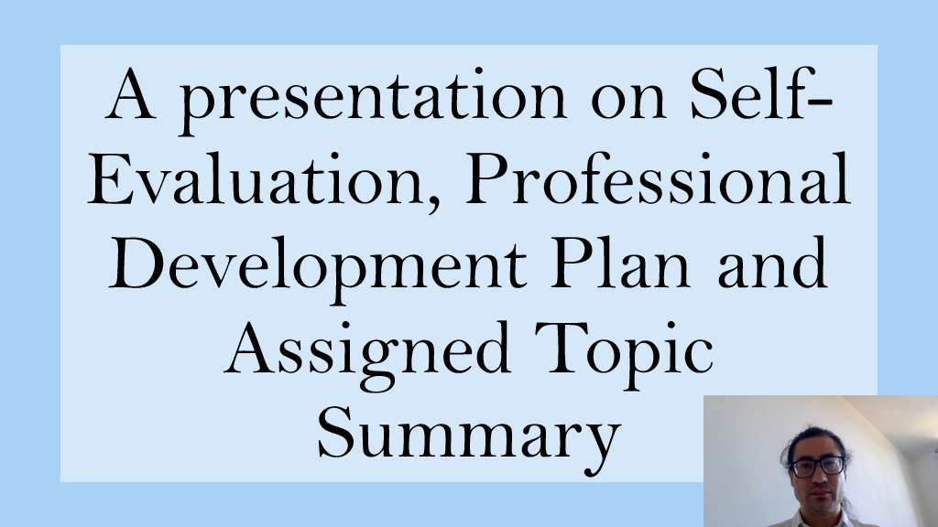

Slide 2 CONTENTS
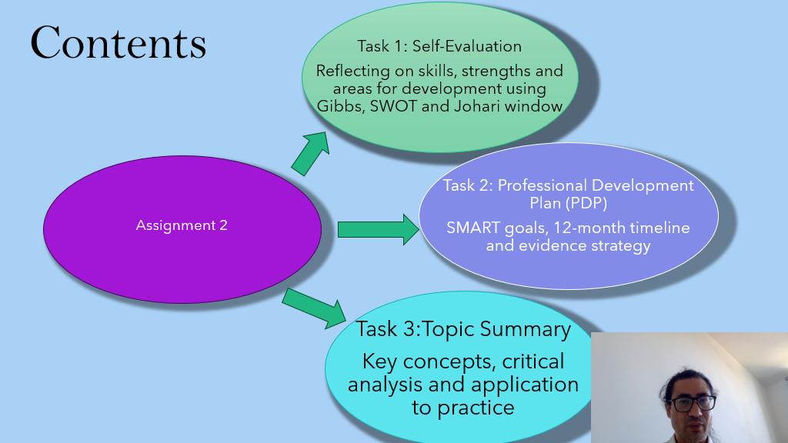
Slide 3 INTRODUCTION
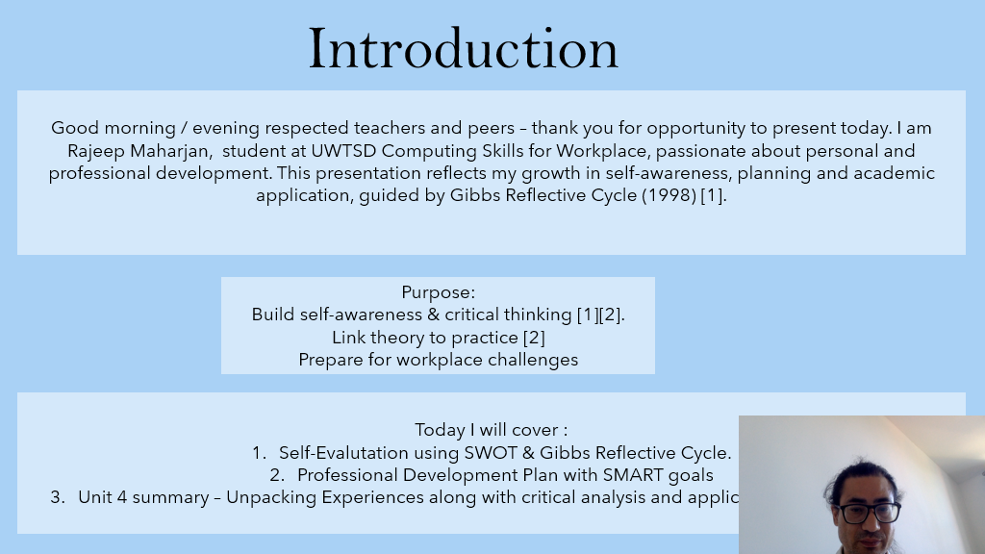

Slide 4 GIBB’s REFLECTIVE MODEL
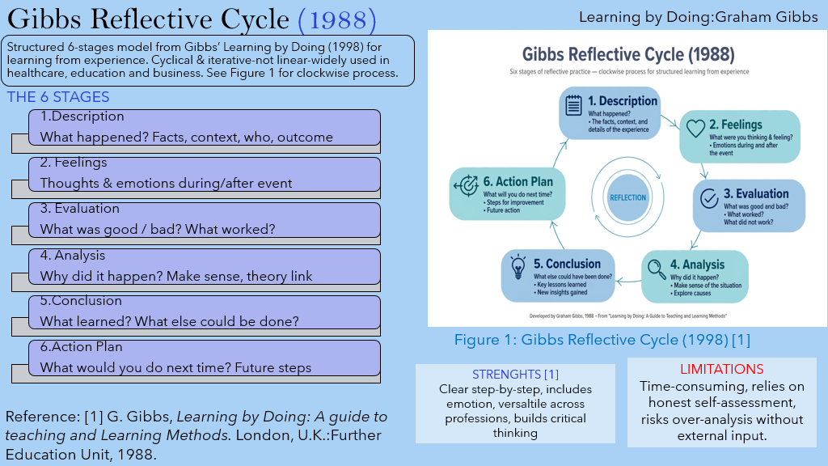
Gibbs Reflective Cycle (1988)
The Gibbs Reflective Cycle is a structured framework designed to help individuals learn from experience through systematic reflection. Developed by Graham Gibbs in 1988, it encourages a cyclical process of reflection where the learner moves from a superficial description of an event to a deeper analysis and a concrete plan for future action. It is widely used in health, education, and professional practice because it promotes critical thinking and self-awareness [1][2][3].

The model consists of six distinct stages:
1. Description: The first stage involves objectively recounting the experience, including what happened, where, when and who was involved [1].

2. Feelings: The second stage focuses on the individual's emotional response, exploring thoughts and feelings before, during and after the event [2].

3. Evaluation: This stage requires an objective judgement of what went well and what did not go well about the experience [1].

4. Analysis: This is the most critical stage, where the learner attempts to make sense of the situation by linking the experience to existing knowledge, theory and previous experiences [3].

5. Conclusion: In this stage, the learner summaries what was learned and what else could have been done differently [1].

6. Action Plan: The final stage is forward-looking, detailing what specific actions will be taken if a similar situation arises in the future, thus completing the cycle [2].

Critical Discussion

Strengths: Gibbs is valued for its clear, step-by-step structure that ensures no crucial aspect is overlooked. It is highly versatile, applied across healthcare, education, and business, and explicitly includes Feelings, which many earlier models (e.g., Kolb) omit. This promotes emotional resilience.

Limitations: Critics argue it can be time-consuming and relies heavily on honest self-assessment, potentially overlooking external perspectives. It also risks over-analysis if not used proportionately.

In practice, Gibbs is not meant to be a rigid checklist. As noted in the literature, a linear representation is misleading; the cycle is iterative [1]. Effective use involves dedicated time, a reflection journal, and seeking external feedback to complement self-assessment.

How I Plan to Apply This Model for My Assignment

For my assignment, I plan to apply Gibbs Reflective Cycle to structure my reflection on Lack of confidence and Prioritisation difficulty.

In the Description stage, I will provide a factual account of the incident. In the Feelings stage, I will explore my personal emotional response to identify my initial reactions. For Evaluation, I will critically assess the positive and negative aspects of the experience. The Analysis stage will be the main focus, where I will link my evaluation to relevant literature to understand why the event unfolded as it did. Finally, in the Conclusion and Action Plan stages, I will summarise my key learning and formulate a specific, actionable strategy to improve my future professional practice [1][3][2].

This structured approach will ensure my reflection is not merely descriptive but demonstrates deep critical analysis and learning which will help me over my anxiety and meeting deadlines in the near future.

Slide 6 TASK 1: SELF EVALUATION
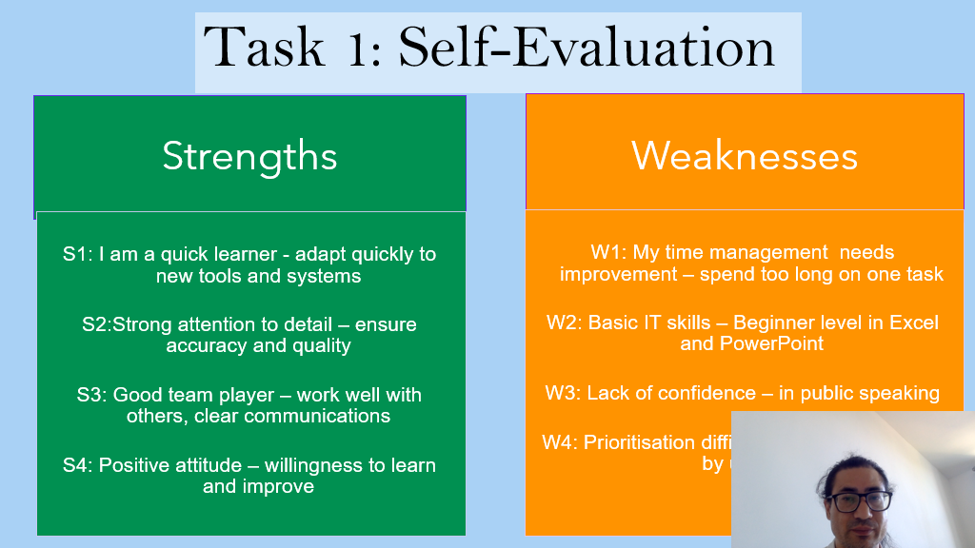
This reflection is based on my personal SWOT analysis. SWOT is a strategic planning tool used to identify internal Strengths and Weaknesses and external Opportunities and Threats.

I have used the Gibbs Reflective Cycle (1988) to reflect on my experiences. Gibbs cycle consists of six stages: Description, Feelings, Evaluation, Analysis, Conclusion, and Action Plan [1].
Based on my individual SWOT analysis, I have identified my key strengths and weaknesses.

One Strength: Strong Attention to Detail (S2)
One of my main strengths is my strong attention to detail, which ensures accuracy and quality in my work. In my SWOT analysis, this is an internal positive factor that gives me an advantage. For example, when completing assignments or tasks at work, I double-check my work to avoid errors. This strength helps me to produce high-quality work and builds trust with my team members and tutors. It also supports my other strengths, such as being a quick learner, because I focus on learning things correctly from the beginning.

One Weakness: Time Management (W1)
One of my main weaknesses is time management. As identified in my SWOT analysis, this is an internal negative factor that can limit my performance. I often spend too long on one task, which makes it difficult to prioritise other tasks (W4). This can lead to delays and stress when I have multiple deadlines. To overcome this weakness, I am learning to use time-management tools such as to-do lists, prioritisation matrix, and time-blocking. I am also setting strict time limits for each task to improve my efficiency. By improving this, I can turn this weakness into a future strength.

Conclusion:
Overall, my SWOT analysis shows that while my attention to detail is a valuable strength that supports my academic and professional growth, my time management is an area that requires continuous development.

Slide 7 TRAITS GAINED FROM THE SELF EVALUATION
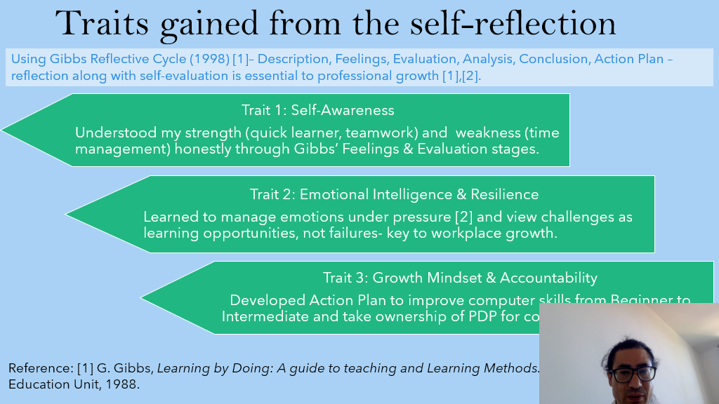
Brief explanation:
This section explains the traits I gained through self-evaluation using Gibbs Reflective Cycle (1998). Reflection along with self-evaluation is essential for professional growth, Gibbs model has six stages: Description, Feelings, Evaluation, Analysis, Conclusion, and Action Plan [1][3].

Trait 1: Self-Awareness
Through Gibbs' Feelings and Evaluation stages, I honestly understood my strengths such as being a quick learner and good teamwork, and my weakness of time management. Self-awareness is the first step to personal development.

Trait 2: Emotional Intelligence & Resilience
Through reflection, I learned to manage my emotions under pressure. I now view challenges as learning opportunities, not failures. This resilience is key to workplace growth and helps me stay positive even when I struggle with prioritization [3].

Trait 3: Growth Mindset & Accountability
Through the Conclusion and Action Plan stages of Gibbs, I developed a growth mindset. I created an action plan to improve my computer skills from beginner to intermediate level and to take ownership of my Personal Development Plan (PDP) for continuous improvement.

In conclusion, self-reflection has helped me develop self-awareness, emotional intelligence, and accountability, which are essential for my academic and career success.

Slide 8 PROFESSIONAL DEVELOPMENT PLAN
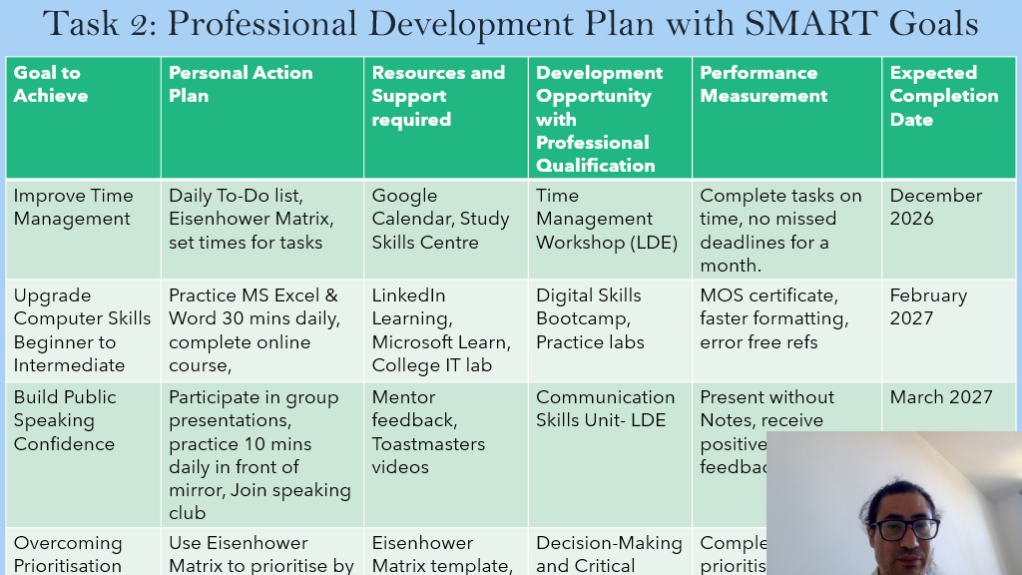
Brief explanation:
This slide presents a Professional Development Plan (PDP) structured using the SMART framework. SMART stands for Specific, Measurable, Attainable, Relevant, and Time-Bound, which helps narrow down big ideas into achievable actions with clear deadlines.[1]

The plan is evaluated against 6 columns: Goal, Action Plan, Resources Required, Development Opportunity, Performance Measurement, and Completion Date.

Improve Time Management (Dec 2026): The action plan uses Daily To-Do lists and the Eisenhower Matrix. The Eisenhower Matrix is a prioritization framework that sorts tasks by urgency and importance into four quadrants - urgent-important, important-not urgent, urgent-not important, and neither. Resources include Google Calendar and Study Skills Centre. Performance is measured by completing tasks on time with no missed deadlines for a month [2][3].

2. Upgrade Computer Skills - Beginner to Intermediate (Feb 2027): Action is 30 mins daily practice of MS Excel & Word and completing an online course. Supported by LinkedIn Learning and Microsoft Learn. This is linked to Digital Skills Bootcamp and measured by achieving a Microsoft Office Specialist (MOS) certificate, which validates expertise in Microsoft Office programs.

3. Build Public Speaking Confidence (March 2027): Action includes group presentations, 10 mins daily mirror practice, and joining a speaking club. Support from mentor feedback and Toastmasters videos. Linked to Communication Skills Unit - LDE and measured by ability to present without notes and receive positive feedback.

4. Overcoming Prioritisation: Uses the Eisenhower Decision Matrix template to prioritize by urgency and importance, linked to Decision Making and Critical skills [3].

Overall, the plan shows a time-bound, measurable approach to career readiness.

Slide 9 UNIT 4 TOPIC SUMMARY
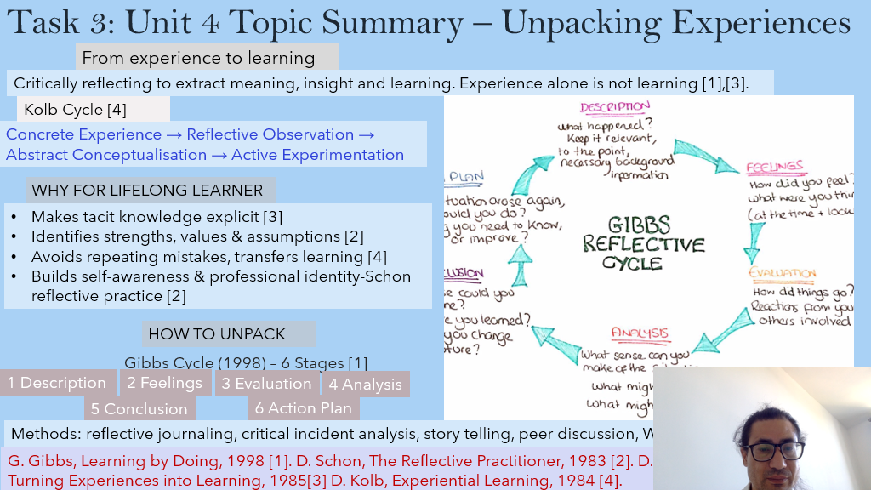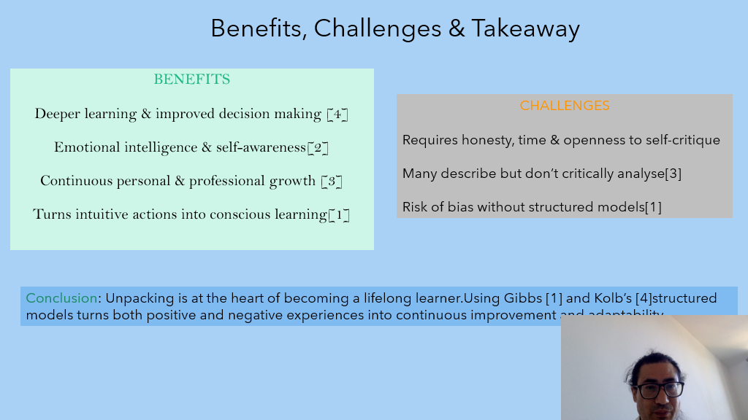

Brief explanation:
Critically reflecting to extract meaning, insight and learning. Experience alone is not learning [1].

Two main models you unpacked:
1. Kolb Cycle - 4 Stages:
Kolb's Experiential Learning Cycle describes learning as including four adaptive modes: concrete experience, reflective observation, abstract conceptualization, and active experimentation. Concrete experiences are the basis for reflections, which are then assimilated into abstract concepts to be used in future contexts [3][2].

Concrete Experience -> Reflective Observation -> Abstract Conceptualisation -> Active Experimentation

2. Gibbs Reflective Cycle - 6 Stages:
Gibbs (1988) expands Kolb's model into a six-stage cycle. Based on your slide diagram:

- Description - 2. Feelings - 3. Evaluation - 4. Analysis - 5. Conclusion - 6. Action Plan

Gibbs' cycle is based on six stages: description, feelings, evaluation, analysis, conclusion, and action plan [1][2][3].

WHY for Lifelong Learner:

• Makes tacit knowledge explicit [2]
• The reflective practitioner acknowledges that much professional knowledge is implicit and context-dependent, requiring reflection to surface and refine.
• Avoids repeating mistakes and transfers learning [3]
• Builds self-awareness & professional identity - Schon. Benefits include Enhanced

Professional Growth: Continuous reflection promotes self-awareness and skill development [4].

HOW TO UNPACK:
Methods: reflective journaling, critical incident analysis, storytelling, peer discussion.

Benefits, Challenges & Takeaway (Bottom slide):

• Benefits: Deeper learning & improved decision making, Emotional intelligence & self-awareness, Continuous personal & professional growth [2].
• Challenges: Requires honesty, time & openness to self-critique. Many describe but don't critically analyse. Risk of bias without structured models [1].
• Conclusion: Unpacking is at the heart of becoming a lifelong learner. Using Gibbs and Kolb's structured models turns both positive and negative experiences into continuous improvement [1][4].

Slide 10 CONCLUSION
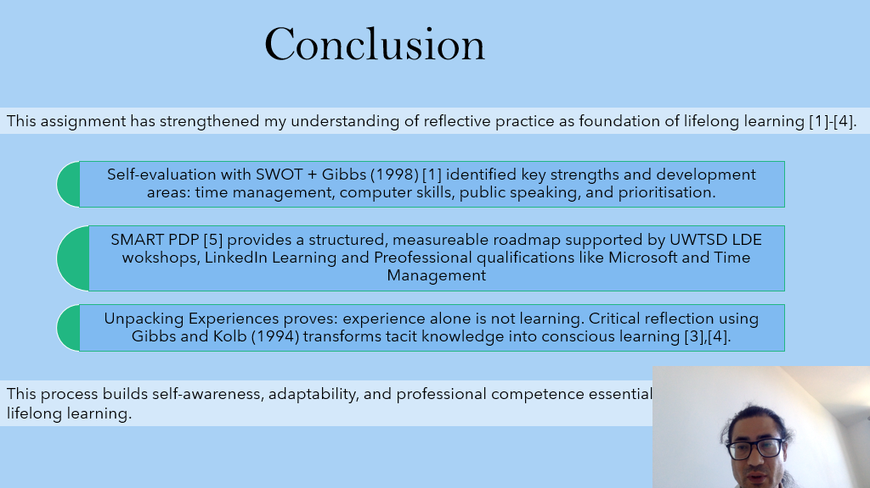

Brief explanation:
This assignment helped me understand that reflective practice is the key to lifelong learning.

1. Self-evaluation: Using SWOT analysis + Gibbs Reflective Cycle (1998) I identified my strengths and 4 areas to improve: time management, computer skills, public speaking, and prioritisation.

2. Action Plan: I created a SMART PDP [Personal Development Plan] - it's a clear, measurable plan. I will achieve it through UWTSD LDE workshops, LinkedIn Learning, and professional courses like Microsoft and Time Management.

3. Learning from Experience: Experience alone is not learning. Using Gibbs and Kolb (1994), I learned how to turn my tacit / hidden experience into conscious learning through critical reflection.

Overall, this process builds self-awareness, adaptability, and professional competence for lifelong learning.

Slide 11
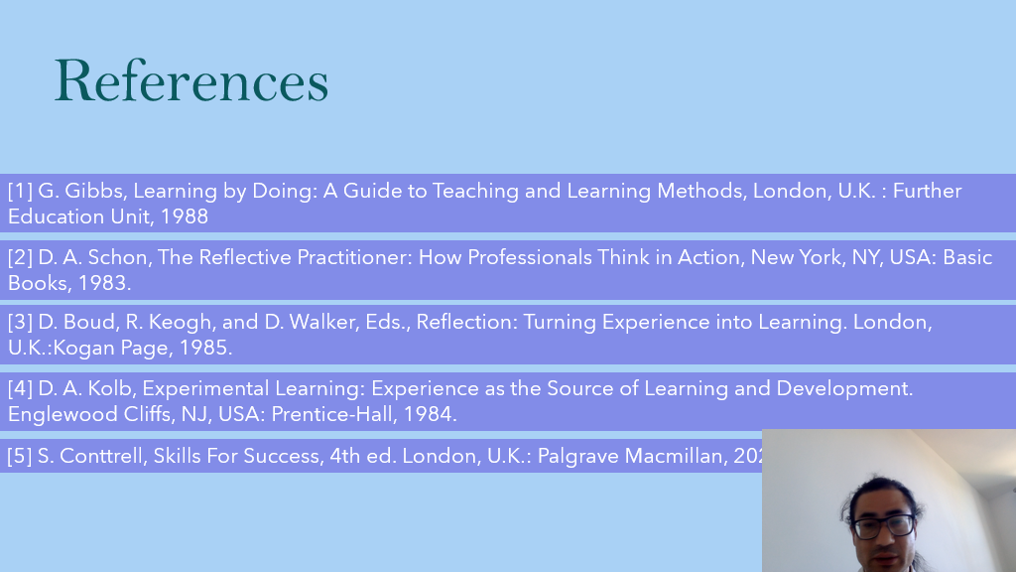

Conclusion
This assignment has significantly strengthened my understanding of reflective practice as the foundation of lifelong learning [1][4].

Through self-evaluation using the SWOT framework integrated with Gibbs' Reflective Cycle (1988), I was able to critically identify my key strengths and pinpoint crucial areas for development, specifically time management, computer skills, public speaking, and prioritisation. This process provided valuable self-awareness, which is the first step toward professional growth [1].

Furthermore, the development of a SMART Personal Development Plan (PDP) has provided me with a structured, measurable, and time-bound roadmap for improvement. This plan will be actively supported by the resources available at UWTSD through LDE workshops, alongside self-directed learning via LinkedIn Learning and professional qualifications such as Microsoft certifications and Time Management training [5].

Finally, by unpacking my experiences, this assignment has proven that experience alone does not equate to learning. It is through critical reflection, using models such as Gibbs and Kolb (1994), that tacit knowledge is transformed into conscious, actionable learning [3][4].

In essence, this reflective process has built the core attributes of self-awareness, adaptability, and professional competence, which are essential for sustained personal and professional development and lifelong learning.

References

[1] G. Gibbs, Learning by Doing: A Guide to Teaching and Learning Methods, London, U.K. : Further Education Unit, 1988
[2] D. A. Schon, The Reflective Practitioner: How Professionals Think in Action, New York, NY, USA: Basic Books, 1983.
[3] D. Boud, R. Keogh, and D. Walker, Eds., Reflection: Turning Experience into Learning. London, U.K.:Kogan Page, 1985.
[4] D. A. Kolb, Experimental Learning: Experience as the Source of Learning and Development. Englewood Cliffs, NJ, USA: Prentice-Hall, 1984.
[5] S. Conttrell, Skills For Success, 4th ed. London, U.K.: Palgrave Macmillan, 2021.

