Kate Hessey (1603772)
University of Wales Trinity Saint David [Company address]
Using at least 3 examples, consider how image makers have
utilised digital technology to explore one of the following: Conflict,
Identity, the Surveillance State, the Technological World?
1603772
Photography in the arts
2008 wc
paul duerinkx

How image makers have
Utilised digital technology to explore
the Surveillance State

In this essay, it will be discussing the topic of the surveillance state and how artist have adapted to utilise the usage of digital technology in order to survey whilst also generally reflecting how it has affected the world around us. Surveillance is not a recent phenomenon but dates to the beginnings of human civilisation. Within this article of writing there will be a brief touching on the history of surveillance, dating back to pre-digital methods of surveying plus also discussing key photographers such as Francis Galton and Alphonse Bertillon who are considered pioneers in the usage of camera technology who have used methods that are still considered effective to this day. There will be mentioning of other artists who have created work based on world surveillance which questions the usage of surveillance and some of the ethical dilemmas which surveillance on a mass scale brings. Despite the benefits that surveillance brings it begs the question of what the negative impacts on the way society functions are whilst under constant surveillance, sometimes the surveillance is unjust and brings a lot of stress and fear to civilisations all over since the added edition of advanced technology such as cameras and the internet.

For hundreds of years, different societies have been finding ways to catalogue individuals whether it be a person’s name, date of birth, occupation etc. There has always been a need to collect the information of others.
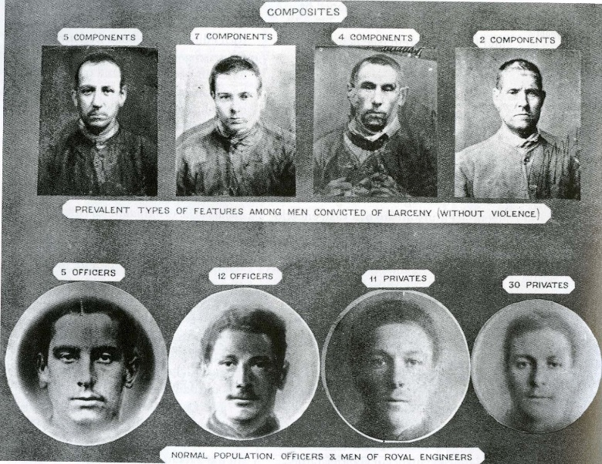
One prominent figure in photographic history is Francis Galton, born in 1822 he was an anthropologist who had a keen fascination with Darwinism and human eugenics. He was most notably famous for his study of the genetic features of a criminal and believed that by having certain facial features or the overall shape of an individual’s skull it would equate to them being a criminal. As ‘proof’ for his theory he would composite portraitures which is the techniques of layer multiple images of faces to merge them into one. He would use the technique with a variety of criminal faces. In order to combine these images, it would be via repeated limited exposure in order to produce one single blended image. Modern studies who have analysed Galton’s theory have claimed it to be a rather weak study as there is very little evidence of a person’s physical appearance having to do with them being a criminal. Although it was a relatively failed theory it is classed as progress in the way we document things now.
Galton's Features of a Criminal

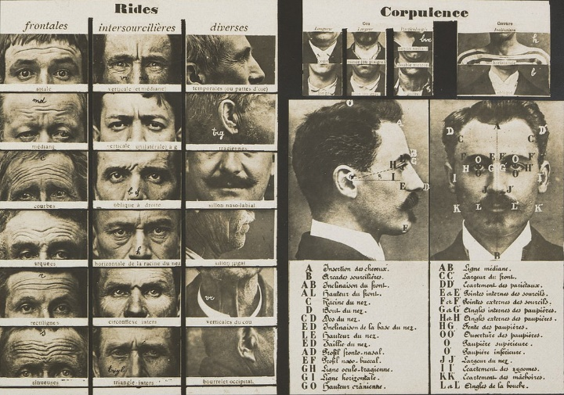
However, Alphonse Bertillon who was a Parisian police officer later invented what is incredibly renounced ‘Synoptic Table of Physiognomic Traits’ created in 1909, which is still used today. The table consisted of both a front facing headshot followed by a profile shot. There would also be a set of finger prints to go along side with the images of the suspect. This was in order to counteract a particular problem of the time where reoccurring criminals would often give fake names, making it difficult to keep a proper track of a person’s criminal record. Once Bertillon had implemented this practice of storing data. He would also include in these the measurements of one’s face and body as well as noting down ay key features (diagram of how to notice these features on the right) to help with the categorisation of criminal records.
Synoptic Table of Physiognomic Traits
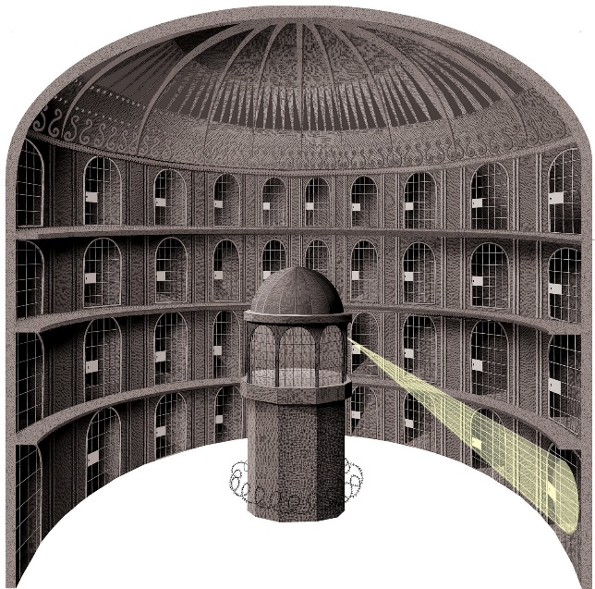
Jeremy Bentham, an English philosopher from the late 17th century to early 18th century who is a prominent theorist, most famous for his theory of utilitarianism but also the philosophy of law such as individual and economic freedoms, separation from church and state. Bentham came up with the concept of creating the Panopticon as a way of saving income from public funds whilst also still being able to manage a prison effectively. Descriptions of the Panopticon are expresses within the book ‘Discipline and Punishment the Birth of Prison’ by Michael Foucault has some very early examples of the usage of surveillance pre-digital age. In order to keep watch upon prisons they invented a type of prison known as the Benthamite Panopticon where in 1841 the basic fundamentals of how this prison should work was spoken by the Minister of the Interior who stated ‘The central inspection hall is the pivot of the system’ The concept was ingenious of its time and was built so that inmates should ‘bear on this object’ as they had worked out that the easier it was for them to survey the less they would need to rely on the sturdiness of the prison itself. was a type of circular shape and would’ve had a tall watch tower in the centre, so prisoners may always sense that they are kept watch upon as the power of feeling like someone is constantly watching can be just as powerful as being watched. A recent study from the University of Newcastle found that by putting up a poster of a pair of eyes near a bike shed had decreased the likelihood of a bike being stolen for parts etc whereas bikes that were kept in sheds without the eye poster the chances of theft increased by up to 2/3rds. Psychologist lectures state that is in our human nature to be terrified of eye contact as it is usual seen as threating. This study correlates the Panopticon as they both use similar psychology to each other.
Benthamite Panopticon Illustration

Progressing forward towards our digital era, many lens-based artists have utilised their media to portray the Surveillance State. Since the creation of digital technology such as digital cameras the amount of world-wide surveillance is very high, especially with aid to the internet which in over a decade of its use has vastly accelerated in advancements with how we track people today. A lot of these digital advancements have benefitted our society for example being able to document criminals digitally or being able to view the world via satellite, however being able to easily survey an place is also a breech of privacy and many peoples in the modern world often feel violated with the amount of data the people of power have over them. These photographers have been able to create work based on these modern fears and annoyances.
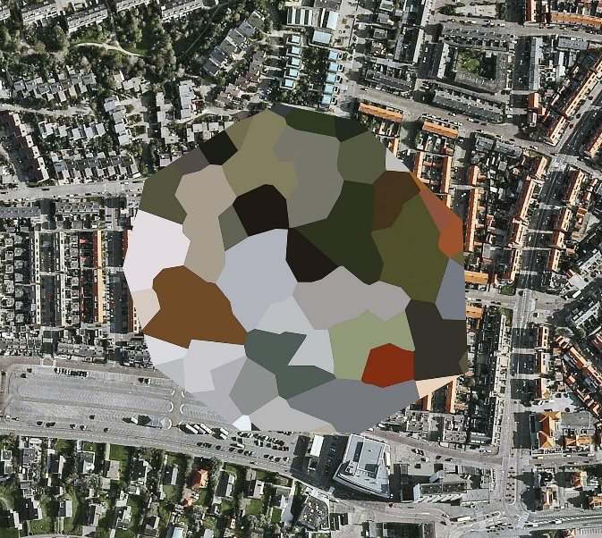
Artists such as Mishka Henner who has compiled multiple projects based on surveillance, even his most recent project ‘Seven Seas and a River’ has underlying impression of CCTV cameras being placed in different locations across the world. In his other projects such as ‘The Fields’, ‘Feed lots’, ‘Dutch Landscapes’ etc he has used satellite technology via Google Earth in order to create a range of works touching on the topic of worldwide surveillance, privacy, the environment and how we shape the world. The image to the left is from his ‘Dutch Landscapes’ (Example just above) collection. With this collection it was based on an observation he had made when Google had first introduced its satellite imagery for any member of the public to see. In Henner’s work it claims the governments were ‘concerned about the sudden visibility of political, economic and military locations’ so Henner started selecting Dutch bases as he found the format, they used, is like abstract art compared to other countries choices of censorship. The hiding of their bases is most likely so these bases will remain powerful and protected from enemies that may wish to attack, this runs along one of Bentham’s ideology that “The more perfect enjoyment is in all these respects”, Bentham wrote, “the greater is the sum of social happiness: and especially of that happiness which depends upon the laws” this translates to meaning to ensure the happiness in wellbeing of others there must be laws in enforced in order for there to be a sense of safety and peace.
Mishka Henner 'Dutch Landscape'
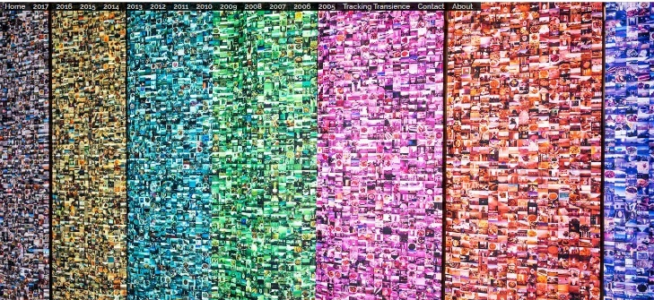
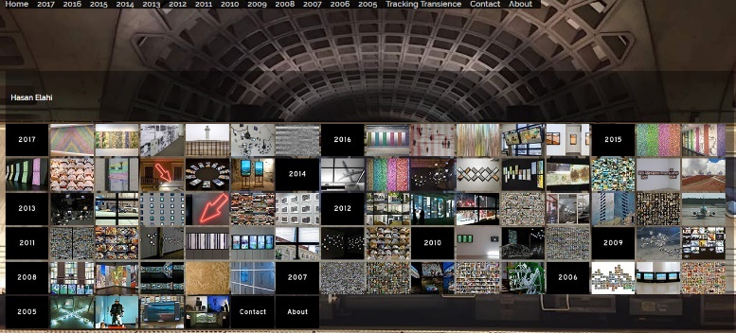
Hasan Elahi another American artist created a project known as ‘Thousand Little Brothers’ (on the left) is compiled of 32,000 images from his this on-going project. Elah was inspired months after from an incident that happened to him in 2002 when he got pulled up from the airport by the FBI for questioning as they had suspected him for being a terrorist. On a TEDTALKS Elahi claimed that if it wasn’t for his detailed records he wound up in prison. The statement was ‘I don't think he was expecting me to have such detailed records of what I did. But good thing I did, because I don't look good in orange.’ Elahi was made to report his whereabouts and plans to the FBI for 6 months until they finally believed him and left him be. Since then he started calling the FBI just to “check in” with them and then it slowly progressed into 2003 where he designed his own website (image of website at the bottom of this paragraph) that tracks every location, he has ever been from then till present. On this it ranges from every plane he has ever caught, every meal he has made and many other parts of his life he has purpose made public as a retaliation of the Surveillance of State. This project is the opposite of Mishka Henner’s ‘Dutch Landscapes’ as Henner’s work focuses on what is hidden such as Dutch military bases on Google maps whereas Elahi’s makes himself fully known in order for the FBI to not worry over him. There is also a sense of irony when comparing these two projects side by side in the sense that these large and powerful government run buildings will not reveal their location and yet it wishes to know everyone else.
Hasan Elahi 'Thousand Little Brothers'
Elahi's website

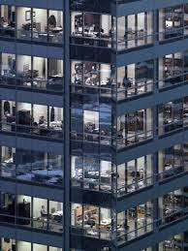
Another photographer who is a good example relating to this subject is the work of Michael Wolf and his project ‘Transparent City’ This project is based in Chicago. He started off generally taking digital photographs with a 112-megapixel large format camera that took imagines with pristine clarity. Whilst photographing these large skyscrapers within the urban landscape he noticed that if he zoomed in on his pictures, he could perfectly make out the people living their lives within this landscape. His project then became a work of voyeurism as he delves into the lives of these citizens. The aspect of voyeurism adds a spy like quality to these images, revealing that the close-up of a bustling city is far more average, dull and isolating for those who live in it. In away these photographs could be an accurate representation of how our society lives now but also the concept of living where all is visible is similar to the Panopticon in the sense that the prison building was designed to be open as possible so that prisoners could have constant watch over by guards. When connecting the two concepts together it creates its own metaphor of a constant watching government.
Michael Wolf- Transparent City
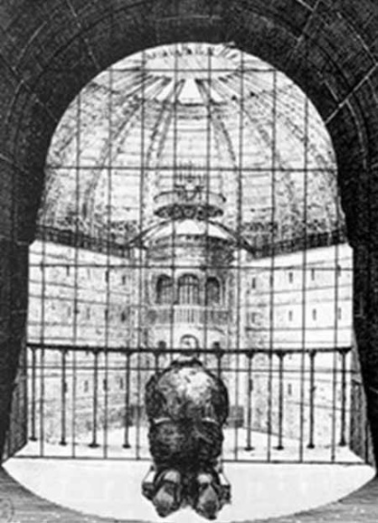
Panopticon Prisoner Illustration
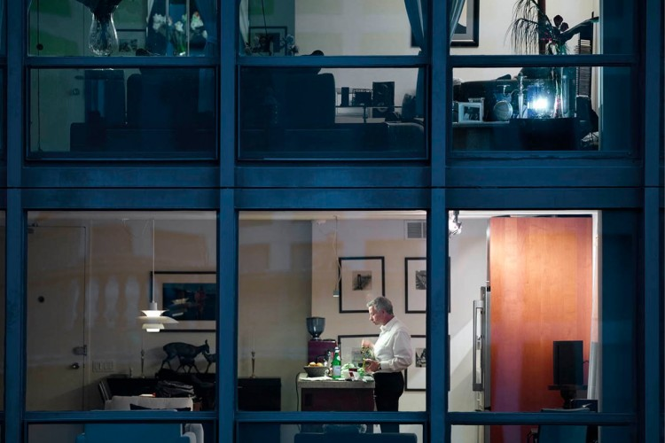
Michael Wolf - Transparent city

In conclusion to this essay, image makers have certainly been able to utilise the Surveillance State using digital media. This essay highlights that Surveillance has manifested in society for a very long. With a brief sprinkling of history, it was able to cover aspects of surveillance during a pre digital era as well as highlighting the key photographers on this topic which are, Francis Galton the anthropologist who did vast studies on eugenics as well as Alphonse Bertillon who was a Parisian police officer who reinvented the way we keep track of criminals. The mentioning of Mishka Henner, Michael Wolf, Hasan Elahi are great examples of modern photographers with projects that resemble the impression of having constant governmental watch via methods of satellite imagery from Google Earth, voyeurism of a skyscraper landscape and by constantly tracking yourself. Each photographer having their own take on the ethics and lack of privacy. Despite the philosophy Bentham used and his utilitarianism approach towards the law, there is certainly much less privacy thanks to the advancements that technology has made.

References
BBC News. (2018). Glaring eyes 'deter bike thieves'. [online] Available at: https://www.bbc.co.uk/news/uk-england-tyne-22270052 [Accessed 13 Dec. 2018].
Foucault, Michel (1977) Discipline and Punish London: Penguin
Henner, M. (2018). Mishka Henner. [online] Mishkahenner.com. Available at: https://mishkahenner.com/ [Accessed 13 Dec. 2018].
Wolf, M. (2018). The Transparent City - Photographs by Michael Wolf | LensCulture. [online] LensCulture. Available at: https://www.lensculture.com/articles/michael-wolf-the-transparent-city [Accessed 13 Dec. 2018].
Elahi, H. (2003). Hasan Elahi. [online] Elahi.umd.edu. Available at: http://elahi.umd.edu/elahi_osf.php# [Accessed 13 Dec. 2018].
Elahi, H. (2018). Transcript of "FBI, here I am!". [online] Ted.com. Available at: https://www.ted.com/talks/hasan_elahi/transcript?language=en#t-851196 [Accessed 13 Dec. 2018].

Bibliography
Batchen, G. (2014). Picturing atrocity. London: Reaktion Books.
Bentham, J., Schofield, P., Pease-Watkin, C. and Blamires, C. (2012). Rights, representation, and reform. Oxford: Clarendon Press.
Foucault, Michel (1977) Discipline and Punish London: Penguin
Tagg, John (1993). The Burden of Representation Minneapolis: University of Minnesota Press
Online:
Agerholm, H. (2018). UK mass surveillance programme violates human rights, European court rules. [online] The Independent. Available at: https://www.independent.co.uk/news/uk/politics/uk-mass-surveillance-gchq-eu-human-rights-echr-edward-snowden-a8535571.html [Accessed 2018].
BBC News. (2018). Glaring eyes 'deter bike thieves'. [online] Available at: https://www.bbc.co.uk/news/uk-england-tyne-22270052 [Accessed 13 Dec. 2018].
The Public Domain Review. (n.d.). Alphonse Bertillon's Synoptic Table of Physiognomic Traits (ca. 1909). [online] Available at: https://publicdomainreview.org/collections/alphonse-bertillons-synoptic-table-of-physiognomic-traits-ca-1909/ [Accessed 13 Dec. 2018].
Crabapple, M. (2018). How the Surveillance State Changes Our Everyday Lives. [online] Vice. Available at: https://www.vice.com/sv/article/nnqk5m/the-surveillance-state-and-you-crabapple-100 [Accessed 13 Dec. 2018].
Elahi, H. (2018). Transcript of "FBI, here I am!". [online] Ted.com. Available at: https://www.ted.com/talks/hasan_elahi/transcript?language=en#t-851196 [Accessed 13 Dec. 2018].
Elahi, H. (2003). Hasan Elahi. [online] Elahi.umd.edu. Available at: http://elahi.umd.edu/elahi_osf.php# [Accessed 13 Dec. 2018].
Henner, M. (2018). Mishka Henner. [online] Mishkahenner.com. Available at: https://mishkahenner.com/ [Accessed 13 Dec. 2018].
Plato.stanford.edu. (2015). Jeremy Bentham (Stanford Encyclopedia of Philosophy). [online] Available at: https://plato.stanford.edu/entries/bentham/#SecAgaMis [Accessed 13 Dec. 2018].
Wolf, M. (2018). The Transparent City - Photographs by Michael Wolf | LensCulture. [online] LensCulture. Available at: https://www.lensculture.com/articles/michael-wolf-the-transparent-city [Accessed 13 Dec. 2018].
Ma, A. (2018). China is building a vast civilian surveillance network — here are 10 ways it could be feeding its creepy 'social credit system'. [online] Business Insider. Available at: https://www.businessinsider.com/how-china-is-watching-its-citizens-in-a-modern-surveillance-state-2018-4?r=US&IR=T#1-using-facial-recognition-technology-that-can-pick-people-out-of-massive-crowds-1 [Accessed Apr. 2018].
Miller, A. (2018). If your name is Ahmed or Fatima, you are a person of interest to the NSA | Anna Lekas Miller. [online] the Guardian. Available at: https://www.theguardian.com/commentisfree/2013/jun/19/nsa-surveillance-muslim-arab-americans [Accessed 13 Dec. 2018].
Tredoux, G. (2018). Francis Galton and Composite Portraiture. [online] Galton.org. Available at: http://galton.org/composite.htm [Accessed 13 Dec. 2018].
Open Society Foundations. (2018). Who’s Watching You?. [online] Available at: https://www.opensocietyfoundations.org/voices/taking-closer-look-surveillance-culture-through-photography [Accessed 13 Dec. 2018].

There are no sources in the current document.

