ACCA4024
Networks and Cyber Security Essentials

Synthesize a solution to a potential real-life scenario

Student ID – 2514523
Student Name – Abdullah Karakan
Group 1

Abstract
The high adoption of Industry 4.0 technologies has improved the operational efficiency of manufacturing organisations, but has increased cybersecurity risks due to their effect on cybersecurity. The vital analysis of the cybersecurity situation in this report of Steel Form Manufacturing Ltd (SFM) is on the internal and external cyber threats of its digital infrastructure. It proposes policies of governance-based security, audit of mitigation plans, and mapping of monitoring and incident response, to enhance organisational resilience. The report proposes that cybersecurity cannot be implemented by use of technology controls alone, but also through organisational governance, employee awareness, and continuous risk management.

Table of Contents
Abstract 2
1. Introduction 4
2. SteelForm Manufacturing Ltd: Company Background 4
3. Identification of Cybersecurity Threats 4
3.1 Internal Threats 5
3.2 External Threats 5
4. Cybersecurity and Data Governance Policies 6
4.1 Access Control Policy 7
4.2 Password and Authentication Policy 7
4.3 Data Governance and Protection Policy 7
4.4 Network & IoT Security Policy 7
4.5 Backup and Disaster Recovery Policy 7
5. Threat Mitigation Measures 8
5.1 Technical Controls 9
5.2 Administrative Controls 9
5.3 Physical Security Controls 9
6. Network Monitoring and Incident Response 9
6.1 Continuous Network Monitoring 10
6.2 Incident Response Process 10
7. Cybersecurity Training and Awareness Programme 11
8. Conclusion 12
References 13
Appendices 14

List of Figures
Figure 1 : Internal and External Cyber Threats Affecting SteelForm Manufacturing Ltd 6
Figure 2 : Secure Network Architecture for SteelForm Manufacturing Ltd 8
Figure 3 : Cybersecurity Incident Response Process at SteelForm Manufacturing Ltd 11

1. Introduction
The introduction of cloud computing, Internet of Things (IoT) devices and automated manufacturing systems has changed the industrial process, but also has exposed the industrial process more to cyber risks. The productivity can be seen through the use of digital transformation in the case of Steel Form Manufacturing Ltd (SFM), although it creates a significant attack surface; collectively defending the company is literally impossible through using conventional perimeter security. Next, cybersecurity is to be viewed as a strategic governance issue, not a technical issue itself (Melaku, 2023). When organisations do not consider security in their business decisions, it disrupts their operations and leads to losses of money and goodwill after cyber-attacks.

2. Steel Form Manufacturing Ltd: Company Background
Steel Form Manufacturing Ltd (SFM) is a medium-sized manufacturing organisation that is already relying on interdependent digital technologies, including IoT-based production machines, cloud-based management systems and automated machinery in the industry. Even though these technologies help to increase the efficiency of the operations held, as well as the precision of the quantities produced, they make the dependence on connected digital resources more exposed, and a breach of which can stop the manufacturing processes and disclose commercially sensitive information. The occurrence of malware attacks, phishing cases and unauthorised access recently shows that the problem of cybersecurity pertains to technological vulnerability and human behaviour (Alshamsi, Shaalan and Butt, 2024). This also means that SFM must have a central security governance process, which will not only ensure that its operations are sustainable, but also that its innovation and organisational competitiveness are sustainable in the long run.

3. Identification of Cybersecurity Threats
The manufacturing organisations' environments are highly interrelated, with operational technology (OT), information technology (IT) and cloud services exchanging masses of sensitive data regarding operations. Consequently, the cybersecurity risks can no longer be termed separately, as the vulnerability of the organisation is mostly disclosed in the interface of technology, human behaviour and management practices (Riurean et al., 2025). Bad governance in the SFM case may increase both internal and external threats since the bad governance can be neglected until the time when a massive breach in operations happens. As such, determining cyber threats is the basis of establishing appropriate security controls and governing policies.

3.1 Internal Threats
Internal threats are people who may gain access to organisational systems either accidentally, on purpose or intentionally. Inattentiveness of the employees, poor password control and poor awareness create a big opportunity for a successful cyberattack, since attackers will make use of human error and not intricate technical gaps (Okdem and Okdem, 2024). Similarly, privileged escalation/ use of the administrative accounts in an unauthorised way can give out confidential information about Production or disrupt production.

3.2 External Threats
Cybercriminals are also increasingly becoming more technologically advanced attackers by using manufacturing organisations to obtain intellectual property, disrupt the production process or deploy ransomware. The operational availability can be disrupted by malware infections, phishing campaigns and distributed denial-of-service (DDoS) attacks; industrial espionage can disrupt the proprietary manufacturing processes and competitive advantage (Ferdous et al., 2025). External attackers have a greater opportunity of utilise unsecured endpoints or network misconfigurations, more so as SFM is less and less reliant on cloud services and other IoT equipment.
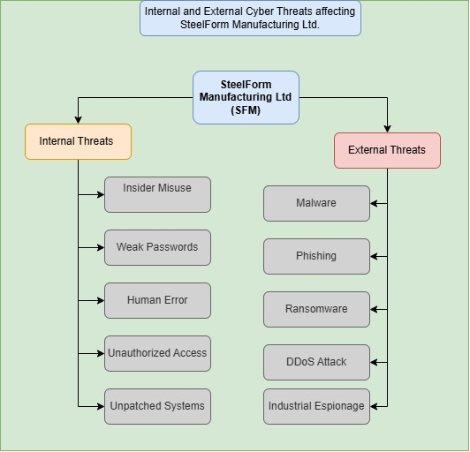
Figure 1: Internal and External Cyber Threats Affecting SteelForm Manufacturing Ltd
To categorise the major cyber threats that took place in SteelForm Manufacturing Ltd, Figure 1 subdivided the sources of threat that were significant into internal and external sources. The diagram indicates that organisations not only put the risk in the hands of external cybercriminals but also add risk through the actions of the employees, ineffective systems and poor access management. The argument presented in the report, which states that effective cybersecurity involves the application of technical controls and governance controls as well as awareness of the staff in the organisation to reduce the total attack surface of the organisation, is substantiated using the classification.

4. Cybersecurity and Data Governance Policies
A comprehensive approach to cybersecurity cannot be linked with mere technical responses to the source of organisational resiliency that is built on a definite set of governance requirements regarding access, data management and usage safety. In the scenario of SteelForm Manufacturing Ltd (SFM), it should be applied in the form of cybersecurity policies which would bring antagonistic quality and restrict impulsiveness and ensure the perpetuation of business and adherence to regulations. Instead of responding to the occurrences of incidents, governmental policies create repulsion towards the risks by demarcating the roles that workers shall assume, authorised security levels and accountability of the organisation.

4.1 Access Control Policy
The principle of least privilege, upon which employees are allowed to perform their designated duties, should be used to access the organisational systems. One of the least invasive approaches can be role-based access control (RBAC) to minimise the unwarranted access of sensitive information in manufacturing and minimise the probability of using such information with malicious intentions by an insider. Administrative privileges should also periodically be revised so as to avoid accumulation of privileges but should also be in tandem with the functions.

4.2 Password and Authentication Policy
Simple security measures against unauthorised use include using passwords. SFM must use tough passwords with multi-factor authentication (MFA) on all systems containing sensitive information, but especially cloud systems and administrative accounts (Otta et al., 2023). Though security is enhanced by the length of the password, the complexity of passwords and frequently changing the credentials will go a long way to minimise the chances of certain phishing attacks and credential theft.

4.3 Data Governance and Protection Policy
Sensitivity: The manufacturing data, customer records and production data must be under the class of sensitivity and should be secured by lifecycle security. Data on the move and at rest ought to be encrypted, and the access logs kept and utilised to demonstrate accountability and audit incidents. It should also be regularly in auditing effective data governance to ensure that it meets the relevant policies in organisations and legal stipulations.

4.4 Network & IoT Security Policy
Firewalls, intrusion detection systems (IDS) and even constant checks should be launched to identify any suspicious network activity that does not occur regularly to ensure that there is no disturbance to operations before that occurs. IoT devices must also be updated frequently with software that is required to minimise possible areas of compromise.

4.5 Backup and Disaster Recovery Policy
When dealing with cyber-attacks, business continuity is reliant on secure backup processes with the ability to restore business operations (Chen et al., 2023). To ensure that it can recover, SFM must have backups, which are encrypted (not linked directly to production systems) and should do recovery tests periodically. Backup strategies do not ensure actual organisational resilience but only perceived resilience without periodic testing.
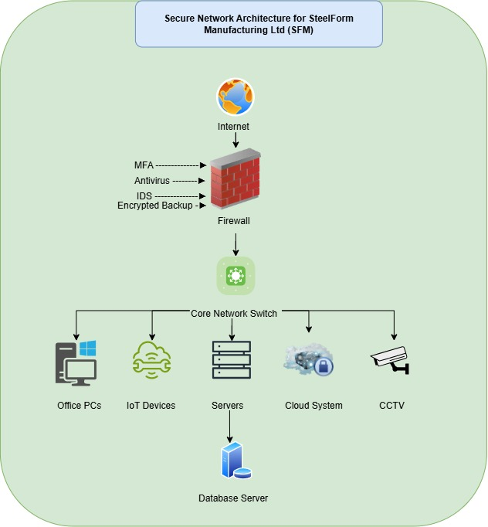
Figure 2: Secure Network Architecture for SteelForm Manufacturing Ltd
The layered network architecture of SFM highlights (refer to Figure 2) how firewalls, secure network formulation, cloud formations and IoT protection enhance cybersecurity, mitigate attack vectors, and reduce business disruption.

5. Threat Mitigation Measures
Unless mitigation strategies are taken, just naming cybersecurity threats does not decrease organisational risk. Cybersecurity has to be controlled at multiple levels since the application of single defence tools poses critical organisational gaps. SFM may then consider a defensive multi-layered approach that comprises the Technical, Administrative and Physical security to heighten the magnitude in reaction to the evolving cyber hazards.

5.1 Technical Controls
The first line of defence is technical controls, and they are used to prevent, identify and respond to cyberattacks. Firewalls, intrusion detection software, endpoint protection software, encryption technologies and multi-factor authentication will all play a part in mitigating the risk of unauthorised access and malware infection (Qureshi and Koo, 2026). Repeated exposure to vulnerabilities via testing and updating of the software also reduces exposure to known vulnerabilities.

5.2 Administrative Controls
The administrative controls also offer the administrative mechanisms of governance that influence the behaviour of employees and the decision-making in an organisation. Regular security awareness training, documenting security policies, conducting of frequent risk assessments and developing incident response strategies will encourage regular security activities in the organisation. Such measures minimise the level of human error that is inherent in cyber-attacks as one of the determinant successes.

5.3 Physical Security Controls
Physical controls help safeguard critical infrastructure against unauthorised physical access and/or compromise of digital systems. There are also access hierarchies, locked server rooms, a visitor management system and CCTV cameras which limit the possibilities of equipment manipulation, work or data interruption. An integrated physical and cyber defence creates resilience within the entire organisation as the cyberspace and physical properties are at the same time fortified.

6. Network Monitoring and Incident Response
Proper cybersecurity goes beyond preventive measures due to the need for organisations to detect, react to and recover from security incidents before serious disruption of normal operations. In the case of SteelForm Manufacturing Ltd (SFM), this can be achieved through constant surveillance, which allows any suspicious activity to be identified early, and an ordained incident response procedure minimises downtime, loss of finances and loss of reputation. Through a programmable response operation together with a monitoring process, consistency and efficiency of security incident response is achievable.

6.1 Continuous Network Monitoring
Constant monitoring should facilitate incorporation of real-time visibility on the corporate networks, cloud environments, and IoT-empowered manufacturing systems. The detection of abnormal behaviour on the network can be achieved by intrusion detection systems (IDS) and automated analysis of logs by use of Security Information and Event Management (SIEM) before the attack can escalate to significant proportions. Compliance can also be facilitated through regular monitoring, which can offer audit trails in order to aid investigations and enhance organisational responsibility.

6.2 Incident Response Process
It would be required to have an incident response process that would include identification of the incident, verifying the incident, threat containment, investigation, system recovery and post-incident review as the required steps in an effective incident response process. Defined roles will make sure that security incidents are dealt with promptly with the least amount of upset caused to the operation. The lessons after every incident enhance organisational resilience as they lead to a smooth enhancement of the cybersecurity policy and response guidelines.
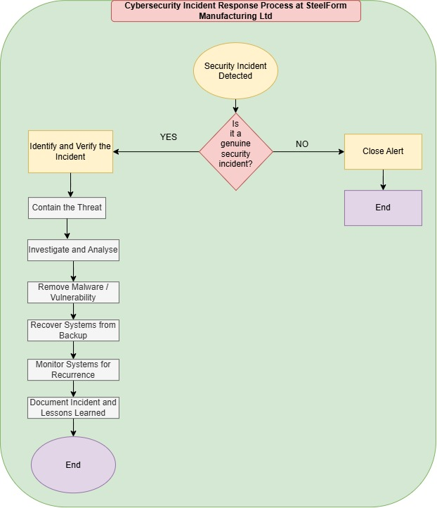
Figure 3: Cybersecurity Incident Response Process at SteelForm Manufacturing Ltd
Given that early detection, containment, investigation, recovery, and the post-incident review can minimise the adverse effect on operations and provide a better understanding of cybersecurity resilience of SFM on the long-term scale, Figure 3 organises and illustrates the lifecycle of incident response.

7. Cybersecurity Training and Awareness Programme
No technology can kill the threat of cybersecurity, as the workers would be an important target of phishing, social engineering and credential theft. To be more exact, it is proposed to introduce a continuous cybersecurity awareness campaign, which will help the employees develop the skill of identifying and responding to cyber threats introduced by SFM. The regular training will cover the topics of password protection and phishing, as well as appropriate organisational data and incident reporting management. Previous training of the employees and strengthening safe behaviour at the workplace should be assessed by formulating phishing games and other refresher training. Making cybersecurity awareness part of organisational culture mitigates human error, enhances the strength of adherence to security policies and complements of technical controls to form a more resilient cybersecurity landscape.

8. Conclusion
Steel Form Manufacturing Ltd requires a holistic strategy towards cybersecurity that incorporates a governance strategy, technical controls and training for its team to counter new cyber threats. The breadth of the security policies, the adoption of multi-layer mitigation, the constant monitoring of the systems and an organised incident response process could be extended to the organisational composure, protection of the required resources and facilitation of safe and secure digital transformation within the organisational manufacturing environment.

References
Alshamsi, O., Shaalan, K. and Butt, U. (2024). ‘Towards Securing Smart Homes: A Systematic Literature Review of Malware Detection Techniques and Recommended Prevention Approach’. Information, [online] 15(10), p.631. https://www.mdpi.com/2078-2489/15/10/631
Chen, Y.-S., Chou, J.C.-L., Lin, Y.-S., Hung, Y.-H. and Chen, X.-H. (2023). ‘Identification of SMEs in the Critical Factors of an IS Backup System Using a Three-Stage Advanced Hybrid MDM–AHP Model’. Sustainability, [online] 15(4), p.3516. https://www.mdpi.com/2071-1050/15/4/3516
Ferdous, J., Islam, R., Mahboubi, A. and Islam, M.Z. (2025). ‘A Survey on ML Techniques for Multi-Platform Malware Detection: Securing PC, Mobile Devices, IoT, and Cloud Environments’. Sensors, [online] 25(4), p.1153. https://www.mdpi.com/1424-8220/25/4/1153
Melaku, H.M. (2023). ‘A Dynamic and Adaptive Cybersecurity Governance Framework’. Journal of Cybersecurity and Privacy, [online] 3(3), pp.327–350. https://www.mdpi.com/2624-800X/3/3/17
Okdem, S. and Okdem, S. (2024). ‘Artificial Intelligence in Cybersecurity: A Review and a Case Study’. Applied Sciences, [online] 14(22), p.10487. https://www.mdpi.com/2076-3417/14/22/10487
Otta, S.P., Panda, S., Gupta, M. and Hota, C. (2023). ‘A Systematic Survey of Multi-Factor Authentication for Cloud Infrastructure’. Future Internet, [online] 15(4), p.146. https://www.mdpi.com/1999-5903/15/4/146
Qureshi, R. and Koo, I. (2026). ‘A Comprehensive Survey of Cybersecurity Threats and Data Privacy Issues in Healthcare Systems’. Applied Sciences, [online] 16(3), p.1511. https://www.mdpi.com/2076-3417/16/3/1511
Riurean, S., Fîță, N.-D., Dragoș Păsculescu and Răzvan Slușariuc (2025). ‘Securing Photovoltaic Systems as Critical Infrastructure: A Multi-Layered Assessment of Risk, Safety, and Cybersecurity’. Sustainability, [online] 17(10), p.4397. https://www.mdpi.com/2071-1050/17/10/4397

Appendices


