Effective Team Work and Communication
MODULE NAME: EFFECTIVE TEAM WORKING AND COMMUNICATION
MODULE NAME: (BMSW4002_LON)
LECTURER NAME: DR ALI GULNAR
STUDENT NAME: MARY OLUSEYE
STUDENT ID NUMBER: 1906246

Table of Contents
Introduction 3
Researched Literature 3
Strategies for Effective Team Working 3
Required Communication Skills 4
Theoretical Approach: Group Dynamics 5
Portfolio 6
Emails and Business Letters 6
Case Study Analysis 7
Team Communication Activities 7
Recommendations and Conclusion 9
References 11

Introduction
Today, it is found that organizations will need to train the employees in the right direction for the purpose of overcoming workplace issues, manage the workplace gaps, and also achieve desirable outcomes. For this purpose, the role of the concerned Human Resources (HR) department will be to make sure that they are working in the right direction and also training the employees regarding skills such as team based working approach and even effective communication.
It will then allow employees to remain goal-oriented, ensure effective communication, provide support to each other, also remain reliable, and thereby demonstrate respect toward all the employees working in the organization (Brock et al., 2017). The employees will thus be able to perform better and on the other hand will be able to complete the allocated tasks on time.
This report will be presenting reflection on team working skills, communication abilities, and the steps that need to be taken for the purpose of achieving desired objectives of the organization. Also, it will include a portfolio on the communication exercises that were either observed or performed amid the given operational environment.

Researched Literature

Strategies for Effective Team Working
As per the researches carried out, it is found that effective team working will only happen at the workplace when the organization will be training the employees in the right direction. Second, these employees need to be informed clearly about the goals and vision of the firm. Third, the employees need to be trained on the aspects of risk management, which will allow them to overcome them through specific actions (Carson et al., 2018).
Also, it will allow employees a strong sense of group commitment and thus will prefer to work through a team-based approach rather than choosing for the individualistic approach in the organization.
It will also be more important for the members to learn specific skills for operating in a team such as - strongly following to the instructions provided, committed to the team, process-oriented, using resources in the most optimal way, having trust on one another, and also having good communication with each other (Carson et al., 2018). It will thus allow the members to perform on the allocated tasks and on the other hand will also be following to the ethical principles of the working environment.
It should be noted that there will be clear direction provided to the employees so that they will be emphasizing more on communication and collaboration tools and also will be sharing resources with each other (Carson et al., 2018). The employees will be overcoming the gaps and misunderstanding among them and thus will remain more focused toward their work tasks. It will then allow them to achieve desired objectives amid the given working environment.

Required Communication Skills
Researchers have mentioned that team members will also need to learn skills pertaining to effective communication at the workplace. It will thus allow them to bridge the gaps and on the other hand will also help them perform better.
Firstly, the team members will need to listen to the tasks provided to them and the instructions that they need to follow to complete the given task. Second, they will need to demonstrate friendliness behavior and approach, which will help them, overcome all the functional loopholes (Carson et al., 2018).
Third, there is a need to have open-mindedness so that employees will be able to work on the given tasks in a clear way and also will avoid all the operational hurdles (Chalak & Fouladi, 2016). Additionally, the organization will also need to provide feedback to the employees from time to time about their performance. It will then allow the individuals to check for their performance and accordingly make modifications in their approach, skills, and even daily work routines.
It will even boost the confidence levels among the staff and on the other hand will motivate them to remain committed to the given organization. Finally, employees should also learn the skills related to non-verbal communication, which will help them from multiple perspectives and on the other hand will even guide them during the difficult times in the organization (Chalak & Fouladi, 2016).
The top-level management thus should emphasize on skills related to - strong work ethic, team work, analytical abilities, and communication that will allow employees to deliver superior performance (Chalak & Fouladi, 2016). However, the HR team will need to conduct training sessions from time to time that will allow the employees to develop new skills related to team-working and effective communication. It will then allow the organization to achieve their goals amid the given operational environment.

Theoretical Approach: Group Dynamics
Group Dynamics refers to a situation wherein the group will be working on a common task that is assigned to them in a given working environment of the organization. They will be either solving a given problem or will be performing their daily work routines in the organization. However, the roles will be different in such a group and hence it will be the responsibility of the group leader to facilitate all the employees, provide them details of the task, and even make sure that the group will be working in the right direction (Ali, 2016).

Portfolio

Emails and Business Letters
It is important to have practical experience regarding effective communication channels and platforms that are used in the organization. I came across such communication channels while analyzing the email and business letter of the management team of one of the companies.
One of my friends was working with the organization and thus he used to share his work details and how he used to perform his work routines. He then showed me email from his manager about work progress and also shared details on the task that was needed to be performed (Gat et al., 2016).
I then concluded that such email communication will be must in the organization as it will be not only a formal communication means but will even allow the managers to track the progress of the project. Second, through business newsletters, the top-level management is able to announce new policies, new rules, and other important decisions (Gat et al., 2016). Thus, all the employees will get aware of such practices and they can accordingly follow to the new work routines provided to them. It will thus allow employees to remain connected with the given vision and mission goals of the organization.

Case Study Analysis
Case study analysis is another communication method that can be used to either train the employees on any specific skill-set or to provide them knowledge about problem-solving approach. The role of the operations team at this juncture will be vital as they need to train the employees working on the project through such an approach. It might happen that the organization will be looking forward to new models and techniques and hence they will need to train the employees in this direction (Keow, 2019).
I thus found that the operations team will be explaining this need through a case study approach, which will allow employees to act accordingly. They can then even implement their creativity and innovation skills, which will allow them to introduce new products in the market. Also, it will overcome conflicts and instead will guide the employees to work through a team-based approach amid the given operational environment (Keow, 2019). The employees will thus be performing accordingly and will ensure trust among each other in a given working environment.

Team Communication Activities
To enhance team communication, I played two activities as demonstrated below.
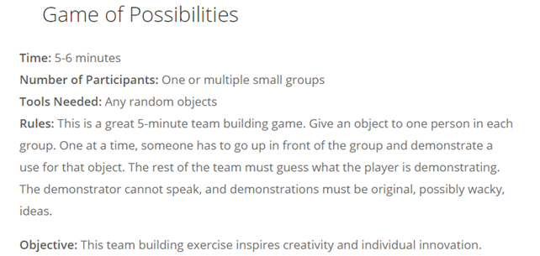
Figure-1: First Activity
Source: https://www.wrike.com/blog/team-building-games/
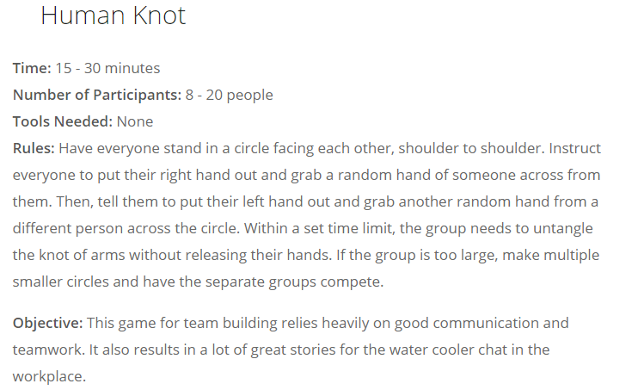
Figure-2: Second Activity
Source: https://www.wrike.com/blog/team-building-games/
The images describe the nature of the activity, the tools needed, and the rules that need to be followed. It then describes the overall objective of playing such an activity amid the given environment. After playing these two communication activities in a virtual workplace environment, it helped me improve on individual innovation skills, team working abilities, and also boosted my morale to perform better (Mossop et al., 2015).

Recommendations and Conclusion
Today, any given organization will need to make sure that they train the employees on the skills of team working and effective communication. It will thus allow them to have high success rate, will allow employees to avoid conflicts, and also ensure that they will be working on the allocated tasks in the organization (Towers-Clark, 2015).
Second, they will remain process-oriented and accordingly will be following to the instructions of the group or team leader. Third, it is even found that there are different communication channels, means, and platforms that can be used in a formal and informal way in the organization. However, it will depend more on the purpose of and objective that needs to be achieved through such communication means (Wisankosol & Chavez, 2016).
The top-level management will always need to use formal communication channels such as emails and newsletters. On the other hand, employees within the team can even use chat options for sharing details of the project, sharing resources, and even for the purpose of knowledge management amid the given environment (Wisankosol & Chavez, 2016). The role of the concerned HR department will be vital as they will need to provide training to the employees and on the other hand will also need to monitor the performance. They can thus provide their suggestions for improving the final outcomes.

References
Brock, S.E., McAliney, P.J., Hui, C., Ma & Sen, A. 2017, "Toward more practical measurement of teamwork skills", Journal of Workplace Learning, vol. 29, no. 2, pp. 124-133.
Carson, O.M., Laird, E.A., Reid, B.B., Deeny, P.G. & McGarvey, H.E. 2018, "Enhancing teamwork using a creativity-focussed learning intervention for undergraduate nursing students - A pilot study", Nurse Education in Practice, vol. 30, pp. 20-26.
Chalak, A. & Fouladi, F. 2016, "Application of Virtual Team-working in Teaching Productive Skills to Iranian EFL Learners", Theory and Practice in Language Studies, vol. 6, no. 11, pp. 2215-2221.
Fayeq Ali Ali. 2016, "Employability Skills among Students and Employers’ Perceptions: An Assessment of Levels of Employability Skills Acquired by Business Students at Ishik University", International Journal of Social Sciences & Educational Studies, vol. 3, no. 2, pp. 81-93.
Gat, I., Pessach-Gelblum, L., Givati, G., Haim, N., Paluch-Shimon, S., Unterman, A., Bar-Shavit, Y., Grabler, G., Sagi, D., Achiron, A. & Ziv, A. 2016, "Innovative integrative bedside teaching model improves tutors' self-assessments of teaching skills and attitudes", Medical Education Online, vol. 21, pp. 31-47.
Keow, N.T. 2019, "Beyond Employability: Embedding Soft Skills in Higher Education", TOJET: The Turkish Online Journal of Educational Technology, vol. 18, no. 2, pp. 1-12.
Mossop, L., Gray, C., Blaxter, A., Gardiner, A., MacEachern, K., Watson, P., Whittlestone, K. & Robbé, I. 2015, "Communication skills training: what the vet schools are doing", The Veterinary record, vol. 176, no. 5, pp. 114-120.
Towers-Clark, J. 2015, "Undergraduate accounting students: prepared for the workplace", Journal of International Education in Business, vol. 8, no. 1, pp. 37-48.
Wisankosol, P. & Chavez, G. 2016, "Developing Cross-Cultural Leadership Skills and Cross-Cultural Team working Skills through Organization Development Intervention: A Case Study of a Multinational Enterprise (MNE) in Thailand, ABAC ODI Journal Vision, vol. 3, no. 2, pp. 71-81.

