Dissertation Proposal:
The Importance of Children Having Outdoor Adventure Experiences from the Facilitators Viewpoint.

1801265
Sam Chivers
Business Inquiry and Research

Introduction
Children are the future. They are the up and coming generation that must leave everything that adults can teach them so they can one day take over and do the same for their children. However, what is the importance of providing children with outdoor adventure experiences? This paper will be an expansion on a possible proposal on ‘The Importance of Children Having Outdoor Adventure Experiences from the Facilitators Viewpoint’ and will give some examples about what could be done as research to find an answer for this question. The study will consist of a series of short qualitative interviews with facilitators of different types of outdoor activities to young people, ranging from youth club workers to teachers to outdoor instructors. The research topic is a largely researched area within educational research and also biological research as the effects that outdoor adventure experiences can have on children are vast and plentiful (Fjørtoft 2001; Bento and Dias. 2017). As the study will be qualitative it is important to start the research process without bias, as a neutral researcher the data provided from the study will give indication of the thoughts of the participants and not the researcher themselves, therefore stopping the interviewer from swaying the data by asking leading questions. Although the starting hypothesis is that there will be some degree of positive benefit occurring from the outdoor adventure experiences, the degree of benefit is undetermined and the importance of experiences has not been deduced. The main aims of this study is to determine the degree of importance that outdoor adventure experiences have on young people from the viewpoint of facilitators. As shown in the study conducted by Fjørtoft (2001), when children are allowed time in the outdoors there are signs of many different benefits occurring. Physical benefits become apparent such as an increase in equilibrium and also improved fine motor skills such as coordination. This is a highly valuable study as it shows the different benefits that children receive from taking part in activities in different outdoor environments, however, more information can be uncovered to the extent in which outdoors activities can benefit young people and the objective of this study is to find more information to increase the current knowledge pool.

Literature Review
The importance of outdoor experiences on young people is a topic that has been looked into many times and some main theories have been discovered to try and prove the importance of outdoor experiences. The one that this research study will focus on is the experiential learning theory.
The most used representation of the experiential learning theory is through Kolb’s learning cycle (1984). Kolb’s theory is that through hands-on experience a learner can achieve a state of reflection that allows them to analyse what has occurred and evaluate how they should proceed to improve within the activity they are partaking in. These reflecting skills can be transferred to learning any skill or any activity and can help the person to progress and learn. One study conducted in 2015 (Richards. et al.) showed that young people who went through a physical programme of experiential learning improved their social skills and academic skills. The participants also showed an improvement in personal growth leading to an increase in self confidence which is extremely important for young people growing up. This piece of literature is important for the study as it evidences that there is some degree of importance in young people experiencing outdoor adventurous activities as there are benefits that will occur from this style of learning and experience.
Experiential learning also allows young people to gather a new perspective of the environment around them. A study conducted by Jose (et al. 2017), of young people participating in outdoor activities showed that after the activities had concluded the young people all showed increased awareness of and knowledge about the local environment they were in. This is beneficial to the young people as it allows them to live a more sustainable life and be able to understand their role within their environment more.
As shown from these small extracts, the other studies into experiential research are plentiful and provide valid information that will help to create the final topic of research for this study. There is also already a sizable collection of data which can be used to back up or validate the information gathered from this research study.

Methodological Approach
The study will have a qualitative approach. The use of a qualitative methodology allows the researcher to understand individual interviewees feelings about the subject and their thoughts on the effectiveness and importance of outdoor adventure experiences. This type of information can not be gathered using quantitative methods as there is no scope to get the study participants feelings on the subject.
‘By providing access to what is ‘inside a person’s head’, [it] makes it possible to measure what a person knows (knowledge or information), what a person likes or dislikes (values and preferences), and what a person thinks (attitudes and beliefs).’ (Tuckman, 1972)
As backed up from this extract from Tuckman (1972), the qualitative approach gives access to information that was previously locked away and can be unlocked through a series of questions diving deeper into the person's thoughts and feelings. As the objective of the aim is to understand the importance of outdoor adventurous activities from the viewpoint of the facilitators the most ideal research method would be to conduct interviews with the facilitators themselves. The reason interviews would be used is that they give the researcher the largest possibility to gather information. By conducting an interview the interviewer is able to structure a conversation with the interviewee and refine the questions they want to ask. If an interview is semi structured it can also account for some lee-way when receiving answers from the participant, there is some leniency to allow for off topic conversation that could be useful and cover something that the interviewee forgot to ask about (Brenner. 2006). Other qualitative techniques such as questionnaires are not as thorough and usually do not allow for as in depth questions to be asked (Brenner. 2006). Despite this disadvantage, questionnaires do have benefits as they completely mitigate the possibility of the participant getting ‘stage fright’ (Cohen. 2007) as they are not answering the questions face to face. Due to the fact that more in depth questions can be asked through face to face interviews, this qualitative approach will be used for this study. The research component of the paper will be solely completed using qualitative methodology, allowing for the most efficient collection of data from the selected participants. The participants selected will be highlighted for selection because of their facilitative role of outdoor adventure experiences, they will not necessarily be picked because of any specific reason other than their facilitative role. This will help to eliminate bias as they will not be selected because they will answer a certain way to the questions or be swayed from their own opinions by the interviewer. The interviewer will also ensure all personal data is kept anonymous if recorded at all and no information at all will be shared with anyone (including in the assignment) without the explicit written consent of the participant. The participant will also have the right to withdraw from the study at any point even after the interview has taken place. As a back-up if this situation was to occur then the interviewer will have a list of more possible candidates for the study that could be contacted (these people will also be selected randomly and will not have any less or more importance to mitigate bias).

Planned Data Analysis and Presentation
Once the interviews have been conducted they will be transcribed. The transcription process will allow for more in depth analysis of the interviews as they can be placed side by side and cross examined. The main method of analysis will be thematic analysis. The reason this method will be used is because it allows for concurrent themes to become evident within the interviews and allows the researcher to determine whether or not these themes are frequent throughout all of the transcriptions or just evident in one of the participants' opinions. Thematic analysis is ‘a method for identifying, analyzing, organizing, describing, and reporting themes found within a data set’ (Braun and Clarke. 2006). This means that it can be used as a method to exhaustively compare the data recorded to process and unlock all of the information that the data set holds. The data will be presented in tables which will contain quotes from the different interviews that all back up the same themes (if recurring themes are present). If recurring themes are not present, tables will show the individual themes that can be found within each transcription and show that the themes are isolated to the individual participant. Thematic analysis is a promising way of increasing the validity of the information received from the data sets as it allows for rigorous in depth analysis of the information gathered (Nowell. et al. 2017). This will help answer the research topic as insights will be given directly from the participants and the researcher will be able to determine whether or not there is correlation between the answers from the different participants.

Research Planning and Ethics

An ethics form will be completed to go with the research paper to highlight any possible issues that could arise from the interview side of the research. All possible issues will be accounted for and safety measures will be put in place, for example, making sure that all personal information from the study participants is kept anonymous and confidential throughout the research assignment and that once the assignment has been submitted and the marking feedback received all participant data will be permanently erased. The study is quite simplistic in terms or resources needed as it only requires a recording device for the interviewee to use to record the interviews so that they can be transcribed and also the personal computer used by the researcher to write the research paper. No specific software such as analytical software is needed.

Summary
As shown by the brief literature review this topic of research is quite fascinating and can lead to understanding the reasons for outdoor activity experiences and also the importance they have on the young people that experience them. This research study will allow more understanding of the importance from the facilitators perspective, possibly giving an insight into the reasons that they choose to facilitate this type of experience. As long as the rough timeplan is followed then the study will be completed with ample time for any additional research to be added.

Project Timetable

Below is a rough timetable that would be followed to create a structure for the timely completion of the many different aspects of the research paper.

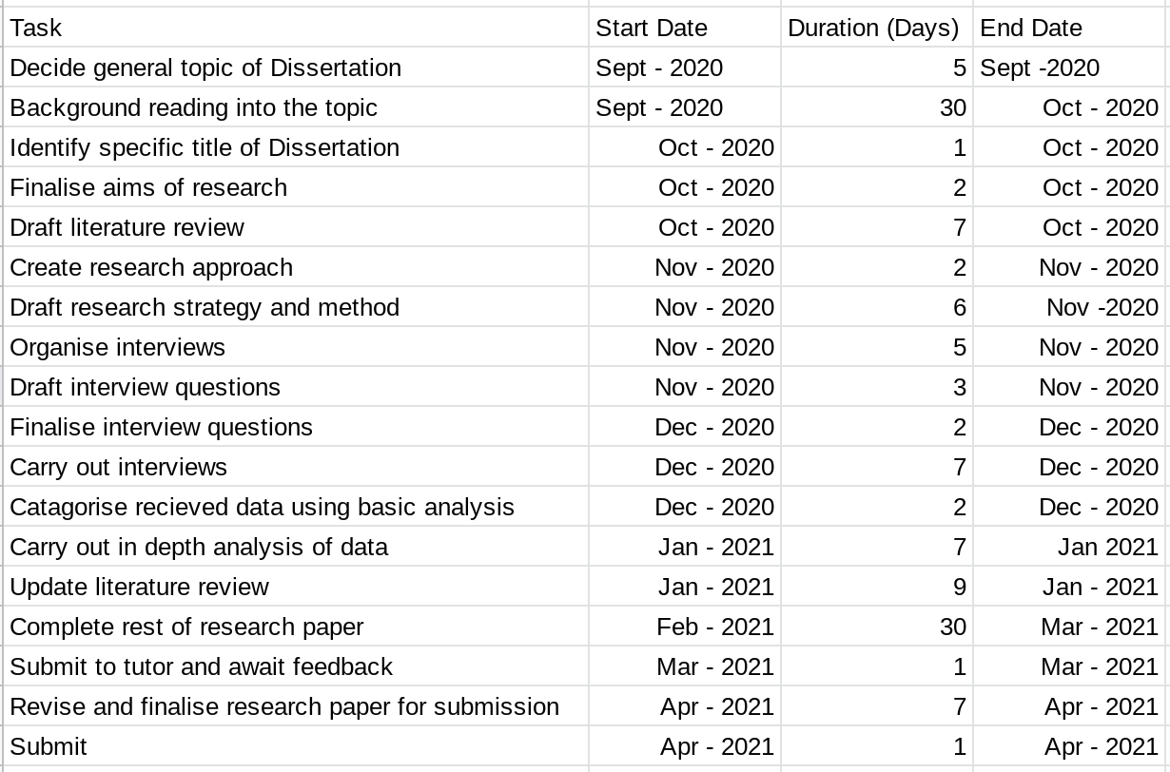

Word Count: 1807

References

Bento, G., and Dias, G. (2017). The importance of outdoor play for young children’s healthy development. Porto Biomedical Journal, vol.2(5), p. 157-160. Elsevier Publishings.

Braun, V., and Clarke, V. (2006). Using thematic analysis in psychology. Qualitative Research in Psychology, 3, 77–101. Available at: doi:10.1191/1478088706qp063oa (Accessed: 20/05/2020)

Brenner, M. (2006) Handbook of Complementary Methods in Educational Research. United States: Lawrence Erlbaum Associates.

Cohen, L., Manion, L., and Morrison, K. (2007) Research Methods in Education, Sixth Edition. London, England: Routledge Publishings.

Fjørtoft, I. (2001). The natural environment as a playground for children: The impact of outdoor play activities in pre-primary school children. Early childhood education journal, 29(2), p.111-117. Elsevier Publishings.

Jose, S., Patrik, P., and Moseley, C. (2017). Experiential learning theory: the importance of outdoor classrooms in environmental education. International Journal of Science Education. Available at: https://doi.org/10.1080/21548455.2016.1272144 (Accessed: 20/05/2020)

Kolb, D. (1984). Experiential Learning: Experience as the Source of Learning and Development. United States, Michigan: Prentice-Hall Publishings.

Nowell, L.S., Norris, J.M., White, D.E., and Moules, N.J. (2017). Thematic Analysis: Striving to Meet the Trustworthiness Criteria. International Journal for Qualitative Methods. Available at: https://doi.org/10.1177%2F1609406917733847 (Accessed: 20/05/2020)

Richards, R., Eberline, A., Padaruth, S., and Templin, T. (2015). Experiential Learning Through a Physical Activity Program for Children With Disabilities. Journal of Teaching in Physical Education. Available at: doi:10.1123/jtpe.2014-0015 (Accessed: 20/05/2020)

Tuckman, B. (1972). Conducting Educational Research. California, United States: Harcourt, Brace and Company.

