

Course: BA Business Management
Name of lecturer: Hossein Shokri
Marketing fundamentals LCBB4004 (assessment 1)
Name of student: Elena Miloshevska 2024564

Processes and stages of marketing including the role of the marketing mix

Date: 26.04.2021

Table of contents

Introduction………………………………………………………………………………….3
Defining the marketing…………………………………………………................................3
Segmentation, Targeting, Positioning……………………………………………………….3
Marketing mix……………………………………………………………………………….4
Marketing process…………………………………………………………………………....5
PESTLE analysis Super Retail group……………………………………………………….6
SWOT analysis Super Retail Group………………………………………………………...7
Porter Five’s forces Super Retail group……………………………………………………8
Conclusion…………………………………………………………………………………….9
References……………………………………………………………………………………10

Introduction

The following essay provides a critical analysis of the processes and stages of marketing; it includes stages of marketing process such as mission statement, situational analysis, objectives, and strategies STP- segmentation, targeting, and positioning and marketing mix Ps4; the essay includes a significant rationale and interpretation of marketing and its process; furthermore, it analyses macro factors for the chosen company; it the essay also includes critical analyses of porter’s forces and swot analysis for the company chosen.

Defining the marketing
According to Jobber, (2016), marketing is about creating value for the customers and building a strong relationship with the customer; it captures value from the customers in return; the marketing aims to understand the marketplace fulfil the needs and wants of the customers. The process of marketing is all about building a profitable relationship and capturing value from the customers. Blythe, (2019), explains marketing in terms of understanding clients’ needs and wants; the customer’s need and demands satisfy the market offerings; it builds a long-term relationship with customers.

Segmentation, Targeting, Positioning
When the company’s segment their market they have a better understanding of the customers needs and wants. Marketing segmentation is the process of dividing a market into distinct groups of buyers who have different needs, characteristic or behaviours and who might require separate marketing strategies or mixes. Also, the market can be segmented by: Demographic segmentation such as age, gender, race, income, education, occupation; Geographic segmentation- such as countries, regions, cities or neighbourhoods; Psychographic segmentation- based on lifestyle or personality characteristics; Behavioural segmentation- based on consumer knowledge, attitudes, uses of a product, or responses to a product; Benefit segmentation- based on differences in specific benefits that consumers expect from a product or responses to a product (Kotler, et al.,2020). Targeting is after the process of segmentation; selecting one or more segment to enter; the company is more specific about who their customers are. Marketing positioning is ability to influence consumer perception regarding a brand or product relative to competitors; marketers plan positions that distinguish their products from competing brands and give them the greatest advantage in their target markets (Kotler, et al.,2017)
Marketing mix
To understand marketing, it is essential to understand marketing mix; marketing is all about using the right product at right time and right place. Marketing mix often uses as substitute for “4Ps”. It is the vital concept which describes different kind of choices that an organization will make during the procedure of marketing; the 4Ps of marketing mix are product (the actual product), place (where the product is located), price (the amount of money needed to buy products) and promotion (advertising-getting the product known). The 4Ps helps us to understand that what are the expectations of customers and what is the right place to launch the new product. It also helps to analyse that what should be the value of our new product and how to reach the targeted audience for marketing of our product (Kotler et al.,2017).

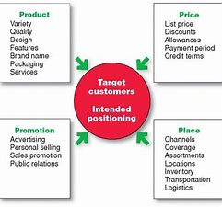
Figure 1 Kotler, (2017)

Marketing process

The marketing process is one of the marketing's outcome; the process of marketing is all about getting potential clients and customers, especially those who are interested in your products and services; Constantinides (2006) examines that marketing involves promotion, selling and distributing the products and services; the marketing process always centres around commercial management of companies for attracting and acquiring the needs of customers.
According to Kotler & Armstrong, (2017), marketing process is series of steps that allow organizations to identify customer problems, analyse market opportunities and create marketing materials to reach the desired audience. The marketing process include five-step models for creating and capturing customer value. First step is understanding the marketplace and customer needs and wants, designing a customer -driven marketing strategy, constructing an integrated marketing plan that delivers superior value, engage customers build profitable relationship and create customer delight, capture value from customers to create profits and customer equity.

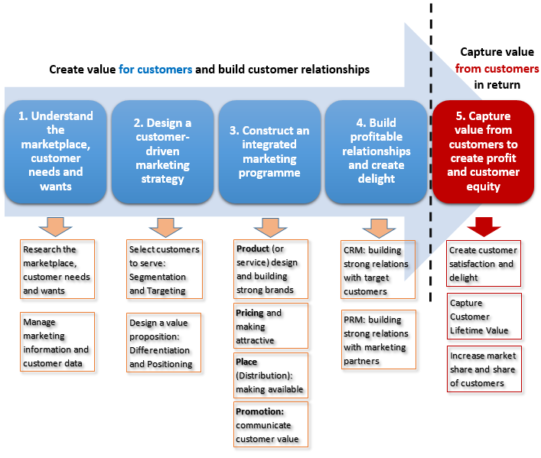
Figure 2 Kotler & Armstrong, (2017)

The marketing process stages comprise the mission statement, situation analysis, marketing strategy, marketing mix with implementation and control. Strategic marketing planning includes setting goals and objectives with analysis of internal and external business factors for product planning and implementation; it tracks the company’s progress and monitoring the results.

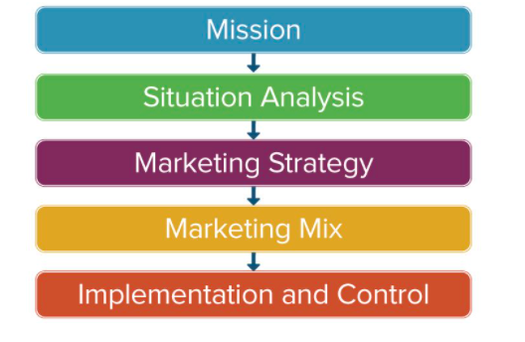
Figure 3 (Smith,2017)

The strategic planning for the Super Retailer Group is all about dedication and bringing on other retailers too. It is one of the top retailers in the Australian stock exchange; its mission is to inspire and live for passion while providing solution and engaging in an experience that inspires customers to make most of their leisure time. The marketing process analyses mission statement and corporate objectives; the situation analysis will further identify the opportunities and strengths through analysis such as SWOT or PESTLE; for the next step, the marketing process includes different marketing strategy such as what audience has targeted; what are the goals and what budget has developed so far; then comes marketing mix including pricing, promotion and distribution. The last step of implementation and control is putting the plan into action and monitoring the result (Baines et al.,2014).
The PESTLE analysis is a strategic tool for analysis of the macro environment of an organization. The Super Retail Group Ltd. is one of the biggest retailers; the factors impacting the company also impacts other players in retailing; According to (Solution-March), the political factors play an important role in determining the factors for certain businesses; the super retail group’s long-term profitability is connected to certain other country’s market too. The factors affecting the business are political stability and importance of the company’s retailing sector; it includes risk and levels of corruption too; the main political factors affecting the company is a legal framework and correct enforcement; it is also about anti-trust laws related to retailing and pricing regulation. Tax rates and incentives highly impact the retail business (Carson, 2017); however, it has seen that the country’s political system is highly stable, which is why the business growing smoothly.
Moreover, as per (Grimmer 2021), culture and society ethics also impact any business environment; the population’s demographics and skill level inform that many individuals constantly buy products in bulk. Consumer preferences indicate that stores in Australia buy various products to avoid running out of condition. The people are highly tech-savvy and always look for easy browsing and digital catalogues; Super group Ltd uses various techniques to manage money after the sale. The retail company highly looks for meeting the needs of a healthy environment for consumers and employee safety. The PESTLE analysis of the company shows that all the conditions are highly favourable for Super Retailer ltd. Another highlighting factor is economics impact the retail industry in Australia; the decrease in the monetary economic situation has influenced the performance of Super Retail group; likewise, the vacillations in the Australian dollar additionally affected the matter of the retail group also (Mendonca, 2019), there are a few legitimate variables which influenced the matter of super retail industry, for example, carbon charge carried out across Australia; the appraisal of the Super retail market shows that there are Australian rivalry and commission that have influenced the activities of the organization across the economy; the other components influencing the retail business demonstrates that the retail tasks are exceptionally influenced by outside industry condition.
As indicated by Baverstock et al. (2013), another traditional factor is SWOT investigation; swot examination is utilized to decide strength, shortcomings, openings, and dangers to any association. SWOT examination of Super Retailer group shows that the ebb and flow retail industry have high brand acknowledgment of top players with extraordinary information on the neighbourhood market, clients and seasons; the shortcoming can be it is limited to Australia and New Zealand and China; there are high odds of incessant value battle because of nonappearance of the fixed retail costs; the high work and inhabitancy is additionally a common issue; the exchanging time distinction is likewise one of the shortcomings establishing an overwhelming climate for the clients; Secondly, according to SWOT investigation, there are wide freedoms for the brand, like odds of worldwide development with business esteem because of present innovation and advancement. As perhaps the biggest retailer, Super Ltd. has confronted different dangers, for example, the danger of new contenders and the developing ascent of online business.
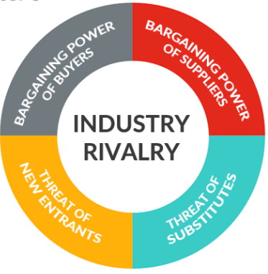
Figure 4 Roseke, (2019)
According to Brenes et al. (2015), the porter’s five forces is a holistic strategy framework that can be better for analysing the present competition; porter’s five forces focus can be used for developing profitable opportunities in the retailing sector. As new entrants in the retail business bring innovation and put a lot of pressure on Super Retail group trough low price with reduced costs strategy; the company has built an effective barrier for safeguarding the business; subsequently, the company has built massive strategies which results in extraordinary profits for new firms and discourage the new players in the competitions (Adeniyi et al.,2020); another threat is the bargaining power of suppliers; the retail group uses its negotiating power for extracting the higher prices; the company has built an effective supply chain with multiple suppliers and hence experiments with different product design for using different materials.
According to Rice (2010), when a new product or service meets customer needs, then most probably the profit of industry suffers; there is always the threat of substitute product and services, the threat is high if the service is also high and offers the value of proposition (Grundy, 2016), The company must be service oriented rather than just product oriented. The company must understand its core need and want the customer is buying, the condition can grow better with increasing switching cost.
Moreover, looking at the analysis above, it has seen that the SWOT is a traditional method for identifying the needs of an organization; Porter five forces is a stronger option for younger and growing companies, it is very helpful for the development of an organization and building a marketing brand; the porter’s five forces are helpful to identify threats and opportunities for better understanding. Both of the tools are helpful to build a strategy; porter five forces help to analyse and address the state of competition within the market; the SWOT analysis supports addressing both internal and external factors affecting the competitiveness of the company.

Conclusion

The essay identifies the process of marketing and recent trends in meeting customer need, the essay comprises examining the process of marketing including marketing mix, which is all about getting potential clients and customers, especially those interested in your products and services. Super Retail group ltd. is one of the top 10 retailers in the Australian stock exchange, their mission is to inspire and live for a pass. The purpose solution and engage in experiences which inspire the customers to make most of their leisure time.
The essay indicates that marketing involves promoting, selling, and distributing the products and services. The marketing process always centres around commercial management of companies to attract and acquire the needs customers. The essay also compares the macro tools of strategic analysis of the company.

References
Adeniyi, O., Brown, A. and Whysall, P., 2020. Retail location preferences: A comparative analysis. Journal of Retailing and Consumer Services, 55, p.102146.
Baines, P., Fill C., Page, K., (2014) Marketing, Oxford, 2nd edition
Beaverstock, J.V., Hall, S. and Wainwright, T., 2013. Servicing the super-rich: New financial elites and the rise of the private wealth management retail ecology. Regional Studies, 47(6), pp.834-849.
Blythe, J. and Martin, J., 2019. Essentials of marketing. Pearson UK.
Brenes, E.R., Ciravegna, L. and Montoya, D., 2015. Super Selectos: Winning the war against multinational retail chains. Journal of Business Research, 68(2), pp.216-224.
Carson, G., 2017. Retail-Never forget the cycle. Equity, 31(4), p.10.
Constantinides, E., 2006. The marketing mix revisited: towards the 21st century marketing. Journal of marketing management, 22(3-4), pp.407-438.
Grimmer, L., 2021. Calls for large retailers to return JobKeeper after Super Retail Group joins Toyota and repays $1.7 million: Interview with Lois Maskiell.
Grundy, T., 2006. Rethinking and reinventing Michael Porter's five forces model. Strategic Change, 15(5), pp.213-229.
Jobber, D., 2016. Principles and Practice of Marketing, McGraw Hill, 8th.ed.
Kotler, P., Armstrong, G. and Opresnik, M.O., 2017. Principles of Marketing (17e Global). Harlow: Pearson Education Limited.
Kotler, P., Armstrong, G., L.C.& He, H., 2020, Principles of Marketing, 18th.ed. Harlow: Pearson.
Mendonça, A.C.L., 2019. Benchmarking and analysis of store performance in a retail group (Doctoral dissertation).
Rice, J.F., 2010. Adaptation of Porter's five forces model to risk management. DEFENSE ACQUISITION UNIV FT BELVOIR VA.
Smith, P.A., 2017. Stakeholder engagement framework. Information &amp; Security, 38, pp.35-45.
SOLUTIONS—March, M.S.C., Looking toward a super retail future.

