Matthew Satterthwaite
Student: 1910496

ACDA60007 – L6 RS&I

Document: Joint Assignment and Practical Exam

10 November 2023

Contents

6.3 Georeferencing 6
6.4 Digital Terrain Relief Model 6
PART 2 8
List of Figures
Figure 1: Topography Drone [3] 3
Figure 2: Triangulation [10] 7

List of Tables
No table of tables entries found.

Part 1

Introduction

Document Scope

A new data set is required for a littoral zone within a friendly urban area. The information to be collected should include:

the topography of the area above the neap lowest astronomical tide chart datum,

local structures and accessways within 250 meters of the mean sea level to a resolution of 15cm

This section details methods for data collection using remote sensing and imaging techniques.

Topography

Topography is the detailed description of landforms and features that include rivers, man-made structures and mountains. Topography information is important during building and construction. Understanding the elevation of the land as well as any underlying geological features present can prevent future delays or issues [1].

Methodology

Collecting data is crucial for various applications, ranging from weather monitoring to surveillance and mapping. Satellites, drones, and light aircraft have been selected as three possible options for data collection.

Satellites

Background

The use of satellites have revolutionized our understanding of the surface of our planet by being used – in several different ways – to map and monitor the earths topography [1].

Satellites can be fitted with a range of sensors that enable them to capture images of the Earth’s surface in wavelengths such as visible light to infrared and microwave. These images can be used to create detailed maps of the Earth’s topography, vegetation, and urban areas, as well as monitor changes in land use, natural disasters, and climate patterns.

Advantages

Satellites provide very wide coverage, enabling data collection from remote areas that are challenging for other methods.

Satellites offer long term monitoring and provide consistent data collection over periods that other, flown methods cannot offer.

Once launched, satellites can obtain data with minimal cost and on a regular basis, making them cost-effective for continuous monitoring.

Disadvantages

Satellites struggle to capture fine details due to their altitude, limiting their ability to provide high-spatial resolution imagery [2].

Satellite data may be affected by adverse weather conditions, reducing the quality and reliability of the collected information.

Users have limited control over satellite operations, making it challenging to tailor data collection to specific needs.

Drones

Background

Drones can be used to obtain the topography of a specific area.

With the correct technical specification, drones can collect accurate data, that is Geo tagged. When combined with suitable photogrammetry processing software, drones can quickly display and present this data as a standardized output.
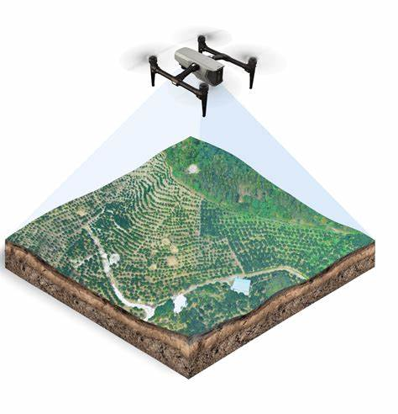
Figure 1: Topography Drone [3]

Advantages

Drones can access hard-to-reach areas, providing close-up views and collecting data from diverse terrains.

Drones are capable of capturing high-resolution imagery, enabling detailed analysis and mapping.

Drones can transmit data in real-time, allowing for immediate analysis and decision-making.

Disadvantages

Drones have a limited flight range due to battery constraints, making them less suitable for large-scale data collection in remote areas.

Operating drones may require adherence to strict regulations and licenses, limiting their usage in certain regions or situations. During times of heightened security, their presence alone – albeit innocent - might result in action.

Adverse weather conditions such as strong winds or heavy rain can hinder the operation of drones and compromise data collection [5].

Drones are not incredible rugged and can be damaged beyond operational use by contact with trees, strong wings, birds or light debris.

Light Aircraft

Background

Light aircraft are used for land surveying, mapping, and aerial photography because of their abilities to fly at low altitudes and at low speeds, for a reasonable amount of time.

This method is commonly used when detailed measurements are required [4].

Advantages

Light aircraft can cover larger areas at higher speeds compared to drones, reducing the time required for larger amounts of data collection.

Light aircraft can carry various types of sensors, allowing for a wide range of data to be collected simultaneously. This might require several drones or an entirely new satellite.

Light aircraft can operate in various weather conditions, providing more reliable data during challenging weather circumstances.

Disadvantages

Light aircraft operations involve notable expenses, including aircraft maintenance, fuel, and pilot fees, making them less economically feasible for some applications. Depending on the technology used, there might also be a requirement for a topographer.

Light aircraft may struggle to access remote or restricted areas due to airport proximity and regulation constraints.

Conclusion on Methodology

Proposal

Each method of data collection, whether satellites, drones, or light aircraft, offers specific advantages and disadvantages.

While satellites provide global coverage and cost-effectiveness, they lack resolution and maneuverability.

Drones offer flexibility and high-resolution data but have limitations in terms of range and regulatory obligations.

Light aircraft provide time efficiency and versatility but come with higher costs and safety concerns.

Considering the task, it is not recommended that the topography data is accessed via satellite as the area in question would be too small to gain any accurate data.

The choice between light aircraft and drone collection will be determine by the project budget and timescale. Both methods would be capable of collecting the data required over the area.

Operationally, the light aircraft would survey the area – to the required detail – quicker than a drone, however the delays might be in correctly resourcing the operation with skilled pilots and topographers. Special permissions may also be required.

The drone may require more than one pass to collect all relevant datapoints but it would not inconvenience any people, industry or airspace outside of the area being surveyed. For this reason, a drone would be the preferred option for this specific task.

The Data Capture Process

Data Acquisition

The first step in processing remote sensing data is to acquire high-resolution imagery compatible with 1:1250 scale data from the Ordnance Survey.

This imagery can be obtained using various remote sensing platforms such as satellites, aerial photography, or LiDAR systems.

It is essential to ensure that the imagery has the necessary resolution and accuracy to achieve the desired results.

Pre-Processing

Preprocessing the raw remote sensing data is crucial to make it compatible with the Ordnance Survey 1:1250 scale data and prepare it for further analysis. This step includes the following sub-steps:

Image Correction: Correcting geometric distortions in the imagery is necessary to align it with the known coordinates of the OS 1:1250 scale data. Georeferencing algorithms are applied to rectify the image by using control points with known coordinates. These control points may include prominent features on the ground or existing OS data points [7].

Radiometric Correction: Radiometric calibration is performed to normalize the imagery and remove any variations in brightness and contrast caused by factors such as atmosphere, sensor characteristics, or solar illumination conditions. The aim is to ensure that the remote sensing data is comparable with the OS 1:1250 scale data in terms of brightness and color [8].

Georeferencing

Once the preprocessing steps are completed, georeferencing is carried out to spatially align the processed remote sensing data with the Ordnance Survey 1:1250 scale data. This ensures accurate geolocation of features in the imagery [9].

The process involves identifying key control points on both datasets and applying appropriate geometric transformation algorithms to establish the transformation relationship.

If control points are present in both sets of data, then they are selected. These points can be road intersections, building corners or specific, identifiable landmarks. The even distribution of these control points is crucial to the accuracy of the georeferencing.

Mathematical models are used to establish the relationship between the remotely sensed data and the data from the OS model.

Digital Terrain Relief Model

Once the georeferencing has been completed, the next step is to create the Digital Terrain Model (DTM). This model will display the three dimensional information, like terrain and elevation, for the desired area.

To accurately display this data, the following steps are followed :

- Data Filtering : as the sole focus of the exercise is to survey the terrain, objects such as buildings and vegetation can be removed from the display. Methods such as slope-based classification can be used to extract the bare earths elevation data.
- Triangulation : All remaining elevation data points are connected to form a triangular network. Specific algorithms connect these elevation points, which ensures an accurate representation of the terrain.
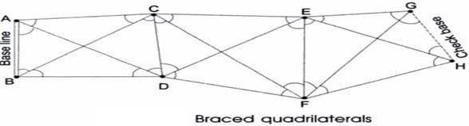
Figure 2: Triangulation [10]
- Interpolation : if there are areas within the triangular network that are unsampled, interpolation techniques such as inverse distance weighting are used to estimate the elevation values. This ensures that the terrain model is continuous [11].
- Validation : the finished model is then compared against field survey data and existing measurements for validation.

These steps contribute to ensuring accurate spatial alignment with existing data and generating reliable terrain information for various applications.

PART 2a

PART 2b

Ordnance Munitions and Explosives (OME) at UWTSD

Introduction

Due to the universities ongoing commitment to the OME sector, there has been a requirement raised for small scale testing and disposal of explosive compositions and energetic components on site, for research purposes.

The university has stated that they intend to venture into the following areas of research through the use of this trials site :

Internal Ballistics – Strength of Design

Arena testing – terminal ballistics

Nano Technology

The purpose of this section is to identify the limitations of the proposed trial site using remotely sensed data and geographical information software.

The proposed site is highlighted below:

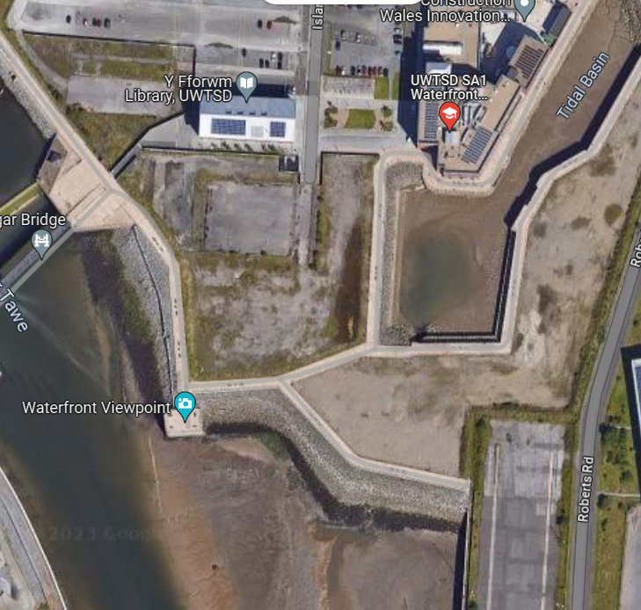
Figure 3: Site Location

The Disposal and test site would be fabricated within the yellow highlighted area with hardware and instrumentation storage placed in the blue section, as well as the potential for a secure laboratory.

Reason for Selection

The site must be on stable ground that is not prone to flooding or rills after heavy rainfall. This would not only pose a safety risk, but also an environmental one. QGIS was used to plot the trial site alongside geological map data to identify these risks.

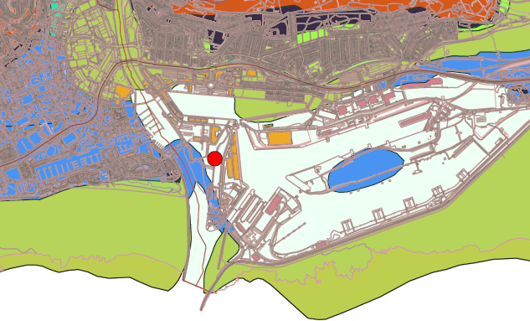
Figure 4: Flood Risk

The site is identified by the red mark and is not located in an area of historical flood risk. The full map, with legend is located in Annex A.

Strength of Design Testing

Concept

The theory behind strength of design testing it to establish the post firing condition of a projectile to check for indifferences with critical dimensions and features. This is commonly completely by performing soft recovery, usually within the shallow waters off coastal areas. This requires the area to be closed off, usually for days to ensure no people or marine traffic can access the safety trace. The objects are then recovered once the tide has gone out and measured.

Traffic Restrictions

Despite several UK MoD test sites utilizing the shallow sea and large tides for over water, soft recovery firings. That will not be a possibility with this trials site, even at very short ranges. Marine Data was added to the map, which identified an active and very busy shipping channel directly in front of the proposed site.

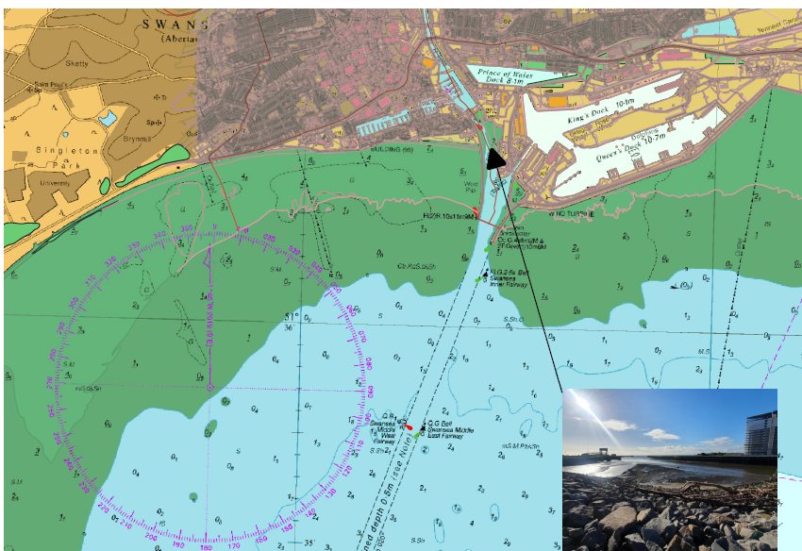
Figure 5: Marine Traffic

The constant presence of marine traffic, as well as port authority workers in the area would make it impossible to secure the necessary safety traces required to do overwater firings out to any meaningful distance.

There is no direction possible that can avoid this access point and therefore this site will be unsuitable for this procedure.

Arena Testing

Concept

An arena trial is used to determine the terminal performance of a warhead by deliberately detonating the test item with the intension of recovering fragments and recording blast pressures. These require a large safety area or a proven method of containment that does not hamper the test results.

Noise and Blast Restrictions

The site would have to have a very limited explosive limit that would control the amount of explosives allowed on test at any time. This would be to limit noise and blast potential in built up area.

For safety reasons, any permitted experiments be required to be surrounded by a pit enclosure that can immediately capture fragments for assessment. This will reduce any fragmentation risk and reduce contamination of the waterways.

The proposed site is close to the main university building structure that is largely glass. For this reason, the blast radius calculations will be based upon the proximity of this structure.

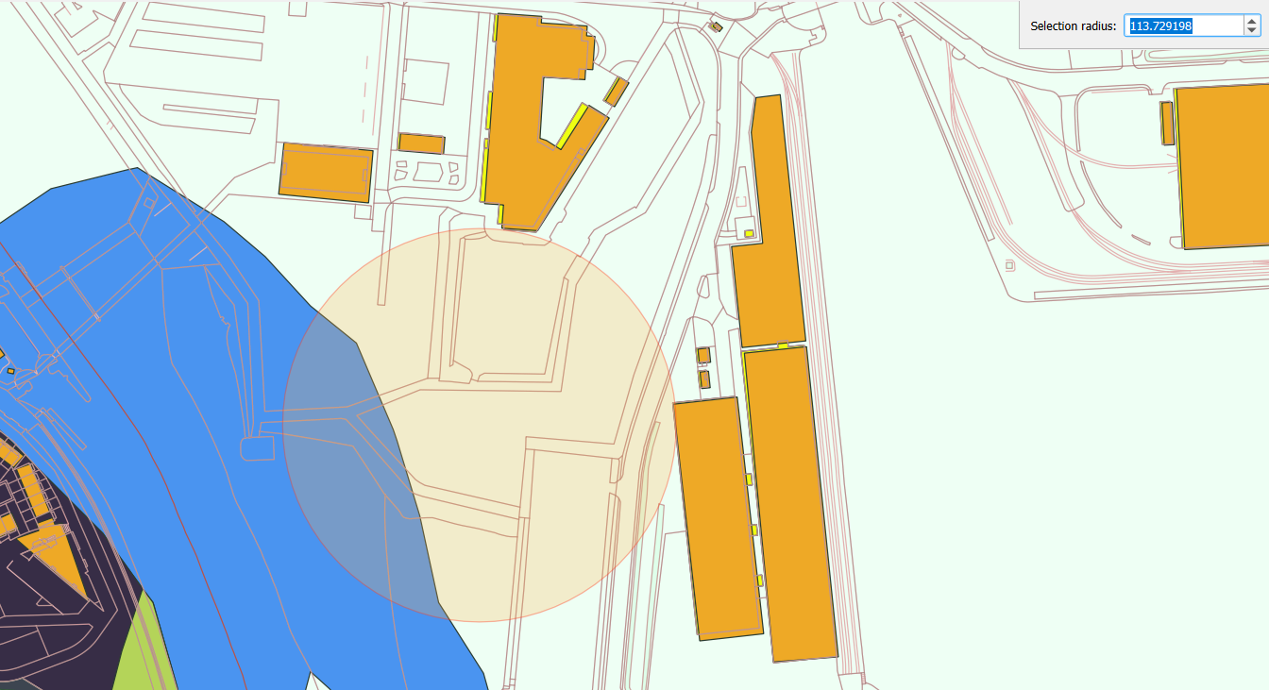
Glass
Corrugated Steel
Figure 6: Blast Radius - Glass Structures

The overpressure figures for typical glass window damage and damage to sheet metal work are shown below [12]:

Table 1: Blast Overpressure Damage
Damage | Overpressure PSI | Overpressure kPa
Glass Window Damage | 1.03 - 1.52 | 7.1 – 10.5
Damage to Sheet Metalwork | 7.58 - 12.41 | 52.3 – 85.5

The required amount of bare explosive capable of those overpressures, at the range of 113m can be worked out using the following formula:

(Distance from Charge/(36.793 * (Required Overpressure^{-0.5344})))³

Larger windows, like the ones facing the proposed trial site are at greater risk and can be damaged, at this range, from as little as 5kg of bare TNT equivalent material. This following ranges have been calculated and checked [13].

Table 2: Window Damage
Criteria | Minimum range to No Break (m)
Small Window 0.55m by 0.55m | 44.46
Medium Window 1.25 by 0.55m | 71.82
Large Window 1.25m by 1.55m | 160.74

Despite the buildings being within this threshold, the blast damage is not going to be the result that prevents arena trials from being permitted on this site. The close proximity of houses, tall building and even a nursery present a significant noise risk.

Using the same 5kg of TNT and the formula below, the minimum range to which a noise level of 140dB will be present can be calculated.

Distance = 215(Explosive Mass)^{1/3}

This returns a range of over 365m, which puts the trials site within range of all of those listed hazards. For context, a charge of 1kg will still surpass those noise levels out past 215m.

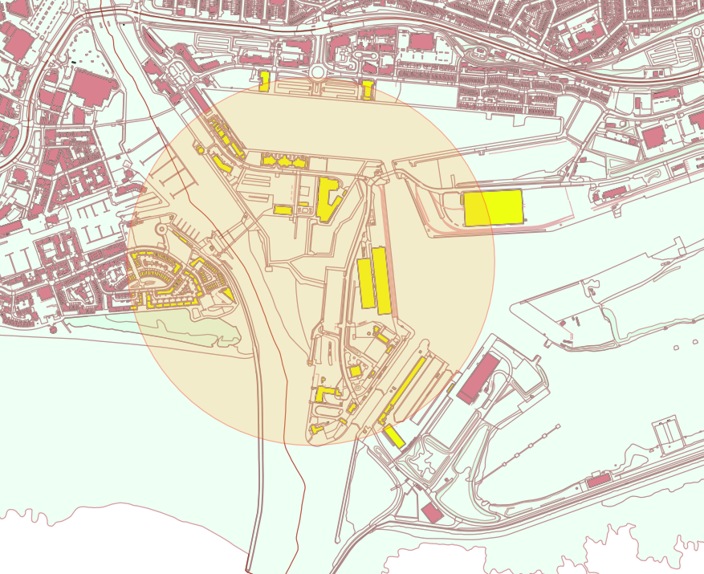
Figure 7: 140dB Radius

The presence of so many high buildings can create channels for the blast waves to propagate, meaning that the pressures and effects can be magnified when they reflect. The following attribute table shows the content of high buildings within the noise damage radius.

Table 3: Building Heights
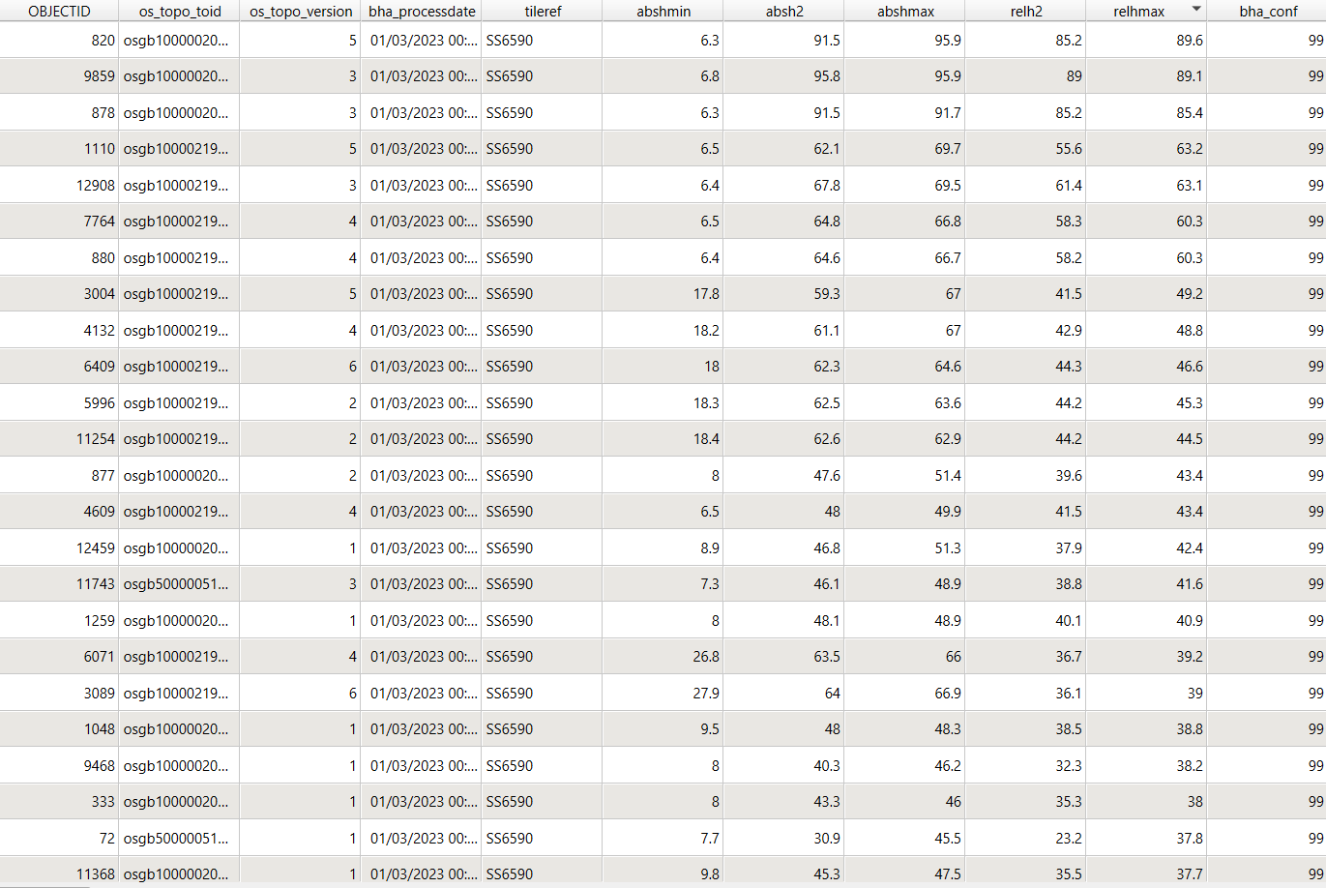

This limit will significantly affect the explosive limits available for arena trials and will likely defer potential customers from engaging, as other relatively local trial sites can handle far bigger quantities.

Nano Scale Testing

Concept

With the constant creation of new technology within the defense industry, it is important to be able to develop ideas that allow us to do more with less. The development of technologies such as Nano thermites and reactive materials is an extremely important area of research and can be developed using very small quantities.

Mixing and Manufacturing Techniques

There is a possibility that the trial site can be used as a small research and development center to develop safer and more efficient methods of mixing these materials.

Usually handled in grams, rather than kilograms, nano thermites and reactive materials can undergo intense combustion, however it lacks the shockwave characteristics associated with explosions. They are more widely used than explosives which tend to be mainly defensively researched.

Testing

Testing the performance of these substances can again, be handled in grams. Common testing techniques include :
- Differential scanning calorimetry : measures the heat flow
- Thermogravimetric analysis : monitors changes in mass as a function of temperature
- Xray Diffraction : Analysing crystallography to ensure proper mixing
- Particle size analysis : determining size distribution

In addition to these methods, the standard suite of Energetic Materials Testing Assessment Policy Manual of Tests (EMTAP) would be carried out on very small samples.

The building would be required to be manufactured from blast walls and have a controlled ventilation system as well as safety and security interlocks.

Disposal

Disposal would have to be handled with controlled burns of leftover or defective formulations.

Although the burns would be extremely fast, this does pose a pollution risk to both the air and the waterways.

Conclusion

Use of Remote Sensing

The use of remote sensing technology and software resulted in the rapid, and remote assessment of a potential sites capabilities.

It was concluded that the trials site will be limited to very small-scale testing due to its proximity to highly populated areas and busy shipping lanes.

The sites liability to water run off prohibits large amounts of open burning and chemical pollution whilst also posing a storage risk.

Annex

Annex A



