The speciesism of intensive farming; and the true cost of fast meat: ethical and ecological comments

If we define speciesism as ‘The assumption of human superiority [often] leading to the exploitation of animals’ (Plotczyk. L, 2020) to justify speciesism, is to accept we are greater or the greatest above all other species, and to see this as truth would be deny our existence as synergistic with other animals and the wider environment that we all share and live in.
Should we be different?
In many ways we are trained to see human animals as superior in the Human animal / species framework. Whilst this dominance is often abused and used in a negative way towards species lower down the order , it is also this hierarchy that allows us to act as their advocates, and their voice for fairer treatment or change. It is this elevated position of power that speciesism afford us, that humans hold above animals, that both can be used to abuse animals or act in their best interests. This power comes with responsibilities and moral duties, and when used appropriately can be powerful in setting about change, and bettering our understanding about the interconnections between species.

Looking at the global meat industry, the mass production of meat relies on fast farming, essentially being able to put food on plates quicker. Without regard for the process and its impact on the wider world, this short-sighted food chain perpetuates many problems. One of these issues is the promotion the deforestation and clearing vast areas of lands, often to grow soy for animal feed.
The knock on effects of this land clearance, can be catastrophic, not only for the local natural environment but also has a wider reach. The clearance of lands to farm for grain or animal pasture lands, creates an imbalance between the natural wild world and the clinical controlled domestication of farmed animals. This method of farming can give way to imbalances. One of which, is very much of our time. Zoonotic disease, amongst many other ecological issues, is perpetuated by this method of interfering with the natural order and blurring the boundaries between wild and domesticated animals. Placing each side by side in close contact, often with humans somewhere in the mix too, this provides the perfect storm for interspecies disease to spread. ‘Once forests start to disappear, populations come in closer contact and disease spreads’ (Rozenbaum. M, 2020 pp1) And what is worse still, is that humans create these problems, ignore their part in the process, and assume no responsibility or call for change to rectify the butterfly effect they triggered by greed and hunger for fast, cheap, unethical meat.

The dualist approach, viewing humans and other animals as separate, as distinct entities, is what sets us apart and creates disparity on how we value ourselves over other species.
In his paper entitled ‘The Worst Mistake in the History of the Human Race’, Jared Diamond outlines that agriculture largely took the place of hunter gatherer lifestyles in favour of the sheer time it took to forage in comparison to settled agriculture in the form of farming. ‘Agriculture gave us free time that hunter-gatherers never had’ . (Diamond. J, 1987, pp3)
If we are to realistically acknowledge that humans consumption of meat is unlikely to completely diminish, we must, at the very least acknowledge the practices of rearing farmed animals. Responsibly sourced, ethically reared meat from animals who have had a quality of life must be considered the norm and become the very basic expectation. For accepting less is to accept not only our superiority over other living entities, but also the speciesist view that animals can not feel pain and suffering in the same way we do. In terms of justifications for this industry appeals to animals’ supposed lack of, for example, moral agency, rationality and language often plays a role. These ‘lacks’ are what are often needed to justify poor conditions, and less ethical treatment of animals. If we accept this, we must also accept that if we reverse speciesism and apply this egalitarian treatment to humans without moral agency, arguably those who are most vulnerable in our society and we normally act to protect, could be classed similarly, and the argument becomes swiftly debased. The argument against moral agency and egalitarian treatment to all species becomes more unravelled when using this application and speciesism becomes morally unsound and therefore ridiculed as an argument, as Singer outlines in ‘the argument for marginal cases’ (Singer. P, 1979, chap3)
With this expectation for higher welfare, we must also become accustomed to paying the true cost of our meat if we choose to eat it. Naturally driving down our consumption by making it less avaible as a every day item, viewing it as a luxury product to be valued as such.
`

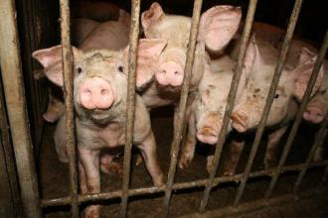

https://socialistworker.org/sites/default/files/imagecache/330/images/fattening_pens2.jpg

So how can we eat meat responsibly?
Firstly we need to address the price.
Singer suggests that ‘The case against using animals for food is at its strongest when animals are made to lead miserable lives so that their flesh can be made available to humans at the lowest possible cost’ (Singer. P, 1979, pp3)
The ethical production of meat, might be a controversial topic. Many might argue that there is no ethical way to slaughter an animal eat its flesh. However, it can not be denied that meat is eaten, and will continue to do so. With this in mind, I feel it is worth addressing how best this can be done. Whilst you cannot really quantify a price on life, we have become accustomed to eating meat without paying the true cost in both ethical and ecological terms. If we are to eat meat, the price we pay financially should in some way reflect the price paid ecologically and ethically for producing that meat. First and foremost factoring in the cost of giving the animal a fair and just quality of life. This would need to factor in, as a very base requirement, ample space, sunlight, good feed and favourable ‘happy’ conditions. An animals right to quality of life matters. Even if it is destined for food.
The paradox is of course, that a farmed animals life only exists due to the call for meat. Which raises the question, is no life better than a life of an intensely farmed animal? Or to put it another way, is no life better than pain and suffering?
Singer offers that ‘Modern forms of intensive farming apply the attitude that animals are objects for us to use’ (Singer 1979, pp3) and that ‘ There can be no moral justification for the regarding of pain that animals feel as less important than the same amount of pain felt by humans’ (Singer 1995 pp15). With these thoughts in mind, this brings me to suppose that, if it is to be eaten, meat should be produced ethically, slowly, with a greater respect for the animal and its journey. We should value meat as something that costs. We can not place a price on life, but by hiking meat prices to a level that reflects its life on this planet and the value of its ecological existence we go some way to reminding humans that this is a food we eat sparingly with conscience. Cheap meat can no longer be a right, or daily sustenance that we have become accustomed to. Meat is a privilege and one that should come with cost and appreciation for its existence. The three-meals-a-day culture towards meat consumption needs addressing.

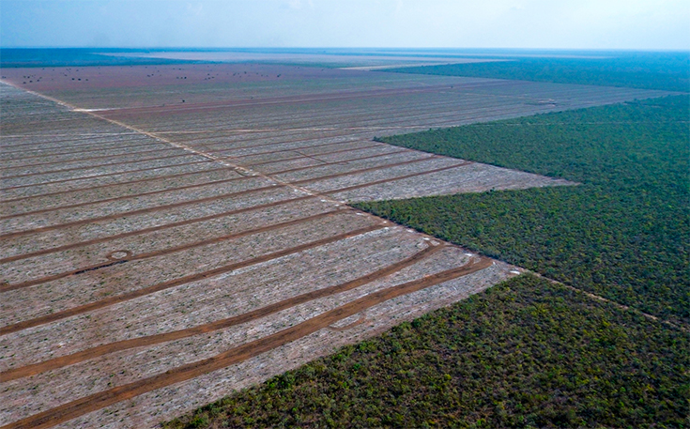
burger king land clearance for soy - Bing images

We already know intensive farming also supports the clearing of land for Soy animal feed. Animals need to eat, and large amounts of farmed domesticated animals means a need for large amounts of feed.
Burger King buys animal feed from soy plantations responsible for burning tropical forests in Brazil and Bolivia (2017 Nelsen. A). The vast space needed for these crops creates a huge impact on local wildlife, displacing both local human communities and animal wildlife. Creating disorder in the equilibrium between wild and farmed lands would as expected come with consequences. The social impact of displacing small communities means pushing native dwellers to new areas which they might not be used to farming on and struggle to feed themselves and their community as a result. Populations may be pushed together in larger numbers, ‘agriculture encouraged people to clump together in crowded societies …[leading]… to the spread of parasites and infectious disease’ (Diamond. J, 1987, pp7). This was not the only effect, however. Large-scale land clearance and agriculture meant local wildlife may be displaced, and die as a result of lack of nourishing resource. Areas in which we clear lands in this way, particularly in the tropics, upset the equilibrium between wild and domesticated agriculture, to the effect that allows the perfect set of circumstances in which zoonosis might occur. Where wild animals are displaced and seek refuge in new areas, humans or domestic animals may come closer to wild animals in a way in which naturally might not have occurred, and it doesn’t take long for pathogenic spread to jump between species, and as we can see with the current COVID-19 situation can create huge consequence as a result. Zoonosis is an example of how pathogenic spread is not speciest. Despite human intolerance to believe all species are of equal value, we are all intrinsically linked by the planet we share, and our mutual need for nourishment and sustenance. The material needs that all species require for life, are undeniable. We breathe the same air, and we drink the same water, when we pollute these essential elements that support all life, we pollute our own sustenance on which we rely on.
Intensive, fast farming of animals for meat, is a really good example of how speciesism works to our human detriment. We seem to be in full denial of how our human actions trigger a butterfly effect, reaping the earth of is limited resource and perpetuating the suffering of animals for our own greed to produce cheap meat. If we cannot show compassion for the pain and suffering of another species, one might think we would still be selfishly aware of our own suffering as a result of our own actions. Except we are not. We are not nearly aware enough of the knock-on effect todays farming has on tomorrows world. So what hope do we have of showing compassion for other species when we can’t even see our own human failings effecting us? Irresponsible treatment of our earth’s limited resources in the form of intensive farming, examples our lack of joined up thinking when it comes to speciesism behaviours. And in one fell swoop everything that is associated with intensive farming shows the very notion of speciesism to be flawed beyond doubt.

Conclusion

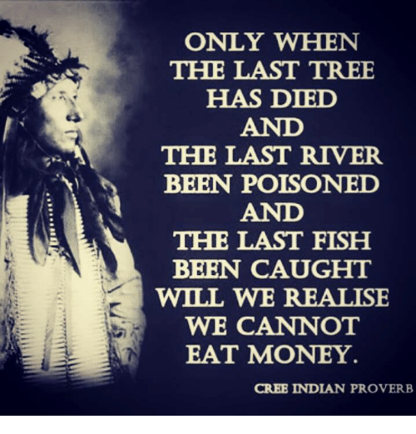

Speciesism, for me, has huge flaws. The interconnected nature of our existence on earth, is greater than simplistic hierarchy. We stand to learn the hard way that all species co-exist in a carefully balanced eco system where all play a vital role in the earths maintenance. We all require the same elements to sustain us, we all share the same the need for quality access to air, water and nutrients. If we pollute the air, soil or the water, it is polluted for us all. If we can’t make this link between the earth we all live on an the impact of our actions effecting us all, then we miss the point of what it is to survive entirely. It’s not a question of a species being greater or more important. It’s a fact that we all live, breathe and rely on the same earth’s resources.

That said more people that ever seem to be talking about this, and the more we talk the further our voices reach, and the closer change becomes. Our impact on the planet and our intrinsic relationship with other species during this age of the Anthropocene in more important that ever. Voices are becoming louder and understandings deeper. Macdonald’s even made the switch to Organic milk in recent years. I have to say, however, that I don’t buy the notion that they have found a conscience, its more likely they jumped on the marketing bandwagon since tipping your hat to the ecological crisis we face has become somewhat fashionable and something consumers are increasingly drawn to. It strikes me thought that the biggest issue we are up against as humans is changing our behaviours. Purchase power is a powerful tool, and in the case of the switch to Organic milk, MacDonald’s played it spectacularly. The Mcdonalds stunt however, is just that, a ploy to make us feel better about our consumerism, without us having to change our behaviours. We want to feel like we are making reasonable choices and ease our guilt, but its juts a drop in the ocean when the burger you purchase along side the extra milky coffee has been responsible for the suffering and devastation linked to intensive farming. I feel some hard decisions are going to have to be made by humans, before the decisions are made for us. Without more joined up thinking and realisations that all species are intrinsically link, we may not be in time to acknowledge the devastation our planet faces in the age of the Anthropocene. Perhaps only then will we realise we were too late.
Our practice today impacts the world we live in tomorrow, regardless of species, we all live on the same spherical ball on the same lands, with the same amount of resource. Whether the environmental or ethical aspects of intensive farming speaks loudest, I feel both issues are intrinsic to the understanding that ‘Only when we have caught our last fish and polluted our own waters will we realise we can’t eat money’ (Cree Indian proverb) and speciesist practices such as factory farming, undermine such an understanding, thwarting the interests of humans, animals and the environment.

Reference List

Diamond. J, 1987, The Worst Mistake in the History of the Human Race.

Plotczyk. L, 2020, Is Specieism Driving the Coronavirus Pandemic? Is Speciesism Driving the Coronavirus Pandemic? (sentientmedia.org).

Nelsen. A, 2017, Burger King animal feed sourced from deforested lands in Brazil and Bolivia, Guardian Newspaper, Burger King animal feed sourced from deforested lands in Brazil and Bolivia | Food | The Guardian.

Singer. P, 1979, ‘Equality for Animals’ in Practical Ethics, Cambridge University Press, Cambridge.

‘Only when we have caught our last fish and polluted our own waters will we realise we can’t eat money’ (Cree Indian proverb)

