
Module Name: Marketing Management
Module Code: LCMB7024
Topic: Marketing Environment Analysis and Strategic Growth for BHP's Transition to A Lower-Carbon Business Model
Student Name: Savitri Gorkha
Student Id: 2538796

Table of Contents
Task 1: Marketing Environment Analysis 3
1.1 Company Selection and Context 3
1.1.1 Overview of BHP 3
1.1.2 BHP's Sustainability and Decarbonisation Journey 3
1.2 External Marketing Environment Actor 1: Natural Environment 5
1.2.1 Influence of the Natural Environment on BHP's Marketing Strategy 5
1.2.2 Natural Environment-Driven Opportunities and Threats 5
1.3 External Marketing Environment Actor 2: Technological Environment 6
1.3.1 Impact of Technological Advancements on BHP's Marketing Environment 6
1.3.2 Technology-Related Opportunities and Threats 7
Task 2: Strategic Growth and Competitive Positioning 8
2.1 Strategic Growth Recommendation through the Ansoff Matrix 8
2.1.1 Analysing The Growth Options Through the Ansoff Matrix 8
2.1.2 Product Development as the Preferred Growth Strategy 9
2.1.3 Addressing Environmental Challenges Through Strategic Growth 10
2.2 Competitive Advantage Through a Lower-Carbon Business Model 10
2.2.1 Developing a Lower-Carbon Business Model 10
2.2.2 Competitive Strategy Based on Porter's Generic Strategies 12
2.2.3 Critical analysis 13
Task 3: Critical Reflection on AI Usage 13
3.1 AI Tool Disclosure 13
3.2 Evaluation of AI-Generated Outputs 13
3.3 Assessment of AI and Personal Contributions 14
3.4 Ethical and Professional Reflection on AI Use 14
References 15
Appendix 1: Jansen project 19

Task 1: Marketing Environment Analysis

1.1 Company Selection and Context

1.1.1 Overview of BHP
BHP is one of the world’s largest diversified mining organisation which, headquartered in Melbourne, Australia, with operations across Australia, the Americas and Asia, employing more than 90,000 employees (BHP, 2026). The company is a leading producer of iron ore, copper, nickel and potash, supplying critical minerals that support the infrastructure, renewable energy and ultimately electric vehicles industries. Owing to its large-scale business operations, strong financial performances alongside an extensive global network, BHP has established a leading position within the global metals and mining sector. As the demand for critical minerals continues to grow, BHP plays a pivotal role across supporting the global energy transition as well as sustainable economic development.
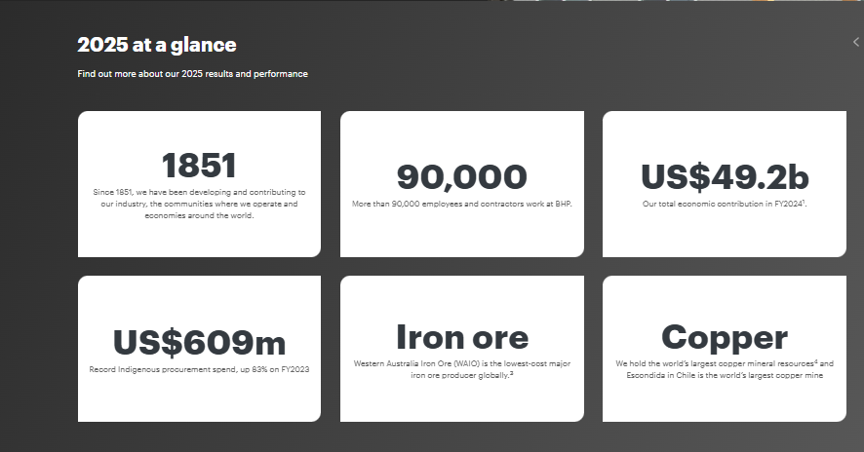

Figure 1: Company statistics
(Source: BHP, 2025)

1.1.2 BHP's Sustainability and Decarbonisation Journey
BHP has embedded sustainability within its corporate strategy through prioritising decarbonisation, along with responsible resource development.
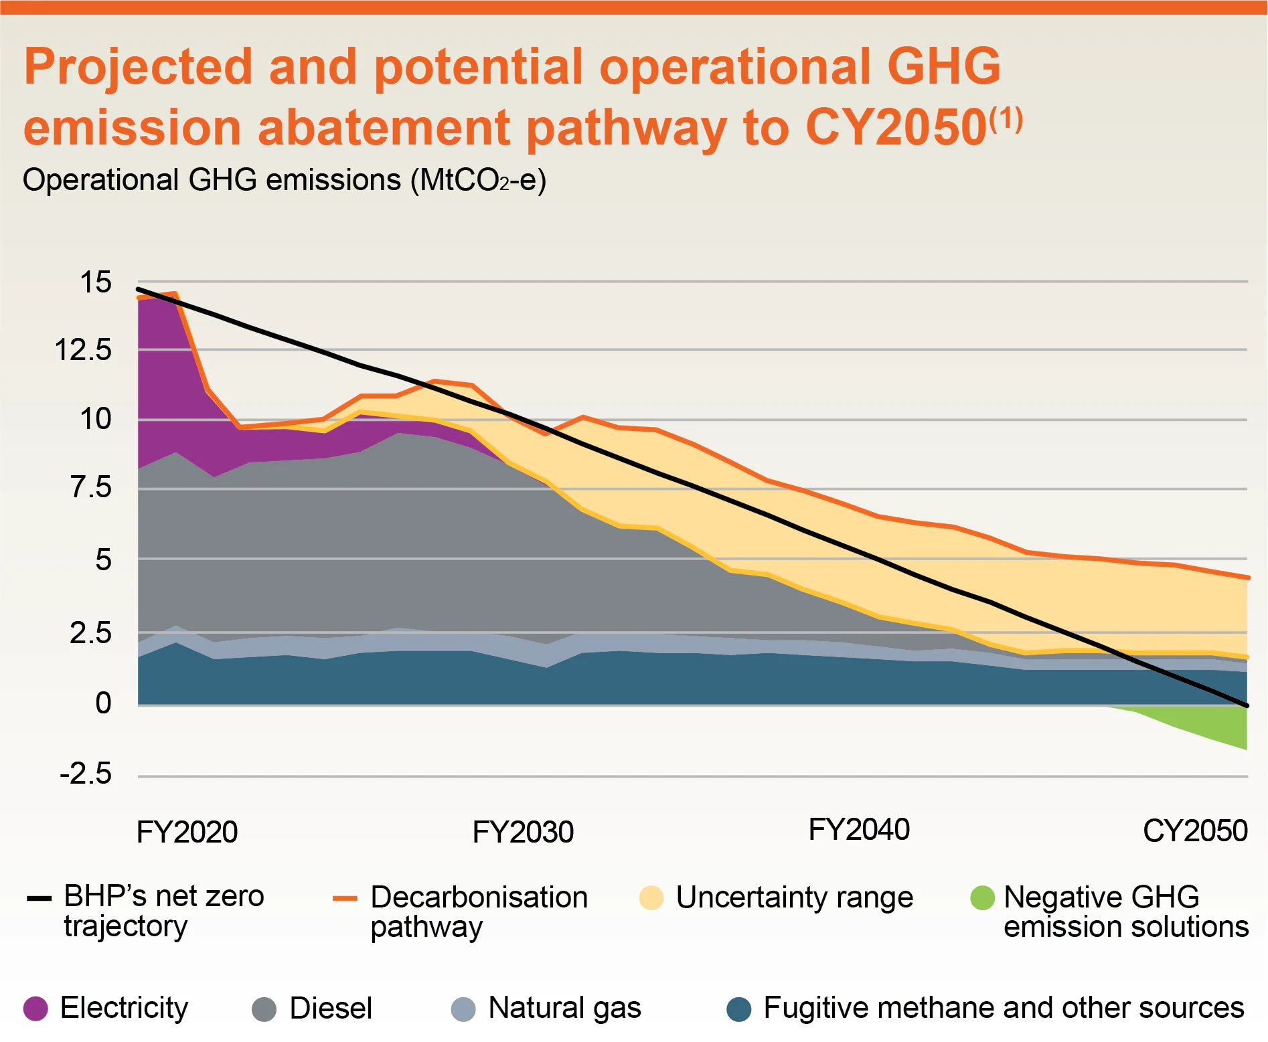

Figure 2: Operational GHG emissions of BHP
(Source: BHP, 2026)
The organisation has committed to attaining net-zero operational greenhouse gas emissions (Scope 1 and 2) by the end of 2050 and also established a medium target of at least a 30% reduction across operational emissions through FY2030 from FY2020 levels (BHP, 2026). In the financial year 2025, approximately 42% of BHP’s operated electricity demand has been supplied from renewable sources, supported through long-term renewable power agreements across Australia and Chile as well (BHP, 2025). In addition, BHP is investing in mine electrification, low-emission haulage technologies and ultimately partnerships to lower the emissions across the steelmaking value chain and thus strengthening its transition towards a lower carbon business model.

1.2 External Marketing Environment Actor 1: Natural Environment

1.2.1 Influence of the Natural Environment on BHP's Marketing Strategy
The natural environment is the dominant external marketing environment actor which significantly influences the strategic transition of BHP towards a lower-carbon business model because environmental pressures increasingly determine market demand, regulatory expectations, as well as preferences of the stakeholders. Rising global decarbonisation efforts have intensified the demand for critical minerals, specifically copper and nickel, positioning BHP to gain advantages from expanding renewable energy as well as electric vehicle markets. This opportunity is reflected across copper, contributing approximately 51% of BHP’s underlying EBITDA in the financial year 2025, thus reinforcing the commercial value of its lower-carbon commodity portfolio (BHP, 2026).
However, these opportunities are not without challenges. Climate change has intensified the water scarcity along with extreme weather events across key operations across countries like Australia and Chile, and thus maximised both operational threats as well as overall costs of production. In addition, attaining the targets of BHP of at least a 30% reduction within the operational greenhouse gas emissions by the end of 2030, despite reaching a 24% reduction by the year 2025, requires substantial investment of capital across renewable electricity, fleet electrification in combination with emissions-reduction technologies (BHP, 2024). Therefore, it can be asserted that though the natural environmental pressures create significant opportunities for growth for the company, they simultaneously impose organisations towards financial as well as operational constraints which requires sustained strategic adaptation.

1.2.2 Natural Environment-Driven Opportunities and Threats
The lower-carbon transition of BHP presents notable market opportunities through maximising the global demand for both nickel and copper, driven by not only renewable energy infrastructure but also electric vehicle production. Moreover, the company’s investment in renewable electricity in combination with low-emission technologies not only strengthens its ESG credentials but also enhances access towards sustainability-focused investors and long-term customer partnerships (Ahmad et al., 2025).
However, these opportunities are balanced by substantial threats. Strict carbon regulations, the growing compliance costs and the climate-related operational disruptions maximise the financial pressures on different mining activities. Furthermore, attaining decarbonisation targets of BHP requires continuous investment of capital within the emerging technologies and thus creates uncertainty concerning both cost recovery and future profitability as well. In essence, it can be asserted that managing the competitive edge completely relies on balancing the sustainability investments with operational effectiveness and financial adaptability as well.

1.3 External Marketing Environment Actor 2: Technological Environment

1.3.1 Impact of Technological Advancements on BHP's Marketing Environment
The technological environment is a crucial external marketing actor that influences the competitive edge of BHP through allowing lower-carbon mining while maximising the investment as well as implementation challenges. Research work by Aithal (2023) cited that technological innovation allows firms to respond to changing market demands through enhancing operational effectiveness while supporting the sustainable value creation.
This mining company has accelerated its technological innovation through autonomous haulage systems, digital asset management, in combination with renewable energy integration in order to improve the operational effectiveness while lowering the rates of emissions. As an example, this mining organisation is trialling battery-electric haul trucks and has also partnered with Komatsu and Caterpillar in order to develop the zero-emission mining fleets which support its emission reduction targets for 2030 (Pollard and Buckley, 2025). Simultaneously, BHP has expanded predictive analytics as well as automation across its Western Australian Iron Ore operations, which assisted in boosting the level of operational productivity while diminishing the energy consumption. However, Kejriwal (2023) argued that these technologies require substantial capital expenditure and they remain commercially immature. Thus, it can not only delay the large-scale deployment but also develop a sense of uncertainty regarding the investment returns. As a result, it can be exemplified that though technological innovation fortifies the sustainability credentials of BHP along with operational effectiveness, its competitive value relies on profoundly balancing the innovation advantages against implementation costs, technological risks and ultimately long-term financial viability.

1.3.2 Technology-Related Opportunities and Threats
BHP’s technological investment offers significant opportunities to fortify both sustainability performances as well as operational effectiveness. Moreover, the strong partnerships with Komatsu and Caterpillar to build battery-electric haul trucks support its targets of lowering operational emissions by replacing the diesel-powered mining fleets. Besides that, the expansion of the autonomous haulage systems within its Western Australian Iron Ore (WAIO) operations has significantly enhanced the productivity, equipment utilisation and safety, thus enabling the organisation to improve its cost competitiveness while guiding its lower-carbon strategy (Pant, 2026).
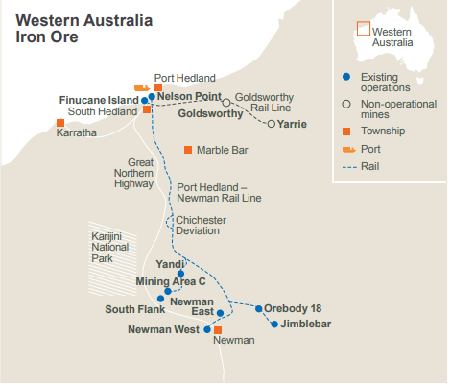

Figure 3: Western Australia Iron Ore (WAIO)
(Source: BHP, 2025)
Despite these significant advancements, BHP acknowledges that battery-electric haul trucks along with other zero-emissions technologies, have not yet reached their full commercial maturity and thus created a sense of uncertainty regarding the large-scale implementation (Leonida, 2022). Additionally, the company recognise that attaining its FY2030 emissions reduction targets relies on both external technology providers as well as renewable energy infrastructures and thus maximising the capital investment requirements while exposing BHP towards supply chain and technology adoption risks.

Task 2: Strategic Growth and Competitive Positioning

2.1 Strategic Growth Recommendation through the Ansoff Matrix

2.1.1 Analysing The Growth Options Through the Ansoff Matrix
Developing on the natural and technological pressures identified across Task 1, the strategic growth of this mining company increasingly depends on expanding the lower-carbon mineral products instead of solely depending on the conventional mining operations.
According to Ansoff organisational growth can be attained successfully through four strategic options such as market penetration, market development, product development and finally diversification (Zugay and Zakaria, 2023). However, Oladele (2025) contends that strategic growth needs to also respond to external environmental pressures, specifically within industries which experiencing both regulatory as well as technological disruptions.
This perspective better highlights the current business strategy of BHP. Market penetration is constrained through mature ore markets, while market development presents limited additional value because of the global presence of BHP. Moreover, diversification into unrelated industries will maximise the investment risks and thus dilute the core competencies. Instead, BHP has prioritised expanding its Escondida copper operations, progressing the US$5.7 billion Jansen Potash Project and also investing across nickel production, commodities which are not only pivotal for renewable energy, but also for electric vehicles and sustainable agriculture as well (BHP, 2023) [refer to Appendix 1].

Figure 4: Ansoff Matrix
(Source: Self-developed)
Therefore, product development represents the most suitable Ansoff Strategy as it closely utilises the existing mining capabilities of BHP while directly responding towards the environmental sustainability demands and future market growth as well.

2.1.2 Product Development as the Preferred Growth Strategy
Though product development is an effective growth strategy for organisations seeking expansion through new offerings within the existing markets, its linear perspective presumes comparatively stable market conditions. However, Trisiana (2024) argues that strategic choices need to be driven by dynamic external pressures, specifically sustainability as well as technological disruption. The strategic direction of BHP supports this latter view. Rather than pursuing market penetration across mature iron ore markets or high-risk diversification, BHP is expanding its Escondida copper operations, advancing the Jansen Potash Project and ultimately investing a heavy amount of capital across Nickel West to cater for the accelerating demand for the critical minerals utilised in both electric vehicles and renewable energy (Smith and Wentworth, 2022). Therefore, it can be asserted that development is not merely a growth option but a strategic response towards decarbonisation, thus allowing BHP to effectively utilise its existing mining capabilities while fortifying its long-term competitiveness within the low-carbon economy.

2.1.3 Addressing Environmental Challenges Through Strategic Growth
Product developments represent the most effective response by BHP to the environmental pressures identified across Task 1 because it converts both the regulatory and climate-related constraints into commercial opportunities with the help of critical minerals. Moreover, expanding the copper and potash production directly addresses accelerating demand driven through both electrification and renewable energy, while investments across lower-emission mining technologies lower the operational carbon intensity. However, this strategy also maximises the capital commitments as well as technology dependence, which means its long-term success will rely on balancing the sustainability investment with not only operational profitability but also execution capability.

2.2 Competitive Advantage Through a Lower-Carbon Business Model

2.2.1 Developing a Lower-Carbon Business Model
The competitive advantages of BHS increasingly rely on successfully embedding decarbonisation throughout its value chain instead of completely increasing the production of critical minerals. The company has established a strategic business collaboration with HBIS POSCO and China Baowu to intensify lower-carbon steelmaking, and thus allowing BHP to fortify its long-term customer relationships while supporting the net-zero ambitions of the customers (BHP, 2024).
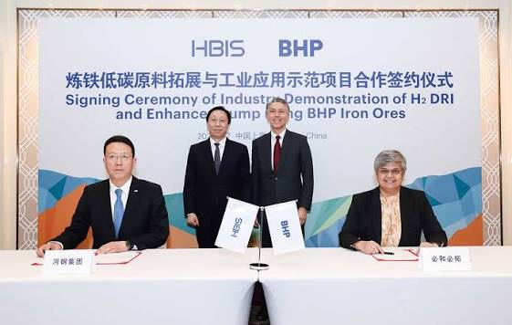

Figure 5: Partnerships of BHP and HBIS
(Source: HBIS, 2023)
In parallel, autonomous mining systems in combination with battery-electric haul truck trails enhance the level of productivity while diminishing the operating costs and thus create a sense of value beyond environmental compliance. However, these collaborative innovations require sustained investment and it rely on the willingness of the customers to adopt the emerging technologies. As a result, it can be exemplified that, BHP’s competitive advantages will be determined not only by its resource base but by its capability to commercialise low-carbon solutions faster than competing miners.

2.2.2 Competitive Strategy Based on Porter's Generic Strategies

Figure 6: Porter’s Generic strategy
(Source: Self-developed)
Historically, BHP has managed cost leadership through the help of large-scale mining operations, high-quality resource assets and effective supply chain integration and thus allowing competitive production costs. However, this advantage is increasingly challenged through rising carbon adherence costs alongside competitors investing within the similar operational effectiveness. As a result, BHP is strengthening its differentiation through supplying responsibly sourced critical minerals as well as collaborating with steelmakers to develop lower-carbon production pathways and thus creating value beyond price competition (Marfo-Yiadom et al., 2025). However, sustaining this business position requires both significant investment as well as continues innovation. Therefore, it can be asserted that BHP’s competitive advantages are best characterised through a hybrid strategy by amalgamating operational effectiveness with lower carbon differentiation to manage the adaptability alongside long-term competitiveness across a rapidly changing mining industry.

2.2.3 Critical analysis
Though operational effectiveness fortifies the cost competitiveness of BHP, it is unlikely to remain a sustainable source of advantage because competing mining firms continue to embrace similar technologies as well as decarbonisation initiatives. On the flip side, differentiation through the help of both lower-carbon products and collaborative value-chain innovation creates profound long-term value through addressing the changing expectations of the customers. However, differentiation also requires substantial investment, and it can expose the BHP towards technological uncertainties. As a result, BHP’s long-term competitiveness will rely on balancing cost-effectiveness with consistent innovation and thus allow the organisation to create value which is not only economically resilient but also environmentally sustainable.

Task 3: Critical Reflection on AI Usage

3.1 AI Tool Disclosure
During the preparation of this report, ChatGpt has been used as the main strategic tool. This tool assisted me to develop new ideas, enhance my sentence structures, refine the academic writing and ultimately organise the different sections of the report. This tool also utiliser to explain the marketing frameworks, incorporating the Ansoff Matrix and Porter's Generic Strategies. However, the final report has not been copied directly from AI. besides that, different company data, academic sources, and critical analysis has been selected, examined and written independently to ensure that the work reflected my own understandings on meeting the requirements of the assessments.

3.2 Evaluation of AI-Generated Outputs
All AI-developed information has been checked thoroughly before incorporating within the business report (Nwozor, 2025). Besides that, company-related information has been verified carefully through leveraging the Annual Report of BHP, sustainability reports and other useful sources. Moreover, different academic concepts like decarbonisation strategy, cost leadership, and low-carbon business model have been confirmed through utilising the journal articles and textbooks as well. In addition, any incorrect or outdated information which has been generated by AI has been removed from the report. These procedures ensured that the report contained accurate along with reliable, and credible information while managing the academic quality while lowering the risk of factual errors.

3.3 Assessment of AI and Personal Contributions
The use of this strategic tool profoundly supported the report through brainstorming, enhancing the writing quality, and ultimately suggesting a logical structure. However, the selection of evidence, critical interpretation of the company data, comparison of the academic literature, and ultimately the critical analysis has been completed independently. Moreover, the final arguments, recommendations, as well as the justification have been based on my own understanding of the context after reviewing the company reports and different academic resources.

3.4 Ethical and Professional Reflection on AI Use
The effective use of AI within the academic work provides significant advantages, but it also creates ethical and professional responsibilities. AI enhanced the overall effectiveness of this business report through supporting the development of ideas, refinements of language and ultimately organisations of the report. However, the excessive dependence on AI can not only lowers the independent critical thinking but also result across inaccurate, biased or finally unsupported the information (Zhai et al., 2024). To manage the academic integrity of the report, all AI-generated content has been verified profoundly through using the reports of BHP and other recognised academic textbooks before inclusion. As a future marketing professionals, I recognise that ethical use of AI requires a sense of transparency, responsible judgement, critical evaluation and finally strict adherence with both academic as well as professional standards to assure credible and evidence based decision-making.

References
Ahmad, F., et.al, (2025) ‘A detailed comprehensive role of digital technologies in green finance initiative for net‐zero energy transition’, Advanced Energy and Sustainability Research, 6(10), p. 2500066. Available at: https://advanced.onlinelibrary.wiley.com/doi/pdfdirect/10.1002/aesr.202500066.
Aithal, P.S. (2023) ‘How to create business value through technological innovations using ICCT underlying technologies’, International Journal of Applied Engineering and Management Letters (IJAEML), 7(2), pp. 232–292. Available at: https://papers.ssrn.com/sol3/Delivery.cfm?abstractid=4541179.
BHP (2023) BHP approves US$4.9 billion investment in stage two of Jansen potash project. Available at: https://www.bhp.com/news/media-centre/releases/2023/10/bhp-approves-investment-in-stage-two-of-jansen-potash-project (Accessed: 15 July 2026).
BHP (2024) BHP and HBIS Strengthen Partnership with New MOU to Advance Decarbonisation in Steel Value Chain. Available at: https://www.bhp.com/news/media-centre/releases/2024/12/bhp-and-hbis-strengthen-partnership-with-new-mou-to-advance-decarbonization-in-steel-value-chain (Accessed: 15 July 2026).
BHP (2024) Climate Transition Action Plan. Available at: https://www.bhp.com/-/media/documents/investors/annual-reports/2024/240827_bhpclimatetransitionactionplan2024.pdf (Accessed: 15 July 2026).
BHP (2025) About us. Available at: https://www.bhp.com/about (Accessed: 15 July 2026).
BHP (2025) Annual Report 2025. Available at: https://www.bhp.com/-/media/documents/investors/annual-reports/2025/250819_bhpannualreport2025.pdf (Accessed: 15 July 2026).
BHP (2026) Decarbonisation: Why our emissions reduction pathway is not a smooth nor straight line. Available at: https://www.bhp.com/news/articles/2023/10/decarbonisation-why-our-emissions-reduction-pathway-is-not-a-smooth-nor-straight-line (Accessed: 15 July 2026).
BHP (2026) Financial results for the half year ended 31 December 2025. Available at: https://www.bhp.com/-/media/documents/media/reports-and-presentations/2026/260217_bhpresultsforthehalfyearended31dec2025_exchangerelease.pdf (Accessed: 15 July 2026).
BHP (2026) Our businesses. Available at: https://www.bhp.com/about/our-businesses (Accessed: 15 July 2026).
HBIS (2023) HBIS & BHP Signed Carbon Reduction Experiment Agreement in Steel Industry. Available at: https://www.hbisco.com/en/news/group/t101/2279 (Accessed: 15 July 2026).
Kejriwal, M. (2023) Artificial Intelligence for Industries of the Future. Cham: Springer International Publishing. Available at: https://link.springer.com/content/pdf/10.1007/978-3-031-19039-1.pdf.
Leonida, C. (2022) ‘Powering Trucks for the Long Haul’, Engineering and Mining Journal, 223(5), pp. 20–25. Available at: https://search.proquest.com/openview/afbe9fb5ef81678221e4471d13d50f03/1?pq-origsite=gscholar&cbl=39.
Marfo-Yiadom, E., et.al, (2025) ‘Efficacy of the Porter’s generic strategies in achieving competitive advantage: The mediating roles of market ambidexterity and firm performance’, Journal of Business and Enterprise Development (JOBED), 13(2). Available at: https://journal.ucc.edu.gh/index.php/jobed/article/download/1753/849.
Nwozor, A. (2025) ‘Artificial intelligence (AI) and academic honesty-dishonesty nexus: Trends and preventive measures’, AI and Ethics, Academic Integrity and the Future of Quality Assurance in Higher Education, 27(3). Available at: https://www.researchgate.net/profile/Mamman-Muazu-2/publication/384969429_AI_and_EthicsAcademic_integrity_and_the_future_of_Quality_Assurance_in_Higher_Education_Hand_Book_on_AI_and_Quality_Higher_Education_in_Honour_of_Prof_Abubakar_Adamu_Rasheed_Volume_3/links/67655ce3117f340ec3cf7d14/AI-and-Ethics-Academic-integrity-and-the-future-of-Quality-Assurance-in-Higher-Education-Hand-Book-on-AI-and-Quality-Higher-Education-in-Honour-of-Prof-Abubakar-Adamu-Rasheed-Volume-3.pdf#page=288.
Oladele, O.K. (2025) The Role of Strategic Planning in Managing Technological Disruptions in Business. Available at: https://www.researchgate.net/profile/Oluwaseyi-Oladele-3/publication/389287926_The_Role_of_Strategic_Planning_in_Managing_Technological_Disruptions_in_Business/links/67bd65c6645ef274a49414a0/The-Role-of-Strategic-Planning-in-Managing-Technological-Disruptions-in-Business.pdf.
Pant, P. (2026) ‘Empowering Sustainability Through Digital Transformation’, in Multimedia and AI Applications for Sustainable Smart Mining and Energy. Hershey, PA: IGI Global Scientific Publishing, pp. 517–548. Available at: https://www.igi-global.com/chapter/empowering-sustainability-through-digital-transformation/402955.
Pollard, M. and Buckley, T. (2025) Transition Tax Incentive: Reforming Fuel Tax Credits into a Decarbonisation Tailwind. Available at: http://climateenergyfinance.org/wp-content/uploads/2025/08/CEF_Transition-Tax-Incentive-Report-FINAL_20August2025.pdf.
Smith, D. and Wentworth, J. (2022) Mining and the Sustainability of Metals. London: Parliamentary Office of Science and Technology, UK Parliament. Available at: https://figshare.le.ac.uk/ndownloader/files/33988796.
Trisiana, A. (2024) ‘A Sustainability-Driven Innovation and Management Policies through Technological Disruptions: Navigating Uncertainty in the Digital Era’, Global Perspectives in Management, 2(1), pp. 22–32. Available at: https://gpim.in/index.php/journal/article/download/GPM24103/102.
Zhai, C., Wibowo, S. and Li, L.D. (2024) ‘The effects of over-reliance on AI dialogue systems on students' cognitive abilities: A systematic review’, Smart Learning Environments, 11(1), p. 28. Available at: https://link.springer.com/article/10.1186/s40561-024-00316-7?fbclid=IwZXh0bgNhZW0CMTEAAR5nkxIdDLo8CdVygkPcbDQO7Tw9yMR1_EgHAElbgowcEB2XoCPscDA4bk47Sw_aem_TwS9UfH378qH6RPQzO9pUg
Zugay, B. and Zakaria, R. (2023) Ansoff Matrix. Thousand Oaks, CA: SAGE Publications. Available at: https://sk.sagepub.com/foundations/ansoff-matrix?tab=Theory+In+Practice.

Appendix 1: Jansen project
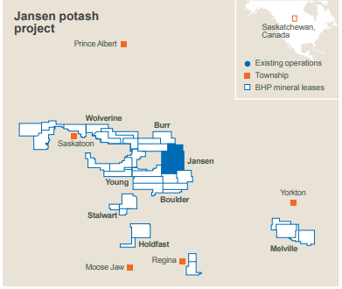
(Source: https://www.bhp.com/-/media/documents/investors/annual-reports/2025/250819_bhpannualreport2025.pdf)

