
A report on communication within the workplace


December 10, 2021
University of Wales Trinity Saint David

Andreea Loredana Mirica (2028692)
UWTSD
10.12.2021
Word count: 2069

Executive Summary

The report started with an overview of the actual situation of Andrea Jones’s retail store in Swansea. It showed problems such as no formal teams, no meetings, no leadership. The report was focused on finding solutions for these problems. The first part was focused on teamwork and how this can be improved using theories such as Tuckman and Belbin. Tuckman showed that the team is caught between the first and the second stage and Belbin showed that there are no clear roles for any of the employees. The second part of the report was focused on communication and three main theories: Shannon Weaver, Berlo and Schramm. It was concluded from this that Shannon Weaver and Berlo are not suitable theories to the case, as they only promote a one-way communication. Schramm was found to be the best theory for the case as a two-way communication is much needed in the store. Lastly, the benefits of an effective team were highlighted, such as increased productivity and the wellbeing of the employees.

The report ended with conclusions and a list of recommendation for Andrea, which included regular meetings, establish each member’s role by using the Belbin questionnaire attached and create an inclusive training program for new joiners, all of these with the main goal of creating an effective teamworking environment in Andrea’s store.

Table of Contents
Executive Summary 1
Terms of Reference 3
Procedure 3
Introduction 4
Findings 5
Conclusion 10
Recommendations 11
Bibliography/References 12
Appendices 13

Terms of Reference

The report on Communication within the workplace was requested by Melanie Squire, who is the lecturer for the Effective teamwork and communication course at University of Wales Trinity Saint David. It is due to be submitted on the 10th of December, and it was submitted by Andreea Loredana Mirica who has the student number 2028692.

The report is focused on finding solutions for Andrea Jones’ company who grew from 5 employees to 27 in a short time and doesn’t have a communication strategy within the team. Firstly, the report will show how theories like Tuckman and Belbin are relevant and can improve the teamwork in Andrea’s case, then, the report will prove the importance of a two-way communication using relevant teamwork theories, explaining why the effective teamwork is important in any organisation. Finally, the report will end with a few recommendations that can solve Andrea’s current problems.

Procedure

The report’s content is based on knowledge provided from books, academic articles, case studies, and relevant websites.

Introduction

The case study represents a medium sized retail store in Swansea who currently has 27 employees who mostly provide online services to its customers. Out of 27 employees, one is out of office due to sickness, and it is expected to be a long-term leave, and majority of others are working part-time shifts or overnight. While there are usually 8 employees in store at any time, the overnight staff doesn’t have a manager to look after them during those hours. Moreover, the teams are not clearly defined, there are no training programmes for the new joiners and the meetings are not regularly, but ad hoc and without all the employees, which affects the way the information is distributed within the team.

Within the report findings, there will be two parts: the first part will focus on teamwork theories, while the second will be more focused on the communication aspect. In the first part, the purpose will be to determine at what Tuckman stage is the team in present, and how is Belbin’s theory applied to the case study. These two will highlight the importance of teamwork at the workplace at how they can help improving the teamwork. The second part will use Shannon-Weaver, Berlo and Scramm theories to show how a two-way communication within the team can improve the store as a whole and will explain the importance of effective team working and communication, as well as giving recommendation that can be followed to reach the full potential of the staff.

Findings

Area 1 - Teamwork
It is clear that the retail team presented in the case study does not work entirely as a team, but more as a group, because even though they work for the same place and have the same targets, the staff is working randomly, they have meeting once in a while and only with the team members available at that moment, the others being left outside, and this can cause multiple consequences, as not having a fully productive team or conflict within the store due to lack of communication. There are a couple of theories that focus on teamwork and its improvement. One on these is Tuckman’s theory which is focused on the natural stages of a team from the formation until the most productive state (Stein, 2021). Tuckman’s stages of development is an important theory because every stage has specific actions, and it is important to recognise those because in this way it will be easier for managers to understand what needs their team has and how to fulfil those in order to move to the next stage, until they will finally achieve the 5th stage, which is called Performance and it is considered to be the goal (Jones, 2019).
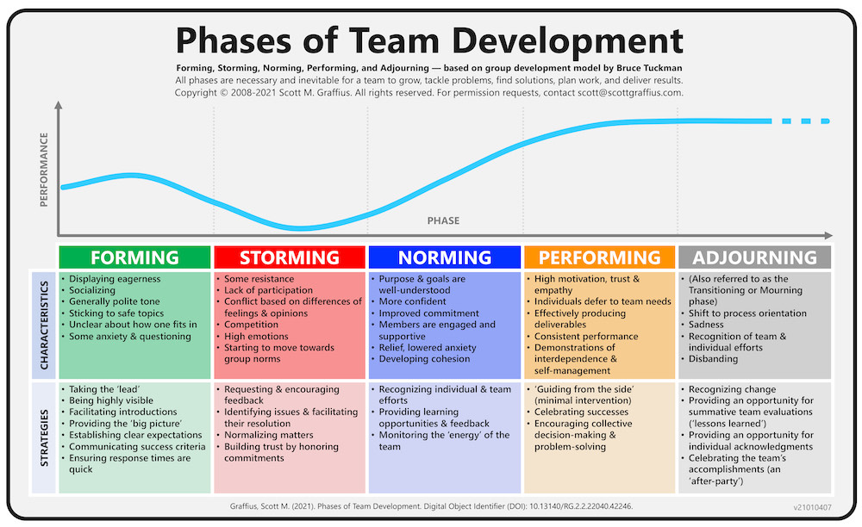
Based on the specific of each stage, the team from the case study is more than likely to be caught between the Forming and Storming stage. The arguments for that are that the staff is lacking a proper split in between teams, lack a clear objective other that doing the job, the communication is mainly non-existent and there are no remarkable leaders, especially for the night shift. According to Nielsen and Randall (2012), the forming stage is it the most important stage, but often managers are focusing mainly on the storming stage to try to solve conflicts. At the same time, the forming stage is being seen as the base of the team, and the base must be the strongest because everything is built from that. By applying Tuckaman’s theory, Andrea Jones will be able to build a strong base of the team and it will be easier to face whatever challenge might appear, as she will have clear strategies to get through each stage and become fully productive.
Meanwhile, while Tuckman’s theory is focused on the team as a whole, another theory is focused on each individual and its role within the team. Belbin’s theory represents 9 main roles that a person can have while being part of a team and it is used to identify the strengths and the weaknesses of a team in order to avoid liability and increase the productivity by using each person’s full potential (Belbin, 2021). The theory uses a questionnaire, available in the first Appendix of the report to determine what kind of roles does a person have, based on their answers.
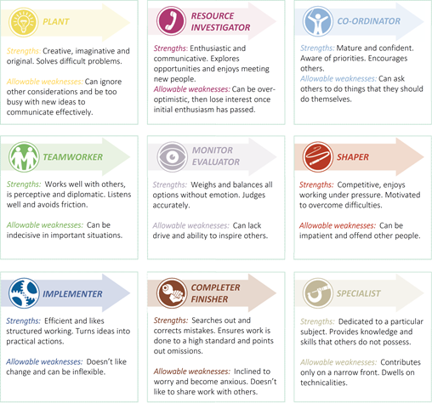

It is not mandatory for a team to have all 9 roles, as one person might have 2-3 roles that they can own, but it is important to note that every role has its own value within the team, as well as strengths and weaknesses (Belbin, 2021). The Belbin’s theory is important for teamwork because it helps managers recognise the abilities of every employee that is part of a team and they can form teams based on their abilities, to make sure that they strengths and weaknesses are complementary and that the conflicts are minimised (Gutierrez et al. ,2018). In Andrea’s case, as there are no formal teams, knowing each staff’s strengths and weaknesses will be helpful in forming the much-needed teams in a way that they can be productive and not conflictual.

Area 2 -Communication
Based on the information from the case study, it is noticeable the fact that there are no regular meetings and when these do happen, some participants are missing almost every time, making the communication faulty and the information cannot be transmitted to all the employees. For this, it is mandatory to create a way of communication that will allow both managers and employees to share information and ideas. This is also known as a two-way communication and its importance is that the managers can share information with the team, which is beneficial especially if there are procedural changes, but, at the same time, employees can also share feeling, feedback, and concerns, which will overall improve the atmosphere at work and also the productivity (mHub, 2019). To identify the best way to create a two-way communication within the team, three theories will be proposed and analysed to identify which one is the most suitable in the case study.
The first theory is the Shannon-Weaver, which is, at base, a mathematical communication theory and is mainly focused on a one-way communication, and often used when the management needs to do an official message (Chandler, 1994).
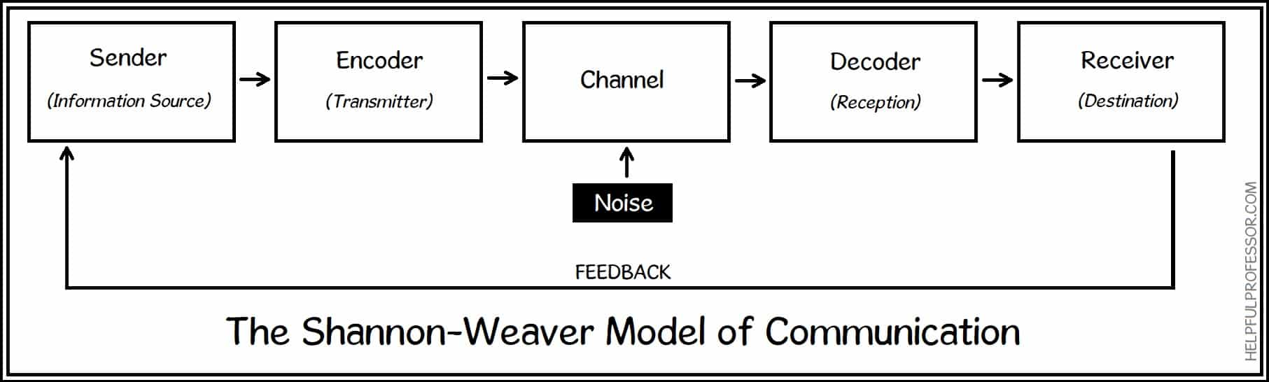
As it can be seen, the theory has many elements, but it only focuses on the initial message to be understood by the receiver, making this a one-way type of communication. The lack of feedback as an element for this theory makes it to be unsuitable for the case study, as Andrea needs to create a two-way system with the team.
Another famous theory is the Berlo theory, which suggests that any communication has 4 levels but all of them are affected by different elements (Bhasin, 2021).
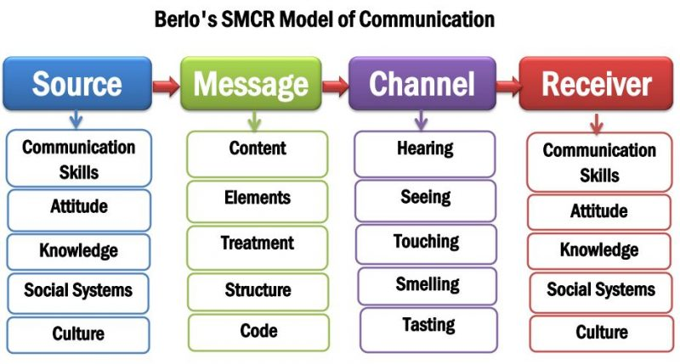
It can be easily observed that this theory does not contain any feedback and the model is not focusing on the receiver changing places with the source, making this a one-way communication theory, without considering any effect and any elements that might affect the message (Corman et al., 2007). Based on this, it is clear that Berlo’s theory is not suitable in the case study as well, as it promotes a one-way type of communication and does not care about the effects, or the opinion of the ones informed.
Lastly, the final communication theory applied to the case study is the Schramm theory, which is centred on the idea that the feedback is mandatory to make sure that the information has been correctly understood, and to overcome any irregularities that might affect the information as it is (Blythe, 2009).
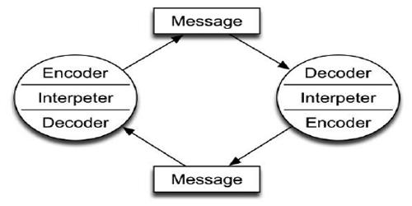
This theory promotes a two-way type of communication and considered that for an efficient communication, the feedback is extremely import in determine that the message is correct and understood, but also to check the feelings of the decoder in regard to the message and check if the ideas will work or not (Bowman, Targowski, 1987). This theory applies perfectly in the case study as it is the best way to ensure that the employees are feeling heard, as well as to make sure that the information is correctly perceived by each member of the staff, thing that caused trouble in the past. If Andrea will ensure that this theory applies in every communication, the staff attitude will considerably improve.
Effective teamwork can be provided through teamwork and communication altogether. The effective teamwork is important for a number of reasons, but, according to YTI (2015) the most noticeable are:
- Problem solving, meaning that an effective team will be keener and fast in solving problems that a non-effective team.
- Improves productivity, meaning that the conflicts will be kept at minimum and the focus will be on productivity.
- Improves morale in employees, which means that the employees will be less-stresses, will be more understood as they will be asked to constantly provide feedback and will have clear teams, goals, and expectations.
- Brings new ideas, which means that the staff will be encouraged to provide constant feedback to be able to improve the workplace.
From the case study, it is clear that the team has a few flaws and is not effective. There are no formal teams, which makes the work to be chaotic, there are no constant meeting, which means that the managers are not focused on the wellbeing of the employees, there is no training plan, which affects the process overall and it makes it unclear, and there is a lack of leadership overnight, which means that the employees are not motivated. All there affect the productivity and the organisation withing the team, which is why it is important for Andrea to start building an effective team.

Conclusion

The case study showed a team that is non effective. Andrea’s employees lacked a series of attributes, and this report was focused on providing arguments and recommendations.
It is concluded that the teamwork is extremely important for the well being of every organisation, but in the case study it is needed as soon as possible. From Tuckman’s theory, the team is somewhere between Forming and Storming stage and the Belbin’s theory showed that the roles are not fulfilled yet.
On the second part, it was showed that the two-way communication will improve the productivity and the wellbeing of the employees, and it was showed that classical theories such as Shannon Weaver or Berlo are not used in the retail store from the case study. Instead, the Schramm theory was found to be the most suitable one, as it is focused on the feedback and the correct interpretation of the message as well.
In conclusion, the store needs a lot of work to become effective, and the managers must use the information from this report to implement new strategies and to build a more effective workforce.

Recommendations

First of all, Andrea must create a meeting pattern, to ensure that the managers are constantly checking up with the staff, not only when there is something to communicate.
Secondly, it is recommended that every member of the staff to complete a Belbin’s questionnaire at one of those meeting.
After the questionnaire will be completed by everyone, based on the shift schedules and answers, the teams must become formal.
A training process must be implemented.
A manager must be present during night shifts.

Bibliography/References

- Belbin (2021) The Nine Belbin Team Roles. Available at: https://www.belbin.com/about/belbin-team-roles (Accessed: 21st of November 2021).
- Belbin (2021) Why Use Belbin Team Roles? Available at: https://www.belbin.com/belbin-for-teams/why-use-belbin-new (Accessed: 21st of November 2021).
- Bhasin, H. (2021) Berlos Model of Communication Explained. Available at: https://www.marketing91.com/berlos-model-of-communication/ (Accessed: 21st of November 2021).
- Blythe, J. (2009) Key Concepts in Marketing. Sage Publications LTD. P. 178.
- Bowman, J.P., Targowski, S. (1987) Modelling the Communication Process: The Map is Not the Territory. Available at: https://journals.sagepub.com/doi/abs/10.1177/002194368702400402 (Accessed: 21st of November 2021).
- Chandler, D. (1994) The Transmission Model of Communication. Available at: http://visual-memory.co.uk/daniel//Documents/short/trans.html (Accessed: 21st of November 2021).
- Corman, S.R., Threteaway, A., Goodall, B. (2007) A 21st Century Model for Communication in the Global War of Ideas. Arizona State University, Consortium for Strategic Communication, Report 0701, pp. 3-4.
- Gutierrez, L., Flores, V., Keith, B., Quelopana, A. (2018) Using the Belbin method and models for predicting the academic performance of engineering students. Wiley Periodicals: Chile, pp. 1-10.
- Jones, A. (2019) THE TUCKMAN’S MODEL IMPLEMENTATION, EFFECT, AND ANALYSIS & THE NEW DEVELOPMENT OF JONES LSI MODEL ON A SMALL GROUP. Journal of Management, Volume 6, Issue 4, pp. 23-28.
- mHub (2019) The importance of two-way communication. Available at: https://www.mhub.tv/importance-two-way-communication/ (Accessed: 21st of November 2021).
- Nielsen, K., Randall, R. (2012) The importance of employee participation and perceptions of changes in procedures in a teamworking intervention. Available at: https://www.tandfonline.com/doi/full/10.1080/02678373.2012.682721 (Accessed: 21st of November 2021).
- Stein, J. (2021) Using the Stages of Development. Available at: https://hr.mit.edu/learning-topics/teams/articles/stages-development (Accessed: 21st of November 2021).
- YTI (2015) REASONS TEAMWORK IS IMPORTANT IN THE WORKPLACE. Available at: https://yti.edu/blog/reasons-teamwork-is-important-in-the-workplace (Accessed: 21st of November 2021).

Appendices
- Appendix 1 – Belbin’s questionnaire


