Please delete the box below and replace it with an “appropriate” passport style photograph that clearly shows your face. Your photo should be roughly the same size as the box:

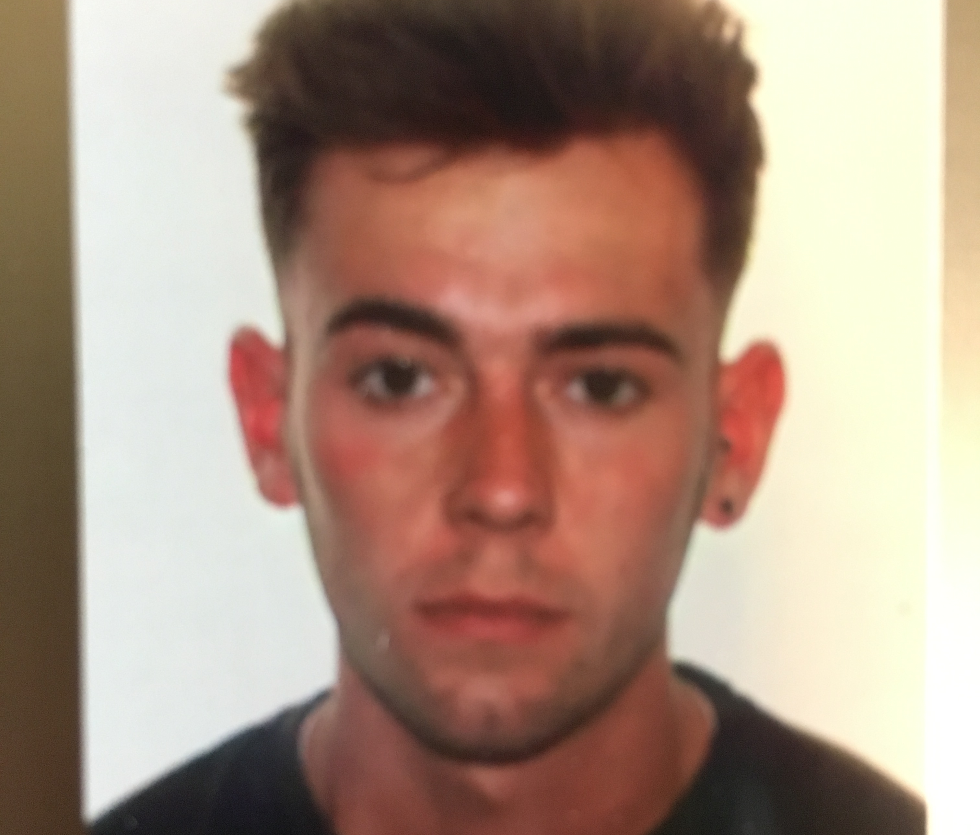

Name: Samuel Hamer

Student number: 1702615

Student email address: 1702615@student.uwtsd.ac.uk

Contact number: 07532333756

Please use the remaining space to give a brief outline of why you have chosen your course of study and any relevant special interests or experiences:

I have chosen to study the outdoor adventure education course because while I was in my first year at college I was in a lecture and a student that had done the same course as me (Uniformed public services) did a talk about her experiences at UWTSD doing outdoor adventure education. As I am an active and outgoing person that enjoys new challenges/ activities I decided to apply for the course. Over the past 3 summers I have been a lifeguard at an aqua park at SheffieldCableWaterski. This has influenced my ability to wakeboard and it is quickly becoming one of my favourite sports. This has also given me the drive to learn new activities.

