Applied Leadership and Management
Module Assignment Submission
Student Name: | Jessica Gillingham
Student Number: | 2318119
Module No: | BMSK4015
Module Title: | Academic and Research Skills

Statement of Confirmation of Authenticity
By the act of making this submission, the student declares that this is the work of the student named above. The work has not, in whole or in part, been knowingly presented elsewhere for assessment, or where assessment has been built on a previous assessment, this has been identified. Where materials have been used from other sources it has been properly acknowledged. If this statement is untrue, the student acknowledges that an assessment offense has been committed.
Attention is drawn to the plagiarism and unfair practice policies of both the University and of ILM.

Table of Contents
1 -introduction
2- what it means to manage remotely
3- Argument, Pros and Cons from working remotely
4- Action Plan & Crapp Test
6- conclusion

1.Introduction
Large companies and organizations often outsource out their teams to increase productivity and consumer satisfaction. However, managing turnovers throughout all areas can be challenging, especially when different people work on the same task from various locations (time zones) with various timelines and deadlines. Therefore, leading these teams requires skills and requirements that go beyond general organizational behaviour. This assignment focuses on the benefits of remote working as well as the negatives, how this can effect you mentally and how to have a work life balance when manging remotely.

2. What it means to manage remotely

Nowadays, working remotely is more common, and more than half of professional employees have worked from home during their careers. The trend is seeing a global increase with the effects of the Covid 19 Pandemic. Working remotely allows you to have skilled workers from across the world. Working remotely can be used for many jobs such as sales and customer service, and more. However, due to their great diversity, working remotely tends to show more conflicts within the team. This assignment describes the challenges faced by working remotely, the types of challenges what teams face, and the types of leadership skills needed by team leaders to reduce issues and gain results, trust, and confidence, and how to keep people motivated. Additionally, this review deals with the effects and causes of the performance and outcomes of leadership practices.

Remote work offers a lot of advantages , keeping overheads low, choice of a wide talent all over the world, and improved work-life balance. But with its advantages comes disadvantages.
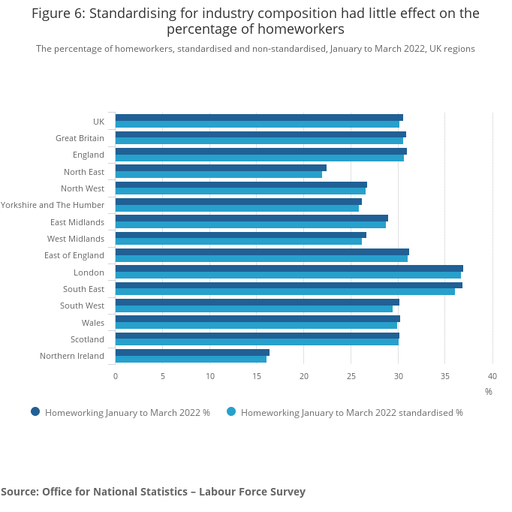

Some people may find working from home isolating and need face-to-face interaction when working remotely you relay on technology as everything is done virtually which you lose basic human skills such as body language and eye contact. A study done by Nathan found that the biggest increases in mental distress and loneliness during the pandemic were felt by those working from home. Managing this may be challenging especially if people are working towards targets in sales roles as their mood effects efficacy and ultimately targets.
Here is a graph of some of challenges that people faced when working from home.
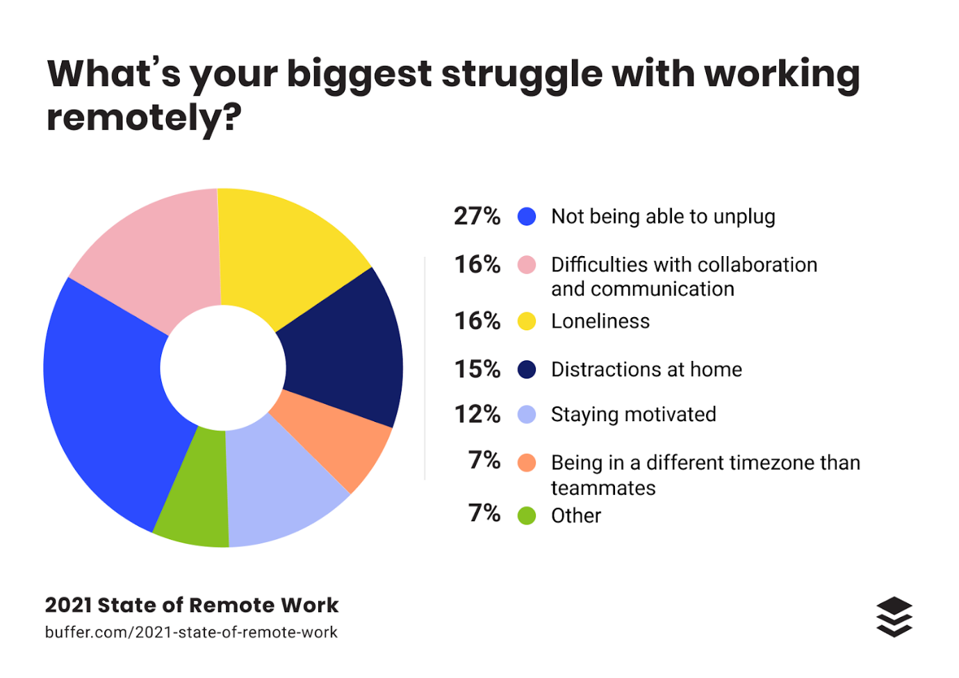The research Natcens study could be used to get team members to feel less alone and therefore be more productive when researching the benefits and negatives of working from home, the same significant negative argument that kept on coming up was isolation and people feeling lonely.
Studies have identified various leadership skills and approaches to address team conflict, such as increasing trust and motivation among team members. In virtual projects, where leaders may lose the ability to directly influence workers, information and communication tools are often used to regain that influence and improve team performance. In certain situations, virtual teams may experience emergent leadership, where active team members take on leadership roles based on the project or proposed work. Different studies have proposed several types of leadership behaviours, including transformational, transactional, and participative behaviours. Some studies have also suggested that team success is not solely the result of the team's efforts, but rather the collective influence of individual members on team performance.
strong leadership is so important when managing remotely. According to research conducted by (Rosen, Furst, and Blackburn), there are six types of leadership that virtual team leaders should adopt. These include consistently communicating via phone, email and teams. managing different ethics, cultures, monitoring team progress and giving recognition and reward for achievements, checking in, and encouraging team members to collaborate among each other. Manging remotely can be hard to motivate and encourage employees. Manging different time zones and languages cultures can be interesting but lots of challenges come with this job.
remote managing faces different obstacles compared to working face to face.
there has to be level of trust, you have to trust your workforce will be working and not be distracted. Trust works both ways but it is important to set clear instructions so everyone on the same page and the tasks and deadlines are met.
It is clear that there are a significant number of difficulties and challenges that present themselves when managing a remote team. Because of these challenges, I would make sure that there was clear instruction and would maybe look at using ‘SMART’ to reiterate the goals and what needs to be done. SMART objectives are specific, measurable, achievable, relevant, and time-bound goals that help guide individuals and teams towards success. Setting SMART objectives can provide a clear instruction :
i. Specific: Clearly define the objective
Objective: Improve team communication and collaboration when manging remotely .
- Develop a communication plan outlining the frequency and mode of communication (email, video calls, messaging platforms).
- Implement a project management tool to track tasks, deadlines, and progress updates.
- make regular team meetings to discuss project updates, challenges, and successes and appraisal .
ii. Measurable: make it clear what you need to do to succeed.
Objective: Increase team productivity by 15% within the next quarter.
- Track team productivity metrics (e.g., completed tasks, project milestones) using project management skills, learning logs.
- Conduct s feedback sessions to gather insights on team members' perceived productivity levels ask team what they need to succeed.
- observe and check data before-and-after to measure the impact of communication and collaboration and how to improve productivity.
iii. Achievable: Ensure the objective is realistic and attainable
Objective: Enhance team engagement through virtual team-building activities.
- Identify and implement two virtual team-building activities per month.
- Encourage team members to participate and provide feedback on the effectiveness of the activities.
- Adjust the frequency or format of activities based on team members' preferences and availability.
iv. Relevant: Align the objective with overall goals and priorities
Objective: Strengthen team cohesion and morale through regular recognition and feedback.
- Implement a recognition program to acknowledge team members' contributions and achievements.
- Provide constructive feedback and coaching sessions to support individual growth and development.
- Monitor team morale and engagement levels to assess the impact of recognition and feedback initiatives.
v. Time-bound: Set a specific timeframe for achieving the objective
Objective: Enhance team communication skills through virtual training sessions.
- Schedule bi-monthly virtual training sessions on effective communication techniques.
- Assess team members' communication skills before and after the training sessions.
- Set a target date for completing the training program and evaluate its impact on team communication within three months.
Project managers play an important role in the success of their teams. When teams are working virtually, face-to-face meetings using communication technology can be challenging due to the costs and time involved in travel. However, it is important for managers to effectively manage information and communication technology to regain control and improve performance in there teams. Researchers have proposed a research model to explore how technology adaption can contribute to building trust and cooperation in virtual teams. The findings suggest that frequent adoption of modern technology is important, as failure to do so can harm productivity. Therefore, leaders must effectively manage the adaptation of information and communication technology to influence team outcomes. It is also important for project managers to take a big-picture approach and avoid micromanagement in virtual projects. They should set and enforce standards, intervene when there are problems, and focus on motivating and communicating with team members. Trust is developed through guidance and feedback, not micromanagement. Overall, project leaders must have a clear understanding of the project and its objectives before selecting the necessary skills and subordinates . here is a graph that shows percentage of people who felt micromanaged.
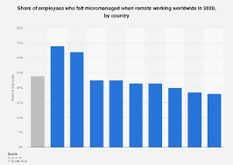
Also related to task outcomes, team member satisfaction and team member commitment is a significant consideration. The study found that shared and rotating leadership roles were common in 7 habits of highly effective people who need to research collaboration virtual teams, highlighting the importance of collaborative leadership in these contexts. Overall, the research emphasizes the need for effective leadership in self-managed virtual teams and provides insights into the behaviours and outcomes associated with leadership in these teams. As Stephen M. R. Covey puts it: “Without trust, you may be able to coordinate, you may even be able to cooperate, but to truly collaborate with team members, customers, suppliers, and other stakeholders, you must have trust.”
To reflect on managing remotely, I will utilize the Gibbs Reflective Cycle, a commonly used model for reflection that consists of six stages: description, feelings, evaluation, analysis, conclusion, and action plan.
Description:
Managing a remote team involves overseeing a group of individuals who work from different locations, often using digital tools and communication channels to coordinate tasks and projects. As a manager who manages remotely you would be responsible for setting clear expectations, providing support, and fostering collaboration among team members.
Feelings:
I can see why people would be enthusiastic about working from home, as it offers flexibility and autonomy for both mangers and team members. However, I also can see how people would of apprehensive about the challenges of communication and team cohesion that can arise when working remotely.
Evaluation:
From my research I have found that effective communication is crucial for success. Clear and frequent communication helps to ensure that team members are aligned, informed, and supported in their work. I have also observed the importance of trust and accountability in remote teams, as team members must be able to rely on each other to deliver results independently.
Analysis:
Reflecting on my experience, I have identified several key factors that contribute to successful remote management. Establishing regular check-ins, setting clear goals and expectations, and utilizing technology for collaboration are essential strategies for managing remote teams effectively. Additionally, fostering a positive team culture and providing opportunities for social interaction can help to combat feelings of isolation and promote team cohesion.

3. Argument, Pros and Cons:
The primary argument in favour of working remotely is the flexibility it offers to employees. Remote work allows individuals to create their own schedules, tailor their work environment to suit their preferences, and eliminate the daily commute to the office. This flexibility can lead to increased job satisfaction, reduced stress, and improved work-life balance, ultimately enhancing employee well-being and productivity. Research has shown that employees who work remotely report higher levels of job satisfaction and are more likely to stay with their current employer due to the flexibility provided by remote work arrangements.

Additionally, remote work can result in cost savings for both employees and employers. By eliminating the need for a physical office space, employers can reduce overhead expenses associated with rent, utilities, and maintenance. Employees, on the other hand, can save money on transportation, meals, and work attire by working from home. These cost savings can lead to increased financial security for employees and improved profitability for organizations, making remote work an attractive option for both parties.

Moreover, remote work has been shown to increase productivity and job performance in many cases. A study conducted by Harvard Business Review found that remote workers often complete more tasks in less time compared to their in-office counterparts, citing fewer distractions and interruptions as key factors contributing to increased productivity. Remote employees have the flexibility to structure their workday in a way that maximizes their focus and efficiency, leading to higher levels of output and performance.

On the other hand, a critical argument against working remotely is the potential for decreased communication and collaboration among team members. Remote work can create barriers to effective communication, as face-to-face interactions are limited, and reliance on digital communication tools may lead to misunderstandings or misinterpretations. Collaboration can also suffer in a remote work environment, as spontaneous brainstorming sessions, informal discussions, and team-building activities are more challenging to facilitate virtually.

Furthermore, remote work can have implications for organizational culture and employee engagement. Building a strong company culture and fostering a sense of belonging and connection among team members can be more challenging in a remote work setting. Employees may feel isolated, disconnected, or disengaged from their colleagues and the organization as a whole, potentially impacting morale, teamwork, and overall job satisfaction.

In conclusion, the academic argument on working remotely presents a nuanced discussion of the benefits and drawbacks of this work arrangement. While remote work offers advantages such as flexibility, cost savings, and increased productivity, it also raises concerns related to communication, collaboration, and organizational culture. By carefully considering these factors and implementing strategies to address potential challenges, organizations can create a successful remote work environment that maximizes the benefits of flexibility and autonomy while mitigating the drawbacks of isolation and communication barriers.

4. Action Plan & CRAPP Test:
Moving forward, I plan to continue refining my communication skills and exploring new tools and strategies to enhance collaboration and engagement within my remote team. I will also prioritize building strong relationships with team members and fostering a supportive and inclusive team culture. By remaining adaptable and proactive in addressing the challenges of remote management, I aim to create a thriving and successful remote work environment for my team
High-performing self-managed teams are more likely to exhibit shared monitoring and concentrated producing behaviours, The early leadership behaviours of subordinates are more predictive of success than those exhibited later. This shared commitment to high-quality outcomes leads to relational development and trust among team members. Both individual and collective leadership behaviours are crucial for the success of self-managed teams. Leading virtual teams requires a range of leadership and project management skills, as communication is different when done electronically. Transformational leaders play a key role in ensuring the success of virtual teams. Managing adaptations of information and communication technology is important for affecting team outcomes. The success of managing remotely depends on the leadership style and interaction between team members. Changes in management principles can enhance leaders' ability to overcome challenges in virtual teams. Understanding how to enhance the performance of virtual teams will lead to improvements in internal leadership roles and conflict management.
When it comes to academic research on managing remote teams, it is essential to evaluate the credibility and reliability of the sources using the CRAPP method. The CRAPP method stands for Currency, Relevance, Authority, Accuracy, and Purpose. By applying this critical evaluation framework, researchers can ensure that the information they gather is trustworthy and valuable for their study.
Currency refers to the timeliness of the information. In the context of managing remote teams, it is crucial to look for recent research studies and publications that reflect the current trends and best practices in remote work management. Given the rapid evolution of technology and remote work practices, outdated information may not be applicable or effective in today's remote work environment.
Relevance pertains to the significance and applicability of the research findings to the topic of managing remote teams. When evaluating research sources, researchers should consider whether the information presented is related to the challenges and strategies involved in effectively managing remote teams. Relevant research should provide insights and recommendations that can be applied in real-world remote work scenarios.
Authority refers to the credibility and expertise of the authors or sources of the research. When assessing research on managing remote teams, researchers should look for studies conducted by reputable scholars, practitioners, or organizations with expertise in remote work management. Peer-reviewed journals, academic institutions, and established research centres are examples of authoritative sources that can offer valuable insights on managing remote teams.
Accuracy involves verifying the reliability and accuracy of the information presented in the research. Researchers should assess the methodology, data collection techniques, and analysis procedures used in the studies to ensure that the findings are based on sound research practices. Accurate research on managing remote teams should be supported by empirical evidence, logical reasoning, and valid conclusions.
Purpose refers to the intention or objective behind the research study. When evaluating research on managing remote teams, researchers should consider the goals, motivations, and biases of the authors or sources. Understanding the purpose of the research can help researchers assess the objectivity and relevance of the findings to their own study on managing remote teams.

5. Conclusion:
Managing remotely presents both challenges and opportunities for growth as a manager. While communication and team cohesion can be more challenging in a remote setting, the flexibility and autonomy offered by remote work can lead to increased productivity and job satisfaction for team members. By implementing effective communication strategies, building trust among team members, and promoting a positive team culture, remote management can be successful and rewarding for both the manager and the team. To increase the chance of success a clean understanding of the situation then a well communicated action plan is required by leaders and team managers.

