

University of WalesTrinity Saint David
HKBM7006 Visions for the Future:
Theoretical Perspectives on Management
Lecturer: Dr. Eddie Yu

Applying the 3H model to evaluate key success factors for
Yau Lee Holdings Limited to become one of the major players in
Hong Kong public housing construction market

King Wong,
Student ID No. 1922248
9 September 2020

Applying the 3H model to evaluate key success factors for
Yau Lee Holdings Limited to become one of the major players in
Hong Kong public housing construction market

- Introduction

Hong Kong is a highly populated area and housing is always a problem for the public. To resolve the problem, Hong Kong Government has injected enormous financial resources to provide various kinds of subsidised public housing in the past. Accordingly, a healthy construction market is vital to ensure sufficient production of public housing in a timely and cost effective manner and to fulfil the large public housing demand. One of the major stakeholders for maintaining a healthy construction market is sustainable contractors with adequate technical and financial capabilities. Among all the contractors in Hong Kong, Yau Lee Holdings Limited (the “Company”) is one of the major contractors which has focused its business in construction of public housing. Therefore, it will be significant to explore the key success factors contributed to the sustainable development of the Company.

The area of study for this research is the effectiveness of strategy formulated by a construction company which sustained through the dynamic Hong Kong public housing construction market since the sixties.

Research aim

By examining the operation of the Company with the 3H model established by Dr. Eddie Yu, this research is aimed to identify: (1) key success factors which assist the Company to become one of the major players in Hong Kong public housing construction market; and (2) sustainability of the firm’s competitive advantages.

Research questions

- Does the management of the Company use the 3H model to manage the Company?
- If so, what are the opportunity / threat facing by the Company now and if there is any “competitive advantage” for the Company’s sustainable development?

Methodology

By reviewing and examine data collected from secondary sources and interviews, this paper is in the form of a qualitative research.

Intended facts and data collection

Facts and data have mainly been collected from secondary sources by reviewing, inter alia, the following literatures:

- Company Annual Reports,
- Articles,
- Information from Government or Public Bodies, i.e. Census and Statistics Department, Financial Services and the Treasury Bureau, Works Bureau and Hong Kong Housing Authority, etc.
- News Clippings.

Face to face interviews have been conducted during lunches or dinners, which lasted for more than two hours, with the following past and current employees of the Company and other industry executives (including retired one), who I must acknowledge their generous assistance:

Mr. Ka Kui Chan , SBS, JP Chairman of the Construction Industrial Council
Dr Peter Ng Yau Yee, PhD, FHKIS Chairman of Beria Consultants Limited
Dr Stanley Wong, DBA, FHKIE Retired CEO of Paul Y ConstructionLimited
Mr. Lam Lap Wah, FAIB Project Director of Yau Lee Construction Limited
Mr. Henry Ng, MCIOB, MRICS Former employee of Yau Lee Construction Ltd.

In particular, Mr. Chan, Dr. Ng and Dr Wong, all are leaders in the Hong Kong construction industry, have provided valuable information about the past, current and future status of the Hong Kong construction industry and some highlight about the Company. I particular, Dr Ng, a very experience quantity surveyor and past chairman of Hong Kong Institute of Construction Manager and past chairman of Australian Institute of Quantity Surveyor (Hong Kong Chapter), has recently published an article regarding the cost benefit of the latest advance construction method, the modular intergraded construction method (MiC). During the interview, Dr. Ng has shared not only his research, but also the past and current construction economic development related to the Hong Kong construction industry. Further, Mr Lam, who has worked for the Company for more than thirty years, has shared his first hand information about the management of the Company, especially how the founder of the Company and his son treated their employees, customers, dwellers of their buildings, contractors and suppliers. After the interview with Mr. Ng, past president of the Australian Institute of Building (Hong Kong Chapter), through his previous working experience with the Company has provided not only his perspective about the management of the Company, but also confirmation about some information provided by Mr. Lam.

Relevant Theory/Model

In this paper, SWOT Analysis has been applied to examine the strategies formulated and practiced by the Company. In addition, VRIO framework has also been applied to examine if there is any “sustainable competitive advantage” for the Company’s future development in accordance with the latest technological and market development in Hong Kong public housing construction market. Finally, the management and strategies of the Company have been evaluated by Dr. Yu’s holistic 3H model.

- Background - Hong Kong Construction Industry

Hong Kong Construction Industry

Hong Kong construction industry can roughly be categorised in two major sectors, namely civil engineering sector and building sector. The civil engineering sector covers construction of infrastructure projects, such as reclamation of land, construction of highways, railroads, water supply and drainage system, etc, for the development of the city. Secondly, the building sector covers construction of various building projects for accommodation of various human activities, such as business, industrial, commercial and/or residential usages.

In general, construction of civil engineering projects emphasize relatively more in the engineering and technical aspects of the construction process, while construction of most building projects requires more attention to management of the construction process as the latter is likely to involve construction of repeated floors in multi-storey buildings.

For most civil engineering projects, they are developed by government and financed by budget expenditure. For building projects, it can further be categorised as private and public building projects. While buildings developed by private developers are underpinned by strong end-use and investment demand on property market, buildings developed by public institutions, mostly government bodies, are mainly for public housing usage despite there are still other buildings used for various institutional uses, such as museums, schools, hospitals, fire stations, etc.

Figure 1:
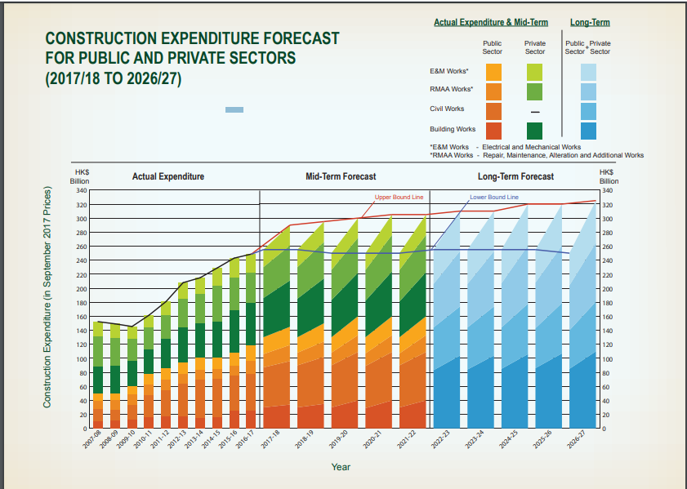

Table 1³: Construction Expenditure in the past 10 years

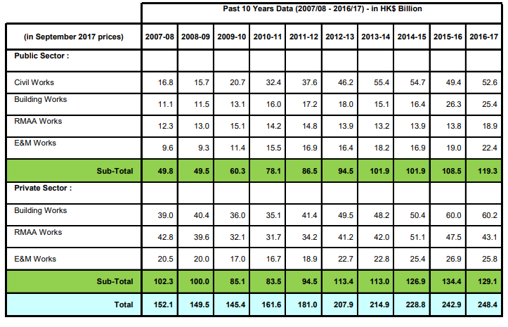

Table 2³: Mid-term Construction Expenditure Forecast
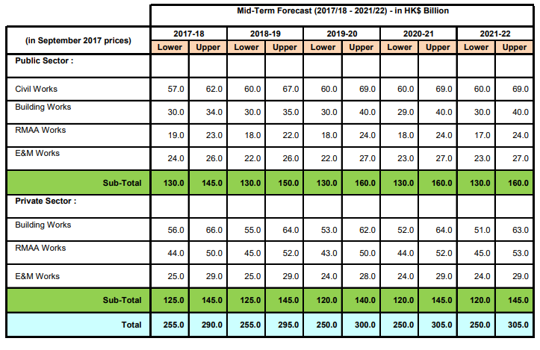

Table 3³: Long-term Construction Expenditure Forecast

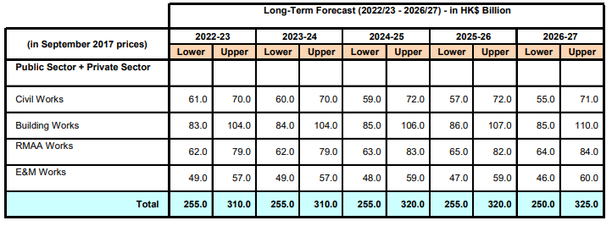

- Yau Lee Construction Holdings Limited (the “Company”)

Yau Lee Construction Company was founded in 1958 by Mr. Wong Ip Kuen and was listed as a subsidiary of the Yau Lee Holdings Limited under the Stock Exchange of Hong Kong in 1991. Currently, it has about a total of 3,000 employees.

Throughout the history of the Company, it has expanded its business to other construction related sectors. In 1982, a subsidiary called Ming Hop Company Limited was established to do contracting business related to installation and provision of project management and consultancy services in the areas of building services, environmental engineering and water treatment. In 1997, another subsidary called Yau Lee Wah Concrete Precast Products Company Limited was formed to produce concrete precast components in Shenzhen for the Company’s public housing works for the Hong Kong Housing Authority (“Housing Authority”). In 1998, to provide construction related IT services, including software development, project management, system development, and integration and IT outsourcing services, another subsidiary was established under the name of VHSoft Technologies Company Limited. Further, the Company also invested in the property market. For instance, in 2011 by applying the Company’s expertise in property investment and construction, the Company develop, design and build a hotel in Sheung Wan. After completion, the hotel is operated under the name of Holiday Inn Express Hong Kong Soho. However, due to COVID-19 pandemic, the hotel operation has been closed since end of March in 2020.

According to the Company’s annual reports, the Company’s business covers five segments including: (1) building construction as well as renovation, fitting-out and maintenance of housings, (2) building services installation and provision of environmental engineering services, (3) supply of building and construction materials, (4) investment and development of properties, and (5) hotel operation. As shown in Table 4 below, according to sales per segment, construction and related electrical and mechanical installation businesses cover more than 90% of the Company’s sale.

Table 4: Yau Lee Holdings Ltd Sales per Business

 | 2019 |  | 2020 |  | Growth
Segment of Business | HKD  (in Million) | % | HKD  (in Million) | % | Growth
Construction | 3,923 | 69.80% | 5,291 | 79% | 34.87%
Electrical and Mechanical Installation | 1,228 | 21.90% | 1,248 | 18.60% | 1.63%
Hotel Operations | 121.46 | 2.20% | 60.96 | 0.90% | -49.81%
Building Materials Supply | 152.91 | 2.70% | 46.63 | 0.70% | -69.51%
Others | 57.43 | 1% | 34.4 | 0.50% | -40.10%
Property Investment and Development | 135.72 | 2.40% | 13.58 | 0.20% | -90%

Since 90’s, the Company has expanded its business to China, Macau, Singapore and the United Arab Emirates. However, as shown in Table 5, the sales per region indicated that more than 97% of the Company’s business is operated in Hong Kong.

Table 5: Yau Lee Holdings Ltd Sales per region
 | 2019 |  | 2020 |  | Difference
 | HKD (in Million) | % | HKD (in Million) | % | Difference
Hong Kong | 5,455 | 97.10% | 6,554 | 97.90% | 20.15%
International | 162.93 | 2.90% | 140.02 | 2.10% | -14.06%

Management of the Company

The founder and chairman of the Company, Mr. Wong Ip Kuen, (“Wong Sr.”) is known for his hands on and traditional Chinese family management style for the operation of the Company’s business despite he is now in his early eighties. As a daily routine, Wong Sr. reads and comments every correspondence related to the operation of all construction site. He also visits each Company’s construction site at least once a week.

In terms of management style, Wong Sr. acts like a father and provides holistically fatherly care to his key management staffs, such as construction project managers and project directors. When these key staffs were hospitalized, he personally visited them, encouraged them to get better treatment from private hospital, and paid for any outstanding medical fees which were not covered by the insurance provided by the Company. When there is a need, he would finance the key staffs to purchase their own apartment, such that they do not have to worry about the ever increasing housing price in Hong Kong. During the SARS incident in 2003, when the construction industry as a whole was going through a down time, the Company did not laid off any employee, but rather, the senior and junior staffs shared the difficult time together by having a 10% and 8% salary reduction respectively. During staff appraisal, Wong Sr. emphasized more on the actual performance of the staff rather than their academic qualifications. However, it is a Company policy to encourage and subsidize its staffs, especially junior staffs; to upgrade their technical knowledge by having Company subsidized part-time education.

Wong Sr. also encourages a team work spirit for the Company as a whole, and not just for a project. By job or project rotation, it is not uncommon that members of a project team for the construction of a particular project will be assigned to different projects upon completion of the project. Further, meetings for experience sharing are conducted once a while such that members from different project teams would have an opportunity to gather together, know each other and learn from each other. Different project teams would share their resources with other project teams in order to boost up the working efficiency and achieve better cost-control. Socially, annual dinner for the whole Company for events such as Spring Festive, Birthday of Master Lo Pan, etc, would be held every year even in the down time of the construction market.

Since Wong Sr. visits the Company’s construction site and communicates with the site staffs frequently, with his training as a carpenter when he was young and his years of hands on site experience, he is able to identify those junior staff and sub-subcontractor who have potential to get promoted to a higher level. He is willing to give opportunity to these potential staffs and sub-subcontractors to try a more responsible position. Accordingly, staffs and subcontractors (or the previous sub-subcontractors) are very loyal to the Company and they are willing to work for an extra mile if it is needed. Consequently, the turnover rate for key staffs is low and the subcontract prices from the subcontractors (the then sub-subcontractors) are low. It is not uncommon for the key staff to have worked for the company for tens of years. The low subcontract prices provided by these loyal subcontractors give the Company an edge in the very competitive low margin public housing market.

On the other hand, as managing director of the Company, Wong Jr. has adopted a different management style. Unlike his father, Wong Jr. is well educated in UK and a qualified professional builder and engineer. In the past, his father had assigned him for different roles in the Company before and after he graduated from University and before he was appointed as managing director of the Company.

However, it is noted that he seldom visits the site and rather, he put much effort in Company’s future development in areas such as site safety, environmental issues and application of IT for the construction process. He is Vice Chairman of Yau Lee Holdings Limited, Managing Director of Yau Lee Construction Company Limited and Yau Lee Wah Concrete Precast Products Ltd., Vice Chairman of REC Engineering Company Limited (former Ryoden Engineering Company Limited before acquired by the Company in 2008) as well as Chief Executive Officer of VHSoft Technologies Company Limited. His interest and expertise is in strategies planning, building construction, precast construction technologies, safety and quality management and green building technologies.

Wong Jr. is very active in public and community services. His experience and expertise in the Company’s business have earned him a respectable status in the community. Just to name a few, he has been appointed as the Chairman of the Occupational Health and Safety Council, Chairman of Hong Kong Green Building Council, Deputy Chairman of Vocational Training Council, the Member of MPF Industry Schemes Committee as well as the Member of the Antiquities Advisory Board, etc. For Community services, Wong Jr. served as the President of the Hong Kong Construction Association and the President of the International Federation of Asia and West Pacific Contractors’ Associations and the Chairman of Pneumoconiosis Compensation Fund Board and the Member of Construction Industry Council. In 2013, Wong Jr. was awarded the Bronze Bauhinia Star (BBS) for his meritorious public and community service, particularly his valuable contribution to the construction industry and promotion of occupational safety and health.

The Company’s board of executive directors mainly consists the Wong’s family members, which includes Wong Sr., his son Wong Jr and his daughter, Ms. Wong Wai Man and a Mr. Sun Chun Wai, who has been appointed as executive director since 1994. Despite the senior staffs are very loyal and trusted by the Company and a high level of freedom has been given to them for their management of the Company operation, the senior staffs do not think any one of them would be appointed to the executive board in the future.

As Wong Sr. is very hands on in the Company’s daily operation, it is not sure if Wong Jr. would be able to pick up the momentum from his father for the future success of the Company as most of key staffs seem very loyal to Wong Sr., but may not necessary have the same level of loyalty to Wong Jr..

Since the set up of the Company in 1958, it has focused its business in construction of government building projects. The Company is one of the leading contractors for public housing construction in Hong Kong. With a market capitalization of about HKD400 million, it has been very successful in securing public housing construction contract. For instance, for the year 2010/2011, 2012/2013 and 2017/2018 the total amount of public housing construction contract awarded to the Company were HKD4,737 million, HKD9,972,.86 million and HKD7,045.51 million respectively; and they represented 28.71%, 48.65% and 21.35% of the total public housing expenditures for the respective years. However, in 2014/2015 and 2015/2016, because one of the Company’s project was involved in the “excess lead in water” incident, the Company was temporarily suspended from tendering new public housing projects of the Housing Authority. Nevertheless, before and after the “excess lead in water” incident, numerous awards, especially related to site safety and environmental issues, have been given to the Company by the Housing Authority and other construction related institutions based on its excellence performance in public housing construction.

In terms of profit before tax for years between 2010 to 2019, except for the year end 2016, 2017,when the Company have to spend a large sum of replacement cost for the piping system found to have excess lead content, the Company is able to achieve a total of HKD512.5 millions in these 8 years, or an average of HKD64 million per years. The percentage of profit before tax is about 16% of the Company’s HKD400 million market capital, which is slightly less than China State Construction International Holdings Limited and Asia Allied Group (Chun Wo Construction Limited), but better than Shui On Group in the industry. For the year end 2020, the Company suffered a loss due to the following reasons: (1) social unrest and adverse impact on the Company’s hotel operation, (2) COVID-19 pandemic which has a serious adverse impact to the Company’s business. In particular, temporarily suspension of the factory caused by the lockdowns of some cities in Mainland and restrictive cross border transportation between the Mainland and Hong Kong causing decrease in production and sales, and temporarily suspened or delay delivery of pre-casting components and other materials to construction projects in Hong Kong.

In the past ten years, other than the adverse impacts caused by the one-off incidents, such as “excess lead water incident”, the social unrest and COVID-19 pandemic, with the numerous award earned by the Company and Wong Jr, the Company’s performance in construction of public housing does enjoy a very high reputation from the industry and high recognition from the Housing Authority and ought to be considered as a successful construction company.

- The STEEP and industry (five forces) dynamics and changes in the past decades

To get an overview of the external factors which are likely to determine the trend of the construction industry development, STEEP analysis is applied and discussed as follows:

Social Factor

The critical social factors that have impact on the Hong Kong construction industry include, inter alias, the followings: (1) demographics of the Hong Kong population, and (2) change in education level and value of the Hong Kong people.

In particular, Hong Kong population has been increased from 7.0 million in 2010 to 7.5million in 2020. The age distribution of the population shows an aging trend in the past ten years. Further, the education level of the population has been higher as the percentage of degree holders for people between 25 and 45 is higher in 2020 than in 2010.

Figure 2: Median age of skilled construction worker vs. overall labour force
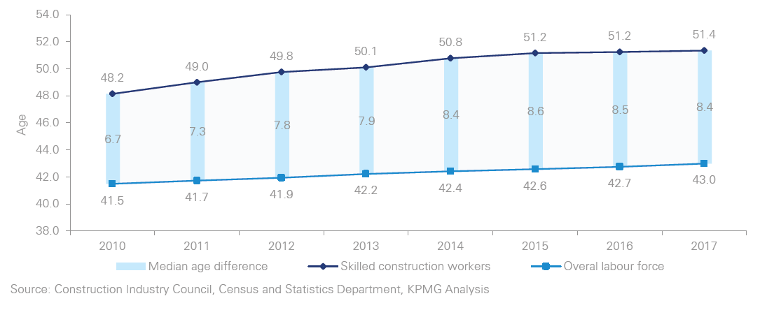

Figure 3also indicated that percentage of total skilled workers at the age of 60 or above working in the construction industry (23%) is much higher than the overall workforce in Hong Kong (9%). Shortage of construction workforce is considered a major factor to drive up construction costs.

Figure 3: Age distribution of skilled construction workers vs overall labour force in 2017
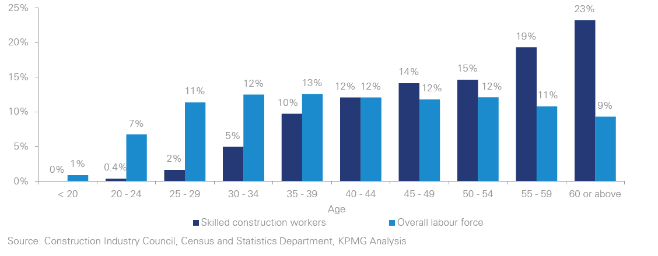

Consequently, there is an increasing demand for housing a larger population in Hong Kong, and on the other hand, there is a shortage of construction workforce due to the aging population and young people’s reluctance to get involved in the construction industry. This is because as more young people in Hong Kong getting higher level of education, there are more degree holders, and there are less young people willing to work as technicians or manual workers in the rough construction site. As a result, there is a shortage of construction working labours.

Technological Factor

In response to the shortage of construction workers and to improved site safety, more environmental friendly, and better construction quality, in the 2017 Policy Address, it has been stated that the Government and the Construction Industrial Council (“CIC”) would implement “Construction 2.0” to upgrade the industry through innovation, professionalisation and revitalization. Construction industry in Hong Kong needs to apply the latest technology development to get industrialized, mechanized and digitalized.

To promote “Construction 2.0”, CIC has advocated the construction industry to adopt two new technologies, i.e. Building Information Modelling (“BIM”) and Modular integrated Construction (“MiC”), to improve construction productivity and cost-effectiveness.

In general, BIM involves measuring and digitizing building information, including the physical size, quantity and quality of each building components, from design drawingsand specifications, thenby applying this digitized building information, production of the building will be managed with the assistance of computer in a time and cost effective manner. Then the digitized information would easily be shared by architect and engineers, the contractors and the property management company throughout the life of the building from its inception to operation, or even demolition. Further, to promote the application of BIM, the government has compulsory required that from 2017 onward, all capital works projects that have an over HKD30 million budget, BIM must be used.

In addition, MiC is one step forward from building construction by using pre-casting building components, such as building facades and kitchen, which have been used by public housing projects in Hong Kong since the 90’s. MiC construction method involves dividing the whole building into small modules such that it can be pre-fabricated off-site in an indoor factory environment and the completed modules will then be delivered and installed on site. Usually, not only the structure of the module has been pre-fabricated, but also all the building services and finishing in the module would also be pre-installed such that onsite installation of the same would be minimized. Sometimes, even built in furniture would also be pre-installed inside the modules. The benefit of the MiC construction method includes, inter alias, the following:
- Better safety and quality control as most of the works are completed in a factory environment.
- Construction time is shortened as the superstructure modules can be constructed at the same time when the foundation work is in progress.
- Productivity and cost-effectiveness of the modules for buildings with standardized multi-level repetitive design can be increased because of economy of scale.
- Better environmental control to the construction site as most of the works are completed off site, therefore noise and dust generated by on site construction activities can be reduced.

On the other hand, it is also clear that there are short comings for the MiC technology, which include, inter alias, the followings:
- Careful planning for production schedule is required for requirement of off-site and on-site storage space.
- Careful planning for logistics, delivery schedule and route, such as, traffic conditions, physical condition of highway (loading, width and headroom), etc, is required.
- The quantity of repeated modules must be large enough to gain the benefit from economy of scale since there is large fix cost involved in preparation and setting up the plant and mould.
- The efficiency of usable floor space would be less as there would be a double wall system allowed for walls for two adjacent modules.
- The architectural design is restrictive in order to apply the use of standardize modules economically.
- The structural design is also restrictive as there is likely to be a large core wall to resist the horizontal loading of the building. Accordingly, there should be a large number of repeated units per floor to share the cost of the common area and construction cost of the structural core wall.

To promote the application of MiC, it has been stated in the 2017 Policy Address that a few public projects would apply this technology for construction. Pilot projects using MiC in Hong Kong including the student residence at Wong Chuk Hang for the University of Hong Kong, services quarters for the Fire Services Department at Tseung Kwan O, InnoCell at Hong Kong Science Park, transitional homes at Nam Cheong Street in Sham Shui Po, etc. The Company is one of the contractors awarded for construction of one of these pilot projects, namely, the services quarters for the Fire Services Department at Tseung Kwan O.

Economic
As mentioned in the above, the Hong Kong population has been increased from 7.0 million to 7.5 million between 2010 and 2020. If the average domestic household size is 2.8, then there would be a demand for approximately 179,000 new units required to house the 0.5 million increased population. During the same period, the total number of public housing flats constructed by the Housing Authority is about 145,179. It is likely that more units are required to house the increased population. However, according to the announcement by the Housing Authority, as of June 2020, there were 259,7000 number of public housing applications and the average waiting time for allocation is about 5.5 years. Some committee member of the Housing Authority expected the waiting time may be increased to more than 6 years.

Table 6: Actual Public Housing Production in HK (2010-2020)
Year | Total (No. of Flats) | Increment
2010/2011 | 14,782 | 0.0%
2011/2012 | 11,186 | -24.3%
2012/2013 | 13,114 | 17.2%
2013/2014 | 14,057 | 7.2%
2014/2015 | 9,938 | -29.3%
2015/2016 | 14,264 | 43.5%
2016/2017 | 14,293 | 0.2%
2017/2018 | 13,661 | -4.4%
2018/2019 | 26,779 | 96.0%
2019/2020 | 13,105 | -51.1%
Total | 145,179

Since the 2008 Lehman Brothers-related Minibonds financial crisis, the US government has adopted a quantitative easing (“QE”) policy. Internationally, the US QE policy has a serious spillovers impact to the world economy. It have created excessive global liquidity and, caused appreciation of real properties and asset price bubbles in other parts of the world.”

In Hong Kong, as the Hong Kong dollar is packed with the US dollar, the spillover impact on the property price has been even more serious. In the past ten years, as indicated in Figure 4, the accumulated increment of the Centa-City Index (CCI) Index is much higher than the accumulated increment of Median Monthly Wage of Employees in Hong Kong. There is a popular saying in Hong Kong that graduates are not able to afford to purchase a private unit unless they have assistance from their parents. Since not every parent is able to assist their children to purchase their own units, therefore, there is a phenomenon in Hong Kong that many students apply for public housing before they graduated. Accordingly, waiting time for public housing has been increased much faster than the natural growth of the population. Since the COVID-19 pandemic, the US has again expanded its QE policy and the interest rate in Hong Kong has been maintained in a relatively low level. It is expected that unless there is a social unstable environment caused by political reasons, otherwise, it is possible that in the near future the property price would again be increased faster than wages and more people in Hong Kong would rely on government subsidies housing and there would be an increasing demand for public housing in the future.

Figure 4: Accumulate increment of Centa-City Index (CCI) as compare to the Media Monthly Wage of Employees in HK (From 2010-2020)

Environmental

In 1995, the government, some property developers and academia had collectively formed a steering committee for the study of Building Environmental Assessment Method (BEAM). BEAM provides building users an assessment tools and standard for overall building performance in relation to the build environment. It covers overall quality of a building, either a new or refurbished building or an existing building. BEAM adopts a life cycle approach and sets the assessment standard for buildings from planning and design, construction and commissioning, management, operation and maintenance. 

In relation to the construction industry, the major areas covered by BEAM include mainly the followings: (1) emissions from the site, (2) materials and waste management, and (3) energy and water consumed by the site.

In particular, for emissions from the site, BEAM will assess the air, noise, light and water pollution emitted from the construction site to the neighboring environment during construction. In relation to the materials and waste management, BEAM will assess construction materials and waste, such as timber used for temporary works, non-cfc based refrigerants used for cooling system, recycling and handling of construction waste, including waste generated during demolition of old structures and recycling of water, used during the construction process. Further, BEAM will also assess the energy and water consumed during the construction process.

After taking into consideration of the latest development of BEAM, it can easily be assess why MiC is the preferred construction methods for public housing since public housing estates consist of large number of repeated and standardized blocks and units which can be divided into standardized modules and pre-fabricated in a factory environment. By MiC, all kind of site pollution and wastage can be minimized, and energy and water consumption can easily be controlled in an efficient and cost effective manner.

Further, operation of a building is one of the major causes for carbon dioxide emission and electricity consumption. By a good design at the inception stage of the building, the Holiday Inn Express Hotel developed by Yau Lee Construction has become one of the most environmentally friendly hotels in the world by achieving the highest ratings in four green building certification systems, including that of Hong Kong, China, Singapore and the United States. According to Wong Jr., through a good construction design, there can be a cost saving for 60 percent of electricity consumption by the Hotel. By comparing the annual electricity cost saving of two to three million dollars with ten million dollars electricity intelligence system installed for the hotel, the Company has demonstrated that green building can be a good investment.

Political

Internationally, there have been numerous vexatious conflicts raised by the US Trump’s administration against China in all aspects, which include, inter alia, economy, technology and diplomatic relationship, etc. Recently, under the unilateral US legislation of the United States–Hong Kong Policy Act 1992, the US government has eliminated the alleged “special treatment” for Hong Kong and has applied the same treatment for the economic and trading conditions, etc, between Hong Kong and the Mainland. The US government has also “penalized” certain key Hong Kong government official for their support and implementation of the Chinese National Security Law. Under such political circumstances, it is expected that the property price in Hong Kong would be very volatile and private property investment would be decreased in the future.

On the other hand, as mentioned hereinabove, because the US has again adopted the QE policy, it is expected that the price of private property is likely to go up and affordability of Hong Kong people to purchase their own private property would be decreased in the future. Accordingly, there would be an increasing demand for public housing. Politically, increasing demand means longer waiting time for the public to get allocation of their public housing unit. Therefore, in terms of domestic politics, it is expected that the Hong Kong government would be under greater pressure to spend more government expenditures to build more public housing in the future.

However, under the current domestic political environment in Hong Kong, there may be a concern in the long run for land supply for construction of public housing if no budget is allowed by the Legislative Council for even feasibility studies of long term land supply solution, such as the Lantau Tomorrow Vision development project.

- SWOT Analysis

Opportunity
From the STEEP analysis, it is clear that there is an opportunity for all Hong Kong construction company to build more public housing to fulfill the increasing demand of Hong Kong people, especially if the private investors are hesitated to buy while the property price is likely to go up in the long run because of QE policy adopted by the US.

Further, there is a high demand for more environmental friendly construction method and MiC is one of the most promising methods for construction of large scale standardized public housing units. By applying the MiC construction method, the labour shortage problem facing by the Hong Kong construction industry can be resolved. As the Company is one of the contractors for one of the MiC pilot projects and operator of its own pre-casting factory, The adoption of MiC is definitely an opportunity for the Company to have larger market shares in the future.

Strength of the Company

In the past, the Company has been focusing its business in the public housing construction market. The benefit of providing construction services to the Hong Kong Government or the Housing Authority is fairness of the tendering process and assurance of payment after work done. Therefore, the Company’s cash flow is highly predictable and can easily be controlled. With the successful fatherly management style of Wong Sr., the Company can successfully compete in the low cost margin public housing construction market because it has a stable and loyal project team who has focused and specialized in public housing construction in the past years. The Company has also nurtured a team of loyal subcontractors who can support the Company at a relatively low subcontract price.

Further, the Company is one of the very few construction company who has its own pre-casting factory and MiC construction experience. To set up and operate a successful pre-casting factory, one needs to have intensive set up capital investment and a team of experience operating staffs. In other words, the enter hurdle for production of pre-casting modules used in MiC construction is high. It is believe that the Company can capitalize on the opportunity to increase its market shares for buildings constructed by MiC.

Weakness

The Company was founded by Wong Sr. since late fifties and he is still very hands on the Company’s daily operation despite he is at the age of early eighties. With Wong Sr’s holistic fatherly management style, it seems he has nurtured a team of staff and subcontractors who are very loyal to him. However, there is a concern that whether the loyalty from the staff and subcontractors would be sustainable after Wong Sr. is retired. It is not sure if Wong Jr. would be able to inherit the same loyalty from the Company’s key management staff and from the subcontractors. In this regard, it would be much better for Wong Sr. to implement a more firm succession plan to hand over the daily operation to Wong Jr., especially when the Company is a family company. In particular, senior key staff should be promoted to the board of directors, such that new blood and new ideas would be introduced to the board management. Further, it would develop trust and loyalty between Wong Jr. and the senior key staffs if their promotion is recommended by Wong Jr..

Threat

Even there is a high demand for the public housing for the next few years, the competition for tender may be high and the margin may be low. This is because if the conflicts between the US and Mainland is getting worse, then private development may be reduced. Other contractors may have to shift their market segment from the private building sector to compete for the public housing market even the profit margin is lower.

Likewise the Company’s business has also focus too much on the pre-casting production, which caused the Company a substantial loss in 2019 and early 2020 due to the factory lockdown and transportation halt between Mainland and Hong Kong for prevention of the COVID-19 pandemic.

Furthermore, if the domestic political conflict is getting worse, it may cause an adverse impact to the long term land supply for public housing construction and indirectly can cause a negative consequence to the Company’s market and business.
It is noted that the Company’s business is too much concentrated to construction of large public housing estates in order to utilize the economy of scale for production of pre-casting components. In 2017, because the scale of public housing projects was smaller due to lack of sizable land, the tender awarded to the Company had been reduced.

Even over 95 percent of the Company’s business is located in Hong Kong, the Company did have construction experience and connection in other locations, such as Singapore, Macau and the Mainland. For the sustainabledevelopment of the Company’s business, it would be positive for the Company to explore opportunities in the Greater China Region, in particular the Guangdong-Hong Kong-Macau Greater Bay Area. It would be beneficial to the Company’s risk management if the Company can diversify its business geographically, such that the Company’s business would be more sustainable even when the Hong Kong construction market is in a downtime for whatever reason.

VRIO Analysis

To identify the Company’s long-term sustained competitive advantage, the VRIO analysis is applied by asking the four-question framework of Value, Rarity, Imitability, and Organization.

First of all, we will examine if the Company can offer any resource that adds value for customers? If so, then how would the Company exploit the opportunity or neutralize competition with the internal capability? To answer this first question, it is suggested that the Company’s pre-casting factory set up in Shenzhen would give the Company an advantage over the other competitors. Currently, there are only a few contractors, including China State Construction International Holdings, have their own pre-casting factory in the Mainland. In Hong Kong, construction by pre-casting component is the method of construction designated by the Housing Authority for construction of public housing. Therefore, even sizable contractors like Paul Y. Construction Company, Limited and Hsin Chong Construction Company Limited, as they do not have their own pre-casting factory; they have to acquire the pre-casted structural components from their competitors, like the Company. It is clear that the visionary pre-casting factory set up by the Company in 1997 is surely a resources that can provide value to its customers.

Secondly, raw materials for production of concrete are relatively scarce. Concrete is a composite product made from a mixture of broken stone or gravel, sand, cement, and water. Due to environmental protection, stone quarry producing gravels with adequate strength is now a scarce resource not only in Hong Kong, but also in southern part of Mainland. Likewise, in Hong Kong, sand become very scarce and expensive construction material as large quantity of sand have been consumed for reclamation of the airport expansion project. Despite the quality of sand required for landfill and for production of concrete are different, but the overall supply of sand is getting scarce. With the Company’s pre-casting factory in Shenzhen and its long term contract for supply of gravels and sands with its partners in the Mainland, the Company can assure stable supply of these scare resources. This stable supply of such scare resources would be another competing advantage to the Company.

Thirdly, the Company’s pre-casting factory is one of the earliest pre-casting factory set up in the Mainland and is almost a quarter century old. To run a business successfully in the Mainland, relationship, especially long term relationship, and trust with the local government officials are essential for smooth operation, or even the survival, of the business. With its long history of establishment in Shenzhen and co-operative working relationship with the local government official, the smooth operation of the pre-casting factory can be assured. In this regard, similar pre-casting factory operation will be difficult to set up or imitate by the Company’s competitors as it would take them a long time to built up the relationship and trust with the local government officials if they want to enjoy the cheap labour and land supply, and stable supply of above mentioned scare resources in the Mainland.

Finally, for the organization of the pre-casting factory as mentioned herein above, since the establishment of the pre-casting factory about 23 years ago, the Company’s production team has proven record for a long time for smooth and stable supply of pre-cast components to the Company’s and other contractor’s public housing project in Hong Kong. In the past, it has taken the Company’s Hong Kong staffs lots of time and effort to run in with the local staffs for resolving differences between the Hong Kong and Mainland corporation and operation cultures. Further, with the fatherly care management style of Wong Sr. and the team building sprite which the Company has operated, the Mainland-Hong Kong production team has now worked together according to a smooth and routine processes set up after years of operation. Again, it will be difficult for other late comer to train a production team within a short time to operate the production of a pre-casting factory as smooth as the Company.

Based on the above VIRO analysis and successful identification of all four components of the VRIO framework for operation of the Company’s pre-casting factory, it is considered that the Company does have achieved the ultimate goal of sustained competitive advantage.

- Identification of the Company’s key successful factors by application of the 3H model

H1. Heart-oriented leadership that can engage and motivate followers

Perceived organizational support (“POS”) is defined as employees’ perception and belief of how much the organization cares about their well-being and values their contributions. Researchers suggested that an organization will obtain positive outcomes based on employee’s perceptions of favorable treatment. Alternative speaking, employees who belief they are treated well by the organization are more probably committed to their organization, satisfied with their job, and will have a better chance to stay with their jobs.

Another research found that top management inclusion and recognition, are pre-conditions required for POS. If the employees have been well taken care of by the organization for a long time, it is likely that their behaviors will be reciprocate to the favorable treatment received from their supervisor and they would be desire and accept a high-quality exchange with their supervisor. The research confirmed it is essential to have good relationships between supervisor and employee for enhancing the job performance from the employee. These findings agreed with the traditional observations about the social exchange view that employees’ commitment to the organization and their belief of the organization’s commitment to them are positively related. This is because the employees expect their reward from the organization would be in proportion to their effort towards accomplishing the organizational goals, accordingly, they would be much affectively attached to the organization.

For the Company, it is argued that Wong Sr.’s fatherly style of care to the senior staffs is one of the success factors for the Company. As a matter of reciprocity, over the years of well treatment by Wong Sr., the senior staff responded positively and become very loyal to Wong Sr. As they know the Company is a family company owned by Wong Sr., they believe their commitment to the Company is equivalent to commitment to Wong Sr. Accordingly, they are willing to stay with the Company and motivated to do the extra miles for the Company. In other words, the leadership by Wong Sr. that can engage, motivate and unit the Company staff to work for the best interest of the Company is the most important factor for the success of the Company.

H2. Head domain driven effective strategy planning process

As discussed hereinabove, one of the effective strategies for the Company is to concentrate its business in the public housing market, a market segment which they can assure for future market demand and payment of work despite the competition is high and profit margin is low.

By concentrating its business in the public housing market, the Company becomes the experts in this market segment. With the standardized public housing block and units, and the requirement for pre-casting construction, the Company has the vision to develop one of the biggest pre-casting factories in Shenzhen since 1997. With the low production cost in the Mainland and economy of scale for production of large quantity of standard structural components, the Company can be very competitive and become very successful in the construction of public housing market.

The strategy for investing a pre-casting factory in the Mainland appears to have been coherently developed and precisely addressed the emergency and long-term goals of the latest development of construction technology, the MiC construction method. As MiC construction method is just one step forward from pre-casting construction, other contractors in Hong Kong which do not have any pre-casting facilities are in an inferior position when compare with the Company.

Further, the Company has also invested in other technologies related to the construction industry, such as computer technologies applied to BIM, environmental technologies applied in BEAM. These technologies will enhance the Company’s competition in building construction market in Hong Kong and other parts of the world.

H3. Hand domain developed competence to execute the Company’s strategy

As mentioned herein above, the Company has put much subsidies and resources to pay up and train up young staffs such that they can develop the skills and techniques as required by the Company. Furthermore, with Wong Sr.’s fatherly care management style, he has given lots of encouragement and opportunities to the junior staffs and sub-subcontractors such that they can be promoted to a higher level of works, such as becoming a senior staff or becoming a subcontractor respectively. By such practice, the Company has developed a team of loyal and competent staffs and subcontractors with the adequate skill, techniques and loyalty to execute the Company’s strategy.

- Limitations

In this research, one of the sources for collecting data is from figures published by the Census and Statistic Department of the Hong Kong Government. The terms and meaning of the data collected from this Department may not be totally tally with the terms and definitions used in the Annual Report of the Company, which is another major source for data collected for this paper.

Also, most of the other construction companies in Hong Kong are now a subsidiary of a holding group with many businesses other than just construction. Benchmark figures for the construction industry is difficult to obtain for comparison as there is very few listed construction companies focus only or mainly on the construction of public housing as the Company. Further, these construction companies are larger in scale and the nature of project involved is more diversify to include civil engineering and building projects developed by private developer or public institutions.

Further, if more time is provided, this paper should have covered financial analysis for the Company in more detail and external economic and political analysis in more thorough and detail manner.

- Conclusion

The Company is a contractor focused and specialized in the public housing construction market. The special characteristic of this construction market is its low technical risk, fairness for tender and assurance for payment, but low profit margin.

Since the Company was established in the late fifties, by the leadership of Wong Sr. and his fatherly holistic management of the Company, he has built up a team of key and loyal staffs and subcontractors who are willing to work an extra mile for the interest of the Company. In particular, a group of loyal subcontractors nurtured by Wong Jr, provides very competitive prices for the Company’s bidding of the low margin housing projects. Accordingly, the Company is able to successfully secure contracts from the Housing Authority and generate reason profit in the past.

By focus on one particular segment of the construction market, the Company become specialized and an expert in the construction of public housing projects. As the Housing Authority has required the buildings to be constructed by pre-casting components and the Company is focused in this market, the Company has a visionary investment in 1997, to set up a pre-casting factory in Shenzhen to control the production of pre-casting components for its own projects. After all these years co-operation between the Hong Kong and mainland staffs, the Company has built up a very smooth production team and enjoyed the low cost of production in the Mainland and to a certain extent avoid the labour shortage problem experienced by other contractors in Hong Kong. In addition, by long term relationship with the local government officials and with the material suppliers, the Company has secured stable supply for some scare resources for production of the precast components. With the time and resources required to set up and run a pre-casting factory smoothly, it is considered that the Company’s ownership and smooth operation of the pre-casting factory in Shenzhen is a sustainable completive advantage for the Company.

To cope with the latest development of the more stringent environmental requirement, one of the latest construction method promoted by the Hong Kong government is MiC. MiC is just a step forward from pre-casting production which the Company has definite competitive advantages as mentioned hereinbefore. In fact, the Company is one of the contractors selected for construction of one of the pilot projects constructed by MiC.

After analyzing the social, economic and political environment, it is expected that there would be a growth of the public housing construction market which the Company is well positioned. With the Company’s competitive advantages identified in the above, it is considered the Company’s success in the past should be sustainable.

However, to ensure the momentum of Company’s competitive advantages, two problems need to be considered. Internally, as Wong Sr. is in his early eighties, a more firm succession plan is required to allow Wong Jr. to pick up the family business smoothly after the retirement of Wong Sr. Externally, unstable domestic politics environment may have an adverse impact to the long term land supply for construction of public housing. In such circumstances, geographical diversification of the Company’s business in the neighboring areas, especially the Greater Bay Area should be considered by the Company.

Yu, E. (2020), “Seminar Day 1: Visions for the Future: Theoretical Perspectives on Management”, Lecture notes, HKBM7006, University of Wales – Trinity Saint David, delivered on 1 August 2020.
Construction Industry Council (2018), Construction expenditure forecast for public and private sectors. http://www.cic.hk/common/Fore/Fore.aspx?lang=en-US&year=2017_18
Source:香港經濟日報–Topick2020/03/31 hkethttps://topick.hket.com/article/2606451/%E3%80%90%E6%96%B0%E5%86%A0%E8%82%BA%E7%82%8E%E3%80%91%E4%B8%8A%E7%92%B0%E8%98%87%E8%B1%AA%E6%99%BA%E9%81%B8%E5%81%87%E6%97%A5%E9%85%92%E5%BA%97%E4%BB%8A%E6%97%A5%E8%B5%B7%E5%81%9C%E6%A5%AD%E3%80%8C%E6%AD%A2%E8%A1%80%E3%80%8D%E3%80%80%E7%B4%8430%E5%93%A1%E5%B7%A5%E9%81%AD%E9%81%A3%E6%95%A3%E3%80%80 Accessed
Sources: the Company’s Annual Reports for the year 2019 and 2020 and complied by the author.
Sources: the Company’s Annual Reports for the year 2019 and 2020 and complied by the author.
Sources: Government Press Releases “2013 Honours List” dated July 1, 2013 (Access: file:///J:/11%20OLD%20TOSHIBA%2007.06.30/1-%20University%20of%20Wales%20DBA/HKBM%207006%20Vision%20for%20Future/Assignment/Conard%20Wong/2013%20Honours%20List.html)
Company Annual Report 2019 to 2020, pp 15 and 16
Apply Daily 29 July 2015, https://hk.appledaily.com/local/20150729/YZI5QANGMPJTGVSSVA5HK5XN74/
Development Bureau of HKSAR Government with assistance of KPMG, Construction 2.0 Time to Change, September 2018
Census and Statistics Department (2017), Quarterly review on general household survey (October to December 2017), Construction Industry Council data (2017).
Development Bureau of HKSAR Government with assistance of KPMG, Construction 2.0 Time to Change, September 2018
Sources: Construction Industry Council web-site at https://www.bim.cic.hk/en (Accessed 23/8/20)
Sources: Development Bureau (2017), Technical Circular No. 7/2017.
Sources: Construction Industry Council web-site at http://www.cic.hk/eng/main/mic/ (Accessed 23/8/20)
2017 Policy Address – Policy Agenda.
CIC web-site at http://www.cic.hk/eng/main/mic/whatsmic/hk_examples/
Population Overview - Census and Statistics Department, Latest revision date: 19 August 2020 (http://www.censtatd.gov.hk/hkstat/sub/so20.jsp)
Marcel Fratzscher, Marco Lo Duca and Roland Straub, On the International Spillovers of US Quantitative Easing, https://academic.oup.com/ej/article/128/608/330/5069118 (Accessed on 25 August 2020)The Economic Journal, 128 (February), 330–377. Doi: 10.1111/ecoj.12435 © 2016 Royal Economic Society. Published by John Wiley & Sons
SOURCE: CENTA-CITY INDEX (CCI), 中原數據 (CENTADATA), http://202.72.14.52/p2/cci/SearchHistory.aspx SOURCE:MEDIAN MONTHLY WAGE OF EMPLOYEES, CENSUS AND STATISTICS DEPARTMENT, https://www.censtatd.gov.hk/hkstat/sub/sp210_tc.jsp?productCode=B1050014
Beam Plus New Buildings Version 2.0 (2019.09) by HKGBC and BEAM https://www.beamsociety.org.hk/files/download/download-20130724174420.pdf
VTC Engineering, Ir Conrad Wong Tin-cheung: Pioneer in green building https://engineering.vtc.edu.hk/en/EngineeringWorldDetails.php?EWID=4
Ming Pao Daily 7 September 2002, (稱政府土供工作「不夠力不夠快」黃遠輝：中短期缺地看不到希望 - 20200907 - 港聞 - 每日明報 - 明報新聞網) https://news.mingpao.com/pns/%e6%b8%af%e8%81%9e/article/20200907/s00002/1599416272073/%e7%a8%b1%e6%94%bf%e5%ba%9c%e5%9c%9f%e4%be%9b%e5%b7%a5%e4%bd%9c%e3%80%8c%e4%b8%8d%e5%a4%a0%e5%8a%9b%e4%b8%8d%e5%a4%a0%e5%bf%ab%e3%80%8d-%e9%bb%83%e9%81%a0%e8%bc%9d-%e4%b8%ad%e7%9f%ad%e6%9c%9f%e7%bc%ba%e5%9c%b0%e7%9c%8b%e4%b8%8d%e5%88%b0%e5%b8%8c%e6%9c%9b
Antecedents and consequences of perceived organizational support for NCAA athletic administrators by Pack, Simon M, Ph.D, The Ohio State University, 2005, 3177185
Tetrick, L. E., Shore, L. M., &Malatesta, R. L. (1997, November), The Role of Fair Treatment and Rewards in Perceptions of Organizational Support and Leader–Member Exchange, Journal of Applied Psychology, 2002, Vol. 87, No. 3, 590–598
Eisenberger, R., Huntington, R., Hutchison, S., & Sowa, D. (1986). Perceived organizational support. Journal of Applied Psychology, 71(3), 00–507. https://doi.org/10.1037/0021-9010.71.3.500

