

COMMUNITY CARE AND MANAGEMENT OF LONGER-TERM CONDITIONS - ASSESSMENT 1

Programme: MSc Public Health and Social Care in Practice
Module name: Community care and Management of longer-term conditions
Module code: LCHS7003
Student name: Smit Kumar Surati
Student ID: 2537381
Lecturer: MUHAMMAD KHAN

Contents
DEFINITION 3
DEFINITION 3
TYPES OF EPILEPSY 3
PREVALENCE OF EPILEPSY 4
CAUSES AND RISK FACTORS OF EPILEPSY 5
IMPACT OF EPILEPSY 6
DIAGNOSTIC EVALUATION OF EPILEPSY 10
Evidence-Based Treatments Available Through the NHS 12
Current Theoretical Perspectives and Frameworks for Improved Outcomes 13
Examination of Local and National Political Health and Social Care Agendas 15
Recommendations for Improving Person-Centred Care 17
REFERENCES 4

EPILEPSY

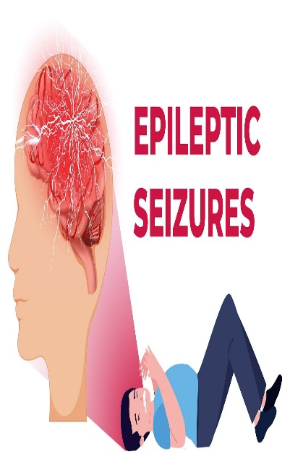
DEFINITION
Epilepsy is a long-term neurological disorder that causes repeated seizures due to abnormal electrical activity in the brain. A person is usually diagnosed with epilepsy after having two or more unprovoked seizures or one seizure with a high chance of recurrence. Seizures can affect movement, awareness, behaviour, emotions, or sensations. With proper treatment, many people with epilepsy can lead healthy and active lives (Zuberi et al, 2022; Kwon et al, 2022).

TYPES OF EPILEPSY
Epilepsy is classified according to where seizures begin in the brain and how they affect the person.
Focal Epilepsy: Seizures start in one area of the brain. A person may remain aware or become confused during the seizure. Symptoms may include unusual movements, changes in sensation, or staring (Specchio et al, 2022; Zuberi et al, 2022).
Generalised Epilepsy: Seizures begin on both sides of the brain at the same time. These include absence seizures, tonic-clonic seizures, myoclonic seizures, tonic seizures, atonic seizures, and clonic seizures (Riney et al, 2022; Zuberi et al, 2022).
Combined Generalised and Focal Epilepsy: Some people experience both focal and generalised seizures (Riney et al, 2022; Specchio et al, 2022).

Unknown Epilepsy: Sometimes doctors cannot identify where seizures begin because there is not enough information (Specchio et al, 2022; Riney et al, 2022).
Correct identification of the type of epilepsy helps healthcare professionals choose the most suitable treatment and improve seizure control.

PREVALENCE OF EPILEPSY
Global Prevalence: Epilepsy is one of the most common neurological disorders worldwide and affects approximately 50 million people (WHO, 2026). It can occur at any stage of life and affects individuals regardless of age, gender, or ethnicity. Most people living with epilepsy are in low- and middle-income countries, where access to healthcare and treatment is often limited (Zhao et al, 2026). Early diagnosis, appropriate treatment, and public education can improve seizure control and overall quality of life (Zhao et al, 2026).
UK Prevalence: In the United Kingdom, around 630,000 people are living with epilepsy, which means about one in every 100 people is affected (NHS Inform, 2026). Approximately 80 people are diagnosed with epilepsy every day. The condition affects children, adults, and older people (Shankar et al, 2024). Many individuals achieve good seizure control with anti-seizure medicines, although some continue to experience seizures despite treatment (NHS Inform, 2026). Public awareness, specialist care, regular follow-up, and support services help improve health outcomes and quality of life for people with epilepsy (Shankar et al, 2024).

CAUSES AND RISK FACTORS OF EPILEPSY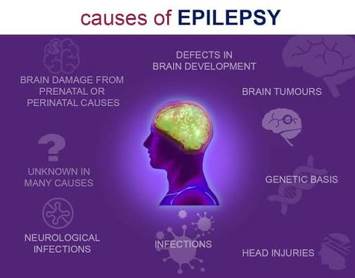

Causes of Epilepsy: Epilepsy can develop from a range of underlying conditions that affect the normal electrical activity of the brain. Brain injury caused by accidents or trauma can damage brain tissue and lead to seizures (Chen et al., 2023). Stroke is a common cause of epilepsy, especially in older adults (Thijs et al., 2019). Brain infections such as meningitis or encephalitis may affect brain function and trigger epilepsy (Chen et al., 2023). Genetic factors can increase the chance of developing certain types of epilepsy (Walsh et al., 2017). Brain tumours may interfere with normal electrical activity in the brain (Chen et al., 2023). Lack of oxygen before or during birth can damage the developing brain (Thijs et al., 2019). Developmental disorders such as cerebral palsy or autism may be associated with epilepsy (Thijs et al., 2019). Head injuries during sports, falls, or road traffic accidents increase the risk (Walsh et al., 2017). Congenital brain abnormalities present from birth may cause seizures (Walsh et al., 2017). In some people, the exact cause remains unknown despite detailed medical investigations (Chen et al., 2023).
Risk Factors: Several factors increase the risk of developing epilepsy. The family history of epilepsy may increase susceptibility. Severe head injuries, stroke, brain tumours, and infections affecting the brain are important risk factors (Walsh et al, 2017). Problems during pregnancy or birth, such as oxygen deprivation, may also contribute (Walsh et al, 2017). Older adults have a higher risk because of stroke and dementia, while young children may develop epilepsy due to birth-related complications or infections (Yang et al, 2021). Excessive alcohol use, drug misuse, and untreated brain diseases can further increase the likelihood of developing epilepsy. Regular medical care may help reduce some preventable risks (Yang et al, 2021).

IMPACT OF EPILEPSY
Physical Signs and Symptoms: Repeated seizures are the main symptom of epilepsy (Lawal et al., 2018). During some seizures, individuals may experience a sudden loss of consciousness, while uncontrolled shaking or jerking movements of the arms and legs are also common (Lawal et al., 2018). Stiffening of the body may occur before or during a seizure, and brief staring episodes can cause a person to stop responding to their surroundings (Hassan et al., 2022). Confusion and tiredness are common after a seizure, and temporary memory loss may also occur (Lawal et al., 2018; Hassan et al., 2022). Some people experience difficulty speaking or understanding words for a short time following a seizure (Hassan et al., 2022). Loss of bladder or bowel control, tongue biting, and injuries resulting from falls may occur during seizures (Lawal et al., 2018). Muscle pain and headaches are frequently experienced after a seizure (Hassan et al., 2022). Some individuals notice unusual smells, tastes, or sensations before a seizure begins, while others may experience vision changes or dizziness before or after seizures (Lawal et al., 2018; Hassan et al., 2022). Sleep disturbances and fatigue are common among people with epilepsy, and frequent seizures can interfere with daily activities, work, school, and independence (Lawal et al., 2018). Some individuals may also experience balance problems after a seizure, while bruises or fractures can result from seizure-related falls (Hassan et al., 2022; Lawal et al., 2018).
Psychological Impact: Living with epilepsy can have a significant effect on emotional and mental well-being. Many people experience anxiety because seizures can occur unexpectedly, creating constant uncertainty and worry about when the next seizure might happen (Kedare and Baliga, 2022). Fear of having a seizure in public may reduce confidence, independence, and willingness to participate in everyday activities. Some individuals also develop depression due to ongoing health concerns, repeated seizures, or lifestyle restrictions associated with the condition (Mula et al., 2022). Stress can make coping with epilepsy more difficult and may increase seizure frequency in some people. Memory and concentration problems can affect learning, work performance, and daily functioning. Some individuals feel frustrated because they are unable to drive, work in certain occupations, or take part in particular activities (Kedare and Baliga, 2022). Positive family support, counselling, stress management, education, and appropriate medical treatment can improve emotional well-being and overall quality of life. Encouraging open communication also helps people with epilepsy feel understood, accepted, and more confident in managing their condition (Kedare and Baliga, 2022).
Social Impact: Epilepsy can have a considerable impact on education, employment, relationships, and social participation. Some people avoid attending social events because they fear having a seizure in public, while misunderstanding and stigma surrounding epilepsy may result in discrimination, social exclusion, or isolation (Strzelczyk et al., 2023). Children with epilepsy may experience challenges at school, whereas adults may face difficulties finding or maintaining employment. Driving restrictions can further reduce independence and make travelling more difficult (Tomasini et al., 2026). Frequent medical appointments and ongoing treatment requirements may also disrupt daily routines. Friends, teachers, employers, and the wider community who understand epilepsy can provide valuable support and help create a safe and inclusive environment (Strzelczyk et al., 2023). Community education plays an important role in reducing myths, improving awareness, and encouraging acceptance, while support groups enable people with epilepsy to share experiences and learn from others (Tomasini et al., 2026). With appropriate treatment, strong social support, and greater public awareness, many individuals with epilepsy can participate successfully in education, employment, family life, sports, and community activities (Strzelczyk et al., 2023).
Impact of Epilepsy on Family and Caregivers: Epilepsy can have a significant impact on family members and caregivers, who often play an important role in supporting the individual with the condition. Family members may worry about when the next seizure will occur, creating ongoing anxiety and uncertainty (Carter et al., 2022). Caregivers frequently assist with administering medicines, attending medical appointments, and monitoring seizure management (Poprelka et al., 2025). Parents may feel particularly concerned about their child's safety at home, school, or during everyday activities (Poprelka et al., 2025). Family routines often need to be adjusted to accommodate seizure management, and the emotional stress associated with caring for someone with epilepsy can affect both caregivers and other family members (Carter et al., 2022). Continuous supervision may also lead to caregiver fatigue and exhaustion (Carter et al., 2022). In addition, the financial costs of treatment, medication, and transport to healthcare appointments may place extra pressure on families (Poprelka et al., 2025). Family members need to learn seizure first aid and emergency care, while brothers and sisters may also require emotional support and information to better understand and cope with the condition (Carter et al., 2022; Poprelka et al., 2025).

DIAGNOSTIC EVALUATION OF EPILEPSY
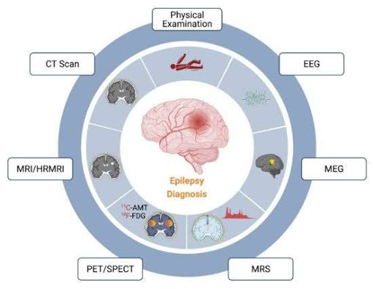The diagnostic evaluation of epilepsy begins with a detailed medical history in which the healthcare provider asks about the seizures, including when they started, how long they last, and what happens before, during, and after each episode. Family history, previous illnesses, injuries, and current medicines are also reviewed to help identify possible causes of epilepsy (Pellinen et al., 2024). A physical and neurological examination is then performed to assess muscle strength, balance, reflexes, sensation, vision, speech, and coordination, helping to identify any abnormalities affecting the brain or nervous system (NHS Inform, 2026). An electroencephalogram (EEG) records the brain's electrical activity using small sensors placed on the scalp and helps detect abnormal brain wave patterns that may indicate epilepsy while assisting in identifying the type of seizure (NHS Inform, 2026). Magnetic resonance imaging (MRI) uses strong magnets and radio waves to produce detailed images of the brain, allowing healthcare professionals to identify brain injuries, tumours, scars, or structural abnormalities that may be responsible for seizures (Pellinen et al., 2024).
A computed tomography (CT) scan uses X-rays to produce detailed images of the brain and is commonly performed in emergencies to identify bleeding, head injuries, or other conditions that may trigger seizures (NHS Inform, 2026). Blood tests help detect infections, low blood sugar, electrolyte imbalances, liver or kidney disorders, and other medical conditions that may contribute to seizures, while also monitoring the effects of anti-seizure medicines (Pellinen et al., 2024). Genetic testing may be recommended when a hereditary form of epilepsy is suspected, as it helps identify inherited conditions and supports treatment planning and family counselling (NHS Inform, 2026). A lumbar puncture, also known as a spinal tap, involves collecting a small sample of cerebrospinal fluid from around the spinal cord and is performed when healthcare professionals suspect infections or inflammation affecting the brain and nervous system that may be causing seizures (Pellinen et al., 2024).

Evidence-Based Treatments Available Through the NHS
The management of epilepsy within the NHS follows evidence-based recommendations developed by the National Institute for Health and Care Excellence (NICE). The primary aims of treatment are to achieve seizure control, minimise seizure-related complications, improve quality of life, and enable individuals to maintain independence (Jones et al, 2023). Management is tailored to each patient according to the type of epilepsy, seizure frequency, age, underlying cause, existing medical conditions, and personal preferences (Jones et al, 2023). A multidisciplinary team, including neurologists, epilepsy specialist nurses, pharmacists, psychologists, and primary care professionals, works together to provide coordinated and person-centred care while regularly reviewing treatment effectiveness and patient outcomes (NICE, 2022).
Anti-seizure medications (ASMs) are the first-line treatment for most people with epilepsy and successfully control seizures in many patients (Jones et al, 2023). Common medicines prescribed by the NHS include lamotrigine, levetiracetam, carbamazepine, oxcarbazepine, and sodium valproate, although the choice depends on the individual's seizure type and clinical circumstances (NICE, 2022). Treatment usually starts with a single medicine at the lowest effective dose, with adjustments made according to seizure control and side effects (NICE, 2022). Regular follow-up appointments help monitor medication effectiveness, encourage adherence, and reduce adverse effects, ensuring that treatment remains safe and appropriate for the patient's needs (NICE, 2022).
For individuals whose seizures remain uncontrolled despite medication, the NHS offers additional evidence-based treatment options (Jones et al, 2023). Epilepsy surgery may be recommended for carefully selected patients with drug-resistant focal epilepsy, while vagus nerve stimulation (VNS) and, in selected cases, deep brain stimulation (DBS) may help reduce seizure frequency when surgery is not suitable (NICE, 2022). Some children with drug-resistant epilepsy may also benefit from a ketogenic diet under specialist supervision. In addition, epilepsy specialist nurses provide education on medication management, seizure triggers, safety precautions, lifestyle modifications, and seizure first aid (NICE, 2022). Psychological support and regular multidisciplinary reviews further help improve long-term seizure management, emotional well-being, and overall quality of life (Jones et al, 2023).

Current Theoretical Perspectives and Frameworks for Improved Outcomes
NHS Personalised Care Model: The NHS Personalised Care Model is a local framework that supports person-centred care for individuals living with long-term conditions, including epilepsy (Glasby, 2017). The framework encourages healthcare professionals to work in partnership with patients to develop personalised care plans based on their individual needs, preferences, and treatment goals (Bali et al, 2016). Key elements include shared decision-making, personalised care and support planning, supported self-management, and social prescribing where appropriate (Bali et al, 2016. For people with epilepsy, this approach improves medication adherence, helps patients identify seizure triggers, encourages healthy lifestyle choices, and promotes greater independence in managing their condition (Glasby, 2017). By involving families, carers, and multidisciplinary healthcare teams, the framework enhances continuity of care, patient satisfaction, and overall health outcomes (Bali et al, 2016). 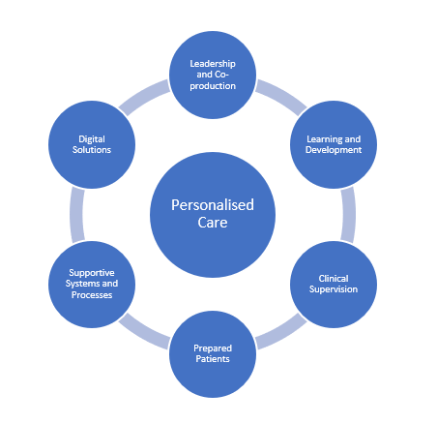
Chronic Care Model (CCM): The Chronic Care Model (CCM) is a nationally recognised framework for improving the management of long-term conditions through coordinated and proactive healthcare delivery (Feng et al, 2025). The model focuses on six key components: healthcare organisation, self-management support, delivery system design, clinical information systems, decision support, and community resources (Anderson et al, 2016). In epilepsy care, the Chronic Care Model promotes regular follow-up, multidisciplinary collaboration, evidence-based clinical practice, and improved communication between primary and specialist healthcare services (Anderson et al, 2016). It also empowers individuals with the knowledge and confidence to manage their condition effectively, reducing seizure-related complications, preventable hospital admissions, and improving long-term quality of life (Feng et al, 2025). The framework supports continuous, integrated care that addresses both the medical and psychosocial needs of people living with epilepsy (Anderson et al, 2016). 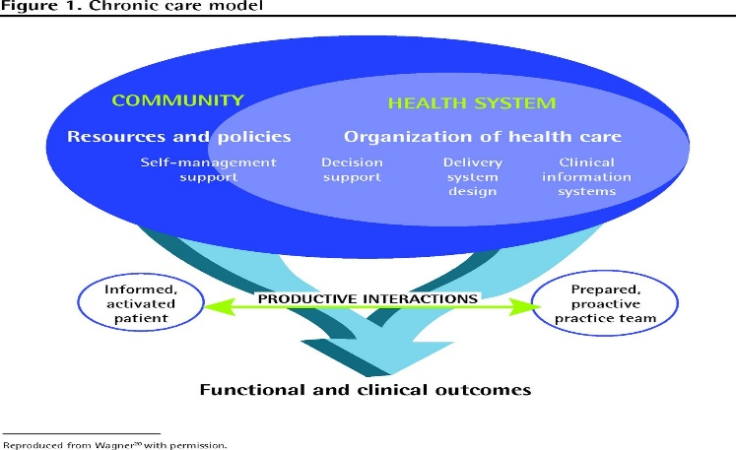

Examination of Local and National Political Health and Social Care Agendas
The management of epilepsy is supported by several local and national health and social care agendas that aim to improve patient outcomes, reduce health inequalities, and ensure high-quality, person-centred care (Al-Najjar et al, 2023). At the national level, the NHS Long Term Plan focuses on prevention, early diagnosis, integrated care, digital healthcare, and improved access to specialist services for people living with long-term conditions (Male et al, 2018). National guidance also promotes evidence-based diagnosis, treatment, regular follow-up, and coordinated care through multidisciplinary teams (Al-Najjar et al, 2023). These initiatives encourage shared decision-making, continuity of care, and greater patient involvement, helping individuals with epilepsy achieve better seizure control and an improved quality of life (Male et al, 2018).
At the local level, Integrated Care Systems (ICSs) work in partnership with NHS organisations, local authorities, social care providers, and voluntary organisations to coordinate epilepsy services within communities (Shillito et al, 2024). This integrated approach improves access to specialist epilepsy nurses, neurology services, mental health support, rehabilitation, and community-based care (Street, 2020). However, despite these developments, challenges remain, including variations in service availability, long waiting times, workforce shortages, and unequal access to specialist epilepsy services across different regions (Shillito et al, 2024). Strengthening collaboration between health and social care organisations, increasing investment in specialist services, and improving equitable access to care are essential for enhancing patient outcomes and ensuring consistent, person-centred management of epilepsy across all communities (Street, 2020).

Recommendations for Improving Person-Centred Care
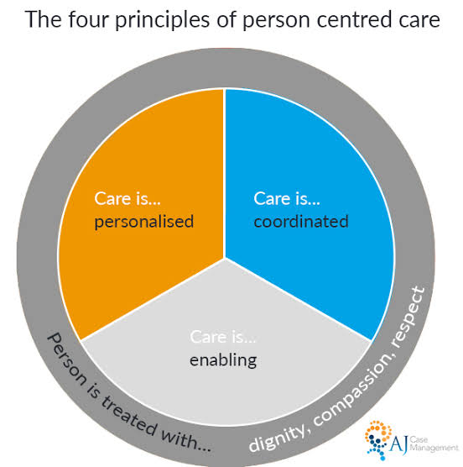
Person-Centred Care and Self-Management: Providing high-quality person-centred care is essential for improving outcomes and quality of life for people living with epilepsy (Higgins et al, 2019). Healthcare professionals should actively involve patients in shared decision-making, ensuring that treatment plans reflect individual needs, preferences, cultural values, and lifestyle (Spanos et al, 2023). Self-management should be encouraged through education on medication adherence, recognising seizure triggers, maintaining healthy sleep patterns, stress management, and seizure first aid (Higgins et al, 2019). The use of digital tools, such as seizure diary applications and remote consultations, can help individuals monitor their condition, improve communication with healthcare professionals, and support timely adjustments to treatment (Spanos et al, 2023).
Multidisciplinary Care and Family Support: A multidisciplinary approach involving neurologists, epilepsy specialist nurses, pharmacists, psychologists, dietitians, social workers, and primary care professionals should be strengthened to provide coordinated and holistic care (Higgins et al, 2019). Greater access to psychological support and counselling is important because many individuals with epilepsy experience anxiety, depression, and social isolation (Spanos et al, 2023). Families and caregivers should also receive education and practical training in seizure management to improve confidence and reduce caregiver burden (Spanos et al, 2023). Public awareness campaigns can further reduce stigma and discrimination, promoting greater acceptance of people living with epilepsy in schools, workplaces, and communities (Higgins et al, 2019).
End-of-Life Care: Although most people with epilepsy have a normal life expectancy, some individuals with severe drug-resistant epilepsy or associated neurological conditions may require advance care planning and end-of-life care (Kälviäinen and Reinikainen, 2019). Discussions about future care preferences should be introduced sensitively and involve patients, families, and healthcare professionals whenever appropriate (Kälviäinen and Reinikainen, 2019). Palliative care services should focus on symptom management, emotional support, dignity, and maintaining the best possible quality of life (Kälviäinen and Reinikainen, 2019). By strengthening person-centred care, promoting self-management, improving multidisciplinary collaboration, and ensuring appropriate end-of-life planning, healthcare services can achieve better long-term outcomes for people living with epilepsy (Kälviäinen and Reinikainen, 2019).

REFERENCES
Al-Najjar, N., Bray, L., Carter, B., Castle, A.P., Collingwood, A., Cook, G., Crudgington, H., Currier, J., Dietz, K.C., Hardy, W.A. and Hiscock, H., (2023). Changing Agendas on Sleep, Treatment and Learning in Epilepsy (CASTLE) Sleep-E: a protocol for a randomised controlled trial comparing an online behavioural sleep intervention with standard care in children with Rolandic epilepsy. BMJ open, 13(3), p.e065769.
Anderson, J., Deravin-Malone, L. and Francis, K., (2016). Frameworks for chronic care management. Chronic care nursing: A framework for practice, pp.3-19.
Bali, A., Hargreaves, D.S., Cowman, J., Lakhanpaul, M., Dunkley, C., Power, M. and Cross, J.H., (2016). Integrated care for childhood epilepsy: ongoing challenges and lessons for other long-term conditions. Archives of disease in childhood, 101(11), pp.1057-1062.
Carter, B., Cook, G., Bray, L., Collingwood, A., Saron, H. and Rouncefield-Swales, A., (2022). Parents’/caregivers’ fears and concerns about their child’s epilepsy: A scoping review. Plos one, 17(9), p.e0274001.
Chen, Z., Brodie, M.J., Ding, D. and Kwan, P., (2023). Epidemiology of epilepsy and seizures. Frontiers in epidemiology, 3, p.1273163.
Feng, T.L., Stoessl, A.J. and Harrison, R.A., (2025). Integrated care in neurology: the current landscape and future directions. Canadian Journal of Neurological Sciences, 52(2), pp.205-213.
Glasby, J., (2017). Person‐centred approaches: A policy perspective. Person‐centred practice in nursing and health care: Theory and practice, pp.67-76.
Hassan, S., Mwangi, E. and Kihato, P.K., (2022). IoT based monitoring system for epileptic patients. Heliyon, 8(6).
Higgins, A., Downes, C., Varley, J., Doherty, C.P., Begley, C. and Elliott, N., (2019). Supporting and empowering people with epilepsy: contribution of the Epilepsy Specialist Nurses (SENsE study). Seizure, 71, pp.42-49.
Jones, K.E.A., Howells, R., Mallick, A.A., Paul, S.P. and Dey, I., (2023). NICE guideline review: Epilepsies in children, young people and adults NG217. Archives of Disease in Childhood-Education and Practice, 108(6), pp.416-421.
Kälviäinen, R. and Reinikainen, M., (2019). Management of prolonged epileptic seizures and status epilepticus in palliative care patients. Epilepsy & Behavior, 101, p.106288.
Kedare, J.S. and Baliga, S.P., (2022). Management of psychiatric disorders in patients of epilepsy. Indian journal of psychiatry, 64(Suppl 2), pp.S319-S329.
Kwon, C.S., Wagner, R.G., Carpio, A., Jetté, N., Newton, C.R. and Thurman, D.J., (2022). The worldwide epilepsy treatment gap: a systematic review and recommendations for revised definitions–a report from the ILAE epidemiology commission. Epilepsia, 63(3), pp.551-564.
Lawal, M., Omobayo, H. and Lawal, K., (2018). Epilepsy: pathophysiology, clinical manifestations and treatment options. British Journal of Neuroscience Nursing, 14(2), pp.58-72.
Male, L.R., Noble, A., Snape, D.A., Dixon, P. and Marson, T., (2018). Perceptions of emergency care using a seizure care pathway for patients presenting to emergency departments in the North West of England following a seizure: a qualitative study. BMJ open, 8(9), p.e021246.
Mula, M., Brodie, M.J., de Toffol, B., Guekht, A., Hecimovic, H., Kanemoto, K., Kanner, A.M., Teixeira, A.L. and Wilson, S.J., (2022). ILAE clinical practice recommendations for the medical treatment of depression in adults with epilepsy. Epilepsia, 63(2), pp.316-334.
NHS Inform (2026), Epilepsy. https://www.nhsinform.scot/illnesses-and-conditions/brain-nerves-and-spinal-cord/epilepsy/
NICE (2022), https://www.nice.org.uk/guidance/ng217
Pellinen, J., Foster, E.C., Wilmshurst, J.M., Zuberi, S.M. and French, J., (2024). Improving epilepsy diagnosis across the lifespan: approaches and innovations. The Lancet Neurology, 23(5), pp.511-521.
Poprelka, K., Fasilis, T., Patrikelis, P., Ntinopoulou, E., Margariti, S., Verentzioti, A., Stefanatou, M., Alexoudi, A., Stavrinou, L.C., Korfias, S. and Gatzonis, S., (2025). Burden in caregivers of adults with epilepsy: a critical review. Epilepsy & Behavior, 164, p.110260.
Riney, K., Bogacz, A., Somerville, E., Hirsch, E., Nabbout, R., Scheffer, I.E., Zuberi, S.M., Alsaadi, T., Jain, S., French, J. and Specchio, N., (2022). ILAE classification and definition of epilepsy syndromes with onset at a variable age: Position statement by the ILAE Task Force on Nosology and Definitions. Epilepsia, 63(6), pp.1443-1474.
Shankar, R., Marston, X.L., Danielson, V., Do Rego, B., Lasagne, R., Williams, O. and Groves, L., (2024). Real-world evidence of epidemiology, patient characteristics, and mortality in people with drug-resistant epilepsy in the United Kingdom, 2011–2021. Journal of neurology, 271(5), pp.2473-2483.
Shillito, T., Watkins, L., Ali, H., Page, G., Pullen, A., Mitchell, S., Roy, A., Sen, A., Kinney, M., Thomas, R. and Tittensor, P., (2024). Evidencing the challenges of care delivery for people with intellectual disability and epilepsy in England by using the Step Together toolkit. BJPsych open, 10(6), p.e186.
Spanos, S., Hutchinson, K., Zurynski, Y., Rapport, F. and Goodwin, N., (2023). Integrated care in epilepsy: A scoping review of the key components of health and social care delivery. International Journal of Integrated Care, 23(S1).
Specchio, N., Wirrell, E., Scheffer, I.E., Nabbout, R., Riney, K. and Samia, P., (2022). ILAE classification and definition of epilepsy syndromes with onset in childhood: position paper by the ILAE task force on nosology and definitions. Epilepsia, 63(6), pp.1398-442.
Street, H.C.U.G.O., (2020). Step Together Integrating Care for People with Epilepsy and a Learning Disability.
Strzelczyk, A., Aledo-Serrano, A., Coppola, A., Didelot, A., Bates, E., Sainz-Fuertes, R. and Lawthom, C., (2023). The impact of epilepsy on quality of life: Findings from a European survey. Epilepsy & Behavior, 142, p.109179.
Thijs, R.D., Surges, R., O'Brien, T.J. and Sander, J.W., (2019). Epilepsy in adults. The lancet, 393(10172), pp.689-701.
Tomasini, A., Salamone, E.M., Grammaldo, L.G., D’Aniello, A. and Di Gennaro, G., (2026). Stigma as social comorbidity in epilepsy. Epilepsy & Behavior, p.111025.
Walsh, S., Donnan, J., Fortin, Y., Sikora, L., Morrissey, A., Collins, K. and MacDonald, D., (2017). A systematic review of the risks factors associated with the onset and natural progression of epilepsy. Neurotoxicology, 61, pp.64-77.
WHO (2026), Epilepsy, https://www.who.int/health-topics/epilepsy#tab=tab_1
Yang, L., Wang, Y., Chen, X., Zhang, C., Chen, J., Cheng, H. and Zhang, L., (2021). Risk factors for epilepsy: a national cross-sectional study from national health and nutrition examination survey 2013 to 2018. International journal of general medicine, pp.4405-4411.
Zhao, X., Dai, J., Jiang, L. and Hu, Y., (2026). Global prevalence of epilepsy and temporal trends, 1980–2025: a systematic review and meta-analysis. Neuroepidemiology.
Zuberi, S.M., Wirrell, E., Yozawitz, E., Wilmshurst, J.M., Specchio, N., Riney, K., Pressler, R., Auvin, S., Samia, P., Hirsch, E. and Galicchio, S., (2022). ILAE classification and definition of epilepsy syndromes with onset in neonates and infants: Position statement by the ILAE Task Force on Nosology and Definitions. Epilepsia, 63(6), pp.1349-1397.

