Amna Khan
1817007
Effective team work and communication
Lecturer; Benedict Maher
August 2019
Table of Contents

Introduction 3
The idea of the various communication 4
Models of communication 6
Methods of written communication 9
Conclusion 12
Reference 13
Appendices 14

Introduction
The teamwork is the most important aspect in the workplace. However, teamwork cannot be formed if there is no communication involved. The communication is the most important aspect of any form of organization as it allows various employers and employees within the workplace to communicate with each other and ensure that they could work effectively with teamwork. The communication also isn’t only related with teamwork.
Communication is the basic way of how we are able to send information from one source to another. So communication is a vital aspect that is taken very seriously within job sector as well. Communication is the key that connects every party involved with the organization. So in this module we learned a lot about the basics of the communication and the various models that explain the different ways communication can take place in the workplace along with the knowledge of various ways to conduct the communication process with individuals related with the organization. This portfolio includes what I have learned so far about communication from our module and the knowledge I have obtained from the various lectures and exercises that were focused on the communication in general. I have also prepared this portfolio using the scenario of my friend’s workplace who is working in a care home organization in the UK so that I could present my understanding on the communication in the context of the health and social care sector in general.

The idea of the various communication
The communication is basically the method that we use to exchange our information to one or more individuals. So this means when an individual is talking to another individual or within a group, then this exchange of information that takes place is the communication. The first communication process is the verbal communication which simply means communication that is done simply through spoken words. This is what we say to people using words, sentences using our mouth. This is the most common form of communication that is happening almost always in the society as well as within the organizations as well. The other is the non-verbal communication which revolves around exchanging information using ways that does not involve speaking (Morgan, 2016). So this usually includes methods such as writing, signs, gestures, visual representation of an information, attitudes of the individuals etc.
So based on these ideas, I can relate my learning from the lecture to the workplace examples of the care home where my friend works. Usually care homes require the service providers to care for people who have certain physical or mental illness that prevents them from moving or doing certain tasks. Care homes also care for people who are elderly.. My friend himself is a care staff so he had been assigned to care for several patients. So there are some patients who are able to talk but cannot do other things such as moving. And there are some patients who cannot talk as well, so in those cases the professionals in the care home has to make use of other ways to communicate with these users. The verbal communication for instance is used on those patients who can talk and hear as they are able to clearly state their needs. However, when dealing with patients who cannot speak or have difficulties in hearing; the care staffs, like my friend, have to use the communication that is non-verbal in general as speaking to these users would not work here. So what my friend and other staffs in their care home do is that they make use of the common gestures and signs that the users can understand and using the same method the staffs try to learn the needs of the users from what signs they are showing to the staffs. In terms of communication between the staffs in the care home, both communication is used, but in case of the non-verbal communication, the care home where my friend works rely most on letters, emails etc.
In our lectures we have also learned that both forms of communication are important when it comes to the job interviews. CV along with a cover letter could do the job as a non-verbal communication to present myself as a competent candidate for the work. But my body language during the interviews is important as it will allow me to show my confidence to the employers. Saying something confident while restricting the body movements would simply mean that I am not really that much confident, which is what the message that the employers would get.
Communication is also very important for the management as well (Blanchard, 2000). For instance, if the management at the care home does not pay attention to what the staffs has to say or does not communicate the organization policies to the staffs clearly, then both situations can lead to employees performing ineffectively that would harm the performance of the organization and all of these at the cost of poor communication.
So in our lectures we have learned that both the verbal and non-verbal communication has to be maintained within the workplace and in terms of health and social care sector this is a necessity.

Models of communication
The models of communication have been described below –

Berlo’s model of communication
This is a communication model that consists of four stages of processes that starts the communication until it reaches to the point where the communication is supposed be ending. The stages basically start with the source that generates the information or expression which would be communicated. The sender in this case use the source to encode the message which could then be ready to transfer to the receiver using a channel. With the help of the channel, the receiver decodes the meaning of the message and then finally receives the actual information from the communication process (Power, 2014). This process can also revert where the receiver would reply something to the sender, in which case the receiver would now become the sender and the original sender would become the receiver, while the entire process of transferring the message would be the same.
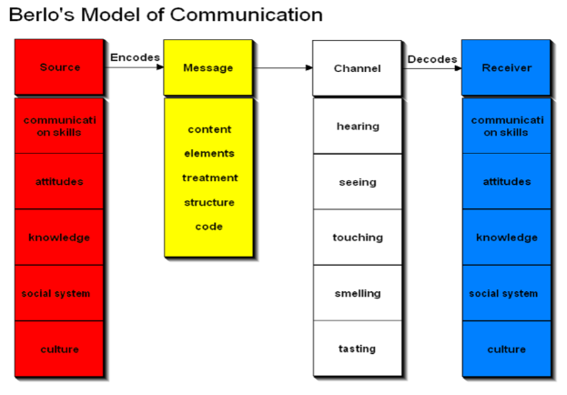
Figure: Berlo’s model of communication

From what I understand from this model that have been explained to us in this module; this model can relate with the care home scenario where my friend works. For instance, if my friend has to communicate with a patient then he has to use the right language and have the right communication skill to start communicating what he has to say to the patient. He would then encode the message through his speech, which will be heard by the patient which means the patient would use hearing sense as the channel to receive the message. Since the message from my friend has to match with the language that the patient speaks, the patient then would be able to decode the message and would realize the meaning of the information. And in this case the patient can also reply to my friend about his needs, which would then be transferred to my friend using the same way he communicated with the patient. This would go on until both of them have finished exchanging their communication process.
Shannon-Weaver Mathematical Model
This model basically indicates the communication process between two individuals while there is a message being transferred from one individual to another. One individual in this case would say something or write something using words and sentences which would be the information source and the words and sentences or signs to describe the information is the way to transmit the message or in other words encoding it. This message then goes to the other individual using a channel which could be for instance a telephone or email. Using the same channel the receiver who listens or reads the message tries to decode it and then it is considered that the message has reached its destination. For instance, if my friend sends an email to his supervisor, then the email system would encode the message to written form and when it is sent to the supervisor, he will decode it by reading and after interpreting what my friend communicated with the email, the supervisor could further send another email to my friend as a reply, in which case this process starts again and keeps happening until they are satisfied that they have exchanged enough information. It is necessary to mention that within this process the channel could be interfered by various noise source which can affect the way the message would be decoded by the receiver and sometimes it is possible that the message would not reach its destination due to noise level. So this model requires the communication process to have less noise to ensure that the communication process could be successful.
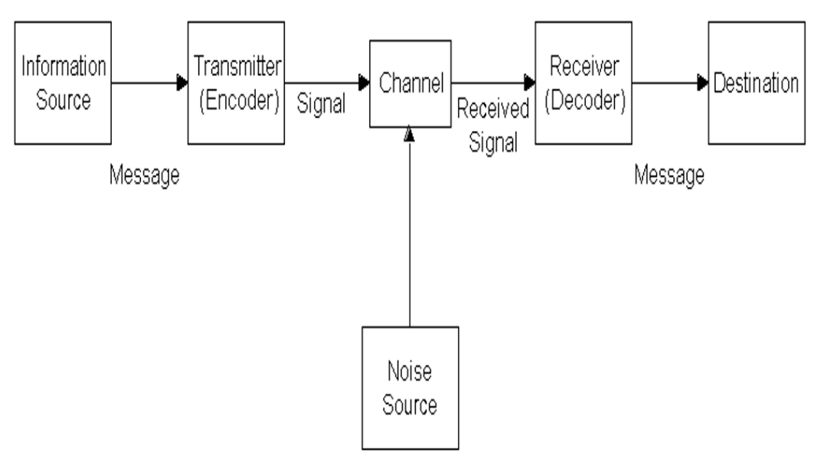
Figure: Scramm’s model of communication

Methods of written communication
The written communication is a bit complicated than the other communication methods. Usually this form of communication is used for formal messages that are sent to the various stakeholders related with the workplace.
In our lectures, we have been introduced to many forms of writing communications. There are letters such as formal letters, formal reports, memos, service information, emails, staff handbooks, marketing advertisements and many other that are used as the means to exchange information through writings.
.In modern days, emails are used largely rather than letters. So from my learning from the lectures in the class about the ways to write a professional email, I have explained this based on the examples of my friend’s workplace which is a care home organization in the UK so that I could explain why these methods are necessary to maintain in health and social care sector.
Knowing the purpose
The sender of the email has to actually know why this email needs to be sent to the receiver. For instance, if my friend, as a care home staff, has to report to his supervisors about a patient’s treatment, then my friend has to know the details and should mention it clearly in the email (Thompson, 2011).
The email has to include a single purpose
The basic of the email is that it is shorter than letters, so one email should communicate about one specific topic. If my friend has to report about the patient’s treatment in the care home to his supervisor, then he needs to only write about this. If there is another issue in the care home, then that needs to be stated in another email, not in the same email.
Showing empathy
The sender also has to care for some empathy approaches in the point of view of the receiver. When my friend communicates with his supervisors or his colleagues about anything, he needs to mention some complimentary words such as thanking the reader for giving the time to read this email.
Keeping the introductions smaller
In health and social care sector, every staffs and managers are busy. So it is necessary for the staffs to keep the introductions as brief as they could.
Emails need to include five sentences
I have learned from my lecture that emails should include maximum of five sentences. This is a good way to keep the email brief.
Maintaining standard structure
I have also learned that standards structure of the email can really help the email to be shorter yet with more meaningful.
Use of shorter words, and sentences
Using short words, sentences and paragraphs can drastically reduce the size of the email, making it easier to understand.

Here is an example of a professional email –

Manager,
X Care Home,
UK.

Sir,
Hope you are doing well. I have been told to report you about the patient suffering from dementia who recently was admitted into our care home. I am happy to let you know that I have been successfully able to communicate with the patient and was able to identify his needs. I have reported the findings to the assigned doctor as well. We are now awaiting your approval for the necessary medications and treatment procedures for the patient so that we could start the treatment.
Waiting for your reply.

Sincerely,
Tom Smith
Care Staff
X Care Home,
UK.

Conclusion
The portfolio successfully explains my learning from the module and I believe I have the understanding of the communication process as well as various methods of communication. I have also learned about professional email writings that can be used as a way to communicate within the health and social care organization.

Reference
Blanchard, K.H., Hersey, P. and Johnson, D.E. (2000). Management of organizational behavior: Leading human resources. 8th edn. United Kingdom: Prentice Hall
Morgan, P. (2016). The Business Student’s Guide to Study and Employability. Sage Publications
De Janasz, S., Crossman, J., Campbell, N., &amp; Power, M. (2014). Interpersonal skills in organisations (2nd ed., pp. 424-431). North Ryde, NSW: Mc-Graw-Hill Education.
Thompson, N. (2011). Effective Communication (2nd ed.). Palgrave Macmillan.

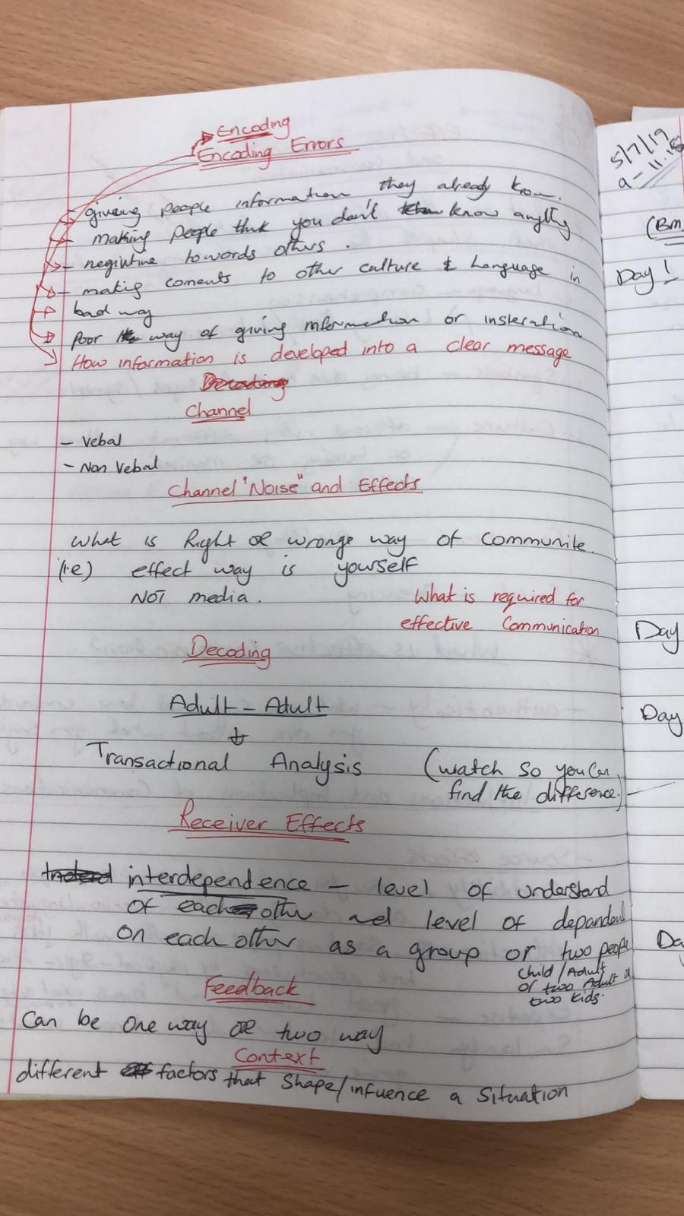
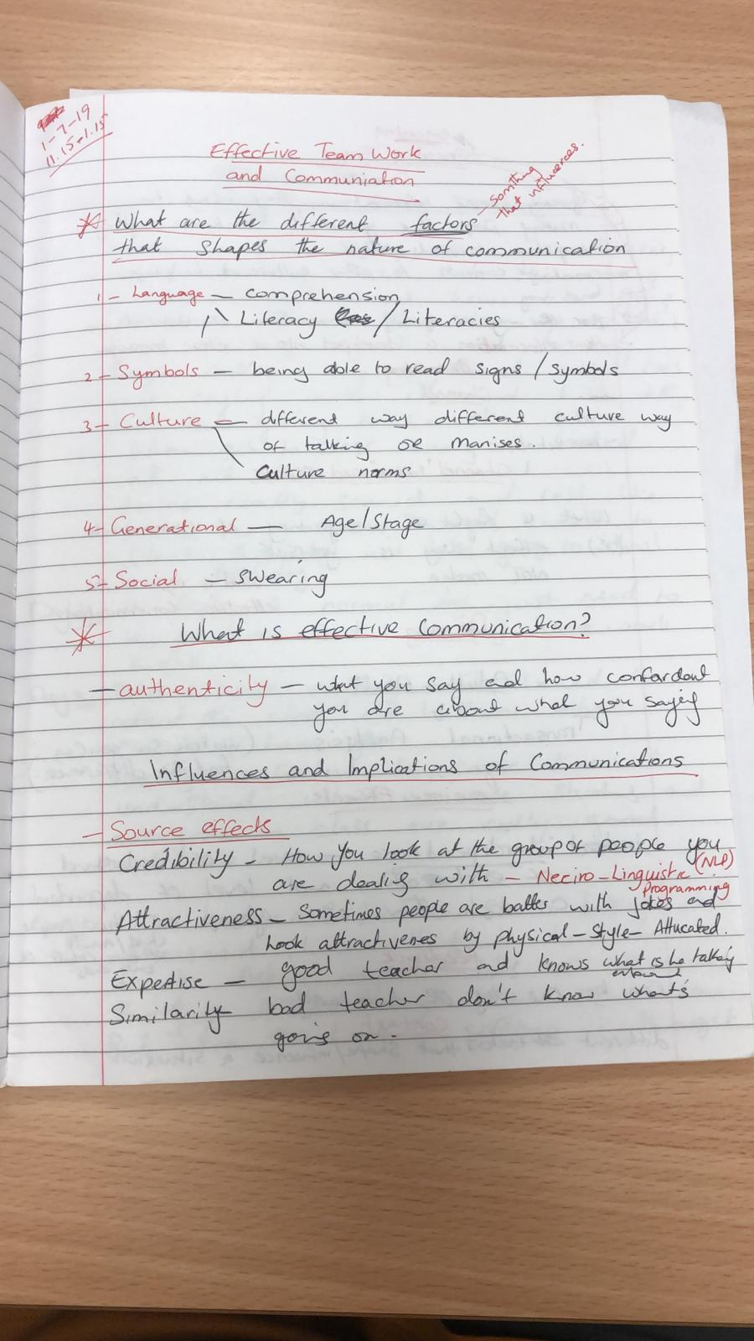
Appendices


