
Skills for the Workplace
Module Assignment Submission
Student Name: | Musharaf Ahmed
Student Number: | 1710622
Module No: | BMSK4004
Module Title: | Problem solving and decision making
Tutor: | Tanja Nathan

- Contents
Introduction: 3
Define the problem 4
Analysis of information 5
The range of alternative solutions 8
Decision-making techniques 9
Plan for implementing the solutions 13
Communicate the plan to the shareholders 14
Appropriate monitoring and review techniques 15
Conclusion 17
References 18

Introduction:
The main objective of a business organization is to maximize the wealth of the shareholders. It can be increased by increasing firm value (Hale, 2017). For this businesses need to ensure customer responsiveness, innovation, efficiency, productivity, management, marketing, production and financial efficiency, employees' efficiency, superior quality, and customer focus. Any lacking regarding these variables can decrease the performance of the businesses. Asda is the second largest supermarket chain in the UK. Recently a net profit margin of the company isn't increasing. So, the earning level expected by the shareholders is not achieved as a result they become disappointed and cut the share price. It also a matter of concern for the management team also. Performance incentives of the managers depend on the performance of the organization. So, management needs to make a proper decision regarding this problem (Bazerman, 2017). This report mainly focuses on the sources of this problem and proper management and solutions of the problem faced by Asda.

Define the problem
The retail industry in the UK is getting very competitive in recent years. Now the industry is in the mature stage of its life cycle. A large number of customers of the market are captured by different retailers. Tesco, Sainsbury, Morrison, and Asda are known as ‘The big four’ grocer in the UK market. Besides, Aldi and Lidl also capture a large market share in the UK marker. The profit margin of Asda has fallen by 10% after the takeover by Wal-Mart. So, Asda requires developing some innovative strategies to retain the current market share and ensure a sustainable growth rate. Asda is one of the largest market players in the UK market (Dittmer, 2017). They always try to ensure a sustainable profit growth. But due to a high level of competition in the market their profit growth rate is decreasing. Recently the sales revenue of Asda is decreased by 5.7%. Net profit in 2016 was £791 million pound but in 2017 it was £712 million pound. The problem arises from some key indicators. They are:
The decrease in sales growth rate and revenue
The market becomes very competitive in the UK. Tesco, Sainsbury, Morrison, Aldi are the major competitors of Asda. Tesco, Sainsbury, Morrison, and Asda are known as the big four in the UK market. In 2016, Wal-Mart took over Asda. After that sales revenue of Asda had fallen 22.3bn pound to £21.6bn pound. So the decrease in the sales revenue causes a decrease in the profit as well (Hale, 2017).
Increase in cost of sales
Recently the cost of goods sold of Asda is also increasing. The results come from several sections of its purchasing and maintaining inventory policies. Asda purchases goods from different supplier group (Rao, 2013). Besides, Asda also uses a different distribution channel as well. Costs regarding these issues also increasing. Besides inventory holding cost is also increasing due to a higher level of inventory holdings by Asda in recent years.

Increase in operating and administrative costs
Recently operating cost of Asda is increasing highly in comparing to operating revenue. Operating costs include different types of management costs, operating overhead costs, distribution costs, administrative costs.

The decrease in return on asset and equity
We know the return on equity and return on directly depend on the after-tax net profit level. In the recent year, the net income margin of Asda has decreased. It causes a decrease in the return of asset and returns on equity. These two ratios are very important for the investors (Bazerman, 2017). They use these ratios to estimate the required rate of return from the business and adjust them to different risk factors.

Analysis of information
Asda is the second largest supermarket chain the UK. In the recent past, Wal-Mart acquired the supermarket chain (Asda) at £6.70bn. After the acquisition, Asda’s sales have fallen from £33.3bn to £21.6, which is almost 5.7% during the year 2016 to 2017. It also results in a decrease in profit before tax and profit after tax also. Profit before tax has fallen by 19% and profit after tax is fallen by almost 10% during that time. To understand the problem we have found several factors that cause a decrease in performance. Some of the major indicators described below:
Grocery price war
We know there are several big grocers in the UK. Among them, Tesco, Sainsbury, Morrison, and Asda is known as ‘the big four' in the UK. They always compete for market share. They use different innovation, technology, strategies to increase the market share. They always try to offer the best quality products at a reasonable and competitive price. Besides, they also render a wide range of after-sales services to the customer. As a result, there is a wide range of price war in the industry (Hale, 2017). Besides Adli, and Lidl has become a major rival in the market. They follow different niche marketing strategies to reach the target market and offer the best services. So, overall grocery industry not only in the UK but also in the world is getting very competitive nowadays. Besides, there is a wide range of price war among the competitors. So, price way may be one of the reasons for the fall in performance of Asda.
Increase in operating cost
We have found a decrease in sales by 5.7% but a decrease in after-tax net profit by 10%. It clearly indicates that the cost of goods sold along with operating and administrative costs have increased (Brest, 2016). We know the major operating costs of Asda include salaries, rent, utility, advertising, promotion, insurance, repair and maintenance expenses etc. There is an increasing trend of these costs figures in comparison to the sales revenue. It is another big reason for the decrease in performance of Asda.
Behavioral aspects of the customers
In 2017, Wal-Mart has taken away a cash dividend of £450 million. Besides, in recent years the views toward American by the UK, and some of the European nations are not quite satisfying. We know about the protest against the arrival of Mr. Trump in the UK. Here Asda was taken over by an American company. As a result customers’ expectation towards Asda is also affected. Actually, we think there might be some behavioral aspects of the customers for the decrease in the sales revenue of Asda after the takeover by Wal-Mart (Bazerman, 2017).
The operational and strategic threat of Wal-Mart's arrival in the UK
Wal-Mart is one of the largest retailers in the world having annual revenue of $500bn per year. It has more competitive resources, strategies, network, and manpower than existing retailers in the UK. As a result retailer like Tesco, Sainsbury, Morrison, and Adli take the entrance of Wal-Mart as a threat to the UK market (Dittmer, 2017). So, they become more active and strategic to retain the existing market share. They also focus on the expansion of customer services as well. For these wide ranges of service, a portion of the temporary customers shifted from Asda to the rest of the competitors. As a result sales of Asda decreased.
The strategy of expanding electrical and DIY operations internationally
There is a technological evaluation all around the world. We know Asda has 642 outlets across the world. Size sometimes a disadvantage for large companies like Asda. With the increase in size, it becomes more complex for efficient management. As a result, technology plays a very big role in success. But Asda didn’t increase its investment in that particular area for the previous year. Besides, Asda uses a different supplier channel to purchase crops instead of purchasing from the farmers. So it also increases cost. Here Asda can use DIY (do it yourself) to reduce cost (Hale, 2017).
There may have some other factors that have a direct or indirect impact on this reduction of performance at Asda. There also may have some external effects like social, political, technological, economic, and environmental for the profit reduction.

SWOT analysis on Asda
To provide some potential solutions to this problem faced by Asda, we need to estimate the potentiality, strength, and weakness of Asda. For this, we can use SWOT analysis. A comprehensive SWOT analysis on Asda is described below:

Strength  - Asda is the second largest supermarket chain the UK, having 642 outlets across the world, and a skilled employee base of 165,000.  - Asda has a very efficient distribution channel which can ensure a timely and cost-effective supply of goods and services  - It has been awarded one of the top 100 companies to work in the UK, which ensure a superior, innovative, and skilled employee base of Asda.  - Asda is a brand of quality, reliability, and excellence across the world  - Its current size, structure, and scope will help to provide more personalized and customized services to the target market segment (Brest, 2016). It will also create a brand loyalty as well. | Weakness  - Acquisition by Wal-Mart gives a bad signal to the market, which reduces the recent financial performance of Asda.  - Asda does not collect crops from the farmer. Collecting crops from different supplier channel increases its cost.  - Little competitive disadvantages in the price war.  - A complex management process of such a large supermarket chain.  - Asda has not been able to tackle the new entrants in the grocery industry. Some of the new retailers are taking away the market from Asda.
Opportunities  - The UK government has introduced a new technology standard and free trade agreement. As a result, Asda can easily enter the new emerging market (Dittmer, 2017).  - Recently we have found a wide range of free cash flow in Asda. They can use this cash flow for expansion in the emerging market (Hale, 2017).  - Now Wal-Mart has acquired Asda, as a result, Asda can use it as an opportunity to expand in the business across the world.  - Asda can use its innovation, skilled human resources, and technology and government flexible tax policy to increase profitability. | Threats  - Supply of innovative products and technology is not consistent and permanent. As a result, a large dependency on innovation and technology may hamper the performance (Bazerman, 2017).  - Different liability laws in different countries can expose to various liability claims given change in policies in those markets.  - The rising price and demand for raw materials can increase the price.  - Bargaining power of different supplier groups is very high. As a result production and distribution of Asda can hamper (Rao, 2013).
Figure: SWOT analysis on Asda

The range of alternative solutions
Management, as well as the stockholders of Asda, is very concern about the recent decline in performance of Asda. So Asda needs to take some actions to overcome from this situation. Some potential solutions for Asda are described below:
Increasing customer focus and concentration
In the modern era of business customers are treated as the most valuable things. Customer satisfaction is very important here. Satisfied customers help to bring new customers to the business. So Asda needs to focus on creating a valued customer base. They need to introduce a wide range of products and services according to the need of the customers. It will help to reduce customer shifting to the different grocer. For this Asda needs to increase effective communication and relationship with the customers.
Increasing employees’ participation in decision making
Employees are the vital resources of Asda. Their job starts from purchasing products and ends up with the distribution to the final consumers. So their efficiency and productivity have a direct relationship with the performance of the organization (Dittmer, 2017). Asda needs to find out the motivational factors to exert the best efforts from the employees. Besides sales representative and sales assistants have more reliable knowledge about the customers’ behavior. So, their participation will not only help to increase sales but also motivate them as well.
Increasing online involvement
After introducing online service in 2000 by Asda there was a large increase in sales revenue. But still, it is far behind of Tesco. Currently, Tesco has an online market share of 16.9%. In comparing to Tesco Asda has only half of that. So it is a very crucial point for improvement to Asda. Besides, it also helps to decrease the operating cost of Asda.
Valuing customers’ feedback
Smooth communication and understanding customer behavior is very crucial. Sometimes there may have an expectation gap between supplier and the customers. Here customer feedback can play a very big role (Hale, 2017). Asda needs to deal with customers’ feedback very consciously. It is a direct and reliable source of customers’ information. If Asda can efficiently manage and deal with customers’ feedback then customers will realize that Asda is concern about their services. As a result, they become more satisfied and bring more customers to Asda.
Offering different discount and pricing strategies
Asda can introduce different discounting techniques to improve sales performance. The price cut may help to bring new customers within Asda (Rao, 2013). Then it can make proper communication, collect feedback, and deal with customers problems regarding products and services of Asda. It helps to build more personalize relationship with the customers and increase customer value.
Acquire or merge with a local representative
Asda can acquire some local distribution channel. The smoothening distribution channel is very crucial. It helps to decrease carrying and distribution cost as well. It may ensure a proper use of free cash flow as well. Besides, it will help to ensure a proper distribution of products and services. It also helps to create a barrier in a different location and reach a wide range of customers as well.

Decision-making techniques
There are several decision-making techniques. There are some decision-making models as well. Efficient decision making depends on several crucial factors like understanding the situation, internal and external factors, customers and environment (Dittmer, 2017). Here, Asda can select different techniques for different locations according to local demand. Some of the efficient decision-making techniques regarding on Asda’s profit decrease are described below:
Force filed analysis:
For taking changing and challenging decisions in Asda’s problem, Force filed analysis technique can be used by management. To conduct this analysis, the possible solutions of profit reduction should be described in the middle of a paper and all possible factors should be listed on the left side of the paper in a column also known as driving forces. Then all forces against changes will be listed on the right side in a column restraining forces. After that management of Asda should pay score and summarize score for every column. These forces will help to achieve the desired state of Asda. Then management can make the decision for increment profit of Asda using this force field analysis.
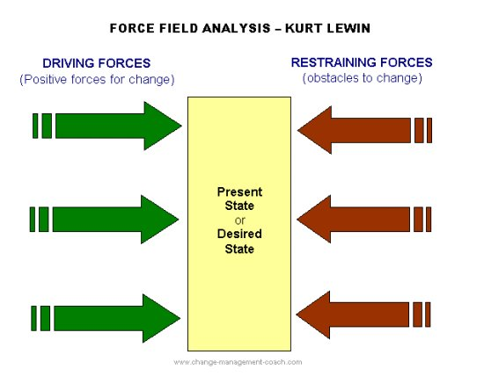
Figure: Forced field model

Burk Litwin model:
Burk Litwin model is a change model which can be used in the decision making in Asda. This model can establish the link among Asda’s productivity and performance and inside and outside factors which influence firm performance. It also deals with environmental factors. These factors can change Asda’s vision, mission, goals, strategy, culture, and so on which can affect the motivation level of employees. Here both the strategic goal and organizational culture help to shape the leadership style within Asda. This model emphasizes the effectiveness of the employees and leadership through shaping organizational culture. It suggests to identify external factors and establish its indirect impact, to examine mission and vision of Asda in terms of workers point of view, to study and change Asda’s leadership and organizational culture, to develop efficiency, quality, and productivity of employees in order to enhance Asda’s profit.
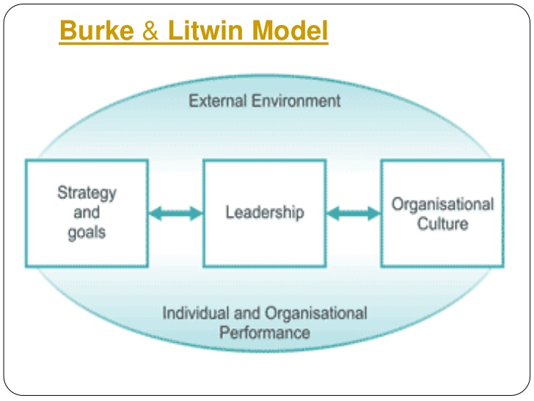
Figure: Burk Litwin model
Decision-making matrix
The decision matrix is widely used for making the best decision regarding different situations. It helps to compare different alternatives solutions with different criteria (Brest, 2016). Then the decision matrix compares worth, cost and value of different alternatives. Here we have found a wide range of solutions for Asda’s current situation. Now using the decision-making matrix we can find the best alternatives for Asda.
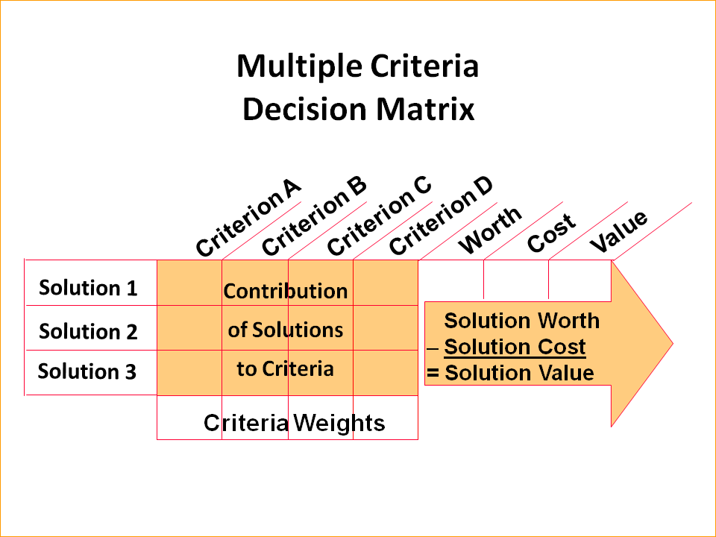
Figure: Decision matrix
Source: (Hale, 2017)

Decision tree
A decision tree is another crucial technique for decision making. It also compares different alternatives regarding their probability. For example, if Asda introduces a cash discount in the market their sales volume will increase. But the fact depends on the competitors in the market. Because if the competitors also introduce discount, the ultimate impact may not be the same as it was in before (Bazerman, 2017). There is also an implementation of probability while comparing different alternatives.
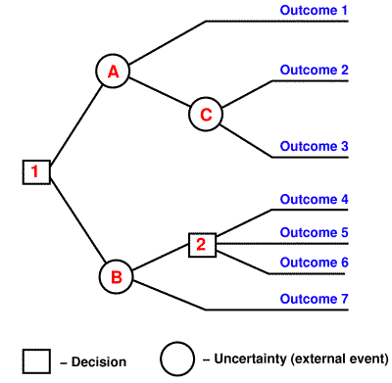
Figure: decision tree
Source: (Brest, 2016)

Z score
Z score is also a widely used technique to evaluate alternatives. It is actually a statistical technique. Under this, it is required to know the Z score for a given level of confidence level (Hale, 2017). If calculated the Z value of an alternative is less than the table value for a given level of confidence level, then the alternative is acceptable.

Plan for implementing the solutions
Asda needs to develop a SMART plan, take proper actions to implement the plan. Here SMART stands for Specific, Measurable, Attainable, Relevant, and Timely. Asda needs to develop such a plan. Executives of Asda should be more practical, technical, and long-term focusing on implementing the plan. Different aspects of developing and implementing the plan are described below:
Develop a SMART plan
We have already described the problem faced by Asda. There is a loss of market share and profit margin as well. Let us assume that Asda wants to increase net profit by 10%. It is actually specific. The plan is segmented to different quartile (Brest, 2016). Each quartile will have a 2.5% profit growth. The target is quite getable for Asda. It is relevant, specific and measurable as well. Then Asda needs to focus on time management as well.
Internal factors co-ordination
Internal factors mainly focus on the human resource of Asda. The team working, communication, decision making, interpersonal skill, customer focus is very crucial here. Besides, Asda should take some steps to increase the motivation of the employee. They may redesign their motivational activities. Performance-based payment may increase the performance of the employee as well (Dittmer, 2017). They also should focus on the incentives to the top management as well to exert the best efforts from them.
Customers focus & market concentration
Customer focus and satisfaction is the most crucial variables to increase the market share. They need to arrange more promotional activities. Besides they need to focus on the price and quality of products and services to increase customer satisfaction. They need to improve personalize customer communication.

Understand the relationship with external variables
External variables mainly include economic, environmental, social, political, and technological factors. For this PESTLE analysis can play a very big role. We know political factors can give some opportunities to Asda. They need to increase social involvement, and concern about legal requirement by the UK government.
Strategies for expanding electrical and DIY operations internationally
Asda should develop a comprehensive plan for expanding and DIY operations internationally. It will help to reach a wide range of customers at a lower cost. Besides, Asda can establish direct communication, and collect feedback using technology. It also helps to analyze the buying behavior of the customers. We know Asda has 642 outlets across the world. Size sometimes a disadvantage for large companies like Asda. So, technological integration is vital for Asda (Bazerman, 2017). Besides, Asda uses a different supplier channel to purchase crops instead of purchasing from the farmers. Here Asda can use DIY (do it yourself) to reduce cost and increase efficiency.

Communicate the plan to the shareholders
The main objective of Asda is to maximize the wealth of the shareholders. The management team works as an agent of shareholders. Shareholders interest is directly related to the profit performance improvement plan (Hale, 2017). We know Wal-Mart becomes the parent company of Asda. So, Asda needs to communicate with Wal-Mart and the rest of the shareholders about the implementation of the plan.
Get prepared the plan
Here we know Asda wants to increase its profit after tax by 10% for the next year. For this management team needs to prepare a report regarding well-developed logics, internal and external analysis, judgments, skills, experience, and findings from the market. The plan must be focusing on the accuracy of information, diversity, flexibility, simplicity as well (Dittmer, 2017).
Prepare the presentation
The presentation is the best way to communicate with a wide range of shareholders at a very short time but very efficiently. In general, the presentation is an integrated technique for presenting relevant information (Rao, 2013). Presentation of data must be more objective rather than subjective data. During a presentation session, the presenters must need to present the crucial information in an efficient way. They can use an image, graph, and figure for that.
Appealing expectations
While presenting information, presenters need to address the expectations of the information users. Here shareholders are concern about the decrease in the profit margin. So, information regarding profit margin improvement is always expected by the shareholders. Shareholders may ask for further improvement and flexibility about the plan. There should have some alternatives answer for different expectations of the listeners.
Specific examples of the data
Specific examples and market data regarding profit decrease are very important. For this presentation, the recent data of the grocery industry is very crucial. It can include total sales revenue data, cost of selling, profit margin, growth, market share, return, dividend etc. of the competitors of Asda. Here the presentation of using priority basis is very crucial. Besides, the presentation should be a focus on some numeric data regarding target sales, growth etc.

Appropriate monitoring and review techniques
Performance improvement is a long run and continuous process. To improve profit performance of Asda a continuous evaluation and monitoring program is very crucial (Brest, 2016). Some comprehensive techniques to develop a good monitoring system is described below:

Designing an effective monitoring and evaluation program
A monitoring system must be developed on cause and effects basis. For this Asda needs to develop a skilled monitoring panel considering the resources available in Asda. The team needs to communicate with the internal and external parties for superior efficiency (Dittmer, 2017). They need to skill enough to understand and describe the different situation and make effective decisions.
Set a scheduled monitoring date
Monitoring team needs to develop a comprehensive monitoring schedule to monitor the performance. Monitoring data should be developed on a short-term basis but related to the long-term objective of raising profit by 10%. They also need to focus on the norms and organizational culture while setting the plan.
Monitoring trigger points for implementation of adaptation actions to improve performance
We know our annual objective is to increase net profit by 10%. For this, we need to develop some sectional and short-term strategies to reach the final destination. The monitor team should collect information on daily sales revenue (Dittmer, 2017). Then compare it to different section wise benchmark. If there is any deviation they need to take action immediately.
Monitoring outputs and taking corrective actions if necessary
Monitoring team should continuously evaluate the outputs of a newly developed plan to improve profit performance of Asda. They need to collect feedback not only from customers but also from the employees of Asda (Hale, 2017). They should always compare the output with the benchmark. If there is any deviation, they need to identify the reasons behind the deviations and take corrective actions as well. There need to have more flexibility, efficiency, and reliability of the monitoring team.

Reporting to stakeholders and community
Asda as a business organization provides quartile and annual report of performance to the stakeholders. In these reports, they should focus on the improvement of adaptation program. it is essential for monitoring team to engage with stakeholders and different relevant communities for reporting purpose (Brest, 2016). There is a tendency of monitoring team to prepare the report using complex and detailed statistical data, graphs etc. But all the shareholders are not skilled enough. They want to know the strengths and weaknesses of a given action. They can describe results using ‘very good', ‘good", ‘poor', ‘very poor', or more general statements such as ‘positive', ‘of concern', ‘action required' etc. Besides, they also need to collect feedback from the shareholders and if necessary should take corrective actions.

Conclusion
There are always some challenges exist in the business environment. Business should always focus on the long-term prospects of the shareholders. Here profit decreasing trend of Asda should not last for a longer period of time (Bazerman, 2017). In this report, we have tried to find out the most crucial things behind the decrease in the profit of Asda. For this, we have identified the impact of the external and internal factors on Asda. Asda is very efficient in human resource management. Depending on some other factors we have developed some strategies to overcome the problem. In this report, we have mainly focused on customer focus, customer involvement, and technological factors to improve the profit performance of Asda.

References
- ADAIR, J. (2017). DECISION MAKING AND PROBLEM SOLVING. [S.l.]: KOGAN PAGE.
- Brest, P., & Krieger, L. (2016) Problem solving, decision making, and professional judgment.
- Cengage Learning Custom P. (2016). Illustrated course guides. [Place of publication not identified].
- Dittmer, R., & McFarland, S. (2017). 151 quick ideas for delegating and decision making. Franklin Lakes, NJ: Career Press.
- Eliot, G. (2016). The mill on the Floss. New York: Open Road Integrated Media.
- Fitzgerald, S. (2013). Decision making. Oxford, U.K.: Capstone Pub.
- Hale, R., & Whitlam, P. (2017). Practical problem solving & decision making. London: Kogan Page.
- Linstone, H. (2009). Decision making for technology executives. Boston: Artech House.
- Shapira, Z. (2014). Organizational decision making. Cambridge: Cambridge University Press.
- Anderson, D., Sweeney, D., & Williams, T. (2017) An introduction to management science.
- Bazerman, M., & Moore, D. (2017) Judgment in managerial decision making.
- Bulger RE, M. (2015). Society's Choices. [Place of publication not identified]: National Academies Press (US).
- Ho, C. (2010). Crisis decision making. New York: Nova Science Publishers.
- Linstone, H. (2009). Decision making for technology executives. Boston: Artech House.
- Papadakis, V., & Barwise, P. (2013). Strategic decisions. Dordrecht: Kluwer Academic Publishers.
- Rao, R. (2013). Decision making in a manufacturing environment using graph theory and fuzzy multiple attribute decision making methods. London: Springer.

