https://github.com/Rhys-Davie5/Lab4

Task 1

What's Happening in this code?
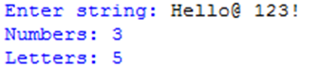
This code works by counting how many letters there are in a string and also counts how many numbers are in a string

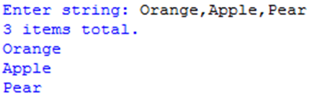

This code works by counting the total number of items and listing them below

What is your understanding of Functions, Methods, and Classes?

A function is a block of code that can perform a series of task when it is called and it then can create an output while also keeping the code clean and simple.

Methods are blocks of code that also perform a task that is specific. However, methods are defined within the context of a class or an object.

Classes are one of the ways to organize and encapsulate data, behavior into a single unit.

Correct the Code

# Given a radius value, print the circumference of a circle.
# Formula for a circumference is c = pi * 2 * radius

class Circle:
def __init__(self, radius):
self.radius = radius

def circumference(self):
pi = 3.14
circumferenceValue = pi * self.radius * 2
return circumferenceValue

def printCircumference(self):
myCircumference = self.circumference()
print("Circumference of a circle with a radius of " + str(self.radius) + " is " + str(myCircumference))

# First instantiation of the Circle class.
circle1 = Circle(2)
# Call the printCircumference for the instantiated circle1 class.
circle1.printCircumference()

# Two more instantiations and method calls for the Circle class.
circle2 = Circle(5)
circle2.printCircumference()

circle3 = Circle(7)
circle3.printCircumference()

Correct the Code 2

class Student:
def __init__(self, name, id):
self.name = name
self.id = id
self.courses = []
self.grades = {}
def register(self, course):
self.courses.add(course)
def add_grade(self, course, grade):
self.grades[course] = grades
def get_grades(self):
return self.grade
class Course:
def __init__(self, name):
self.name = name
self.students = []
def add_student(self, student):
self.students.append(student)
def get_students(self):
return self.student

def main():
# create students
alice = Student("Alice", 1)
bob = Student("Bob", 2)
charlie = Student("Charlie", 3)
# create courses
math = Course("Math")
physics = Course("Physics")
chemistry = Course("Chemistry")
# register students for courses
math.add_student(alice)
math.add_student(bob)
physics.add_student(bob)
chemistry.add_student(charlie)
# add grades
alice.add_grades(math, 90)
bob.add_grades(math, 85)
bob.add_grades(physics, 92)
charlie.add_grades(chemistry, 87)
# print out student grades
for student in [alice, bob, charlie]:
grades = student.get_grade()
for course, grade in grades.items():
print(f"{student.name} received a grade of {grade} in {course.name}")
if __name__ == "__main__":
main()

The register method is attempting to call the add method on self courses, but its initialized as an empty list, not a set. I should change it to self.courses = set() or use the append method instead of add.

In the add grade method, the dictionary self grades are being updated with non-existent variable grades. It should be self grades[course] = grade.

The get grades method is returning self grade, which is not defined. It should be.
In the Course class, the add student method is using self student, which is not defined. It should be self students.

Similarly, the getstudents method is returning self student, which should be self students.

Task 2
https://github.com/Rhys-Davie5/Lab4

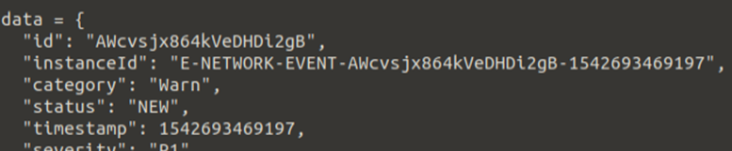

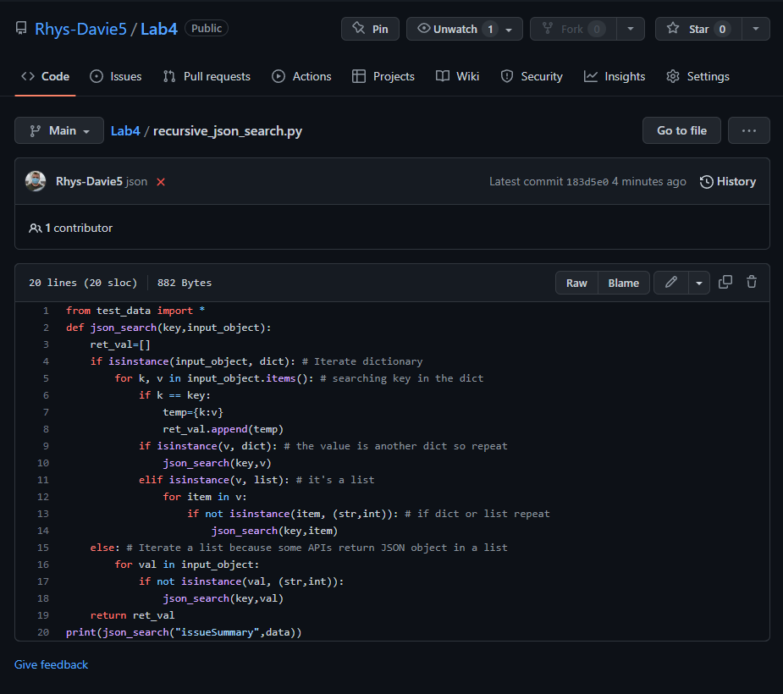

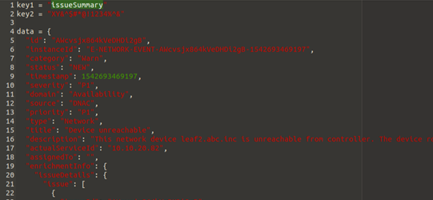

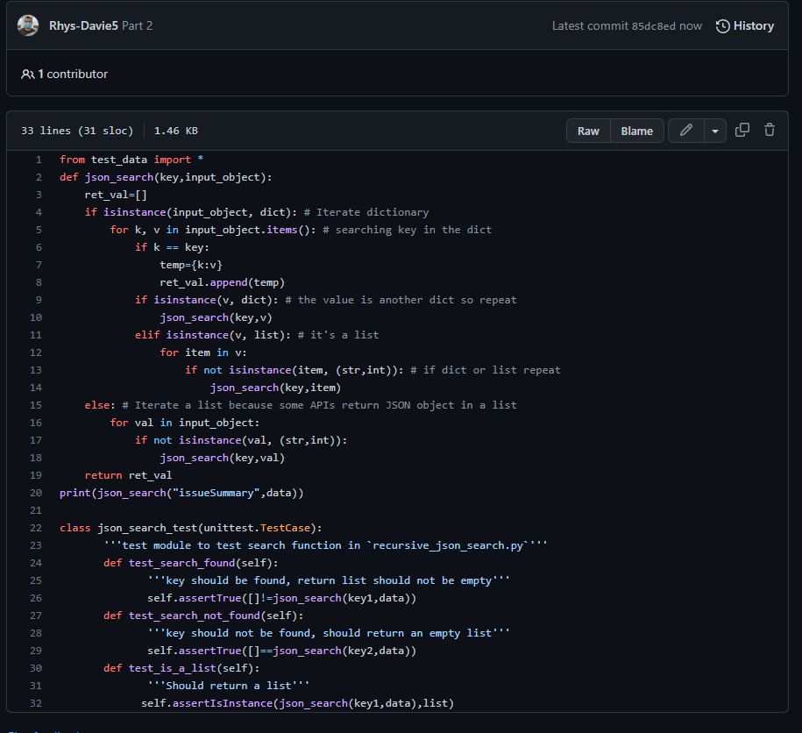

In this screenshot I added the new code that subclasses the testcase of the unittest framework

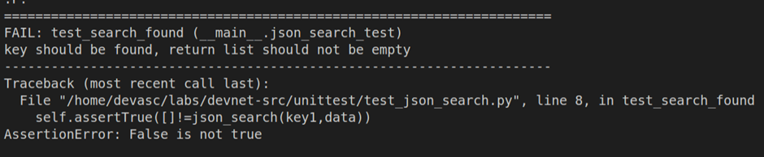

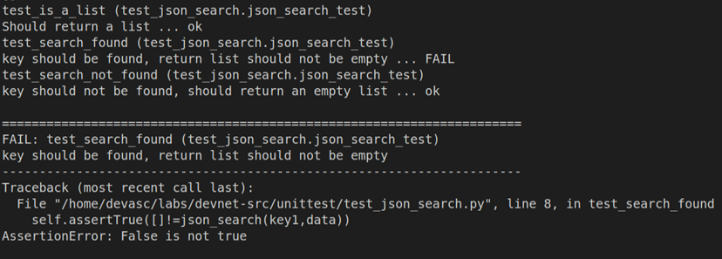

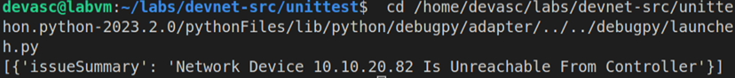

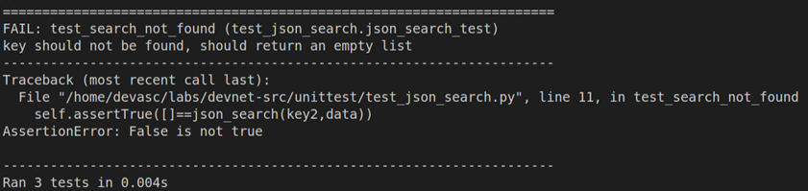

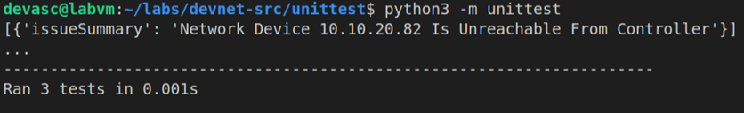

Task 3
Explain the theories, concepts, etc. meaningfully to show your understanding.
Clean Coding is writing code that is easy to read and understand to everyone else that reads the code, this is important because if the code isn’t readable then there are going to be a lot of setbacks.

There is also a technique called Unit testing that is used for testing different components of code in an isolated environment so it doesn’t break or destroy and other software that is running on the computer.

The last process is called Parsing and it’s a method of analyzing code for its structure and meaning and it's mainly found in compilers like PyCharm which turns source code into code that is able to be run on a computer efficiently.

Examine and break information down into parts, make inferences, compile, compare information.
Clean coding, Unit testing and Parsing is useful for software development because of their wide benefits in the development of projects.

Rather than describing what, you also need to justify: Why? How? When? Who? Where? At what cost? Etc appropriately and adequately.

Clean coding is important for everyone else to read the code, this is done by sorting the code into functions so they can then be called when they are needed instead of copying and pasting the same code again and again.

It is crucial to provide evidence that you have reflected. provide justification/evidence for your arguments and judgements.
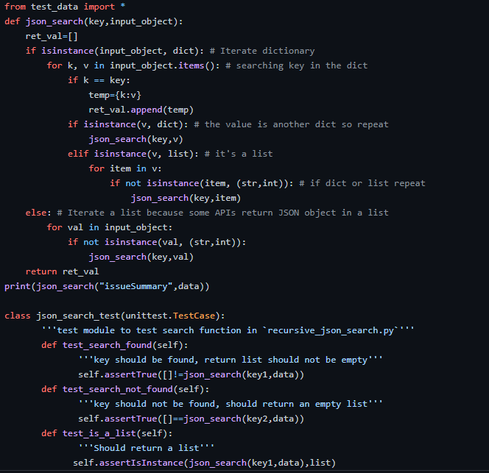
In this code it's sorted into a function which can be called later on in the code which is useful for keeping the number of code itself slim to also reduce file size but also increase the speed of the program when it is run.

Explain the code

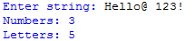

This code works by counting how many letters there are in a string and also counts how many numbers are in a string

This code works by counting the total number of items and listing them below

What errors did you get while doing the above task?
When writing this code I had trouble with the list code because I am not familiar of the correct method to use the list but after a bit of testing I figured out how to do it.
What is your understanding of Functions, Methods, and Classes?
Functions, methods, and classes are concepts in object oriented programming. A function is a piece of code that performs a task that is specific and can be called multiple times to execute that task. A method is similar to the function, but it is defined within a class and operates on instances of that class. A class is a blueprint for creating objects that contain attributes and methods. Classes allow for encapsulation, inheritance, and polymorphism, which are all important concepts in object-oriented programming.
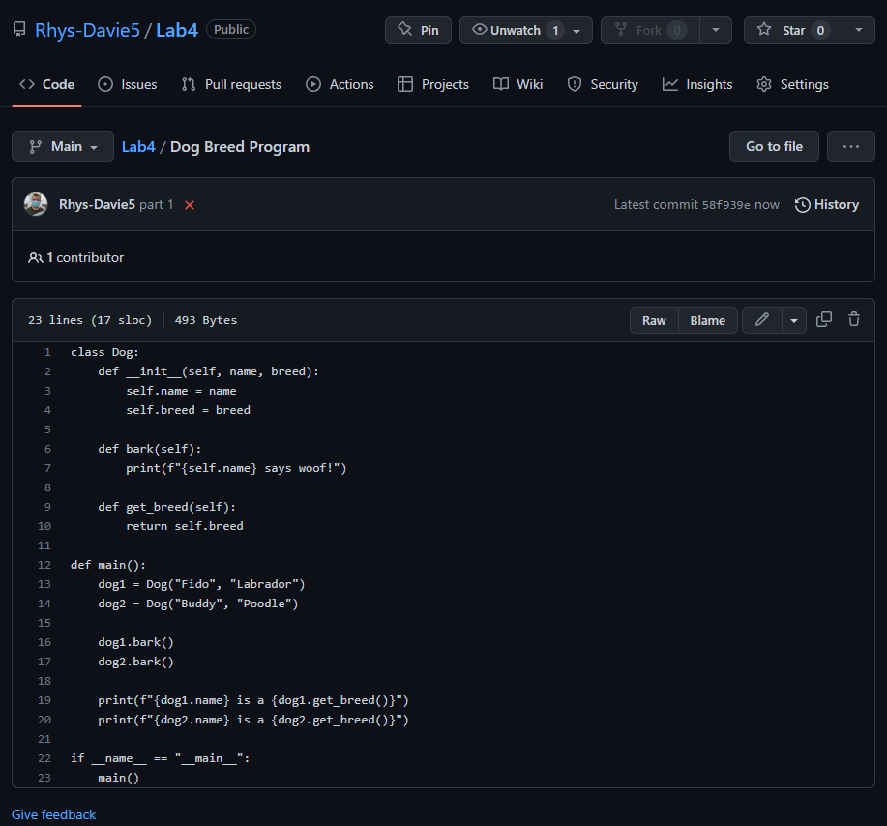
Here is a program that was quickly made to demonstrate Classes, Methods, and Functions. The program defines a dog class that represents a dog, with instance variables for the dog's name and breed, and methods for making the dog bark and retrieving its breed.

In the main function, two dog objects are created and their methods are called to demonstrate their behavior. The first Dog object, named Fido, is a Labrador and is made to bark. The second Dog object, named Buddy, is a Poodle and is also made to bark. The program then prints out the breed of each Dog object using the get breed method.

