Problem solving and decision making case study (TESCO)
Table of Contents
Introduction 3
Task 1 4
Providing an overview to the organization which includes the development of TESCO and a description of it’s current product portfolio 4
Task 2 6
Discuss how TESCO has planned, communicated, monitored and reviewed previous attempts to resolve its problems 6
Task 3 8
Describing the nature, scope and impact of the current problems facing TESCO 8
Task 4 10
Using your research information undertake an analysis of the causes of the problems at TESCO by using the following models 10
Task 5 13
Based on the analysis draw a conclusion that clearly identifies the main issues faced by TESCO. 13
Task 6 14
Suggesting possible business options that enables decision makers at TESCO to resolve the problems identified in your report. 14
Conclusion 15
References 16

Introduction
The whole report has been made on the basis of the TESCO plc. They are dealing with 500,000 employees who are working within 6,500 shops. Their net income is near 55€ million with the turnover of the 600€ million. In order to achieve the goals of TESCO plc, there will be so many issues related to the departmental issues. For the present case of TESCO plc, there are several problems which are appearing into the system.

Task 1

Providing an overview to the organization which includes the development of TESCO and a description of it’s current product portfolio
TESCO plc is a British multinational groceries and general merchandise retailer with headquarters in Welwyn Garden City, England. They have currently 500,000 employees working within 6,500 shops. Their net income is near 55€ million where the operating income is about 1.6€ million. However, they have products for the supermarket, hypermarket, superstore, convenience store. They have several operating department who are responsible for the continual of the regular activities of the TESCO plc.
In order to achieve the goals of TESCO plc, there will be so many issues related to the departmental issues. There will be departments like human resource department who will be collecting the employees from the system (Blackmore and Sachs, 2012). TESCO plc’s human resource department will do the selection, recruitment and so on. Following this, activities of TESCO plc will require the financial support as well.
Finance department of any organization will be focuing on these issues which will be providing the financial support to the different organization. Howver, the marketing department of TESCO plc will also require to understand the market information as well. The marketing department will be collecting market information and following the market information, market research can also be done here. In this way, the marketing department can be operational in TESCO plc.
On the other side, there will be so many different aspect of the operations department as well. Operations department will be focusing on the production activities and so on. The production, supply chain management and so on will be maintained by the operations department of TESCO plc (Czinkota and Ronkainen, 2013). In this way, different departmental activities are getting managed from the view of TESCO plc.

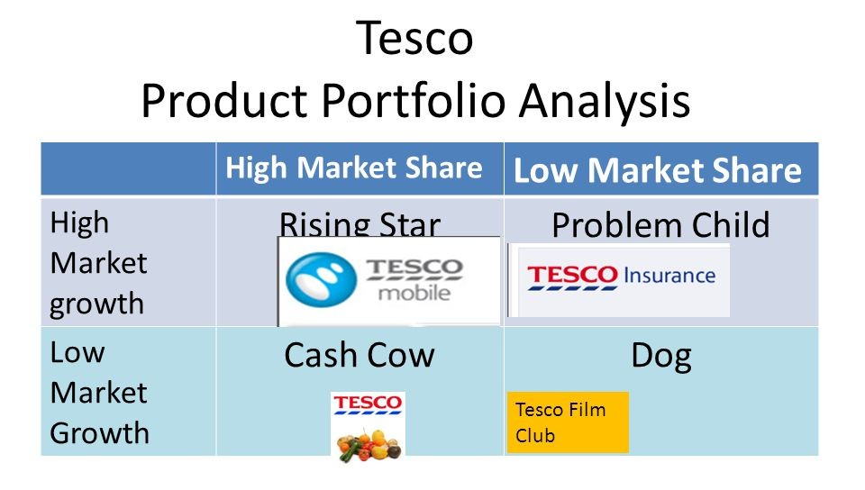
Figure: Product portfolio of Tesco (Davies and Crane, 2013)
In case of the product portfolio of TESCO plc, there are several dimension which are required to be placed and understood. Tesco Mobile is the rising star as they have the highest market share follwed by the high market growth. On the other side, Tesco Insurace is on the problem chid side which is on the high makret growth but low market share.
Tesco Firm is on the cash cow where the market growth is literally low but the market share is the highest. On the other side, the Tesco Film club is on the dog where the market growth and market share will be low in both cases. This is how, their products are getting aligned with the system properly.

Task 2

Discuss how TESCO has planned, communicated, monitored and reviewed previous attempts to resolve its problems
In case of planning the TESCO plc, there has been so many problems which are appearing into the system. These problems can be solved with the help of several goals and activities. TESCO plc will need to follow several places and steps which will be able to provide information about the solution of several problems. These problems can be solved by the series of plannd steps.
Step 1: Planning
TESCO plc will require to focus on the planing step at the first place. There can be so many problems which can appear from the organizational system. The organizational problems will be focusing on the planning activities as well. There can be so many problems appearing in the system and the understanding of the problems will be done in the planning (Deresky, 2010). TESCO plc usually does the problem analysis along with the planning activities too. TESCO plc will also need to focus on the planning activities and the planning will be done. They make plans according to the needs within the system.
Step 2: Communicaion
However, once the planning is done in the context of TESCO plc, there will be issues for the communication as well. The communication is required to be understood from so many factors as well. There will be several communication factors which can appear from the system. The communication can appear based on both diagonal and horizontal system. There will be diagonal and horizontal communicaitonal system which can provide with several information within the system. So, this is how the TESCO plc will be doing the communication isuses.
Step 3: Monitoring
After the communication is done, the monitoring will be done from the side of TESCO plc. In this case, the monitoring will be working on so many several sides (Grant, 2016). The monitoring can be done from the side of TESCO plc. The monitoring will be done based on the key performance indictors, benchmarking and so on. In this way, the montoring activities will be done for the TESCO plc. Monitoring and Evaluation is a process that helps improve performance and achieve results. Its goal is to improve current and future management of outputs, outcomes and impact. In this way, TESCO plc will be doing the monitoring.
Step 4: Reviewing
TESCO plc willl need to review several factors on the system. Once the changes and so on are made and controlled, that will require the regular reviewing as well. In this case, the review of any plan will be required. If the plans are not well reviewed, it will not be able to provide with a good result. As the reason of it, reviewing of the problems of TESCO plc will be playing so many important impact within the system.
In this way, TESCO plc usually does the communication, plannig, monitoring and reviewing.

Task 3

Describing the nature, scope and impact of the current problems facing TESCO
In the present case of TESCO plc, there are several problems which are appearing into the system. Based on these problems, there can be many nature, scope, impact and so on. Here, all this aspects will be stated against the current problems and the situations.
High competition for customers and resources
Basically, competition is the main problem that is appearing from the side of customers and resources. The number of customers and resources are constraint and all the companies working within the system will need to adjust on these limited number of customers and resources. On the other side, customers and resources will be made based on the high competitive system. Highly competition for the customers and resources will be making impact on the system (Kaplan and Norton, 2011). The nature of the problem is long term and the scope of the problem is impact on profit and sales too. TESCO plc will be dealing with the high competition in this system.
New and existing competition
Following these, there can be several new and existing competition in the system as well. Based on these competitions, the market issues are getting changed. The competition within the system of TESCO plc is very high and that is accelerating the quality battle. But the competition in many cases are very much high for the customers and resources which care creating some other problems. The nature of this problem is longer lasting and the scope of this problem is making isuse on the profit and sales. Because of the high competition, the impact is made on the mind of customers and on the market share as well.
Market shift to globalization
Here, the market is sustaining so many shift in the system as well. The market is now getting changed and the focus has been on the globalization right now. The employees and TESCO plc will be focusing on the marketing factors. The market system is getting changed and it is becoming the global phrased (Kotler and Armstrong, 2010). The globalization has been effective on the business environment of the global activities. In this place, the market condition will be focusing on so many factors which is appearing from the international market. The nature of the problem is changeable as it will get changed from time to time. On the other side, the globalization issues on the market shift will be focusing on these factors.
Foreign brands
In case of TESCO plc¸ there are several foreign brands available as well. There are foreign brands like Lidl, Aldi Plc and so on. Based on the understanding of these issues, competition in the system will be increased. There will be several foregin brands in the system as well. It is increasing the competition in the area of this market. The nature of problems will be severe in the future. The future problms will be increased in the system too. The scope of the system of TESCO plc will be making impact on the customers’ mind. The mind of the customers are getting changed and developed. As the result of it, the foreign brands are getting assured and altered.
Perception of low quality
There are some issues related to the low quality as the perception of the low quality will be different in many cases. In the system of UK, TESCO plc will need to focus on the quality percption. It has been seen that the understanding of the quality will be different in many different phases. So, TESCO plc will need to understand the quality issues too (Liu, 2014). The nature of the problem is changeable as the perception can be changed from time to time, system to system. In this way, the percetion of the low quality will be defined and placed.
So, these are the problems which will be happening in the context of TESCO plc.

Task 4

Using your research information undertake an analysis of the causes of the problems at TESCO by using the following models
In order to understand and demonstrate the problem issues properly, there will be several models and issues available in the system. The understanding of these models will be helpful to defend the problems at the place of TESCO plc.
SWOT analysis
SWOT analysis of the TESCO plc will be focusing on the research information in the system. Here, several issues will be found from this dimension which can provide with several issues in the system.
Strengths
TESCO plc will be focusing on the polictical factors as the support from political sides are getting assured. The relation with the political parties of the organizations like TESCO plc are very well. However, they have strong customer base along with the competitive advantage (Muthuri et al., 2012).
Weaknesses
There are several weaknesses available in the system available too. Their cost of the production is also getting increased. Along with it, the social context are often getting against the system properly as well.
Opportunities
On the other side, there will be several opportunities which will accelerate the activities of TESCO plc. They have the strong organizational role along with the functional understanding as well. In this way, the opportunities will be assured (Scherer et al., 2013).
Threats
From the system of TESCO plc, there will be several threats like the skill of employees and rising cost. The market is now getting changed and the focus has been on the globalization right now. This transformation is also causing the threat into the TESCO plc.
PESTLE Analaysis
On the other side, there will be so many environmental understanding which is appearing in TESCO plc. There are several dimensions on which the factors and condition of the external environment will be demonstrated.
Political
The political side of the organiation is very much different. The relation with the political parties of the organizations like TESCO plc are very well. The impact on the political parties are higher. Recently, Brexit has changed the way in which TESCO plc used to operate themselves (Smith et al., 2010).
Economic
However, the economic impact on the system will be develoepd and changing. It is becoming able to increase the profit within the system and so many job opportunities are also getting created in the context of TESCO plc. Their cost of the production is also getting increased (Stensaker and Vabø, 2013).
Social
In the social aspect, the impact of society can not be changed and developed. The scoiety is equipping the services of TESCO plc and they are often haappy with the system as well. It has been seen that the understanding of the quality will be different in many different phases.
Technology
The technology is creating so many opportunities from the side of TESCO plc. The technology issues has created opportunities for the effective working system. It has made the system even more efficiently.
Legal
In terms of TESCO plc, it has been seen that there are no bad impact made on the legal sides from it. TESCO plc are following all the acts and ordinances in the system properly so that these can make a direct impact.
Environment
On the other side, the environmental issues are important to be understood. No subsidiary and other companies of TESCO plc are making bad impact on the environmental issues. However, they are doing many corporate social responsibilities here.
Stakeholders’ Analysis
The analysis from the side of stakholders will be effective. It will provide with idea about who are the perfect stakeholders and these issues are required to be understood for several understanding and planning.
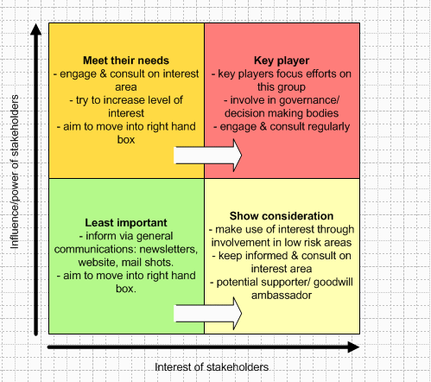
Figure: Stakeholders’ analysis (Tate et al., 2014)
Four types of stakeholders are available in the system of TESCO plc. Firstly, meeting the needs is a dimension where customers and buyers are belonging. They may switch their places to the key players anytime. The issues of key players will be are mandatory as the market competitors, law enforcing parties and so on are on the key player side. However, the media, press and other parties like them are the least important in the system. Showing the consideration willl be made on the case of goodwill issues and so on. The ambassador and so on parties will be related in the system.

Task 5

Based on the analysis draw a conclusion that clearly identifies the main issues faced by TESCO.
At last, it has been seen that several problems and issues are getting faced from the system of TESCO plc. The competition within the system of TESCO plc is very high and that is accelerating the quality battle. But the competition in many cases are very much high for the customers and resources which care creating some other problems.
The issues of customers and resoruces are important at any case. The number of customers and resources are constraint and all the companies working within the system will need to adjust on these limited number of customers and resources. On the other side, customers and resources will be made based on the high competitive system. The market system is getting changed and it is becoming the global phrased.
The globalization has been effective on the business environment of the global activities. In this place, the market condition will be focusing on so many factors which is appearing from the international market. There will be several foregin brands in the system as well. It is increasing the competition in the area of this market. However, globalization is changing and making impact on the social factors in many cases.

Task 6

Suggesting possible business options that enables decision makers at TESCO to resolve the problems identified in your report.
On the other side, there will be several problems related to the decision making of the context. There will be so many recommendation which will be available in the system as well. TESCO plc will have several recommendation available to solve these kinds of problems into the system.
- The TESCO plc will require to deal with the investment issues as well. They will need to increase the level of investment level,
- Focusing on the needs of the customers is another important issue available in the system. The customers’ understanding will be important in this matter,
- On the other side, TESCO plc will need to do the controlling and reviewing activities. It will help to accelerate the business goals,
- Several issues related to the marketing activities are needed to be understood as well. They will need to invest even on th marketing roles.

Conclusion
In case of the product portfolio of TESCO plc, there are several dimension which are required to be placed and understood. Based on these problems, there can be many nature, scope, impact and so on. Here, all this aspects will be stated against the current problems and the situations. There are several dimensions on which the factors and condition of the external environment will be demonstrated. The competition within the system of TESCO plc is very high and that is accelerating the quality battle. But the competition in many cases are very much high for the customers and resources which care creating some other problems.

References
Blackmore, J. and Sachs, J. (2012), Performing and reforming leaders: Gender, educational restructuring, and organizational change. Suny Press.
Czinkota, M.R. and Ronkainen, I.A. (2013), International marketing. Cengage Learning.
Davies, I.A. and Crane, A. (2013). Ethical decision making in fair trade companies. Journal of Business Ethics, 45(1-2), pp.79-92.
Deresky, H. (2010). International management: Managing across borders and cultures. Pearson Education India.
Grant, R.M. (2016), Contemporary strategy analysis: Text and cases edition. John Wiley & Sons.
Kaplan, R.S. and Norton, D.P. (2011). The strategy-focused organization: How balanced scorecard companies thrive in the new business environment. Harvard Business Press.
Kotler, P. and Armstrong, G. (2010). Principles of marketing. Pearson education.
Liu, T. (2014). Conflicting Objectives in Interfaces of Construction Project.
Muthuri, J.N., Moon, J. and Idemudia, U. (2012), corporate innovation and sustainable community development in developing countries. Business & Society, 51(3), pp.355-381.
Scherer, A.G., Palazzo, G., and Seidl, D. (2013), Managing legitimacy in complex and heterogeneous environments: Sustainable development in a globalized world. Journal of Management Studies, 50(2), pp.259-284.
Smith, W.K., Binns, A. and Tushman, M.L. (2010), Complex business models: Managing strategic paradoxes simultaneously. Long range planning, 43(2-3), pp.448-461.
Stensaker, B. and Vabø, A. (2013), Re‐inventing shared governance: Implications for organizational culture and institutional leadership. Higher Education Quarterly, 67(3), pp.256-274.
Tate, W.L., Ella, L.M., Schoenherr, T. and Petersen, K.J. (2014), Global competitive conditions driving the manufacturing location decision. Business Horizons, 57(3), pp.381-390.

