

MSc Public Health and Social Care in Practice

Module: Population Health and Digital Health Promotion
Module code: LCHS7009

Lecturer: Dr Ping Wu

Student Name: - Rutvika Goswami
Student ID: - 2430971

BLOG 1: Evaluate existing physical-activity trackers like Fitbit, Garmin, or Apple Health
“Can Fitness Trackers Really Improve Health? A Critical Look at Fitbit, Garmin, and Apple Health”
Introduction: The Problem of Physical Inactivity
The problem of physical inactivity is a severe issue in the modern population. Lack of sufficient movement causes many individuals to be obese, develop type 2 diabetes, heart disease, and suffer poor mental health. The WHO states that every year, millions of adults miss the recommended amount of activity (World Health Organization, 2024). In this blog, the researcher examines the role of digital activity trackers such as Fitbit and Apple Health in promoting physical activity and enhancing health.

Figure 1: Digital tools supporting healthy lifestyles
(Source: Self Developed)
Global Trends in Inactivity
The world is growing more inactive. The WHO has estimated that more than 25 per cent of adults are not physically active enough. This puts one at risk of chronic illness, and it has high medical costs. The percentage of people experiencing weight-gain problems, cardiovascular diseases and fatigue is high. Physical exercise should also be promoted as this will aid in improving health, averting illnesses as well and aid in a better quality of life. Most of these diseases are partially resisted by physical health and fitness, although by the year 2030, it is projected that 500 million new cases of preventable diseases will occur. This will have cost about 300 billion dollars, which will add 27 billion dollars to the healthcare spending in the world. [Figure 2]
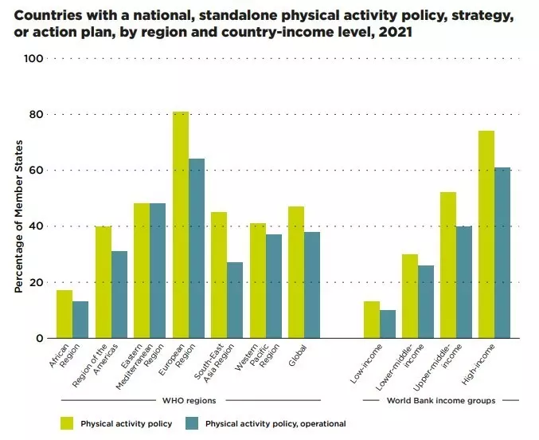
Figure 2: Global inactivity trends
(Source: Wellable, 2023)
Fitbit, Garmin, and Apple Health are some examples of devices that make use of the little sensors that count the number of steps that have been made, heart rate, the time spent sleeping, the amount of calories burned and the number of minutes spent exercising (Vigliotta, 2025). They give daily goals to the user like 10,000 steps, and remind or badge on reaching it. They have simple graphs and feedback on their applications, and allow people to see how they have grown over time. The other trackers also allow users to share their data or involve their friends in a contest to get the latter motivated and keep them in motion (Shameli et al., 2017).
Evidence of Effectiveness
According to the studies by Ferguson et al. (2022), individuals who wear activity trackers tend to be more active. According to one meta-analysis, wearable trackers had a medium effect and augmented the average number of steps taken by users each day. A different study by Tang et al. (2020) finds that physical activity on trackers has reported modest gains in the short-term when healthy adults were involved. Some interventions also demonstrated small weight loss among those who had trackers as opposed to those who did not (trackers).
There is a high impact of the activity trackers on behaviour change. It is more motivating to many users knowing that they will be able to see their progress daily. This assists in developing healthy practices and self-awareness. Remote monitoring is also supported by them and is applicable in preventive care. Accuracy can be untrustworthy; there are instances where some individuals quit the use of trackers after a few months. There is also the issue of the privacy of personal health information.
Better AI and medical testing can enhance accuracy. Individual coaching practices can assist in keeping individuals more active. Public-health assistance might be used to make trackers less expensive. An effective privacy policy and enhanced data security can create a trustworthy environment and secure the user base.
REFERENCES
Ferguson, T., Olds, T., Curtis, R., Blake, H., Crozier, A.J., Dankiw, K., Dumuid, D., Kasai, D., O’Connor, E., Virgara, R. and Maher, C. (2022). Effectiveness of wearable activity trackers to increase physical activity and improve health: a systematic review of systematic reviews and meta-analyses. The Lancet Digital Health, [online] 4(8), pp.e615–e626. doi:https://doi.org/10.1016/s2589-7500(22)00111-x.
Shameli, A., Althoff, T., Saberi, A. and Leskovec, J. (2017). How Gamification Affects Physical Activity: Large-scale Analysis of Walking Challenges in a Mobile Application. [Online] arXiv.org. Available at: https://arxiv.org/abs/1702.07437.
Tang, M.S.S., Moore, K., McGavigan, A., Clark, R.A. and Ganesan, A.N. (2020). Effectiveness of Wearable Trackers on Physical Activity in Healthy Adults: Systematic Review and Meta-Analysis of Randomized Controlled Trials. JMIR mHealth and uHealth, 8(7), p.e15576.
Vigliotta, C. (2025). The 10 Best Fitness Trackers, According To Our Editors. [Online] Forbes. Available at: https://www.forbes.com/sites/forbes-personal-shopper/article/best-fitness-trackers/.
Wellable (2023). Physical Inactivity Costs Millions Of Lives & Billions Of Dollars | Wellable. [Online] Wellable. Available at: https://www.wellable.co/blog/physical-inactivity-costs-millions-of-lives-and-billions-of-dollars/.
World Health Organization (2024). Nearly 1.8 Billion Adults at Risk of Disease from Not Doing Enough Physical Activity. [Online] World Health Organization. Available at: https://www.who.int/news/item/26-06-2024-nearly-1.8-billion-adults-at-risk-of-disease-from-not-doing-enough-physical-activity.

BLOG 2: Design a gamified movement-motivation platform using peer challenges
“MoveTogether: Using Gamified Challenges to Fight Physical Inactivity”
Introduction: The Need for Daily Movement
Physical inactivity is a severe international problem nowadays. Lack of movement causes obesity, heart disease, diabetes and depression in many people. According to the WHO, out of every four adults, one is inactive. This raises the cost of healthcare and strains the health systems of the population (Bull et al., 2020). It is necessary to encourage everyday movement to avoid illness and promote healthier living.

“Small daily movement can create a big difference”
(Source: Self Developed)
Proposed Solution
My proposed technology is a mobile application named MoveTogether. It seeks to encourage human beings to exercise more using gamified challenges and peer support. The users have the opportunity to participate in step battles, team events and weekly leaderboards. Rewards come in the form of points, badges and levels. The application links with the phone sensors and wearables to record daily activity easily and entertainingly.

Figure 1: Layout of MoveTogether showing movement points and rankings
MoveTogether is a tool that allows individuals to remain active by providing goals that are easy to achieve and reminders. The peer challenge option makes the users feel supported and responsible. To ensure that the motivation is maintained, the app displays progress charts, streaks of habits, and social leaderboards. The friendly community is developed through push alerts and group chats. The platform might also be connected to schools, workplaces, and hospitals in the future as a way to help with larger health programmes and motivate more people to move (Pulimeno et al., 2020).
Behavioural Impact and Accessibility
MoveTogether can greatly influence physical activity, as peer support and friendly competition can make people move more. The motivation and enjoyment of the process of teamwork can be effective, as well as enhance the mental well-being of many users. It will be cheaper than purchasing fitness trackers and thus more individuals can use it, and it can facilitate distance health programmes. However, some users might be stressed with competition or social comparison. The application should also be updated regularly and have good technical support. Unless people are users of smartphones, they might be excluded because of cost and access factors (Haenssgen, 2018).
Limitations and Strategies
The deficiencies can be mitigated through the provision of varying levels of challenges so that users are allowed to select what they are comfortable with. Rayland and Andrews (2023) have explained that mental health messages can be used to assist pressurized users. Many people can be recruited through free access through schools or community groups. Safety and access can be enhanced with an offline mode and solid privacy regulations (Durnell et al., 2020).
REFERENCES
Bull, F.C., Al-Ansari, S.S., Biddle, S., Borodulin, K., Buman, M.P., Cardon, G., Carty, C., Chaput, J.-P., Chastin, S., Chou, R., Dempsey, P.C., DiPietro, L., Ekelund, U., Firth, J., Friedenreich, C.M., Garcia, L., Gichu, M., Jago, R., Katzmarzyk, P.T. and Lambert, E. (2020). World health organization 2020 guidelines on physical activity and sedentary behaviour. British Journal of Sports Medicine, [online] 54(24), pp.1451–1462. doi: https://doi.org/10.1136/bjsports-2020-102955.
Durnell, E., Okabe-Miyamoto, K., Howell, R.T. and Zizi, M. (2020). Online privacy breaches, offline consequences: Construction and validation of the concerns with the protection of informational privacy scale. International Journal of Human–Computer Interaction, [online] 36(19), pp.1834–1848. doi: https://doi.org/10.1080/10447318.2020.1794626.
Haenssgen, M.J. (2018). The struggle for digital inclusion: Phones, healthcare, and marginalisation in rural India. World Development, 104, pp.358–374. doi: https://doi.org/10.1016/j.worlddev.2017.12.023.
Pulimeno, M., Piscitelli, P., Colazzo, S., Colao, A. and Miani, A. (2020). School as Ideal Setting to Promote Health and Wellbeing Among Young People. Health Promotion Perspectives, [online] 10(4), pp.316–324. doi: https://doi.org/10.34172/hpp.2020.50.
Rayland, A. and Andrews, J. (2023). From Social Network to Peer Support Network: Opportunities to Explore Mechanisms of Online Peer Support for Mental Health. JMIR Mental Health, [online] 10(1), p.e41855. doi: https://doi.org/10.2196/41855.

