CHASE

  - COURSEWORK: ESSAY

Student Name: Valeria Peeva
Student Number: 2029005

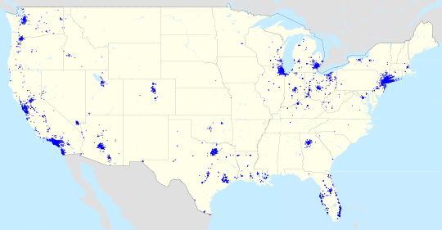
This Photo by Unknown Author is licensed under CC BY-SA

Programme: BA Business Management
Module: International Business Communications
Module code: LCBB6001
Module Leader: Husam Alharahsheh

Contents

INTRODUCTION 3
FOSTERING AN INCLUSIVE WORKPLACE IN THE UK: THE ROLE OF LINE MANAGERS 3
CULTURAL SENSITIVITY IN UK BUSINESS OPERATIONS 5
COMMUNICATION BARRIERS IN A DIVERSE WORKFORCE 6
COMMUNICATION STRATEGIES AND RECOMMENDATIONS 8
CONCLUSION 10
REFERENCES 11


This Photo by Unknown Author is licensed under CC BY-SA

INTRODUCTION
Embracing diversity and encouraging a welcoming environment does more than only make people feel welcome; it also increases efficiency and creativity. Line managers, who are the front-line leaders responsible for guiding and influencing their teams, play a crucial role in ensuring the successful implementation of such policies. This paper will look at how international and intercultural communication theories can be applied in the context of the United Kingdom. Effective business communications are critical in developing a healthy and inclusive workplace environment in the United Kingdom. Embracing diversity and cultivating an inclusive culture benefits not only employee well-being but also creativity, innovation, and productivity. We will look at the role of line managers in driving inclusive workplace policies and procedures within a UK-based organisation in this paper.
This report attempts to assist Chase Bank to survive by considering theories of international and intercultural communication, evaluating cultural sensitivity, identifying communication impediments, and giving appropriate strategies. In the context of British business communications, inclusion is critical to fostering a healthy work environment. This paper seeks to explore how Chase Bank may foster an inclusive environment for its UK-based business operations, with a focus online managers' duties. Chase Bank is a well-known global financial company that provides a variety of banking and financial services. Chase Bank, which has a presence in the United Kingdom, encourages diversity and inclusion, recognising that a varied staff enriches the organisation and improves the customer experience.

FOSTERING AN INCLUSIVE WORKPLACE IN THE UK: THE ROLE OF LINE MANAGERS
The use of international and intercultural communication theories, such as those developed by Hofstede, Samovar, Jandt, and others, can have major ramifications in a variety of elements of communication within the United Kingdom. These theories offer useful insights on comprehending and successfully negotiating the complexity of cross-cultural encounters.
Hofstede's Cultural Dimensions Theory
Line managers at Chase Bank must grasp these elements to foster inclusion and customise communication techniques accordingly. The cultural aspects framework developed by Geert Hofstede outlines numerous significant dimensions of country culture that can influence communication methods and preferences. In the context of the United Kingdom:
- Individualism vs. Collectivism: Understanding the individualistic culture of the United Kingdom can assist in emphasising personal success and autonomy in communication, while also recognising the importance of individual perspectives and decisions.
- Masculinity vs. Femininity: In the UK context, this dimension can impact communication by recognising the balance between assertiveness and nurturing tendencies.
- Recognising the UK's comparatively lower uncertainty avoidance can help to promote open communication and a willingness to adapt to innovative ideas and change.

Jandt's Intercultural Communication Model
Jandt's model emphasises the necessity of cultivating cultural awareness, knowledge, and skills to improve intercultural communication. Jonathan Jandt established the theory of intercultural conflict styles. This approach can be used in the UK to:
- Promote cultural awareness and competency among individuals and organisations, particularly given the multicultural nature of UK society.
- Encourage the development of techniques for dealing with potential communication issues caused by cultural differences.
- In intercultural encounters, Jandt's philosophy emphasises cultural awareness, empathy, and flexibility. Line managers at Chase Bank should be conscious of their own cultural prejudices, show empathy for various team members, and modify their communication techniques to accommodate cultural differences.
Samovar and Porter's theory
Line managers in the United Kingdom, where a multicultural workforce is the norm, can receive help from this idea by increasing their cultural competence and sensitivity. Managers may create an environment in which employees feel safe expressing their views and concerns by being aware of and accommodating their employees' preferred techniques of conflict resolution. This theory emphasises the fluidity of cultural identity and its implications for communication. This approach can aid in the United Kingdom, where cultural variety is significant due to historical and contemporary factors:
- Encourage intercultural communication by recognising and promoting the country's distinct cultural identities.
- Recognise how individuals' cultural backgrounds influence their communication methods and preferences to facilitate productive communication.
Cross-Cultural Communication in Business:
Applying these theories in a business environment can benefit UK-based companies:
- Marketing and advertising strategies should be tailored to the cultural values and tastes of the UK audience. Create effective negotiation and conflict resolution tactics that take cultural norms and communication styles into account.
- Education and Training: Incorporating these theories into educational curricula and training programs can help. Provide students and professionals with the knowledge and abilities they need to engage in effective intercultural communication. Create an inclusive and courteous workplace in which people from various backgrounds may successfully communicate and collaborate.
- Media and Communication Strategy: These theories can help media outlets and communication platforms create material that resonates with the cultural values and preferences of the UK population. Increasing cross-cultural understanding through various representations and tales.

Overall, the use of international and intercultural communication theories in the UK context can help to foster more successful and amicable interactions among individuals, communities, enterprises, and organisations in the country's culturally diverse environment.

CULTURAL SENSITIVITY IN UK BUSINESS OPERATIONS
Employees can learn to accept and understand the unique viewpoints of others through increased awareness of and familiarity with cultural norms, beliefs, and communication styles. Employees can show and resolve any cultural problems by having open conversations and supplying feedback. Recognizing and honouring holidays and observances with cultural significance can also promote diversity and inclusion in the workplace. Cultural sensitivity is essential when conducting business in the UK, especially given the workforce's unusual backgrounds. Line managers must be culturally sensitive to foster an inclusive atmosphere. They should, for example, be conscious of different religious practises and holidays, accommodate linguistic disparities, and encourage varied perspectives in decision-making processes.
- Diversity of Workforce:
Chase Bank, like many major institutions, have a diverse staff that includes people from many cultural, ethnic, and socioeconomic backgrounds. Culturally sensitive practises should include the implementing activities to promote equitable opportunities for career growth regardless of cultural background. Offering mentorship programmes that match individuals from underrepresented backgrounds with senior leaders, for example. Educating employees about unfamiliar cultural norms, communication styles, and behaviour to improve intercultural understanding and minimise prejudices. The cultural sensitivity of Chase Bank should extend to customer interactions to serve a varied clientele, provide customer service in several languages. Customers will be able to converse effectively and easily because of this. Giving customer service employees training on how to recognise and appreciate cultural differences when aiding consumers. Understanding diverse cultural views on personal financial and money management, for example.
- Advertising and Marketing:
Chase Bank's marketing tactics should be sensitive to cultural differences and creating advertising strategies that appeal to a wide range of audiences by highlighting ethnic diversity and inclusivity. Avoiding preconceptions and accurately depicting varied ethnic origins. To prevent offending certain cultural groups, be aware of and respect cultural taboos in advertising content.
- Workplace Policies:
Workplace policies should include cultural sensitivity and religious accommodations are rules that are put in place to accommodate religious practises, such as offering flexible work hours during religious holidays. Recognising and celebrating cultural festivals and holidays to build an inclusive workplace.
- Leadership and Decision-Making:
Chase Bank's leadership and decision-making processes should take cultural sensitivity into account and varied leadership representation. Encouraging varied leadership at all levels of the organisation to reflect the multicultural workforce and ensuring that different opinions are considered. Promoting open debates and decision-making procedures that respect and integrate different points of view.

- Training and Professional Development:
Chase Bank can make continual investments in cultural sensitivity training and professional development. Providing employees with ongoing training to improve their cultural competency and comprehension of different perspectives. Providing workshops to help staff enhance their cross-cultural communication skills and negotiate varied client encounters.
In conclusion, cultural awareness is critical for Chase Bank to establish a welcoming and courteous atmosphere for both workers and customers. Chase may improve employee satisfaction, customer connections, and overall business success by considering and appreciating the divergent backgrounds of its personnel.
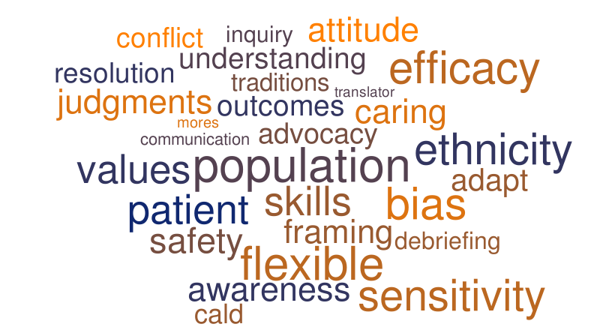
This Photo by Unknown Author is licensed under CC BY-NC-ND

COMMUNICATION BARRIERS IN A DIVERSE WORKFORCE
Communication Styles
• Diverse cultures may value different communication approaches, from being open and outspoken to being more reserved and subtle. Conflict and misunderstandings about expectations and intentions might result from such dissimilarities. To limit this, it is important to focus on building mutual understanding. Employees that receive cross-cultural communication training can better grasp diverse cultural values, attitudes, and communication styles. This can help to reduce the potential for misunderstandings and conflict.
• An instance from Chase’s team member from a culture that places a high value on direct criticism supplies constructive input to a teammate from a culture that places a lower value on direct criticism in a multicultural project team. The aggrieved coworker's mood and motivation to work together suffer as a result. Chase's team member should have been aware of the cultural differences and provided input in a more tactful manner. To prevent similar incidents from occurring in the future, Chase should ensure that all team members are aware of the cultural norms of their teammates. Cross-cultural training should also be provided to help team members understand and appreciate diverse cultural backgrounds.
• Conflicts, diminished trust, and a drop in open communication are all outcomes of mismatched communication styles. Organisational effectiveness can be negatively affected because of stifled problem-solving and information sharing. Employees can become frustrated due to misunderstandings and a lack of recognition for their ideas. This can lead to decreased morale and productivity, which can have a long-term impact on the organisation.
Language Barriers
Employees from various linguistic backgrounds may be present in Chase Bank's UK workforce, resulting in language challenges. Line managers can help to alleviate this by giving language training and utilising multilingual communication tools. Such tools can help employees to communicate more effectively. They can also help to reduce misunderstanding and establish trust between colleagues. This can result in increased productivity and better team performance.
Nonverbal Communication Differences
Nonverbal cues differ among cultures and might lead to misunderstandings. Line managers should be aware of these distinctions and provide training to ensure that they are correctly interpreted. This will help to ensure that international teams are able to communicate effectively and avoid any potential conflicts. Managers must also be cognizant of their own cultural prejudices while collaborating with personnel from other cultures.
Stereotypes and Prejudices
In a diverse workforce, unconscious prejudices and stereotypes can impede efficient communication. To address these concerns and establish an unbiased work environment, Chase Bank should provide diversity and inclusion training. Training should be conducted regularly to ensure that employees are aware of their own biases and how they can address them. The training should also provide employees with the tools to recognize and challenge unconscious biases in their colleagues. Finally, the company should provide resources for employees to report instances of discrimination or prejudice.
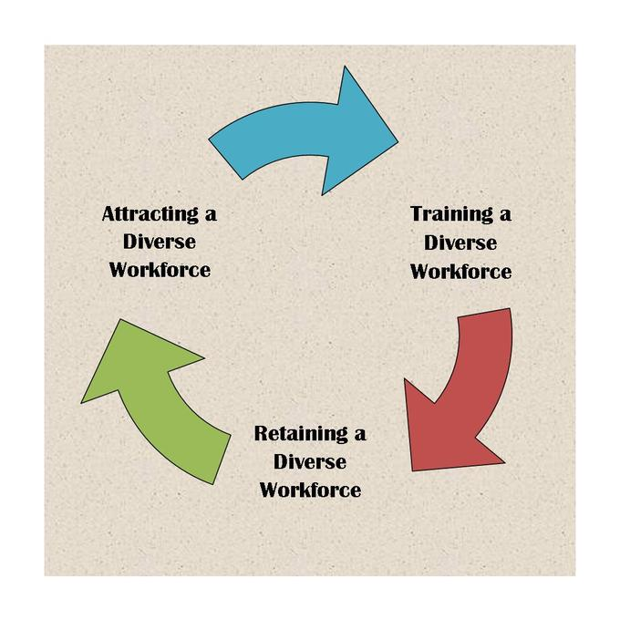
This Photo by Unknown Author is licensed under CC BY-SA

COMMUNICATION STRATEGIES AND RECOMMENDATIONS
At Chase Bank, creating a positive atmosphere for everyone to flourish entails employing effective communication techniques and implementing inclusive practises. Here are some suggestions for Chase Bank to examine to achieve this goal:
- Emphasize Active Listening - Line managers should be coached to use active listening techniques whenever they interact with their teams. Managers can foster a positive work atmosphere in which their employees feel appreciated and heard by listening attentively, asking questions, and displaying empathy. To better understand and connect with their staff, line managers can receive help from training in empathy and emotional intelligence. Leaders that are empathetic are better able to understand the struggles of a multicultural workforce and rally their teams around them. Surveys and feedback sessions should be used on a regular basis to monitor the effectiveness of diversity and inclusion programmes.

- Diversity and Inclusive Policies and Procedures - Chase Bank should implement inclusive policies and practises that encourage diversity and inclusion. To develop an inclusive work atmosphere, line managers must uphold these policies. Form ERGs focusing on certain cultural, ethnic, or affinity groupings. Employees can use these groups to network, share experiences, and contribute ideas to the organisation. Blind recruiting procedures should be used to reduce unconscious biases during the hiring process. Instead of demographic information, emphasise talents, qualifications, and experience.

- Cultural Awareness Training - Provide cultural awareness training to all employees, particularly line supervisors, to improve their grasp of cultural differences and communication. Provide regular cultural awareness and sensitivity training to all employees, including those in positions of leadership. These sessions can help to eliminate unconscious biases, increase empathy, and improve cross-cultural communication.

- Promote Open Dialogue - Encourage open communication channels so that employees may freely discuss their ideas and concerns. Regular feedback sessions and town hall meetings might help to foster open discourse. Establish clear communication channels that allow employees to express problems, suggestions, and comments without fear of punishment. Regular town hall meetings, suggestion boxes, and anonymous feedback systems are examples of this.

- Employee Resource Groups - Encourage the creation of employee resource groups catering to various cultural and affinity groups. These organisations can provide a sense of belonging as well as mutual assistance. Create recognition programmes that recognise varied achievements, contributions, and milestones among employees from various backgrounds. Cultural festivities and observances could be included. Managers should be trained to conduct performance reviews that consider employees' cultural backgrounds and various strengths. Acknowledge accomplishments in both solo and group endeavours. Collaboration with local community organisations and activities to demonstrate the bank's commitment to diversity and inclusion. Participate in events and programmes that benefit underserved areas.

- Inclusive Leadership Development - Encourage inclusive leadership development programmes to provide line managers with the skills they need to effectively lead diverse teams. Implement leadership development programmes that focus on nurturing workers from varied backgrounds for leadership positions. Encourage possibilities for mentorship and sponsorship.

- Work-Life Balance - Set aside a month to celebrate diversity through events, conferences, and educational efforts that emphasise diverse cultural backgrounds and perspectives.

- Culturally Sensitive Customer Service - Provide customer service staff with training to ensure that they recognise and respect cultural variations when aiding clients. This can lead to better consumer experiences. Form decision-making panels with individuals from various cultural backgrounds to ensure a diverse range of viewpoints are considered.

By using these communication methods and ideas, Chase Bank may create an environment in which everyone, regardless of cultural, ethnic, or socioeconomic background, feels valued, respected, and empowered to achieve.

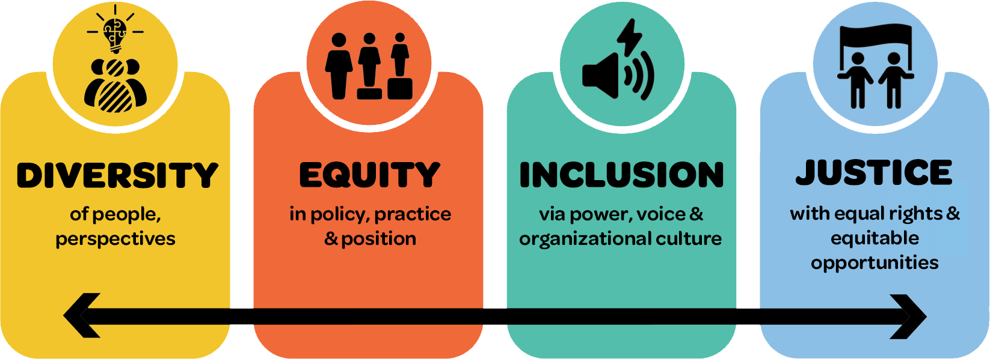
This Photo by Unknown Author is licensed under CC BY-NC

CONCLUSION
Line managers may set an example for their employees by practicing what they preach when it comes to effective communication methods and cultural awareness. Their value in breaking down barriers of communication and fostering cohesion at work is immeasurable. Finally, Chase Bank has an excellent potential to promote an inclusive work climate in its UK-based operations. Line managers are crucial in encouraging cultural awareness, breaking down communication obstacles, and putting suitable solutions in place. Chase Bank can establish a positive and thriving workplace where everyone can succeed by embracing diversity, fostering open communication, and giving cultural awareness training. In today's global economic landscape, embracing diversity and tolerance is not only a moral obligation, but also a strategic benefit. The United Kingdom values diversity, understanding that an inclusive workplace promotes innovation, productivity, and employee well-being.

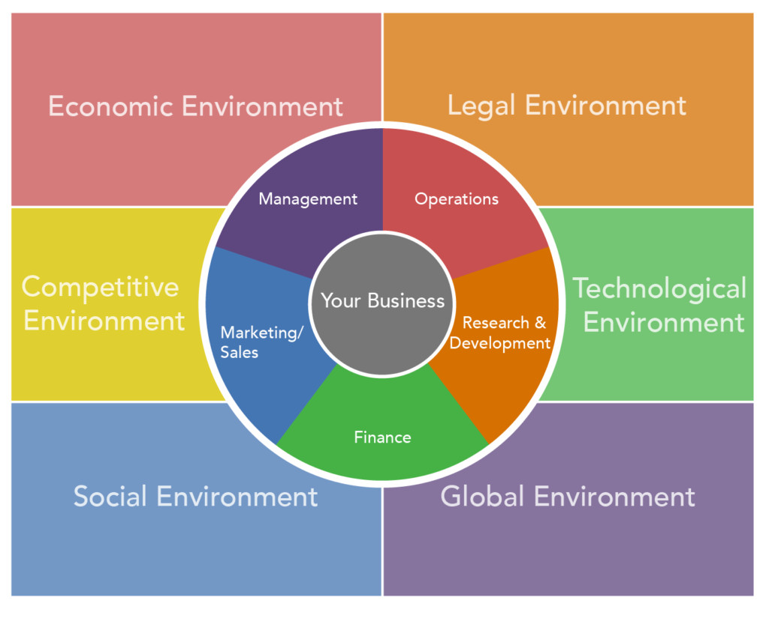
This Photo by Unknown Author is licensed under CC BY

REFERENCES
BRITISH BUSINESS COMMUNICATION STYLES, Available at: https://www.worldbusinessculture.com/country-profiles/great-britain/business-communication-style/ (Accessed on 12/08/23)
Carté, Penny., (2008). Bridging the culture gap: a practical guide to international business communication, Kogan Page
Chase Bank review: Is it the best UK digital bank? Available at: https://moneytothemasses.com/banking/chase-bank-review-is-it-the-best-uk-digital-bank (Accessed on 13/08/23)
Cultural Communication Barriers in the Workplace, Available at: https://smallbusiness.chron.com/cultural-communication-barriers-workplace-13888.html (Accessed on 14/08/23)
Hofstede’s Cultural Dimensions Theory, Available at: https://accounting.binus.ac.id/2021/11/15/hofstedes-cultural-dimensions-theory/#:~:text=Hofstede's%20cultural%20dimensions%20theory%20is,structure%20derived%20from%20factor%20analysis. (Accessed on 11/08/23)
How to improve team communication: 6 strategies and tips, Available at: https://asana.com/resources/team-communication (Accessed on 11/08/23)
Introducing Chase, Available at: https://www.chase.co.uk/gb/en/our-story/ (Accessed on 14/08/23)
Koh, S. C. L., (2009). Information, and communication technologies management in turbulent business environment, Information Science Reference
Top challenges of diversity in the workplace, Available at: https://www.kallidus.com/resources/blog/top-challenges-of-diversity-in-the-workplace/#:~:text=Communication%20issues%20can%20be%20somewhat,challenges%20before%20they%20become%20problematic. (Accessed on 12/08/23)
What diversity really means, and why it is crucial in the workplace, Available at: https://www.betterup.com/blog/what-diversity-really-means-and-why-its-crucial-in-the-workplace (Accessed on 10/08/23)
8 Effective Communication Strategies for the Workplace, Available at: https://www.lifesize.com/blog/communication-strategies/ (Accessed on 13/08/23)
10 effective organizational communication strategies for the modern workplace, https://joinblink.com/intelligence/organizational-communication-strategies/ Available at: (Accessed on 15/08/23)
39 Types of Diversity in the Workplace You Need to Know, Available at: https://builtin.com/diversity-inclusion/types-of-diversity-in-the-workplace (Accessed on 15/08/23)

