LEVEL 4 – Student Journal (750 words)

- Ratings, Inspections and Reporting Procedures

Student Name: Thomas Marian Nica  Student Number: 2122261 | Module: Hotel Placement Food&beverange  Lecturer: Lola Villard

Topic of choice: | Ratings, Inspections and Reporting Procedures
RATINGS –
The implementation of food safety procedures includes a variety of rules which administer the provision of safe food to the consumers by the government of the United Kingdom (Wu et al., 2018). The scheme of SFFB is introduced by the Food standards agency. SFFB stands for Safer food, a better business aiming to increase the provision of safer food to the consumers. This also includes the implementation of HACCP which stands for seven principles of avoiding hazards in a food business.
• H – Hazard
• A - Analysis
• C - Critical
• C - Control
• P – Point (López-Santiago et al., 2022)
The seven principles which are also the steps for implementation of HACCP include the following –
• Hazard analysis
• Critical control point identification
• Establishing critical limits
• Monitoring procedures
• Corrective actions
• Process verifications
• Record-keeping.
The compliance for SFFB includes regulation no. 852/2004 wherein the businesses are required to implement food safety procedures with HACCP to ensure consumers are provided with safe food (food.gov.uk., 2022). SFBB training and execution practices are assisted by the Food Standards Agency, United Kingdom. This helps in maintaining a standard of food which results in an improved reputation of the business. The SFBB pack also promotes the aim of the initiative helping food businesses maintain quality standards (food.gov.uk., 2022).
The rating criterion is covered under the Food Hygiene rating scheme which was first implemented by Wales and Northern Ireland. The scheme provides rating stickers on the food business premises ensuring the consumers provide feedback on the hygiene and safe food provision. The ratings for food are based on the quality, service, culinary skills, food presentation, and relaxation and comfort provided by the food business. The rating scheme can prove to be highly effective in all the businesses providing food and beverages to the citizens. The places include restaurants, cafes, supermarkets, pubs, bars, schools, hospitals, and others. The training provided by FSA help in the effective implementation of the scheme on the premises. The ratings are provided on a scale of 0-5 where 0 represents the least satisfaction with standard implementation which reflects urgent need whereas 5 represents the most satisfaction (food.gov.uk., 2022).
Figure 1: The premise stickers under the rating scheme
(Source: food.gov.uk., 2022)
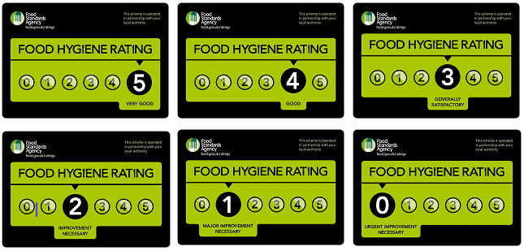
INSPECTIONS –
Inspections are carried out by authorised professionals assigned to different local food businesses. The officers visit food business premises to ensure it complies with food safety standards. The major parts of the food business officer focus on are premises, working style, food safety management system and preparation methods followed to prepare a dish or food item. The officers are authorised to visit the business at any time to inspect the premises and practices. Routinely inspections are carried out twice a year but there are no fixed rules on the inspections (gov.uk., 2022). The officers are authorised to take strict actions and this can lead to serious legal actions as well. The food can be seized, if necessary, which is deemed unfit for consumption. If the changes do not reflect any public hazards, the businesses are advised to implement changes for betterment.
Figure 2: the FHIS ratings
(Source: gov.uk., 2022)
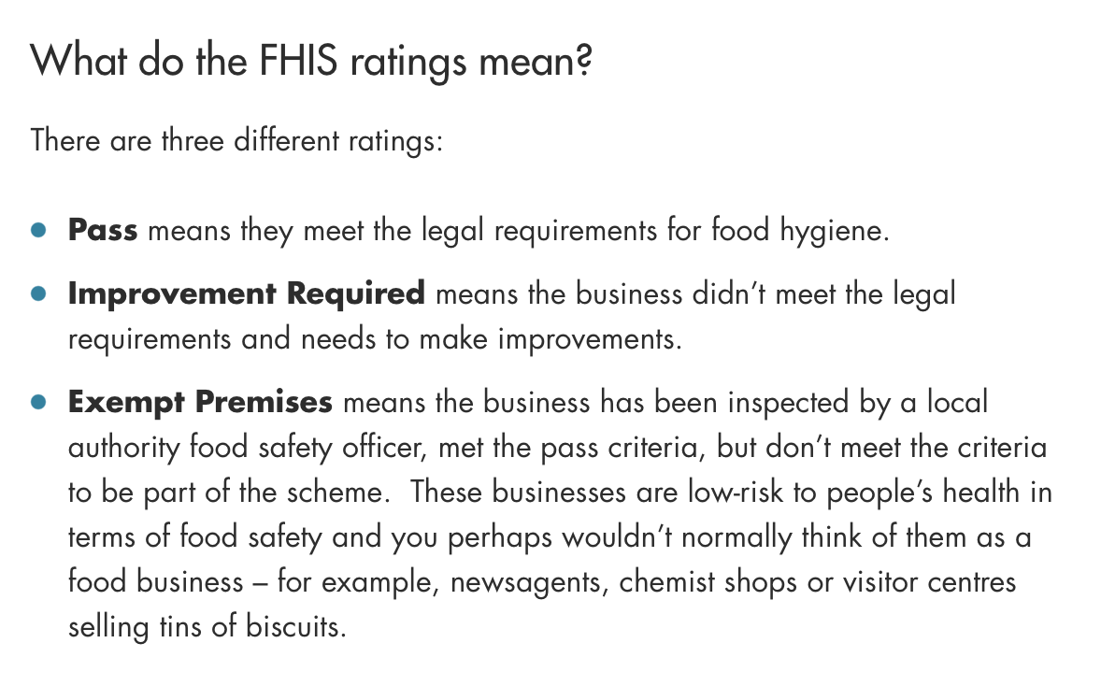
The rating in terms of food professional includes three major types which implicate the working of a business. This includes pass, the improvement required, and exempt premises which can also be called a failure to comply with the regulation.
REPORTING PROCEDURES –
Reporting can be done by any citizen or resident of the country depicting the incompliance with food standards at a business. The reporting procedures can be filled with any local authority or by online method on the Food standard agency, UK. The investigations are done with the help of these reports to ensure the authenticity of the information provided. The reports help in the identification of public hazards and other foodborne diseases. This further helps the government take strict actions to avoid any severe health issues in a larger part of the country’s population. The threats posed can be easily mitigated if the information is provided at the beginning. The objectives kept in the report which help in identifying practice issues include – substandard food hygiene and handling, food decay signs, unhygienic practices, misleading allergen information, foreign matter in the food item, and cases of food poisoning.
Reporting procedures can prove to be highly effective in avoiding major disease outbreaks as well (gov.uk., 2022).

REFERENCE LIST (not included in word count)
Food.gov.uk., 2022 Food Hygiene Rating Scheme Online available at https://www.food.gov.uk/safety-hygiene/food-hygiene-rating-scheme. Last accessed May 2022
food.gov.uk., 2022 How to report a food safety or hygiene issue Online available at https://www.food.gov.uk/contact/consumers/report-problem/report-a-food-safety-or-hygiene-issue. Last accessed May 2022
gov.uk., 2022 Food safety - your responsibilities Online available at https://www.gov.uk/food-safety-your-responsibilities/food-inspections#:~:text=You%20can%20be%20inspected%20by,business%20poses%20to%20public%20health. Last accessed May 2022
gov.uk., 2022 Food safety - your responsibilities Online available at https://www.gov.uk/food-safety-your-responsibilities/report-a-food-safety-incident. Last accessed May 2022
López-Santiago, J., García, A.I.G. and Gómez-Villarino, M.T., 2022. An Evaluation of Food Safety Performance in Wineries. Foods, 11(9), p.1249.
Wu, L., Liu, P., Lv, Y., Chen, X. and Tsai, F.S., 2018. Social co-governance for food safety risks. Sustainability, 10(11), p.4246.

