Addressing the Skills Gap in Biophilic Construction Methods in Wales:
Implications for NetZero and the Built Environment

Robyn Lewis
2309827
BSc Construction Management
UWTSD





Copyright Statement

The copyright of this dissertation rests with the University of Wales, Trinity Saint David. No information derived from this dissertation shall be published without the prior consent of the University.

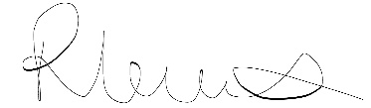

Signed: ………………………………………….

Date: …6/5/2026…………………………………….

Author’s Declaration

I declare that the work in this dissertation was carried out in accordance with the regulations of the University of Wales, Trinity Saint David. The work is original except where indicated by special references in the text and no part of the dissertation has been submitted for any other degree.
Any views expressed in the dissertation are those of the author and in no way represent those of the University of Wales, Trinity Saint David.
The dissertation has not been presented to any other University for examination either in the United Kingdom or overseas.
I hereby give permission for my work, if accepted, to be available for photocopying and inter-library loan, and for the title and summary to be made available to outside organisations.

Signed ………………………………………………………………………………………………………….
Date ………6/5/2026………………………………………………………………………………………

Acknowledgements

I would like to express my sincere thanks to my supervisor, Ian Brown, for his guidance throughout this dissertation. His teaching and lectures first introduced my interest in sustainable construction, and his support helped me to find a genuine interest in a course that I initially found challenging, and for that I am grateful.
I would also like to thank my family for their ongoing support and encouragement throughout my studies.
A special thank you goes to my partner for the constant support, reassurance and encouragement during the more demanding stages of this work.
Finally, I would like to thank my daughter for her patience while ‘Mummy spent so much time working on her computer’. Her understanding, even at such a young age, has meant more than I can put into words.

Abstract
This study explores the skills gap in biophilic construction methods within the Welsh construction industry and considers what this means for achieving Net Zero targets. Biophilic construction focuses on integrating natural elements and principles into the built environment, offering benefits for both sustainability and occupant wellbeing. Despite this, its use across the industry remains limited.
A mixed-methods approach was used to investigate the issue, combining a questionnaire survey with semi-structured interviews involving construction professionals, educators and sustainability stakeholders. This approach allowed for both a broad overview of industry trends and a more detailed understanding of individual experiences and perspectives.
The findings show that while there is a growing awareness of sustainable construction and the importance of Net Zero, there is a clear gap between understanding and practical application. Many participants reported low confidence in applying biophilic construction methods, alongside a strong perception that a skills gap exists. This gap was most evident in practical and technical areas, with current education and training seen as too theoretical and not closely aligned with real-world construction practice.
The research also identified several key barriers to adoption, including lack of knowledge, limited training opportunities, cost constraints and low client demand. These challenges are particularly significant for SMEs and self-employed workers, who may face additional difficulties in accessing training and investing in new skills.
Overall, the study highlights that the skills gap in biophilic construction is a key issue for the Welsh construction industry and has direct implications for achieving Net Zero targets. It suggests that without a more skilled and prepared workforce, progress towards sustainable construction will remain limited. The research recommends a stronger focus on practical, industry-relevant training, improved collaboration between education and industry, and increased support to encourage wider adoption of biophilic practices.

Contents
Copyright Statement 2
Author’s Declaration 3
Acknowledgements 4
Abstract 5
Contents 6
List of Figures 8
List of Abbreviations 9
Chapter 1: Introduction 10
1.1 Background 10
1.2 Research Aim 10
1.3 Research Objectives 10
1.4 Scope and Limitations 10
Chapter 2: Literature Review 11
2.1 Defining Biophilia 11
2.2 Development of Biophilia in relation to the Built Environment 11
2.3 The importance of Biophilia and its effect on people 12
2.4 Relevance of Biophilia to the Construction Industry 13
2.5 Net Zero and the Construction Industry 13
2.5.1 The Welsh Government's Net Zero Strategy Plan 13
2.5.2 Well-being for Future Generations (Wales) Act 2015 14
2.6 Green Skills Gap in Wales 14
2.7 Education and Training in the Built Environment 14
2.8 Literature Review Summary 15
Chapter 3: Research Methodology 16
3.1 Research Design 16
3.2 Data Collection Methods 16
3.2.1 Questionnaire Survey 16
3.2.2 Semi-Structured Interviews 17
3.2.3 Online Webinar 17
3.3 Sampling Strategy 18
3.4 Data Collection 18
3.5 Data Analysis 19
3.6 Ethical Considerations 19
3.7 Reliability and Validity 19
3.8 Limitations 20
Chapter 4: Findings 21
4.1 Questionnaire Results 21
4.1.1 Awareness of Biophilic Construction 21
4.1.2 Perceived Skills Gap 22
4.1.3 Areas of Skills Shortage 22
4.1.4 Education and Training Effectiveness 23
4.1.5 Demand for Training 23
4.1.6 Net Zero Readiness 24
4.1.7 Barriers to Adoption 25
4.1.8 Summary of Questionnaire Findings 27
4.2 Thematic Analysis (Interviews) 28
4.2.1 Awareness of Biophilic Construction 29
4.2.2 Skills Gap Across the Sector 29
4.2.3 Education and Industry Disconnect 29
4.2.4 Barriers for Implementations 29
4.2.5 Opportunities for Improvement 30
4.2.6 Summary of Interview Findings 30
Chapter 5: Discussion 31
5.1 Research Objective 1: Assess the current levels of understanding and awareness of biophilic construction methods with trades and construction professionals in Wales. 31
5.2 Research Objective 2: Identify gaps within existing education, training and professional development relating to biophilic construction methods 31
5.3 Research objective 3: Explore barriers preventing upskilling and the adoption of biophilic construction practices. 31
5.4 Research Objective 4: Evaluate the implications of an identified skills gap on achieving Net Zero targets within the Welsh construction industry. 32
5.5 Research Objective 5: Propose recommendations for improving skill development and supporting the adoption of biophilic construction methods. 32
5.5.1 Training and Upskilling 32
5.5.2 Increasing Client Demand 33
5.5.3 Stronger Industry-Education Links 33
5.7 Discussion Summary and Future Research 33
Chapter 6: Conclusion 35
References 36
Bibliography 40
Appendices 41
Appendix A – Questionnaire 41
Appendix B – Interview Questions 47
Appendix C – Interview Transcripts 48

List of Figures
Figure 1 – Familiarity with biophilic construction findings (Questionnaire) 20
Figure 2 – Confidence in biophilic construction Findings (Questionnaire) 21
Figure 3 - Perception of skills gap Findings (Questionnaire) 21
Figure 4 - Areas of skills shortage findings (Questionnaire) 22
Figure 5 - preparedness for sustainable construction findings (Questionnaire) 22
Figure 6 - Demand for training findings (Questionnaire) 23
Figure 7 - Required training findings (Questionnaire) 23
Figure 8 -Readiness for Net Zero findings (Questionnaire) 24
Figure 9- Importance of biophilic construction findings (Questionnaire) 24
Figure 10 - Perceived barriers to adoption findings (Questionnaire) 25
Figure 11 - Adoption of biophilic construction findings (Questionnaire) 25
Figure 12 – Thematic mapping of Interview data 28

List of Abbreviations

CIOB - The Chartered Institute of Building
CITB - The Construction Industry Training Board
CPD – Continuing Professional Development
FE – Further Education
HE – Higher Education
SMEs - Small to medium-sized enterprises

Chapter 1: Introduction

1.1 Background
The construction sector plays a significant role in addressing climate change, particularly in relation to achieving Net Zero carbon emissions. In the UK, and specifically in Wales, the built environment is responsible for a high proportion of total carbon emissions, which includes both operational and embodied carbon (UKGBC, 2021). There is now an increasing pressure on the construction industry to adopt more sustainable approaches to design and delivery. (Rushanim Hashim et al., 2022)
One sustainable approach is the adoption of biophilic construction, which focuses on the integration of natural materials, methods and materials into the built environments. Biophilic design has been associated with environmental sustainability, occupant well-being and improved building performance. (Browning et al., 2014)
Despite its benefits, the adoption of biophilic methods is limited within modern methods of construction; while sustainability has become a priority within the industry, more focus has been put on energy efficiency and regulatory compliance, rather than a holistic approach such as biophilic design. (Morton, 2025)
For the construction industry to adapt, it must prioritise new skill sets and upskilling of the existing workforce to facilitate the shift towards the adoption of sustainable building practices. (Terry, 2025) The need to address this issue within Wales is urgent due to ambitious decarbonisation targets and the commitment to Net Zero by 2050. (Welsh Government, 2021)

1.2 Research Aim
The research aim is to investigate the skills gap in biophilic construction methods in the Welsh Construction industry and its implications for achieving NetZero.

1.3 Research Objectives
1. Assess the current levels of understanding and awareness of biophilic construction methods with trades and construction professionals in Wales.
2. Identify gaps within existing education, training and professional development relating to biophilic construction methods.
3. Explore barriers preventing upskilling and the adoption of biophilic construction practices.
4. Evaluate the implications of an identified skills gap on achieving Net Zero targets within the Welsh construction industry.
5. Propose recommendations for improving skill development and supporting the adoption of biophilic construction methods.

1.4 Scope and Limitations
This research focuses specifically on the Welsh construction industry and evaluates the skills gap in relation to biophilic construction methods. The study includes perspectives from a variety of stakeholders, including industry professionals and educators.
The research is limited by the sample size and reliance on self-reported data. While the findings will provide valuable insight, they may not be applicable outside of Wales.

Chapter 2: Literature Review
This chapter reviews existing literature related to biophilic construction, Net Zero policy and skills gaps within the construction industry. It aims to establish a theoretical foundation for the research and identify gaps in existing knowledge.

2.1 Defining Biophilia
Biophilia is most commonly understood as the human tendency to affiliate with or seek connections with nature and living systems. The term Biophilia was first introduced by psychologist Erich Fromm, who described it as ‘the love of life and all of that is alive’(Fromm, 2010) Fromm’s interpretation positioned biophilia as a positive psychological orientation towards growth and well-being, contrasting it with destructive tendencies.
The biophilia hypothesis was formally articulated by biologist and naturalist Edward O. Wilson, who expanded the concept by framing it as an innate and evolutionarily developed human trait. Wilson proposed that humans possess a biologically based inclination with life and life-like processes that are rooted in human evolutionary development. (Wilson, 1984) According to the Wilson hypothesis, humans’ preferences, emotional responses and well-being outcomes are understood as adaptive responses to environments that historically support human survival. (Wilson, 1984)

2.2 Development of Biophilia in relation to the Built Environment
While Wilson’s work established the theoretical foundation of biophilia, it was later translated into the context of the built environment by Stephen Kellert through the concept of biophilic design. (Kellert et al 2008) Kellert argued that the modern built environment disconnects occupants from natural systems and that contemporary buildings frequently prioritise efficiency, technology and standardisation over environmental connection. (Kellert, Wilson, 1993)
In response, Kellert proposed that buildings should be deliberately designed to incorporate natural elements and environmental features and characteristics that reflect humans’ innate connection with nature. Kellert’s approach encompasses both direct interactions with nature, such as planting, daylight and water alongside indirect reference to nature through materials, forms and spatial configurations that support experiences of prospect and refuge and human health and wellbeing. (Kellert, 2018)
Through Kellert’s work, biophilia evolved from a biological theory into a practical framework for the built environment. Instead of existing as a theoretical explanation for human connection to nature, the concept was developed into a set of practical design principles that could directly inform the design, planning and construction of buildings and urban spaces. (Kellert et al, 2008) Kellert emphasised that biophilic design doesn’t involve simply applying any form of nature to the built environments, but requires an informed approach grounded in the understanding of human nature relationships. (Kellert, 2018) To support this, he identified six design principles that provide guidance for integrating biophilic thinking into the planning and construction of buildings:
- Environmental Features – This principle refers to including nature within the buildings, such as daylight, natural ventilation, water features and views of nature or landscapes, to provide immediate sensory engagement with nature and is considered fundamental to biophilic design. (Kellert et al, 2008)
- Natural Shapes and Forms – This principle involves the incorporation of organic geometries that reflect natural forms with the intention of creating an environment that feels familiar, drawing on the innate human response to natural shapes. (Kellert et al, 2008)
- Natural Patterns and Processes – This principle relates to the structures of the natural world and design elements that reflect patterns found in nature, which also reflect natural processes like ageing or change over time. (Kellert et al, 2008)
- Light and Space – This principle focuses on how occupants experience space and recommends varied lightings to mimic how humans experience light outdoors. (Kellert et al, 2008) Features like natural light, shadows, openness are associated with creating feelings of safety and wellbeing.
- Place-Based Relationships – This element focuses on connection to ecology and biogeographical features by responding to the local or regional climate, materials and cultural identity. (Bochart, 2019) Incorporating place-based design aids in creating environments that feel meaningful and grounded. (Kellert et al, 2008)
- Evolved human-nature relationships – This principle recognises that humans have developed to feel more comfortable in environments that reflect natural patterns that feel engaging and safe that provide a sense of security. This final principle recognises the ‘bigger picture’ and features attributes to include: Protection and Refuge; Order and Complexity; Curiosity; Change; Security and Protection; Exploration; Information and Cognitions; Affection and Attachment; Awe and Reverence.‌ (Mackie, 2024).
A successful biophilic design takes these attributes into consideration and addresses the deeper human responses by designing beyond aesthetics to support wellbeing and long-term occupant satisfaction. (Kellert, 2018)

2.3 The importance of Biophilia and its effect on people
A key argument within the evidence base for biophilic design is that exposure to nature or natural elements can contribute to significant improvements in stress reduction, recovery rates, and overall general well-being. (World Green Building Council, 2014)
Research suggests that the benefits are not limited to direct contact with nature, and that even indirect contact, such as views of natural landscapes from within buildings, has been shown to influence positive psychological and physiological effects. A widely cited study is Ulrich’s investigation into post-surgery recovery outcomes; this study found that patients recovering from surgery who were assigned to rooms with windows with views of natural scenery experienced shorter hospital stays and required fewer pain management medications than patients with windows that faced walls. This study provides evidence that the quality of the built environmental conditions can influence human health outcomes. (Ulrich, 1984)
Comparable evidence has also been identified in commercial environments; Industry reviews suggest that buildings that have been designed with biophilic principles are associated with lower stress levels, improved health and enhanced productivity. (World Green Building Council, 2014) These findings strengthen the case for investing in higher-quality buildings by demonstrating that design can influence performance as well as individual well-being. To further reinforce this, the World Green Building Council’s Health and Wellbeing Framework highlights that interactions with nature in and around buildings are a significant contributor to occupant wellbeing and identifies that biophilic design principles promote stress-reducing environments. (World Green Building Council, 2016)

2.4 Relevance of Biophilia to the Construction Industry
The construction industry plays a significant role in shaping the environment in which humans occupy every day. Buildings such as workplaces, homes and educational and healthcare facilities are all results of the construction process, and the way in which they are designed has a direct effect on occupants’ physical health, mental well-being, and level of comfort.(Design Council n.d.) Humans have evolved to lifestyles which involved spending an increased amount of time indoors; therefore, the relationship between building design and human experience has become an important consideration. (Kellert, 2008)
Decisions made during the building design, construction and retrofitting affect environmental conditions such as ventilation and indoor air quality, access to daylight, thermal comfort, acoustic comfort, material selection and access to outdoor space; however, these considerations are often only addressed in relation to the building energy performance and efficiency rather than occupant wellbeing. (World Green Building Council, 2014)

2.5 Net Zero and the Construction Industry
NetZero refers to the balance between greenhouse gas emissions produced from human activities, which are balanced by those that are removed from the atmosphere. (Craig, 2022) To achieve Net Zero in the construction sector, a fundamental shift in how buildings are designed, constructed, and maintained is required. This shift should include the adoption of low-carbon materials, improved energy efficiency and sustainable construction methods. (HM Government, 2021)
Research suggests that achieving these goals requires more than just technological solutions; instead, there is recognition that workforce capability and upskilling are essential for the transition to Net Zero. (Wiek et al., 2011) Without a green skilled workforce, the implementation of sustainable construction will be limited.
Furthermore, the current industry focus on Net Zero is often limited to operational energy efficiency rather than to a holistic approach that includes embodied carbon and whole-life carbon. This reinforces the importance of implementing the approach of biophilic construction. (Kellert, 2018)

2.5.1 The Welsh Government's Net Zero Strategy Plan
The Welsh Government has set an ambitious target to achieve Net Zero emissions by 2050 (Welsh Government, 2021), and the built environment has been identified as a key sector to achieve these targets, particularly through improvements in building performance and construction methods.
The Net Zero Wales Carbon Budget 2 outlines a series of measures that encourage the reduction of emissions within the construction industry, which includes the use of low-carbon building materials, increased energy efficiency, and improved building standards. (Welsh Government, 2021)
However, while the policy outlines a clear strategy, there is little mention of the skills or training that is needed to implement these measures. Research conducted by CITB highlights this gap between policy ambition and industry capability. (CITB, 2021)
While sustainability is a priority in the Welsh Government's strategy, there is limited reference to nature-based or biophilic practices, which demonstrates that these concepts are not yet integrated into policy frameworks.

2.5.2 Well-being for Future Generations (Wales) Act 2015
The Well-being for Future Generations (Wales) Act 2015 (Welsh Government, 2015) provides a legislative framework for sustainable development in Wales, which requires public bodies to consider the long-term impacts of their social, economic and environmental decisions.
The Act encourages principles that are closely aligned with biophilia, which includes health and wellbeing, environmental resilience and sustainable resources and encourages a more holistic approach, which is consistent with the principles of biophilic design.
However, the RTPI (Royal Town Planning Institute) Cymru have identified knowledge and training gaps that provide a barrier in the implementation of the Act. (Royal Town Planning Institute, 2015) This gap reinforces the importance of skill development, as a successful implementation of the Act depends on a capable, skilled workforce.

2.6 Green Skills Gap in Wales
The green skills gap refers to the shortage of skilled workers that is required to fill incoming jobs that are created by the transition into a more sustainable built environment. (Ashton, 2025) Within this sector, this includes the lack of knowledge of sustainable materials, low-carbon construction methods and the understanding of why these methods and materials are important.
In Wales, this issue is significant as the scale of transformation of the industry that is required to meet the Net Zero targets is extensive. The Construction Industry Training Board (CITB) reports that the industry is not currently equipped with the necessary skills to deliver the transition to a low-carbon economy. (CITB, 2021)
The skills gap is considered to be unevenly distributed across the construction industry; larger firms may have better access to training courses and resources, while smaller firms face challenges in accessing these due to financial constraints and capacity. (CITB, 2021) Larger organisations are able to adapt to sustainability requirements, while small and medium-sized enterprises (SMEs) may fall behind. The Welsh industry consists of a large proportion of SMEs, which results in an uneven distribution of green skills within the sector. (Miller Research, 2004)

2.7 Education and Training in the Built Environment
Education and training play a significant role in addressing the skills gap within the construction industry, particularly in the context of the transition to Net Zero; there is a consistent emphasis within policy literature on the need for upskilling of the workforce to support the implementation of sustainable construction methods. (Welsh Government, 2021)
However, existing literature would suggest that current education systems are not aligned with the demands of sustainable construction. (Wiek et al., 2011) Traditional construction education has prioritised trade-specific skills and compliance-based knowledge, which doesn’t adequately prepare workers for the adoption of sustainable practices. (Construction Leadership Council, 2019)
This issue is evident within the Welsh industry as recent research has suggested that training provisions for green construction skills remain limited, with insufficient implementation across further education (FE), higher education (HE) and industry pathways. (Data Cymru, 2022) Initiatives such as the Built Environment Sustainability Training (BEST) programme in Wales demonstrate that while training interventions can support upskilling in sustainable practices, there remains a demand for systematic change in the delivery of training and education. (Hopkinson and Gwilliam, 2015) While theoretical knowledge of sustainability is incorporated into curricula, there is not enough focus on translating this knowledge into real industry practice.
Overall, while education and training are widely recognised as critical to addressing the green skills gap, current provisions within Wales do not fully meet the needs of sustainable construction. This is due to a lack of collaboration between disciplines, limited opportunities for learning and unequal access to training across the industry. To address these barriers, the industry needs to adopt a more coordinated and integrated approach. (Wiek et al., 2011)

2.8 Literature Review Summary
This chapter has reviewed key literature relating to biophilic construction, Net Zero policy, skills gap and education within the built environment. The findings show that while biophilia is a recognised concept in relation to human wellbeing and design, its adoption within the construction industry remains limited, suggesting a gap between theory and real-world implementation.
The literature also identifies the important role of the construction industry in achieving Net Zero. In Wales, the Net Zero Wales strategy and the Wellbeing of Future Generations (Wales) Act 2015 demonstrate the government's commitment to sustainability; however, a gap has been identified in the policy goals and the industry's ability to deliver.
A major theme throughout is the green skills gap, which refers to the lack of knowledge and skills needed to support sustainable construction. This gap is not only technical but also relates to practical experience and is made even more challenging by the structure of the built environment in Wales, which comprises many SME’s that have limited access to training.
The review also shows that current education and training provisions are not fully meeting the needs of the industry, while sustainability is included in courses, it is often taught theoretically, with limited courses in practical application.
There is also a clear gap in research specifically focused on biophilic construction within the Welsh context.
This study aims to address this gap by exploring the skills needed for biophilic construction and examining how this affects the ability of the Welsh construction industry to achieve Net Zero.

Chapter 3: Research Methodology
This chapter outlines the research methods used to investigate the research topic; it explains the research design, data collection methods, sampling strategy and analysis techniques that were used as part of the study.

3.1 Research Design
This study adopts a mixed-method research approach to investigate the skills gap in biophilic construction methods in Wales and its implications for Net Zero targets and the built environment. A mixed-methods design was selected to enable both quantitative measurement of industry trends and qualitative exploration of stakeholders' perspectives to provide a more comprehensive understanding of the issue. (Creswell and Clark, 2017)
A purely qualitative approach was considered; however, it was deemed insufficient for capturing depth and would limit the ability to identify any broader patterns across the subject.
The research follows a pragmatic research philosophy, which means the focus is on answering the research topic, rather than strictly sticking to one specific method. (Saunders et al., 2023) This approach is suitable as it allows for methodological flexibility and the integration of quantitative trends to blend with descriptive stakeholder insight. This approach is particularly relevant when investigating skills shortages alongside individual experiences and provides a more balanced and realistic understanding of the topic.
An inductive research approach was used, where patterns and themes were identified from the data rather than a predefined theory. (Bryman, 2016) This is an appropriate approach due to the limitations of research focused on biophilic construction skills in Wales.
The study focused specifically on the Welsh construction sector to get results that are relevant to the local area, rather than relying on UK-wide data. By talking to Wales-based stakeholders, the findings will be directly useful for:
- Welsh training and education programmes
- The specific challenges and opportunities within the local industry
- Regional policy implementation

3.2 Data Collection Methods
To address the research aim and objectives, three main data collection methods were used:
- Questionnaire survey
- Semi-structured interviews
- Online webinar

3.2.1 Questionnaire Survey
A structured questionnaire (see Appendix A) was used as the primary quantitative data collection tool. Surveys are widely recognised as effective for collecting standardised data from a large sample, which enables statistical comparison and allows the identification of any trends. (Bryman, 2016) In this study, the questionnaires provided an overview of current industry trends and identified common patterns.

Design of the Questionnaire
The questionnaire was designed to capture key elements of the research topic, including:
- Awareness of biophilia and biophilic construction methods
- Perceived skills gap in the Welsh construction industry
- Training needs and barriers to implementation
- Opinions towards Net Zero targets
The questionnaire includes a combination of multiple-choice and closed questions and Likert-scale items, as well as an open-ended question. These were designed to generate quantitative data. Questionnaires are an effective method for collecting high-quality usable data from a wide group of stakeholders in a consistent and efficient form. (Marshall, 2005)
However, questionnaires can be limited in depth and personal experience, as stakeholders are not given the opportunity to fully explain their response. For this reason, the questionnaire data was supported by qualitative methods. (Martinez et al., 2019)

3.2.2 Semi-Structured Interviews
Semi-structured interviews were conducted as they provide depth and allow the researcher to explore stakeholders' lived experiences and insight, and capture unique perspectives (Chavez, 2025) and allow for leeway for following up on any topics the interviewer deems important. (Brinkmann, 2014)
Interviews were conducted with a range of stakeholders, including construction professionals, educators and sustainability professionals (see Appendix C). All participants were asked the same set of questions to ensure comparability across responses, while allowing for open discussion. The interviews provided a detailed insight into stakeholders' perspectives on the implementation of biophilic construction and the associated skills gap. This qualitative data adds depth to the findings and supports the questionnaire results.
Why not Structured or Unstructured interviews?
Structured interviews were decided against due to the rigidity and inability to explore any emerging themes. (Beaumont-Oates, 2022) Unstructured interviews are inconsistent and reduce the ability to compare (McGill, n.d.). Semi-structured interviews offer a balance between rigour and flexibility (Kvale and Brinkmann, 2015) and allows the researcher to identify any hidden skills gaps and barriers.

3.2.3 Online Webinar
An online webinar was initially planned as part of the data collection process to allow for a wider stakeholder engagement and discussion around biophilic construction skills within the Welsh construction industry. The webinar was designed to bring together a variety of participants, including industry professionals, educators, and sustainability stakeholders, to encourage a collaborative discussion.
However, due to time constraints associated with the submission deadline and stakeholder availability, the webinar is scheduled to take place after submissions and therefore no longer forms part of the data collected for this study.
Despite this, a significant amount of preparation was undertaken in readiness for the webinar. This includes stakeholder mapping, identification of relevant participants and early-stage engagement with industry professionals. This preparation was informed by the research aim and objectives to ensure that the webinar is targeted towards individuals who would contribute relevant insight into biophilic constructions and skills, and the shortage in green skills.
While findings from the webinar do not contribute to the findings in this research, it highlights the potential for future investigation beyond this study.

3.3 Sampling Strategy
A purposive sampling approach was used to select stakeholders with relevant industry knowledge and experience within the built environment. (Saunders et al., 2023)
Participants consisted of:
- Builders and contractors
- Project manager / Management Roles
- Educator (college)
- Sustainability professionals
- Architect
This sampling strategy ensured that a range of perspectives were explored, which allowed for an in-depth understanding of the skills gap within the Welsh construction industry.

3.4 Data Collection
Data collection for this study involved conducting qualitative semi-structured interviews with selected professionals working within the Welsh construction industry. The interviews explored stakeholders' understanding of biophilic construction, current skill levels, training provision, and the challenges associated with implementing sustainable and nature-based construction practices in Wales. The semi-structured format incorporated open-ended questions to ensure consistency while allowing the participants to expand on their responses if they wished to. The questions were informed by the literature review and focused on key themes such as awareness of biophilic construction, skills gaps within the industry, barriers to adoption and opportunities for improving education and training
The interview questions are listed in Appendix B.
In addition to the interviews, a structured questionnaire was distributed to a sample of construction professionals (see Appendix A). The questionnaire included a mix of multiple-choice, Likert-scale and open-ended questions, which allowed for the collection of data from a broader range of participants, providing an overview of patterns or trends.
The questionnaire was distributed electronically to ensure it was accessible and to increase the response rate. This allowed participants from different sectors and roles within the Welsh industry to contribute to this research. Using a structured questionnaire ensured consistency in the responses, making it possible to analyse data using comparative methods such as percentages and frequencies.

3.5 Data Analysis
The data collected from both the questionnaire and interviews were analysed using a combination of quantitative and qualitative methods. Questionnaire responses were analysed using statistical techniques, including percentages and frequency distributions, to identify trends and patterns across the sample (Young, 2020). This approach is commonly used in survey research to allow for a clear comparison between the responses and highlight any key patterns. (Bryman, 2016)
The qualitative data collected from the semi-structured interviews were analysed using thematic analysis. This involved reviewing transcripts, identifying recurring patterns and grouping responses into key themes. Thematic analysis is widely recognised as an effective method for analysing qualitative data to allow the researcher to interpret patterns across a dataset (Braun and Clarke, 2006). This approach is appropriate for this study as it allows for a deeper understanding of participants' perspectives.
The use of both quantitative and qualitative analysis methods supports a triangulated approach, where findings from different datasets are compared and reinforced. Triangulation is widely used in mixed-methods research to improve the credibility of the findings as it draws on multiple forms of evidence. (Saunders et al., 2023)
In this study, patterns identified in both the questionnaire and interview were compared against each other for a more comprehensive understanding of the research topic.

3.6 Ethical Considerations
Ethical considerations were taken into account throughout the research process. Stakeholders were fully informed about the purpose of the study and provided consent before taking part. Participation was voluntary, and participants were allowed to withdraw at any stage.
The research was conducted in line with The University of Wales Trinity Saint David (UWTSD) Ethic & Integrity Code of Practice (UWTSD, 2022), as well as standard ethical principles for academic research. (BERA, 2024)
Participants agreed to interviews being recorded and transcribed, all responses were anonymised, and no personal information was disclosed. Transcripts have been edited to remove personal information, informal conversation and any content not relevant to the research. This ensures the data is clear, remains focused on the research aims and ensures participant anonymity. Professions have been included.

3.7 Reliability and Validity
Steps were taken throughout the research to ensure both reliability and validity. The use of a structured questionnaire and standardised questions for all the interview participants helped to ensure comparability across responses and reduce the likelihood of inconsistency within the data collection process. (Saunders et al., 2023)
Validity was strengthened by the use of triangulation, as this is widely recognised as a method for improving validity in mixed-method research approaches. (Saunders et al., 2023)
Purposive sampling was used to improve credibility, as the data were collected from participants who are directly involved with the Welsh construction industry.
Semi-structured interviews also contributed to the validity as they allowed participants to expand their responses to give more detailed perspectives; this helped to ensure the findings were real experiences rather than predefined responses. (Kvale and Brinkmann, 2015)

3.8 Limitations
The sample size is relatively small and will not fully represent the wider Welsh Construction industry, while a range of stakeholders were included, findings may not capture all perspectives across different roles and regions.
Questionnaire data can be limited in depth as the responses are restricted and may not fully represent participants' views. While the questionnaire was supported by interview data, there is still potential for limited detail in some responses. (Marshall, 2005)
The exclusion of data from the planned webinar also represents a limitation. Although preparation work was undertaken, the webinar did not take place within the research time frames and could not contribute to the findings. This reduced the opportunity for wider stakeholder engagement and discussion.

Chapter 4: Findings

4.1 Questionnaire Results
Overall, the questionnaire results indicate a low level of familiarity and confidence in applying biophilic construction principles, along with a clear perception of a skills gap across both practical and technical areas. Participants also highlighted limitations within existing education and training provisions, and a strong emphasis on the need for more practical, industry-relevant training. The findings also suggest that while the importance of sustainable construction in achieving Net Zero is recognised, there is little confidence that the industry is ready to meet these demands.
Key barriers were identified to include lack of knowledge, insufficient training and cost considerations, while opportunities for improvement were centred around enhanced education, policy and government support.

4.1.1 Awareness of Biophilic Construction
Awareness of biophilic construction with participants was limited; Figure 1 shows that the majority of participants indicated either no familiarity (42.3%) or only slight familiarity (38.5%). This pattern is also reflected in participants' confidence in applying biophilic construction principles, as highlighted in Figure 2. A majority (76.9%) reported being not confident, with only a small number indicating slight (15.4%) or moderate confidence (7.7%) and none reporting high confidence.
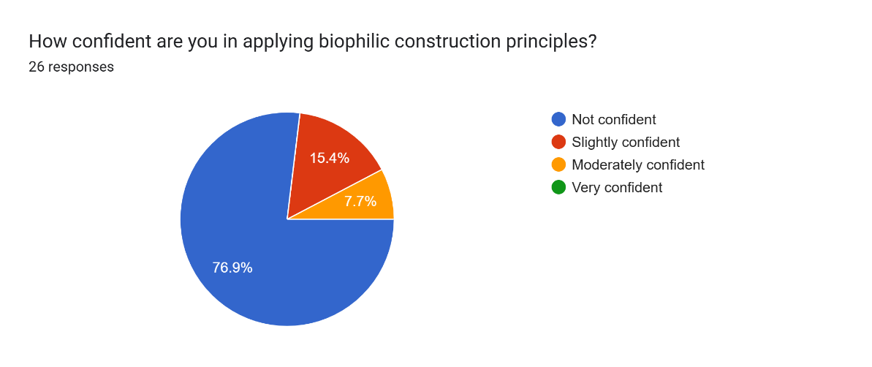
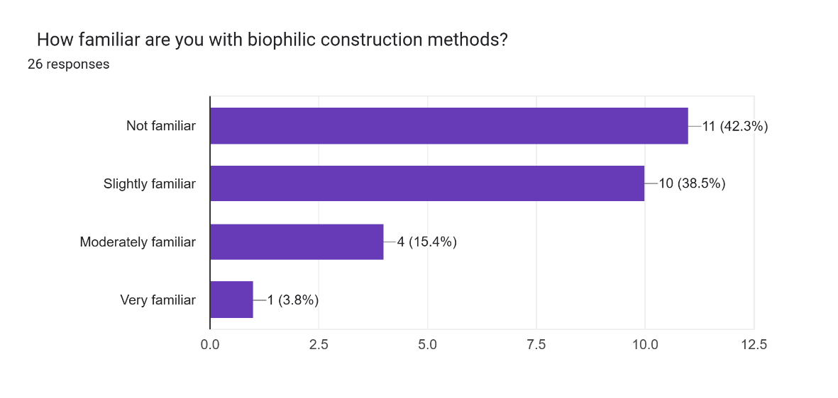
These findings show a clear disconnect between awareness and capability, and suggest that biophilic construction is not yet embedded within industry practice. This supports existing research that identifies gaps in knowledge and skills relating to sustainable construction approaches. (CITB, 2021)
Figure 2 – Confidence in biophilic construction Findings (Questionnaire)
Figure 1 – Familiarity with biophilic construction findings (Questionnaire)

4.1.2 Perceived Skills Gap
Building on the identified limited awareness, participants also strongly agreed that a skills gap exists in biophilic construction in Wales. Figure 3 shows that 53.8% strongly agreed and 38.5% agreed, with only 7.7% remaining neutral, and no disagreement was recorded.
When considered alongside the low awareness and confidence levels that have been identified, the findings suggest a clear link between limited understanding and competence and support existing research, which identifies skill shortages as a key barrier to the adoption of sustainable construction methods. (UK Green Building Council, 2023). Overall, the findings confirm a significant skill gap and highlight the need for improved education and training to support the implementation of biophilic construction methods.
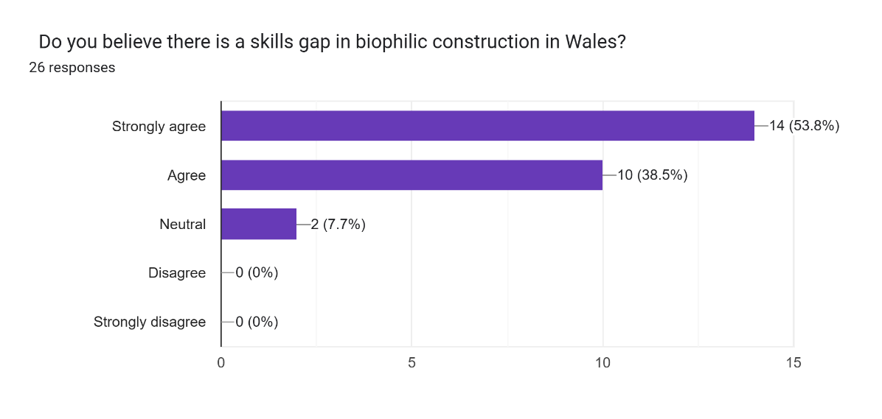
Figure 3 - Perception of skills gap Findings (Questionnaire)

4.1.3 Areas of Skills Shortage
The questionnaire findings provide further insight into the specific areas where it is perceived that skill shortages are lacking the most. Figure 4 shows that the most significant gap was identified in practical construction skills, which was selected by 84.6% of participants, followed by material knowledge (76.9%) and design knowledge (69.2%). In contrast, fewer participants (46.2%) selected sustainability knowledge, while project management skills were the least identified (3.8%).
This indicates that the skills gap is mainly concentrated in the practical and technical application of biophilic construction methods rather than the general awareness of sustainability or management roles. These findings align with recent industry evidence that suggests the skills gap is driven by the increasing demand for specialised skills and insufficient workforce capability. (CITB, 2026)
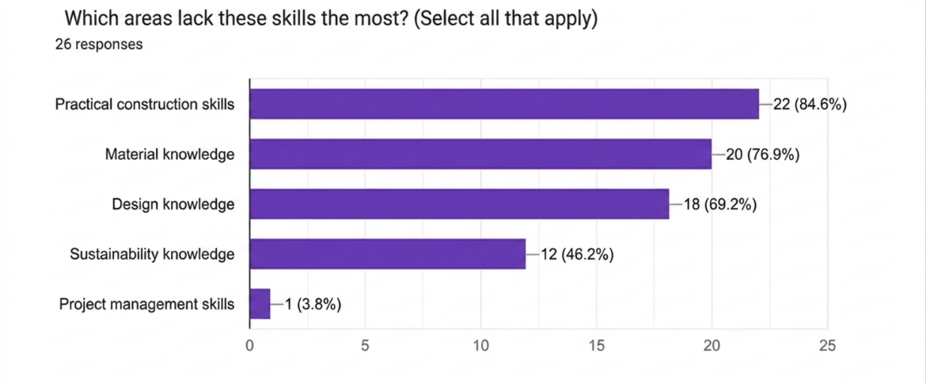
Figure 4 - Areas of skills shortage findings (Questionnaire)

4.1.4 Education and Training Effectiveness
Findings suggest that the current education and training systems are not preparing the workforce for sustainable construction. Figure 5 shows that the majority of participants (69.2) believe that existing provisions do not effectively support the development of green skills, while only 15.4% believe it does; and a further 15.4% were unsure.
These results show a lack of confidence in the current education and training framework and point to a gap between current training and industry needs, especially when considered alongside the skills gap identified in earlier questions, which reflect the wider industry concerns, where limitations in training or upskilling contribute to the skills gap. (CIOB, 2025)
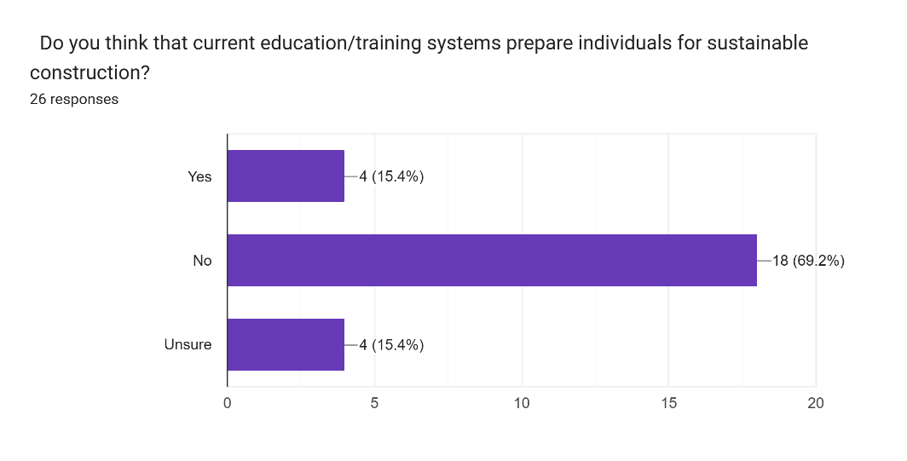

Figure 5 - preparedness for sustainable construction findings (Questionnaire)

4.1.5 Demand for Training
The findings show a clear demand for further training in biophilic construction, as shown in Figure 6. The majority of participants (61.5%) expressed interest in further training compared to 38.5% who did not. This suggests that industry professionals recognise the need to develop their skills, particularly in response to the gaps that have been identified.
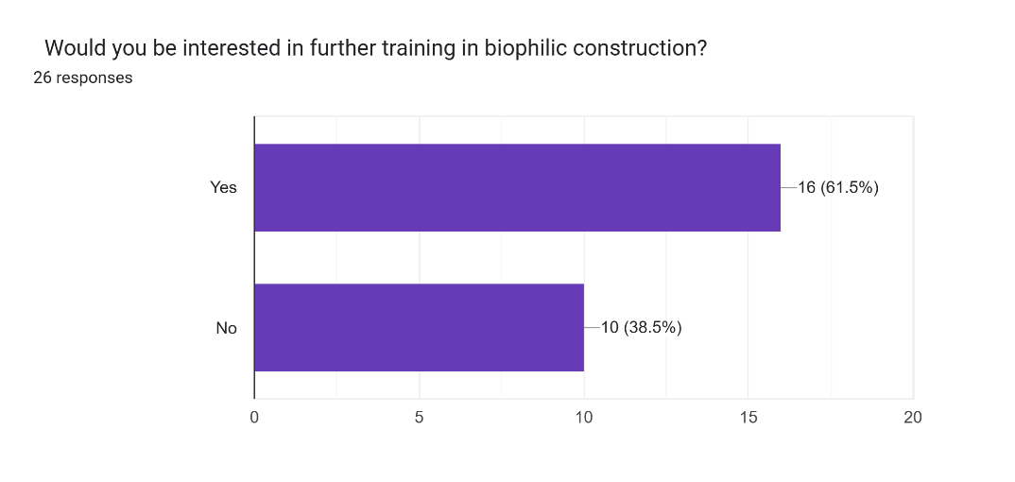
Figure 6 - Demand for training findings (Questionnaire)
The above is supported by the responses relating to the type of training that is required (Figure 7). Continuing professional development (CPD) was selected most frequently (88.5%), followed by practical or on-site training (73.1%) and university-level education (53.8%). Apprenticeships (34.6%) and workshops (26.9%) were selected less often.
These findings suggest that while there is a strong interest in upskilling, there is a clear preference for flexible and practical forms of training, highlighting the need for accessible, industry-focused training.
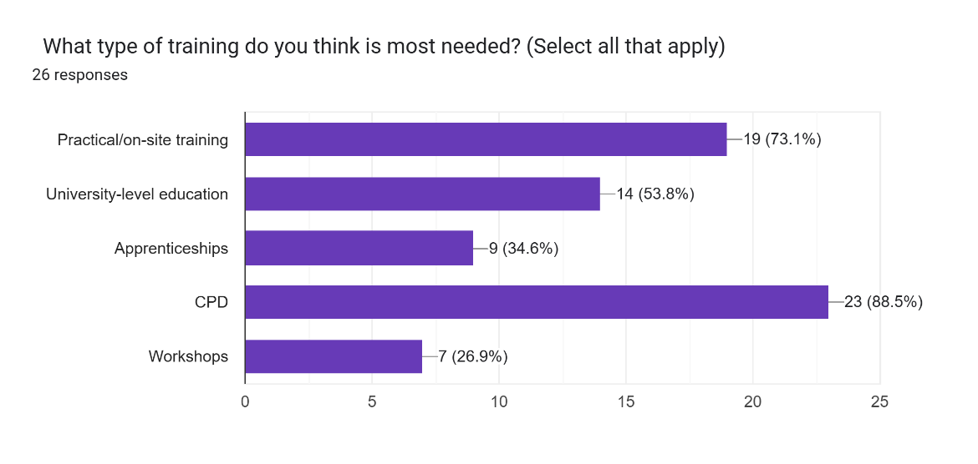
Overall, these findings reinforce the importance of expanding training opportunities, particularly those that support practical applications.
Figure 7 - Required training findings (Questionnaire)

4.1.6 Net Zero Readiness
The findings suggest that while the importance of sustainable construction is recognised throughout the industry, there is limited confidence in the industry's readiness to meet Net Zero targets. Figure 8 shows that most participants (57.7%) felt that the Welsh construction industry is not currently prepared, with only a small number expressing confidence and a number remaining unsure.
This reflects a level of uncertainty within the industry. While Net Zero is considered a priority, there are concerns about whether it is achievable. This links back to earlier findings, where low awareness, limited confidence and clear skill gaps have been identified.
Figure 9 shows that biophilic construction is considered important in achieving Net Zero targets; the majority of participants rated it as either moderately important (57.7%) or very important (30.7), with only a small number considering it slightly important, and none considering it as not important.
These findings suggest a strong recognition of the role that biophilic construction can play in supporting more sustainable building practices. However, when considered alongside the earlier findings around low awareness, limited confidence and the skills gaps, it highlights a disconnect between understanding its importance and applying it in practice.
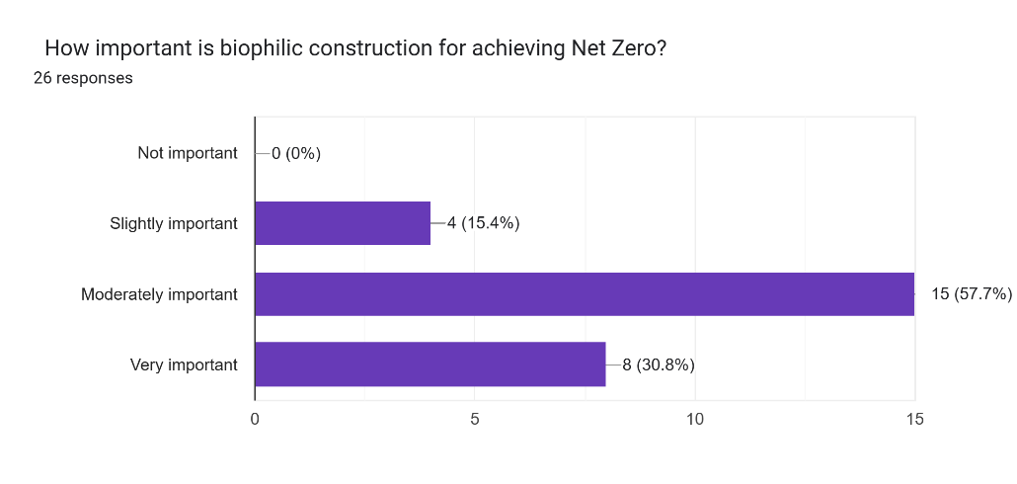
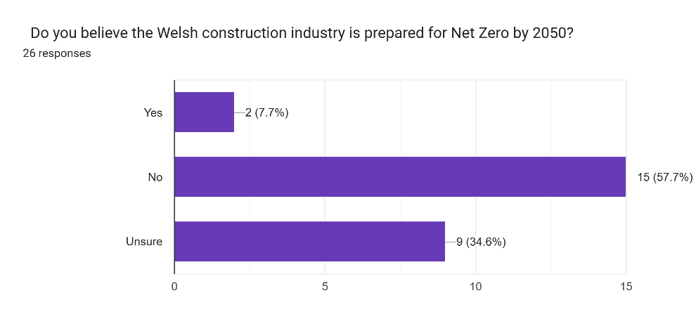
These findings reflect industry evidence that suggests sustainable construction approaches are valued but not fully understood or implemented due to gaps in skills and knowledge. (CIOB, 2025).
Figure 9- Importance of biophilic construction findings (Questionnaire)
Figure 8 -Readiness for Net Zero findings (Questionnaire)

4.1.7 Barriers to Adoption
While Net Zero is clearly seen as important, the results show that there are concerns about how achievable It is in practice. As shown in Figure 10, participants identified several key barriers to adopting biophilic construction methods, with the most significant being lack of knowledge (88.5%) and lack of training (80.8%). Cost was also identified as a major barrier (53.8%), along with lack of client demand (61.5%). Other barriers were identified, such as industry resistance (30.8%) and policy limitations (11.5%).
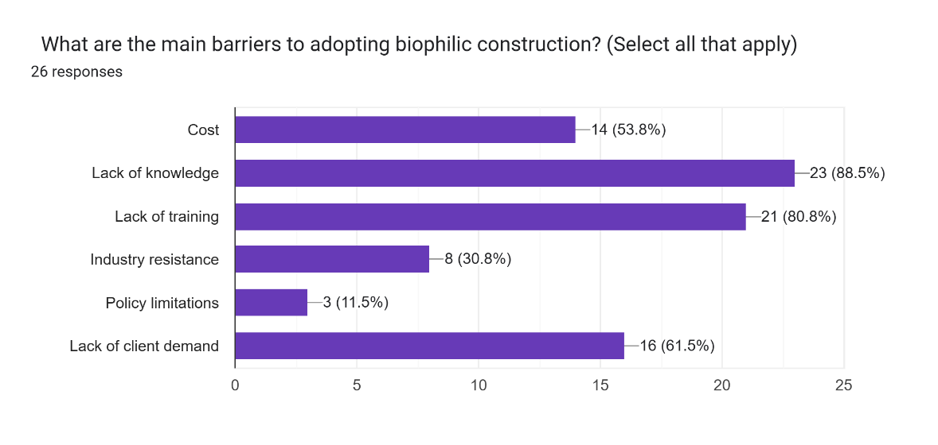
The findings suggest that the main challenges are linked to knowledge and capability rather than purely financial or regulatory issues. This supports earlier findings, where low awareness and confidence were highlighted, showing that many industry professionals do not feel fully prepared to apply biophilic construction in practice.
Figure 10 - Perceived barriers to adoption findings (Questionnaire)

These results are further supported by responses relating to what would improve adoption (Figure 11). The most common suggestion was improved education and training (93.3%), followed by government incentives (69.2%). Other options, such as stronger regulations, industry collaboration and increased use of case studies, were selected less often.
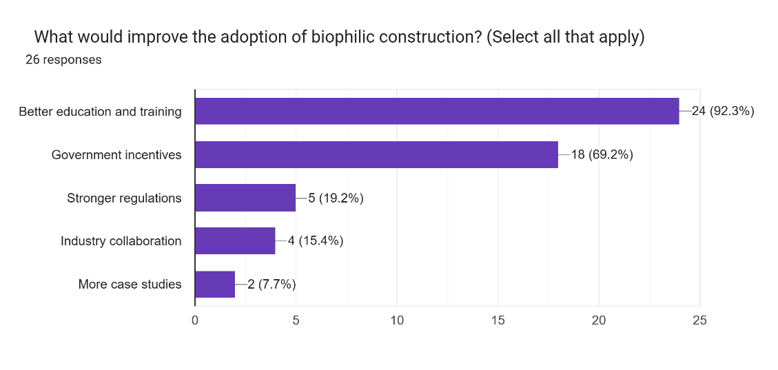
Overall, these findings show a clear correlation between the barriers and the solutions. The strong focus on education and training reflects the wider industry research, which highlights that skills and knowledge gaps remain a major challenge for delivering sustainable construction (Weishaupt and Quiceno-Soto, 2026). Factors such as cost and client demand also continue to influence how widely these approaches are adopted. (UK Government, 2021)
Figure 11 - Adoption of biophilic construction findings (Questionnaire)

4.1.8 Summary of Questionnaire Findings
The questionnaire findings highlight several consistent patterns across the Welsh construction industry in relation to biophilic construction and Net Zero. Overall, the results show low levels of awareness and confidence in implementation, alongside a clear perception of a skills gap, particularly in practical areas. This is supported by an agreement among participants that current skill levels are insufficient and that current education and training provisions are not preparing the workforce for the transition to sustainable practices.
The results also show a clear demand for further training with a preference for flexible approaches, such as on-site training and CPD, suggesting that industry professionals are aware of the need to upskill but require more accessible training opportunities, which reflects the wider concerns around the alignment of training provisions with industry needs.
The importance of Net Zero and sustainable construction is widely recognised; however, there is limited confidence in the industry's readiness to meet these targets. This reflects a gap between awareness of sustainability goals and the ability to deliver them.
Key barriers were identified to include insufficient training, lack of knowledge, and cost, as well as lack of client demand and industry resistance. The possible solutions identified by participants mirror these challenges, with an emphasis on improving training and education.
Overall, the findings suggest that the skills gap in biophilic construction is not just about awareness, but also relates to broader issues involving education, training and industry awareness. These results provide a starting point for further discussion in the discussion chapter.

4.2 Thematic Analysis (Interviews)
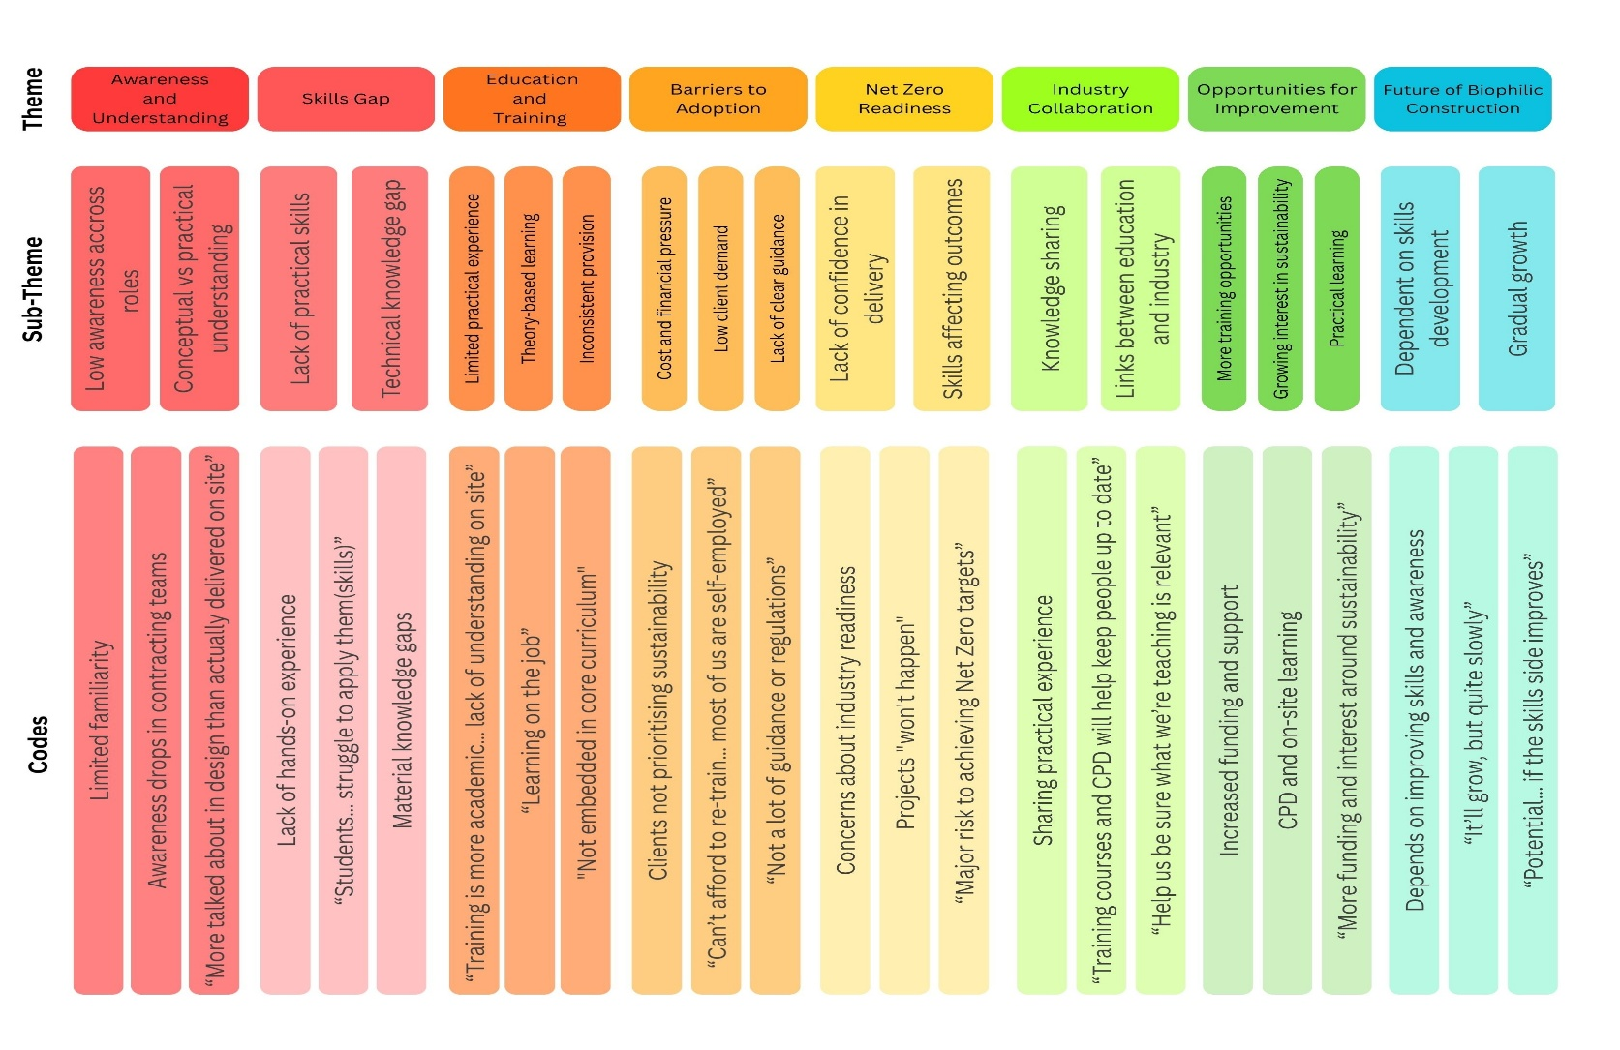
The following analysis brings together the qualitative data collected from the five semi-structured interviews with stakeholders working within the Welsh industry, as outlined in the Interview Transcripts (Appendix C). The data was analysed using thematic analysis to identify recurring patterns across participants' responses. (Braun and Clarke, 2006)
Figure 12 - Thematic mapping of interview data

To support this analysis, the data have been organised into a thematic map (see Figure 12). This framework shows how the findings have been developed from the research aims to specific themes, sub-themes and coded data derived from participants' responses.
Additionally, key quotes from participants have been included throughout this section to provide evidence and support the interpretation of findings. This strengthens the reliability of the analysis and demonstrates how themes have been derived from the data. (Braun and Clarke, 2006)

4.2.1 Awareness of Biophilic Construction
The findings suggest that awareness of biophilic construction is generally low across the industry, particularly with site-based roles. While some participants showed basic understanding of the concept, this was not consistent across all stakeholders.
For example, participant 1, a project manager, described it as ‘’Something I’ve heard about more recently, but not something we actively design for’’ while Participant 3, a builder, explained that ‘’it’s not something we really talk about on site’’. In contrast, Participant 2, an architect, referred to it as ‘’central to design thinking’’.
This difference highlights a clear gap between roles, with awareness being higher in management and design-based roles and lower within construction and delivery. While awareness is developing within certain areas of the industry, it is not yet embedded in practice.

4.2.2 Skills Gap Across the Sector
A clear and consistent theme across all of the interviews was the presence of a skills gap, particularly when it comes to practical application. While some participants understood the idea behind biophilic construction, many highlighted difficulties in actually applying these methods in practice.
For example, Participant 1 referred to the need for ‘’how to actually deliver these ideas on site’’, while Participant 3 pointed out the importance of ‘‘hands-on skills and knowing how to build differently’’. Participant 4 noted that " students understand sustainable concepts but struggle to apply them’’.
These responses suggest that the skills gap is not limited to knowledge, but also capability, particularly in real-world construction environments.

4.2.3 Education and Industry Disconnect
The interviews identified a disconnect between education and industry requirements. While sustainability principles are introduced within education, participants questioned how effectively this is transferred into practice.
Participant 1 described training as ‘’More academically inclined’’, while Participant 2 stated a ‘’disconnect between design education and real-life practice’’. From a construction perspective, Participant 3 explained that ‘’a lot of boys that come on to site… have never dealt with these ideas before’’
This highlights the need for stronger links between education providers and industry to ensure training is relevant.

4.2.4 Barriers for Implementations
Several barriers were identified that participants believe make it difficult to adopt biophilic construction methods in practice; the most common issues raised were cost, lack of knowledge, and limited demand from clients.
Participant 1 explained that ‘’clients don’t want to pay it’’, while Participant 3 highlighted that ‘’ We can’t afford to re-train… most of us are all self-employed’’. Participant 2 also stated that ‘’clients aren’t asking for sustainable buildings’’, suggesting that demand is still relatively low.
There were also concerns around policy and guidance, with Participant 5 stating ‘’there’s not a lot of guidance or regulations in place’’. These findings show that the challenges are not just technical, but also financial and industry-wide, making it difficult for sustainable approaches to be adopted throughout the sector.

4.2.5 Opportunities for Improvement
Participants were asked what could improve the situation; a number of suggestions were highlighted to include training, upskilling or gaining practical experience and improving collaboration throughout the industry.

4.2.6 Summary of Interview Findings
The interview findings highlight a number of clear themes across the Welsh construction industry in relation to biophilic construction; overall, awareness is fairly limited, particularly outside of design-focused and management roles. Many participants showed only a basic understanding of the concept and how these methods can be applied in practice.
A clear skills gap was identified, especially in practical and technical areas; participants often pointed out how difficult it is to apply these ideas on-site. This was closely linked to a gap between education and industry, where training is considered to be too theoretical and doesn’t fully prepare workers for real-world construction work.
Participants also raised concerns regarding barriers to adoption, which included cost, lack of knowledge, and a limited demand from clients, along with a lack of guidance in biophilic construction. At the same time, there were clear opportunities for improvement, particularly through more practical training and better links between education providers and industry.
The findings suggest that while biophilic construction is becoming recognised, it is not yet fully understood. These results support the questionnaire findings and help build a clearer picture of the main challenges within the industry and where there are opportunities for improvement.
The next chapter builds on these findings by looking at them in more detail and linking them to existing research. It will also consider what these results mean for the industry, particularly in relation to the skills gap and the ability to meet Net Zero targets.

Chapter 5: Discussion

5.1 Research Objective 1: Assess the current levels of understanding and awareness of biophilic construction methods with trades and construction professionals in Wales.
Both sets of research findings have revealed a significant gap between awareness and capability within the Welsh construction industry. While 88.5% of questionnaire participants recognise the importance of biophilic construction for Net Zero, familiarity remained superficial. 42.3% of participants admitted to being ‘not familiar' with specific biophilic methods, suggesting that while the green skills agenda is known within the industry, the technical specifics, such as the ‘natural patterns and processes’ principle (Kellert, 2018), are not yet fully understood.
This gap between awareness and capability is reinforced in both the questionnaire and interview findings; while the questionnaire highlighted that confidence levels in implementing these methods are low and there is a strong agreement that a skills gap is present, the interviews indicated that the issue lies in practical delivery rather than understanding the concept. Participants explained that the knowledge tends to be present with those in design roles but is lacking once projects move into construction and delivery. As a result, workers responsible for implementing these ideas on-site lack the confidence to do so effectively, reflecting the wider industry findings around gaps in practical skills and workforce capability. (CITB, 2021)

5.2 Research Objective 2: Identify gaps within existing education, training and professional development relating to biophilic construction methods
The research identified a failure in current education provisions, clearly identifying a skills gap across the sector, with 69.2% of participants stating that existing education does not prepare the workforce for Net Zero. There is a clear gap between traditional construction qualifications and the skills needed to apply biophilic methods in practice, suggesting that current education provisions are not fully aligned with sustainable, nature-based construction.
The interview findings support this and provide more depth, showing that the issue is not just a lack of knowledge. Participants described education as ‘’overly academic’’ and not reflective of real-life site conditions, reinforcing the idea that there is a disconnect between education and industry. For biophilic construction, which relies on the use if natural materials, classroom-based theory is insufficient.
A key theme emerging across both methods is the importance of practical learning. The questionnaires show a demand for practical training and continued professional development, indicating that workers prefer hands-on learning and real-world experience, rather than classroom-based approaches. The interviews highlight this further as participants suggest a lack of ‘’hands-on’’ skills and difficulties applying concepts on site. This aligns with Data Cymru’s (Data Cymru, 2022) concerns that current FE and HE provision needs to become more practical and locally tailored if the industry is to meet Net Zero requirements.

5.3 Research objective 3: Explore barriers preventing upskilling and the adoption of biophilic construction practices.
Both the questionnaire and interviews identified similar barriers, which include lack of knowledge, limited training, cost and low client demand. This strong overlap suggests that these are key issues across the construction industry.
Lack of knowledge is identified as the most obvious barrier; the research highlights underlying issues, particularly on the reliance on SMEs and sole traders. Interview participants explained that the financial impact of training, including both course fees and time away from work, makes upskilling difficult to justify, acting as a major barrier.
A key finding from the interviews that was less visible in the questionnaire is the role of client demand, which reflects a wider market challenge. Several participants noted that clients are not asking for biophilic or sustainable features, and that without financial incentive or clear requirements, clients are less willing to pay for the additional costs of biophilic methods, which reduces the need for contractors to invest in new skills. This created a cycle where adoption remains limited to smaller, high-profile projects rather than becoming common practice, reflecting CITB’s argument that the skills gap is not only an educational issue, but also an economic one. (CITB, 2020) This also links to the Net Zero Strategy: Build Back Greener, which suggests that market demand plays a key role in driving industry change (HM Government, 2021).

5.4 Research Objective 4: Evaluate the implications of an identified skills gap on achieving Net Zero targets within the Welsh construction industry.
Both data sets show that while Net Zero is considered important, there is little confidence in the industry's ability to achieve these targets. The questionnaire showed low readiness levels, while the interviews highlighted concerns about insufficient skills and knowledge. This confirms that the skills gap has direct implications for Net Zero. Without a workforce that is capable of delivering sustainable construction, policy targets are unlikely to be achieved, which reinforces findings from the literature which highlighted that the transition to Net Zero is not just a technical challenge, but also a skill-based one, such as CITB’s report Building Skills for Net Zero in Wales (CITB, 2021) and the Construction Leaderhsip Councils’ Future Skills Report (Construction Leadership Council, 2019).
Findings also highlight a gap between what the policy aims to achieve and what the industry is actually capable of delivering. While the Net Zero Wales Carbon Budget 2 (Welsh Government, 2021) sets out clear targets, this research suggests that the workforce is not currently equipped to meet them, and suggests that policy on its own is not enough.

5.5 Research Objective 5: Propose recommendations for improving skill development and supporting the adoption of biophilic construction methods.
The findings from both the questionnaire and interviews have highlighted several areas for improvement throughout the industry, particularly in relation to training, collaboration an industry support. There is a clear agreement across both data sets that the current approach to skill development is not sufficient to support the implementation of biophilic construction or the transition to Net Zero.

5.5.1 Training and Upskilling
The findings show a clear demand for more practical, industry-relevant training, particularly in the form of on-site training or CPD. This was reflected in both datasets; a proportion of the questionnaire participants preferred practical workshops, and the interview findings highlighted the importance of ‘hands-on ' experience and learning through real projects. Based on these findings, it is recommended that:
- Government-funded programmes that focus on green skills and sustainable construction methods should be expanded.
- Grants should be introduced to support SMEs and sole traders to help reduce the financial burden of upskilling.
- Training provisions should be adapted to focus on practical application to ensure that workers are not only aware of sustainable methods, but understand the importance of them and are able to implement them effectively in practice.
These recommendations address the issues identified in the findings and align with the wider research that highlights the need for targeted, skills-based training to support the transition to sustainable construction. (CITB, 2021)

5.5.2 Increasing Client Demand
A key finding from the interviews is the role of client demand in driving industry change. Participants noted that clients are not opting for or willing to invest in sustainable or biophilic features, particularly where these are seen as an added cost. To address this, it is recommended that:
- Financial incentives or grants are offered for homeowners or developers to encourage the use of biophilic features in new builds and retrofits.
- Awareness campaigns should be developed to highlight the benefits of biophilic design, to include wellbeing, energy efficiency, and long-term cost benefits.
- Policy measures or building regulations should be strengthened to encourage or require more sustainable approaches and materials.
Increasing client demand could aid in creating a stronger market for biophilic design; without a clear demand or financial incentive, there is little motivation for companies to invest in new skills or adopt sustainable approaches (UK Government, 2021).

5.5.3 Stronger Industry-Education Links
The findings identified a disconnect between education and industry in relation to practical skills. While it was found that sustainability is being introduced at the college level of education, it is not always aligned with real-life construction practices. To address this, it is recommended that:
- Stronger partnerships should be developed between training providers, education facilities and industry to ensure that education and training reflect the current industry needs.
- Industry professionals should be more involved with curriculum development to ensure that content is relevant.
Implementing changes would aid in reducing the gap between theory and practice to better prepare the future workforce and push the drive towards Net Zero.

5.7 Discussion Summary and Future Research
Overall, the findings from this research highlight a clear and consistent pattern across both datasets to show that the skills gap in biophilic construction is a multi-layered issue which involves awareness, education, industry structure and market demand. The similarities in both datasets strengthen the reliability of the findings and support the key themes identified in the literature review.
Across Objectives 1 and 2, both methods showed that while awareness of biophilic construction is increasing, the level of understanding is basic and not supported by the skills that are required to implement it. This links back to the literature, which highlights the gap between understanding sustainable concepts and being able to deliver them in practice (Kellert, 2018). The findings also suggest a wider issue with how skills are developed, which supports earlier research in the Future Skills Report that current education and training are not aligned with industry needs (Construction Leadership Council, 2019).
Objectives 3 and 4 demonstrate that the skills gap is influenced by industry and economic factors; both datasets identified cost, lack of training and low client demand as key barriers, while interviews gave more details on how this affects SMEs and sole traders. This supports literature that suggests the skills gap is influenced by market conditions and financial pressures (CITB, 2021).
Objective 5 builds on this by suggesting practical ways to improve the situation; these recommendations reflect the findings, which highlight the need for a more coordinated approach across education and policy.
This research also highlights the need for further study in this area. Biophilic construction is still relatively under-researched, particularly within the Welsh construction industry and in relation to practical skills and implementation. Through the study, further opportunities have been identified through industry engagement. The author has been invited to join the REPAIR: Retrofitting for the Future (Biophilic Wales, n.d.) research project as an intern; this project explores biophilic living and the integration of nature-based practices within the built environment. This project is linked to wider research initiatives in Wales. This highlights the value of further research, helping to understand how biophilic construction can be applied more widely across the Welsh industry.
Overall, the findings show that the challenges linked to biophilic construction are connected to wider issues within the construction sector, including skills, education and industry practice. Addressing these challenges is imperative in the move towards Net Zero.

Chapter 6: Conclusion
This research aimed to investigate the skills gap in biophilic construction methods within the Welsh construction industry and explore what this means for achieving Net Zero targets. By using both questionnaire data and semi-structured interviews, the study has provided a clear overview of current awareness, skill levels and training provision across the sector.
The findings show that although there is a general awareness of sustainable construction and its importance for Net Zero, this does not translate into confidence or ability in practice. Across both sets of data, there is a clear gap between understanding the concept of biophilic construction and actually being able to apply it on site. This suggests that while the idea is becoming more recognised, it is not yet part of everyday industry practice.
A key finding from this research is the presence of a clear and ongoing skills gap. This is not just about a lack of knowledge, but also a lack of practical skills and experience needed to deliver biophilic construction methods effectively. The research also shows that current education and training do not fully prepare individuals for this shift. Learning is often too focused on theory, with limited opportunities to apply these ideas in real-world construction settings. This creates a disconnect between what is taught and what is needed in practice.
Alongside this, the study identified several wider barriers that make it difficult to adopt biophilic construction. These include the cost of training, particularly for SMEs and self-employed workers, a lack of client demand, and limited policy guidance. These challenges show that the issue is not just about skills, but also about how the industry operates more broadly.
The impact of this skills gap is significant when considering Net Zero targets. The findings suggest that while these targets are widely recognised as important, there is little confidence in the industry’s ability to meet them. This highlights a gap between policy goals and what the workforce is currently able to deliver. Without the right skills in place, it is unlikely that these targets will be achieved.
To respond to this, the research has suggested a number of practical recommendations. These focus on improving access to training, particularly hands-on and industry-relevant learning, strengthening links between education and industry, and encouraging greater demand for sustainable construction through incentives and awareness. Supporting SMEs and smaller businesses is particularly important to ensure that opportunities for upskilling are accessible across the whole sector.
Overall, this research helps to build a clearer picture of the challenges facing the Welsh construction industry in relation to biophilic construction. It shows that while the concept is gaining attention, there is still a long way to go before it can be widely applied in practice.
In conclusion, addressing the skills gap is essential if the industry is to move towards more sustainable construction methods and meet Net Zero targets. This will require a more joined-up approach across education, industry and policy. Without this, the benefits of biophilic construction are unlikely to be fully realised, and progress towards Net Zero will remain limited.

References
Ahmed, S.K., Mohammed, R.A., Nashwan, A.J., Ibrahim, R.H., Abdalla, A.Q., Ameen, B.M.M. and Khidhir, R.M. (2025). Using Thematic Analysis in Qualitative Research. Journal of Medicine, Surgery, and Public Health, [online] 6(6), p.100198. doi:https://doi.org/10.1016/j.glmedi.2025.100198.
Ashton, D. (2025). What is the green skills gap (and why does it matter)? [online] University of the Built Environment. Available at: https://www.ube.ac.uk/whats-happening/articles/green-skills-gap/ [Accessed 11 Nov. 2025].
Beaumont-Oates, W. (2022). Structured Interviews. [online] Thomas International. Available at: https://www.thomas.co/resources/type/hr-blog/structured-interviews [Accessed 12 Dec. 2025].
BERA (2024). Ethical Guidelines for Educational Research, Fifth Edition (2024). [online] www.bera.ac.uk. Available at: https://www.bera.ac.uk/publication/ethical-guidelines-for-educational-research-fifth-edition-2024-online [Accessed 12 Dec. 2025].
Biophilic Wales (n.d.). REPAIR: Retrofitting for the Future. [online] Biophilic.wales. Available at: https://biophilic.wales/ [Accessed 8 Jan. 2026].
Bochart, S. (2019). Six Principles of Biophilic Design - Biophilic Design Elements. [online] Shepley Bulfinch. Available at: https://shepleybulfinch.com/evolving-our-connection-with-nature-six-biophilic-design-applications/. [Accessed 4th February 2026]
Braun, V. and Clarke, V. (2006). Thematic analysis. [online] ResearchGate. Available at: https://www.researchgate.net/publication/269930410_Thematic_analysis [Accessed 22 Apr. 2026].
‌BREEAM (2025). How BREEAM works - BREEAM . [online] BREEAM. Available at: https://breeam.com/about/how-breeam-works. [Accessed 20th February 2026]
Brinkmann, S. (2014). Unstructured and semi-structured interviewing. The Oxford Handbook of Qualitative Research, pp.276–299. doi:https://doi.org/10.1093/oxfordhb/9780199811755.013.030. [Accessed 12 December 2025]
Brown, M. (2016). Futurestorative : working towards a new sustainability. Newcastle Upon Tyne: Riba Publishing.
Browning, W., Ryan, C. and Clancy, J. (2014). 14 Patterns of Biophilic Design Improving Health & Wellbeing In The Built Environment. [online] Available at: https://www.terrapinbrightgreen.com/wp-content/uploads/2014/09/14-Patterns-of-Biophilic-Design-Terrapin-2014p.pdf [Accessed 2 Nov. 2025].
Bryman, A. (2016b). Social Research Methods. [online] Oxford: Oxford University Press. Available at: https://arunodayauniversity.ac.in/wp-content/uploads/2025/01/Social-Research-Methods-4th-Edition-Bryman.pdf [Accessed 3 Feb. 2026].
Chavez, A. (2025). Semi-Structured Interviews: (2025): The Comprehensive Guide. [online] MAXQDA. Available at: https://www.maxqda.com/research-guides/semi-structured-interviews [Accessed 12 Dec. 2025].
CIOB (2025). CIOB Skills Gap Research 2024 Full Report . [online] Ciob.org. Available at: https://www.ciob.org/search-results?keyword=skills+gap+report&submit=Submit [Accessed 28 Mar. 2026].
CITB (2020). Net Zero and construction - Perspective and pathways. [online] Fmb.org.uk. Available at: https://www.fmb.org.uk/resource/citb-report-net-zero-and-construction-perspective-and-pathways.html [Accessed 5 Nov. 2025].
CITB (2021). Building Skills for Net Zero in Wales CITB Industry Insights and Analysis. [online] Available at: https://www.citb.co.uk/media/bdrbdlmo/b06414_net_zero_report_wales_v7.pdf [Accessed 10 Nov. 2025].
CITB (2026). Industry Picture report explores challenges and opportunities underpinning construction skills gap. [online] CITB. Available at: https://www.citb.co.uk/news/updates-insights-and-stories/industry-picture-report-explores-challenges-and-opportunities-underpinning-construction-skills-gap [Accessed 20 Mar. 2026].
Construction Leadership Council (2019). Future Skills Report. [online] Available at: https://www.constructionleadershipcouncil.co.uk/wp-content/uploads/2019/06/CLC-Skills-Workstream_Future-Skills-Report_June-2019_A4-Print-Version.pdf [Accessed 15 Nov. 2025].
Craig, S. (2022). Defining Net Zero: differences and challenges | National Centre for Social Research. [online] National Centre for Social Research. Available at: https://natcen.ac.uk/articles/defining-net-zero-differences-and-challenges [Accessed 12 Nov. 2025].
Creswell, J. and Piano Clark, V. (2017). Designing and Conducting Mixed Methods Research. Australian and New Zealand Journal of Public Health, 31(4). [Accessed 5 December 2025]
Data Cymru (2022). The labour market of tomorrow. [online] Available at: https://chcymru.org.uk/cms-assets/documents/The-labour-market-of-tomorrow-%E2%80%93-Jobs-Skills-and-the-Transition-to-a-Green-Economy.pdf [Accessed 15 Nov. 2025].
Dept of Psych EDI committee, McGill (n.d.). Structured vs. Unstructured Interview: Improving Accuracy & Objectivity. [online] Available at: https://www.mcgill.ca/psychology/files/psychology/structuredinterviews.pdf [Accessed 12 Dec. 2025].
Design Council n.d How buildings and spaces create economic and social value. (n.d.). Available at: https://www.designcouncil.org.uk/fileadmin/uploads/dc/Documents/the-value-of-good-design.pdf.
Fromm, E. (2010). The heart of man: its genius for good and evil. Riverdale, Ny: American Mental Health Foundation Books.
HM Government (2021). Net Zero Strategy: Build Back Greener. [online] gov.uk. UK Government. Available at: https://assets.publishing.service.gov.uk/media/6194dfa4d3bf7f0555071b1b/net-zero-strategy-beis.pdf [Accessed 9 Nov. 2025].
Hopkinson, L.L. and Gwilliam, J.A. (2015). Driving education for sustainable development potential within professional curricula: Built environment sustainability training and training development for professionals in Wales. Local Economy: The Journal of the Local Economy Policy Unit, 30(3), pp.280–291. doi:https://doi.org/10.1177/0269094215579014. [Accessed 15 November 2025]
Kellert, S.R. (2018). Nature by Design: The practice of biophilic design. New Haven: Yale University Press.
‌Kellert, S.R. (2018). Nature by Design: The Practice of Biophilic Design. New Haven, Ct: Yale University Press.
Kellert, S.R. and Wilson, E.O. (1993). The Biophilia Hypothesis. Shearwater Books.
Kellert, S.R., Heerwagen, J.H. and Mador, M.L. (2008). Biophilic design: The theory, science, and practice of bringing buildings to life. Hoboken, Nj: Wiley.
Kvale, S. and Brinkmann, S. (2015). InterViews: Learning the Craft of Qualitative Research Interviewing. 3rd ed. [online] Los Angeles: Sage Publications. Available at: https://www.scribd.com/document/458107609/InterViews-Learning-the-Craft-of-Qualitative-Research-Interviewing-1-ed-Kvale-1996-pdf [Accessed 12 Dec. 2025].
‌Mackie, A. (2024). The Six Principles of Biophilic Design — Vera Iconica Architecture. [online] Vera Iconica Architecture. Available at: https://veraiconica.com/the-six-principles-of-biophilic-design/. [Accessed 4th February]
Marshall, G. (2005). The Purpose, Design and Administration of a Questionnaire for Data Collection. Radiography, [online] 11(2), pp.131–136. Available at: https://www.sciencedirect.com/science/article/abs/pii/S1078817404001208 [Accessed 4 Dec. 2025].
Martinez, J., Wong, C., Piersol, C.V., Bieber, D.C., Perry, B.L. and Leland, N.E. (2019). Stakeholder engagement in research: a scoping review of current evaluation methods. Journal of Comparative Effectiveness Research, [online] 8(15), pp.1327–1341. doi:https://doi.org/10.2217/cer-2019-0047. [Accessed 11 December 2025]
Miller Research (2004). Construction Skills in Mid Wales Final Report to National Council for Education and Training for Wales. [online] Available at: https://www.gov.wales/sites/default/files/statistics-and-research/2019-06/040310-construction-skills-mid-wales-en.pdf [Accessed 15 Apr. 2026].
Morton, J. (2025). Systems Thinking in Construction: A Holistic Approach to Sustainable Building. [online] SUSTAINABLE STORIES. Available at: https://www.sustainablestories.uk/articles/systems-thinking-in-construction-a-holistic-approach-to-sustainable-building [Accessed 2 Nov. 2025].
‌Passivhaus Trust (2025). What is Passivhaus? [online] www.passivhaustrust.org.uk. Available at: https://www.passivhaustrust.org.uk/what_is_passivhaus.php#2. [Accessed 20th February 2026]
Royal Town Planning Institute (2015). Barriers to the successful Implementation of the Well-Being of Future Generations (Wales) Act 2015 | Championing the power of planning. [online] Rtpi.org.uk. Available at: https://www.rtpi.org.uk/new-from-the-rtpi/barriers-to-the-successful-implementation-of-the-well-being-of-future-generations-wales-act-2015/ [Accessed 11 Nov. 2025].
Rushanim Hashim, Sarah Cooper, Nurul Azita Salleh and Mohd Nasrun Mohd Nawi (2022). The Influence of Regulatory Pressure in Shaping Construction Firms’ Decision to Adopt Green Innovation. Journal of Advanced Research in Applied Sciences and Engineering Technology, 28(2), pp.301–310. doi:https://doi.org/10.37934/araset.28.2.301310. [Accessed 2 November 2025]
Saunders, M., Lewis, P. and Thornhill, A. (2023). Research Methods for Business Students. 9th ed. [online] Pearson. Available at: https://www.researchgate.net/profile/Mark-Saunders-10/publication/240218229_Research_Methods_for_Business_Students/links/66caf9f575613475fe7891e4/Research-Methods-for-Business-Students.pdf?origin=publication_detail&_tp=eyJjb250ZXh0Ijp7ImZpcnN0UGFnZSI6InB1YmxpY2F0aW9uIiwicGFnZSI6InB1YmxpY2F0aW9uRG93bmxvYWQiLCJwcmV2aW91c1BhZ2UiOiJwdWJsaWNhdGlvbiJ9fQ&__cf_chl_tk=3FzFLNQexJd3BlyM7JuO62jMl1Fw_eXPuGNr4bQqpLM-1776609574-1.0.1.1-BIxI2EaqE9s6IlnVxghP.wFeZt94ONP_aRYDClZWUWk [Accessed 5 Dec. 2025].
Terry, S. (2025). 2025 Green Skills Gap Concerns in Construction. [online] Astutis.com. Available at: https://www.astutis.com/astutis-hub/blog/green-skills-gap-construction [Accessed 2 Nov. 2025].
UK Government (2021). Net Zero Strategy: Build Back Greener. [online] GOV.UK. Available at: https://www.gov.uk/government/publications/net-zero-strategy.
UK Green Building Council (2023). The Levelling Up white paper and the sustainable built environment | UKGBC. [online] UKGBC. Available at: https://ukgbc.org/news/the-levelling-up-white-paper-and-the-sustainable-built-environment/ [Accessed 4 Feb. 2026].
UK Green Building Council n.d Sustainable Construction Practical Guide (n.d.) Available at: https://ukgbc.org/wp-content/uploads/2024/07/Sustainable-Construction.pdf. [Accessed 5th February 2026]
UKGBC (2021). Net Zero Whole Life Carbon Roadmap. [online] Available at: https://ukgbc.org/wp-content/uploads/2021/11/UKGBC-Whole-Life-Carbon-Roadmap-A-Pathway-to-Net-Zero.pdf. [Accessed 2 November 2025]
Ulrich, R. (1984). View through a Window May Influence Recovery from Surgery. Science, 224(4647), pp.420–421. [Accessed 5th February 2026]
University of Wales Trinity Saint David (UWTSD) (2022) Research Ethics Policy. Available at: https://www.uwtsd.ac.uk/research/research-ethics/ (Accessed: 12 December 2025)
Vasconcelos, C. and Calheiros, C.S.C. (2022). Enhancing environmental education through nature-based solutions. Cham: Springer. [Accessed 22 February 2025]
Weishaupt, T. and Quiceno-Soto, G. (2026). Skills development in sustainable energy transitions: A systematic map and critical review of the drivers and barriers. Energy Research & Social Science, 134, p.104576. doi:https://doi.org/10.1016/j.erss.2026.104576.
Welsh Government (2015). Well-being of Future Generations (Wales) Act 2015. [online] Legislation.gov.uk. Available at: https://www.legislation.gov.uk/anaw/2015/2/contents [Accessed 11 Nov. 2025].
Welsh Government (2021). Net Zero Wales Carbon Budget 2 (2021 to 2025) | GOV.WALES. [online] GOV.WALES. Available at: https://www.gov.wales/net-zero-wales-carbon-budget-2-2021-2025 [Accessed 2 Nov. 2025].
Welsh Government (2022). Net Zero Strategic Plan. [online] Available at: https://www.gov.wales/sites/default/files/publications/2022-12/welsh-government-net-zero-strategic-plan.pdf. [Accessed 20th February 2026]
‌Welsh Government (n.d). Stronger, Fairer, Greener Wales: Net Zero Skills Action Plan. (n.d.). Available at: https://www.gov.wales/sites/default/files/publications/2023-02/net-zero-skills-action-plan.pdf. [Accessed 20th February 2026]
Wiek, A., Withycombe, L. and Redman, C.L. (2011). Key Competencies in sustainability: a Reference Framework for Academic Program Development. Sustainability Science, [online] 6(2), pp.203–218. doi:https://doi.org/10.1007/s11625-011-0132-6. [Accessed 9 November 2025]
Wilson, E.O. (1984). Biophilia. Cambridge, Massachusetts ; London: Harvard University Press.
World Green Building Council (2014). Health, Wellbeing & Productivity in Offices The next chapter for green building. [online] Available at: https://worldgbc.org/wp-content/uploads/2022/03/compressed_WorldGBC_Health_Wellbeing__Productivity_Full_Report_Dbl_Med_Res_Feb_2015-1.pdf. [Accessed 5th February 2026]
World Green Building Council (2014). Health, Wellbeing & Productivity in Offices The next chapter for green building. [online] Available at: https://worldgbc.org/wp-content/uploads/2022/03/compressed_WorldGBC_Health_Wellbeing__Productivity_Full_Report_Dbl_Med_Res_Feb_2015-1.pdf. [Accessed 5th February 2026]
World Green Building Council (2016) BUILDING THE BUSINESS CASE: Health, Wellbeing and Productivity in Green Offices (2016). Available at: https://worldgbc.org/wp-content/uploads/2022/03/WGBC_BtBC_Dec2016_Digital_Low-MAY24_0.pdf. [Accessed 5th February 2026]
Young, J. (2020). What is Frequency Distribution. [online] Investopedia. Available at: https://www.investopedia.com/terms/f/frequencydistribution.asp [Accessed 10 Feb. 2026].

Bibliography
Brown, M. (2016). Futurestorative : working towards a new sustainability. Newcastle Upon Tyne: Riba Publishing.
Browning, W.D., Ryan, C.O. and Heatherwick, T. (2020). Nature inside. A biophilic design guide. London: Riba Publishing.
Chartered Institute of Building (CIOB) (2025) Skills Gap in the Construction Industry Report.(PowerPoint Presentation) Available at: https://www.ciob.org [Accessed 3 December 2025]
De Vere, N. (2021). Creating a biophilic Wales: increasing the health and wellbeing of people, biodiversity and the environment. Sibbaldia: the International Journal of Botanic Garden Horticulture, (20), pp.57–68. doi:https://doi.org/10.24823/sibbaldia.2021.314. [Accessed 22 February 2026]
Heerwagen, J., Kellert, S.R. and Mador, M. (2013). Biophilic design : the theory, science and practice of bringing buildings to life. Hoboken, N.J.: Wiley.
Lefosse, D., van Timmeren, A. and Ratti, C. (2023). Biophilia Upscaling: A Systematic Literature Review Based on a Three-Metric Approach. Sustainability, [online] 15(22), p.15702. doi:https://doi.org/10.3390/su152215702. [Accessed 3 November 2025]
Rudestam, K.E. and Newton, R.R. (2015). Surviving Your Dissertation : a Comprehensive Guide to Content and Process. 4th ed. Los Angeles, Calif.: Sage. [Accessed 22 February 2025]
Smith, C.S., DeMattia, E.A., Albright, E., Bromberger, A.F., Hayward, O.G., Mackinson, I.J., Mantell, S.A., McAdoo, B.G., McAfee, D., McCollum, A., Paxton, A.B., Roderer, A., Stevenson, K., Vidra, R.L. and Zhao, Z. (2025). Beyond despair: Leveraging ecosystem restoration for psychosocial resilience. Proceedings of the National Academy of Sciences, 122(2). doi:https://doi.org/10.1073/pnas.2307082121.[Accessed 3 November 2025]
Vasconcelos, C. and Calheiros, C.S.C. (2022). Enhancing environmental education through nature-based solutions. Cham: Springer. [Accessed 22 February 2025]
Welsh Government (2025). Economic mission: green skills review | GOV.WALES. [online] GOV.WALES. Available at: https://www.gov.wales/economic-mission-green-skills-review-html [Accessed 11 January 2026].
Zhong, W., Schröder, T. and Bekkering, J. (2021). Biophilic design in architecture and its contributions to health, well-being, and sustainability: A critical review. Frontiers of Architectural Research, [online] 11(1), pp.114–141. doi:https://doi.org/10.1016/j.foar.2021.07.006. [Accessed 3 November 2025]

Appendices

Appendix A – Questionnaire
Questionnaire - Assessing the Skills Gap in Biophilic Construction Methods in Wales and its Implications for Net Zero
This questionnaire relates to the Welsh Government’s target to achieve Net Zero greenhouse gas emissions by 2050, which requires significant changes across the construction and built environment sectors. One approach that supports this transition is biophilic construction, which focuses on incorporating natural elements, materials, and processes into building design and construction to improve sustainability and wellbeing. This study aims to explore current awareness, skills, and challenges associated with biophilic construction, and how these may impact the industry’s ability to contribute to Net Zero targets.
Your participation is voluntary, and all responses will be kept anonymous and used solely for academic purposes. The questionnaire should take approximately 5–10 minutes to complete.
* Indicates required question
- Consent: *
I confirm that I have read the information above and consent to take part in this research.
Check all that apply.
Yes
No
- What is your role within the construction or built environment sector? *
Check all that apply.
Architect
Engineer
Contractor/Builder
Project Manager
Sustainability Consultant
Educator
Policy/Local Authority
Other:
- How many years of experience do you have? *
Check all that apply.
0-5
6-10
11-20
20+
- Which sector do you primarily work in? *
Mark only one oval.
Residential
Commercial
Infrastructure
Public Sector
Mixed
- How familiar are you with biophilic construction methods? *
Check all that apply.
Not familiar
Slightly familiar
Moderately familiar
Very familiar
- How would you rate your understanding of biophilic design principles? *
Check all that apply.
Very low
Low
Moderate
High

- Have you been involved in any projects incorporating biophilic design? *
Check all that apply.
Yes
No
Unsure
- Do you believe there is a skills gap in biophilic construction in Wales?
Check all that apply.
Strongly agree
Agree
Neutral
Disagree
Strongly disagree
- Which areas lack these skills the most? (Select all that apply) *
Check all that apply.
Practical construction skills
Design knowledge
Material knowledge
Interdisciplinary collaboration
Project management skills
Sustainability knowledge
- How confident are you in applying biophilic construction principles? *
Mark only one oval.
Not confident
Slightly confident
Moderately confident
Very confident

- Do you think that current education/training systems prepare individuals for * sustainable construction?
Check all that apply.
Yes
No
Unsure
- What type of training do you think is most needed? (Select all that apply) *
Check all that apply.
Practical/on-site training
University-level education
Apprenticeships
CPD
Workshops
- Would you be interested in further training in biophilic construction? *
Check all that apply.
Yes
No
- How important is biophilic construction for achieving Net Zero? *
Check all that apply.
Not important
Slightly important
Moderately important
Very important

- Do you believe the Welsh construction industry is prepared for Net Zero by * 2050?
Check all that apply.
Yes
No
Unsure
- What are the main barriers to adopting biophilic construction? (Select all that * apply)
Check all that apply.
Cost
Lack of knowledge
Lack of training
Industry resistance
Policy limitations
Lack of client demand
- What would improve the adoption of biophilic construction? (Select all that * apply)
Check all that apply.
Better education and training
Government incentives
Stronger regulations
Industry collaboration
More case studies
- Please provide any additional comments or insights: *
Thank you for taking the time to complete this questionnaire. Your responses are greatly appreciated and will contribute valuable insights to this research on biophilic construction and the skills gap within the Welsh construction industry.

This content is neither created nor endorsed by Google.
Forms

Appendix B – Interview Questions
Interview Questions – Biophilia Research
Questions 1 - What is your understanding of biophilic construction methods?
Question 2 - How widely understood are biophilic principles within your sector or the wider construction industry?
Question 3 - What Skills do you think are currently lacking in relation to biophilic construction?
Question 4 - How do you think this skills gap will impact the delivery of Zet Zero targets within the built environment?
Question 5 - What barriers do you think exist to adopting biophilic or sustainable construction methods?
Question 6 - How well do you think current education and training providers prepare people for these challenges?
Question 7 - What role should industry collaboration (webinars, CPD, partnerships etc) play in addressing the issue?
Question 8 - What role do policy and government initiatives play in addressing the skills gap?
Question 9 - What opportunities are you aware of that exist for improving skills in biophilic construction?
Question 10 - How do you see the future of biophilic construction in Wales?

Possible prompts for further details.
- Examples from your experience?
- What changes would you like to see in the industry?

Appendix C – Interview Transcripts
Participant Overview
Participant 1 | Project Manger
Participant 2 | Architect (Residential)
Participant 3 | Local Builder (SME)
Participant 4 | College Lecturer
Participant 5 | Sustainability Officer (Engineering Firm)

Question 1: What is your understanding of biophilic construction methods?
Participant 1 (Project Manager):
‘’I’d say it’s about bringing natural elements into buildings, whether that’s materials, lighting, or even layout. It’s something I’ve heard more about recently, but I wouldn’t say it’s something we actively design for on most projects.’’
Participant 2 (Architect):
‘’For me, it’s quite central to design thinking now — integrating nature into the built environment to improve wellbeing and sustainability. But I think it’s still more talked about in design than actually delivered on site.’’
Participant 3 (Builder):
‘’Honestly, it’s not something we really talk about on site. I’ve heard the term, but we’re just building what’s on the drawings.’’
Participant 4 (Lecturer):
‘’We cover it within sustainability topics, but more at a general level. Students are aware of it, at least they should be.’’
Participant 5 (Sustainability Officer):
‘’It’s about reconnecting people with nature through design isn’t it. There’s a lot of evidence around wellbeing benefits but translating that into construction is where the challenge lies.’’

Question 2: How widely understood are biophilic principles within your sector?
Participant 1:
‘’Not very, if I’m honest. It’s something a few people mention, but it’s not widely understood across project teams.’’
Participant 2:
‘’It’s becoming more common, but once you move into contractors or delivery teams, the awareness drops quite a bit.’’
Participant 3:
‘’I don’t think it's understood at all. Most boys on site wouldn’t know what it means.’’
Participant 4:
‘’It’s moderate in construction education at the college level, but still not embedded into the core curriculum.’’
Participant 5:
‘’It’s growing, but still quite niche.’’

Question 3: What skills are currently lacking?
Participant 1:
How to actually deliver these ideas on site.’’
Participant 2:
‘’Material knowledge is a big one, and understanding how systems work together’’
Participant 3:
‘’Hands-on skills and knowing how to build differently’’
Participant 4:
‘’Bridging theory and practice. Students understand sustainable concepts but I think they struggle to apply them.’’
Participant 5:
‘’I think professionals working together, like people working together across design and construction phases’’

Question 4: How will this impact Net Zero delivery?
Participant 1:
‘’It’ll slow things down. If people don’t have the skills, projects won’t meet targets.’’
Participant 2:
‘’We risk missing opportunities to design better and more eco-friendly buildings.’’
Participant 3:
‘’If we don’t know how to do it, it won’t happen’’
Participant 4:
‘’If the next generation isn’t educated enough, we’ll struggle to deliver’’
Participant 5:
‘’It’s a major risk to achieving Net Zero targets.’’

Question 5: What barriers exist?
Participant 1:
‘’It’s expensive, material is expensive, re-training trades or bringing specialists on the job is expensive, project prices increase when you introduce these processes to a project, clients don’t want to pay it’’
Participant 2:
‘’Clients aren’t asking for sustainable buildings; there isn’t a huge demand for it in South Wales’’
Participant 3:
‘’Builders and tradies can't afford to re-train, these courses cost money and were expected to be working, I certainly can't afford the upfront costs as well as the says off work, most of us are self-employed.’’
Participant 4:
‘’We’re educating future civil engineers/managers/QS’s, the education in sustainability needs to spread further across the industry.’’
Participant 5:
‘’There’s not a lot of guidance or regulations in place to make people implement more sustainable methods of building.’’

Question 6: How effective is current education and training?
Participant 1 (Project Manager):
‘’I think a lot of the training is more academically inclined, and when it comes to actually delivering something on site, there’s a lack of understanding’’
Participant 2 (Architect):
‘’I’d say it’s improving, but still quite design-focused. There’s a good level of awareness at university level, but there’s a bit of a disconnect between design education and real-life practice.’’
Participant 3 (Builder):
‘’From what I’ve seen, it’s not really preparing people for what we do day-to-day. A lot of boys come onto site and they’ve never dealt with these kinds of ideas before. It’s very much learning on the job’’
Participant 4 (Lecturer):
‘’We do include sustainability principles in the curriculum, but it can be quite difficult to keep up with how quickly the industry is changing. There’s also limited time within courses to go into real depth’’
Participant 5 (Sustainability Officer):
‘’There’s definitely progress, but I think it’s still quite fragmented. Some institutions are doing really well. I think there needs to be more collaboration to make sure what’s being taught is actually relevant.’’

Question 7: What role should industry collaboration (webinars, CPD, partnerships etc) play in addressing the issue?
Participant 1 :
‘’I think it’s really important, especially from a practical point of view. Things like training courses and CPD will help keep people up to date on new methods.’’
Participant 2:
Partnerships between universities and the industry would be good, we find a lot of challenges between design and delivery, maybe working together could improve this’’
Participant 3:
‘’Anything that shows how it actually works on site would help. Webinars are fine, but again, I don’t have the time to be doing things like that.’’
Participant 4:
‘’Industry collaboration would be beneficial, it’ll help us be sure that what we’re teaching is relevant.’’.
Participant 5:
‘’It plays a big role. Collaboration allows us to share our knowledge’’

Question 8: What role do policy and government initiatives play in addressing the skills gap?
Participant 1:
‘’They definitely set the direction, but it doesn’t always filter down that quickly. On paper it all sounds good, but on projects you don’t always see it reflected straight away.’’
Participant 2:
‘’Yeah, they’re important, they kind of set the expectations. But I think sometimes there’s a gap between policy and what’s actually happening in practice.’’
Participant 3:
‘’To be honest, we only really notice it when it affects building regulations.’’
Participant 4:
‘’They play a big role, especially in shaping what we teach’’
Participant 5:
‘’They’re really important for setting long-term goals, but without proper training, it can be hard for the industry to keep up’’

Question 9: What opportunities are you aware of that exist for improving skills in biophilic construction?
Participant 1 (Project Manager):
‘’There’s definitely more training around now, which helps. I think there’s also an opportunity to learn more on projects themselves, that’s where most people pick up new skills.’’
Participant 2:
‘’I’d say education is a big one, but also just getting more real projects using these ideas. The more it’s used, the more people will learn.’’
Participant 3:
‘’I’m not aware of any, it's not something I look for either. I learn about sustainable buildings on Grand Designs.’’
Participant 4:
There’s a lot we can do through the curriculum, but students need to get some practical experience.
Interviewer: What do you think will help them gain more practical experience?
‘’I think we need stronger links with industry’’
Participant 5:
‘’There’s definitely more funding and interest around sustainability now, so that creates opportunities for training and collaboration. It’s just about making sure those opportunities are actually reaching the right people.’’

Question 10: How do you see the future of biophilic construction in Wales?
Participant 1:
‘’I think it’ll grow, but quite slowly. It depends on how quickly the industry jumps on the sustainability bandwagon.’’
Participant 2:
I can see it becoming more normal in design, definitely. It’s just about making sure it actually carries through into construction.
Participant 3 (Builder):
‘’It’s got potential, yeah, but only if people know what they’re doing. Otherwise it’ll just stay as something we see on tv.’’
Participant 4:
I think it’ll become more important over time, especially with all the focus on sustainability.
Participant 5:
There’s definitely potential there. If the skills side improves, it could play a big role in how we build in the future.

