Contents
Process 2
Creating Forms 2
Menu Form 2
Add Form 2
All Form 3
Find Form 3
Evaluation of VB 4
Appendix 5

Process
The process that has been taken to combat this scenario was as follows;

Creating Forms
The first step was to produce all the forms, this is so all the different functions had a place to be implemented within the program. This also allowed the use of multiple forms; Menu, Add, All and Find. The use of multiple forms allowed the structure to be chosen in an orderly fashion, i.e. everything was not on one form and everything was not all cramped together.
Menu Form
The second step was to work on adding all the features and code onto the menu form. This being because it is the simplest form to complete, all that was needed for the features were three command buttons; these were to link to the other forms.
Appendix 1 shows the design of the form. This form is designed in a simple way, as this is only the menu form and its main purpose is to link to the other forms, so not a lot of features are needed on this form.
The code that was used for this was simply for the buttons. The code, as shown in appendix 2 shows the layout of the code and the different coding techniques used. The reasoning for this code is because it was simple and easy to use.

Add Form
The third step was to work on the features and the code aspects of the add form. This is because this is the main form that will be used by the user, as this form allows the user to add information to the excel document that is linked with the program.
Appendix 3 shows the overall design of the form. This form was designed in way that allows the user to simply add the information that is needed to the excel document. As is shown, there are text boxes, labels and a data grid; these are all for the user to know where to insert the information into the program. There are also command buttons; these command buttons are there to add the information to the spreadsheet and to export it from the spreadsheet.
The coding techniques that have been used are different than the previous form in all cases apart from the buttons. The buttons generally have the same task, when pressed they will have a purpose – in this case the purpose is to either add or export information to or from the spreadsheet. This piece of code is shown in appendix 4
There is code linking the program to the spreadsheet. This is done by the “Dim Exellocation” and the “Dim my ss” code. The datagridview code allows the information to be placed into the spreadsheet by comparing the cells from the datagrid to the cells in the excel document.
The export button just shows the code for the exporting of the information inserted in the excel document to the program. This is done by the code technique “Dim ColumnsCount”. This piece of code adds the information from each cell into the corresponding cell of the data grid on the program. This piece of code is shown in appendix 5.

All Form
The fourth step was to add the features and implement the code into the “All” form. This form was created next because it uses the information from the previous form, the “Add” form, and shows the information in a clear order.
Appendix 6 shows the overall design of the form. The design of the form is done in the way that allows the user to press a button and print off the necessary information, in this case the necessary information was to show the amount of medals that have been achieved by the members of the swimming club; this is shown in the list boxes and have been named for the user to know where the information is going to be shown.
The coding techniques that have been used are shown in appendix 7. There are the same code techniques as the other forms with the command button, i.e. the user presses the button and then the information gets printed off, the only difference being that the location of the information being printed; in this case it will be printed off in each of the list boxes.

Find Form
The last form that was designed and had the code implemented was the “Find” form. This form was done last as this form is used to find the relevant data and present information form the data, in this case the information being presented was the percentages of what gender got each medal
Appendix 8 shows the overall design of the form. This form was designed in the way that the user could select the gender and then add the medals for each of the gender. This then allows the user to press the calculate button and this then works out the total and is presented in the txtCalculate text box. This information is stored and will be presented in either the male or the female text box, depending on what the user selected. This has been done in the way that it allows the user to easily distinguish which gender got more medals as it shows the overall percentage.
The coding techniques are shown in appendix 9. The techniques that have been used in this form are mainly to do with calculations and printing off the information. The claculatiosn are done by the use of the “If” statement code and the holding and printing off the information is mainly done with the use of the “cmdTotal” code.

Evaluation of VB
VB seems to be an overall simple coding interface to use, this is mainly due to the fact that when there is an error it will show and not run the program. This is useful, for beginner and experienced coders, as it allows people to go over and check to see if the code is correct and, if not, what needs to be changed.
Another plus of VB is that when writing a prefix or syntax there will be option available to be chosen, this is a help for people who do not really know what they are doing when it comes to coding as it can help them to learn new aspects of coding and learning different features.
The main issues that was observed is that VB sometimes uses the older files when running the program, this did happen when trying to run this program. What this means is that when the program is running it will not load any of the assets on the page, so no buttons or code will load, even though all the assets are there and the code is correctly implemented; this made testing the program overall an impossible task.

Appendix
1
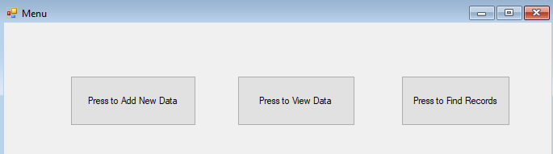
2
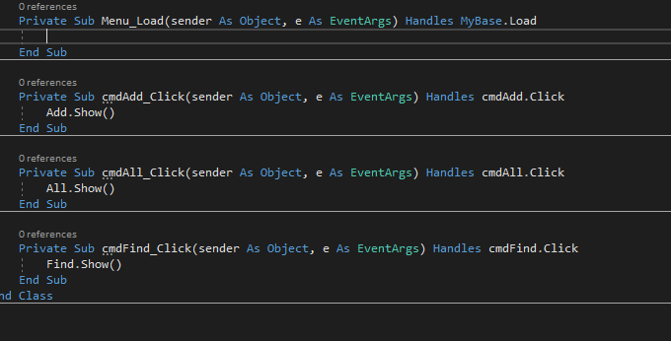

3
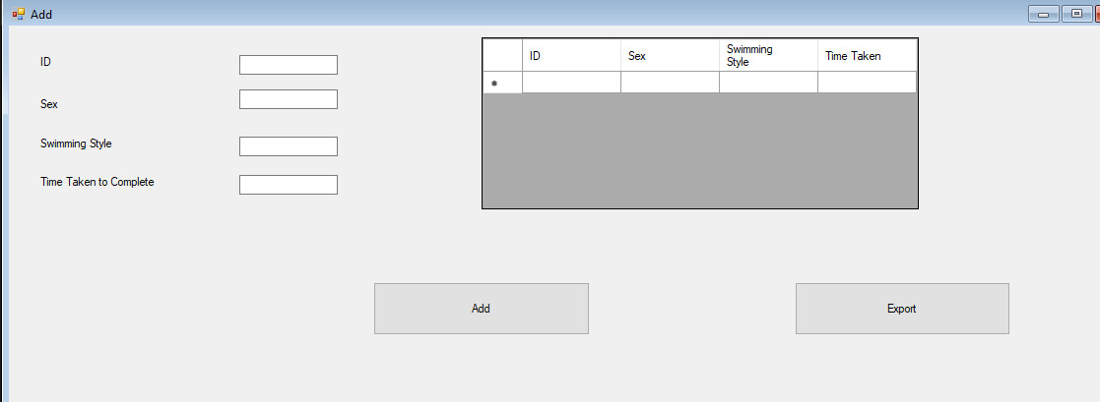
4
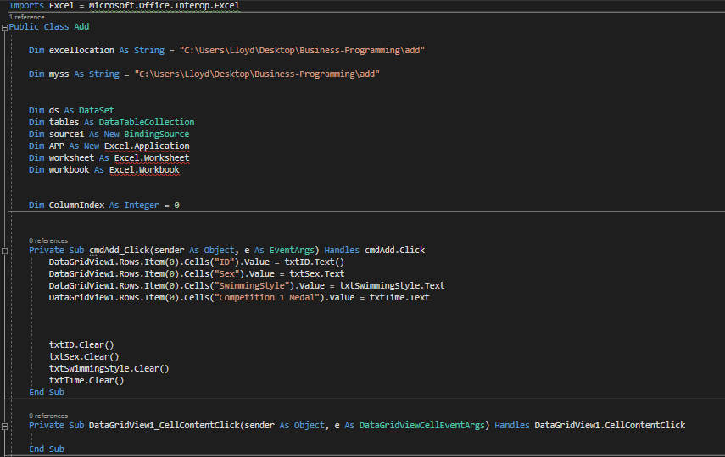

5
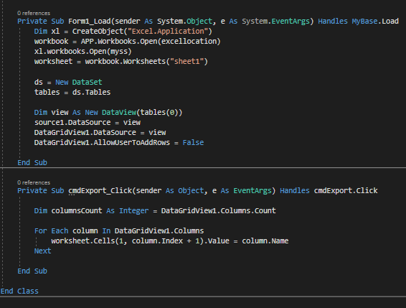

6
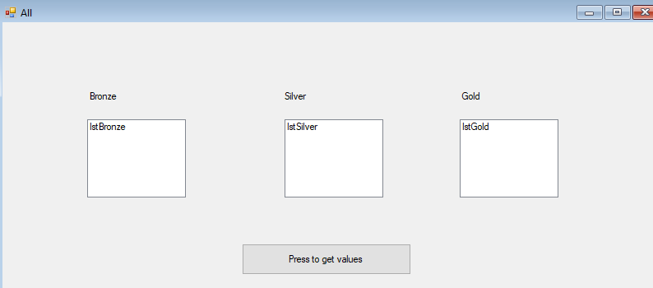
7
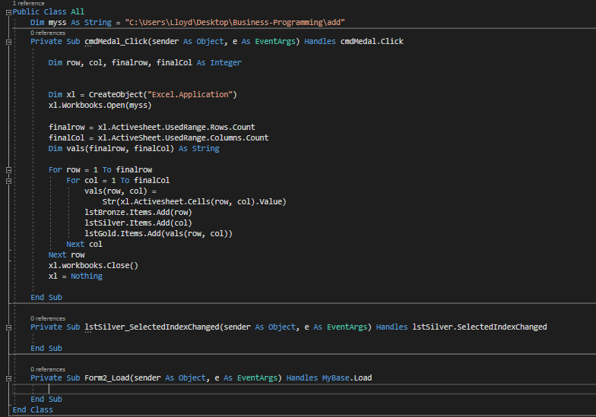
8
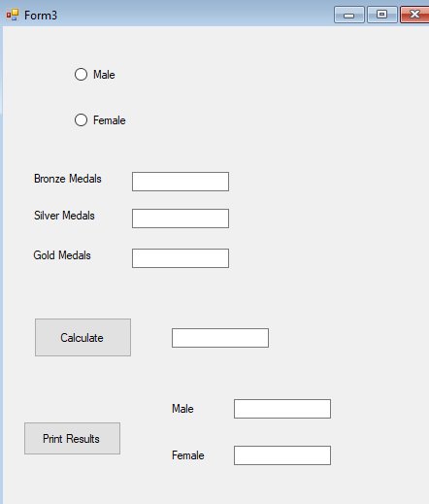
9


