Kristian Cole (1810705)

Database Design
The Book Store

Contents
1.0 Task 1 3
1.1 Tables created 3
1.1.1 Table Requirements 1 3
1.1.2 Table Requirements 2 3
1.1.3. Table Requirements 3 3
1.2 Fields created 3
1.2.1 Book Fields 3
1.2.2 Customer Fields 3
1.2.3 Store Fields 3
1.2.4 Genre Fields 4
1.2.5 Staff Fields 4
1.2.6 Publisher Fields 4
1.2.7 NewsLetter Fields 4
1.2.8 Supplier Fields 4
1.2.9 Stock Fields 4
1.3 Suitable foreign keys created 4
1.3.1 Book Foreign Keys 4
1.3.2 Staff Foreign Keys 4
1.3.3 Publisher Foreign Keys 4
1.3.4 NewsLetter Foreign Keys 4
1.3.5 Stock Foreign Keys 5
1.3.6 Order Foreign Keys 5
1.4 Suitable relationships created 5
1.5 Design Meets User Requirements 5
1.6 3NF 5
2.0 Task 2 5
2.1 Create Queries 5
2.1.1 Create Supplier 5
2.1.2 Create Book 5
2.1.3 Create Store 6
2.1.4 Create Staff 6
2.1.5 Create Orders 7
2.1.6 Create Publisher 7
2.1.7 Create NewsLetter 7
2.1.8 Create Customer 8
2.1.9 Create Genre 8
2.2 Insert Scripts 8
2.2.1 Customer Insert 8
2.2.2 Supplier insert 9
2.2.3 Publisher Insert 9
2.2.4 Store Insert 10
2.2.5 Book Insert 10
2.2.6 Staff Insert 11
2.2.6 Orders Insert 11
2.3. Forms 12
2.3.1 Book Form Screen Capture 12
2.3.2 Supplier Form Screen Capture 13
2.3.3 Publisher Form Screen Capture 13
2.3.4 Genre Form Screen Capture 14
2.3.5 Staff Form Screen Capture 14
2.3.6 Store Form Screen Capture 15
2.3.7 Stock Form Screen Capture 16
2.3.8 Customer Form Screen Capture 17
2.3.9 Order Form Screen Capture 17
2.3.10 Newsletter Form Screen Capture 18
2.4 Report Output 18
2.4.1 Books In Stock 18
2.4.2 Publisher Orders By Staff 19
2.4.3 Customer Orders 19
2.4.4 First Editions 20
2.5 Documentation – User Guide 20
2.5.1 Purpose Of Database 20
2.5.2 Forms 20
2.5.3 Form Functions 20
2.5.4 Reports 21
References 21
Appendix 22
Appendix 1 22

1.0 Task 1

1.1 Tables created

The Book Store database requirements:

1.1.1 Table Requirements 1

Staff placing orders with Suppliers – A Table for Staff , Store and Orders needs to be created to hold Staff details , what Store they are employed at and where they make their Orders from.

1.1.2 Table Requirements 2

Customers placing orders of books – a table for Customers details and one for Books details needs to be created.

1.1.3. Table Requirements 3

Customers receiving Newsletters – A Newsletter table needs to be created.

1.2 Fields created

1.2.1 Book Fields
BookID (Autonumber) – The primary key of the table, applied an autonumber to increment when new records are added (Holland, Information Engineering - Relationships In MS-Access, 2019).
Title (ShortText) , ISBN (Integer) , Author (ShortText) , Price (Integer) – details about real life Books are plain text so can be updated by the user. There are no reliance between tables for this table, is in line with 1NF. This data is referenceable by the foreign key in alternate tables. This is an example of normalisation within the system (Holland, Information Engineering - Normalisation, 2019).
FirstEdition (ShortText) – limited to one character entry for whether it is a Y/N first edition book. This field will be used for the reporting purpose of providing all first edition books that are marked with a ‘Y’.
StockID (Integer) , Genre (Integer) , PublisherID (Integer) , StoreID (Integer) – all foreign keys.

1.2.2 Customer Fields
CustomerID (Autonumber) – The primary key of the table, applied an autonumber to increment when new records are added.
FirstName (ShortText) , SecondName (ShortText) , Location (ShortText) , HouseNo (ShortText) , Address_Line1 (ShortText) , Address_Line2 (ShortText) , Address_Line3 (ShortText) , PostCode (ShortText) , TelephoneNo (Integer) – Customer Details and Address are plain text so can be updated by the user. This table has been created in a 1NF structure so that any references to it are by foreign key alone.

1.2.3 Store Fields
StoreID (Autonumber) – The primary key of the table, applied an autonumber to increment when new records are added. The primary key provides a constraint that the created record is not only indexed but that provides access to a static record.
Storelocation (ShortText) , Address_Line1 (ShortText) , Address_Line2 (ShortText) , Address_Line3 (ShortText) , PostCode (ShortText) , TelephoneNo (Integer) – Store Details and Address are plain text so can be updated by the user. Only appears once in the database to provide redundancy of data across the system (Holland, Information Engineering - Normalisation, 2019).

1.2.4 Genre Fields
GenreID (Autonumber) – The primary key of the table, applied an autonumber to increment when new records are added.
Genre (ShortText) - holds the genre data of the book (e.g. Horror , Romance , etc). This table is structured under the rules of 3NF as this data is not repeated in the Book table but referenced in the Genre table.

1.2.5 Staff Fields
StaffID (Autonumber) – The primary key of the table, applied an autonumber to increment when new records are added.
FirstName (ShortText) , Surname (ShortText) – Staff Details are plain text so can be updated by the user.
StoreID – Foreign Key

1.2.6 Publisher Fields
PublisherID (Autonumber) – The primary key of the table, applied an autonumber to increment when new records are added.
PublisherName (ShortText) , Address_Line1 (ShortText) , Address_Line2 (ShortText) , Address_Line3 (ShortText) , PostCode (ShortText) – Publisher details and address are plain text so can be updated by the user.
SupplierID (Integer) – a foreign key linking the supplier table to the publisher table

1.2.7 Newsletter Fields
NewsLetter (Autonumber) – The primary key of the table, applied an autonumber to increment when new records are added.
BookID (Integer) , CustomerID (Integer) , StoreID (Integer) – Foreign keys

1.2.8 Supplier Fields
SupplierID (Autonumber) – The primary key of the table, applied an autonumber to increment when new records are added,
SupplierName (ShortText) , Address_Line1 (ShortText) , Address_Line2 (ShortText) , Address_Line3 (ShortText) , PostCode (ShortText) – Details and address of the supplier are plain text so can be updated by the user.

1.2.9 Stock Fields
StockID (AutoNumber) The primary key of the table, applied an autonumber to increment when new records are added,
BookID (Integer) – Foreign Key
Amount (Integer) – amount of books left in stock

1.3 Suitable foreign keys created

1.3.1 Book Foreign Keys
StockID (Integer) , Genre (Integer) , PublisherID (Integer) , StoreID (Integer) – Foreign keys linking stock (Amount of books) , Genre (Type of book) , Publisher (which publishing house published the book) and Store (where book is being sold). The one to many relationship between stock and book shows the decrementing amount of books left when orders are filled. The one to many relationship between book and genre shows there is one genre that can be applied to one book.

1.3.2 Staff Foreign Keys
StoreID – Foreign Key showing what staff works in what store. This relationship will be one to many relationship. So one member of staff will work in many stores across the country. This can also be updated very easily if a staff member moves to work in another store in any part of the country as the foreign key can be altered to accommodate this change.

1.3.3 Publisher Foreign Keys
SupplierID (Integer) – a foreign key linking the supplier table to the publisher table. This relationship will be a one to many relationship because one supplier can source books from many publishers. The supplier will remain the same but the publishing house may change over time. The supplier is a foreign key in the publisher for this reason.

1.3.4 NewsLetter Foreign Keys
BookID (Integer) , CustomerID (Integer) , StoreID (Integer) – Foreign keys showing books customers may be interested in. This table is largely made up of foreign keys over substantial data as it is a transactional table where the main data appears in alternate tables.

1.3.5 Stock Foreign Keys
BookID (Integer) – Foreign Key linking book. This table links back to the Book table and shows how much stock is left after an order is placed and completed. This data should not exist in the Book table due to its dynamic content.

1.3.6 Order Foreign Keys
BookID (Integer) , CustomerID (Integer) , StoreID (Integer) , SupplierID (Integer) – another transactional table where the data is statically placed in other tables, existing once and updated in their own tables.

1.4 Suitable relationships created
The ERD Visio diagram in Appendix 1 shows how the database design links all the tables together. The main design of the ERD diagram shows how to link the table via foreign keys so that all the tables have a relationship (Holland, Business Rules and Naming Conventions, 2019). The relationships between the tables are set on a many to one or one to many relationship type. This enforces that the records in one table may either be present once in the one to many relationship (One Supplier can have be present in many Orders) or many times in one table such as in a many to one relationship (Many Publishers can have one supplier).

1.5 Design Meets User Requirements
- User can enter Customer details
- User can create newsletter based on customer purchases
- User can update , delete and add records
- User can run reports that show total customer orders and staff supplier orders

1.6 3NF
Normalisation has been achieved in the Book Store database due to the fact that there is no duplication of data in all entities (Holland, Information Engineering Normalisation, 2019). The data has either been linked via a transactional table such as the Orders table that includes foreign keys rather than constructing an entity that has data that is housed in another entity.

2.0 Task 2

2.1 Create Queries

2.1.1 Create Supplier

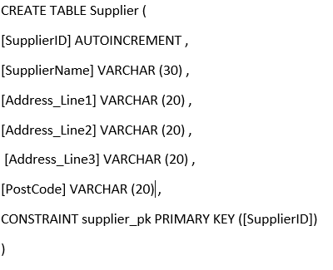

2.1.2 Create Book

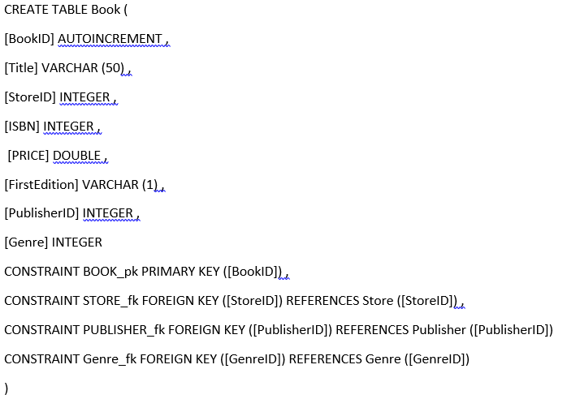

2.1.3 Create Store

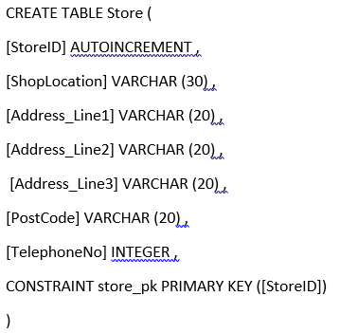

2.1.4 Create Staff

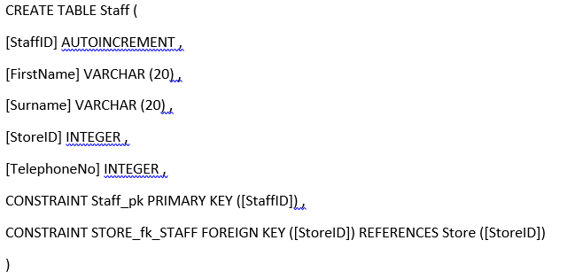

2.1.5 Create Orders

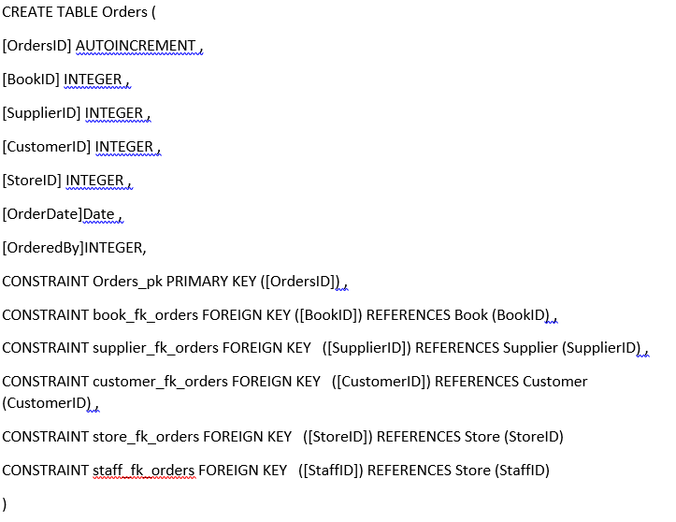2.1.6 Create Publisher

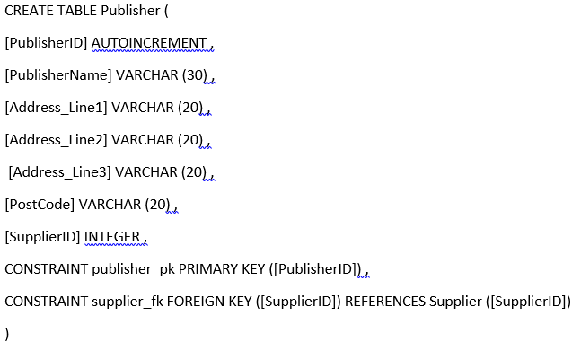

2.1.7 Create NewsLetter

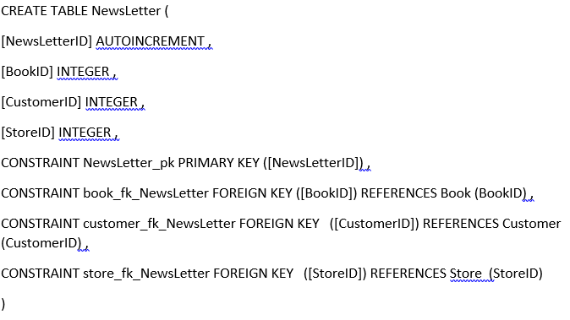2.1.8 Create Customer

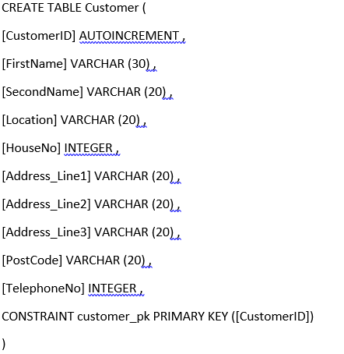

2.1.9 Create Genre
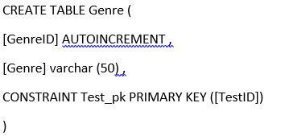

2.2 Insert Scripts

2.2.1 Customer Insert
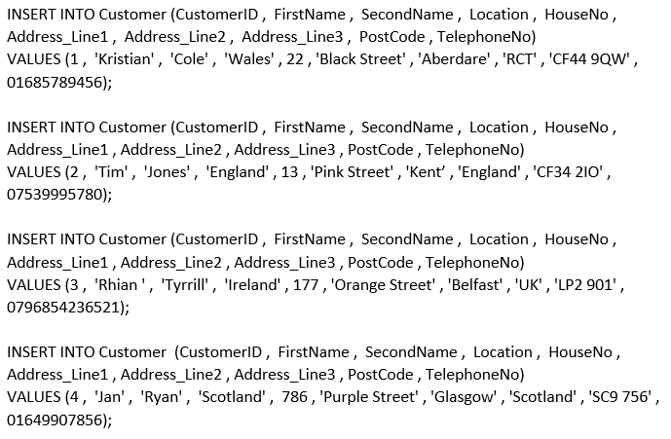

2.2.2 Supplier insert
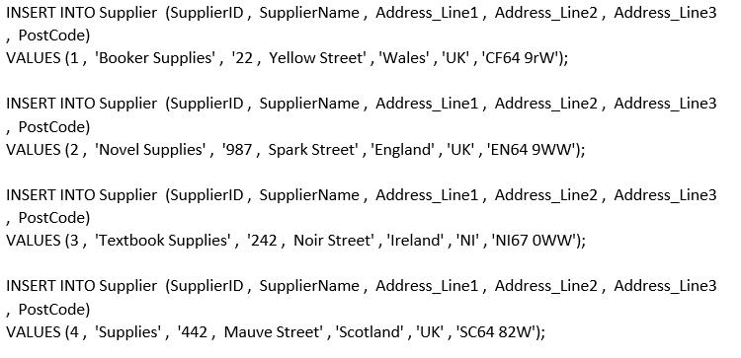

2.2.3 Publisher Insert
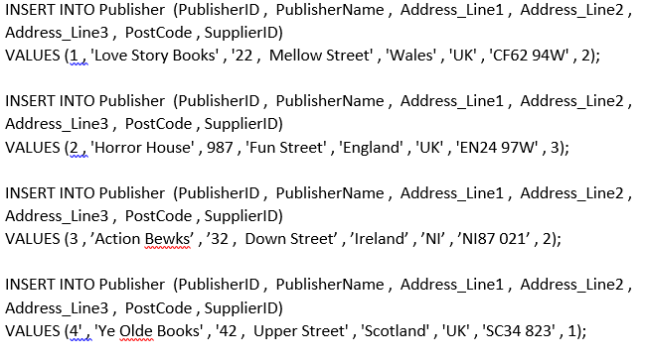

2.2.4 Store Insert
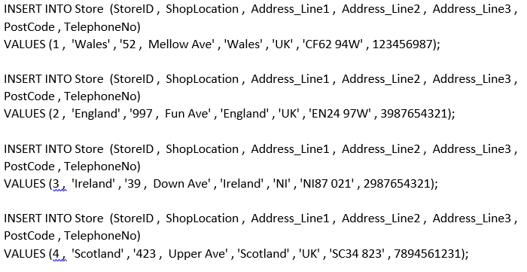

2.2.5 Book Insert
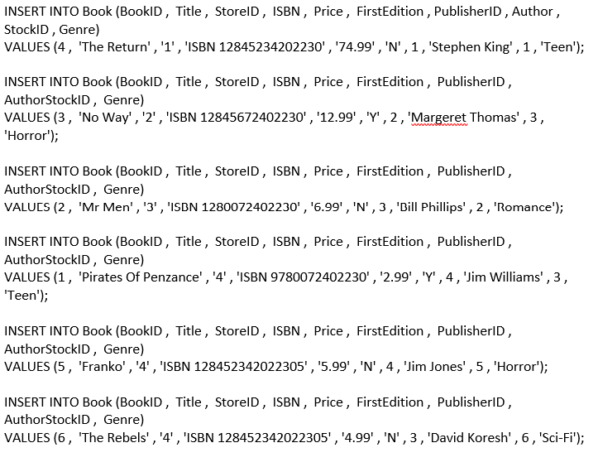
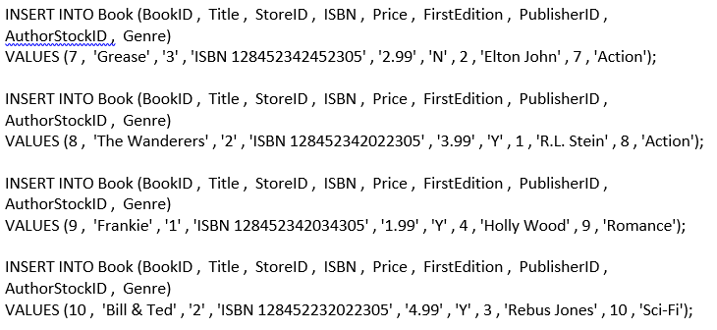

2.2.6 Staff Insert

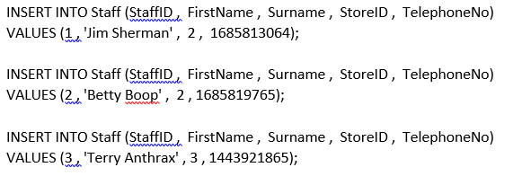

2.2.6 Orders Insert
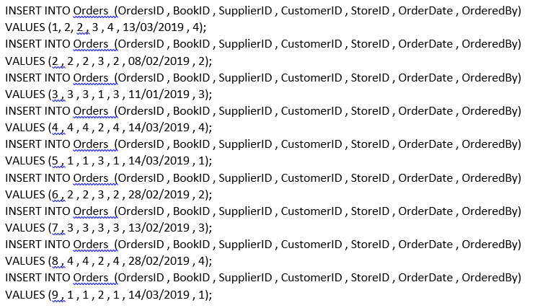

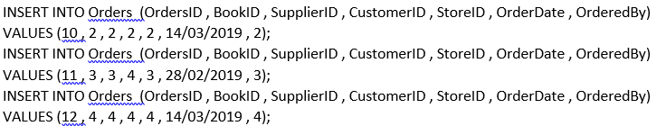2.3. Forms

2.3.1 Book Form Screen Capture
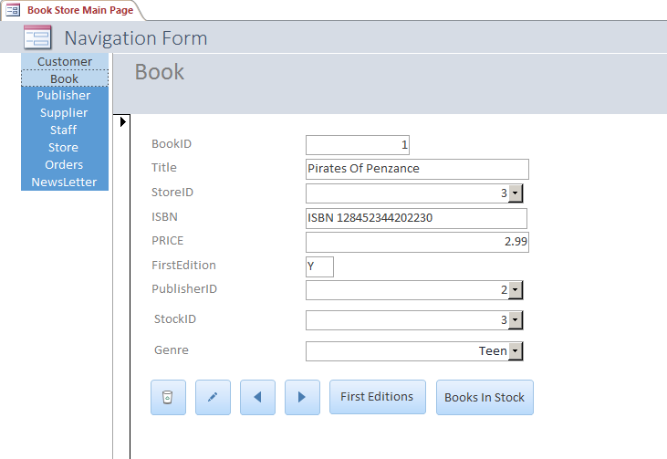

2.3.2 Supplier Form Screen Capture
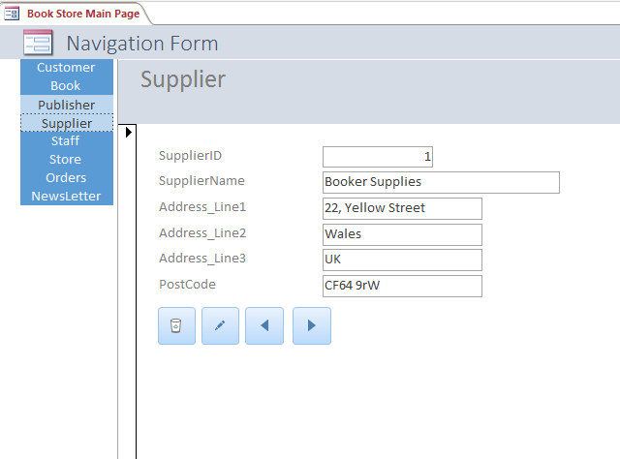

2.3.3 Publisher Form Screen Capture
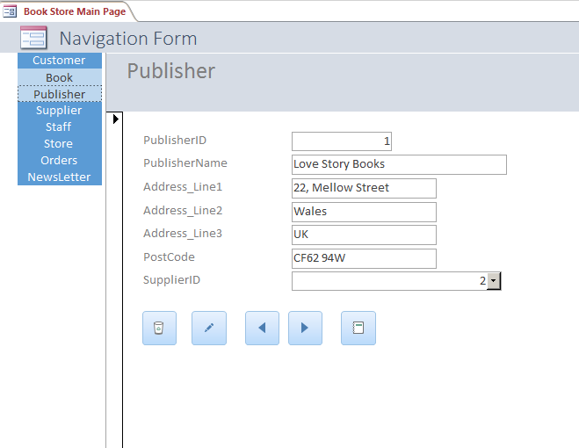

2.3.4 Genre Form Screen Capture
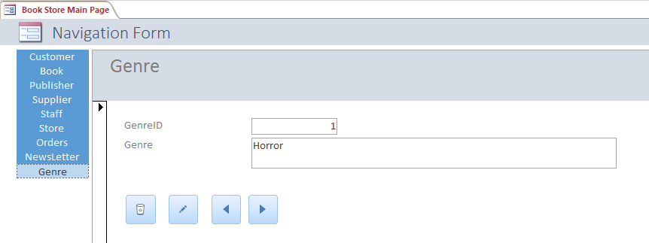
2.3.5 Staff Form Screen Capture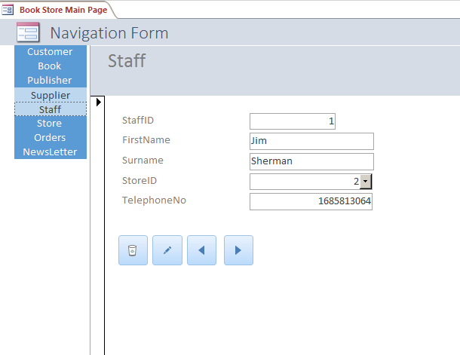

2.3.6 Store Form Screen Capture
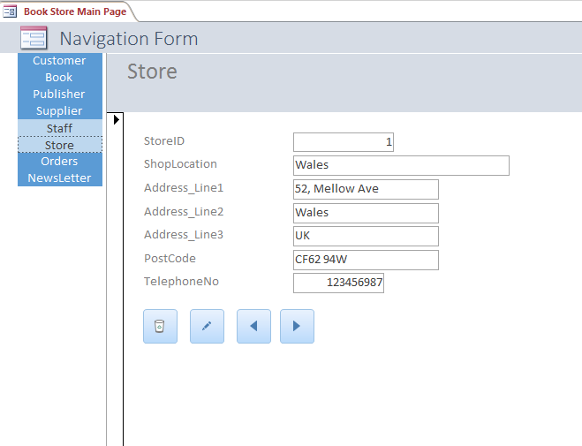

2.3.7 Stock Form Screen Capture
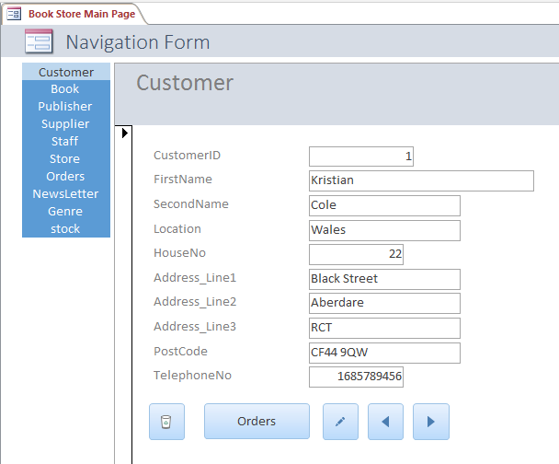

2.3.8 Customer Form Screen Capture
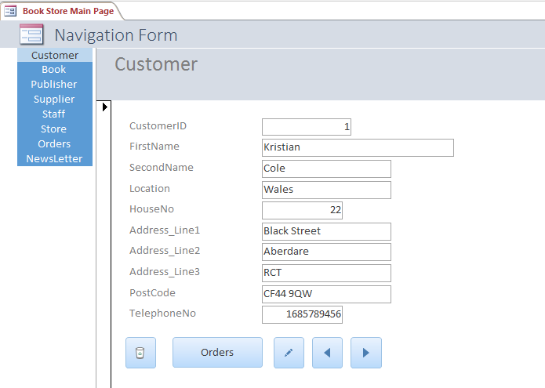

2.3.9 Order Form Screen Capture
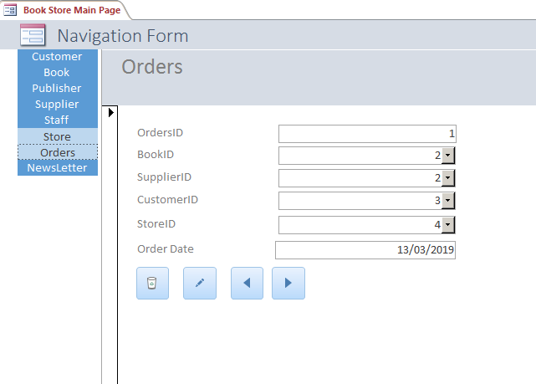

2.3.10 Newsletter Form Screen Capture
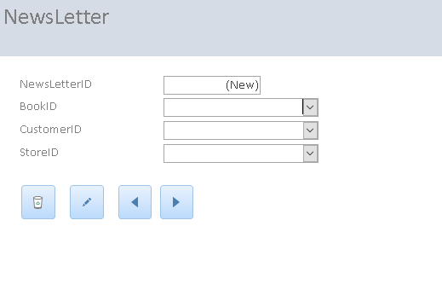

2.4 Report Output

2.4.1 Books In Stock
The Books in stock report shows all books presently available in the Book Store database. The most relevant information is presented for the user.
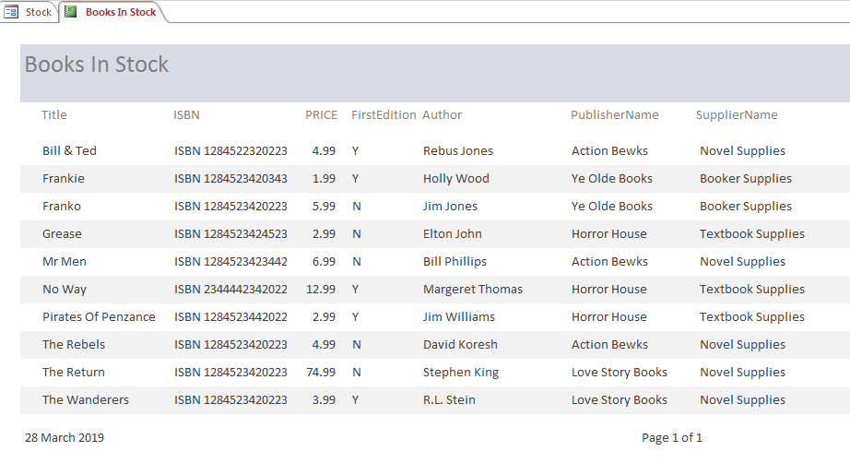

2.4.2 Publisher Orders By Staff
This report shows book orders created by Book Store staff members for suppliers based on what they think customers will purchase.
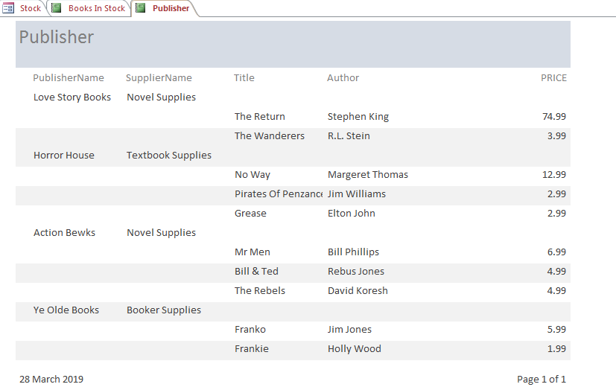

2.4.3 Customer Orders
This report highlights what orders customers have placed in the Book Store.
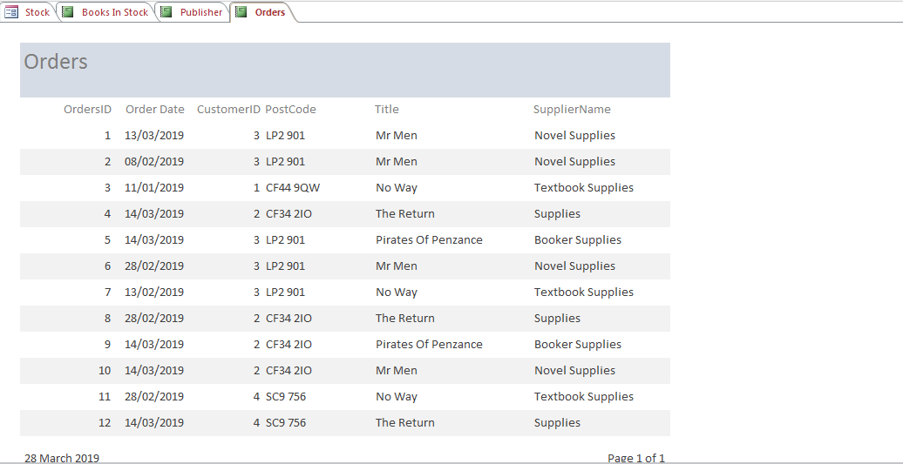

2.4.4 First Editions
This report shows all first edition books available in the Book store. If a Book has a Y in the First Edition column then it is a first edition book.
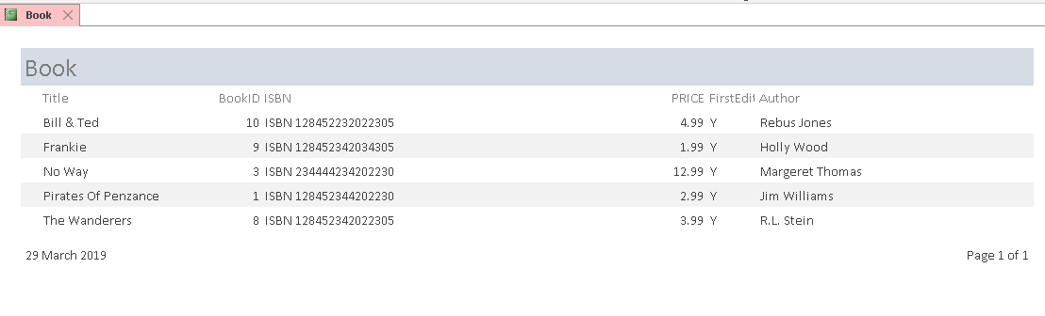

2.5 Documentation – User Guide

2.5.1 Purpose Of Database
The Bookstore database is designed to streamline the process of ordering books for customers and ordering books from publishers by suppliers.

2.5.2 Forms
Access the bookstore by the ‘Book Store Main Page’ navigation form:
The navigation buttons grant the user access to any part of the database:
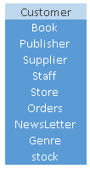
Customers , Books , Orders , Suppliers , Staff , Store , Orders , Newsletter , Genre and stock can be accessed and edited from this area. Links between tables are shown as combo box drop down.

2.5.3 Form Functions
Each form has the following clickable buttons to edit forms data, navigate forms and delete:
Delete current record
Add new record
Navigate to previous record
Navigate the next record

2.5.4 Reports
Customer has a button called ‘Orders’ that presents a report that shows orders for that Customer.
Book has a button called ‘First Editions’ that presents a report that shows all first editions.
Book has a button called ‘Books In Stock’ that presents a report that shows all books in stock.
Publisher has a button that presents a report of all publishers books.

References
Holland, B. (2019). Business Rules and Naming Conventions. Swansea.
Holland, B. (2019). Information Engineering - Relationships In MS-Access. Swansea.
Holland, B. (2019). Information Engineering Normalisation. Swansea.

Appendix

Appendix 1

