
Developing Innovation and Creativity for Business Advantage
Coca-Cola

March, 2023
danica dickson
1904977.

Executive summary.

Contents page.

- Introduction.

The purpose of the following report is to discuss the difference between Innovation and creativity and how they differ, it will look at an innovation change which was implemented within the chosen company, the report will use innovation models and techniques to evaluate the innovative change which was undertaken by the company. News articles, web sites, books ands journals will assist in researching and compiling the following report.
The chosen company which will be evaluated is Coca-Cola Company, it is an American firm created in 1892 and is well known for its production of Coca-Cola beverages, The business additionally creates and sells other soft drinks and beverages. The company has over 2,800 products available in 200 countries, this making the company the leading drink manufacturer and supplier within the world. (Britannica, 2023)
Tool Hero (2023) describes Innovation as not just the establishment or application of new concepts or processes. It defines innovation as being a process which requires various actions to find a better way of doing things. Its emphasis is on brand new ways to achieve similar or improved outcomes but at a quicker or cheaper rate and making an improvement on the process as a whole.
Linda Naiman (2021) defines creativity as a process of making new and ingenious ideas become a reality. Creativity is considered to be the ability to see the world in a new way, to reveal and distinguish patterns, to put together links between occurrences which appear to be unrelated and produce a resolution. Naiman believes creativity requires two practices firstly thinking and then producing.
Julie Burstein (2012) states there are four stages of creativity firstly being aware of the world and one’s surroundings, secondly to gather understanding from difficult parts of life, thirdly to move forward and breakthrough the limits of what a person can or cannot do, lastly is to Embrace loss and by incorporating these four stages a person can be creative.

- Main findings.

  - – Overview of the Innovation Opportunity.
Innovation is an advantage within a workplace as it allows the company to gain access to markets faster and gives the company the power to develop markets, which would expand them towards better and bigger prospects. (Theodore Henderson,2017)
Brand director for Coca-Cola Trademark Kate Carpenter stated that by adding flavours to the coke products is a way to persuade consumers which are looking for more variety to stay with Coca-Cola instead of picking up different drink, and by having an extension of the product it will take more space upon the retailers’ shelves, and usually flavoured drinks are not sold at a lower rate, therefore Coca-Cola is able to escalate its profits by marketing the flavoured varieties of the product. (Danielle Wiener-Bronner, 2019)
General Manager of Coca‑Cola Great Britain and Ireland Jon Woods stated that the company’s plan is to offer their customers a wide variety of beverages to meet various lifestyles and occasions, the company will continue to develop and expand the choice of products which they offer allowing the British customers a greater selection of drinks. The company have already boasted a varied range from its flavoured coke, diet coke, coke zero, Signature Mixers, energy drinks and coffees. (Coca-Cola company,2023)
  - -Type of Innovation.
The four types of innovation, firstly is Disruptive Innovation which is the most known form of innovation. It has successful utilisation of brand-new technology and offers great results. Disruptive innovation comes with many challenges. This is usually the process of how small businesses with less resources will move upmarket and challenge larger reputable companies. (Biznewske,2023) Secondly is Incremental Innovation comprising of a steady but constant advancement on current products and services. It doesn’t offer large changes but is thought to offer the most apparent benefit to a business and by constantly enhancing products the company could consistently increase its market share. Thirdly is Sustaining Innovation this is thought to be a proactive approach to protecting the company’s position within the market. It concentrates on slight enhancements to current products to rise prices or consumers satisfaction. Sustaining innovation aims on at changes which will achieve or retain a leading market positioning. This type is centred on generating new elements or services which will separate their product from its rivalries. Lastly is Radical Innovation this usually uses a technical discovery which recreates industries and generates new markets. This form of innovation can cause alterations within a company and how it would cooperate within the marketplace. (Ryan Ottinger,2021)

2.3- The Creativity Thinking Process.

Creative thinking is the foundation for innovation within organisations, Mumford et al. (1991) claimed that there are eight fundamental processes which are used during creative problem-solving. It is thought that creative problem solving starts with an explanation of what the problem is, then individuals shall collect data and knowledge about the said problem. The information which had been collected can then be combined to help create new concepts and assist in inventing new ideas. The new ideas will then be assessed and evaluated before being developed, it will then be decided how the idea should be implemented and will be monitored to reduce restrictions.
James Quincy (2022) states their purpose as a company is to “refresh the world and make a difference “and their vision is to create the brands and range of beverages which people love and enjoy, to refresh people in body and spirit. And to do it in a way which that makes a more sustainable business and improved shared future which will make a change in others’ lives, neighbourhoods, and earth.
by being creative Coca-Cola is able to accomplish their vision of developing and creating beverages which will be enjoyed by people and by being creative with their packaging they can reach their goal of becoming more sustainable in the future and making 25% of their packaging reusable by 2030.

2.4 -Models of innovation.
2.4.1 open/closed innovation.
Figure 1. 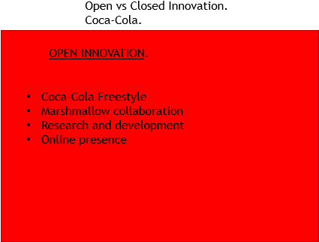
A closed innovation is classified as innovations which are established by the companies themselves, the innovation development is entirely within the business starting with the initiation of ideas to the creation and marketing.
Whereas open innovation is defined as the innovation process being open to outside the corporations’ boundaries, enabling the company to increase their innovation ability via effective and tactical from the environment. Innovation consequently develops from the collaboration of internal and external concepts, technology, methods, and sales revenues with the intention that the business creates innovative results, it can be accomplished by using the companies’ employees, consumers, traders or rivals and firms from other trades which could be united. (Brian Fried,2022)
Innovative society (2023) suggests that the benefits of using an open innovation method are that it encourages the involvement of more people and businesses, which can help the company reach the right audience and targets for the new idea, and involving the customers directly within the process of development assisting in the creation of a greater product as it will allow direct knowledge of what the consumer wants and needs are, another beneficial point of using the open innovation method is that it could save the company money by out sourcing it saves on salaries and work hours.
In regard to figure 1. An open innovation which Coca-Cola has used is the implementation of the Coca-Cola Freestyle which uses “micro-dosing” technology to provide a selection of touch-to-pour drink options, by receiving immediate data from all machines, the Coke can see the trending flavours and what are the “most poured” mixtures. The results have assisted the business's innovation pipeline the customers creativity has helped drive some of Coke’s latest drink innovations.
Coca-Cola held a “Make Your Mix” contest that asked the contestant to combine two or three of the almost 200 beverage ranges on Coca-Cola Freestyle and share pictures of the creations made on Twitter or Instagram using hashtag #MakeYourMixContest. This contest showcased the vast selection of drinks which were available on Freestyle and made Coke’s vision to become a drinks corporation which actively listens to its customers and rapidly makes innovations and new ideas come alive.” (Coca-Cola company,2019)
2.4.2 -The Innovation Process.
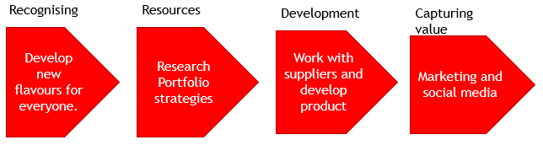figure 2.
The innovative process is the interpretation of the idea into a product or services which produces value. In organisations, innovative processes will assist in making the goods or services be more enticing to the consumers and can help boost the company's competitive edge. The process generally has three steps: discovery, growth, and commercialisation. Whilst larger businesses will usually add numerous additional stages to guarantee precision and effectiveness during new advancements. All innovative process consist of being aware of possible complications and analysing a variety of ways to resolve such complications. (Indeed, 2022)
The innovative process is significant as it allows:
- The company to adjust to changes
- The company to maximise its revenue by developing into various markets
- Increase the company’s competitive edge in a certain market
- Look at variations in consumers likings and styles
- Help the business grow and advance

2.4.3 – 4P’s to Innovation.
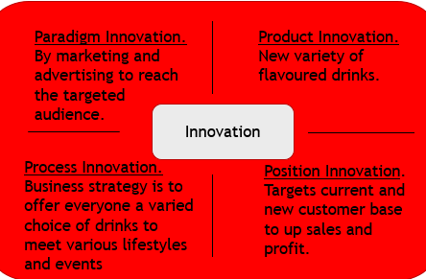 Figure 3.

In reference to figure 3, Coca Cola implemented an incremental innovation of improving upon their original product such as diversifying and adding new flavours into their product line to satisfy their customers satisfactions. The company also applies a Sustaining Innovation by modernizing the packaging, Natalia Suarez, the senior brand manager said “the company aimed to modernize and streamline the appearance of the packaging to assist the customer in finding the flavour that they are searching for on the shelves by using a colourful yet tidy packaging design” by featuring a bold logo located to visibly indicate between what is a full-sugar product using white script and a zero-sugar/calorie-free by using black script options. Full-coloured cans will refer to single flavours, and stacked colours will convey double flavours with no alterations being made to the Coca‑Cola Flavours recipes. (Coca-Cola Company,2022)

2.5 – Assessment of the Effectiveness.

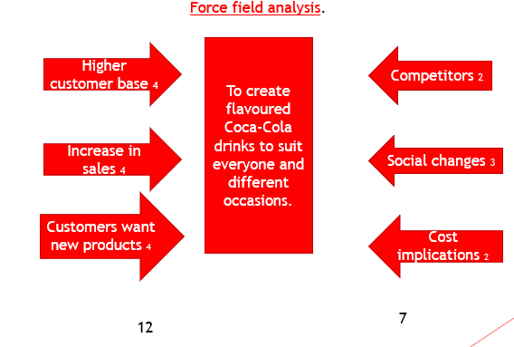Figure 4.

Force field analysis (Lewin, 1951) is generally applied in change management and is a practice a company might utilize to discover, evaluate, and track the issues that support or disagree with the intended change. Many companies use this practise to determine if they should accept or decline any new structural changes. The force field analysis aims to assist change leaders detect and assess the various aspects of a prospective change.
Indeed (2023) states that the benefits of using the force field analysis is that it needs all stake holders and workers to be involved so that a comprehensive prospective can be made, they also believe it is a simple management tool to be used which gives them the results to make highly informed decisions in regard to change.

2.5.1 – Barriers & Risks.
Toby Olshanetsky (2019) states there are 5 main barriers to innovation:
- Politics: As a business evolves, also the intricacy of its internal politics grows
- Cultural Issues: The shame of failing will slow down a business's innovation processes
- Inability to Act: being able to recognise the need for change
- Budget: a lack of finances can hinder a company’s ability to infiltrate the market
- Vision: understanding the vision and staying relevant.
One of the opposing factors which was identified in figure 4. Are social changes this was identified as consumers wanting more healthier options to drink as they become more health conscientious, with reports stating that drinking of fizzy drinks is likewise connected to obesity. (Ful Foods,2023)
This was also seen as a positive driving force as Coca‑Cola (2023) Great Britain has made great chances to what they offer with a greater variety of low or zero-sugar alternatives, creating new low-calorie beverages and reducing sugar from all of the products.

2.6 – Leadership & Management
James Quincey is Chairman and CEO of The Coca-Cola Company (2019) and stated that the continued evolvement and diversification of the beverages will be a priority, especially with the customers changing tastes and needs, that the consumers happiness will always be the heart of what Coca-Cola do.
A good leadership style to use when implementing a new idea would be transformational leadership as it lets the employees explore diverse ways and methods of approaching a situation and be creative with their thinking, this style fosters a relationship between the leader and the employees where they feel safe to voice opinions and still ask for help when they need it. (Zoe Sharan,2023)

- Conclusion.

Reference List.

