

The impacts of mental health disorders and how that can affect work-based demand of the police service.
Jake Byrne (2236103)

Declaration
This work has not previously been accepted in substance for any degree and is not being concurrently submitted in candidature for any degree.
Signed: J.Byrne
Date: 02/10/2025

STATEMENT 1
This dissertation is being submitted in partial fulfilment of the requirements for the degree of BA.
Signed: J.Byrne
Date: 02/10/2025

STATEMENT 2
This dissertation is the result of my own independent work/investigation, except where otherwise stated.
Other sources are acknowledged by footnotes giving explicit references. A bibliography is appended.
Signed: J.Byrne
Date: 02/10/2025

STATEMENT 3
I hereby give consent for my dissertation, if accepted, to be available for photocopying and for interlibrary loan, and for the title and summary to be made available to outside organisations.
Signed: J.Byrne
Date: 02/10/2025

STATEMENT 4
I hereby give consent for my dissertation, if accepted, to be available on the university’s IT system to those who have consent to use the system.
Signed: J.Byrne
Date: 02/10/2025

Acknowledgements.

I would like to thank Melaine Thomas, Jane Davies, I would also like to especially thank my dissertation supervisor Michelle Hill. As they have supported me through my third year of university and provided me with support and guidance.

I would also like to thank my family, friends and partner for their support during my three years of university, as without their support and motivation I would have struggled to maintain a positive mindset. Furthermore, I would like to thank my work colleagues who have provided me with never-ending guidance and reassurance when it comes to the completion of university work. Finally, I would like to thank my supervisor Police Seargent Thomas Reed for his ability to push me towards becoming not only a better police officer but a better person.

Abstract.
This dissertation aim is to investigate the impact of mental health disorders on police officers and how that can affect the work-based demand of the police service. Mental health disorders within police officers are of growing concern for the police service in the United Kingdom, as police officers are often tasked with responding to traumatic incidents that can have a long-lasting effect on them as an individual. Alongside this, the work-based demand placed on police officers is increasing resulting in increased workloads, which means an increased level of responsibility and stress for each individual police officer.

It is important to understand and identify what mental health disorders are and how that can corelate with the impact of being exposed to numerous traumatic incidents and how the increase of work-based pressures can also result in the development of mental health disorders. So, via a mixed method approach of conducting a questionnaire and primary research this dissertation answers four main objectives, which will help to answer the title of the dissertation. These four objectives being:

- define mental health based upon different definitions of the same.
- To explore the impact of mental health effects on police officers
- To discuss how police officers suffering with mental health issues can affect the work- To based demand of the police service.
- To discuss what changes the police services can employ to better understand mental health issues among their staff, and how they can implement that understanding to better safeguard their staff’s wellbeing.

Table of Contents.

Chapter 1 - Introduction 9
1.1 Background 9
1.2 Research Rationale 9
1.3 Aims and Objectives 9
1.4 Structure 10
1.5 Conclusion 10
__________________________________________________________________________________
Chapter 2 - Literature Review 12
2.0 Introduction 12
2.1 Definition of menal health 12
2.2 Exploring the impact of mental health on police officers 13
2.3 To discuss how police officers sufering with mental health issues can affect the work based demand of the police service 14
2.4 To discuss what changes the police services can employ to better understand mental health issues among their staff, and how they can implement that understanding to better safeguard their staff’s wellbeing
15
2.5 Conclusion 16
__________________________________________________________________________________
Chapter 3 - Methodology 18
3.0 Introduction 18
3.1 Ethical Practice 18
3.2 Informed consent 18
3.3 Data collection method 19
3.4 Research tool 31
3.5 Sampling 32
__________________________________________________________________________________
Chapter 4 - Data Analysis and Findings 21
4.0 Introduction 21
4.1 Question 1 21
4.2 Question 2 21
4.3 Question 3 22
4.4 Question 4 23
4.5 Question 5 23
4.6 Question 6 24
4.7 Question 7 24
4.8 Question 8 24
4.9 Question 9 25
__________________________________________________________________________________
Chapter 5 - Conclusion and Recommendations 26
5.0 Introduction 26
5.1 Summary of primary findings 26
5.2 Objectives 27
5.3 Recommendations 28
5.4 Final thoughts 28

__________________________________________________________________________________
Bibliography 29
__________________________________________________________________________________

Chapter 1- Introduction.

The purpose of this dissertation is to outline the impacts of mental health disorders on police officers and how that can affect the work-based demand of the police service. This introduction will help to explain the context and therefore the need for this study. To do this the introduction will discuss the background of the study and the implications of mental health on police officer. Whilst providing a research rationale as to why the study is needed to further the understating of the growing concern of mental health disorders in police officers. Then leading onto the aims and objectives of the study and how they will be answered within the dissertation ultimately providing an explanation of the structure of the dissertation, which leads into the conclusion of the chapter.

1.1 Background.
The understating of mental health within the past twenty years or so has vastly improved with Guhrie et el (2018) stating that there are key factors that corelate with mental health and suggests that “high risk” groups such as emergency service workers are more likely to suffer with their mental health. This is due to the constant exposure to traumatic incidents within their carer, leading to long lasting affects of a mental health disorder. The Word Health Organization (2001) further states that mental health factors are down to a combination of social, work and psychological pressures placed on an individual. This ties in with the stressors of a police officer as the societal pressures placed on them by members of the public, the pressures placed on them by the work-based demand, plus the stressor of traumatic incidents can lead to the catalyst of mental health. This is why this study is essential in providing recommendations on how to best improve mental health services provided to police officers, as the suggestions are as a result of vast research methods.

1.2 Research Rationale.
The reason that this research is so important is that it helps to identify the national concern surrounding the increase in mental health disorders in police officers. As the Police Federation (2021) found that approximately ten thousand police officers were off work due to work related mental health disorders in the early 2020’s, like post-traumatic stress disorder and anxiety. However, studies form the Police Federation (2025) showed that number was on the rise and has not decreased in the last eleven years since the study was founded. This is why the research hopes to identify and discuss mental health disorders and explore ways in which the police force can implement better mental health services, further to this the research is also needed to help educate police officers on the early signs of mental health disorders in the hopes of early identification.

1.3 Aims and Objectives.
The aim of the research that has been conducted, is to answer the question: The impacts of mental health disorders on police officers and how that can affect work-based demand of the police service.

These aims will be achieved by completing the following objectives:
- define mental health based upon different definitions of the same.
- To explore the impact of mental health effects on police officers
- To discuss how police officers suffering with mental health issues can affect the work- To based demand of the police service.
- To discuss what changes the police services can employ to better understand mental health issues among their staff, and how they can implement that understanding to better safeguard their staff’s wellbeing.

1.4 Structure.
The dissertation is structed to answer each of the stated objectives through the use of labelled chapters. Chapter two of this dissertation will use previous academic research into key aspects of mental health, helping to define what the current understanding of mental health is believed to be. Exploring the impacts of mental health on police officers and what can be put into place by police services to tackle mental health disorders in police officers.
Chapter three will discuss the use of the research methods used to obtain data for the dissertation in the form of a questionnaire.
Chapter four will look to analyse and understand the data obtained via the questionnaire. Helping to further the reasoning behind the importance of the research,
Chapter five will discuss the findings because of the research methods and primary research findings. This chapter will tie in the research conducted as part of the study and assist in identifying recommendations for future studies. Whilst also helping to identify further support avenues for police officers in the future.

Conclusion.

This chapter has outlined the introduction to the dissertation and the question of the impacts of mental health disorders on police officers and how that affects the work-based demand of the police service. It assisted in identifying the key objectives in which this dissertation is trying to answer.

Chapter 2- Literature Review

2.0 Introduction
This literature review will outline the impacts of mental health disorders on police officers and how that can affect work-based demand of the police service. It will go on to discuss each research topic individually by using available literature on the topic. By defining what mental health is and the effects that mental health conditions can have on police officers, in the long and short term. Then going onto discuss how the impact of police officers suffering with mental health can impact the work-based demand placed on the police service. Also discussing the changes, the police services can implement to reduce the risk of their police officers suffering from mental health conditions. Before concluding how police services are currently training their officers to manage their mental health and the improvements, they can implement to provide a better understanding of mental health and mental illnesses.

This chapter has the following objectives:
- To define mental health based upon different definitions of the same.
- To explore the impact of mental health effects on police officers
- To discuss how police officers suffering with mental health issues can affect the work-based demand of the police service.
- To discuss what changes the police services can employ to better understand mental health issues among their staff, and how they can implement that understanding to better safeguard their staff’s wellbeing.

2.1 Definitions of mental health

There are many differing definitions of mental health, as the understanding and research has developed over the years. As the World Health Organization (2004) describes mental health as being a state of mental wellbeing within an individual’s life, based on how they cope with stress and everyday decisions, which then in turn allows them to notice their own ability. This definition suggests that mental health is not only linked with the concept of mental illnesses. Instead lending itself to the concept of how positive feelings can impact an individual’s mental wellbeing. Which is key when defining the positive impacts that an individual can have when they are able to maintain a healthy mindset.

This is further supported by the National Institute of Mental Health (2022) who stated that there are three main impact factors of mental health, these are emotional, psychological and social wellbeing. These three factors are vital when it comes to understanding how an individual deals with their mental health.

The three main factors of mental health are influenceable in the way they help an individual understand the balanced components to sustaining healthy mental wellbeing. As emotional wellbeing is stated as being the ability for an individual to regulate and understand their emotions in a health manner (NHS, 2025).

Whereas psychological wellbeing is stated as being an individual’s ability to process information and how they function on a cognitive level. This entails an individual’s ability to interpret the information they are provided with, whether that be in the form of how to deal with stress, or how to cope with the everyday challenges of life (Mental Health Foundation, 2015).

Furthermore, social wellbeing is stated as being an individual’s ability to be able to form a connection with another individual, and how they can maintain that relationship. Including how they function regarding their own social network and how they contribute to society (Mental Health Foundation, 2015).

Horwitz (2010) takes a different approach to the definition of mental health stating that mental health and mental illness are linked to social circumstances. Also believing that mental health is linked to our personality type and how we deal with a life event is as a result of our personality and social circumstances. This aspect of defining mental health leans into the sociological perspective, as how we approach life events, social structures is dependent on the individual. Evoking the idea that if an individual who is faced with similar circumstances as another individual in the same social condition will react similarly, meaning that they will struggle with similar levels of mental health or mental illness issues.

2.2 Exploring the impact of mental health on police officers

Mental health and policing often interlink as Police officers are often exposed to a wide variety of high stress situations and traumatic incidents. They often face individuals during a mental health crisis and can also be subject to a mental health crisis themselves. This is as a result of constant exposure to traumatic incidents. As the Police federation (2021) estimates that police officers may attend approximately four hundred to six hundred traumatic incidents in their careers. Over time this can affect the police officers personal and work life and has led to approximately ten thousand officers who are unable to attend work and had to take sickness leave due to stress, depression, anxiety and post-traumatic stress disorder. Police federation (2021).

Acquadro Maran et al, (2015) states that police officers with more than three years of experience have lower stress levels, than those of less than three years of experience. This is believed to be because they have had more exposure to traumatic incidents and stressful situations, therefore their ability to effectively cope has adapted. Building resilience and understanding coping strategies is a vital part of everyday life, especially when in highly stressful and traumatic situations which police officers are often exposed to throughout their career.

Van der Velden (2013) conducted a study whereby they compared the role of a police officers to nine other occupations like workers of banks and supermarkets. To determine whether police officers suffer more with there mental health because of their occupation finding that mental health is not more prevalent in police officers compared to more standard occupations. However, throughout this study the researchers focused on police officers self-reporting their mental health conditions, instead of conducting assessments to determine whether the police officers suffered from any undiagnosed mental health conditions. .

Despite this Regehr (2019) argues that due to the number of traumatic incidents that police officers attend and their constant exposure to events that a normal individual would consider extreme and trauma inducing that they are most likely going to experience an adverse reaction to these events that will result in a form of mental health whether that be increased levels of anxiety or post-traumatic stress disorder. This leads into Van der Velden (2010) whereby they suggest that facing levels of aggression from an individual during an incident can result in a police officer suffering with mental health. They surmised that mental health factors for a police officer when facing aggression, is dependent on the individual. Suggesting that an individual who is more likely to develop mental health issues due to genetics or other factors is more likely to be adversely affected by mental health issues if they are constantly exposed to aggression. The studies conducted by Reghr (2019) and Van der Velden (2010) are a few years old, which may suggest the research is outdated and there is a need for newer more developed research into that area.

Porter (2024) states that ninety two percent of police officers are exposed to a critical incident within their first two years of being a police officer. However, despite being exposed to a critical incident and the traumatic implications that come with that, most police officers suggest that they are afraid to disclose that they are suffering with their mental health due to the risk that they may be marginalised by their colleagues. Evoking, that in the police services there is a stigma surrounding mental health and officers are afraid to discuss their mental health issues as they may face judgement from colleagues.

2.3 To discuss how police officers suffering with mental health issues can affect the work-based demand of the police service.

Police officers suffering with their mental health are shown to affect the work-based demand on the police service. Which is of great concern to those police officers as individuals but can have a greater effect on the police service as a whole. As previously mentioned in this literature review that as of 2021 approximately ten thousand police officers are on sick leave, due to mental health issues (Police Federation, 2021). This has in turn placed a higher demand on police services because they are faced with an ever-growing demand with lower resources to cope with it. Houdmont et el (2016) stated that twenty-seven percent of police officers in England reported working longer hours due to the high demand placed on the police service. Ninety five percent of these officers have suggested that as a result of working the longer hours they feel an increase in emotional exhaustion suggesting that as a result of the mental health crisis the police service are facing with their officers and then increase in sickness level as an outcome of this, that the officers who are faced with the increasing demand are also facing mental health crisis themselves.

Furthermore, police officers who are struggling with their mental health will suffer with an increase of stress and anxiety which will affect their ability to work efficiently as their mental health issue will impact their decision-making ability which in turn effects their ability to deal with high stress situations meaning that their decision-making ability could influence their decision to make a safe and practical judgement call, placing them in an unsafe or compromising position. (Porter, 2024).

Porter (2024) also suggests that a contributing factor to poor mental health within the police service is tied with work related stressors, including shift work, shift work and lack of support from senior management. Stating that these stressors pose a bigger impact to police officers mental health compared to the operational demand placed upon police officers. This is further argued by Lumsden (2020) whereby they also suggest that shift work can have a negative impact on an individual, due to the lack of factors like lack of sleep and sociable hours. This maybe indicates that work patterns and other influences rather than the job itself can cause issues.

2.4 To discuss what changes the police services can employ to better understand mental health issues among their staff, and how they can implement that understanding to better safeguard their staff’s wellbeing

An important factor to improving mental health within the police force is recognising the signs and symptoms of mental health. This will help with early prevention of those suffering with mental health issues, as if a police officer is suffering with their mental heath early identification of this is key. As it allows for early treatment before it becomes more severe. (Foley et el, 2018).

This leads onto the ability to recognise that mental health is of growing concern within the police is of vital importance, because if it is recognised that mental health is affecting police officers and their ability to do their job, then measures can be put in place to help police officers wellbeing. Police forces must implement better training around mental health as education around the topic of mental health will in turn allow officers to spot the early signs and symptoms of mental health. Trombka et al (2018) evokes that mindfulness training surrounding the pressure of mental health help spot the early indications of mental health, by taking a proactive approach to spotting and dealing with mental health. This means that instead of waiting until an individual is struggling with mental health, that instead through training that individual will be able to deal with the stress of mental health before it becomes a larger issue. This is why the research into this area is being conducted, as it will help to outline the recommendations for further education into identifying mental health disorders in police officers.

Police officers are taught how to deal with an individual having a mental health crisis and it seems to be of great importance to police services that officers have training surrounding this as per the College of policing (2024). However, there does not seem to be adequate training provided to officers regarding their mental health and how to deal with the unique pressures of being a police officer. Furthermore, police services have introduced the trauma risk incident management. The trauma risk and incident management were first introduced to policing in 2010 after a critical incident in Cumbria. Whereby the Cumbria constabulary recognised that their officers were being exposed to traumatic incidents that left lasting effects. So, TRIM was introduced to evaluate the psychological risks those traumatic incidents had on the individual and advise on what early intervention methods could be put in place in order to reduce the risk of trauma related mental health issues for that individual. (E.Hunt et el, 2013).

It appears that there is not enough research surrounding how police forces are teaching their officers on how to deal with their own personal mental health. As the focus on police training appears to be on teaching officers how to deal with an individual suffering from a mental health crisis. Furthermore, this appears to be a systematic issue within all police forces as officers appear to be insufficiently trained on how to cope with the stressors regarding how to deal with high stress situations and the traumatic incidents they face. Although there is support offered to officers following the events of a traumatic incident, this service does not allow for a proactive approach to be taken so officers can seek early intervention regarding any mental health concerns they may have.

2.5 Conclusion

In conclusion, mental health and policing interlink as the role of a police officer is unique in the aspect that they deal with many highly stressful situations operationally on the front line but police officers also have work related stressors when it comes to the high demand from the general public, which they have to combat with low resources due to financial cuts and a reduced number of officers.
In summary from the research, it is clear and shows that policing is extremely mental challenging as well as physically, and other influences such as shift work, overtime, unsociable hours, attending traumatic incidents, lack of support management, insufficient time given to mental health training and coping strategies all add to the toxic mix of factors influencing a police officers mental health.

Having identified this so much more could and should be done to improve the police services ability to influence individual officers’ mental health. There is also a lack of academic research surrounding the direct impact all these stressors can have on a police officer.

Chapter 3 – Methodology

3.0 Introduction
This chapter will aim to discuss the research method which have been conducted as a part of this dissertation. The chapter will give an insight into the ethical practices this study has taken when providing research to evidence in the dissertation. Also justifying why, the research has been conducted and why the specific type of research has been chosen over other research methods.

3.1 Ethical Practice
It is vital that when carrying out a study that ethical practice is adhered to throughout the process of carrying out research. To make sure that ethical practice was carried out during research an ethics form was submitted to the ethics committee prior to the commencement of the study. The ethics from contained information that related to the intended aims and objectives of the study, an insight into how the research and data was going to be conducted, in this case a questionnaire. The ethics form also outlined the risks posed by the research to potentially participants and how to mitigate those risks (Aguinis, 2004).

3.2 Informed consent
Informed consent is an important part of the study as it allows the participant to understand all the relevant factors of the study and why it is being conducted. It is also important as it allows the participant to understand the potential risks of being involved in the study, allowing the participant to make an informed decision on whether they wish to participate (Nijhawan et el, 2013). To make sure this study had informed consent a disclaimer was provided before carrying out the questionnaire, the disclaimer outlined that the information provided by the participants was being used in an academic study, whilst also informing the participants that the information that provided as part of the questionnaire would remain anonymous so that they would be able to answer the questionnaire without the risk of personal exposure. As the results of the questionnaire would be stored on a password protected computer and the only persons viewing the information would be involved in the study. (Mandal, 2014).

3.3 Data collection method.
As part of this study an online questionnaire was carried out, this questionnaire was completely anonymous. The reason for this being is that participants of the questionnaire would be able to answer without feeling the pressure feeling judged for their answers as the questionnaire asked questions surrounding mental health, which often can lead to the participants feeling anxious if they are at risk of being exposed due to their answers (Joinson, 1999). The benefit of conducting an online questionnaire over other research methods like interview was the fact that it allowed for a larger sampling pool of participants and allowed the participants to maintain their anonymity. The format of a questionnaire in this research also allowed for a simple but effective way of gauging various viewpoints on mental health without putting too much strain on the participant, as they were able to answer the questionnaire in their own timeframe and not be pressured into answering questions within a time framed format like an interview (Menon, 2018). Using quantitative data via the use of a questionnaire is beneficial to the study as it allows it provides precise and measurable data. Meaning that the research presented in this dissertation can be presented in a clear way to the reader via simple and readable graphs.

3.4 Research tools.
During the course of the study multiple methods of data collection were considered, however due to the benefits of an online questionnaire being the most practicable given the circumstances as it allowed for participants to remain anonymous, whilst allowing for the participants to answer within their own time scale (Eckerdal, 2017).

An online questionnaire was conducted, consisting of ten multiple choice questions. The questionnaire received a total of twenty-nine responses from participants with a variety of different viewpoints. Some of these viewpoints could of been expanded on using interviews as a way of furthering the study. However, due to the questionnaire being anonymous it was unclear who to question as to their unique viewpoint. Another important consideration of an interview if the fact that an interview is time consuming, an interview is also dependent on the interviewer and certain characteristics can taint the results of the interview (Roulston, 2018). Implying that if the interviewer’s tone of voice or bodily language is perceived a certain way then this can affect the response from the participant leading to interview bias (Salazar, 1990).

3.5 Sampling
The participants of the questionnaire were all serving police officers from South Wales, the reason for this being is the question of this dissertation is focused on exploring the impacts of mental health on police officers, therefore the appropriate sampling pool for this questionnaire had to be focused on police officers. The questionnaire was sent out to the participants via email and was posted on websites only accessible to police officers. This has been beneficial to the study as the questionnaire was sent via email to police officers in a range of different departments in the hope of having a varied response to the questions posed, to include a range of different viewpoints. The drawback of sending the questionnaire via email and internal police websites is that there is often a negative stigma in the police service surrounding mental health, and even though the questionnaire is anonymous some police officers may think that despite this the questionnaire will be traced back to them (Hinshaw et el, 2008). This may lead to tampered results as the questions have not been answered truthfully or could lead to less responses to the questionnaire (Salazar, 1990).

Chapter 4 – Data Analysis and Findings.

4.0 Introduction.

This chapter will discuss the findings of the data as a result of the questionnaire. A total of 29 participants took part in the questionnaire. The purpose of the questionnaire was to answer the question what are impacts of mental health disorders on police officers and how that can affect work-based demand of the police service. To answer this question, four main objectives were identified:

- To define mental health based upon different definitions of the same.
- To explore the impact of mental health effects on police officers
- To discuss how police officers suffering with mental health issues can affect the work-based demand of the police service
- To discuss what changes the police services can employ to better understand mental health issues among their staff, and how they can implement that understanding to better safeguard their staff’s wellbeing

4.1 Question 1 – Do you feel as a police officer you have been exposed to a traumatic event?

Results of this question found that 96.6% of participants in the questionnaire had been exposed to traumatic events within their policing career. Quantifying the statistic that one in five police officers suffer with a form of post-traumatic stress disorder because of the incidents they attend (Miller et el, 2022). Despite this 3.4% of the participants have stated that during their career that they have not attended a traumatic incident. Which would suggest some of the participants may be younger in service and therefore have attended fewer incidents, limiting their expose to traumatic incidents.
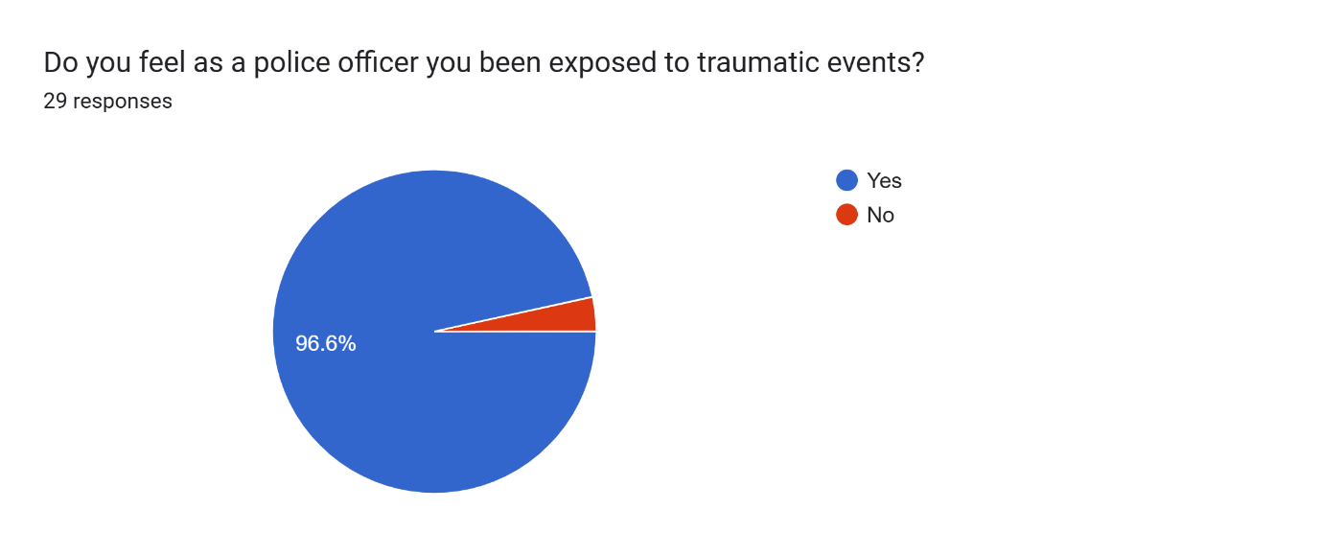

4.2 Question 2 – If so, are you able to estimate how many traumatic incidents you have attended?

Only 26 of the 29 participants answered the above question. Participants were asked this question to understand the rough estimations of how many traumatic incidents the average police officer attends during their career. The answers to this question were varied, over half of the participants stated that they had been to over ten traumatic incidents, with at least each of the participants suggesting that they have been to at least one traumatic incident. Furthermore, a particularly interesting answer evoked that they had been to over fifty or more traumatic incidents but stated that most of the incidents they have attended would be considered as traumatic to a member of the public. However, to a police officer these events may be seen as the norm as they are desensitised and can no longer recognise when something is traumatic (Warren, 2015).

4.3 Question 3 – Do these traumatic incidents effect your work life?
All 29 participants answered this question, with 51.7% answering no and 48 .3% answering yes. This implies that not all participants are affected by the traumatic incidents they witness. Which could be a result of numerous factors, Bonanno (2004) states that certain individuals have a psychological resilience to traumatic incidents, so they are able to regulate their emotions better when it comes to trauma.

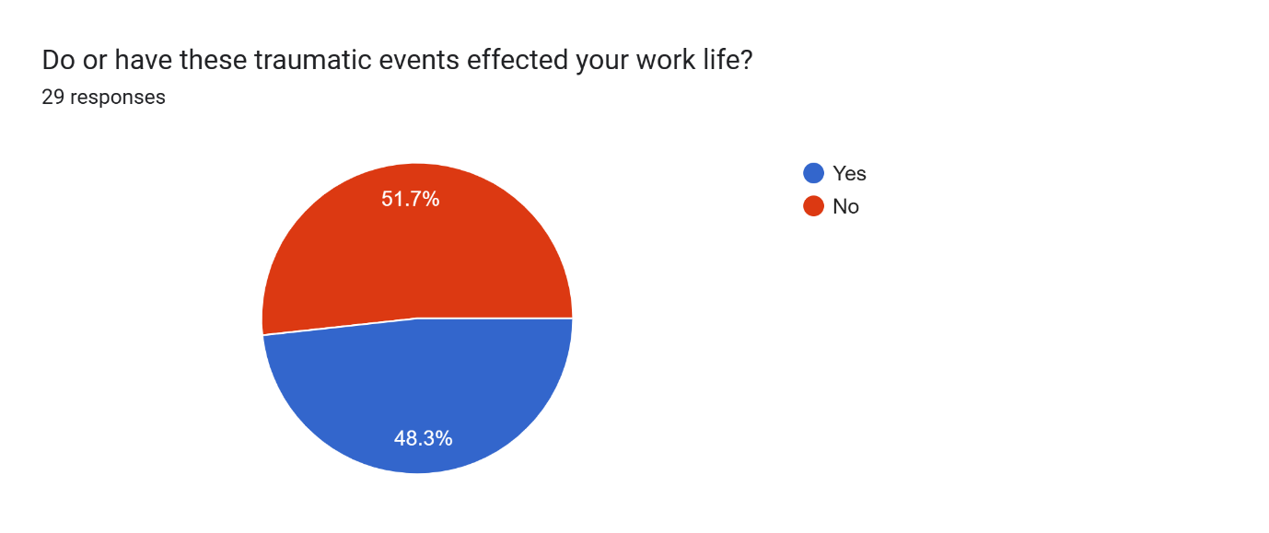
4.4 Question 4 – How has it effected your work life?
Only 21 of the 29 participants answered this question. The findings of the question. Most of the participants suggest that the traumatic incident have led to increased stress levels whilst in work, changing how they deal with incidents, as they are numerous when attending potentially traumatic calls as it could bring up trauma from the past, with one of the participants suggesting that as a result of the traumatic incident they attended that they have dreams that relate to the incident. Miller (2017) implies that there is a clear correlation between traumatic incidents and dreaming, finding that exposure to a traumatic event can lead to dream recall whereby the individual relives the traumatic incident.

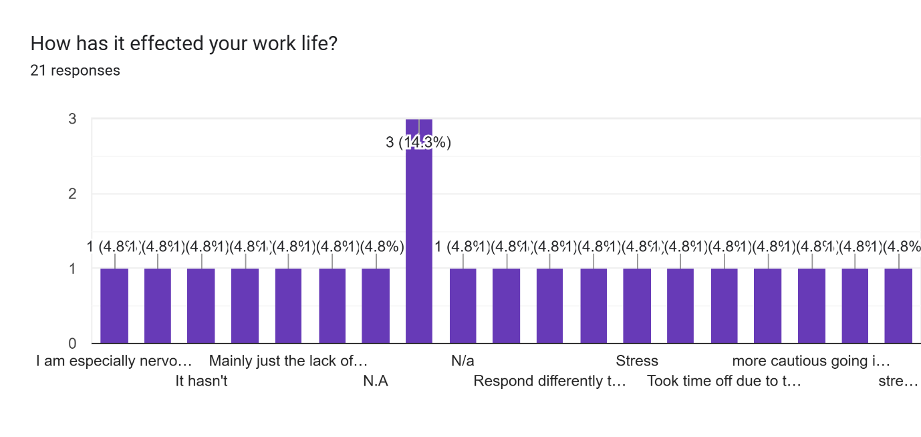

4.5 Question 5 – Does work based demand cause a strain on your mental health?
One of the main contributions to poor mental health within the police service is the stress related to work-based demand on police officers. This question highlight’s this as 93.1% stated that the demand from their work places a strain on their mental health. This can lead to police officers burning out as one of the occupants stated that because of the work pressures they took time off work. Meaning that resourcing levels were affected. As, Cartwright (2021) found further evidence of this as 57% of police personnel are absent due to psychological illness, trauma or stress.

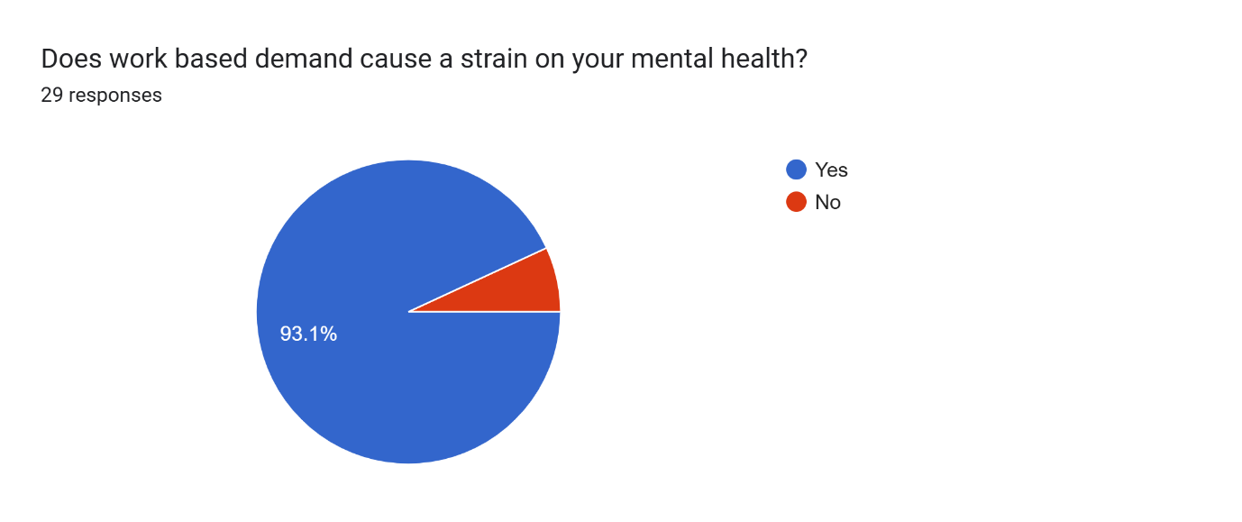

4.6 Question 6 – How has this high demand effected your mental health?
Furthermore, 24 out of the twenty-nine participants have answered this question. The common answer to this question is that the participants have stated that they are feeling stressed, as the University of Cambridge (2019) states that one in five police officers struggle with work related stress, one of the main factors being the high demand being placed on them. None of the participants have suggested that they do not suffer with stress.

4.7 Question 7 – Have you sought support from South Wales Police regarding your mental health?
Out of the 29 participants only 9 of them have sought support from mental health services whilst the remaining 29 have not. Bullock (2017) suggests that there is still a stigma surrounding mental health in the police service, which may in turn sway officers away from seeking support as they do not want to be seen as weak.

4.8 Question 8 – Was the support received beneficial?
The results of this question are varied, as most participants have stated that the support they received was beneficial and helped them get back on track. However, one of the participants as stated that they were off work for several months and received no support, which made their mental health worsen. This ties in with the British Medical Association stating that mental health support services do not have the funding nor support to function efficiently.

4.9 Question 9 - Do you think South Wales Police have sufficient services to deal with police officers mental health?
Alas, 28 of the participants answered the above question with 64.3% putting no and 35.7% putting yes. This suggest that from the perspective of a police officer, South Wales Police do not offer enough mental health support. Government Events (2024) evoked that there is support in the form of peer support networks, occupational health among others. Despite this the questionnaire clearly outlines that police officers do not feel as though that support is available to them, or they may be unaware that the support exists.

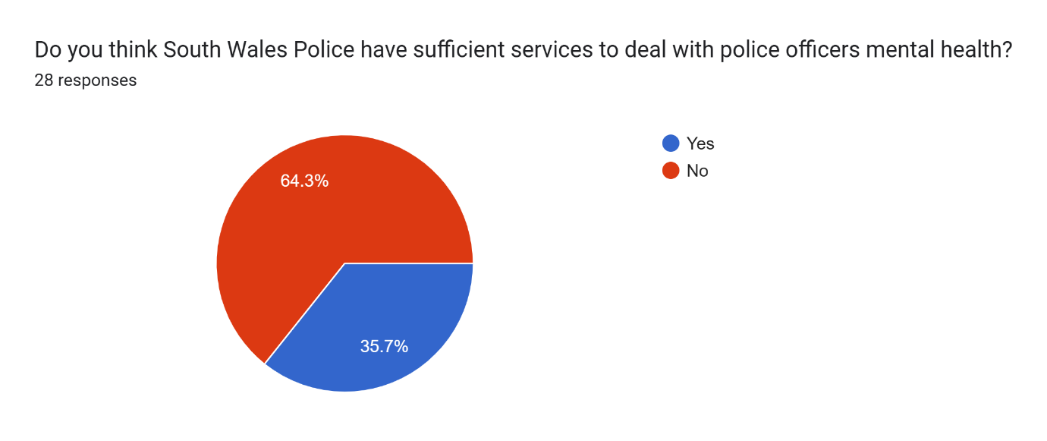

Chapter 5 – Findings and conclusions

5.0 Introduction
The conclusion chapter will provide a summary of the primary research findings. It will then look to revisit the objectives laid out in the introduction for two specific reasons:
Reason 1- To ascertain if the objectives of this dissertation have been met.
Reason 2- To evaluate if the findings of this research corroborate or contradict the findings of the research discussed in the literature review. The chapter will then conclude with its recommendations.

- To define mental health based upon different definitions of the same.
- To explore the impact of mental health effects on police officers
- To discuss how police officers suffering with mental health issues can affect the work-based demand of the police service
- To discuss what changes the police services can employ to better understand mental health issues among their staff, and how they can implement that understanding to better safeguard their staff’s wellbeing.

5.1 Summary of primary findings

This dissertation focused on the impact of mental health disorders on police officers and how that can affect work-based demand. To answer this question an online survey was developed with a total of twenty-nine participants. The questionnaire provided both quantitative and qualitative data. The results of the questionnaire show that most of the participants have been exposed to a traumatic event, and as a result this has affected their mental health, which in turn has had a lasting effect on them. Leading them to have long lasting effects like post-traumatic stress disorder among other mental health disorders. Further to most participants have felt that the work-based demand placed upon them has caused them to suffer with increased stress levels, effecting their mental wellbeing. This furthered by Cartwright (2021) research that suggests 57% of police personnel are off on sickness from the police service because of psychological illness, trauma and stress. Another key finding of the research found that there is limited support for police officers who are suffering because of mental health disorders, as the participants stated that there were limited resources when it came to support for copying with a traumatic incident, as the only significant support police officers receive is trauma risk management (England, 2020).

5.2 Objectives

5.3.1 To define mental health based upon different definitions of the same.
This objective was completed by using definition from World Health Organization, National institute of mental health (2024) and the World Health Organization and the National institute of mental health (2022). Which largely stated that mental health comes down to the understating of an individual’s mental wellbeing.

5.3.2. To explore the impact of mental health effects on police officers.
To answer this objective the participants were asked how many traumatic incidents they have attended during their professional career. From the averages of the questionnaire most of the participants had been to at least ten traumatic incidents thus far.

5.3.3 To discuss how police officers suffering with mental health issues can affect the work-based demand of the police service
To meet this objective, participants were asked how the work-based demand effects their mental health. Most participants stated that the work demand causes them to feel an increased level in stress. With some participants furthering this by stating that because of work-based demand, they have had to have a break from work due to stress related illness. This is backed up by the research conducted by the Police Federation (2025) which states that 14,500 police officers were off work due to poor mental health, which is a 9% increase since the previous year. This suggests that police officers suffering with mental health is on the increase and that is largely in part to the increase of demand on police officers.

5.3.4 To discuss what changes the police services can employ to better understand mental health issues among their staff, and how they can implement that understanding to better safeguard their staff’s wellbeing.
To answer this objective the participants were asked the following question. Do you think South Wales Police have sufficient services to deal with police officers mental health. Resulting in 64.3% of participants stating that they felt that there was not enough support offered to police officers. To further this question, the participants were asked what they thought South Wales Police could implement to improve mental health support. The participants stated that they believed that mandatory counselling would be of significant benefit to police officers, alongside fewer cancelled rest days so that it allows officers a chance to recharge (NHS, 2023).

5.3 Recommendations.
From completing this dissertation, the following recommendations are being made.
- For police officers to have be provided with education about identifying mental health symptoms within themselves and colleagues.
- Another recommendation is for police officers to undergo mandatory counselling sessions every three months via a third-party organisation in order to provide early identification of mental health disorders.
- Further studies to help identify best practices for to support police officers suffering with mental health disorders.

5.4 Final Thoughts.
Through the findings of the research, it has been identified that mental health disorders to have an impact on the work-based demand of the police service. This is for several reasons. Firstly, there is still a stigma within the police service that mental health can be a sign of an individual’s inability to cope with the pressure of the job, whether the impacts of mental health are a combination of stress due to the demand placed on police officers or due to the impact of attending multiple traumatic incidents. Secondly, if a police officer is struggling with the effects of mental health, then through the research it has been identified that police officers feel as though there are limited resources available to them to seek support. Despite this, the research has also found that everyone responds differently to the effects of mental health and that means that the support in which may benefit them may not benefit another. Therefore, a better understanding of mental health within the police force is required to provide a variety of different support networks.

Bibliography.

Aguinis, H. and Henle, C.A., 2004. Ethics in research. Handbook of research methods in industrial and organizational psychology, pp.34-56.

Acquadro Maran, D., et al. 2015. Occupational Stress, Anxiety and Coping Strategies in Police Officers. Occupational Medicine 65(6) pp. 466–473,

Bonanno, G.A., 2004. Loss, trauma, and human resilience: have we underestimated the human capacity to thrive after extremely aversive events?. American psychologist, 59(1), p.20.

British Medical Association (2024). ‘It’s broken’ Doctors’ experiences on the frontline of a failing mental healthcare system. [online] Available at: bma-mental-health-report-2024-web-final.pdf [Accessed on: 1st of October 2025].

Cartwright, A. and Roach, J., 2021. The wellbeing of UK police: a study of recorded absences from work of UK police employees due to psychological illness and stress using freedom of information act data. Policing: A Journal of Policy and Practice, 15(2), pp.1326-1338.

Copeland, William E., et al., 2007. Traumatic Events and Posttraumatic Stress in Childhood. Archives of General Psychiatry, vol. 64, no. 5, 1, p. 577,

College of Policing.,2024. “Mental Health Training for Incidents | College of Policing.” College of Policing, Mental health training for incidents | College of Policing. Available at: www.college.police.uk/support-forces/practices/mental-health-training-incidents. [Accessed on 2 May 2025]

E. Hunt et el., 2013 TRiM: an organizational response to traumatic events in Cumbria Constabulary, Occupational Medicine, Volume 63, Issue 8.

Eckerdal, J.R. and Hagström, C., 2017. Qualitative questionnaires as a method for information studies research.

England, N. (2020). NHS England» Supporting staff through trauma risk management. [online] England.nhs.uk. Available at: NHS England » Supporting staff through trauma risk management [Accessed on: 1st of October 2025]

Foley et el., 2018. Police officers and post-traumatic stress disorder: Discussing the deficit in research, identification and prevention in England and Wales. The Police Journal, 92(1), pp 23-34.

Guthrie, S., Lichten, C.A., Van Belle, J., Ball, S., Knack, A. and Hofman, J., 2018. Understanding mental health in the research environment: A rapid evidence assessment. Rand health quarterly, 7(3), p.2.

Government Events (2024). Initiatives to Support the Mental Health of UK Police Officers. [online] Government Events. Available at: Initiatives to Support the Mental Health of UK Police Officers • Government Events [Accessed on: 1st of October 2025].

Joinson, A., 1999. Social desirability, anonymity, and Internet-based questionnaires. Behavior research methods, instruments, & computers, 31(3), pp.433-438.

Hinshaw, S.P. and Stier, A., 2008. Stigma as related to mental disorders. Annu. Rev. Clin. Psychol., 4(1), pp.367-393.

Horwitz, A.V., 2010. An overview of sociological perspectives on the definitions, causes, and responses to mental health and illness. A handbook for the study of mental health, pp.6-19.

J. Houdmont et el,. 2016 Working hours and common mental disorders in English police officers, Occupational Medicine, Volume 66, Issue 9, 19 December 2016, Pages 713–718,

Karen Bullock and Jon Garland., 2017. Police Officers, Mental (ill-) Health and Spoiled Identity, Criminology & Criminal Justice, Vol.18(2), pp.173-189

Lumsden et el., 2020. Police officer and staff well-being and the management of emotions. Policing and Mental Health: Theory, Policy and Practice. Routledge.

Mandal, J. and Parija, S.C., 2014. Informed consent and research. Tropical parasitology, 4(2), pp.78-79.

Mental Health Foundation (2015). What is well-being, how can we measure it and how can we support people to improve it? [online] www.mentalhealth.org.uk. Available at: What is well-being, how can we measure it and how can we support people to improve it? | Mental Health Foundation. [Accessed on: 5th of October 2025]

Miller, K.E., Brownlow, J.A., Woodward, S. and Gehrman, P.R., 2017. Sleep and dreaming in posttraumatic stress disorder. Current psychiatry reports, 19(10), p.71.

Menon, U., 2018. Role and relevance of questionnaires. Amrita J Medicine, 14, pp.4-6.

Miller, J.K., Brewin, C.R., Soffia, M., Elliott-Davies, M., Burchell, B.J. and Peart, A., 2022. The development of a UK police traumatic events checklist. The police journal, 95(1), pp.207-223.

Nijhawan, L.P., Janodia, M.D., Muddukrishna, B.S., Bhat, K.M., Bairy, K.L., Udupa, N. and Musmade, P.B., 2013. Informed consent: Issues and challenges. Journal of advanced pharmaceutical technology & research, 4(3), pp.134-140.

NHS. Post-Traumatic Stress Disorder., 2022. Nhs.uk, National Health Service. Available at: www.nhs.uk/mental-health/conditions/post-traumatic-stress-disorder-ptsd/overview/. [Accessed on: 2 May 2025]

NHS (2023). Counselling. [online] NHS. Available at: Counselling - NHS. [Accessed on: 5th of October 2025]

NHS (2025). 5 steps to mental wellbeing. [online] Talking Therapies. Available at: 5 steps to mental wellbeing | Talking Therapies. [Accessed on 5th of October]

Police Federation. “Capture Data on Traumatic Incidents.” Www.polfed.org,. 2021. Available at: www.polfed.org/avonsom/news/news-articles/capture-data-on-traumatic-incidents. [Accessed on: 2 May 2025]

Police Federation (2025). Record 14,508 officers were signed off with poor mental health in the past year. [online]. Available at Record 14,508 officers were signed off with poor mental health in the past year [Accessed on: 1st of October 2025]

Roulston, K. and Choi, M., 2018. Qualitative interviews. The SAGE handbook of qualitative data collection, pp.233-249.

Regehr et el., 2019. A systematic review of mental health symptoms in police officers following extreme traumatic exposures. Police Practice and Research, 22(1), pp 225–239

Salazar, M.K., 1990. Interviewer bias: How it affects survey research. Aaohn Journal, 38(12), pp.567-572.

NHS, 2021. “Stress - Every Mind Matters.” Available at: www.nhs.uk/every-mind-matters/mental-health-issues/stress/. [Accessed on 2 May 2025].

Trombka M et el., 2018. Study protocol of a multicentre randomized controlled trial of mindfulness training to reduce burnout and promote quality of life in police officers: the POLICE study.

University of Cambridge (2019). Police workforce: almost one in five suffer with a form of PTSD. [online] University of Cambridge. Available at: Police workforce: almost one in five suffer with a form of PTSD [Accessed on: 1st of October 2025].

Van der Velden et el,.2010. Confrontations with aggression and mental health problems in police officers: The role of organizational stressors, life-events and previous mental health problems. Psychological Trauma: Theory, Research, Practice, and Policy, 2(2),pp 135–144.

Van der Velden et al., 2013 Police officers: a high-risk group for the development of mental health disturbances? A cohort study.

World Health Organization, 2001. The World Health Report 2001: Mental health: new understanding, new hope.

World Health Organization., 2004. Promoting mental health: concepts, emerging evidence, practice (Summary Report) Geneva: World Health Organization; Available at: Promoting mental health: concepts, emerging evidence, practice. [Accessed on 2 May 2025]

Warren, T.A., 2015. The effects of frequent exposure to violence and trauma on police officers. Walden University.

