

Module Name – BMSW4011 – Managing enterprise
Module Lead : Jaliya de Silva j.de-silva@uwtsd.ac.uk

1000-word Business Plan
500 words Reflection

  - Daniel Sticlaru (2126941) Word count: 1081 words Business Plan 494 words reflection

Contents
GreenVelvet Terrace 2
The business idea 2
The inspiration 2
The mission of GreenVelvet Terrace 3
The Unique Selling Proposition 3
Marketing activities 3
Figure 1 4
Figure 2 5
Figure 3 5
Financial resources 5
A competitor analysis 5
A SWOT analysis 6
In conclusion 6
References 7
Reflection 8

GreenVelvet Terrace
The business idea presented in this plan is called GreenVelvet Terrace, a relaxation terrace designed to provide customers with a calm environment where they can escape everyday stress and enjoy leisure time in a natural setting. The concept combines elements commonly associated with holiday resorts, such as a swimming pool, palm trees, sunbeds and lounge areas, but located close to a city. Visitors will be able to relax by the pool, enjoy drinks and light food, and spend time with friends or family in a comfortable atmosphere. The aim is to create an experience like a short holiday without travelling far.
GreenVelvet Terrace will offer services including access to the swimming pool, sunbeds, shaded seating areas and a small bar serving cocktails, coffee and soft drinks. A light food menu will also be available, consisting of snacks and simple summer dishes suitable for a relaxed environment. In the evenings the terrace may include background music or small events to create a pleasant atmosphere. According to Kotler and Keller (2016), modern consumers increasingly seek memorable experiences rather than simply purchasing products. Similar trends have also been identified in hospitality research, where service quality and customer experience play a central role (Walker, 2017).
The inspiration for this idea comes from my interest in hospitality and leisure spaces. As a young entrepreneur aged twenty-nine, I wanted to create a place where people can relax and escape daily stress. From visiting terraces and leisure venues, I noticed that customers enjoy environments that combine nature, comfort and social interaction. Research also shows that successful business ideas often start by recognising everyday opportunities in the market (Hisrich, Peters and Shepherd, 2017; Scarborough and Cornwall, 2016).
Another important factor is the location of the business. I own a large piece of land in Șimnicu de Sus, about seven miles from Craiova city in Romania. The area has developed quickly as more people move outside the city while staying close to urban facilities. The land is in a quiet environment without close neighbours, so music and social activities would not disturb the community. Location is also important in hospitality businesses because accessibility and atmosphere influence the customer experience (Morrison, 2018).
GreenVelvet Terrace will operate initially as a family-based sole trader business. This structure allows the owner to maintain full control while keeping administration relatively simple. Sole trader businesses are common in small hospitality start-ups because they are easier to establish and manage than partnerships or limited companies (Burns, 2016). Research in small business management also highlights that many successful businesses begin as family enterprises that expand gradually (Bridge and O’Neill, 2018). One advantage is that all profits belong to the owner, although the owner is personally responsible for business debts.
The mission of GreenVelvet Terrace is to create a welcoming place where customers can enjoy a resort-style experience near Craiova. During the first year, the business aims to attract around 1,200 customers per month in summer, gain 3,000 social media followers and achieve over 90% customer satisfaction. It also aims to cover operating costs and reach financial stability. These objectives follow the SMART framework (Doran, 1981).
The Unique Selling Proposition of GreenVelvet Terrace is the creation of a resort-style relaxation environment in a quiet countryside location close to the city. Many entertainment venues focus mainly on nightlife, while this concept emphasises comfort and relaxation. By combining palm trees, a swimming pool and comfortable sunbeds, the terrace aims to offer visitors a leisure experience similar to a small holiday destination. Creating distinctive value is essential for gaining competitive advantage (Porter, 2008).
The business will initially employ a small team including family members and additional staff. Roles will include a manager responsible for daily operations, bar staff preparing drinks, waiting staff assisting customers and a maintenance employee responsible for the pool and facilities. Recruiting reliable employees is important because service quality strongly influences customer satisfaction in hospitality businesses (Walker, 2017).
Marketing activities will focus on digital promotion, as social media is important for attracting customers to hospitality venues. Platforms such as Instagram and Facebook will be used to share photos, promote events and communicate with visitors. Visual marketing influences customer choice because people often select destinations based on atmosphere and design (Kotler, Bowen and Makens, 2019). Branding and customer perception are also important in competitive hospitality markets (Bowie and Buttle, 2011).

Before developing the concept, primary market research was conducted through conversations with potential customers and an informal online questionnaire. The questionnaire included 10 respondents. The results showed that 7 participants would be interested in visiting a terrace with swimming pool and sunbeds (Fig.1), while 6 respondents indicated that a relaxing atmosphere is the most important factor when choosing a venue (Fig.2). In addition, 7 participants stated they would be willing to travel between 5 and 10 kilometres for a unique leisure experience (Fig.3), supporting the proposed location in Șimnicu de Sus. Secondary research also shows that consumers increasingly value leisure experiences and lifestyle environments (Pine and Gilmore, 2011).

Figure 1
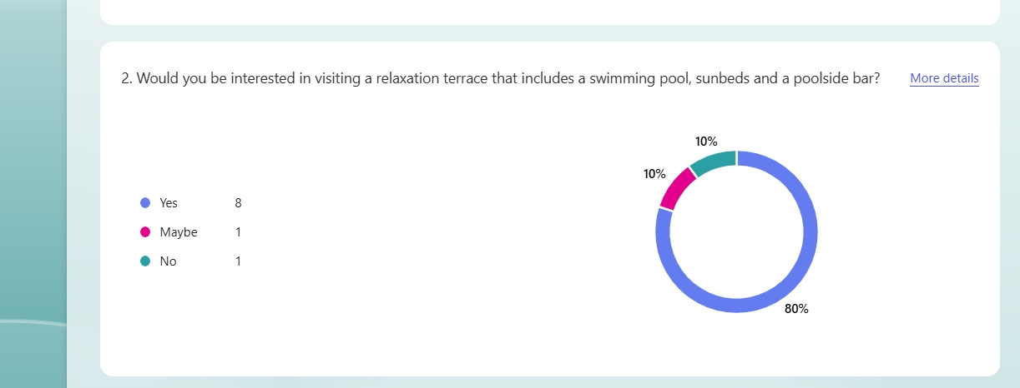

Figure 2
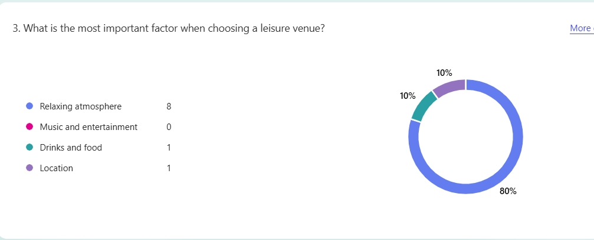
Figure 3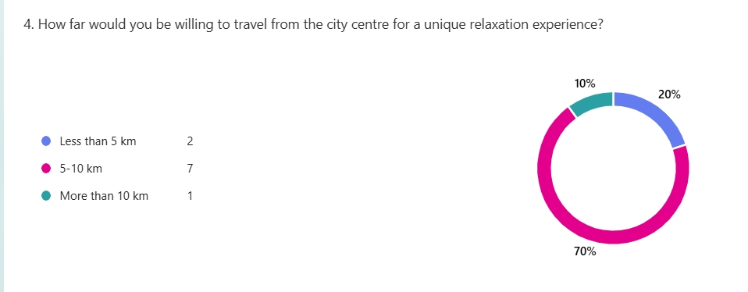

Financial resources for the project will mainly come from personal savings and possible family investment. The main start-up costs include construction of the swimming pool, outdoor furniture such as sunbeds, bar equipment and landscaping. Entrepreneurship research highlights that careful financial planning is essential during the early stages of a business (Timmons and Spinelli, 2009). Although the initial investment may be significant, hospitality businesses can generate stable revenue if they attract a consistent number of customers (Barrows, Powers and Reynolds, 2012).
A competitor analysis shows that the main competitors are bars, terraces and hotel leisure areas in Craiova. Many focus on nightlife or restaurant dining rather than relaxation. GreenVelvet Terrace will therefore differentiate itself by offering a calm leisure environment focused on comfort and nature. Strategic positioning and differentiation are important factors for business success in competitive markets (Stokes, Wilson and Wilson, 2010).
A SWOT analysis evaluates the feasibility of the idea. Strengths include the unique concept, the availability of land and the quiet location near a developing city. Weaknesses include the initial investment and the seasonal nature of outdoor hospitality businesses. Opportunities include growing demand for leisure experiences and the development of the Șimnicu de Sus area, while threats include competition and economic changes that may influence consumer spending.
In conclusion, the analysis suggests that GreenVelvet Terrace has strong potential as a hospitality business. With careful planning and effective promotion, the terrace could become a popular leisure destination for residents of Craiova and the surrounding region.

References
Barrows, C., Powers, T. and Reynolds, D. (2012) Introduction to Management in the Hospitality Industry. 10th edn. Hoboken: Wiley.
Bowie, D. and Buttle, F. (2011) Hospitality Marketing. Oxford: Butterworth-Heinemann.
Bridge, S. and O’Neill, K. (2018) Understanding Enterprise, Entrepreneurship and Small Business. 5th edn. London: Palgrave Macmillan.
Burns, P. (2016) Entrepreneurship and Small Business. 4th edn. London: Palgrave Macmillan.
Doran, G. (1981) There's a S.M.A.R.T. Way to Write Management’s Goals and Objectives. New York: Management Review.
Hisrich, R., Peters, M. and Shepherd, D. (2017) Entrepreneurship. 10th edn. New York: McGraw-Hill.
Kotler, P. and Keller, K. (2016) Marketing Management. 15th edn. Harlow: Pearson.
Kotler, P., Bowen, J. and Makens, J. (2019) Marketing for Hospitality and Tourism. 7th edn. Harlow: Pearson.
Morrison, A. (2018) Marketing and Managing Tourism Destinations. 2nd edn. London: Routledge.
Pine, B. and Gilmore, J. (2011) The Experience Economy. Boston: Harvard Business School Press.
Porter, M. (2008) Competitive Strategy. New York: Free Press.
Scarborough, N. and Cornwall, J. (2016) Essentials of Entrepreneurship and Small Business Management. 8th edn. Harlow: Pearson.
Stokes, D., Wilson, N. and Wilson, M. (2010) Small Business Management and Entrepreneurship. 6th edn. London: Cengage.
Timmons, J. and Spinelli, S. (2009) New Venture Creation. New York: McGraw-Hill.
Walker, J. (2017) Introduction to Hospitality Management. 5th edn. Harlow: Pearson.

Reflection
During the lecture series and while completing my assignments, I developed a better understanding of entrepreneurship and the skills required to build a successful business. One of the most important things I learned is that a business cannot succeed without good collaboration between the owner and the staff. As a business owner, the way you communicate and behave with employees has a strong influence on how they work and how they treat customers. If the relationship between the owner and the staff is positive and respectful, employees are more motivated, and this usually leads to better customer service and higher customer satisfaction.
Another important lesson for me was the role that family can play in the development of a business. When a business starts as a proprietorship, family members can be very helpful in supporting the owner, especially during the early stages. They can help with daily activities, decision-making and sometimes even financial support. This can create a strong foundation for the business because trust and commitment already exist within the family environment. Through my lectures and coursework, I realised that many successful small businesses start as family projects that grow over time.
I also understood that the capability of an entrepreneur is not only about having financial resources. While funding is important, the personal involvement of the entrepreneur is even more important for the long-term success of the business. An entrepreneur must constantly work on improving the business, looking for new ideas and solutions. Success does not come simply by opening a business and waiting for results. The owner needs to be actively involved in daily operations, monitoring progress and motivating the team. In this way, the entrepreneur becomes a leader who guides the business towards growth and improvement.
Another skill that became clearer to me during this module is the importance of marketing. Even if a business offers a good product or service, customers will not know about it without effective promotion. A strong marketing team can make a significant difference, especially when the business experiences difficult periods or strong competition. Good marketing strategies can attract new customers, increase brand awareness and help the business stand out from competitors.
Finally, I learned that when starting a business from zero, profit should not always be the main focus during the first months. In the early stages, it is more important to attract customers and build a strong reputation. If people enjoy the experience and feel satisfied with the service, they will return and recommend the business to others. Once the business becomes more popular and develops a stable customer base, it becomes easier to focus on balancing customer growth with financial profit.
Overall, this module helped me understand that entrepreneurship requires many skills, including leadership, communication, teamwork and strategic thinking. The knowledge gained during the lectures and assignments helped me see more clearly how a business develops and what responsibilities an entrepreneur must take in order to build a successful and sustainable company.

