

An Investigation Into The Correlation Between Mental Illness Related Crime In South Wales
Humphrey, Leigh
1911068

BSc (Hons) Professional Policing

September 2021

Word Count: 10000

Acknowledgments

I would like to thank my participants, colleagues and most importantly my Supervisor, Deepak Patel for their time and support throughout the course of the dissertation process. I would also like to thank, Jane Thomas for their initial guidance and assistance at the start of the third year.
Finally, I would like to thank my family, specifically my partner and her parents, my parents and family, work colleagues and friends for their encouragement throughout this university course. The time and help you all gave to ensure I could succeed is something I will forever be grateful for.

Impact of COVID -19 and working as a full-time Police Constable.

Due to the continuance of the global epidemic and my employment as a full-time Response Police Constable, it is vital that I include a statement at the opening of my dissertation detailing the impact this has had on the undergraduate research I have performed.

The University of Wales Trinity Saint David recognizes that the role of a full-time Police Constable and the COVID-19 pandemic, in addition to the 18th March 2020 campus closures and national and international lockdowns, have had a direct or indirect impact on the work of a number of our undergraduate researchers. Therefore, training was developed utilising suitable meeting software, and materials were distributed electronically. In addition, every research data gathering was conducted with computerised data collection.

This remark is inserted to alert the reader, both now and in the future, that the pandemic may have affected the scope, direction, and presentation of the research.

The award's academic qualifications and quality standard have not altered. I would like to inform you that this comment does not lack original research or quality.

Declarations

- Declaration - This work has not previously been accepted in substance for any degree and is not being concurrently submitted in candidature for any degree.
Signed: Leigh Humphrey
Date: 25/06/2022

- Statement 1 - This dissertation is being submitted in partial fulfilment of the requirements for the degree of BSc.
Signed: Leigh Humphrey
Date: 25/06/2022

- Statement 2 - This dissertation is the result of my own independent work/investigation, except where otherwise stated. Other sources are acknowledged by footnotes giving explicit references. A bibliography is appended.
Signed: Leigh Humphrey
Date: 25/06/2022

- Statement 3 - I hereby give consent for my dissertation, if accepted, to be available for photocopying and for interlibrary loan, and for the title and summary to be made available to outside organisations.
Signed: Leigh Humphrey
Date: 25/06/2022

- Statement 4 - I hereby give consent for my dissertation, if accepted, to be available on the university’s IT system to those who have consent to use the system.
Signed: Leigh Humphrey
Date: 25/06/2022

Contents
Acknowledgments 2
Impact of COVID -19 and working as a full-time Police Constable. 2
Declarations 3
Chapter 1 Introduction 6
1.1 Background 6
1.2 Aims and objectives 7
1.3 Aims 8
1.4 Objectives 8
1.4 Rationale 9
1.5 Structure 9
1.7 Conclusion 10
Chapter 2 – Literature Review 11
2.1 Introduction 11
2.2 What is Mental Illness 12
2.3 Self-perception 13
2.4 Historic perception of mental illness related crime in South Wales. 14
2.5 Modern Perception on Mental Illness 16
2.6 Perception of Mental Illness related Crime and Police. 17
2.7 Mental health-related crime in South Wales. 19
2.8 Conclusion 20
Chapter 3 - Research Methodology 20
3.1 Introduction 20
3.2 Definitions 21
3.3 Philosophy 21
3.4 Approach 23
3.5 Strategy 23
3.6 Choice 24
3.7 Time Horizon 24
3.8 Data Collection and Analysis 25
3.9 Survey Design 26
3.10 Interview 26
3.11 Reliability and Validity 26
3.12 Limitations 27
3.13 Ethical Consideration 28
3.12 Conclusion 29
Chapter 4 - Analysis of results 29
4.1 Introduction 29
4.2 Data Analysis 30
4.3 Descriptive Statistics and Demographics 31
4.4 Questionnaire Findings 33
4.5 Public perception on encountering persons with a mental illness 33
4.6 Public perception of individuals with mental illness being involved with police 35
4.7 Public perception of individuals involved in crime 37
4.8 Public perception on what types of crime involvement 38
4.9 Is mental illness related crime increasing 39
4.10 Impact factors on police dealing with mental illness related crime. 41
4.11 Public perception on Government support services 43
4.12 Response from interview. 44
4.13 Conclusion 45
Chapter 5 45
5.1 Introduction 45
5.2 Main findings 46
5.3 Recommendations 46
5.4 Limitations 47
5.5 Further research 47
5.6 Achievement of objectives 48
5.7 Conclusion 49
Bibliography 50
Appendices 57

Chapter 1 Introduction

The purpose of this chapter is to provide background and justification for the study. It will explain the purpose and objectives of the research, as well as its description and structure.
The relationship between mental illness and criminal behaviour has been extensively studied on an international scale, and the topic is currently receiving a great deal of public interest (Julian, 2017). At least ten percent of the world's population suffers from any one of a variety of mental illnesses; in 2010, 700 million people were diagnosed with a mental illness (Patel and Saxena, 2014). According to the findings of the Global Burden of Disease Study conducted in 2010, mental illnesses accounted for 7.4% of the global burden of disease when measured in terms of impairment (Whiteford et al, 2010). In recent years, there has been a substantial increase in media coverage of mental illness-related issues. The charitable organisation known as "Heads Together" was founded in 2016 by the Duke and Duchess of Cambridge, Kate Middleton, and Prince Harry in order to raise public awareness of mental health and illness issues (The Royal Family, 2016). There is still a great deal of stigma associated with mental illness issues, which is largely attributable to a general lack of awareness about the problems. Despite the increasing public recognition and acceptance of mental health issues, there is still a stigma associated with individuals that suffer from them. More and more people are becoming aware that it is prevalent in the majority of societies and is no longer restricted to South Wales.

Background

In Britain, According to Turner et al. (2015), post war psychiatry is primarily described through two interconnected narratives: psychopharmacology and 'de-carceration.' He cites Hess and Majerus (2011), such narratives are concerned with rights, detention, therapies, and the asylum population. British mental health services at the start of the twenty-first century encountered many changes such as social policy, legislative, medico-legal, service design, service delivery, and clinical practise advances lack rigorous historical study due to the scope and speed of change. Person-centred care, well-being, recovery, service user involvement, and increased access to psychological therapies are all lacking in historical context. The language of mental health has also evolved. Contemporary actors use 'costs,' 'risks,' 'needs,' 'inclusion,' and 'equality' to create opposing visions of mental health services, complicating a rights-based historical narrative. Many novel psychiatric medications have been released in the modern era, such as the first antipsychotic drug, chlorpromazine, in 1952, and others used to successfully treat the vast majority of persons with mental illness. Due to a lack of funding and the fact that the majority of persons may be treated successfully in the community, very few people are placed in mental hospitals for extended durations. Crime and incarceration of the mentally ill, as well as the shortage of beds and resources to treat those with severe mental illness, continue to be significant issues (Tracey, 2019).
The history of mental illness related crime is not well documented throughout the South Wales region mostly as the country abides by the same legislation as the rest of the UK. Therefore, many statistics and data collected are conjoined results. However, with the countries that make up the UK now having their own representative governments more concentrated data on particular efforts are being made available.

Aims and objectives

The dissertation research background will consist of the historical synthesis between mental illness and the police service leading into a modern view of the questions asked in this research dissertation with a concentrated effort on the geographical location of South Wales, UK. The research intending on answering the questions, objectives and aims of gathering research and data on the following aims and objectives:

Aims

- Are individuals with poor mental health more likely to be involved with crime and in what capacity?

- What are the impact factors of mental illness related crime for response policing in the geographical area of South Wales?

1.4 Objectives

- To examine and evaluate the current literature on mental illness-related criminality in South Wales.

- Select an acceptable study methodology to explore professional and public perspectives and comprehension on the subject of crime related to mental illness.

- Analyse the obtained data to determine the relationship between the public, professionals, and individuals with mental illness and crime, as well as if they believe there is sufficient assistance.

Rationale

This research is justified due to the fact that issues concerning the many different types of mental illnesses in South Wales are slowly but surely being brought to the forefront (Time to Change, 2022), as well as the fact that crime-related mental illness and its influence and consequences on individuals are slowly but surely being recognised. People who suffer from mental illness are commonly suspected of being involved in criminal behaviour, either as perpetrators or victims; in either scenario, the assistance of the police is required. As a result of the fact that response policing is frequently the initial point of contact, the police service frequently interacts with individuals who are suffering from mental illness (Forensic Colleges, 2022). We believe that conducting research on this topic would be extremely interesting because of the nature of these interactions.

Structure

In order to accomplish what this study set out to do, the dissertation will be broken up into five chapters.
The research was presented in the first chapter, which provided context, defined the justification for the done research, the purpose, objectives and outlined the overall purpose of the research. The investigation will include both primary and secondary data, which will be gathered through the use of a questionnaire, two interviews, and a thorough examination of the pertinent literature.
The second chapter is a literature review, and it focuses on research that investigate the relationship between mental illness and crime in South Wales. Through self-perception, public perception, and the connection between police and government, the literature study will help to a better understanding of mental illness. After this, there will be a discussion of the different research approaches in the third chapter.
The approach and methodology that will be used to determine the proper primary research techniques for this study are going to be demonstrated in the third chapter of this book. It is hoped that this will contribute to filling in the gaps in the research, following which the data can be analysed.
The primary data will be analysed in the following chapter, which will use the approach described in the previous chapter (chapter three). In order to demonstrate the results, statistical analysis will be carried out. After this, there will be time allotted for debate and analysis.
In the fifth chapter, we are going to talk about and go through the overall goals and purposes of the research. In order to bring this whole thing to a close, there will be a discussion on the most important findings, some recommendations, and the limitations of the research.

1.7 Conclusion

The goal of this project is to investigate whether people with mental illness are more likely to be involved in crime and to what capacity as victims or perpetrators of crime. In addition, what factors influence the behaviour of response police departments and officers when dealing with crimes connected to mental illness and if there is enough sufficient funding in place to help these individual. According to the College of Policing (2016), a series of national reports have been released in response to recurring issues regarding the care and management of people with mental illness. These articles investigate how police officers utilise prison, police custody, and the criminal justice system to handle such individuals from the time they contact the police until their release. As reported by the Her Majesty's Inspectorate of Constabulary (HMICFRS); Policing and mental health: Picking up the pieces (2018), police services in the 43 local authorities of England and Wales are evaluated on their ability to protect the vulnerable and support victims, as well as their capacity to respond to and support individuals with mental health issues. I believe that focusing on these issues in the geographical region of South Wales would make for an intriguing research topic.

Chapter 2 – Literature Review

2.1 Introduction

The purpose of this chapter is to review current academic literature in order to determine the current correlation between crime and mental illness and its impact on response policing in South Wales. A literature review is typically one of the first steps taken after selecting a topic for an academic paper, such as a dissertation in this case. The reading and analysis may aid in refining the topic's geographical scope and developing research questions.

In addition, a literature review can aid in developing a sense of familiarity with existing research on mental illness, crime and response policing before beginning the investigation.

The review should determine what prior research has been conducted on this topic by summarising and analysing previous studies and hypotheses. Additionally, it is necessary to identify disagreements and gaps that have not yet been studied academically. Therefore, it is widely acknowledged as an excellent tool for assisting academics in preparing, creating, refining, and writing reviews on specific subject areas.

Examining literature obtained from the UWTSD e-learning online library database and Google Scholar will satisfy the requirement for the use of academic sources. Google Scholar is a web search engine designed specifically to locate academic and scholarly sources. This popular academic resource focuses on peer-reviewed academic publishers, professional societies, preprint repositories, universities, and other scholarly organisations to provide peer-reviewed papers, theses, books, book chapters, abstracts, and articles.

Search terms such as Mental health, mental health and crime, the history of mental health and crime, the modern perception of mental health and crime, and the public's perception of mental health were used to narrow down the literature sources used in this literature review.
In addition to these academic sources, the use of local libraries, social media sources, mental health charities and organisations in the South Wales region, and any other credible sources will enable the achievement of the objectives outlined in this dissertation.

2.2 What is Mental Illness

To understand the objectives aiming to be achieved, first the definition of what mental illness is will be explained to give clarity as scientifically possible. Mental illness is defined by Webster (2022) as "a broad range of medical conditions characterised primarily by sufficient disorganisation of personality, mind, or emotions to impair normal psychological functioning and cause noticeable grief or disability, and that are typically associated with a disruption in standard judgement, emotion, mood, behaviour, or interaction." Webster also notes that Major depression, schizophrenia, obsessive-compulsive disorder, and panic disorder are examples of medical illnesses. The different types of mental illnesses and their associated behavioural conditions can potentially put the individual at risk of being involved in crime as a victim or suspect potentially leading to engagement from response police officers.

2.3 Self-perception

As the police are typically the first to respond to incidents involving mentally ill individuals, the need to distinguish between mental health and mental illness is essential for ensuring that individuals receive the appropriate care. Knowing and engaging with individuals afflicted with mental disorders ranging from serious depression to schizophrenia has provided both personal and professional insight into mental illness. Rubin (2016), notes that a person with insight is one who recognises the need for therapy for an illness which is necessary not to dismiss the illness.

The extent to which the general public are aware of mental illness and how they perceive those individuals suffering from mental illnesses may impact how they experience and deal with mentally ill individuals and potentially develop negative attitudes toward mental illness in general.

According to Chuang et al. (2019), regular engagement and associations with mental health facilities can result in a higher level of insight from experience and knowledge in engaging with members of the public with mental illnesses, thereby changing the personal stigma associated with mental illness. With more knowledge of illnesses such as schizophrenia and treatment adherence, the likelihood of adopting the label of mental illness and internalising the stigma may increase a positive perception of mental illness however it may have an adverse effect increasing the negative perception on mental illness. At present research into these possible outcomes are limited in the area of South Wales and need to be more fully researched.

In addition to the stigmatisation of individuals with any form of mental illness, which may also have been influenced by societal assumptions about mental disorders, media stories, films, novels, experience with institutional systems, and previous restraining orders. As a result, stigma is regarded as a risk factor for the prognosis and rehabilitation of people suffering from mental illnesses.

Chuang et al. (2019b), also mention that while conducting research, people with mental illnesses may have internalised stigma, also known as self-stigma, regarding how they perceive their mental illness. Self-stigmatization is the internalisation of stigmatised feelings as a result of embracing unfavourable views and stigmatising oneself.

Internalized stigma has been linked to a number of negative psychosocial outcomes in people with mental illnesses, including lower quality of life, life satisfaction, lower self-esteem and self-efficacy, recovery orientation, increased psychiatric symptoms, marginalisation, rejection, shame, and isolation. As a result, internalised stigma is regarded as a risk factor for psychological disease diagnosis and rehabilitation. However, Drapalski et al. (2013), states that the incidence of internalised stigma among people with mental illnesses, its consequences on psychosocial outcomes, and the patterns of linkages between internalised stigma and these outcomes have not been thoroughly investigated.

2.4 Historic perception of mental illness related crime in South Wales.

The goal of this section is to provide a brief historical and theoretical background to the police understanding and framing of mental illness in South Wales, however its acknowledgement is also linked to the history of England because the country follows the same legislation and there has been limited research into the Welsh perspective.

Academic researchers have been fascinated by the relationship between mental illnesses and crime. Mental illness related crime is common in most countries, but its impact and consequences on individuals have only recently been recognised in South Wales with the Welsh government updating the Mental Health Act in 2007 to introduce new measures of support. They note that, the 2010 Measure is all about the support that should be available for people with mental health problems in Wales wherever they may be living (Mental Health Wales, 2019).

The National Institute for Health and Care Excellence (NICE) (2017), mentions how mental health was regarded during the time period of "The Victorian Legacy." People committing crimes while suffering from mental illness were institutionalised at this time in "brutal Victorian asylums," where they were separated from their communities and hidden from public view, and a pervasive stigma remained attached to them. Their conditions were also frequently described using the terms "lunacy" and "mental infirmity" (National Institue for Health and Care Excellence, 2017) again intensifying the stigma associated with mentally ill individuals.

The article continues by mentioning the Mental Health Act of 1959, which marked a significant shift in which patients with mental health issues were no longer admitted to asylums, but rather to more conventional hospital wards in the community. Communities, on the other hand, remained uneasy throughout the 1990s as a result of insensitive journalistic coverage of psychiatric patient incidents and crimes in general (National Institue for Health and Care Excellence, 2017b).

Since 1959, progress has been made, most notably in 2002, publications of up to 80 pieces of mental health guidance on clinical, public health, and social care themes ranging from the mental health of people involved in the criminal justice system to social and emotional wellness in primary education and mental wellbeing in care facilities for the elderly (National Institue for Health and Care Excellence, 2017c).

This emphasises that mental health services in the United Kingdom have improved significantly over the last seven decades, easing the burden on crime and response policing, however, is yet to be researched thoroughly by these claims.

2.5 Modern Perception on Mental Illness

Throughout this research from various academic sources, the general opinion of mental illness is changing for the better. Age-old stigmatism is slowly being broken down and dissected as more knowledge, research, and advanced medical treatment are becoming available. People are starting to talk about their problems and any issues more openly and actively seeking treatment. It is a topic that will forever keep changing, and fortunately, people suffering from mental illnesses can receive the correct help and support rather than be punished for it.

From 1948 to the present, reports suggest that significant progress has been made in raising public understanding of mental health issues in the United Kingdom. To begin, they acknowledge that terrible incidents in the media, many of which involved celebrities, as well as well-publicized campaigns have raised public awareness of the importance of protecting the nation's mental health (National Institute for Health and Care Excellence, 2017d). This is critical in today's society; for example, one of the most tragic celebrity mental illness stories is that of Caroline Flack. As a result of increased social media coverage and persecution following allegations of domestic abuse gave her serious depression, Flack took her own life.

Previous research conducted into the area of mental illness and its correlation with a crime is still a relatively new area of academic research in the proposed research area. The issues and understanding fully individuals with mental health, is seen to be mainly researched on a global scale. Saxena et al (2005), keen to start research on the topic area, published The Mental Health Atlas that concluded a four-year investigation conducted on a global scale concluding that due to lack of government statistics and data, a full report was not accessible.

Fifteen years later, with a broader knowledge and understanding of Mental illness, academic research has been conducted on a smaller, closer to home scale. Government inquiries (NHS Digital, 2021) and local councils collecting information and statistics to help support research around this topic area. For example, one report conducted by Mind (2013), a mental health organisation, collected information and data that corroborated that individuals with serious mental illnesses are often associated and involved in a crime. Statistics from their report show that forty-five per cent of crime victims had SMI and are five times more likely to be a victim of assault than people in the general public.

2.6 Perception of mental illness related crime and police.

The police service is one organisation that is regularly in contact with persons who are suffering from mental illness. Misunderstandings and the fact that the police are not generally qualified to deal with such people have been highlighted in a number of high-profile incidents such as in 1992 Jonathan Zito was stabbed and killed by Christopher Clunis, a psychiatric patient, on the platform of a London Underground station (Timmins, 1994).

Since the creation of the police force, involvement with people with mental illnesses has always been a feature of response policing. However, this position has only recently become the subject of scientific inquiry and analysis, according to The Kings Fund (2022a), particularly since the era beginning in the 1960s with the widespread closure of most asylums for the mentally ill. Furthermore, with the end of institutionalised mental health services, Police forces around the country expressed worry about the impact on the role of response officers that was heavily about to increase.

Police on being presented with the release of over 100,000 individuals (The Kings Fund, 2022b) with crippling mental illnesses for whom there was no longer any mental health support from the disbanded institutions. Chappell & O'Brien (2019), notes the absence of local mental health programmes in the community or provided little to no support in guiding the police in dealing with such individuals. Consequently, the police at the time, facing this massive issue, fell into a cycle of arrest and admittance into the criminal justice system.

However, according to Teplin & Pruett (1992), the legal structure did not dictate the resolution of such encounters, and whether police defined the disordered individual to be "bad" (and should be arrested) ", mad" (and hospitalised), or merely eccentric was decided by discretion rather than rules of law.
Poor treatment and chronicity for people with mental illness became one of the main results due to a lack of comprehensive policies and training and the absence of collaboration with and by the police and mental health services.

Since the 1960s, police services have sought to progressively better their response to people with mental illness due to these factors. Moving forward into the modern era, as a result of these progressions and understanding of mental illness, a range of policing policies in approaching mental health situations and individuals with moderate to severe illnesses have arisen to improve the delivery of aid to those who are facing a mental health crisis. As the researcher has noticed, In the modern period, police services nationwide are constantly attempting to reform police perceptions, improve pathways for persons apprehended, and increase mental health referrals.

According to the report, Policing and Mental Health, Picking Up the Pieces (2018), conducted by Her Majesties Inspectorate of Constabulary and Fire and Rescue Services (HMICFRS), summarises that most mental health crises are avoidable and preventable. They note that it would help lower the cost of health care providers by intervening early rather than pay for professional crisis therapy after harm and distress have occurred. The report presents to the reader that a few police forces, for example, The Met (Metropolitan Police Service), mentioned the strain that is responding to repeat callers' places on command and control systems. The top five most frequent callers to the Metropolitan Police Service (all of whom have mental illness issues) made a total of 8,655 calls in 2017. Simply answering the phone cost, the organisation £70,000.

2.7 Mental health-related crime in South Wales.

According to Kane et al. (2021), while conducting a national census exercise based in England and Wales, the number of mental health incidents handled by police services and other mental health-based organisations involved is understudied. Despite this, the report goes on to say that while occurrences involving mental health issues do drain police resources, they do not constitute an excessive demand in terms of the number of incidents.

However, according to the chief constable of South Wales Police, the force's ability to carry out its core duties is under increasing strain due to an increase in mental illness related calls, response calls of a mental health nature, unless the individual is unfortunately caught up in a crime, essentially diverts attention away from critical tasks such as dealing with domestic violence and other types of crime. Many officers, from personal perception, believe that despite not being the most appropriate service to assist those experiencing a mental health crisis, the force was frequently "filling a gap" because it operated 24 hours a day, seven days a week (Rees, 2019).

The definition of such incidents as described by the College of Policing (2020)
is 'Any police incident thought to be related to someone's mental health in which their vulnerability is at the centre of the incident or in which the police have had to do something additional or differently as a result of it.

2.8 Conclusion

This chapter has shown evidence of achieving the aims and objectives set out in chapter one.
In conclusion to this literature review, there is limited research on mental illness and its involvement in crime within the geographical area of South Wales. The literature review concluded that research gaps are due to Welsh statistics often being in conjunction with studies and research associated with England. This area still needs to be researched from an independent Welsh viewpoint. Still, mental illness and crime are complex issues, only made worse through government budget cuts into public mental health services. It is clear to see that police forces are indeed "mopping up". The literature review outlined specific gaps in the objectives from a statistical, locational and policing perspective and, in the next chapter, identified appropriate research methodology to address these highlighted gaps.

Chapter 3 - Research Methodology

3.1 Introduction
According to Varghese (2017), research is the acquisition of new knowledge and is a systematic endeavour to collect, analyse and interpret the challenges confronting humanity. It is a way of thinking and a scientific method for analysing a problem and finding a solution. It is a comprehensive examination based on contemplative thought.

3.2 Definitions
In general usage, research refers to the pursuit of knowledge. One can alternatively define research as a scientific and methodical quest for relevant knowledge on a certain issue. Research is an academic endeavour, and the phrase should be used in a technical meaning.
- According to the Oxford Learners Dictionary (2022), research is “A careful study of a subject, especially in order to discover new facts or information about it”.
- Redman and Mory (1932) define research as "a systematic endeavour to acquire new knowledge."
- Cambridge Advanced Learner’s Dictionary (2022), defines research as "A detailed study of a subject in order to discover information or achieve a new understanding of it”

3.3 Philosophy
The research philosophy according to Bajpai (2011) is related to the investigation's premise, knowledge, and nature by focusing on the specific process of learning information that can assist us in gaining a deeper grasp of these assumptions.

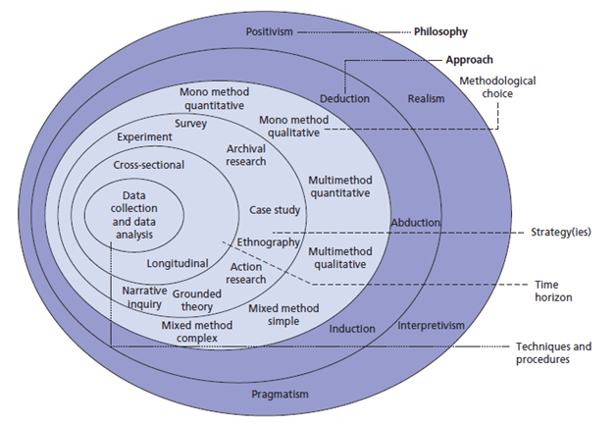
Fig 1 Research philosophy in the ‘research onion’ Saunders et al. (2009)
At each stage of the research procedure, assumptions are made concerning the nature of knowledge and the information sources. Important assumptions of the researcher will be expressed in the research philosophy, which will serve as the basis for the study strategy. In general, research philosophy is subdivided into numerous branches that are applicable to a wide range of disciplines. In particular, there are four important research philosophies to consider: Pragmatism, Positivism, Realism, and Interpretivism (Collis, 2014).
This selected study topic contains interpretivism because a variety of reactions are feasible, subjective, and necessitate the public's and professionals' viewpoints on people with mental illness and criminal behaviour. Interpretivist research as noted by Saunders et al (2007) bring a number of advantages to study findings, as it can increase precision and provide a clear explanation of the perspective. In addition, the researcher will conduct an interview with a subject diagnosed with mental illness and a policing professional, allowing interpretivism to seek an understanding of a given scenario and permitting the incorporation of many viewpoints from different groups or organisations.

3.4 Approach
According to Chetty (2016), the research approach is a plan and practise that ranges from general assumptions to specific data collecting, analysis, and interpretation techniques. Consequently, it is determined by the nature of the research problem being addressed. According to Streefkerf (2022), the research approach is divided mostly into two categories:
- the methodology of data gathering (Inductive).
- the methodology of data analysis (deductive).

The author notes that it is not uncommon for both approaches to be used however, the approach the researcher has chosen for this dissertation is an inductive approach as it can provide assistance to any future research on the relevant information.

3.5 Strategy
Methods are the techniques and procedures utilised for data collection and analysis (Bhandari, 2022). In order to obtain a wide variety of anonymous responses, surveys will be created and distributed via survey monkey, as well as uploaded to social media sites and distributed to frontline response officers. Questionnaires are commonly employed as an important research approach because the results can be a flexible method of data collection producing both quantitative and qualitative results about the characteristics, preferences, opinions, or beliefs of a group of people (McCombes, 2022).
In order to obtain a deeper understanding of mental illness, crime, and response police, the researcher will also conduct an interview with a member of the public who has been diagnosed with mental illness and a response police officer. According to George (2022), Interviews offer greater flexibility in terms of question responses as there are several types of interviews that gives a qualitative research method. At present, the choice of interview style will be based upon a structured interview however depending on the interviewee’s engagement may potentially become unstructured or semi-structured.

3.6 Choice
Throughout this investigation, a mixed method design will be used or a “point of integration” by Morse and Niehaus (2016), which is a mechanism for collecting data at various stages of the research process and mixing quantitative and qualitative data at various stages of the research process within a single study. When it comes to understanding a study problem more effectively, using a mixed technique approach might be beneficial and unbiased. However, it appears that selecting one research method over another drastically restricts the study's range. As Creswell and Clark (2011), noted a single approach cannot answer all the questions that may arise during the investigation of a topic. When used together, quantitative and qualitative methodologies provide a more complete picture of the situation and allow for more thorough investigation. The quantitative method will be used in this investigation. It is recommended that qualitative and quantitative methods be employed together in interpretive research; nevertheless, quantitative methods will be used when comparing and converting answers from the questionnaire into percentages. This delivers data that is consistent and reliable, but it can be difficult to understand the context in which it is presented.

3.7 Time Horizon
A time horizon research methodology according to Phillips et al. (2008) is utilised by academics to evaluate alternative approaches and typically focus on future changes to the research topic and is a valuable research tool. Academics are primarily concerned with a substantive and correct methodology for qualitative research. In addition, this permits the researchers to examine the participants in their normal context, resulting in a deeper comprehension of the research.
In order to help the researcher, have a better knowledge of the topic, time horizon can be divided into the two categories below.
Longitudinal study, employs the concept of repeatedly interviewing the same sample of people over time to detect any changes that may occur (Thomas, 2022).
Cross-Sectional Study: Cross sectional research is studied over a single point in time (Thomas, 2022).
Consequently, due to time limits of this research, the researcher will employ a cross-sectional method for this study.

3.8 Data Collection and Analysis
Primary research according to Gaillet and Eble (2016) is defined by as a “primary source or archive of physical or virtual place for locating information. The researcher will primarily use questionnaires for data collection and analysis alongside an interview. However, the inclusion of a number of positives and negatives will be considered. A questionnaire as noted by Kupfer & Eisensmith (2021) is used to “take the temperature of the state of the field”. It will be used to gather information from the general public and professionals to provide access to perspectives on issues such as mental health, crime and response policing. It is inexpensive, practical and quick way to gather data. However, there are certain downsides to using a questionnaire, including dishonest answers, unanswered questions and differences in understanding and interpreting the data (Debois, 2022). An interview poses the researcher asking face to face questions in a comfortable environment for the interviewee. The advantages of interviewing are that it can give the interviewee a feel for the topic of research and also has the ability to target specific audience. However, the disadvantages are potential time travel factors, cost of the interview and potential influence of the interviewee’s surroundings (George, 2022b).

3.9 Survey Design
The online questionnaire consisted of nine questions and could be finished in two minutes. It is essential that the questionnaire contain a mixture of open and closed questions, as to encourage respondents to fill it out since it will be seen as less laborious and time consuming to do so (McLeod, 2018). The questionnaire included both open-ended and closed-ended questions in order to collect as much data as possible.

3.10 Interview
The respondents will be asked five questions about their experiences dealing with mental illness, criminal activity, sufficient support and any other issues that may have had a role in responding policing during the course of the ten-minute interview. One was conducted with a serving police officer and another was conducted over the telephone with an individual with paranoid schizophrenia.

3.11 Reliability and Validity
According to Middleton (2019), both reliability and validity are utilised as descriptors in the process of determining the overall quality of the research. They offer information concerning the accuracy of a method, procedure, or measuring test. When we talk about the dependability of a measurement, we mean that it is consistent. On the other hand, when we talk about the validity of a measurement, we mean that it is accurate.
Especially in quantitative research, it is essential to keep the importance of reliability and validity in mind while planning of a research project, organising the technique, and writing up research findings.
According to Choudhury (2022), in terms of the reliability of the information they provide, questionnaires offer a number of clear advantages. When using methods like interviews and observations, the reliability of the responses obtained depends on how the researcher recorded them. They are free to present their own biased or prejudiced information at this point. However, when using the questionnaire method, the responses of the respondents are made available in both their original language and version. Therefore, there is no way for the researcher to interpret it properly.
In addition, responses to the questionnaire will remain anonymous. The respondents have a greater sense of confidence that they would not be recognisable as a result of expressing a particular position or opinion. They will feel more at ease as a result of this method and will have more freedom to express their opinion.

3.12 Limitations
In terms of Limitations, Roberts (2012), acknowledges there are aspects of the study that have a negative impact on the results or your capacity to generalise and have no influence over. Typical limitations include sample size, methodological limitations, research length, and response rate.
The first potential limitation could be potentially caused by the fact that the phrases "mental health" and "mental illness" do not mean the same thing. These two expressions are frequently confused by the general public, who believe that they have the same meaning. However, this misconception was prevented by providing clarifications of what each phrase means at the very beginning of both the questionnaire and the interview.
A second potential research limitation is the time frame that was presented upon the researcher. Due to the nature and reasoning of the research, the undergraduate dissertation has a time constraint of a few months combined with further social and economic limitations on the researcher has prevented further, deeper research being conducted.
This affected the duration of time that the questionnaire was active and could be answered.
Lastly, a major contributor of this research could potentially be the lack of previous studies on the topic as found in the literature result.

3.13 Ethical Consideration
When conducting research, Bhandari (2021) acknowledges it is important to keep in mind a set of ethical concerns, which are a set of principles that guide any study designs and procedures. When gathering information from individuals, scientists and researchers are obligated to conduct themselves in accordance with a predetermined set of standards.
Understanding real-world occurrences, researching and developing more efficient therapies, gaining insight into people's behaviours, and generally making people's lives better are frequently the objectives of research involving humans. Important ethical considerations come into play both with regard to the topic chosen to investigate and the methods used to do so.
These factors contribute to the protection of the research participants' rights, as well as the enhancement of the research's validity and the upkeep of the scientific integrity.
Polonski (2004) identified four other potential ethical issues, including voluntary involvement, informed consent, confidentiality, and anonymity, but the list is not exhaustive. To prevent unethical research, participation must be voluntary and there must be no compulsion or fraud, with potential participants understanding what they are being asked to do and being made aware of any potential negative repercussions of their participation. During this study, the researcher did not expect any substantial psychological effects. Participants may withdraw from the activity at any time if necessary; however, they will be provided with information regarding the confidentiality and/or anonymity of their responses. Any information stored online or in databases must be encrypted with a secure password to prevent information leaks.

3.12 Conclusion
This chapter was able to effectively complete the objective, which was to select an acceptable research approach to study public perceptions and understanding on the subject of mental illness and its association to crime, as well as how it effects response police.
This chapter has provided the methodology to be taken by the researcher by identifying and describing the research approach and a clear reasoned view why a mixed methods strategy has been chosen to conduct the research

The following chapter's objective is to compile, analyse, and report the findings from the data collection that was carried out using the procedures that were described in the current chapter.

Chapter 4 - Analysis of results

4.1 Introduction
This research's methods and approach were described in Chapter 3. This chapter is intended to accomplish the third objective:
To analyse the data collected to understand the relationship between the public, professionals and individuals with mental illness’s relation to crime and whether they believe enough support exists.
This chapter will provide and analyse the data obtained from the main research conducted by the researcher. The public's opinion of mental illness-related crime and the influence elements on response police were ascertained by means of an online survey with 42 respondents however data was only available from 10 respondents due to financial limitations. Throughout this chapter, references will be made to the responses of a person with a mental illness and a professional police officer to a series of questions.

4.2 Data Analysis
According to LeCompte and Schensul (2012), research data analysis is a technique employed by researchers for reducing data to narrative form and extracting insights from it. It makes sense that the data analysis process aids in the separation of a large data set.
Three essential steps occur during the initial data organisation phase of the data analysis procedure. Together, summarization and categorization make up the second known data reduction technique. It facilitates the identification and linking of patterns and themes discovered in the data. The third and final method is data analysis.
Marshall and Rossman (2016), on the other hand, characterise data analysis as a messy, ambiguous, and time-consuming method for bringing order, structure, and meaning to a mass of collected data.
Data analysis and interpretation can be described as the application of deductive and inductive logic to research and data analysis.
The data was collected and analysed by using survey monkey survey creation tool. Using this survey tool has allowed the researcher the ability to reach a larger public audience by giving it the ability to use online social media platforms. This survey tool has given the researcher the ability of a much quicker response from respondent’s and easier building of data analysis to show the results.

4.3 Descriptive Statistics and Demographics
Descriptive statistics are succinct descriptive coefficients that summarise a particular data set, which may represent the full population or a sample of the population (Hayes, 2022).
Prior to submitting their questionnaire replies, all participants gave their consent for their responses to be included in the dissertation with a pre-written conclusion under the survey title heading.
To establish whether there were substantial disparities in respondents' viewpoints, participants were categorised according to gender and age range. This poll had ten participants who were at least 18 years old and volunteered to participate. Facebook was used to distribute the poll in order to reach a greater number of potential responders. A key requirement of research is to communicate results in a manner that is comprehensible, dependable, and valid, as indicated.
The gender and age range questions were added because the researcher sought to discover whether gender and age range impacted the perceived utility of the questionnaire. Women are more likely to answer to a questionnaire than males, particularly for online surveys, and younger generations are more likely to engage than older generations, according to previous studies (Smith, 2008).
However, results from the survey notes that there is data to show that there is an equal 50/50 gender split in response to the survey and an age range of 26-35 years old giving 70% of the responses.

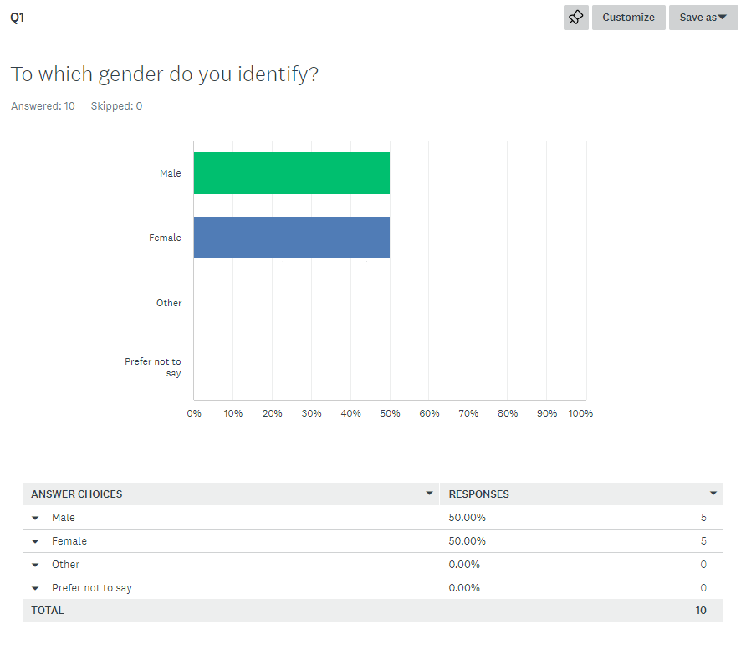 Fig 2 – Data Graph showing results of survey question

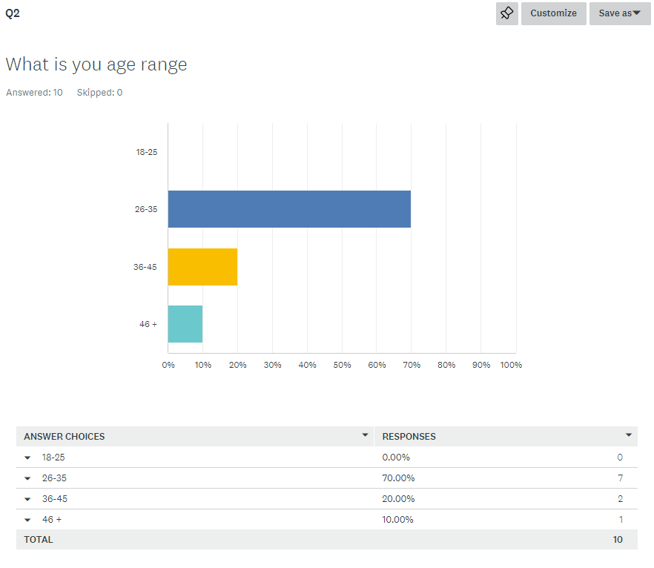
Fig 3 – Data Graph showing results of survey question

4.4 Questionnaire Findings
This section of the chapter is to discuss the results from the ten respondents and analyse the findings of each question.

4.5 Public perception on encountering persons with a mental illness

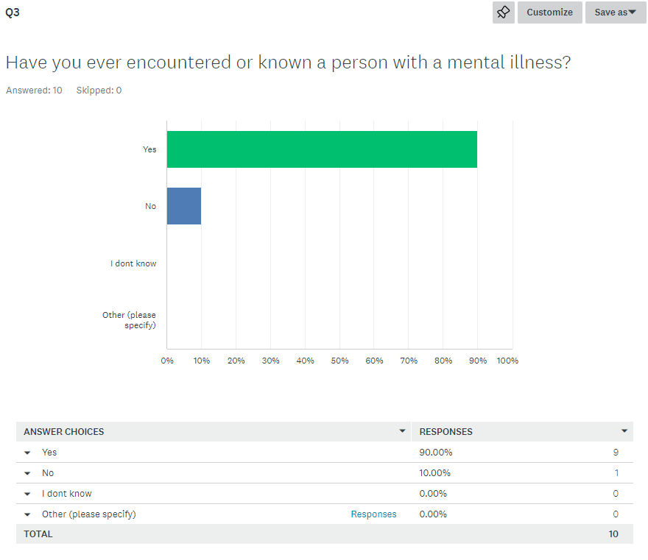 Fig 4 – Data Graph showing results of survey question

When the data from the 10 responses were analysed, it became abundantly evident that the general public had a highly one-sided picture of what it's like to know someone who has a mental condition. According to the collected data, 90% percent of the respondents answered yes to being aware of someone who had been diagnosed with a mental illness. In spite of the limited number of respondents, these findings indicate that the general public has a strong awareness of those who suffer from mental diseases and frequently interacts with those individuals.
10% of the respondents answered ‘no’ to being aware of someone who had been diagnosed with a mental illness.
This is in line with the findings of a study conducted, which focuses on mental health, which found that an increasing percentage of people are aware of and have personal experience with those who have a mental illness. According to their findings, the rate of expansion increased from 58 % in 2009 to 63 % in 2012 (MIND, 2013).
Cvetkovska (2022), further observes that, according to global mental health statistics, the prevalence of mental disorders has risen substantially during the previous decade noting that stigma and lack of understanding and support surrounding mental illness concerns contribute to the increase in the number of mental health problems.

4.6 Public perception of individuals with mental illness being involved with police
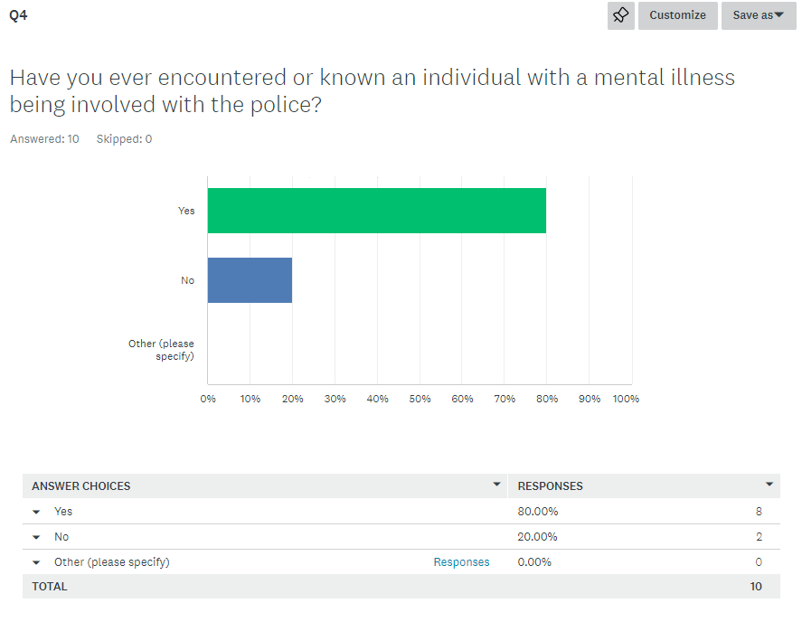
Fig 5 – Data Graph showing results of survey question

When 10 respondents' data is analysed, it is revealed that eighty percent of respondents answered yes to knowing someone with mental illness who had encountered response police officers in some way.
Livingston (2016) accepts the popular perception that people with mental problems are overrepresented in interactions with law enforcement. The prevalence of such interactions is offered as evidence that our health care and social assistance systems are plagued with substantial difficulties.
Due to these difficulties explained above, The Bradley Review (Bradley, 2009) notes that the legal system and penal policy in the United Kingdom and other legal countries do not consider criminals with mental illness issues to be a unique group. However, within the CJS, the fact that a person has a mental Illness condition can be considered while making crucial decisions such as arrest, charging, entering a plea, and sentencing (Cummings, 2012).

4.7 Public perception of individuals involved in crime
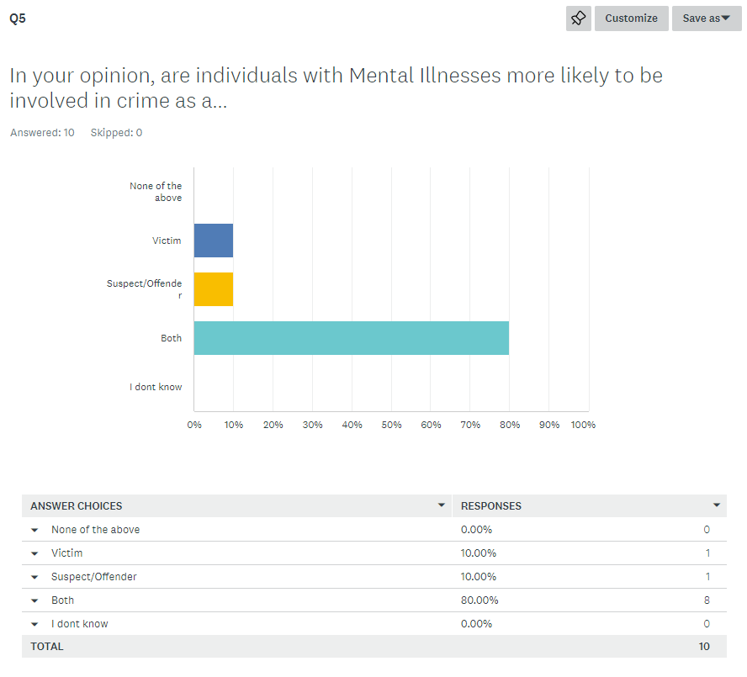
Fig 6 – Data Graph showing results of survey question

When analysing the 10 responses, the public’s perception on individuals being involved in crime showed that 80% of the responses believed that persons with a mental illness would be involved in crime as both perpetrators and victims. In addition, of the 10 respondents 10% noted that a person suffering with mental illness would only be involved in crime as a victim. Furthermore, another 10 % of the respondents noted that persons with mental illness would only be a subject of crime. This is consistent with data found during the literature phase of research that most of the public believe that mentally ill individuals are involved in crime on some capacity.

4.8 Public perception on what types of crime involvement

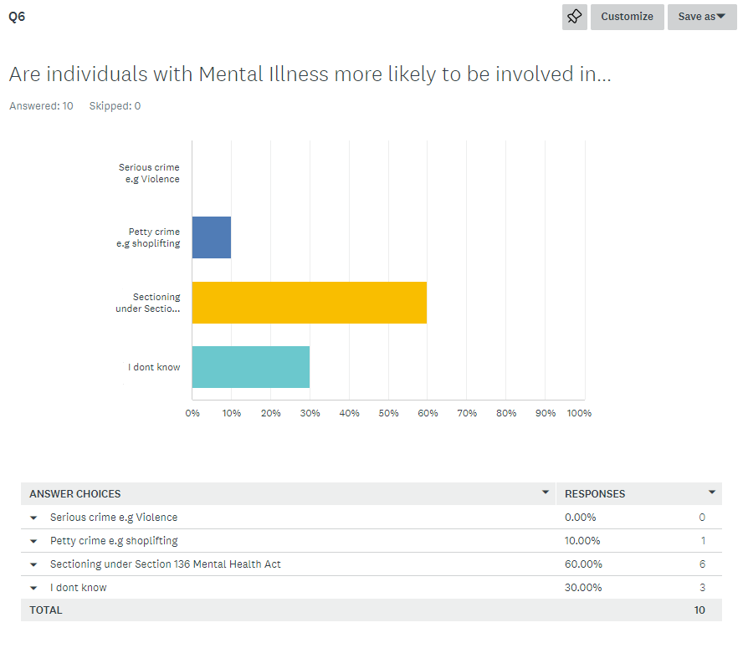
Fig 7– Data Graph showing results of survey question

Analysing the data from the 10 respondents, there was a wide range of responses to the issue of what kind of criminal activity will be committed by those with mental illness.
Respondents were given four options, including minor offence, serious crime, mental health act sectioning, and I don't know. The data indicates that 30% of respondents did not know what type of crime a person with mental illness would commit, which may indicate a lack of comprehension of the topic question.
10% of respondents indicated that people with mental illness would conduct minor offences such as shoplifting. This evidence is consistent with Belfrage's (1998) assertion that the majority of acts committed by people with mental illness are shoplifting or issuing threats and were modest, as is typical of social dropouts.
60% of respondents indicated that they believed the police would detain people with mental illness under section 136 of the Mental Health Act of 1983. This data corresponds with previous data from the Welsh Government, which indicates that 71.9% of detained individuals were transported to a health-based site of safety as their initial place of safety, with a police car being the most likely mode of transportation there (Gov.Wales, 2022).
Intriguingly, among the 10 respondents, the results for public perception of crimes involving serious violence committed by those with mental illness scored 0%. This information appears to corroborate Hammond's (2015) findings that just 1% of violent crime victims believed the perpetrator's mental disorder contributed to the crime. However recent reports suggest that persons suffering with Schizophrenia are more violent and aggressive and contribute between 5-10% of all UK murders and violent crimes.

4.9 Is mental illness related crime increasing

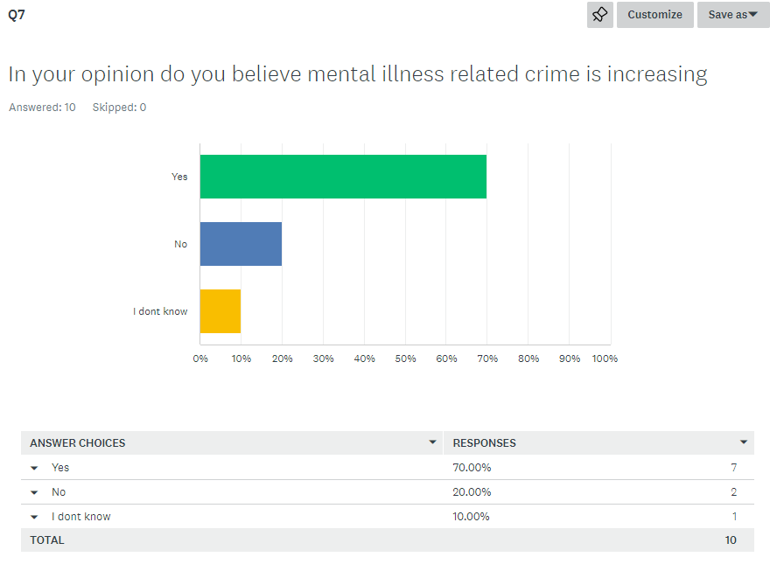
Fig 8 – Data Graph showing results of survey question

On analysing data from the 10 respondents responding to the question, is mental illness related crime increasing, The data shows that 10% noted that they did not know. This result may indicate a lack of knowledge on the topic question.
Of the ten respondents, 20% indicated that they did not think that mental illness crime was rising.
Of the ten respondents, 70% of them agreed that mental illness related crime was increasing.
In a report conducted by Rees (2019), the report shows data obtained from by the National Police Chiefs’ Council (NPCC) and Home Office that in the area of Gwent, there has been a 10% fall in mental illness related crime, however in South Wales, statistics show a 22% increase of mental illness related crime. They concluded however that poor data from the respective constabularies was difficult to establish the reason for this. However, as the researcher has used the social media platform Facebook, majority of respondents may potentially be from these two areas confirming the data may be correct however it is not conclusive.
According to Das (2019), a consultant of forensic psychiatrist, he notes that the outcomes of this topic studies may vary. There are numerous reasons for this, including the fact that different populations are researched, the definition of mental illness might vary, and violence can be defined and assessed in various ways (arrests vs convictions; severe vs more minor). Although the vast majority of patients with serious mental diseases (such as schizophrenia) do not exhibit violent behaviour, there is still an undeniable correlation.

4.10 Impact factors on police dealing with mental illness related crime.
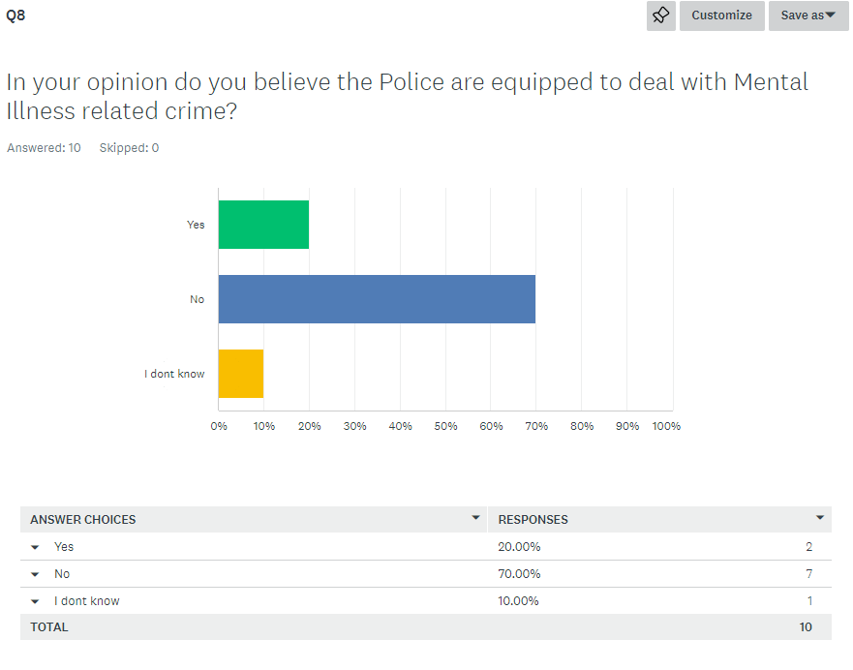
Fig 9 – Data Graph showing results of survey question

Analysing the responses of ten respondents to the question " In your opinion do you believe the police are equipped to deal with mental illness related crime" revealed a range of opinions.

The fact that 10% of respondents responded with "I don't know" suggests that there may be a lack of information available to them regarding the topic of the inquiry.

Of the 10 respondents, 20% believe the police are adequately able to handle crimes related to mental illness.
Of the 10 respondents, 70% felt the police are not equipped to handle crimes related to mental illness.
Research conducted on this topic question appears to agree that the answer is no. This corroborates the literature evidence found by the dismantling of state mental hospitals, the changing mentally ill population, the tightening of requirements for receiving mental health support, and the offering of limited psychological services are bringing the police into contact with more people with mental illness. According to research conducted by Kitt and Rogers (2017), there are various reasons why the police are not equipped to handle crimes related to mental illness. They add that mentally ill offenders can provide inaccurate testimony and make fake admissions. Further research shows a lack of systematic and effective screening, inadequate training for police, a disregard for self-reporting, an overreliance on the importance of visual behaviour, such as anxiety and stress, used then in comparison with other people detained, the effects of alcohol or drugs masking identification, and detainees actively attempting to conceal their condition may all contribute to low identification rates of the mentally vulnerable/disordered by custody staff. In 2013/14, 33% of individuals died while in police custody, and 66% committed suicide within two days of their release.

4.11 Public perception on Government support services
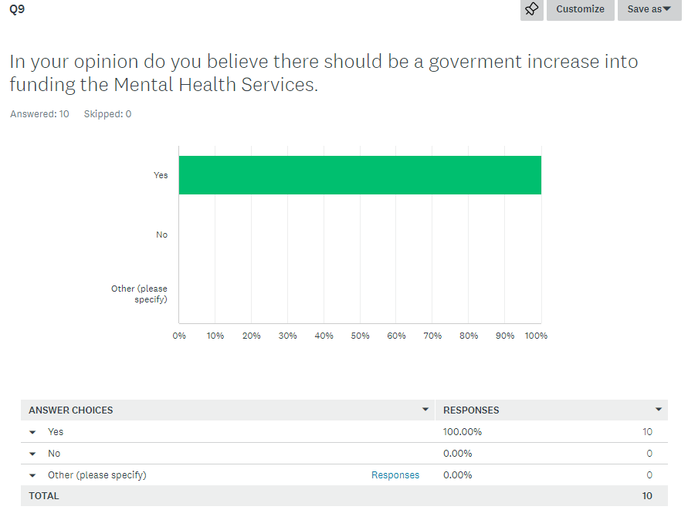
Fig 10 – Data Graph showing results of survey question

Analysing data from ten respondents in response to the question Do you believe the government should increase funding for the Mental Health Service? yielded a unanimous 100% yes response.
According to Bradley (2009), 50% of Health Boards lacked an overall strategy to facilitate operational planning, management, and the delivery of criminal justice liaison and diversion services. The report notes that The Welsh Government acknowledges that the vast majority of individuals who come into contact with criminal justice mechanisms originate from extremely disadvantaged communities with poor physical and mental health. In Wales, 90% of prisoners are affected by mental illness as a result of significant increases in the prison population over the past decade which shows support at fundamental level are lacking.
According to research conducted by the University of London (2022), 41% of mental health trusts are understaffed, only 33% of individuals in crisis who contacted NHS services for support were assessed within four hours and 10% of all crisis teams still do not provide a 24 hour seven days a week service. According to their statistics, 21% of crisis teams will only accept persons not known to them. Only 14% of individuals receiving assistance and treatment felt they received the necessary assistance
These finding appear to be consistent with the respondent’s question answer.

4.12 Response from interview.
A professional police officer (Interviewee 1) and an individual undergoing evaluation for schizophrenia participated in the interview (Interviewee 2).
In the absence of outside support services over the past three years, Covid-19 is believed to have played a significant role in the rise of crimes related to mental illness, according to the results of interviews with both parties. Due to insufficient or non-existent mental health support during covid-19, individuals with mental illness were far more likely to be involved in misdemeanours such as criminal damage and violent offences. During interview with the police officer, it was discovered that individuals with mental illness would experience a build-up of stress and anxiety and place themselves in circumstances where police intervention was required in order to seek faster assistance. Both participants acknowledged this to be the case.
In addition, further data revealed that individuals with mental illness frequently made suicidal threats during the custody process. This increases the strain on the response police force, as officers are frequently required to stay and monitor the individual's safety, and interviewee 2 noted that they did not want to be alone with their thoughts. In addition, interviewee 1 response officers building complex case files feel that their time is wasted on discovering court results via the criminal justice system, that individuals are not given a conviction due to their diagnoses rendering them incapable of accepting liability for the crime.
Due to their vulnerabilities, most individuals with mental illness can be both victims and perpetrators of crime, the officer revealed during the interview. Difficulties in controlling their emotions and behaviour can contribute to them committing crimes, as well as being exploited by criminals in organised crime gangs (Cuckooing, etc). The interviewee 2 verified this, indicating to both criminal involvement and financial exploitation by others. Both participants noted a lack of support services especially in the case of first-time admittance to a mental health facility and government support.

4.13 Conclusion
This chapter achieved the objective:
Analyse the obtained data to determine the relationship between the public, professionals, and individuals with mental illness and crime, as well as if they believe there is sufficient assistance.
The present investigation revealed that the general population and interview respondents, recognised and was aware of a correlation between mental illness and criminal behaviour. The respondents to both forms of data collection was also extremely aware of the need for considerable reforms and an increase in government funding for the mental health care, according to further data. There is also a beneficial correlation in that crimes related to mental illness affect response policing in many ways and more training for officers needs to be available. The data and literature collected in this chapter of the study are consistent with data and literature researched in the literature review in chapter two.

Chapter 5

5.1 Introduction
This chapter will focus on the main findings of the research conducted followed by recommendations followed by limitations. It will also include a section on further research, achievements of objectives and a final conclusion.

Main findings
According to the findings of this survey, the general population recognises and is aware of a connection between criminal behaviour and mental illness. Additional research revealed that the general public has a strong awareness of the importance of major service improvements as well as a much-needed increase in the amount of government resources invested in the mental health system. The researcher had access to previous research as well as data, both of which confirmed the existence of a direct correlation between the public's perception of mental illness and the public's awareness of people who suffer from mental illness. There appears to be direct connection between mental illness related crime and the requirement for an increase in government funding for mental health support services in South Wales. There is also a positive link in the sense that crimes related to mental illness have a variety of effects on response policing, and these effects correlate with the data that has been collected as well as existing literature and data indicating that the police are not fully equipped to deal with mentally ill individuals fully. It would appear that the data gathered is consistent with the majority of the data and literature that is available in the United Kingdom. This is the case despite the fact that a significant portion of the research data that is currently statistically unavailable or limited in the geographical region of South Wales.

Recommendations
While conducting this study there is a wide variety of recommendations that can be made from the data and literature collected. There appears to be a succinct lack of support in place for persons suspected of having a mental illness to be assessed and ongoing support for those that have been diagnosed. Exposure of information to this research topic, could assist in identify gaps and help in providing more support earlier to persons suspected or diagnosed with a mental illness and in turn lessening the chance of police encounters within the South Wales area.
Further recommendations from this research is that the police forces covering the geographical area of South Wales may need further training in dealing with mentally ill persons or adding to/modifying existing processes. Overall, much more co-operation between mental health services and the police forces is needed with the potential for a specific unit in charge of dealing with mental illness related crime along with professional training in mental illness. Earlier support will help limit the burden on police response departments in dealing with mental illness related crime in South Wales.
Furthermore, there is strong data and literature to show the desperate need for further funding and support by the government to existing mental health facilities and support groups is essential to the wellbeing of those dealing with mental illnesses.

Limitations
This study has shown a few limitations to which are highlighted below.
The data collected throughout this study is only from a small percentage of the population of South Wales and is not conclusive of the views from entire general population within that region.
In addition, limitations due to financial restrictions, a full comprehensive review of available statistical data was not viable.
Furthermore, limitation during this research of a restricted timeline has placed limitations on researching the study topic area thoroughly.

5.5 Further research
Due to the time constraints of the dissertation, only a small sample of the general public's opinions were gathered, as the data that was collected was based on a representative sample of the entire population. Due to the limited amount of time, the research utilised a sample that was convenient; nonetheless, it would be fascinating to employ a wide range in order to enable the results to be generalised to a larger population. This may allow future study to acquire a more balance distribution of results. This study has the potential to be revisited at a later date.
When viewed from the perspective of the general public once more, additional research may provide various pathways of research fields associated to this study. This could provide a heighten degree of understanding on the topic area to the public, police and governments which could be utilised to flag areas that may need further attention and dedication.
The current investigation discovered that there is not a great deal of statistical data or published material available on the subject matter of the studies geographical area. Additional research into this topic would provide additional insight into the ways in which the treatment of mental illness can avert any potential engagement with the police.

Achievement of objectives
This research has accomplished its aims:
- To examine and evaluate the current literature on mental illness-related criminality in South Wales.
This objective was achieved by conducting a literature review that focused on past studies pertaining to mental illness-related criminality in South Wales. The purpose of the present study was to examine public perceptions regarding mental illness-related criminal awareness, reaction policing, and the sufficiency of mental health resources.

- 2.Select an acceptable study methodology to explore professional and public perspectives and comprehension on the subject of crime related to mental illness.

This purpose was accomplished through the use of the research onion (Saunders et al, 2016). This study collected data using an interpretivist approach and a mixed method approach. A questionnaire investigating public perception was distributed to a representative sample of the general community. Additionally, two interviews were performed, one in-person and one via telephone.
- Analyse the obtained data to determine the relationship between the public, professionals, and individuals with mental illness and crime, as well as if they believe there is sufficient assistance.
This objective was accomplished using survey monkey, followed by an examination of the questionnaire's results. The collected data revealed the significance of the public's perspective of mental illness-related criminality, the extent to which they would be involved, and whether there was sufficient support in place to assist those with mental illnesses.

Conclusion
In conclusion, the dissertation has highlighted and focused on the issue of policing mentally ill individuals. The researcher has adopted an objective stance and incorporated the societal struggles of these individuals and those involved from a policing perspective. In addition, significant reforms in support for mentally ill individuals have been mentioned; however, there are gaps in the literature that have been identified and outlined throughout this research. These gaps could be investigated further in the near future in order to expand current knowledge and improve support accessibility. The dissertation has raised awareness of the current problem in the hope that additional resources can be added to address the issue of providing support to mentally ill individuals in order to assist them in living a police-free life. This dissertation has presented numerous challenges, as well as rewarding opportunities. The dissertation has taught the researcher the importance of time management and self-directed learning. The researcher has developed new Excel skills and demonstrated the ability to work and learn independently.

Bibliography

Bajpai, N., 2011. “Business Research Methods” Pearson Education India. [Online]
Available at: https://books.google.co.uk/books?id=wY2bSaEm8l8C&pg=PA19&source=gbs_toc_r&cad=3#v=onepage&q&f=false
[Accessed 12th May 2022].
Belfrage, H., 1998. Link to Brain Dysfunction in Disordered/Criminal/Psychopathic Behaviour. Brittish Journal Of Criminology,, 38(1), pp. 145-155.
Bhandari, P., 2021. Ethical Considerations in Research. [Online]
Available at: https://www.scribbr.com/methodology/research-ethics/
[Accessed 12th May 2022].
Bhandari, P., 2022. Data Collection | A Step-by-Step Guide with Methods and Examples. [Online]
Available at: ttps://www.scribbr.com/methodology/data-collection/
[Accessed 12th May 2022].
Bradley, K., 2009b. Lord Bradley’s review of people with mental health problems or learning disabilities in the criminal justice system. [Online]
Available at: https://lx.iriss.org.uk/sites/default/files/resources/The%20Bradley%20report.pdf
[Accessed 10th June 2022].
Bradley, K., 2009. Lord Bradley’s review of people with mental health problems or learning disabilities in the criminal justice system. [Online]
Available at: https://lx.iriss.org.uk/sites/default/files/resources/The%20Bradley%20report.pdf
[Accessed 7th June 2022].
Cambridge's Advancered Learner's Dictionary, 2022. Defintion of Reaseach. [Online]
Available at: https://dictionary.cambridge.org/dictionary/english/research
[Accessed 11th May 2022].
Chetty, P., 2016. Importance of Research Approach in a Research.. [Online]
Available at: https://www.projectguru.in/selecting-research-approach-business-studies/?msclkid=c8716b5dd11c11ec9ecdca16d7fea98a
[Accessed 11th May 2022].
Choudhury, A., 2022. Questionnaire Method of Data Collection : Advantages and Disadvantages.. [Online]
Available at: https://www.yourarticlelibrary.com/social-research/data-collection/questionnaire-method-of-data-collection-advantages-and-disadvantages/64512
[Accessed 12th May 2022].
Chuang S, P., 2019b. Self Perception of Mental Illness and Subjective. [Online]
Available at: https://www.dovepress.com/getfile.php?fileID=49252
[Accessed 6th May 2022].
Chuang S, P., 2019. Self perception of Mental Illness and subjective. [Online]
Available at: https://www.dovepress.com/getfile.php?fileID=49252
[Accessed 6th May 2022].
Clark, J. &. C., 2011. Designing and Conducting Mixed Methods Research, SAGE publications. [Online]
Available at: https://books.google.com/books?id=YcdlPWPJRBcC&pgis=1
[Accessed 11th May 2022].
College of Policing, 2016. Mental Health Introduction and Strategic Considerations. [Online]
Available at: https://www.app.college.police.uk/app-content/mental-health/introduction-and-strategic-considerations/#portraying-mental-health-in-the-media
[Accessed 8th November 2021].
College of Policing, 2022. Mental Health, Introduction and Strategic Considertions. [Online]
Available at: Introduction and strategic considerations (college.police.uk)
[Accessed 29th January 2022].
Collis, J. &. H. R., 2014. Business Research: A Practical Guide for Undergraduate and Postgraduate Students. 4 p54 ed. Palgrave: MacMillian.
Cummings, I., 2012. Policing and Mental Illness in England and Wales post Bradley. [Online]
Available at: https://academic.oup.com/policing/article-abstract/6/4/365/1461375
[Accessed 7th June 2022].
Cvetkovska, L. 2. T. 1. W. M. H. S. f. 2., 2022. Top 10 Worldwide MentaCvl Health Statistics for 2022. [Online]
Available at: https://loudcloudhealth.com/resources/mental-health-statistics/#:~:text=Sadly%2C%20worldwide%20mental%20health%20statistics%20show%20that%20the,of%20awareness%20and%20support%20surrounding%20mental%20health%20problems
[Accessed 7th June 2022].
Das, 2019. How strong is the link between mental health and crime?. [Online]
Available at: https://www.gq-magazine.co.uk/article/mental-health-and-crime
[Accessed 9th June 2022].
Debois, S., 2022. 10 Advantages And Disadvantages Of Questionnaires. [Online]
Available at: https://surveyanyplace.com/blog/questionnaire-pros-and-cons/?msclkid=81d1be77d12f11ec9df411c4fa0d75ba
[Accessed 11th May 2022].
Drapalski, A., 2012. Amodel of Internalised Stigma and its effect on people with Mental Illness. [Online]
Available at: https://ps.psychiatryonline.org/doi/full/10.1176/appi.ps.001322012
[Accessed 6th May 2022].
Eble, L. &. G. M., 2016. Primary Research and Writing, People, Places and Writing. [Online]
Available at: https://books.google.co.uk/books?id=9sdmCgAAQBAJ&newbks=0&printsec=frontcover&pg=PR5&hl=en&redir_esc=y#v=onepage&q&f=false
[Accessed 11th May 2022].
Eddie Kane, J. C. &. J. W., 2021. Mental health-related police incidents: Results of a national census exercise in England and Wales. Criminal Behaviour and Mental Health/, 31(4), pp. p.262-274.
Eisensmith, P. &. K. P., 2021. Questionnaire Introduction. [Online]
Available at: file:///C:/Users/406945/Downloads/316-Article%20Text-1226-1-10-20210222.pdf
[Accessed 11th May 2022].
Forensics Colleges, 2022. Dangerous Minds: The Mental Illnesses of Infamous Criminals. [Online]
Available at: https://www.forensicscolleges.com/blog/resources/dangerous-minds-criminal-mental-illness
[Accessed 10th June 2022].
George, T., 2022. Advantages and Disadvantages of Interviews. [Online]
Available at: https://www.scribbr.com/methodology/interviews-research/
[Accessed 12th May 2022].
George, T., 2022b. Advantages and disadvantages of interviews. [Online]
Available at: https://www.scribbr.com/methodology/interviews-research/
[Accessed 12th May 2022].
Gov.Wales, 2022. Detentions under Section 135 and 136 of the Mental Health Act. [Online]
Available at: https://gov.wales/detentions-under-section-135-and-136-mental-health-act-january-march-2022
[Accessed 8th June 2022].
Hammond, C., 2015. The myth of Mental Illness and Violence. [Online]
Available at: https://www.bbc.com/future/article/20150723-the-myth-of-mental-illness-and-violence#:~:text=In%20the%20UK%2C%20between%2050%20and%2070%20cases,a%20significant%20mental%20illness%20at%20any%20given%20time.
[Accessed 7th June 2022].
Hayes, A., 2022. Descriptive Statistics. [Online]
Available at: https://www.investopedia.com/terms/d/descriptive_statistics.asp#:~:text=What%20Are%20Descriptive%20Statistics%3F%20Descriptive%20statistics%20are%20brief,of%20central%20tendency%20and%20measures%20of%20variability%20%28spread%29.
[Accessed 1st June 2022].
Her Majesties Inspectorate of Constabulary and Fire and Rescue Services, 2018. Picking Up The Pieces. [Online]
Available at: (justiceinspectorates.gov.uk)
[Accessed 29th January 2022].
Her Majesties Inspectorate of Constabulary and Fire and Rescue services, 2018. Policing and Mental Health:Picking up the pieces. [Online]
Available at: Policing and mental health: picking up the pieces (justiceinspectorates.gov.uk)
[Accessed 29th January 2022].
Julian, 2017. 5 British Celebrities That Have Helped to Raise Mental Health Awareness. [Online]
Available at: https://dr-julian.com/latest-news/5-british-celebrities-that-have-helped-to-raise-mental-health-awareness/
[Accessed 12th November 2021].
Livingston, J., 2016. Contact Between Police and People With Mental Disorders: A Review of Rates.. [Online]
Available at: https://ps.psychiatryonline.org/doi/full/10.1176/appi.ps.201500312#:~:text=There%20is%20widespread%20belief%20that%20people%20with%20mental,in%20our%20health%20care%20and%20social%20support%20systems
[Accessed 7th June 2022].
Majerus, . H. a. B., 2011. ‘Writing the History of Psychiatry in the 20th Century’. History of Psychiatry, 22(2), pp. 139-45.
Marshall, C. a. R. G., 2016. Designing Qualitative Research.. 6th ed. Thousand Oaks.: SAGE.
McCoombes, 2022. Doing Survey Research step by step Guide & Examples. [Online]
Available at: https://www.scribbr.com/methodology/survey-research/
[Accessed 12th May 2022].
McLeod, S., 2018. Questionnaire: Definition, Examples, Design and Types. [Online]
Available at: https://www.simplypsychology.org/questionnaires.html
[Accessed 12th May 2022].
Mental Health Wales, 2019. A Guide for Mental Health Service Users and Thier Families. [Online]
Available at: https://www.mentalhealthwales.net/mental-health-measure
[Accessed 6th June 2022].
Middleton, F., 2019. Reliability vs Validity in Research | Differences, Types and Examples. [Online]
Available at: https://www.scribbr.com/methodology/reliability-vs-validity/
[Accessed 12th May 2022].
MIND, 2013. Latest results from national study show public attitudes towards mental illness are moving in the right direction. [Online]
Available at: Latest results from national study show public attitudes towards mental illness are moving in the right direction - Mind
[Accessed 27th January 2022].
MIND, 2013. Latest results from national study show public attitudes towards mental illness are moving in the right direction. [Online]
Available at: Latest results from national study show public attitudes towards mental illness are moving in the right direction - Mind
[Accessed 28th January 2022].
Mind, 2022. Mental health crisis care services ‘under-resourced, understaffed and overstretched’. [Online]
Available at: https://www.mind.org.uk/news-campaigns/news/mental-health-crisis-care-services-under-resourced-understaffed-and-overstretched/
[Accessed 11th June 2022].
National Institue for Health and Care Excellence, 2017b. Mental Health and the NHS - What's to changed and what's to come. [Online]
Available at: https://indepth.nice.org.uk/mental-health-and-the-nhs/index.html
[Accessed 8th June 2022].
National Institue for Health and Care Excellence, 2017c. Mental Health and the NHS. [Online]
Available at: https://indepth.nice.org.uk/mental-health-and-the-nhs/index.html
[Accessed 8th June 2022].
National Institue for Health and Care Excellence, 2017. Mental Health and the NHS - What's changed and what's to come. [Online]
Available at: National Institue for Health and Care Excellence
[Accessed 1st June 2022].
National Institute of Health and Care Excellence, 2017d. Mental Health and the NHS - Whats changed and whats to come. [Online]
Available at: https://indepth.nice.org.uk/mental-health-and-the-nhs/index.html
[Accessed 8th June 2022].
NHS Digital, 2021. Mental Health Act Statistics, Annaul Figures 2020-21. [Online]
Available at: Mental Health Act Statistics, Annual Figures - 2020-21 - NHS Digital
[Accessed 27th January 2022].
Niehaus, J. &. M. L., 2016. Mixed Method Design, Principles and Procedures. [Online]
Available at: https://www.taylorfrancis.com/books/mono/10.4324/9781315424538/mixed-method-design-janice-morse
[Accessed 11th May 2022].
O'Brien, C. &., 2019. Police encounters with persons with a mental illness. [Online]
Available at: Police Encounters with Persons with a Mental Illness - Criminology - Oxford Bibliographies
[Accessed 28th January 2022].
Oxford Learner's Dictionary, 2022. Research Definition. [Online]
Available at: https://www.oxfordlearnersdictionaries.com/definition/english/research_1?q=research
[Accessed 8th May 2022].
Phillips, Z. &. K. C. S. P., 2008. The Half-Life of Truth:What are the appropriate time horizon for Research Desicions?. [Online]
Available at: https://journals-sagepub-com.ezproxy.uwtsd.ac.uk/doi/10.1177/0272989X07312724
[Accessed 11th May 2022].
Polonski, 2004. Ethical Consideration chapter 5. [Online]
Available at: https://www.sagepub.com/sites/default/files/upm-binaries/4999_Polonski_Chapter_5.pdf
[Accessed 12th May 2022].
Pruett, T. &., 1992. 'Police as street corner psychiatrist. Managing the mentally ill', International Journal of Law and Psychiatry, , 15(2), pp. 139-156.
Redman, M. &., 1932. The Romance of Research. [Online]
Available at: https://archive.org/details/in.ernet.dli.2015.59410/page/n5/mode/2up?msclkid=4606d54ed11611ec8c97a6218591bbc7
[Accessed 8th May 2022].
Rees, J., 2019b. Mental Health: police detentions up 30% in five years. [Online]
Available at: https://www.bbc.co.uk/news/uk-wales-50222385
[Accessed 9th June 2022].
Rees, J., 2019. Mental Health: police detentions up 30% in five years. [Online]
Available at: https://www.bbc.co.uk/news/uk-wales-50222385
[Accessed 8th June 2022].
Roberts, C. .., 2012. The Dissertation Journey: A Practical and Comprehensive Guide to Planning, Writing, and Defending your Dissertation.. [Online]
Available at: https://sk-sagepub-com.ezproxy.uwtsd.ac.uk/books/the-dissertation-journey-2e
[Accessed 12th May 2022].
Rogers, C. &. F. K., 2017. Policing, Crime and Mental Illness in England and Wales: Insights. [Online]
Available at: https://pure.southwales.ac.uk/ws/portalfiles/portal/1345709/67558_247588_1_PB.pdf#:~:text=One%20agency%20that%20is%20constantly%20in%20contact%20with,not%20generally%20equipped%20to%20deal%20with%20such%20individuals.
[Accessed 9th June 2022].
Rubin, E., 2016. The Importance Of Insight. [Online]
Available at: https://www.psychologytoday.com/us/blog/demystifying-psychiatry/201604/the-importance-insight
[Accessed 28th May 2022].
S. Saxena, P. Sharan, M. Garrido & B. Saraceno, 2005. Mental Health Atlas. [Online]
Available at: https://www.ncbi.nlm.nih.gov/pmc/articles/PMC1636128/
[Accessed 8th June 2022].
Saunders P & Lewis, M., 2009. Understanding Research Philosophies and approaches. [Online]
Available at: https://www.researchgate.net/publication/309102603_Understanding_research_philosophies_and_approaches
[Accessed 12th May 2022].
Saunders, M. L. P. &. T. A., 2007. Research Methods for Business Students. 6th ed. London: Pearson.
Saxena, P. &., 2014. Transforming Lives, Enhancing Communities — Innovations in Global Mental Health. [Online]
Available at: https://www.nejm.org/doi/10.1056/NEJMp1315214#article_references
[Accessed 28th October 2021].
Schensul, J. &. L. L., 2012. Analysis and Interpretation of Ethnographic Data: A Mixed Methods Approach. 2nd ed. Lanham: AltaMira Press.
Smith, W., 2008. Does Gender Influence Online Survey Participation?. [Online]
Available at: https://files.eric.ed.gov/fulltext/ED501717.pdf
[Accessed 1st June 2022].
Streefkerf, R., 2022. Inductive vs Deductive Reasoning/Difference & Examples. [Online]
Available at: https://www.scribbr.co.uk/research-methods/inductive-vs-deductive-reasoning/#:~:text=The%20main%20difference%20between%20inductive%20and%20deductive%20reasoning,generalisations%2C%20and%20deductive%20reasoning%20the%20other%20way%20around
[Accessed 11th May 2022].
The King's Fund, 2022a. Case study 1: Deinstitutionalisation in UK mental health services, Part of a transformationfund to sustain the future of the NHS. [Online]
Available at: Case study 1: Deinstitutionalisation in UK mental health services | The King's Fund (kingsfund.org.uk)
[Accessed 28th January 2022].
The King's Fund, 2022b. Case study 1: Deinstitutionalisation in UK mental health services, part of a tranformation fund to sustain the future of the NHS. [Online]
Available at: Case study 1: Deinstitutionalisation in UK mental health services | The King's Fund (kingsfund.org.uk)
[Accessed 28th January 2022].
The Royal Family, 2016. Heads Together. [Online]
Available at: https://www.royal.uk/heads-together-0
[Accessed 6th May 2022].
Thomas, L., 2022. Cross-Sectional Study | Definitions, Uses & Examples.. [Online]
Available at: https://www.scribbr.com/methodology/cross-sectional-study/
[Accessed 12th May 2022].
Thomas, L., 2022. Longitudinal Study | Definition, Approaches & Examples.. [Online]
Available at: https://www.scribbr.com/methodology/cross-sectional-study/
[Accessed 12th May 2022].
Time to Change, 2022. Mental health conditions. [Online]
Available at: https://www.timetochangewales.org.uk/en/mental-health-stigma/mental-health-conditions/#:~:text=The%20most%20commonly%20diagnosed%20forms%20are%20depression%2C%20anxiety%2C,problems%20include%20self-harm%2C%20suicidal%20thoughts%20and%20panic%20attacks.
[Accessed 10th June 2022].
Timmins, N., 1994. Christopher Clunis Report: Schizophrenic made series of violent attack. [Online]
Available at: https://www.independent.co.uk/news/uk/christopher-clunis-report-schizophrenic-made-series-of-violent-attacks-1396250.html
[Accessed 10th June 2022].
Tracey, N., 2019. The History of Mental Illness. [Online]
Available at: https://www.healthyplace.com/other-info/mental-illness-overview/the-history-of-mental-illness
[Accessed 1st June 2022].
Turner J, H. R. A. K. e. a., 2015. The History of Mental Health Services in Modern England: Practitioner Memories and the Direction of Future Research. [Online]
Available at: The History of Mental Health Services in Modern England: Practitioner Memories and the Direction of Future Research - PMC (nih.gov)
[Accessed 21st October 2022].
Varghese, S., 2017. Research Methodology. [Online]
Available at: http://14.139.185.6/website/SDE/sde578.pdf#:~:text=Research%20methodology%20is%20a%20way%20to%20systematically%20solve,Abraham%20Kaplan%20defines%20research%20methodology%20in%20this%20way.?msclkid=ccc15a66d06b11ec9c764fb6ab3aeaff
[Accessed 28th May 2022].
Webster, M., 2022. Mental Illness. [Online]
Available at: https://www.merriam-webster.com/dictionary/mental%20illness
[Accessed 6th May 2022].
Whiteford, 2010. Global burden of disease attributable to mental and substance use disorders: findings from the Global Burden of Disease Study 2010. [Online]
Available at: Global burden of disease attributable to mental and substance use disorders: findings from the Global Burden of Disease Study 2010 - PubMed (nih.gov)
[Accessed 28th October 2021].

Appendices



