

University of Wales Trinity Saint David

School of Computing

Network Operating Systems & Services (NOSS)

ACCA5023

Hafiz Uddin
Student no

1807533

30/04/2021

Table of Contents
Routing & Packet Filtering Within Core TCP/IP Services & Critical Failover/Redundancy Practices. 3
Introduction 3
Methodology 3
Task 1 - Utilising ARP and Routing Tables. 3
Fig 1.0 Shows the ARP table from server 1, 3
Fig 1.1 An updated ARP table after doing a ping test. 3
Fig 1.2 Shows the IPV4 routing table with all the routing information. 4
Fig 1.3 Showing the results of the ping test carried out. 4
Fig 1.4 Showing the successful ping from client 1 to client 2. 4
Fig 1.5 Server 1 successful pings to the other users on the network. 5
Task 2 – Deploy Core Services (FTP Server). 5
Fig 1.6 verifying that a user has been created on server 2. 5
Fig 1.7 The user has been added to the permissions table to enable it to be able to connect through FTP, the user is highlighted. 5
Fig 1.8 Verifying the firewall setting has been turned off. 5
Fig 1.9 Showing the folder that was created for the purpose of FTP transfer. 6
Fig 2.0 Command prompt window shows the welcome banner that was created. 6
Fig 2.1The file that was uploaded through the FTP is confirmed on server 2. 6
Task 3 - Installing and configuring the routing and remote access service. 6
Fig 2.2 The only option was the DHCP Relay Agent when incorrectly following the steps. 7
Fig 2.3 The routing option in the roles section. 7
Fig 2.4 RIP adapter and PublicNet and PrivateNet added to the interface. 7
Fig 2.5 Showing both servers with the green arrow to indicate they are running. 7
Observation. 7
How do routers reference which networks they are able to connect to? 7
Task 4 – IP Packet Filtering. 8
Fig 2.6 unsuccessful ping showing the ping request was timed out when testing the filter. 8
Fig 2.7 shows successful pings to all the other users. 8
Fig 2.8 client 1 refused access to server 2 ftp server. 9
Fig 2.9 Client 2 FTP logins to other hosts denied. 9
Fig 3.0 Client 2 FTP login to Private net 2 on server 2 was successful. 9
Fig 3.1 Client 1 FTP logins to other hosts denied. 10
Fig 3.2 Client 1 FTP login to private net 2 on server 2 successful. 10
Fig 3.3 Server 2 FTP logins to other hosts denied. 10
Fig 3.4 Server 2 FTP login to private net 2 on server 2 successful. 10
Fig 3.5 Server 1 FTP logins to other hosts denied. 11
Fig 3.6 Server 1 FTP login to private net 2 on server 2 successful. 11
Task 5 – Failover Clustering for High Availability Systems/Services. 11
References 13

Routing & Packet Filtering Within Core TCP/IP Services & Critical Failover/Redundancy Practices.

Introduction

The component of this worksheet is divided into two parts. The first part will look at routing and remote access services, this will include the role of ARP, routing tables and routing protocols as well as the role of firewalls and how it is utilised through IP packet filtering showing inbound and outbound traffic within a network and how the filtering enhances security. The second part would consist of an independent research looking at the role of failover clustering in an enterprise network.

Methodology

Task 1 - Utilising ARP and Routing Tables.

Address Resolution Protocol (ARP) is a way to finding a host’s MAC (Media Access Control) address, this is when setting up a local area network (LAN) and the point that only the IP address is known. Using the ARP table will help to maintain the link between the MAC address and its corelated IP address. An ARP converts an IP address to a MAC address. An ARP keeps a look-up table where it stores all known IP address and its corresponding Mac address. When a packet is sent it is checked against the ARP table to see if it knows the address to forward the packet to, if the IP address is not known it will send a broadcast to its network to ask who this IP belongs to, if a device on the network does have this address it will reply and the ARP can then save or cache this to its ARP table for future correspondences. To check the ARP table on this network ARP -A command was used in the command prompt window on server 1 which replied with the current ARP table, this is shown in Fig 1.0.[1]
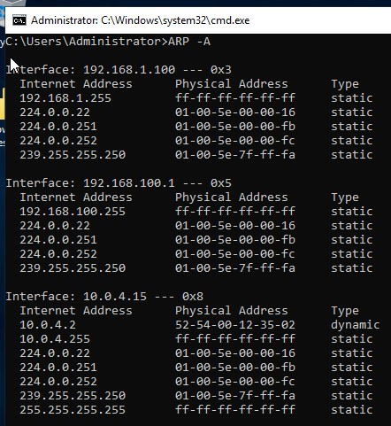

Fig 1.0 Shows the ARP table from server 1,
the information in the table shows the Network Interface card (NICs) of the physical machine, the physical address of the NIC (MAC) and the internet address of this particular NIC. When this server is connected to other servers on this network this ARP table would be more populated and will get regularly updated. One way to check this would be to do an ICMP operation such as ping tests then running the command again in command prompt, and updated ARP table is shown in Fig 1.1.
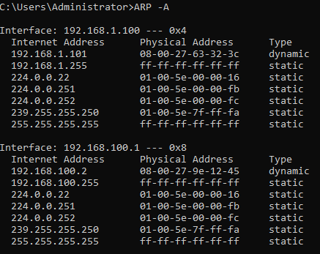

Fig 1.1 An updated ARP table after doing a ping test.

One way to check and verify what network a host is on is through a route print from the command prompt. This gives a printout of the routing table as shown in Fig 1.2. the information that is displayed is of the network destination address (what path is taken to get the traffic to the destination), the subnet mask applied to each network (Netmask), the default gateway IP address for reaching the destination network (Gateway), which interface is used to forward the traffic out of and it shows which network IP on your host is going to be used to reach this network, the last one is the metric, this is the cost calculated for reaching the destination network. [2]
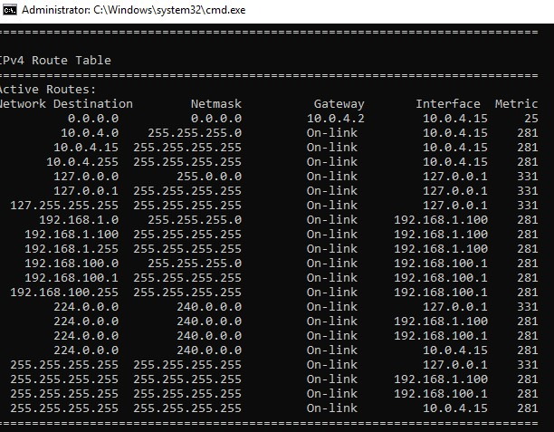

Fig 1.2 Shows the IPV4 routing table with all the routing information.
On the routing table in Fig 1.2 it was identified that the network was not able to send and receive packets from client 1 to client 2. A ping test was carried out and this was confirmed that there was an issue in the network. A ping result is shown in fig 1.3.
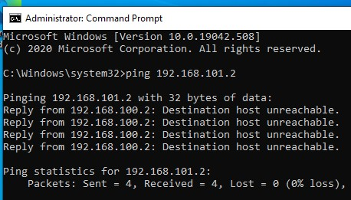

Fig 1.3 Showing the results of the ping test carried out.
It was identified after trouble shooting that there was an issue with the gateway, this was resolved through resetting all the network adapters and restarting them. Another ping test was carried out with success to show the packets were sent and received from client 1 to client 2 in Fig 1.4.
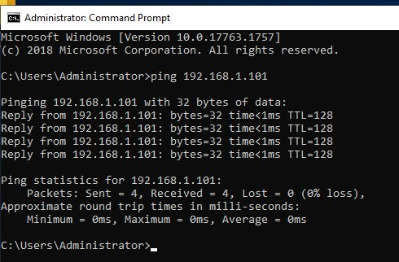

Fig 1.4 Showing the successful ping from client 1 to client 2.
Other ping test were carried out between server1 to server 2, server 1 to private net 2, and server 1 to client 2. And the same from server 2. Pings from server 1 is shown in Fig 1.5.
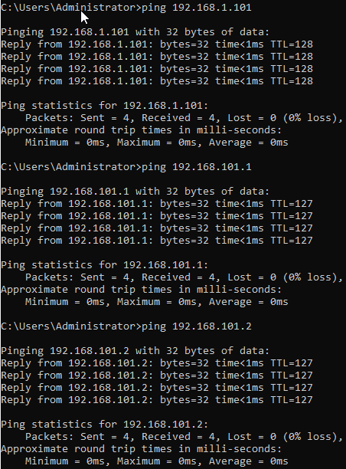

Fig 1.5 Server 1 successful pings to the other users on the network.

Task 2 – Deploy Core Services (FTP Server).

File Transfer Protocol (FTP) is a way to connect and share files safely on a network and the internet. This is a protocol that exchanges supported by TCP and IP protocols on a network. There are two types of FTP, one is an FTP server the other a FTP client. An FTP server waits for a request from a client to connect and then it can fulfil that request by exchanging files, it can also receive, and store files sent by the client. For a transfer to happen between a client and a server with FTP the client would need a server address to which it can request a connection once this connection is made a port will be open and transfers between the server and client can take place. [3] [4]
By creating an FTP server, it would be possible to send and receive files safely within the network first a user was created on server 2 as shown in Fig 1.6
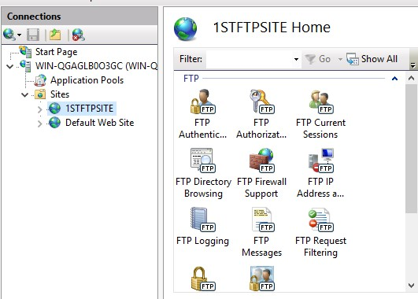

Fig 1.6 verifying that a user has been created on server 2.
This is to enable the client to be able to connect and send and receive files. The user had to be given permission to be able to use the FTP service this is verified in Fig 1.7.
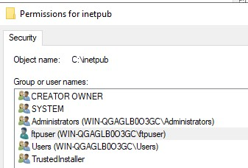

Fig 1.7 The user has been added to the permissions table to enable it to be able to connect through FTP, the user is highlighted.
A welcome banner was created to ensure that the client is connected successfully to the right server this is shown on the fourth line in Fig 2.0. the next process was to ensure that the firewall setting on server 2 was disable this is shown in Fig 1.8.
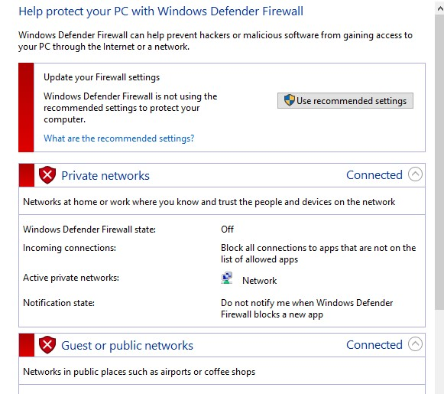

Fig 1.8 Verifying the firewall setting has been turned off.
This would ensure that there are no issues with the connection through the testing period. After this has been verified it was necessary to log out of client 2 and log back in as an administrator, this is because the command prompt has been disabled for non-admin users. The firewall setting was also checked on client 2 PC to make sure it was also turned off. A folder and text file were then created on the C drive of client 2, this is the folder and file that would be used to test the folder transfer, this is shown in Fig 1.9.


Fig 1.9 Showing the folder that was created for the purpose of FTP transfer.
The next step was to open a command prompt window and with the command and IP address of server 2 (“ftp 192.168.101.1”) the request to connect to the server was sent, a username and password was requested before the connection was confirmed. The connection and the confirmation are shown in Fig 2.0.
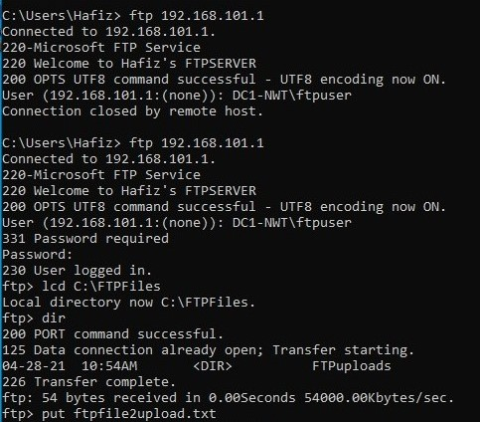

Fig 2.0 Command prompt window shows the welcome banner that was created.
Other information in Fig 2.0 is the connection stages to the FTP server and the file from client to that is to be uploaded.
After signing into server 2 it was then confirmed that the file has been successfully uploaded this is verified in Fig 2.1.

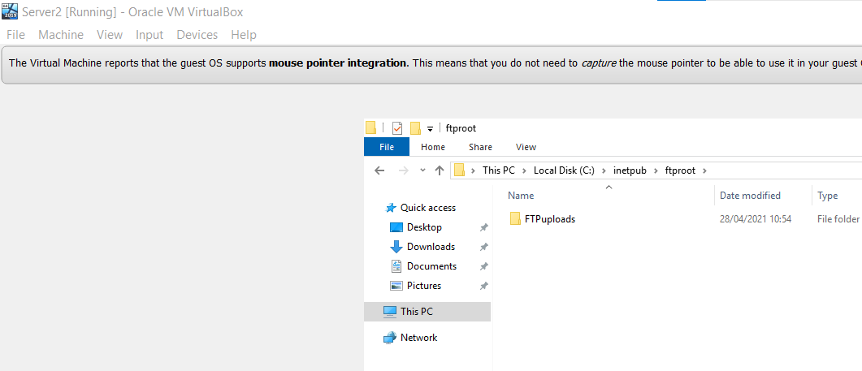

Fig 2.1The file that was uploaded through the FTP is confirmed on server 2.

Task 3 - Installing and configuring the routing and remote access service.

In this task the aim is to expand the initial network design by building two remotely connected LANs using layer 3 devices and protocols which are referred to as routers and routing protocols, this will enable the two disconnected LANS which has been created to be able to connect together and communicate with each other as one network. A routing service will be enabled to each of the two LANs by providing a routing service on PrivateNet1 and PrivateNet2.
The first time the routing and remote access protocol was created a part of the creating process was not followed correctly, due to this and the adapter option for RIP2 was not offered but instead the adapter DHCP Relay Agent (shown in Fig 2.2) was the only option, the protocol was created which led to the VMs not being able to communicate between them. After troubleshooting this was resolved at the point of when choosing role services, direct access and VPN, roles, remote access the routing option was not ticked this was corrected when following the steps, the second time, shown in Fig 2.3.

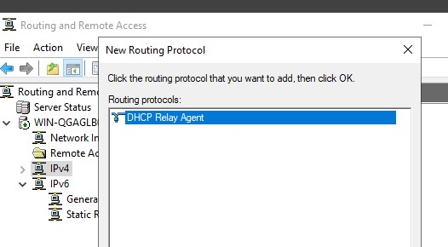

Fig 2.2 The only option was the DHCP Relay Agent when incorrectly following the steps.

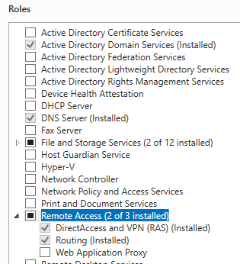

Fig 2.3 The routing option in the roles section.
This has now been put on and the RIP adapter was available and both PublicNet and PrivateNet have been installed correctly on both servers.
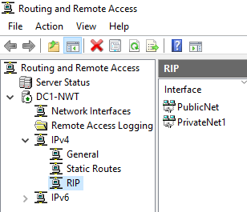

Fig 2.4 RIP adapter and PublicNet and PrivateNet added to the interface.

When the service is up and correctly running a green arrow on the server will be visible as shown in Fig 2.5.
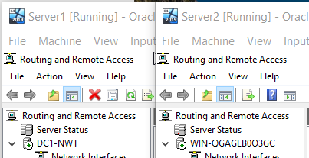

Fig 2.5 Showing both servers with the green arrow to indicate they are running.

To test the wide area Network ping tests were carried out to ensure all the devices can communicate with each other. the tool associated with Internet Control Messaging Protocol (ICMP) is known as a ‘ping’. A ping is when packets are sent from a source device to a destination device to verify if a connection is there and that they can communicate successfully. If the destination device responds with packets, then it shows the connection between them is working, it will also show the time it took for the packets to reach the destination and the time it took to respond.
The first ping test were carried out as shown in Fig 1.3 and 1.4, after troubleshooting all the pings were successful as shown in Fig 1.5, this verifies the wide area network is configured correctly.

Observation.

How do routers reference which networks they are able to connect to?
The job of a router is to route the paths needed to send and receive data packets. Routers have internal memory known as RAM. Once a path or connection is acquired and confirmed it is put into a table, this table is stored in the RAM. This table is then used as a reference to where it has been before, the known paths. Routers reference the IP address of the destination, their routers as well as the network it belongs to. A routing table also contains information or identifiers of the next router, this is known as the next hop, another important information that the routing table holds is the net id’s (netids), this information helps the router when a netid is either unreachable or the path is congested to store alternative routes to the destination can be found ASAP. There is a mechanism within the router which resolves this issue known as routing mechanism protocol. This protocol helps generate the routing table in advance so that interruptions or downtimes are minimised. A routing algorithm also helps in the updating of the routing table, this helps to determine the fastest and best route. [5]

Task 4 – IP Packet Filtering.

IP packet filtering is used to monitor and filter packet flow within the network. Restriction can be manually set to allow or restrict packets depending on the parameters set. IP packet filtering is a basic firewall configuration service from Microsoft. There are two concepts to the filtering protocol these are inbound filters and outbound filters. Inbound filters the packets coming into the router before it is sent to the destination, here it will check the packet against the configuration and then either receive and forward the packets or drop the packets if the criteria are met, depending on the criteria’s set out. Outbound filters will check the packets leaving the network from the source before forwarding them to the destination.
The first filter that was implemented was ‘stopping anyone in PrivatNet1 from pinging the router firewall setting’. This was set through the routing and remote access tab of the service manager in server 1. The destination of the IP address and subnet mask had to be inputted to ensure the right host was affected by the restriction. This was implemented on client 1.the protocol for this filter was the ICMP, which affects the ping service. Once this was completed test was carried out to ensure the restriction work and only for the target host and not the other hosts on the network.
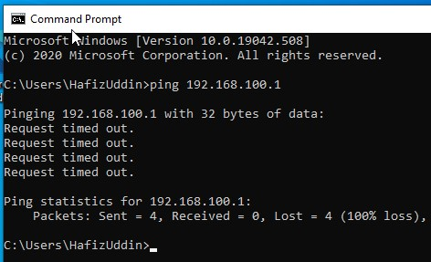

Fig 2.6 unsuccessful ping showing the ping request was timed out when testing the filter.

Test were then carried out to show that the filter did not affect the other users/hosts on the network. This is shown in Fig 2.7.
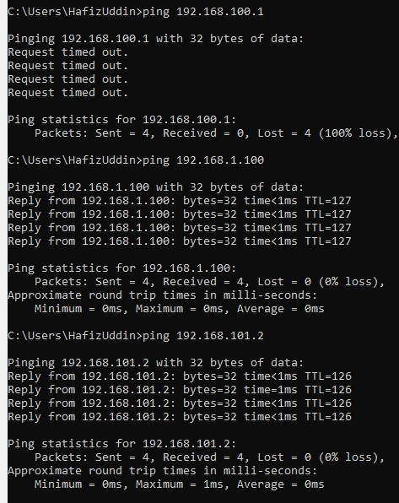

Fig 2.7 shows successful pings to all the other users.
The second filter that was implemented was to ‘Restrict Access to FTP Service running on Server2 to only hosts in PrivateNet2.
This was implement using the service manager routing and remote access. The filter was implemented on the public net connection interface on the outbound filter. This is where anything leaving the router through public net connection would be checked for the restrictions set including where its coming from. The IP address and subnet mask were set ensuring the ‘Receive all packets, except those that meet the criteria below’ was enabled, for this filter it was the TCP protocol of which the destination port also had to be inputted, this was port 21. Once this filter was implemented it was tested to make sure it was working.
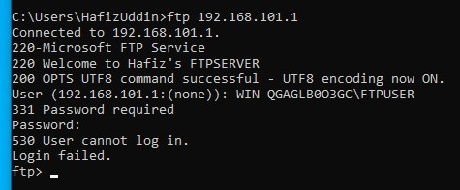

Fig 2.8 client 1 refused access to server 2 ftp server.
This show that the filter that was applied is in place and working.
For filter 3 “Only allow specific host in private net to access the FTP service running on server 2” the same steps as filter two were followed but the IP address of all other hosts on the network were included except for server 2 private net 2. This was to ensure that filters can be applied to more than one host, as this would be the case if this needed implementing on a larger scale like an organisation with multiple departments, were restrictions and protocols would need to be implemented to give or restrict access. Once this was implemented it needed testing from all the hosts on the network, by trying to log onto the FTP server from each host using their respective IP address. The results of the of the tests are shown in Fig 2.9 – Fig 3.6

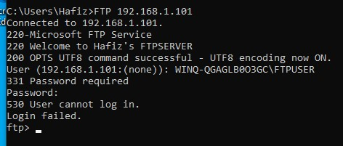
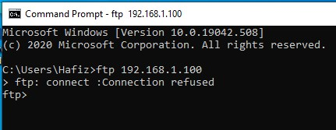
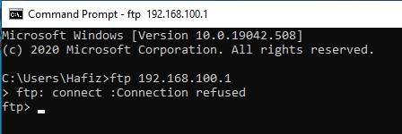
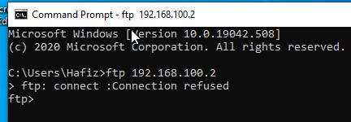

Fig 2.9 Client 2 FTP logins to other hosts denied.

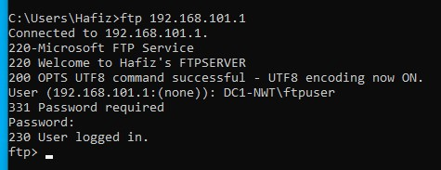

Fig 3.0 Client 2 FTP login to Private net 2 on server 2 was successful.

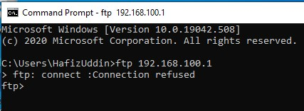
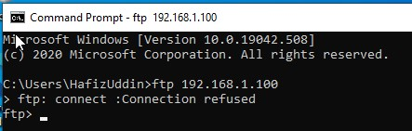
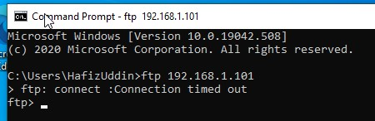
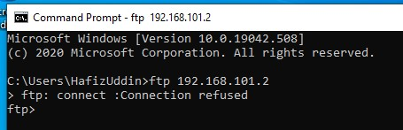

Fig 3.1 Client 1 FTP logins to other hosts denied.

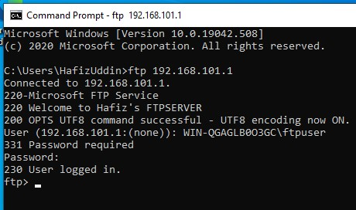

Fig 3.2 Client 1 FTP login to private net 2 on server 2 successful.

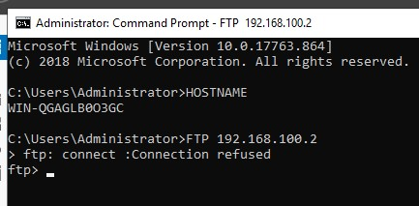
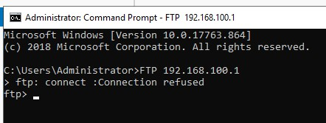
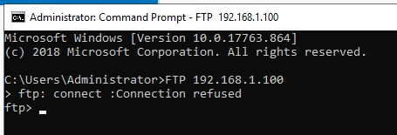
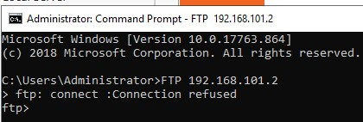

Fig 3.3 Server 2 FTP logins to other hosts denied.

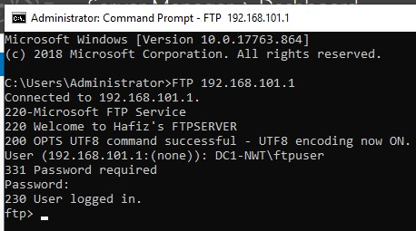

Fig 3.4 Server 2 FTP login to private net 2 on server 2 successful.

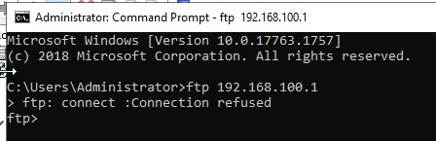
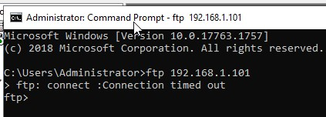
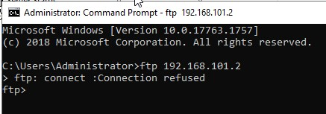

Fig 3.5 Server 1 FTP logins to other hosts denied.

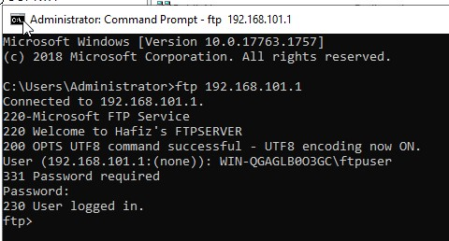

Fig 3.6 Server 1 FTP login to private net 2 on server 2 successful.

These show that the filter was implemented restricting access to FTP service for all except for one, which was the private net 2 on server 2.

Task 5 – Failover Clustering for High Availability Systems/Services.

A failover cluster is a group of computers connected and work together to facilitate and increase the scalability and availability of its environment for all the applications and resources that run within its enterprise network. Availability is the services and resources that are stored in the server or node and the period of when they can be accessed, or the speed in which the server responds to requests mad by users. High availability is when a system is created to avoid downtime or when it is not available, this means that the services that it provides is almost always available unless something goes wrong. This is when another dedicated server/node becomes active as the main node to the system. In a cluster there must be a minimum of two servers which have to be identical, if there are more than two servers than they all must be identical, this is to make sure that they provide the same service if one fails or due to downtime or maintenance or other failures, this is known as ‘failover’. Services cannot stop in a cluster as the service they provide to a network is so important, this is another reason why 2 or more servers must be available in a cluster, so that the high availability service continues with minimal disruption to the service. Failover clusters facilitate to either high availability or continuous availability. Continuous availability has high availability combined with the continuous running of the system to ensure that companies important services and resources continue to run without noticeable downtime. Another concept to consider is fault tolerance, this is a system that can continue to function even if there is a failure, it can achieve high levels of availability through redundancy in hardware components. Downtime in an enterprise setting can be costly not just financially but also unhappy staff or customers. To maximise availability for an enterprise setting best practices would need to be followed to achieve the lowest downtime. Other concepts that need to be implement would be setting up more dedicated servers for clustering to reduce downtime to a minimum, and increase high availability and to ensure continuous service, HA clustering detects and fixes faults when they occur and re- starts these on another server without administrative assistants known as failover. A failover clustering must have high availability to avoid loss of service.
Things to consider when setting up HA for business, what would be the cost downtime, cost of setting up the failover clustering, set RPOs recovery point objectives and RTO recovery time objectives, set up redundancy strategies and disaster recoveries when all fails. [6] [7] [8]

References

[1] |  |  | M. S. O. S. Hijazi, “Address resolution protocol spoofing attacks and security approaches: A survey,” Security and Privacy, vol. 2, no. 1, 2019.
[2] |  |  | R. B. B. Woolberg, “Destination Network,” 2007. [Online]. Available: https://www.sciencedirect.com/topics/computer-science/destination-network#:~:text=Destination%2Dbased%20static%20routes%20use,They%20have%20the%20following%20properties%3A&text=IP%20Address%2FNetmask%20The%20IP,known%20as%20the%20destination%20network.. [Accessed 28 April 2021].
[3] |  |  | S. A. e. a. R. Rahim, “Prototype File Transfer Protocol Application for LAN and,” International Journal of Engineering & Technology, vol. 7, no. 2, pp. 345-347, 2018.
[4] |  |  | M. Horan, “How Does an FTP Server Work and What are Its Benefits?,” FTP TODAY, 04 September 2019. [Online]. Available: https://www.ftptoday.com/blog/how-does-an-ftp-server-work-the-benefits. [Accessed 29 April 2021].
[5] |  |  | K. R. D. Medhi, “Network Routing: An Overview,” in Network Routing: Algorithms, Protocols, and Architectures, second Edition, Cambridge, MA, Morgan Kaufmann, 2018, pp. 5-7.
[6] |  |  | P. S. Weygant, “Basic High Availability Concepts,” in Clusters: Sor High Availability Second Edition, London, Prentice-Hall Inc, 2001.
[7] |  |  | e. a. J. Gerend, “Failover Clustering in Windows Server,” 06 June 2019. [Online]. Available: https://docs.microsoft.com/en-us/windows-server/failover-clustering/failover-clustering-overview. [Accessed 30 April 2021].
[8] |  |  | S. H. E. Wahanani, “Performance Analysis Of Failover Cluster For System Recovery,” in 3rd International Conferences on Information Technology and Business (ICITB), Tangerang Selatan, Indonesia, 2017.

