
Morgan Jones
Jon17833067
Dynamics Control and Instrumentation
Assignment

Contents | Page
Introduction | 1
Task 1- Open and Closed loop | 1
Task 2- Stability of a dynamic system | 2
Task 3- Stress and load of a bearing structure | 3
Task 4- Two masses system | 5
Sources | 7

Dynamic Control & Instrumentation Assignment

Introduction
This assignment is about the key information and recent tops that I have been learning and practicing within our class sessions and will include our MATLAB and Simulink work also work on following and reading system and circuit drawings and our work on different types of systems and how they are similar and different like our most recent topic which was open and closed loops, this assignment also includes all of our theory and mathematical side of our course and the definitions of all the different key topics and key words within our topics to show that we know what we are talking about and to make sure we were listening, I will show my knowledge and answer all of the given questions below.

Task 1 – Open & Closed Loop
A)
When researching the differences between open and closed loops systems I came across 6 key differences between the 2 terms the first key difference is the effect of the output an open loop system acts completely on the input to the system and the output has no effect on the control action but the effect the output has on a closed loop system considers the current output and alters it to the desired condition but for both systems the controlling action is based on the output. The second key difference is the reaction to internal and external disturbances an open loop system works only on fixed operation conditions and to ensure there are no disturbances within the systems to affect the running of the system, a closed loop system on the other hand does not encounter and react on any external disturbances or internal variations which could affect the system if a disturbance did occur and could cause the system to stop working. The third key difference is the stability of the 2 systems they both work in different ways the open loop systems are mostly stable but there is a risk when using them, a closed loop systems stability is a major issue which means when using this system, you must take care and keep in mind the system could have an issue when carrying out the test or use of the closed loop systems. The 4 key difference if the different effects the 2 systems have on the gain, when carrying out an open loop system there is no effect on the gain, when using the closed loop system there is no-linear change in the systems gain. The fifth key difference is the implementation which is the plan each system has like the structure of each of the systems the open loop systems is rather easy to construct which means it can reduce your time needed to program the system it also means the system can be easily implemented. The closed loop systems working principle and structures within the system are rather complex, which means they are often more difficult to implement which could mean they are harder to use which could push people into picking to use an open loop system rather than a closed loop system using. The sixth and final key differences between the open loop and closed look systems are the cost impact of each system, When adding up the factors of the cost of the system you have to take into effect that the open loop system is easy to implement, needs lesser number of components to be constructed, open loop systems need good calibration and lesser power rating, all of these factors mean that the open loop systems overall cost is low because of these factors I have stated above, but a closed loop system needs a larger list of components than an open loop system needs their by increasing the cost another factor is the closed loop system needs less calibration but needs a higher power rating increasing the price again which means overall the cost of a closed loop system is higher than that of an open loop system.
B)
C)
Set point- The desired or target value for an essential variable, or process value of a system. An Example of this is if a process temperature needs to be kept within 5 °C of 100 °C, then the SETPOINT is 100 °C.
Process variable- The current measured value of a particular part of a process which is being monitored or controlled. An example of this would be the temperature of a furnace.
Plant- Often referred to with a transfer function (commonly in the s-domain) which indicates the relation between an input signal and the output signal of a system without feedback.
Setting Time- The time required for an output to reach and remain within a given error band following some input stimulus.
Steady state error- The difference between the input (command) and the output of a system in the limit as time goes to infinity.
PID- proportional–integral–derivative. An example of this is cruise control on a car were the PID restores the measured speed to the desired speed with short delay and overshoot by increasing the power output of the engine.
Task 2 – Stability of a Dynamic System
The system stability is “the finite output produced by a finite input of the system”. If the output of the system is infinite even when a finite input applied to a system, then this system is called “unstable system”, that is, stable system has bounded output when bounded input is applied to a system.
When working out the stability of a dynamic system you can use many ways to find the stability, I have decided to demonstrate 2 of them they are root locus and pole zero diagrams first I will demonstrate the root locus, the roots of the characteristic equation are used to determine the stability of the closed-loop system. More specifically, the location of the closed-loop poles in the s-plane gives information about the stability of the closed-loop control system. For example, we have a closed-loop system, For the closed-loop system, gain K is a variable parameter which is a part of the forward path of the system. So, transfer function of control system we are already know the transfer function is 0. With the system gain K, the characteristic equation will be given as- (1+ KG(s)H(s) = 0), This shows that the roots of the characteristic equation given above now depends on the variable ‘K’. This leads to taking us to the conclusion that if gain K is varied from – ∞ to + ∞ then every individual value of k within this range will provide a different set of locations of the poles in the s-plane. Hence, root locus is defined as the locus of the poles of the closed-loop control system achieved for the various values of K ranging between – ∞ to + ∞. However, it is generally assumed to be between 0 to ∞.
The Other method we could use if Pole zero diagrams to find the stability. Take this example, for instance: F = (s-1)/(s+1) (s+2). It has a zero at s=1, on the right half-plane. Its step response is: F = (s-1)/(s+1) (s+2) Step Response As you can see, it is perfectly stable. The characteristic function of a closed-looped system, on the other hand, cannot have zeros on the right half-plane. For open-loop stability, all the poles of the open-loop transfer function G(s)H(s) must be in the left half-plane. For closed-loop stability (the one that matters), all the zeros of the transfer function F(s) = 1 + G(s)H(s) must be in the left half-plane. These zeros are the same as the poles of the transfer function of the closed-loop system (G(s) / (1+G(s)H(s)). So, if you draw the poles and zeros of G(s)H(s) in a graph, the poles must be in the left half-plane for open-loop stability. But if you draw the poles and zeros of the closed-loop transfer function (G(s) / (1+G(s)H(S)) then if all the poles are in the left half-plane, the closed-loop system is stable.
We can see that both ways I have stated can find the stability of a dynamic system each in their own different way and both get the answer in the end, but each are applied to different systems and the same on one account, but we can see that they are both good methods to use to get to the answer.

Task 3 – Stress and load of a bearing structure
Stress Equation
Stress = force/ area
Stress = 5kN/0.068m = 10.41MPa

Strain Equation
For the strain we are not given the difference when the force is applied to the object so we cannot calculate the equation, but we can place a number in them for example to show how the strain is worked out, I gave the length as 200 x${10}^{-6}$.
Strain= ∆L/L
= Strain

In this stress and strain graph you can see in the curve of the graph that with the increase in stress on the object the strain will then increase in till its breaking or snapping point which we can see on the graph, then after the snap the strain will then decrease due to the lack of stress on the object.
Gauge Factor Equation
Say R = 120 Ω E= 200µ ($x{10}^{-6}$)
2 = ∆R/R÷ E
2 E = ∆ R ÷ R = 2 (Typically)
Strain = Stress ÷ Youngs Modulus = 10.42 MPa ÷ 10.3 GPa = 1.0117x${10}^{-3}$

2. 200x${10}^{-6}$= ∆R ÷ 120
∆R = 2x200x${10}^{-6}$x120
= 0.048Ω
Wheatstone bridge with a Strain gauge
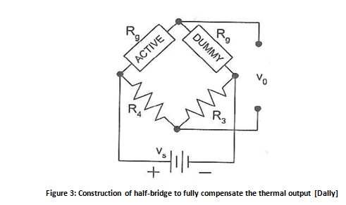

This is an example to show how the question would be laid out.
0.03m
Steel = E = 200 GPa
Mass = 750 kg
A= 7.74
Stress = F/A = 750 X 7.74 / ${0.03}^{2}$ = 6450000
=6.45 x${10}^{6}$
=6.45 MPa
E = Stress / Strain
Strain = Stress / E = 6.45x${10}^{6}$/200x${10}^{9}$ = 3.225x${10}^{-5}$
Strain does not have units.
G. F= ∆R/R ÷ E
G.F E = ∆R ÷ R
AR = GF.E. R = 2x 3.225x${10}^{-5}$x120= 0.00774
VA = 5v
VB= 120X 10 ÷ 120 + 120.00774 = 4.999838755
VA – VB = 0.000161245

Task 4 – Two Masses system

Transfer Function
t1
F- M1 t1 – k1 t1 – c1 t1 + k1 t2 + c1 t2 =0
M1 t1 = F- k1 t1 – c1 t1 + k1 t2 + c1 t2
t1 = 1/m1 (F- k1 t1 – c1 t1 + k1 t2 + c1 t2 )
t1 = 1/1.5 (1-0.3+1+0.3)
t1 = 1/1.5 ( 2.73)
t1 = 0.24
t2
K2 t1 + c2 t1 – k2 t2 – c2 t1 – k2 t2 – c2 t2 – m2 t2 = 0
M2 t2 = k2 t1 + c2 t1 – 2 k2 t2 – 2 c2 t2
t2 = 1/m2 ( k2 t1 + c2 t1 – 2 k2 t2 – 2 c2 t2)
t2= 1/1 ( 2+0.5- 2(2)- 2(0.5))
t2 = 1/1 (-2.5)
t2 = -0.4

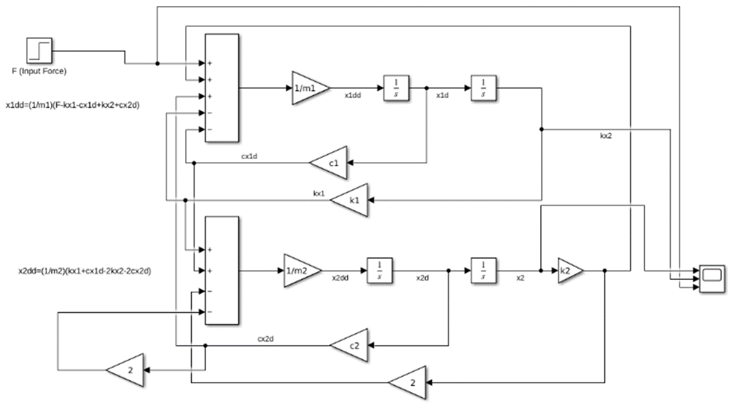

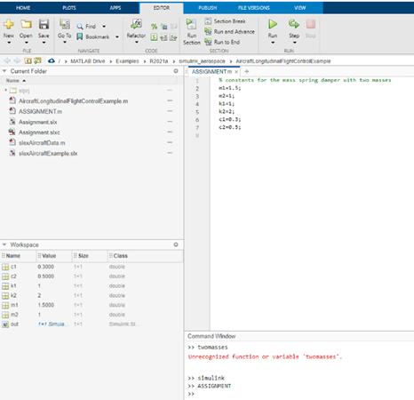

First, I put in the units for M1,M2,K1,K2,C1,C2 , then I wrote them on to the MATLAB software once I did that I ran the program to make the units were active, after that I clicked on the Simulink button to make the system, I then went on to Simulink and started making the system I then added a board to the system and added a +++-- to the left hand side of it I then added a gain going from the centre on the right hand side I then ladled that (1/m1), I then placed a integration to the left hand side of the gain I labelled the line between the gain and the first integration (x1dd) and then added another integration to the right of that I labelled the line in between them(x1d),I then added a gain underneath the first gain branching of between the 2 integrations I then labelled that C1 with the other end of that line attaching to the bottom – on the board I labelled that line (cx1d), I then added another gain underneath the C1 gain I labelled that one K1 the other end of that line is attached to the first – I labelled that line (kx1), I then added another board underneath where the other board was I added a ++-- to the left hand side of the board, I attached a line branching of (cx1d) going to the second + I also attached a line branching from the (kx1) line attaching to the first + on the board, I then added a gain coming from the centre of the board I labelled that gain (1/m2), I then added a integrator to the left of the gain I labelled the line in between them (x2dd), I then added another integrator next to that I labelled the line in between the two integrators (x2d), next to that I added another gain I labelled that (k2) the line between the gain and the integrator I labelled that (x2), then the line after the (k2) gain was then attached to the second gain on the top board also branching of that line was another line going to the first – on the bottom board the gain on that line was 2, in-between the two integrators a line came from that going to the third + on the first board the gain on that line I labelled (c2) I also labelled the line (cx2d) then coming of that line was another line going to the second – on the bottom board the gain on that line was labelled 2. I then added a step and a scope to the system and labelled the step ( F (input force)) a line then came of that going to the bottom input of the scope, I then added a line branching of the (kx1) line going to the middle input of the scope, I also added a branch line coming from the (x2) line going to the top input of the scope. We added three input to the scope so we can have the input of the system, which is the step, then added the other two for each part of the system and we can then see the readings for each part of the system.
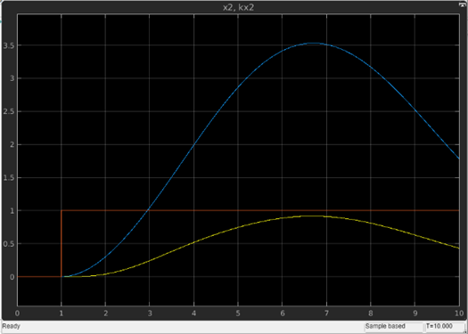

From the scope we can see can see that the orange line is the input because it is constant, we can then see that the blue line is m2,k2 and c2 due to the higher values of k2 and c2 and we can see that the step also takes place at the same time as the yellow line but due to the higher values of the blue line the increase is greater, we can then see that the yellow line is the values of m1,k1 and c1 due to the lower input values and as I said we can see the step take place due to the peak then decrease of the peak.

Sources
https://engineering.electrical-equipment.org/panel-building/difference-between-open-loop-closed-loop-systems.html - Task 1
https://electronicscoach.com/root-locus.html - Task 2

