

Task 1 – Reading Task Template
Upload your photo of your A3 in-class notes here:
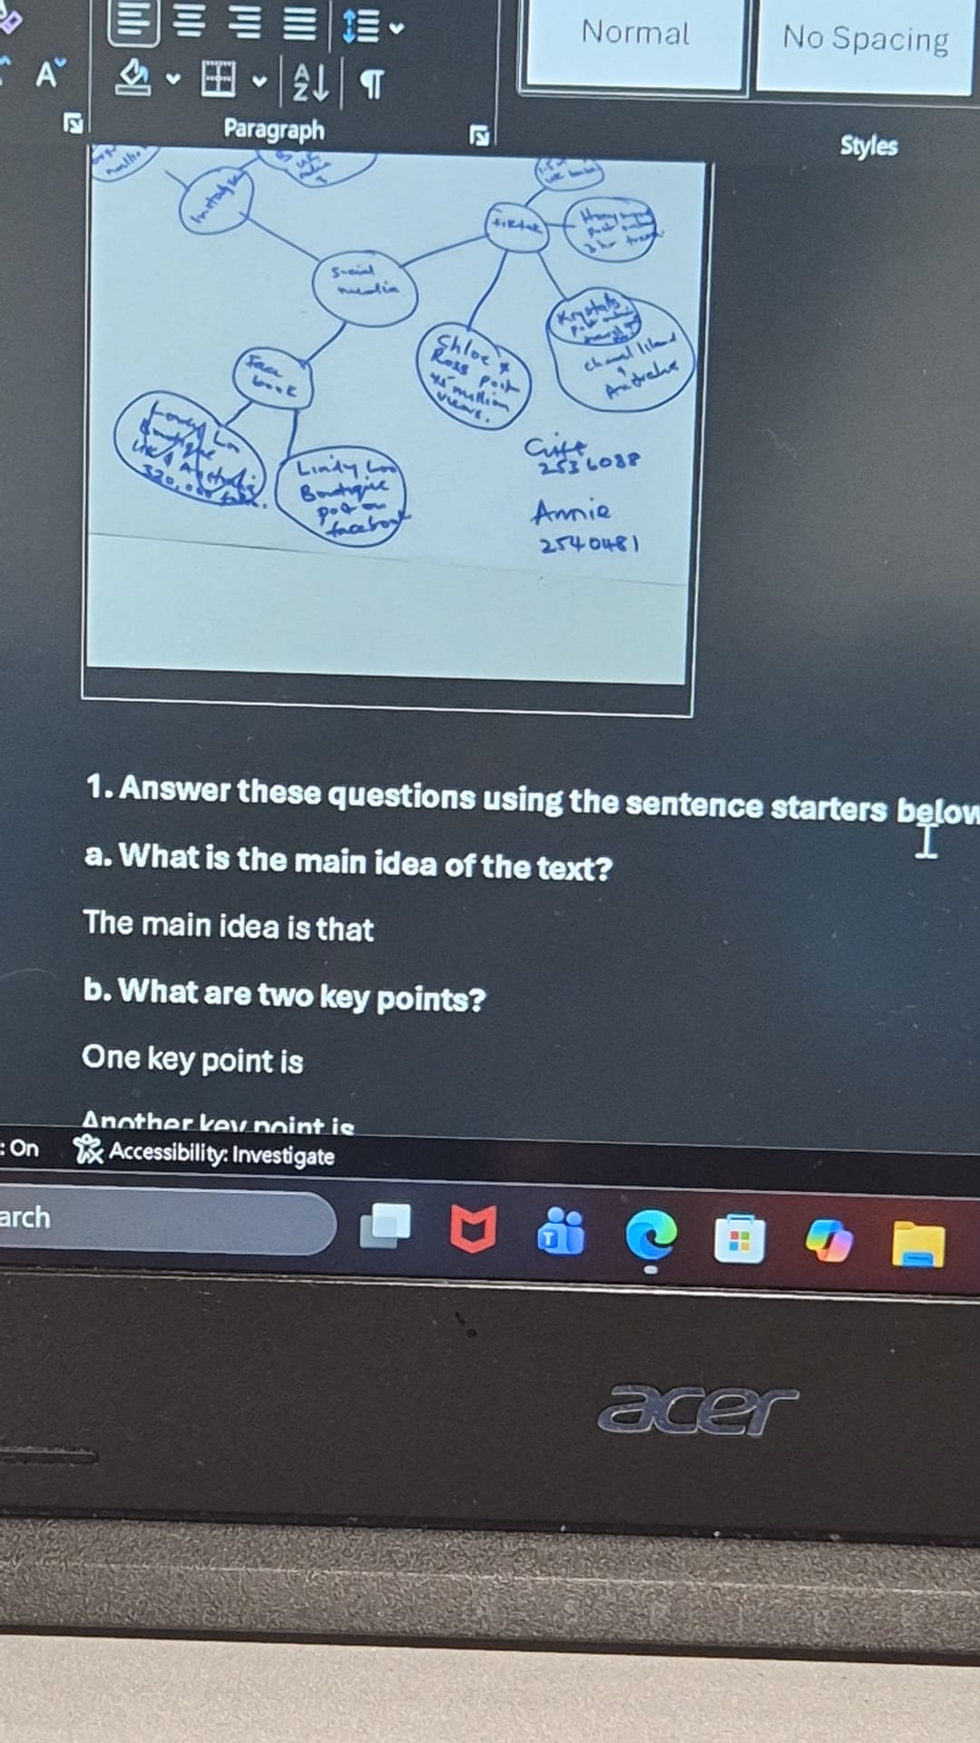

1. Answer these questions using the sentence starters below
a. What is the main idea of the text?
The main concept is that digital communication and social media have a large effect on how businesses work together with customers and advertise their products and services.
b. What are two key points?
One key point is that social media platforms help businesses reach a wider audience and boost the engagement of customers.
Another key point is that businesses can use customer reviews and online feedback and opinions to better their products and services.
c. What part of the text did you find most important? Why?
The most important part is how businesses use digital platforms to connect with customers as it shows how important digital skills are in modern business management.
d. Was anything unclear or difficult to understand?
no
e. How did your group help you understand the text better?
My group helped me by explaining key concepts to me and communicating with me to help me better understand the content.
3. One sentence reflection
Question: What did you find challenging about this task?
The hardest part was trying to find the most crucial information and correlating it to business management concepts like digital skills, academic skills and information literacy.

