

Apple Blog

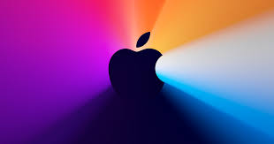

University of Wales Trinity Saint David
Module Number: LCBB4004
Module Name: Marketing Fundamentals
Module Tutor: Efua Adams
Student name and ID: Constantin Alexandru Frunza 2008383
Table of Contents
About Apple 3
Apple iPhone Quality 5
The reason to buy apple pc 6
IOS 7
It’s Apple Stock good to Buy? 8
Why to buy Apple iPhone 12? 9
References ………………………………………………………………………………... 10

About apple

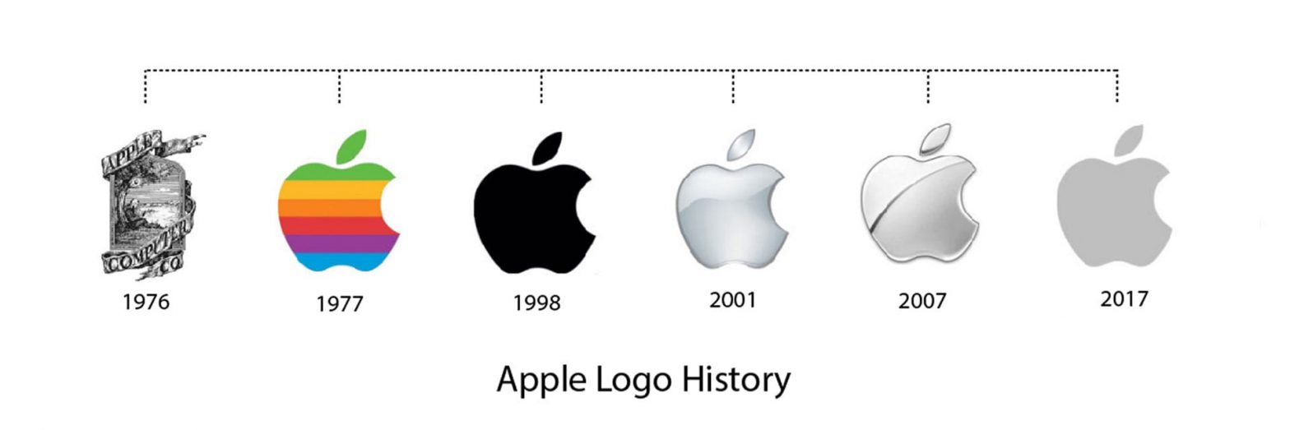
Apple it’s an American multinational technology company with headquarters in California, and designs, develop and sells electronics, computer software and online services. It’s considered one of the BIG FIVE companies on U.S.
Jobs and Wazniak hired a staff of computer designers and have a production line starting in Jobs garage, apple was going public in 1980 and the result was an instant financial success. Over the course of the following not many years Apple delivered new PCs with creative graphical UIs, like the first Macintosh in 1984.
However, because the hight price furthermore, restricted application library caused issues as fueled battles among chiefs and in 1985 Wozniak departed Apple amicably and remain as honorary employee while Jobs resigns and found NeXT in 1997. Jobs regain leadership status in 2000 becoming CEO of apple, after this change of leadership apple swiftly returned to profitability.
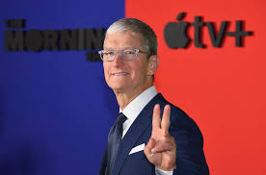
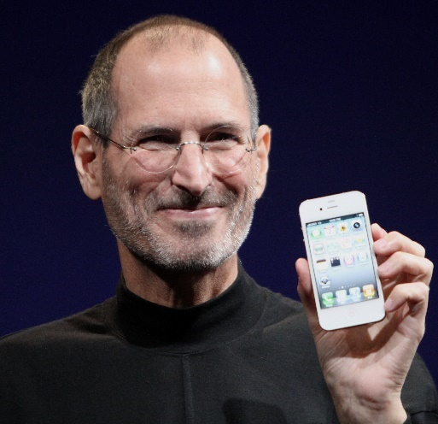
In 2007 Apple introduced the touch-screen iPhone, a phone with capacities for playing MP3s and accounts and for getting to the Internet. The fundamental models were available just identified with AT&T's distant help and couldn't be used over the latest third-age (3G) far off associations. In 2010 apple presented iCloud, a distributed computing administration wherein a client's applications, pictures , reports and as of late bought music will be put away in iCloud and naturally refreshed in the client gadgets.
In august 2011 Tim Cook its named CEO of Apple, this was happed because of if health of Steve Jobs and in October 2011 he was died from cancer. In the early long stretches of Cook s residency, apple did no present any all-new items yet rather brought out new forms of past items ,, for example, the iPhone 4s which contains an individual right hand program ,Siri, that could react to spoken orders and questions.

In 2014 Apple made its biggest obtaining by purchasing the earphone maker and music-streaming organization Beats for $3 billion.
In 2015 Apple delivered a smartwatch, the Apple Watch. A remodel with a sensor that might make electrocardiograms (ECGs) changed into offered as Series four in 2018. AirPods, a hard and fast of wi-fi earphones, have been delivered in 2016 and have become a pinnacle dealer in that market.
Propelled with the aid of using the recognition of the iPhone, in 2018 Apple have become the primary agency to attain a fee of 1 trillion dollars. Two years later Apple have become the primary agency to double that figure.
In 2020 Apple delivered its personal microprocessor, the M1, for Macintosh computers, which had formerly used Intel chips. The M1 changed into one of the quickest microprocessors to be had and changed into designed to be speedy even as additionally the use of much less electricity than preceding chips.

Apple iPhone Quality

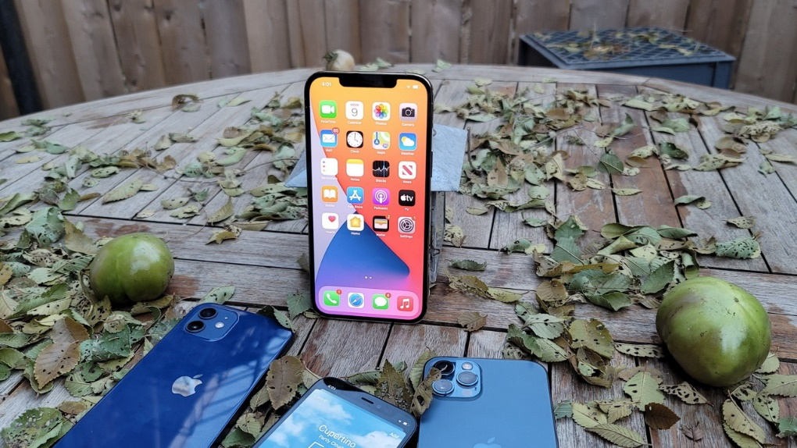
If you're an iPhone user, you'll greatly benefit from the fact that all Apple devices work seamlessly together. So it's worth sticking to other Apple devices, like the iPad or Apple Watch.

They keep fee – iPhone fashions are very famous and are visible as a luxurious item. This manner they keep their fee lots higher than even top-class Android phones, like Samsung's Galaxy series. This is well worth bearing in mind, due to the fact it is probably you may in the end need to promote your vintage iPhone and purchase a brand-new model. Those more budget may be placed toward a sparkly new iPhone.
Because there are not absolutely any reasonably-priced iPhones, Apple's handsets commonly provide superb overall performance.

The reason to buy apple pc

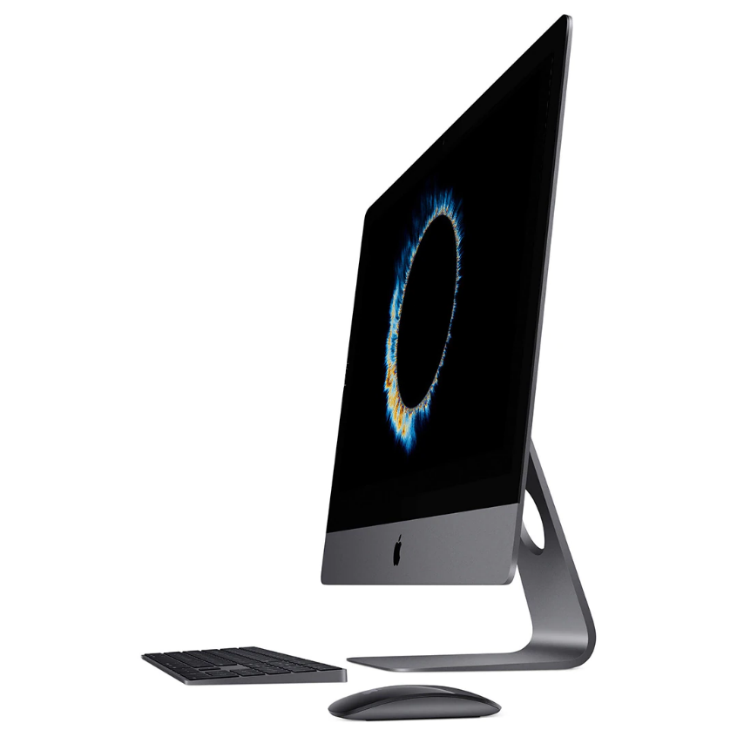
MAC its really working and they don’t have any bugs, I don’t remember when I was having the last bug on mac.
All drivers included in the operating system. I don't think so. Windows also has a bunch of generic drivers, but not all. And the boys also say that in order to see Bluetooth phones and devices, you have to restart your PC. Maybe they, I don't have to restart, I use Scan for Available Devices.
Instant video chat. Here they may be right, at Windows you have to buy a webcam (if you don't already have a laptop) and install some programs. Here Apple wins, if you often use video chat. If not, the situation is the same as in the case of 3G. How many of you make video calls?
You can do amazing things with MACs. Yes, of course, PCs are not good for anything, if you want to make money you definitely need something called Apple. That's right, you can make money if you have the right program (the offer of programs for the Windows platform clearly exceeds that for Apple).
Extraordinary design of MACs and graphical interface. It's only true if you like milky white (I don't say what I think it looks like) or silver and very rarely black (not all of their products are available in cool black). An enthusiastic user is not satisfied with some stock, but he personalizes his PC as he wants. Take a look here and see what can be done with talent and enthusiasm. If all standard cars were cool enough, there would be no car tuning, West Coast Customs or Orange County Choppers.
Apple comes with a photo sharing and manipulation suite. Let's be serious, there are enough free programs for PC: Picasa, Irfanview and I can't think of them now, but there are enough. It is enough to search on Softpedia.
IOS

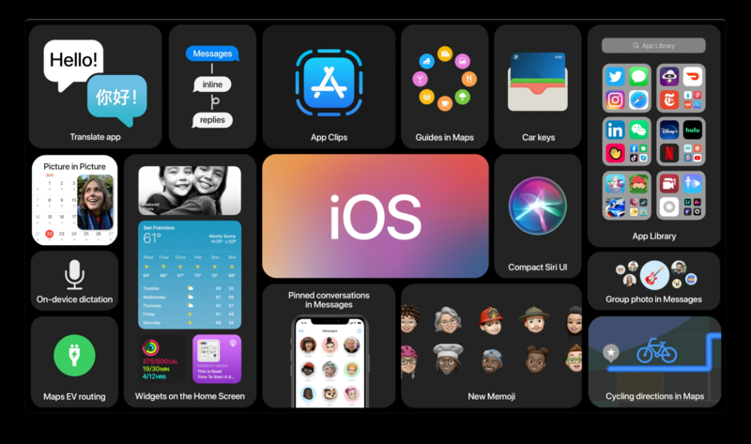
What is an operating system?
The operating system (OS) is the most important program running on a computer. Specifically, it is a software framework that oversees and arranges equipment and programming asset and permits different projects to run, being an interface between client applications and the equipment of that hardware, regardless of whether we are alluding to PC, PC, tablet or cell phone.
A simplified scheme of computer equipment places the operating system as follows:
Hardware -> Operating System -> Applications -> User
About iOS
iOS is the operating system developed by the American company Apple, for a limited number of smart devices, namely iPhone, iPod, iPad and Apple TV, this being the chronological order in which the innovations bearing the signature of Steve Jobs were launched.
It is a machine this is a part of the Unix family, like Linux, and that for the reason that first the model has borrowed many additives and capabilities from the Mac OS X running the machine, that's the idea of Mac computers.
The first iPhone was launched in 2007, and the latest version of the iOS system - iOS 10 - was announced in November 2016. The success of the iPhone - the best-selling gadget of all time, has a great deal to do with operating system capabilities and the number great applications that it offers through the App Store.

It’s Apple Stock good to Buy?

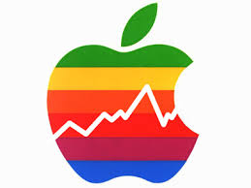
Apple (NASDAQ:AAPL) turned into the world's first $2 trillion organization in August 2020. Such far reaching development lately makes it really evident that the organization has done amazingly well and that Apple investors have do Apple's greatest advantage
Apple has set up itself as one of the world's head brands, and the organization has gotten inseparable from smooth, popular tech. Thus, Apple's notable items - from iPhones and iPads to MacBook and Air Pods - have mass allure on a worldwide scale. Also, that makes it harder for lesser-realized organizations to rival this tech titan.ne directly close by it.
To positioned Apple's scale in perspective, the organization had 1. sixty-five billion gadgets in use around the world as of December 2020. Moreover, the iPhone is the maximum famous phone in North America, and the iPad is the market-main pill worldwide. While this makes it more difficult to generate destiny boom in the ones markets, Apple's large person base remains a treasured asset, and it can be the important thing that unlocks destiny opportunities.
Weak iPhone sales in 2019 and pandemic-related headwinds in 2020 caused Apple's sales growth to slow. Notwithstanding, in the principal quarter of financial 2021 (detailed before the end of last month), Apple's development reaccelerated generously, determined by a rush of new items.
Why to buy Apple iPhone 12?

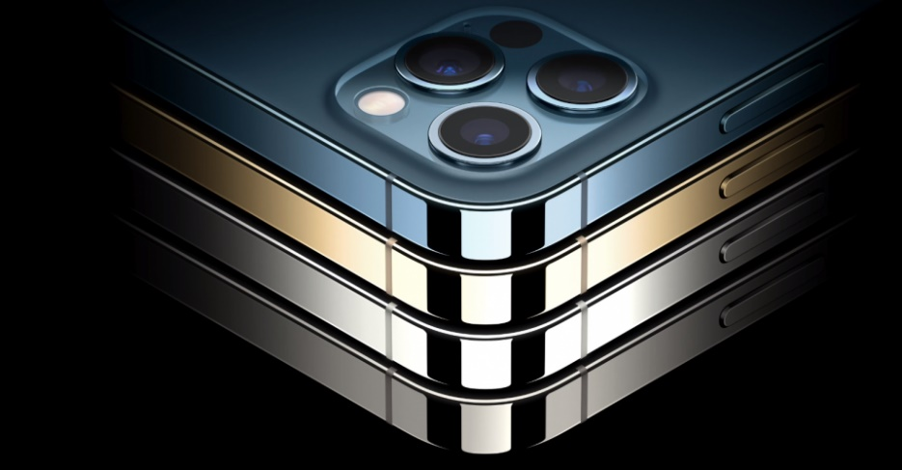
In 2020, Apple has developed exuberantly in the eyes of technology enthusiasts, like a real colossus of 1 trillion dollars. It launched 5 new phones, a processor with its own design for laptops and computers, but also new watches and tablets. It is the year with the largest iPhone so far, diagonally, iPhone 12 Pro Max, but also the year of the most compact 5G phone, iPhone 12 Mini. The iPhone 12 quartet arrived fragmented this fall, with a gap of a few weeks between versions and I mean the arrival in stores.
The performance of the iPhone 12 Pro Max is a top level
The mia screen left me not looking for this phone, but even this one offers probably one of the most fluid user experiences on 60 Hz, just like in the case of the iPhone 12 (review) models tested previously. You won't notice a difference in performance in normal use between the four new Apple phones. And the performance tests also place him in that performance area, even a little higher in some tests, but lower in others. Probably the larger surface of glass and steel helps to dissipate the heat released by the processor more efficiently compared to the 12 and 12 Mini models, but lower than the 12 Pro, for example in AnTuTu.

References

