

LEVEL 7 ASSESSMENT SPECIFICATION

Programme: | Master of Business Administration
Module: | Marketing Management
Module code: | LCMB7024 | Contribution to  Overall Module  Assessment (%): | 50%
Student Name: | Rutvi Rajnik Bhandari | Contribution to  Overall Module  Assessment (%): | 50%
Student I’d: | 2420026 | Internal Verifier: | Vasilios Tavlaridis and Hoang Dang Nguyen
Lecturer: | Tushara Balendran | Submission date: | 28th march 2025
Assignment Title: | Assessment Component 1- Essay | Word count (or  equivalent): | 2522

Market Entry Strategies: Evaluating the Advantages and Product Life Cycle Strategies of Pioneer and Follower Companies

Introduction
In current dynamic business environment companies need to carefully decide when to introduce new products and technologies into market. This strategic choice mainly focuses on two key approaches such as to be a pioneer or a follower. A pioneer company is first to introduce an innovation and this approach helps companies to gain early market recognition and technological leadership along with brand loyalty. On the other hand, a follower company enters later and it utilises market insights of pioneers that helps it to improve upon existing products and reduce risk associated with innovation. The timing of market entry significantly impacts competitive positioning of a company along with its long term success and profitability. Pioneer set industry standards and they enjoy first mover advantages however followers can refine strategies and they can be benefited from cost efficiencies. This essay will explore advantages of both strategies and analyse real world examples of successful pioneer and follower companies. Additionally, this essay will also examine how companies utilize product lifecycle strategies to sustain growth and maintain competitive advantage in a constantly changing marketplace.

Main Body

Advantages of Being a Pioneer and a Follower Company
In strategic marketing, decision to be a pioneer or followers significantly impacts market position of a company as well as it also affects its competitive advantage and long term profitability. Both strategies provide advantages and their success is dependent on various internal and external factors.

Advantages of Being a Pioneer
First-Mover Advantage: A pioneer company is first to introduce a product service or technology in a market. This approach has several benefits. Pioneers enjoy an early mover advantage as these companies develop brand recognition and customer loyalty before competitors enter market. According to Cirik and Makadok (2021), first movers in a new product category often capture a significant portion of market share and they outperform later entrants significantly. This advantage comes from customer loyalty, brand recognition and economies of scale that are achieved through entering market early. For example, Tesla is a pioneer in electric vehicle industry as this company launched its road star in 2008 that was followed by Model S in 2012. Currently Tesla has a 19.9% global electric vehicle market share in 2023 and it has made this company largest player in electric vehicle market (Road Genius, 2023). This company also leads in charging infrastructure battery technology and brand dominance. However, competition in the sector is increasing significantly as companies like BYD closely follow at a market share of 17.1% (Road Genius, 2023). Even in this competition, early entry of Tesla helped it to develop gigafactories and an extensive charging network that helped this company to gain a competitive advantage. Additionally, research also highlights that in certain industries first movers can secure a significant portion of market share. This initial dominance can create high customer loyalty as wants customers invest in a new technology the cost both financial and psychological of switching to another provider can be significantly high.
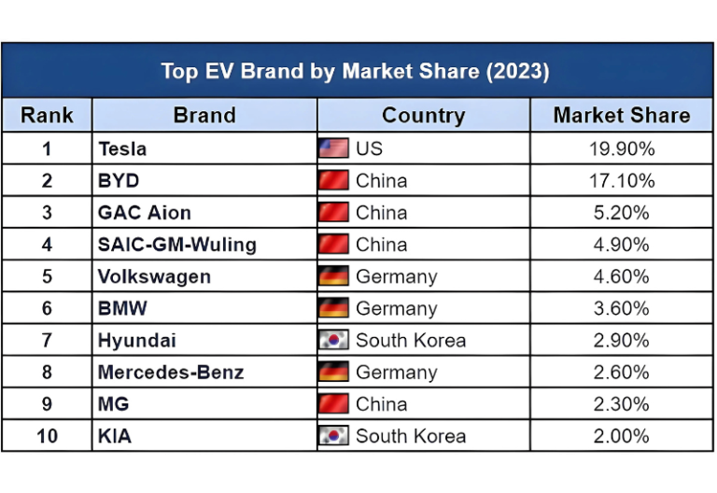
Figure 1: ‘Top EV brand market share, 2023’
(Source: Road Genius, 2023)
Technological Leadership and Innovation: According to Chavez and Chen (2021), pioneers of inset industry standards and it makes it difficult for competitors to surpass them. Pioneer scan patent technologies protect intellectual property and influence market trends. Pioneer invest in research and development and it can result in proprietary technologies and fittings that secured long term competitive advantage. Moreover, this leadership position helps pioneers to influence technological trends and regulatory standards. Apple introduced first iPhone in 2007 that redefined smartphone industry. With its continuous innovation and integration of software hardware and services. Apple has been able to gain a market share of 51.9% in the US smartphone market in 2023 that further solidifies position of this company as a dominant player in this industry (Diaconescu, 2024). This data highlights there is an increase from 47.6% in 2022 that highlights continuous growth and strong consumer preference of Apple in its home market (Diaconescu, 2024).
Premium Pricing and Market Influence: It is significant for companies to be first in market as it helps pioneers to charge premium prices due to their unique value proposition. Customers are often willing to pay more for innovative products that have no direct substitutes (Xie, Donthu and Johnston, 2020). Pioneer can often benefit from high margins during initial phases of market development as consumers are willing to pay extra for innovative products. However, their pricing power need to be balanced with ongoing need to innovate. Netflix is a pioneer in video streaming industry and this company transitioned from DVD rentals to an online subscription based model in 2007. As of early 2025 Netflix had approximately 301.6 million global subscribers and it has made a significant increase from 260.28 million subscribers recorded at 2023 (MSN, 2025). This data highlights even with increasing competition from Amazon Prime Disney+ and Hulu Netflix is leading this industry. Early dominance of Netflix helped it to influence pricing models and consumer preferences.
Stronger Customer Loyalty and Switching Costs: As per the perspective of Halberstadt et al. (2022), once customers adopt a pioneer product, they often remain loyal due to their habit formation and high switching cost. It is significant that more integrated a product is into lives of consumers, harder it is for competitors to lure them away. Pioneers also get benefit by developing substantial barriers to entry that disrupt new competitors. These barriers are capital investment in technology expensive patents and well developed supply chain and distribution network. These barriers protect market share of Finance as well as they also add overall perceived value of the brand. For example, Microsoft introduced Windows in 1985 and it became dominant force in personal computing worldwide. As of early 2025 windows have approximately 73% of global desktop operating system market share (Gangarapu, 2022). This dominance is mainly due to widespread adoption of desktop operating system in both professional and personal environments. Many businesses and individuals remain loyal to Windows due to familiarity with enterprise integrations and software compatibility.
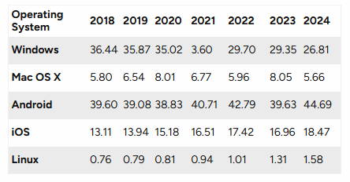
Figure 2: ‘Operating system market share (2018-2024)’
(Source: Gangarapu, 2022)

Advantages of Being a Follower
Lower Risk and Reduced R&D Costs: A follower company enters market after a pioneer and it learns from success and mistakes of first mover. Pioneers take on higher risk on the other hand followers are benefited from an established market landscape. Followers avoid high research and development expenses that are enqueued by pioneers. They can replicate successful features as well as minimise financial risk. Late entrants spend less on research and development in comparison to pioneers. It is mainly due to their ability to utilise existing market knowledge, consumer insights and technologies established by pioneers. Followers observe success and missteps of early entrance and it helped them an opportunity to optimise their strategies and allocate resources more efficiently. Studies highlight that lead entrance can reduce research and development expenditure in comparison to first movers and it helps followers to focus on refining and optimising existing technologies. However, it can also limit their capacity for groundbreaking innovation (Silver, Kelly and Small, 2021). Samsung entered smartphone market after Apple however it quickly adapted to current market conditions and improved Harvard as well as provided a wide range of models. As of 2025 Samsung has 20% of global smartphone market share that is slightly above than market share of Apple that is 16% (MFK, 2024). The diverse product range and innovation of Samsung particularly in Galaxy series have helped this company to maintain its leading positional market. On the other hand, strong ecosystem and premium positioning of Apple helps it to secure its loyal customer base. Samsung efficiently utilises innovations of Apple and provides diverse product options across price segments.
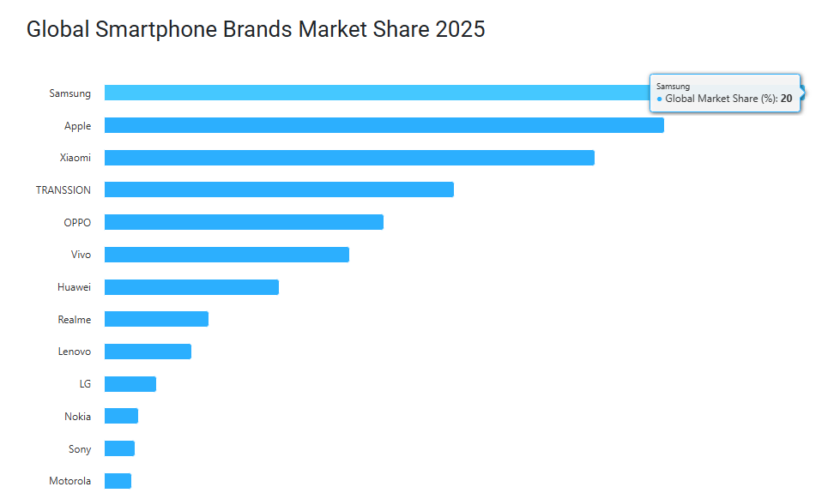
Figure 3: ‘Global Smartphone Brands Market Share 2025’
(Source: MFK, 2024)
Improved Product Offerings: Followers analyse products of pioneers and they identify flaws and customer pain points and then they launch improved versions of products (Vaskelainen et al., 2021). Followers analyse customer feedback and market trains through which they introduce improved versions of products that address shortcomings found in earlier models. The significant process often results in more refined and user friendly products that can rapidly capture consumer interest. Yahoo was a pioneer of Internet search however Google entered later with a superior algorithm, PageRank. as of early 2025 Google commanded approximately 89.62% of global change in market that far surpassed Yahoo at 1.34% of market share and Binge at 4.04% of market share (Bianchi, 2025). The dominance of Google is significant and it is mainly due to its user friendly interface, advanced algorithms and its integration across various platforms.
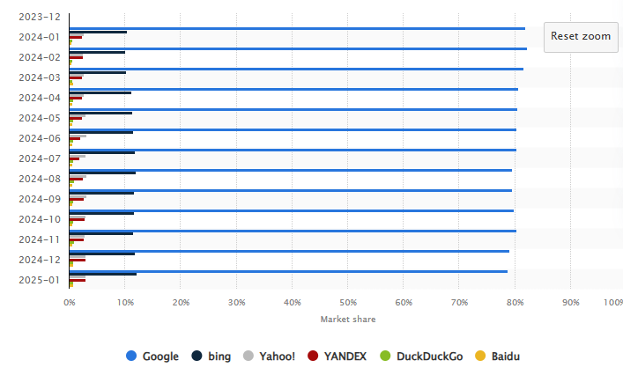
Figure 4: ‘Market share of leading desktop search engines worldwide from January 2015 to January 2025’
(Source: Bianchi, 2025)
Faster Market Expansion and Scalability: Followers can scale faster in comparison to pioneers as followers utilise existing supply chains, distribution channels and consumer insights (Chavez and Chen, 2021). Facebook enters social media space after myspace however it is dominated due to improving user experience as well as it also introduced targeted ads and expanded globally. Currently Facebook has approximately 3.07 billion monthly active users and 2.11 billion daily active users (Kumar, 2025). It has made Facebook as most popular social media platform all across the Globe and a significant share of world population is engaged with this platform regularly.
Cost Leadership and Competitive Pricing: Followers can achieve cost advantage as they can use more efficient production methods. They benefit from economies of scale and undercut pioneers with low prices (Halberstadt et al., 2022). Huawei entered smartphone and 5G telecom market after Samsung and Apple however this company gained significant market share with help of its high quality yet affordable alternatives. In 2020 Huawei briefly surpassed Samsung as the largest smartphone manufacturer worldwide and for this Huawei utilised its aggressive pricing and rapid technological advancements (MFK, 2024).
Flexibility and Adaptability: Followers are more agile to respond to market trends, consumer preferences and regulatory changes. They are not bound by early product design decisions and it helped followers to pivot quickly (Vaskelainen et al., 2021). YouTube was a pioneer online video content however Tiktok entered later with short form videos that are specially tailored for mobile users. Currently Tik Tok has approximately 1.69 billion monthly active users that has made it one of the most popular social media platforms worldwide (Singh, 2025). This platform has also surpassed YouTube in engagement rates among younger audiences as users spend an average of 52 minutes per day on this app (Sisian, 2025). The success of this platform is mainly due to its algorithm driven content and short form video format that resonate well with millennials and generation Z.

Product Life Cycle Strategies of Pioneer and Follower Companies
The product life cycle consists of four stages such as ‘introduction, growth, maturity, and decline’. Companies need to implement strategic approaches at each phase to maximise market share and sustain profitability as well as this strategic approaches can also help them to maintain a competitive advantage in market. Pioneer companies and follower companies adopt different product life cycle strategies to achieve these objectives.

Product Life Cycle Strategies of Pioneer Companies
Introduction Stage: Market Development and Brand Positioning
Pioneer needs to develop demand awareness and consumer trust as they introduce a new product or technology into market (Dreiling and Bican, 2022). Tesla launched its first electric vehicle the road started in 2008 and during this time Tesla focused on high end customers who are willing to pay a premium for innovation. This company developed market trust and brand exclusivity and for it tesla invests in battery technology performance and an extensive charging infrastructure. Currently Tesla has a 19.9% global electric vehicle market share in 2023 that highlights power of early brand positioning (Road Genius, 2023).
Growth Stage: Rapid Expansion and Market Penetration
Pioneers need to utilise their first mover advantage to expand production and optimise costs as well as they also need to focus on capturing a wider audience (Gómez, Pérez-Aradros and Salazar, 2022). Apple launched the iPhone in 2007 and after that Apple focused on continuous innovation and launched new models with enhanced features like OLED displays, face ID and 5G capabilities. Apple has been able to gain a market share of 51.9% in the US smartphone market in 202 (Diaconescu, 2024)3. Apple has maintained this market share due to its capability of maintaining premium pricing as well as expanding with help of an efficient ecosystem and carrier partnerships.
Maturity Stage: Product Differentiation and Customer Retention
With gradual entrance of competitors in market pioneers need to differentiate their offerings as this approach can help them to sustain market dominance more efficiently (Kamp and Ruiz, 2023). Netflix was a pioneer of online streaming in 2007 however this company experienced intense competition from Amazon Prime, HBO Max and Disney+. Netflix is set to invest approximately $18 billion in content production in 2025. This is a significant increase from its 16.2 billion dollars spending in content production in 2024 and it highlights this company is committed to expand its global content library and maintain its competitive advantage in market (Manfredi, 2025). Additionally, Netflix also introduces original series' interactive content and artificial intelligence revenge recommendations that helps aid to maintain its 301.6 million global subscribers engaged with its platform.
Decline Stage: Innovation or Diversification
Pioneers experience market saturation and declining demand and they need to address these challenges with reinvent their business model and expand into new markets (Salmen, 2021). Windows dominated personal computing however this company experienced significant stagnation. Then Microsoft shifted its focus towards cloud computing through Azure. According to current data Azure contributes significantly to revenue of Microsoft that accounts for approximately 33% of total revenue of this company (Microsoft, 2025). This cloud computing has made it a key driver of growth even with its declining PC sales.

Product Life Cycle Strategies of Follower Companies
Introduction Stage: Cost Leadership and Market Entry Timing
Followers enter market and they analyse success and failures of pioneers and it provides them an opportunity to provide improved products to customers at lower costs (Eslami, Ghasemaghaei and Hassanein, 2022). Samsung entered smartphone industry after Apple but quickly became a larger smartphone manufacturer worldwide as this company provided a wide range of devices at different price points and it has made smash smartphones of Samsung mode accessible in comparison to premium models of Apple (MFK, 2024).
Growth Stage: Aggressive Marketing and Rapid Scale-Up
Followers differentiate themselves with help of aggressive marketing, regional expansion and partnerships (Shakouhi et al., 2021). Tik Tok entered video sharing space after YouTube however it utilised artificial intelligence to event content recommendations localised marketing and influencer partnerships that help this platform to grow rapidly. Currently Tik Tok has approximately 1.69 billion monthly active users (Singh, 202). It surpasses YouTube in engagement rates among younger demographics.
Maturity Stage: Continuous Innovation and Competitive Pricing
Followers need to sustain growth and for aid they can introduce incremental innovations, maintain comparative pricing as well as improve user experience (Salmen, 2021). For example, Google entered search engine market after Yahoo, however Google outperformed competitors with help of its superior algorithms, cost effective advertising solutions and artificial intelligence driven personalization (Bianchi, 2025). Currently Google has a significant portion of global search engine market on the other hand Yahoo and Bing are far behind.
Decline Stage: Business Model Adaptation and Diversification
Many followers experience challenge of saturated market and hence they can pivot these challenge if they efficiently adopt new business models and integrate adjacent technologies (Vaskelainen et al., 2021). For example, Huawei entered smartphone market later than Apple and Samsung, however this company gained a significant market share as it provided affordable date high quality devices to customers. Huawei shifted its focus to 5G network infrastructure when US trade restrictions limited its smartphone business and it helped Huawei to become a global leader in telecommunications (MFK, 2024).

Conclusion
Both pioneer and followed companies have distinct advantages. Pioneers are benefited from first mover advantages such as technological leadership, brand recognition and market dominance that can be observed in companies like Tesla and Apple. However, pioneers also experienced significant challenges due to high research and development cost competitive rates and market uncertainty. On the other hand, there are followers like Tiktok and Samsung who capitalise on improved product designs, lower development cost and aggressive scaling strategies and often followers achieve greater long term success in comparison to pioneers. Effective product life cycle strategies are significant for companies to sustain their growth in market. Pioneers focus on market creation differentiation and innovation on the other hand followers prioritise rapid expansion cost leadership and competitive pricing.

Reference List
Bianchi, T. (2025). Search engine market share worldwide. [online] Statista. Available at: https://www.statista.com/statistics/216573/worldwide-market-share-of-search-engines/ [Accessed 6 Mar. 2025].
Chavez, D.E. and Chen, H. (Allan) (2021). First-mover advantages and innovation success: a contingency approach. Journal of Business & Industrial Marketing, 37(6).
Cirik, K. and Makadok, R. (2021). First-Mover Advantages Versus First-Mover Benefits: What’s the Difference and Why Does It Matter? Academy of Management Review, 48(3).
Diaconescu, A. (2024). Apple destroyed all its US rivals in 2023, but the unlocked phone segment has a different leader. [online] PhoneArena. Available at: https://www.phonearena.com/news/us-smartphone-market-report-2023-apple-top-vendor-motorola-unlocked-leader_id156493?form=MG0AV3&form=MG0AV3 [Accessed 6 Mar. 2025].
Dreiling, A. and Bican, P.M. (2022). Pioneer or Follower. Routledge eBooks, [online] pp.100–115. Available at: https://www.taylorfrancis.com/chapters/edit/10.4324/9781003046899-10/pioneer-follower-aleksej-dreiling-peter-bican [Accessed 6 Mar. 2025].
Eslami, S.P., Ghasemaghaei, M. and Hassanein, K. (2022). Understanding consumer engagement in social media: The role of product lifecycle. Decision Support Systems, 162(0167-9236), p.113707.
Gangarapu, K.R. (2022). Ethics of Facial Recognition: Key Issues and Solutions. G2.com. [online] Available at: https://learn.g2.com/ethics-of-facial-recognition?utm_source=chatgpt.com [Accessed 22 Jan. 2025].
Gómez, J., Pérez-Aradros, B. and Salazar, I. (2022). How to beat early movers: The role of competitive strategy and industry dynamism on followers’ performance in the telecommunications industry. Long Range Planning, 55(5), p.102244.
Halberstadt, J., Kollhoff, S., Kraus, S. and Dhir, A. (2022). Early bird or early worm? First-mover (dis)advantages and the success of web-based social enterprises. Technological Forecasting and Social Change, 181, p.121784.
Kamp, B. and Ruiz, I. (2023). Leveraging (in)formal early-mover and diligent-follower advantage mechanisms to attain international niche market leadership: insights from Basque ‘hidden champions’. Competitiveness review, 33(6). doi:https://doi.org/10.1108/cr-10-2022-0158.
Kumar, N. (2025). Facebook Users Statistics (2025) — Worldwide Data. [online] DemandSage. Available at: https://www.demandsage.com/facebook-statistics/?form=MG0AV3&form=MG0AV3 [Accessed 6 Mar. 2025].
Manfredi, L. (2025). Netflix’s $18 Billion in Content Spend for 2025 ‘Not Anywhere Near a Ceiling,’ CFO Says. [online] Yahoo Finance. Available at: https://finance.yahoo.com/news/netflix-18-billion-content-spend-002603798.html?form=MG0AV3&form=MG0AV3&guccounter=1 [Accessed 6 Mar. 2025].
MFK (2024). Global Smartphone Brands Market Share 2025 - Worldostats. [online] Worldostats. Available at: https://worldostats.com/global-smartphone-brands-market-share-2025/?form=MG0AV3&form=MG0AV3 [Accessed 6 Mar. 2025].
Microsoft (2025). FY25 Q1 - Intelligent Cloud Performance - Investor Relations - Microsoft. [online] Microsoft.com. Available at: https://www.microsoft.com/en-us/Investor/earnings/FY-2025-Q1/intelligent-cloud-performance?form=MG0AV3&form=MG0AV3 [Accessed 6 Mar. 2025].
MSN (2025). MSN. [online] Msn.com. Available at: https://www.msn.com/en-us/money/companies/netflix-content-spending-set-to-hit-18-billion-in-2025-is-not-anywhere-near-a-ceiling-cfo-says/ar-AA1AkJsU?form=MG0AV3&form=MG0AV3 [Accessed 6 Mar. 2025].
Road Genius (2023). EV Sales by Brand | 2023 - 2024 Global Statistics & Forecasts. [online] Road Genius. Available at: https://roadgenius.com/cars/ev/statistics/sales-by-automaker/?form=MG0AV3&form=MG0AV3 [Accessed 6 Mar. 2025].
Salmen, A. (2021). Does digitalization boost companies‘ new product launch success? SCENTIA International Economic Review, 1(1), pp.62–83.
Shakouhi, F., Tavakkoli-Moghaddam, R., Baboli, A. and Bozorgi-Amiri, A. (2021). A competitive pharmaceutical supply chain under the marketing mix strategies and product life cycle with a fuzzy stochastic demand. Annals of Operations Research, 324(1).
Silver, I., Kelly, B.A. and Small, D.A. (2021). Selfless First Movers and Self‐Interested Followers: Order of Entry Signals Purity of Motive in Pursuit of the Greater Good. Journal of Consumer Psychology, 31(3).
Singh, S. (2025). How Many People Use TikTok 2025 (Users Statistics). [online] DemandSage. Available at: https://www.demandsage.com/tiktok-user-statistics/?form=MG0AV3&form=MG0AV3 [Accessed 6 Mar. 2025].
Sisian, H. (2025). Social Media Showdown: Snapchat vs. Instagram vs. TikTok. [online] The Knight Crier. Available at: https://www.knightcrier.org/opinion/2025/03/04/social-media-showdown-snapchat-vs-instagram-vs-tiktok/?form=MG0AV3&form=MG0AV3 [Accessed 6 Mar. 2025].
Vaskelainen, T., Münzel, K., Boon, W. and Frenken, K. (2021). Servitisation on consumer markets: entry and strategy in Dutch private lease markets. Innovation, 24(1), pp.1–20.
Xie, F.T., Donthu, N. and Johnston, W.J. (2020). Beyond first or late mover advantages: timed mover advantage. Journal of Business & Industrial Marketing. [online] Available at: https://www.emerald.com/insight/content/doi/10.1108/jbim-11-2018-0334/full/html [Accessed 6 Mar. 2025].

