Lab – Understanding Ethernet Cable Standards
Topology
Addressing Table
Device | Interface | IP Address | Subnet Mask | Default Gateway
PC-A | NIC | 192.168.10.1 | 255.255.255.0 | N/A
PC-B | NIC | 192.168.10.2 | 255.255.255.0 | N/A
Objectives
Part 1: Analyze Ethernet Cabling Standards and Pinouts
Part 2: Build an Ethernet Crossover Cable
Part 3: Test an Ethernet Crossover Cable
Background / Scenario
In this lab, you will build and terminate an Ethernet crossover cable and test it by connecting two PCs together and pinging between them. You will first analyze the Telecommunications Industry Association/Electronic Industries Association (TIA/EIA) 568-A and 568-B standards and how they apply to Ethernet cables. You will then construct an Ethernet crossover cable and test it. Finally, you will use the cable you just constructed to connect two PCs together and test it by pinging between them.
Note: With autosensing capabilities available on many devices, such as the Cisco 1941 Integrated Services Router (ISR) switch, you may see straight-through cables connecting like devices.
Required Resources
- One length of cable, either Category 5 or 5e. Cable length should be 0.6 to 0.9m (2 to 3 ft.)
- 2 RJ-45 connectors
- RJ-45 crimping tool
- Wire cutter
- Wire stripper
- Ethernet cable tester (optional)
- 2 PCs (Windows 7 or 8)
- Analyze Ethernet Cabling Standards and Pinouts
The TIA/EIA has specified unshielded twisted pair (UTP) cabling standards for use in LAN cabling environments. TIA/EIA 568-A and 568-B stipulates the commercial cabling standards for LAN installations; these are the standards most commonly used in LAN cabling for organizations and they determine which color wire is used on each pin.
With a crossover cable, the second and third pairs on the RJ-45 connector at one end of the cable are reversed at the other end, which reverses the send and receive pairs. The cable pinouts are the 568-A standard on one end and the 568-B standard on the other end. Crossover cables are normally used to connect hubs to hubs or switches to switches, but they can also be used to directly connect two hosts to create a simple network.
Reflection:
Write a research report (Max word count 600) on Cat 5e and 6 Ethernet cable standards.

Introduction:
In this report the author will discuss the differences and similarities between category 5e and category 6 cabling as well as the frequency standards that define their categorization and some of the additional features and varieties of both.

Cat 5e:
Figure 1 UTP [4]
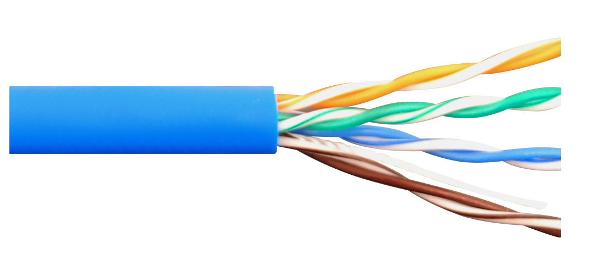
Category 5 enhanced Ethernet cable was first introduced in 1999[1] and boasts a top speed of 1000Mbps over a maximum length of 100 meters as with most ethernet standards, and operates at a frequency of 100MHz and is available in two primary varieties; Unshielded twisted pair (UTP) which consists of 4 twisted pairs of cables housed in a standard sheath, see figure 1, shielded twisted pair (STP), see figure 2, however provides an additional sheath that provides protection from electromagnetic interference which in some cases may be given off by radio equipment in the nearby area and can even prevent eavesdropping on the cable[2] thus making STP preferable for a more secure, uninterrupted connection.
Figure 2 STP [5]
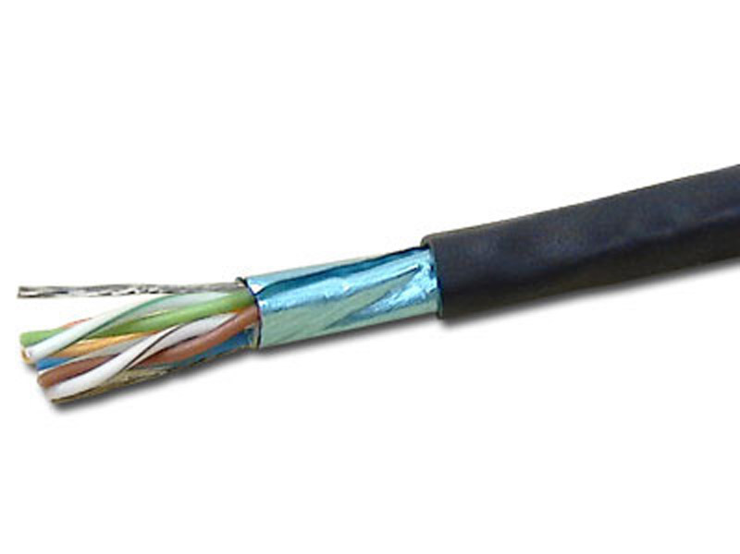

Cat 6:
Category 6 Cable is similar to Cat 5e in many ways but also hosts some improvements, whilst still available in both UTP and STP variants there is also a spine separator added between the cables to further reduce interference and additionally improves cable strength, see figure 3. A further increase to the maximum throughput of the device has been made, with the highest capability now at 10Gb/s but this is only up to 55 meters in cable length (ref) and at an increased frequency of 250 MHz although the cable can operate up to the standard 100 meters, throughput of 10 Gb/s is not available but is supported up to 1Gb/s
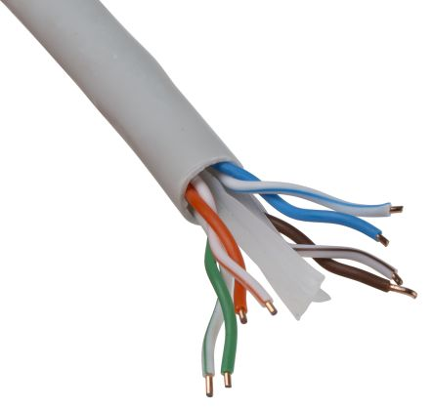

Conclusion:
In practice Cat6 cable has been shown to provide a justifiable improvement to network speed due to its upgrades from Cat5e and has been shown to reduce crosstalk owed to its spine separator and stricter manufacturing specifications [3] and higher throughput capacity and transmission frequency making this cable to most superior, regardless of this both of the discussed cabling standards are still widely used as cat5e’s maximum bandwidth (1Gb/s) is still not widely accessible commercially to the public and most end users in an enterprise setting would not require a 1 Gb/s connection to work meaning cat5e is still suitable to be used in some circumstance whereas it would be more advisable to use cat6 cables (or higher categories) within a datacenter or server room environment to benefit from the additional specifications.
Figure 3 Cat6 UTP [6]

Bibliography:
[1] “Cat5 vs Cat5e vs Cat6: What’s the Difference?” [Online]. Available: http://www.fiber-optic-tutorial.com/differences-between-cat5-cat5e-and-cat6-cables.html. [Accessed: 12-Dec-2019].
[2] Inet Daemon, “Unshielded Twisted Pair::InetDaemon.Com,” 2018. [Online]. Available: https://www.inetdaemon.com/tutorials/basic_concepts/cabling/shielded_twisted_pair.shtml. [Accessed: 12-Dec-2019].
[3] “Difference between Cat5E and Cat6.” [Online]. Available: https://www.bittree.com/blogs/get-connected/difference-between-cat5e-and-cat6. [Accessed: 10-Dec-2019].
[4] “Solid CAT5e UTP 350 MHz Riser Cable - Blue - 1000FT | Computer Cable Store.” [Online]. Available: https://www.computercablestore.com/solid-cat5e-utp-350-mhz-riser-cable-blue-1000ft. [Accessed: 10-Dec-2019].
[5] “CAT5E STP CMR Solid Shielded PVC Ethernet Cable 4PR 1000’ Box - Telexpress Live Store.” [Online]. Available: https://telexpresslive.com/c5e2404lsh-wh-cat5e-stp-cmr-solid-shielded-pvc-4pr-1000ft-box/. [Accessed: 10-Dec-2019].
[6] “RS PRO Grey Cat6 Cable UTP LSZH, PVC Unterminated/Unterminated Low Smoke Zero Halogen (LSZH), 100m | RS Components.” [Online]. Available: https://uk.rs-online.com/web/p/cat6-cable/8427324/. [Accessed: 10-Dec-2019].

  - Analyze diagrams and tables for the TIA/EIA 568-A standard Ethernet cable.
The following table and diagrams display the color scheme and pinouts, as well as the function of the four pairs of wires used for the 568-A standard.
Note: In LAN installations using 100Base-T (100 Mb/s), only two pairs out of the four are used.
568-A 10/100/1000Base-TX Ethernet
Pin Number | Pair Number | Wire Color | 10Base-T Signal  100Base-TX Signal | 1000Base-T Signal
1 | 2 | White/Green | Transmit | BI_DA+
2 | 2 | Green | Transmit | BI_DA-
3 | 3 | White/Orange | Receive | BI_DB+
4 | 1 | Blue | Not Used | BI_DC+
5 | 1 | White/Blue | Not Used | BI_DC-
6 | 3 | Orange | Receive | BI_DB-
7 | 4 | White/Brown | Not Used | BI_DD+
8 | 4 | Brown | Not Used | BI_DD-

The following diagrams display how the wire color and pinouts align with an RJ-45 jack for the 568-A standard.
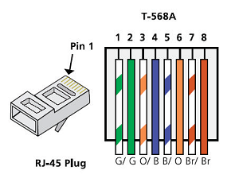
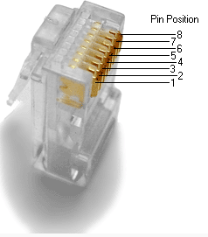
  - Analyze diagrams and tables for the TIA/EIA 568-B standard Ethernet cable.
The following table and diagram display the color scheme and pinouts for the 568-B standard.
568-B 10/100/1000-BaseTX Ethernet
Pin Number | Pair Number | Wire Color | 10Base-T Signal  100Base-TX Signal | 1000Base-T Signal
1 | 2 | White/Orange | Transmit | BI_DA+
2 | 2 | Orange | Transmit | BI_DA-
3 | 3 | White/Green | Receive | BI_DB+
4 | 1 | Blue | Not Used | BI_DC+
5 | 1 | White/Blue | Not Used | BI_DC-
6 | 3 | Green | Receive | BI_DB-
7 | 4 | White/Brown | Not Used | BI_DD+
8 | 4 | Brown | Not Used | BI_DD-
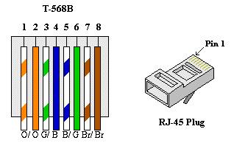

- Build an Ethernet Crossover Cable
A crossover cable has the second and third pairs on the RJ-45 connector at one end, reversed at the other end (refer to the table in Part 1, Step 2). The cable pinouts are the 568-A standard on one end and the 568-B standard on the other end. The two following diagrams illustrate this concept.
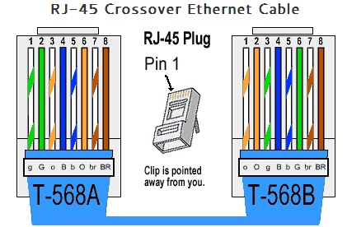
  - Build and terminate a TIA/EIA 568-A cable end.
    - Determine the cable length required. (Your instructor will let you know the cable length you should make.)
Note: If you were making a cable in a production environment, the general guideline is to add another 12 in. (30.48 cm) to the length.
    - Cut off a piece of cable to the desired length and using your wire stripper, remove 5.08 cm (2 in.) of the cable jacket from both ends.
    - Hold the four pairs of twisted cables tightly where the jacket was cut away. Reorganize the cable pairs into the order of the 568-A wiring standard. Refer to the diagrams, if necessary. Take as much care as possible to maintain the twists in the cable; this provides noise cancellation.
    - Flatten, straighten, and line up the wires using your thumb and forefinger.
    - Ensure that the cable wires are still in the correct order for the 568-A standard. Using your wire cutters, trim the four pairs in a straight line to within 1.25 to 1.9 cm (1/2 to 3/4 in.).
    - Place an RJ-45 connector on the end of your cable, with the prong on the underside pointing downward. Firmly insert the wires into the RJ-45 connector. All wires should be seen at the end of the connector in their proper positions. If the wires are not extending to the end of the connector, take the cable out, rearrange the wires as necessary, and reinsert the wires back into the RJ-45 connector.
    - If everything is correct, insert the RJ-45 connector with cable into the crimper. Crimp down hard enough to force the contacts on the RJ-45 connector through the insulation on the wires, thus completing the conducting path. See the following diagram for an example.
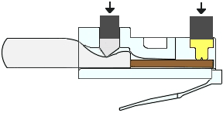
  - Build and terminate a TIA/EIA 568-B cable end.
Repeat steps 1a to 1g using the 568-B color wiring scheme for the other end.
- Test an Ethernet Crossover Cable
  - Test the cable.
Many cable testers will test for length and mapping of wires. If the cable tester has a wire map feature, it verifies which pins on one end of the cable are connected to which pins on the other end.
If your instructor has a cable tester, test the crossover cable for functionality. If it fails, check with your instructor first as to whether you should re-cable the ends and re-test.
  - Connect two PCs together via NICs using your Ethernet crossover cable.
    - Working with a lab partner, set your PC to one of the IP addresses shown in the Addressing Table (see page 1). For example, if your PC is PC-A, your IP address should be set to 192.168.10.1 with a 24-bit subnet mask. You partner’s IP address should be 192.168.10.2. The default gateway address can be left empty.
    - Using the crossover cable you made, connect the two PCs together via their NICs.
    - On the PC-A command prompt, ping the PC-B IP address.
Note: The Windows firewall may have to be temporarily disabled for pings to be successful. If the firewall is disabled, make sure you re-enable it at the conclusion of this lab.
    - Repeat the process and ping from PC-B to PC-A.
Assuming IP addressing and firewall are not issues, your pings should be successful if the cables were properly made.
Reflection
  - Which part of making cables did you find the most difficult?
____getting the cables to go into the connector in the correct order with a good level of shielding still protecting the cable end

Why do you have to learn how to make a cable if you can easily buy pre-made cables?
As it is better practice to have bespoke length cables as it prevent excess slack

