
HTML & CSS Web Development REPORT
Donnavon Ethan Furbert
January 10, 2025

—

Intro to Web & Database Concepts

—
Ms. Diyva

Table of Contents
— 1
Intro to Web & Database Concepts 1
— 1
Introduction 3
The Requirements 4
Website Introduction 4
Validation 10
Evaluation 11
Sources 12
Appendices 13
“Home.html” 13
“About.html” 15
“Positions.html” 18
“Formations.html” 21
“contacts.html” 23
“styles.css” 24
“contact.css” 29

Introduction
This report will be about what website I created and the process of it. I will mention the website's purpose, subject, and target audience.

I will then show you a few images of my website I’ve created
and describe how such coding was validated while also talking about the errors/mistakes I may have made while hand-coding my website in HTML / CSS. While also giving my own self-evaluation on the website I’ve created and how I’d do better or at least improve.





The Requirements

Website Introduction

The website is about football, it’s supposed to help newcomers to the sport to have a better understanding of the game’s rules, history, and why it’s so significant in today’s media.

You may ask? Why create a football website? I chose to make a website about the game of football because it’s one of my hobbies. Growing up, it was one of the things I consistently played, and had many memories of playing and watching.
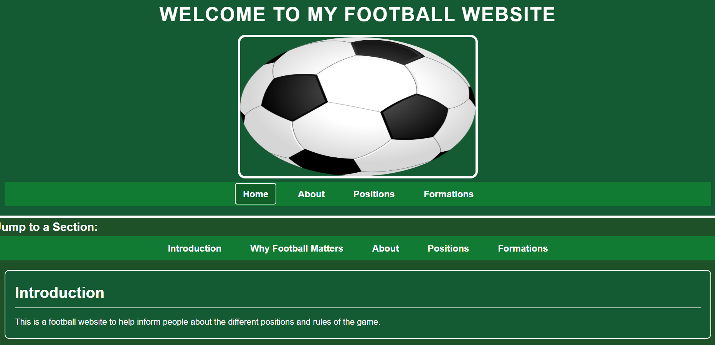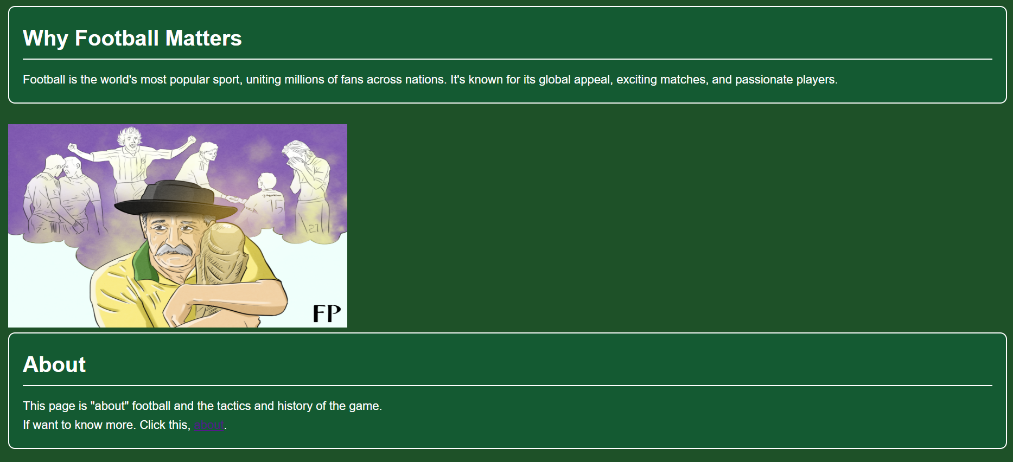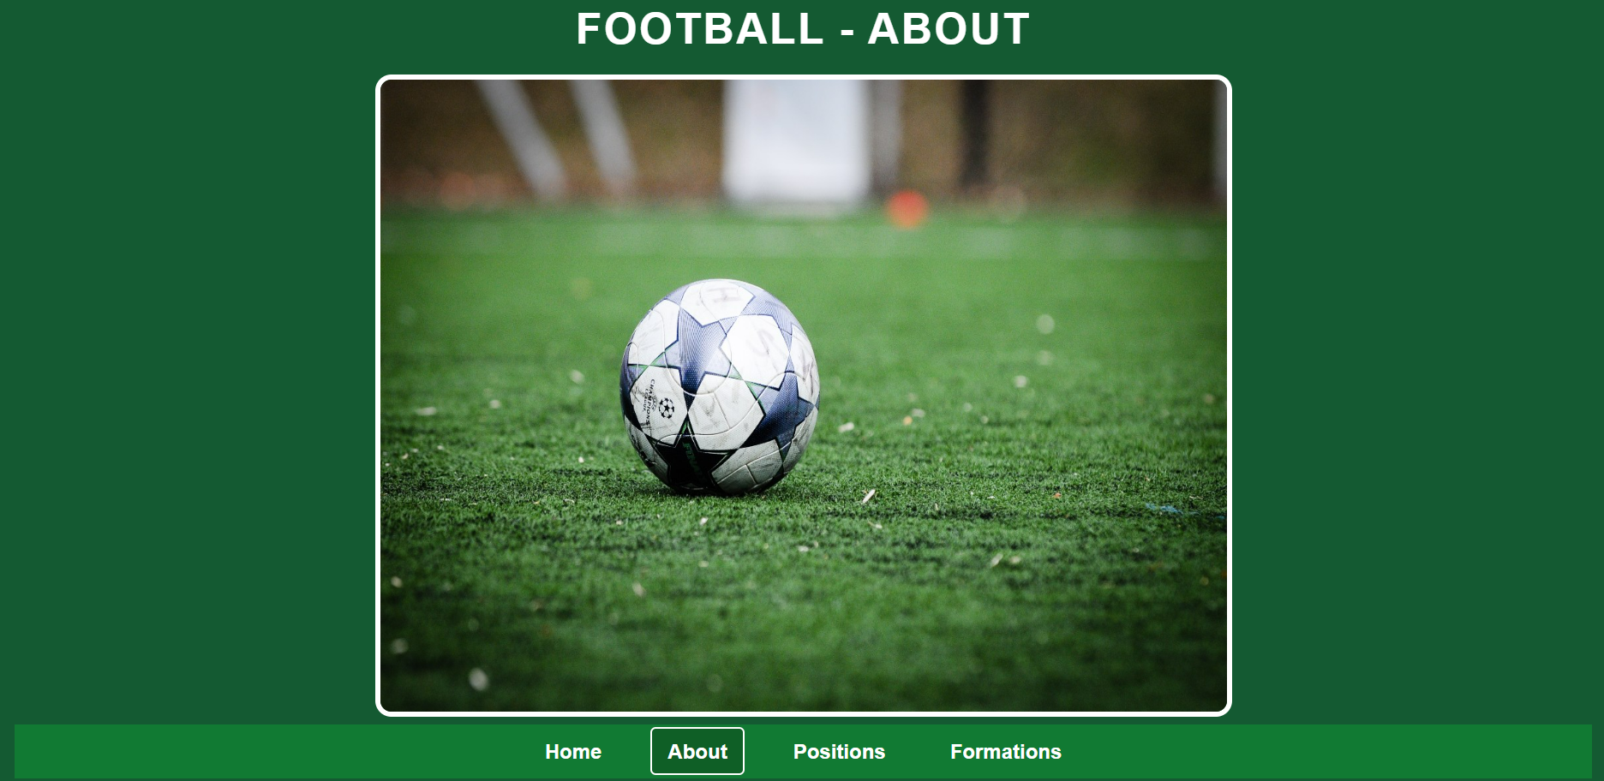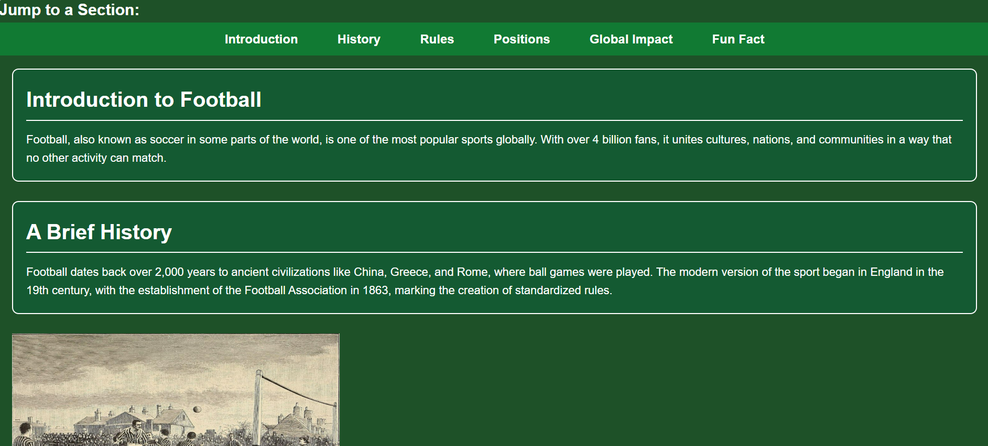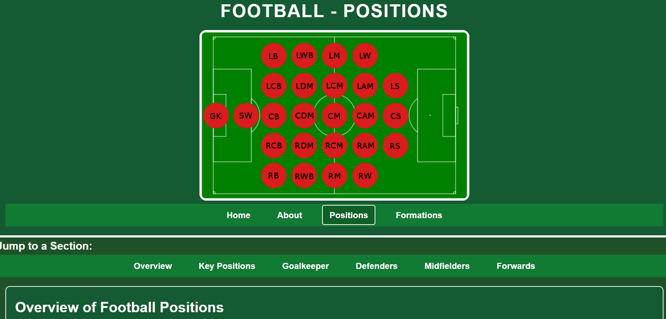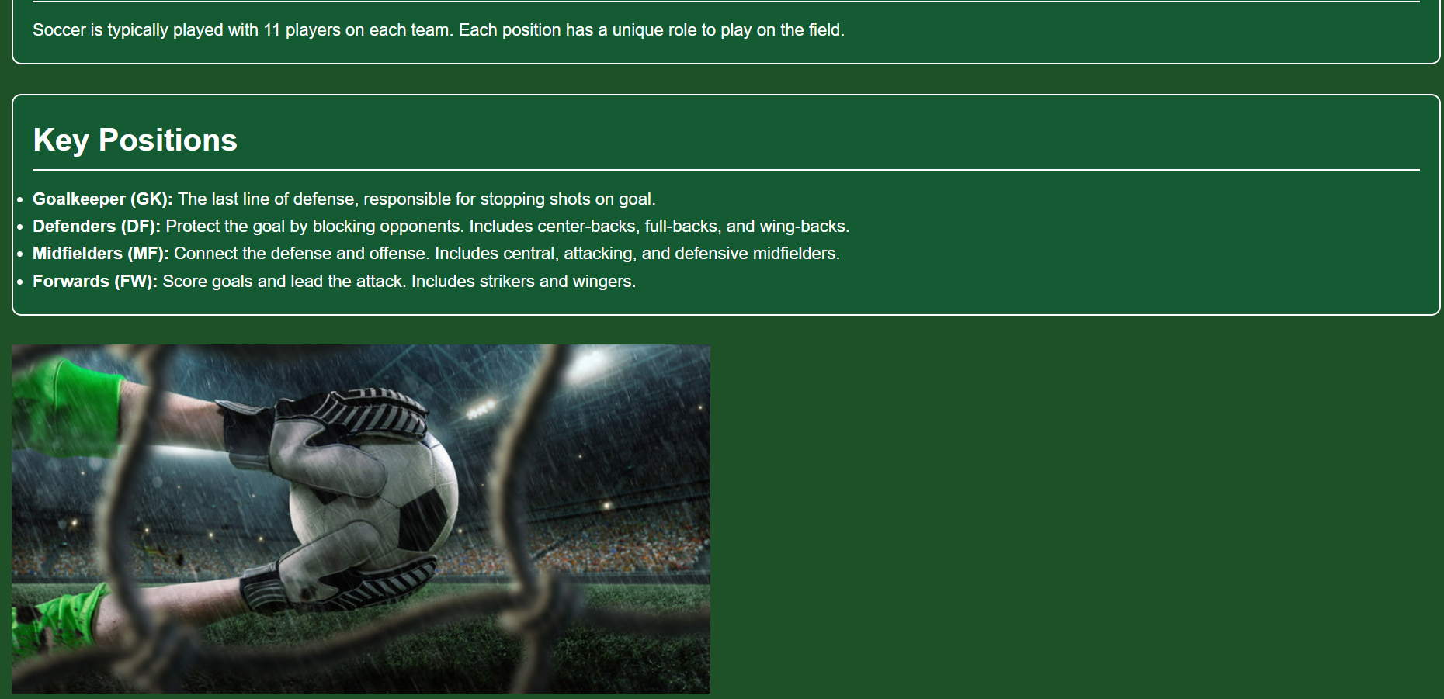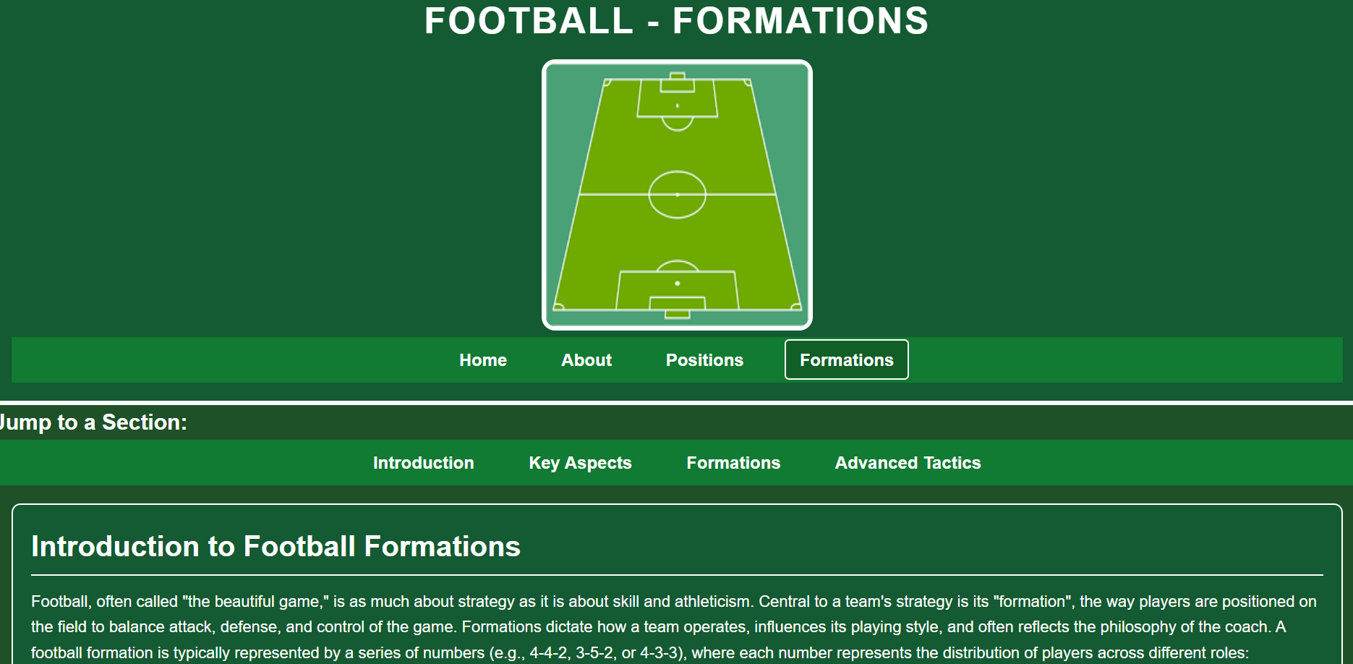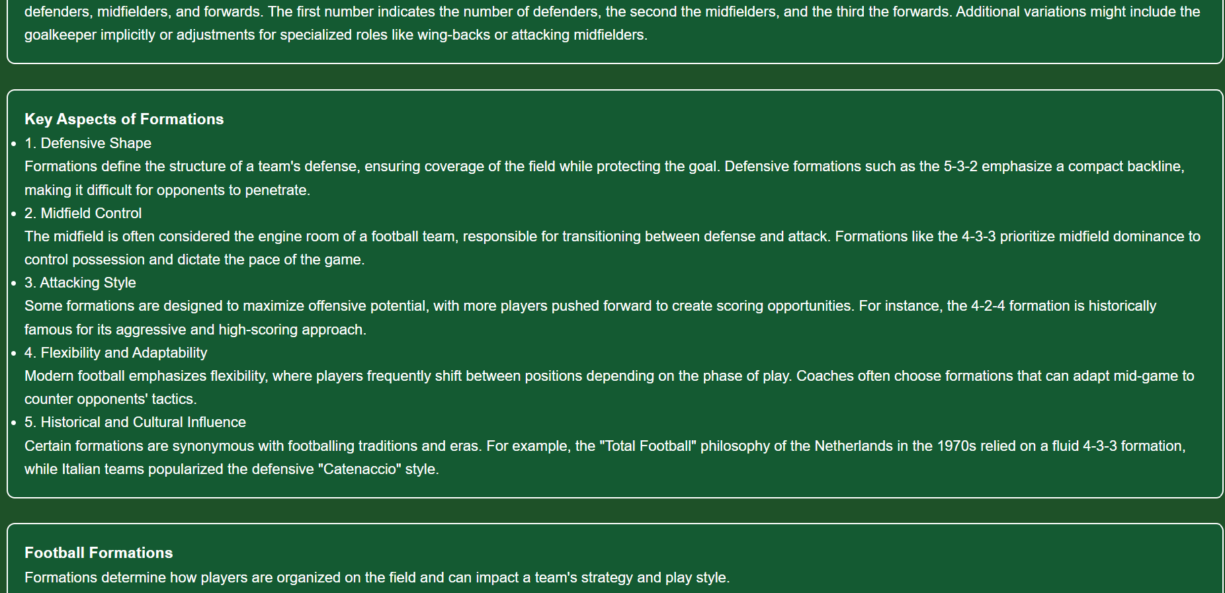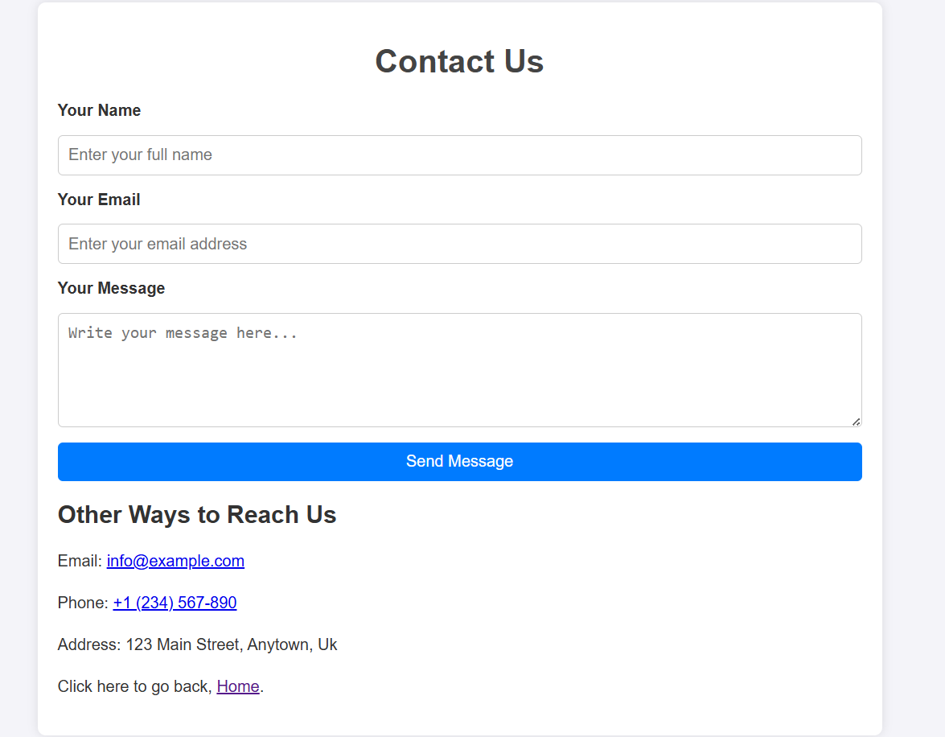

 | Validation
 | When validating my HTML code for my website, I found the errors that were the most recurring ones named “navigation” and the validator deemed it unnecessary for “nav” line or “missing closings” for like <strong> and “openers” for </p>. The navigation prompt was used twice in each of my pages because it’s use for the user was to switch between pages and can be used as a shortcut on any page the user was currently on. There was a few errors that were related to certain commands not being allowed as a child of another element, then were warnings that mention <section> needing <h2>-<h6> in order to be considered valid too. |  | With CSS, it was much simpler for me the structure, so when copying my CSS code to the validator I received no warnings or errors. With a strong grasp of structure and design, my CSS implementation successfully shows the basic styling concepts. The user experience is improved by the thoughtful integration of essential features including responsive layouts, accessible navigation, and thematic components. Flexbox and Grid are two techniques that emphasize adaptability for contemporary web settings, while the usage of text alignment, padding, and margins shows attention to detail.

 | REPORT TITLE | PAGE 3

Evaluation
1. Usability
Usability pertains to how intuitive and user-friendly the website is for its visitors. Here's the assessment:

- Navigation:
The website has a clear and straightforward navigation menu, it performs well. Dropdown menus or responsive navigation bars might be absent or not functional.

- Visual Design:
Overuse of bold colors (common in sport themes).

- Load Time:
Simple HTML/CSS websites generally load quickly.

2. Accessibility
Accessibility ensures that people with disabilities can use the website. Here's the evaluation:

- Semantic HTML Usage:
Uses semantic tags well (like <header>, <main>, <footer>). This makes the content easier to interpret for screen readers.

- Alt Text for Images:
Football-themed sites often feature numerous images (team logos, player photos, match highlights). Lack of descriptive alt text for these images can make the site inaccessible to visually impaired users.

- Color Contrast:
Football sites typically use bright, bold colors to represent team identities, but poor contrast between text and background can render content unreadable for users with visual impairments.

3. Search Engine Optimization (SEO)
SEO determines how well the website ranks in search engine results. Key areas of evaluation include:

- Meta Tags and Descriptions:
The site omit critical <title> tags, meta descriptions, or keyword-rich content, which are essential for SEO.

- Heading Structure:
Proper use of headings (<h1>, <h2>, etc.) is crucial for search engines to understand the site structure.

- URL Structure:
The website uses a clear URLs (e.g., page1.html instead of team-stats.html), which can positively impact SEO.

- Content Quality:
The content in some areas could be seen as thin but from others it tends to favor, which can lead to inconsistency in the search rankings. Additionally, a lack of internal linking reduces crawlability.

Suggestions for Improvement
To enhance usability, accessibility, and SEO, the following steps are recommended:

- Adopt semantic HTML tags to improve accessibility and SEO.

- Use high-contrast color schemes and ensure text is legible.

- Ensure the site is keyboard-friendly and integrates ARIA roles for interactive elements.

By addressing these areas, the website can become more user-friendly, accessible, and discoverable.

Sources

[1] | J. Nielsen, "Jakob Nielsen's Usability Heuristics for User Interface Design," 30 January 2024. [Online]. Available: https://www.nngroup.com/articles/ten-usability-heuristics/.
[2] | "Google Material Design Guidelines," [Online]. Available: https://material.io/design/.
[3] | S. L. Henry, "Web Content Accessibility Guidelines (WCAG) 2.1," 12 December 2024. [Online]. Available: https://www.w3.org/WAI/standards-guidelines/wcag/.
[4] | "Accessibility Insights for Web," [Online]. Available: https://accessibilityinsights.io/.
[5] | "Google Search Central (Webmasters Guidelines)," [Online]. Available: https://developers.google.com/search.
[6] | moz, "Moz Beginner's Guide to SEO," [Online]. Available: https://moz.com/beginners-guide-to-seo.
[7] | mdn, "MDN Web Docs," [Online]. Available: https://developer.mozilla.org/.
[8] | W3C, "W3C Validator," [Online]. Available: https://validator.w3.org/.



 | REPORT TITLE | PAGE 4

Appendices

“Home.html”

<!DOCTYPE html>
<html lang="en">
<head>
<!-- Document metadata -->
<meta charset="UTF-8">
<meta name="viewport" content="width=device-width, initial-scale=1.0">
<meta name="description" content="A simple website showcasing basic soccer knowledge, positions, and global impact of the sport.">
<meta name="author" content="Your Name">
<meta http-equiv="X-UA-Compatible" content="IE=edge">
<title>Football Website</title>
<link rel="stylesheet" href="styles.css"> <!-- Link to external CSS file -->
</head>

<body>

<!-- Header Section -->
<header>
<!-- Main heading of the website -->
<h1>Welcome to My Football Website</h1>
<!-- Featured image -->
<img src="football.webp" alt="A soccer ball on the field" width="500" height="300">

<!-- Navigation Bar -->
<nav>
<ul>
<!-- Navigation links to different pages -->
<li><a href="Home.html" aria-current="page">Home</a></li>
<li><a href="About.html" title="Learn more about soccer">About</a></li>
<li><a href="Positions.html" title="Get in touch with us">Positions</a></li>
<li><a href="Formations.html" title="Get in touch with us">Formations</a></li>
</ul>
</nav>
</header>

<!-- Section Shortcuts -->
<nav aria-label="Section Shortcuts" class="section-nav">
<!-- Quick navigation links to sections on the same page -->
<h2>Jump to a Section:</h2>
<ul>
<li><a href="#introduction">Introduction</a></li>
<li><a href="#football-matters">Why Football Matters</a></li>
<li><a href="#about">About</a></li>
<li><a href="#positions">Positions</a></li>
<li><a href="#formations">Formations</a></li>
</ul>
</nav>

<!-- Main Content Section -->
<main>
<!-- Introduction Section -->
<section id="introduction">
<h2>Introduction</h2>
<p>This is a football website to help inform people about the different positions and rules of the game.</p>
</section>

<!-- Why Football Matters Section -->
<section id="football-matters">
<h2>Why Football Matters</h2>
<p>Football is the world's most popular sport, uniting millions of fans across nations. It's known for its global appeal, exciting matches, and passionate players.</p>
</section>

<!-- Additional image -->
<img src="mat.webp" alt="A soccer ball on the field" width="500" height="300">

<!-- About Section -->
<section id="about">
<h2>About</h2>
<p>This page is "about" football and the tactics and history of the game.</p>
<!-- Link to the About page -->
<p>If you want to know more, click this, <a href="About.html">about</a>.</p>
</section>

<!-- Positions Section -->
<section id="positions">
<h2>Positions</h2>
<p>This page is on the different types of players that take place in the game and their roles.</p>
<!-- Link to the Positions page -->
<p>If you want to know more, click this, <a href="Positions.html">positions</a>.</p>
</section>

<!-- Formations Section -->
<section id="formations">
<h2>Formations</h2>
<p>This page is to help dictate the position and tactics each plan to use to get one over their oppositions.</p>
<!-- Link to the Formations page -->
<p>If you want to know more, click this, <a href="Formations.html">formations</a>.</p>
</section>
</main>

<!-- Footer Section -->
<footer>
<!-- Copyright and additional information -->
<p>© 2024 My Soccer Website</p>
<p>Created with passion for the beautiful game and a commitment to accessibility and user-centric design.</p>
<p>Created with love for the beautiful game. For suggestions, <a href="contacts.html">contact us</a>.</p>
</footer>

<!-- Accessibility Features -->
<!-- Example of a dialog for accessibility notice -->
<div role="dialog" aria-labelledby="dialog1" id="dialog1" style="display:none;">
<h2>Accessibility Notice</h2>
<p>We aim to provide an inclusive experience for all soccer fans. Please let us know if you have suggestions for improvement.</p>
</div>

</body>
</html>

“About.html”

<!DOCTYPE html>
<html lang="en">
<head>
<!-- Metadata and Document Information -->
<meta charset="UTF-8"> <!-- Sets the character encoding for the document -->
<meta name="viewport" content="width=device-width, initial-scale=1.0"> <!-- Ensures proper rendering and touch zooming on mobile devices -->
<meta name="description" content="Discover the beautiful game of football, its history, rules, and global impact."> <!-- Brief description of the page -->
<meta name="author" content="Your Name"> <!-- Author of the page -->
<meta http-equiv="X-UA-Compatible" content="IE=edge"> <!-- Ensures compatibility with older versions of Internet Explorer -->
<title>Football - The Beautiful Game "About"</title> <!-- Page title displayed in the browser tab -->
<link rel="stylesheet" href="styles.css"> <!-- Link to the external CSS file -->
</head>
<body>

<!-- Header -->
<header>
<!-- Main heading of the page -->
<h1>Football - About</h1>
<!-- Featured image -->
<div class="full-page">
<img src="football2.jpg" alt="A football" width="800" height="600">
</div>
<!-- Main navigation bar -->
<nav aria-label="Main Navigation">
<ul>
<!-- Links to different pages of the website -->
<li><a href="Home.html">Home</a></li>
<li><a href="About.html" aria-current="page">About</a></li>
<li><a href="Positions.html">Positions</a></li>
<li><a href="Formations.html">Formations</a></li>
</ul>
</nav>
</header>

<!-- Section Shortcuts -->
<nav aria-label="Section Shortcuts" class="section-nav">
<!-- Quick navigation within the page -->
<h2>Jump to a Section:</h2>
<ul>
<li><a href="#introduction">Introduction</a></li>
<li><a href="#history">History</a></li>
<li><a href="#rules">Rules</a></li>
<li><a href="#positions">Positions</a></li>
<li><a href="#global-impact">Global Impact</a></li>
<li><a href="#fun-fact">Fun Fact</a></li>
</ul>
</nav>

<!-- Main Content -->
<main>
<!-- Introduction Section -->
<section id="introduction">
<h2>Introduction to Football</h2>
<p>Football, also known as soccer in some parts of the world, is one of the most popular sports globally. With over 4 billion fans, it unites cultures, nations, and communities in a way that no other activity can match.</p>
</section>

<!-- History Section -->
<section id="history">
<h2>A Brief History</h2>
<p>Football dates back over 2,000 years to ancient civilizations like China, Greece, and Rome, where ball games were played. The modern version of the sport began in England in the 19th century, with the establishment of the Football Association in 1863, marking the creation of standardized rules.</p>
</section>

<!-- Image for History -->
<div class="full-page">
<img src="Old.jpg" alt="A football pitch" width="500" height="300">
</div>

<!-- Rules Section -->
<section id="rules">
<h2>Basic Rules</h2>
<ul>
<!-- List of football rules -->
<li><strong>Each team consists of 11 players, including a goalkeeper.</strong></li>
<li><strong>The objective is to score more goals than the opposing team by getting the ball into their net.</strong></li>
<li><strong>Players cannot use their hands or arms, except for goalkeepers within their penalty area.</strong></li>
<li><strong>A match consists of two halves, each lasting 45 minutes, with a 15-minute halftime break.</strong></li>
</ul>
</section>

<!-- Image for Rules -->
<div class="full-page">
<img src="rules.jpeg" alt="A football pitch" width="400" height="700">
</div>

<!-- Positions Section -->
<section id="positions">
<h2>Player Positions</h2>
<p>Football positions are divided into four main categories:</p>
<ul>
<!-- List of player positions -->
<li><strong>Goalkeeper:</strong> Protects the goal and prevents the opposing team from scoring.</li>
<li><strong>Defenders:</strong> Includes center-backs, full-backs, and wing-backs who block attacks.</li>
<li><strong>Midfielders:</strong> The link between defense and attack, responsible for controlling the game.</li>
<li><strong>Forwards:</strong> Includes strikers and wingers who lead the attack and score goals.</li>
</ul>
<!-- Link to more information about positions -->
<p>Want to know more about each position? Click here, <a href="Positions.html">more</a>.</p>
</section>

<!-- Image for Positions -->
<img src="ppos.webp" alt="A football pitch" width="500" height="500">

<!-- Global Impact Section -->
<section id="global-impact">
<h2>Football's Global Significance</h2>
<p>Football is more than just a sport; it’s a global phenomenon. Events like the FIFA World Cup and UEFA Champions League draw millions of viewers, fostering unity and pride among nations. Grassroots initiatives use football to empower youth, promote health, and build communities worldwide.</p>
</section>

<!-- Image for Global Impact -->
<div class="full-page">
<img src="ronaldo.jpg" alt="A football pitch" width="500" height="500">
</div>

<!-- Fun Fact Section -->
<section id="fun-fact">
<h2>Fun Fact</h2>
<p>The FIFA World Cup is the most-watched sporting event in the world, with over 3.5 billion people tuning in to watch the 2018 edition.</p>
</section>
</main>

<!-- Footer -->
<footer>
<!-- Footer content -->
<p>© 2024 Football Website</p>
<p>Created with love for the beautiful game. For suggestions, <a href="contacts.html">contact us</a>.</p>
</footer>

</body>
</html>

“Positions.html”

<!DOCTYPE html>
<html lang="en">
<head>
<!-- Meta information for the page -->
<meta charset="UTF-8">
<meta name="viewport" content="width=device-width, initial-scale=1.0">
<meta name="description" content="Learn about different soccer positions and their roles on the field.">
<title>Football - The Beautiful Game "Positions"</title>
<link rel="stylesheet" href="styles.css"> <!-- Link to the external CSS file -->
</head>
<body>
<!-- Header section -->
<header>
<h1>Football - Positions</h1>
<div class="full-page">
<img src="pos.png" alt="Centered image"> <!-- Image displaying football positions -->
</div>
<!-- Navigation menu -->
<nav aria-label="Main Navigation">
<ul>
<li><a href="Home.html">Home</a></li> <!-- Link to the home page -->
<li><a href="About.html">About</a></li> <!-- Link to the about page -->
<li><a href="Positions.html" aria-current="page">Positions</a></li> <!-- Current page -->
<li><a href="Formations.html">Formations</a></li> <!-- Link to the formations page -->
</ul>
</nav>
</header>

<!-- Section Shortcuts -->
<nav aria-label="Section Shortcuts" class="section-nav">
<h2>Jump to a Section:</h2>
<ul>
<!-- Links to different sections within the page -->
<li><a href="#overview">Overview</a></li>
<li><a href="#key-pos">Key Positions</a></li>
<li><a href="#goalkeeper">Goalkeeper</a></li>
<li><a href="#defender">Defenders</a></li>
<li><a href="#midfielder">Midfielders</a></li>
<li><a href="#forward">Forwards</a></li>
</ul>
</nav>

<!-- Main content -->
<main>
<!-- Overview section -->
<section id="overview">
<h2>Overview of Football Positions</h2>
<p>Soccer is typically played with 11 players on each team. Each position has a unique role to play on the field.</p>
</section>

<!-- Key Positions section -->
<section id="key-pos">
<h2>Key Positions</h2>
<ul>
<!-- Brief descriptions of key positions -->
<li><strong>Goalkeeper (GK):</strong> The last line of defense, responsible for stopping shots on goal.</li>
<li><strong>Defenders (DF):</strong> Protect the goal by blocking opponents. Includes center-backs, full-backs, and wing-backs.</li>
<li><strong>Midfielders (MF):</strong> Connect the defense and offense. Includes central, attacking, and defensive midfielders.</li>
<li><strong>Forwards (FW):</strong> Score goals and lead the attack. Includes strikers and wingers.</li>
</ul>
</section>

<!-- Image for visual context -->
<div class="full-page">
<img src="gksave.jpg" alt="Centered image"> <!-- Image related to goalkeeper actions -->
</div>

<!-- Goalkeeper section -->
<section id="goalkeeper">
<h2>Goalkeeper (GK)</h2>
<p>The goalkeeper is the backbone of the defense and the only player allowed to use their hands, but only within their penalty area...</p>
<section>
<h3><strong>Alternative Roles:</strong></h3>
<ul>
<!-- Different styles of goalkeeping -->
<li><em>Traditional Shot-Stopper:</em> Focused on making reflex saves and blocking shots with minimal involvement in the playmaking.</li>
<li><em>Sweeper Keeper:</em> Plays aggressively outside the penalty area...</li>
</ul>
</section>
</section>

<!-- Similar structure for Defenders, Midfielders, and Forwards -->
<div class="full-page">
<img src="def.webp" alt="Centered image"> <!-- Image related to defenders -->
</div>
<section id="defender">
<h2>Defender (DF)</h2>
<p>Defenders are responsible for protecting their team's goal...</p>
<section>
<h3><strong>Alternative Roles:</strong></h3>
<ul>
<li><em>Center-Back (CB):</em> Positioned centrally, tasked with aerial duels...</li>
<li><em>Full-Back (FB):</em> Positioned on the flanks...</li>
</ul>
</section>
</section>

<div class="full-page">
<img src="mid.jpg" alt="Centered image"> <!-- Image related to midfielders -->
</div>
<section id="midfielder">
<h2>Midfielder (MF)</h2>
<p>Midfielders are the engine of the team...</p>
<section>
<h3><strong>Alternative Roles:</strong></h3>
<ul>
<li><em>Defensive Midfielder (DM):</em> A deep-lying player...</li>
<li><em>Box-to-Box Midfielder:</em> A versatile role...</li>
</ul>
</section>
</section>

<div class="full-page">
<img src="str.webp" alt="Centered image"> <!-- Image related to forwards -->
</div>
<section id="forward">
<h2>Forward (FW)</h2>
<p>Forwards are the primary goal-scoring threat...</p>
<section>
<h3><strong>Alternative Roles:</strong></h3>
<ul>
<li><em>Striker (ST):</em> Focuses on scoring goals...</li>
<li><em>Winger (LW/RW):</em> Operates on the flanks...</li>
</ul>
</section>
</section>
</main>

<!-- Footer section -->
<footer>
<p>© 2024 My Soccer Website</p>
<p>Created with love for the beautiful game. For suggestions, <a href="contacts.html">contact us</a>.</p>
</footer>
</body>
</html>
“Formations.html”

<!DOCTYPE html>
<html lang="en">
<head>
<!-- Metadata section for SEO and responsive design -->
<meta charset="UTF-8">
<meta name="viewport" content="width=device-width, initial-scale=1.0">
<meta name="description" content="Learn about different soccer formations and tactics used by teams.">
<title>Football - The Beautiful Game "Formations"</title>
<link rel="stylesheet" href="styles.css"> <!-- Link to external CSS stylesheet -->
</head>
<body>
<header>
<!-- Page header with title and main navigation menu -->
<h1>Football - Formations</h1>
<img src="template.png" alt="A football pitch" width="300" height="300">
<nav aria-label="Main Navigation">
<!-- Navigation menu linking to different pages -->
<ul>
<li><a href="Home.html">Home</a></li>
<li><a href="About.html">About</a></li>
<li><a href="Positions.html">Positions</a></li>
<li><a href="Formations.html" aria-current="page">Formations</a></li>
</ul>
</nav>
</header>

<!-- Section shortcuts for quick navigation within the page -->
<nav aria-label="Section Shortcuts" class="section-nav">
<h2>Jump to a Section:</h2>
<ul>
<li><a href="#introduction">Introduction</a></li>
<li><a href="#key-aspects">Key Aspects</a></li>
<li><a href="#formations">Formations</a></li>
<li><a href="#advanced">Advanced Tactics</a></li>
</ul>
</nav>

<main>
<!-- Section: Introduction -->
<section id="introduction">
<h2>Introduction to Football Formations</h2>
<p>Football, often called "the beautiful game," is as much about strategy as it is about skill and athleticism...</p>
</section>

<!-- Section: Key Aspects -->
<section id="key-aspects">
<h3>Key Aspects of Formations</h3>
<ul>
<li>1. Defensive Shape</li>
</ul>
<p>Formations define the structure of a team's defense...</p>
<ul>
<li>2. Midfield Control</li>
</ul>
<p>The midfield is often considered the engine room of a football team...</p>
<ul>
<li>3. Attacking Style</li>
</ul>
<p>Some formations are designed to maximize offensive potential...</p>
<ul>
<li>4. Flexibility and Adaptability</li>
</ul>
<p>Modern football emphasizes flexibility...</p>
<ul>
<li>5. Historical and Cultural Influence</li>
</ul>
<p>Certain formations are synonymous with footballing traditions...</p>
</section>

<!-- Section: Formations -->
<section id="formations">
<h3>Football Formations</h3>
<p>Formations determine how players are organized on the field...</p>
</section>

<!-- Images of different formations -->
<img src="442.png" alt="A football pitch" width="300" height="300">
<img src="433.png" alt="A football pitch" width="300" height="300">
<img src="352.png" alt="A football pitch" width="300" height="300">
<img src="532.png" alt="A football pitch" width="300" height="300">
<img src="4231.png" alt="A football pitch" width="250" height="300">

<!-- Section: Common Formations -->
<section>
<h3>Common Formations</h3>
<ul>
<li><strong>4-4-2:</strong> Balanced with four defenders, four midfielders, and two forwards.</li>
<li><strong>4-3-3:</strong> Offensive, with three forwards supported by three midfielders.</li>
<li><strong>3-5-2:</strong> Midfield-heavy, focusing on ball control and counter-attacks.</li>
<li><strong>5-3-2:</strong> Defensive, with five defenders and a counter-attacking approach.</li>
<li><strong>4-2-3-1:</strong> Balanced, but also flexible with the option to either be more defensive or offensive.</li>
</ul>
</section>

<!-- Section: Advanced Tactics -->
<section id="advanced">
<h3>Advanced Tactics</h3>
<p>Teams often adapt their formations dynamically during a match...</p>
<section>
<h3>Examples of These:</h3>
<ul>
<li><strong>Park the Bus:</strong> All outfield players on a team to drop back into their own half...</li>
<li><strong>Counter-Attack:</strong> When first winning the possession of the ball...</li>
<li><strong>All-out Attack:</strong> Push almost all outfield players on a team to push up...</li>
</ul>
</section>
</section>

<!-- Full-page image for advanced tactics -->
<div class="full-page">
<img src="tactical-board.jpg" alt="Centered image">
</div>
</main>

<!-- Footer section -->
<footer>
<p>© 2024 My Soccer Website</p>
<p>Created with love for the beautiful game. For suggestions, <a href="contacts.html">contact us</a>.</p>
</footer>
</body>
</html>

“contacts.html”

<!DOCTYPE html>
<html lang="en">
<head>
<!-- Basic metadata for SEO and responsive design -->
<meta charset="UTF-8">
<meta name="viewport" content="width=device-width, initial-scale=1.0">
<title>Contact Us</title>
<link rel="stylesheet" href="contact.css"> <!-- Link to external CSS file for styling -->
</head>
<body>
<!-- Main container for the Contact Us page -->
<div class="container">
<h1>Contact Us</h1> <!-- Main heading for the page -->

<!-- Contact form section -->
<form>
<!-- Input field for the user's name -->
<label for="name">Your Name</label>
<input type="text" id="name" name="name" placeholder="Enter your full name" required>

<!-- Input field for the user's email -->
<label for="email">Your Email</label>
<input type="email" id="email" name="email" placeholder="Enter your email address" required>

<!-- Text area for the user's message -->
<label for="message">Your Message</label>
<textarea id="message" name="message" rows="5" placeholder="Write your message here..." required></textarea>

<!-- Submit button for sending the form -->
<button type="submit">Send Message</button>
</form>

<!-- Contact information section -->
<div class="contact-info">
<h2>Other Ways to Reach Us</h2> <!-- Heading for additional contact methods -->
<p>Email: <a href="mailto:info@example.com">info@example.com</a></p> <!-- Email link -->
<p>Phone: <a href="tel:+1234567890">+1 (234) 567-890</a></p> <!-- Phone number link -->
<p>Address: 123 Main Street, Anytown, Uk</p> <!-- Physical address -->
<p>Click here to go back, <a href="Home.html">Home</a>.</p> <!-- Link back to the home page -->
</div>
</div>
</body>
</html>

“styles.css”

/* General Reset */
/* Resets margin, padding, and sets the box-sizing model for consistent layouts */
* {
margin: 0;
padding: 0;
box-sizing: border-box;
}

/* Base Styles for the Body */
/* Sets the font, background color, text color, and line height for the entire page */
body {
font-family: 'Arial', sans-serif;
background-color: #1e5128; /* Turf green background */
color: #ffffff; /* White text for readability */
line-height: 1.6;
margin: 0;
}

/* Header Styles */
/* Styles for the header, including background, text alignment, and borders */
header {
background: #145a32; /* Darker green for contrast */
color: #ffffff;
padding: 20px;
text-align: center;
border-bottom: 5px solid #ffffff; /* Mimics the boundary lines on a soccer field */
}

/* Header Text */
/* Styling for the main heading inside the header */
header h1 {
font-size: 2.5rem;
font-weight: bold;
text-transform: uppercase;
letter-spacing: 2px;
}

/* Header Image */
/* Adds styling for images in the header */
header img {
border: 5px solid #ffffff;
border-radius: 15px; /* Rounded image for a modern look */
margin-top: 10px;
}

/* Navigation Bar */
/* Styles the navigation bar and its items */
nav ul {
list-style: none; /* Removes bullet points from the list */
display: flex; /* Arranges navigation items horizontally */
justify-content: center;
background: #117a33; /* Slightly lighter green */
padding: 10px 0;
}

/* Navigation List Items */
/* Adds spacing and alignment to navigation links */
nav ul li {
margin: 0 15px;
}

/* Navigation Links */
/* Sets colors, fonts, and hover effects for the navigation links */
nav ul li a {
color: #ffffff;
text-decoration: none;
font-size: 1.2rem;
font-weight: bold;
padding: 10px 15px;
border-radius: 5px;
transition: background-color 0.3s, transform 0.2s;
}

/* Hover Effect for Navigation Links */
nav ul li a:hover {
background: #0f5f26;
transform: scale(1.1);
}

/* Main Content Area */
/* General padding and spacing for the main content sections */
main {
padding: 20px;
}

/* Section Styles */
/* Adds background, borders, and spacing to sections */
main section {
margin-bottom: 30px;
padding: 20px;
background: #145a32;
border: 2px solid #ffffff; /* Mimics soccer field lines */
border-radius: 10px;
}

/* Section Headings */
/* Styling for section titles with borders for emphasis */
main h2 {
font-size: 2rem;
border-bottom: 2px solid #ffffff;
padding-bottom: 5px;
margin-bottom: 15px;
}

/* Section Text */
/* General text and list styling for sections */
main p, main ul li {
font-size: 1.1rem;
}

/* Footer Styles */
/* Styles for the footer area with background and padding */
footer {
background: #117a33;
color: #ffffff;
text-align: center;
padding: 15px;
border-top: 5px solid #ffffff;
margin-top: 20px;
}

/* Footer Text */
/* General font size for footer text */
footer p {
font-size: 1rem;
}

/* Accessibility Dialog */
/* Styles for dialogs, with a darker background and white text for contrast */
div[role="dialog"] {
background: #0f5f26; /* Darker overlay effect */
color: #ffffff;
padding: 20px;
border: 3px solid #ffffff;
border-radius: 10px;
}

/* Highlight Active Tab */
/* Adds special styling for the currently active navigation tab */
nav ul li a[aria-current="page"] {
background: #0f5f26;
font-weight: bold;
border: 2px solid #ffffff;
}

/* Button Styles */
/* Styling for buttons, including hover effects */
button {
background: #0f5f26;
color: #ffffff;
border: 2px solid #ffffff;
padding: 10px 15px;
border-radius: 5px;
font-size: 1rem;
cursor: pointer;
transition: background-color 0.3s, transform 0.2s;
}

/* Hover Effect for Buttons */
button:hover {
background: #145a32;
transform: scale(1.05);
}

/* Responsive Design */
/* Styles for screens smaller than 768px for better mobile compatibility */
@media (max-width: 768px) {
/* Stacks navigation items vertically for smaller screens */
nav ul {
flex-direction: column;
align-items: center;
}

/* Adjusts header font size for smaller screens */
header h1 {
font-size: 2rem;
}

/* Reduces padding for the main content */
main {
padding: 10px;
}

/* Reduces margin for navigation items on smaller screens */
nav ul li {
margin: 5px 0;
}

/* Section Navigation Styling for Smaller Screens */
.section-nav {
background: #117a33;
padding: 10px 20px;
margin: 20px 0;
border: 2px solid #ffffff;
border-radius: 10px;
}

.section-nav h2 {
color: #ffffff;
font-size: 1.5rem;
margin-bottom: 10px;
}

/* Styles for the section navigation list and items */
.section-nav ul {
list-style: none;
display: flex;
flex-wrap: wrap;
gap: 10px;
padding: 0;
}

.section-nav ul li {
margin: 0;
}

/* Styles for links in the section navigation */
.section-nav ul li a {
color: #ffffff;
text-decoration: none;
font-weight: bold;
background: #145a32;
padding: 5px 10px;
border-radius: 5px;
transition: background-color 0.3s;
}

/* Hover effect for section navigation links */
.section-nav ul li a:hover {
background: #0f5f26;
}
}

“contact.css”

/* Base Styles for the Body */
/* Sets the default font, removes margin and padding, and applies a light background color */
body {
font-family: Arial, sans-serif; /* Clean, simple font */
margin: 0; /* Removes default margin */
padding: 0; /* Removes default padding */
background-color: #f4f4f9; /* Light gray background for a clean look */
color: #333; /* Dark gray text color for readability */
}

/* Container Styles */
/* Centralizes and styles the main content container */
.container {
max-width: 800px; /* Limits the width of the content */
margin: 50px auto; /* Centers the container vertically and horizontally */
padding: 20px; /* Adds space inside the container */
background: #fff; /* White background for contrast with the body */
border-radius: 8px; /* Slightly rounded corners for a modern look */
box-shadow: 0 0 10px rgba(0, 0, 0, 0.1); /* Subtle shadow for depth */
}

/* Heading Styles */
/* Centers the main heading and applies color */
h1 {
text-align: center; /* Centers the heading text */
color: #444; /* Darker gray for emphasis */
}

/* Form Styles */
/* Lays out the form elements and adds spacing */
form {
display: flex; /* Enables flexible layout for form elements */
flex-direction: column; /* Stacks elements vertically */
gap: 15px; /* Adds space between form elements */
}

/* Label Styles */
/* Boldens the labels for better readability */
label {
font-weight: bold; /* Highlights the labels */
}

/* Input, Textarea, and Button Styles */
/* Applies consistent styling to form inputs, textarea, and button */
input, textarea, button {
font-size: 1rem; /* Ensures consistent text size */
padding: 10px; /* Adds space inside the elements */
border: 1px solid #ccc; /* Light border for a clean look */
border-radius: 5px; /* Rounded corners for modern appearance */
}

/* Button Styles */
/* Styles the submit button for a professional look */
button {
background-color: #007BFF; /* Blue background for the button */
color: #fff; /* White text for contrast */
border: none; /* Removes default button border */
cursor: pointer; /* Changes the cursor to pointer on hover */
}

/* Hover Effect for Button */
/* Adds interactivity by changing the button color on hover */
button:hover {
background-color: #0056b3; /* Darker blue when the button is hovered */
}

/* Contact Information Section */
/* Styles the additional contact information below the form */
.contact-info {
margin-top: 20px; /* Adds space above the contact information */
}

/* Contact Information Text */
/* Sets a comfortable line height for readability */
.contact-info p {
line-height: 1.6; /* Increases space between lines for better readability */
}

