AI Cover Sheet
I confirm that I have not presented any AI generated text as my own work. I confirm I have copies of my drafts, notes and other resources I used before, and after the use of AI tools which I may be asked to provide in evidence.
Cover sheet

Section 1-Page 3
Section 2- Page 4-8
Section 3- Page- 9-13
Section 4- Page 14-19
Reference list- Page 20-24

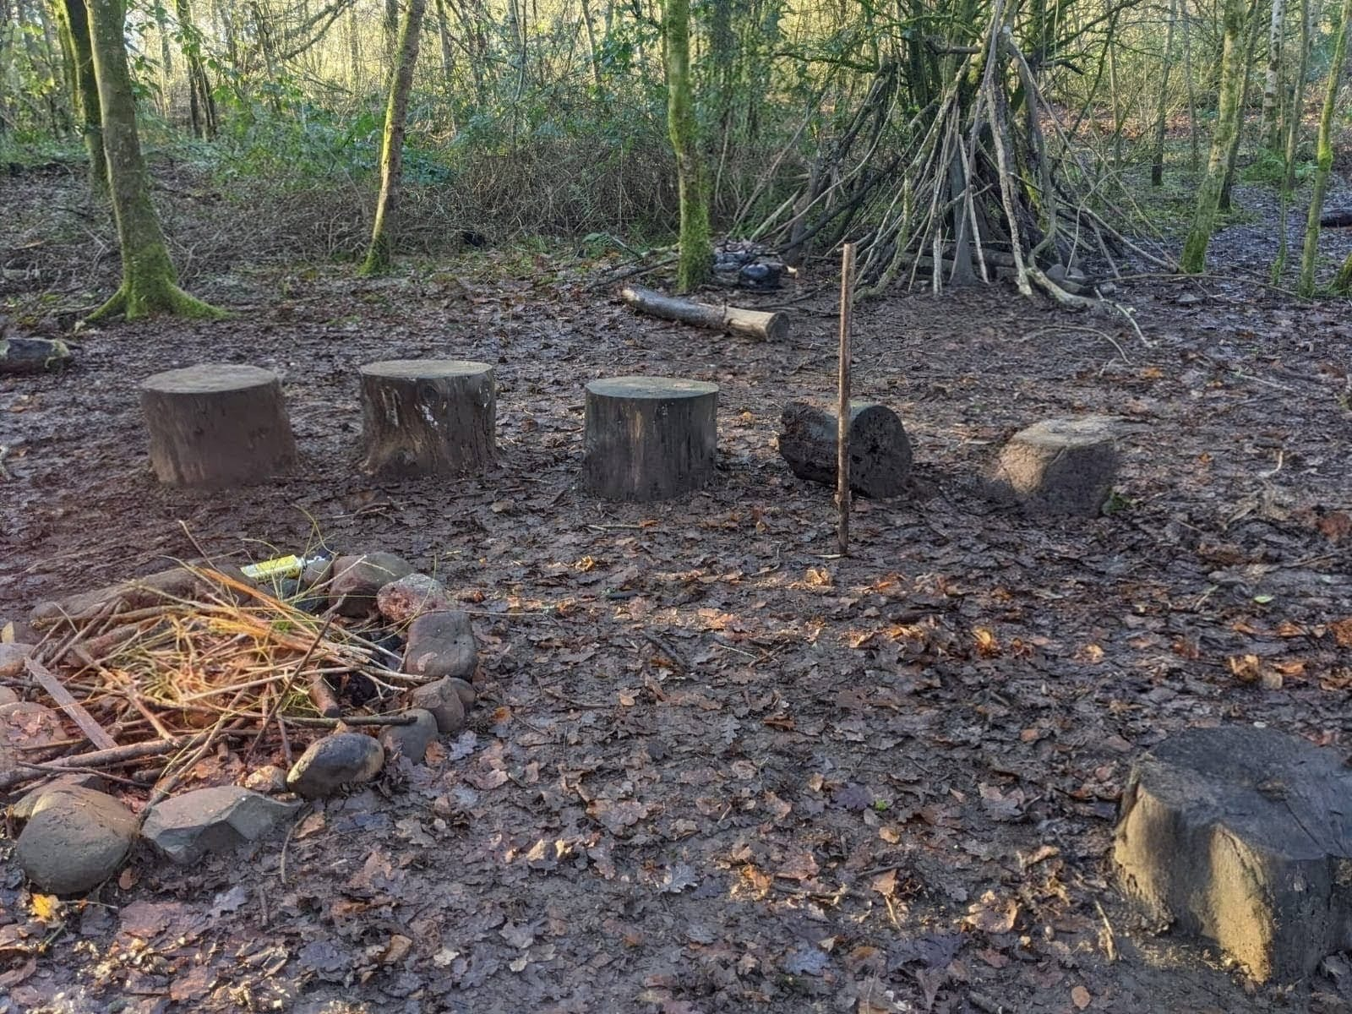
Taff Snail woodland area
Begum (2025)

Learning reflection
This session took place at the woodland fire pit area with a group of 15 children aged 4–5 years old. A total of five staff members were present, giving a ratio of 1:3. This higher ratio allowed staff to position themselves around the area for supervision and safety while also being available to join in conversations, initiate open-ended questions, and extend the children’s learning without taking control.
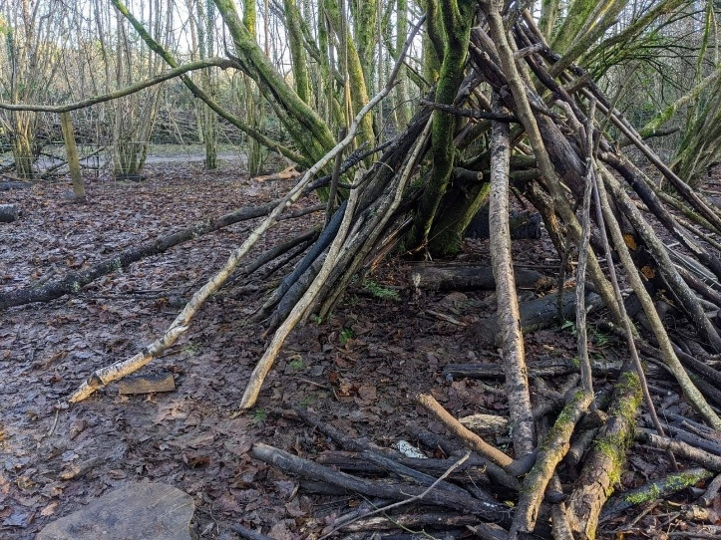
The den quickly became the centre of the children’s play. A small group children gathered natural materials, selecting sticks of different lengths and thicknesses. Some worked together to drag larger branches, while others carefully chose smaller sticks that were easier to carry. This highlighted the collaborative nature of the activity, with children of different abilities contributing in ways that suited their strengths.
Begum (2025)
They experimented by testing how to balance sticks against the structure. Each attempt brought anticipation as they waited to see if the stick would hold. When it did, their excitement showed a clear realisation that certain positions gave more stability. One child observed, “The sticks are holding each other up,” which demonstrated early scientific thinking linked to forces and balance. This connects to the Science and Technology Area of Learning and Experience in the Curriculum for Wales, where children begin to notice cause and effect in the physical world (Welsh Government, 2022)
Adults supported the play by observing and asking open-ended questions that encouraged children to think deeper without interrupting the play. For example, asking, “Why do you think that one stayed up?” or “What would happen if we used a heavier stick?” helped scaffold children’s reasoning. These types of questions supported metacognitive talk amongst children, encouraging children to reflect on their actions and share their thinking with friends. Conversations between the children also showed this reflection, with comments such as, “That one fell because it’s wet,” or “Let’s try putting it the other way.”
As well as developing scientific understanding, the den gave children the chance to build resilience. When sticks fell, they remained resilient and tried again. This willingness to persist highlighted confidence in taking risks and not being discouraged by setbacks, supporting their development as healthy, confident individuals (Welsh Government, 2022). The physical aspect of lifting, carrying, and balancing sticks also built gross motor strength and coordination, which links to their physical well-being.

To extend the play further, loose parts such as ropes, tarpaulin, or fabric were introduced, offering opportunities to explore different materials and test how they change the strength or stability of the den. Children also measured sticks, introducing elements of mathematical learning through comparing lengths and problem solving. In this way, the simple activity of building a den created rich opportunities for holistic development. This links to Mathematics- measuring and comparing, Science and Technology- cause and effect and Health and Well-being by interacting with others within the Curriculum for Wales (Welsh Government, 2022).
Peak mountaineering (n.d.)

By the firepit, a group of children began “cooking” with the natural resources around them. They gathered leaves, sticks, stones, and mud, mixing them together to create their own recipes. Some stirred with sticks, others crushed leaves between their hands, and a few proudly presented their “soups” to friends. This showed imagination and collaboration, as they shared ideas and offered one another a taste of their creations. There was clear anticipation each time they revealed a new mixture, and persistence when their first attempts didn’t go as planned.
Begum (2025)

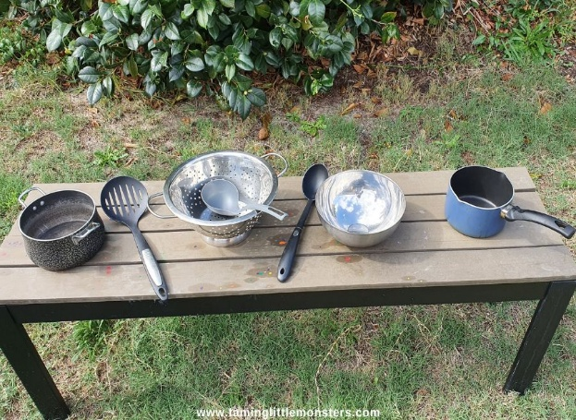
When cooking resources were added, the play deepened. The children quickly noticed that filling the pan with water made it heavier. One child pointed out, “It’s full now, that’s why it’s harder to lift,” showing their awareness of how water changes weight. Adults encouraged reflection by asking questions such as, “Why do you think it feels heavier now?” and “What do you think will happen if we add more?” These questions supported the children in making links between cause and effect, connecting directly to the Science and Technology Area of Learning and Experience in the Curriculum for Wales (Welsh Government, 2022).
Taming little monsters (2025)

The resources also encouraged fine motor skills and independence. Children stirred leaves in bowls, carefully handing spoons, and worked hard to thread leaves onto sticks. At first this was tricky, but their persistence paid off, and the pride on their faces showed how much they valued their achievement. Adults supported by modelling safe tool use and stepping back to let the children problem-solve on their own, which helped build resilience and confidence.
As well as technology and science learning, the play brought important social and emotional development. Children took turns with the tools, supported one another with tasks, and celebrated each other’s creations. With the right tools and adult support, the children explored cause and effect, developed independence, and strengthened both their social and physical skills.
Within the school setting, children can visit the mud kitchen and forest school area and use theses spaces to build on their ideas, experiment with natural materials, and extend their learning through imaginative play, problem solving, and science and technology experiences. To extend this activity further, additional resources such as measuring jugs, sieves, or child-safe knives can be introduced. These will give children opportunities to explore how equipment is used for purpose, such as pouring, sifting, cutting, developing independence and practical skills that link to science and technology area of learning in the Curriculum for Wales (Welsh Government, 2022).

Within the woodland area, some children started picking up sticks and stones, making little piles on the ground. Straight away they compared who had more and who had less, which led to them trying to share things out, so it was fair. One child suggested, “We can all have the same,” and the others agreed. This showed their early number skills but also their sense of fairness, as they wanted everyone to be included. Adults joined in with questions like, “How can we share these, so everyone gets some?” which helped the children to think about problem-solving and numbers in a way that made sense to them. Here, they were showing themselves to be ambitious, capable learners by using their curiosity and reasoning to solve problems (Welsh Government, 2022). Adding resources such as muffin trays, bowls and other containers helped the children to sort into quantities precisely ensuring fairness.
Renkel (n.d.)

As they played, they began noticing differences in size and shape. Some sticks were long, some short, and this led to sorting and comparing. A few children lined the sticks up from biggest to smallest, while others made repeating patterns using sticks and stones. They explained their ideas to friends, using words like “longer,” “shorter,” and “same.” Adults also added in simple Welsh words such as “mwy” and “llai” , which the children repeated as part of their play, linking their learning to literacy and Welsh language.
The physical side of the activity was clear too. Carrying logs, balancing sticks, and placing stones into groups all helped build strength and coordination. They were becoming healthy, confident individuals through this, showing persistence, resilience, and pride in their achievements. Socially, the activity brought lots of opportunities to work together. Sometimes there were disagreements over who had the biggest stick or the most stones, but these moments gave the children the chance to practise sharing, turn-taking, and compromise. They were proud when they solved a problem, like when they found a way to make the piles equal. They supported each other and celebrated together, which helped build confidence and relationships. This also linked to them being ethical, informed citizens within the Curriculum for Wales (Welsh Government, 2022), as they were thinking about fairness, inclusion, and how their choices affected others.
Across the session, the children demonstrated the Four Purposes of the Curriculum for Wales (Welsh Government, 2022). They were ambitious learners as they explored and tested ideas, creative contributors as they built, engaged in imaginative play, and invented recipes, ethical citizens in respecting nature and each other, and healthy, confident individuals as they built resilience, independence, and physical well-being through play. The activities also showed how science, maths, and technology linked naturally to literacy, expressive arts, humanities and health and well-being. With enough staff present to ensure safety and guide conversations, the children were able to take the lead, while adults extended their thinking through meaningful questions. The key qualities of exploration, anticipation, persistence, initiation, and realisation were visible throughout, making this a great example of child-led outdoor learning.

RISK BENEFIT ASSESSMENT

Location / Activity: | Taff Snail woodland area | Date: | 12.09.2025
Assessor: | Acklima Begum | Review date: | 12.09.2026

Area/activity being assessed | How will young people BENEFIT from this activity? | Hazards and associated risks | Who is at risk? | PRECAUTIONS in place to reduce the risk of injury | Overall risk after precautions  RATING: L/M/H
Supervision | Children learn about staying safe as part of a group. They learn rules and boundaries and why they are important. Builds responsibility. | Children wandering away, becoming lost, stranger danger. | Children | Clear boundaries explained and marked. Safety talk before the activity. Regular headcounts to be taken. High staff ratio 1:3. Children reminded to stay where adults can see them | Low
Medical needs | Inclusive practice and children can fully take part and be included. Builds independence as children learn how to manage their own health. | Asthma attacks, allergic reaction, existing health conditions. Existing injuries, cuts and grazes. | Children | Medical forms to be checked before trip and consent to be given. Staff to carry required medication, inhalers/epi-pens. First aid trained staff to be available. First aid kit carried at all times. | Low

Travel (bus  and  boarding) | Children get used to travelling as group. They practice, waiting, listening, following instructions and sitting safely with a seatbelt on. Helps build confidence for future trips | Slips on steps, pushing when excited, rod traffic accident, children moving around the bus. Risk of separation. | Children and staff | Travel will be arranged with a trusted bus company. Bus parked in a safe location. Staff at door to help children on and off one at a time. Reminders given to hold the handrail and no push. Seatbelts checked before leaving. Staff sat across the bus for supervision. High staff to children ratio. Children to wear high vis vests. Staff keep close supervision and check head count regularly and at every transition point. Sick bags and wipes carried. Emergency kit to be carried | Low
Weather | Children will learn how different weather feels, if they are hot or cold. They will learn the importance of preparing for different weathers and learn to dress appropriately, learning self-care. | Heavy rain, snow or ice making ground slipperly. Strong winds causing branches to fall resulting in serious injuries. Sunburn, dehydration, children getting too hot or too cold. | Children and staff | Weather checked on Met Office prior to trip. Cancel if it is unsafe. Children to wear suitable clothing. Staff to carry spare waterproofs, hats, gloves. Parents to supply suncreams and spare suncream to be carried by staff. Water breaks to be given frequently for hot weather. Staff to remind children to walk slowly on slippery grounds. Towels to wipe log circles to avoid slips. | Low
Woodland area, uneven group, pot holes, sticks. | Children build confidence moving on uneven grounds developing the vestibular sense and learning to balance. Opportunities to see natural environment, great for their well-being. | Trips, slips, scratches, insect bites, allergies. Children wandering off. | Children and staff | Clear rules and boundaries explained. Staff placed around areas for close supervision. First aid kit to be carried. Allergy details to be checked before trip and medication to be supply and signed for by parents. High vis vest to be worn by children. Staff to know the procedures in the case of an emergency. | Moderate
Woodland area, plant and wildlife | Children get hands on experience exploring the natural environment, spot plants and insect/animals. Help them understand nature and how to be safe. | Eating or touching mushroom, berries or unknown plants. Stings from nettles. Animal faeces carrying germs. Risk of insect bites or wasp stings | Children and staff | Clear safety instructions given before activity. Children told not to eat or touch unknown plants or berries. Staff to check area and remove any hazards. Wipes and hand sanitisers to be carried. First aid kit. Allergies checked before trip and parents to supply and sign for medication. | Low
Fire pit | Children will learn about fire safety. Building social interaction by sitting around the firepit and listening. Helps develop self-control and risk management | Burns, tripping into pit. Unlit fire pit, risk of falling into pit. | Children and staff | Fire only to be lit by trained forest school staff. Clear instructions before fire is lit. Fire circle clearly marked, and children made aware not to pass the mark. Staff supervision around fire pit. Only one child goes up at a time if using the fire.  Children reminded not to climb in. | Low
Stick den structure | Children get hands on experience of exploring and building. They develop social skills through teamwork and creativity skills. They learn to be resilient. Eary understanding of science and how thing stay up or fall. | Sticks falling onto the children , risk of hitting face, head and resulting in injury. Children playing rough within the den- risk of the den collapsing, resulting in injury. | Children | Staff to check the den structure before use. Children be given clear rules and boundaries, no climbing, no pushing, no rough play. Close adult supervision, ensuring the den is not overcrowded. First aid kit to be available and staff to know the procedure in an emergency | Moderate
Logs and  seating area | Children practice turn taking and sharing the log seating. They develop social skills by sitting together in groups. Good for mathematical concept when there are not enough logs and how to share | Falls, slips if the logs are wet, Children pushing logs resulting in splinters | Children | Staff to check all logs before use. Wipe if wet. Remind children not to push or jump on logs. Area to be supervised to stop overcrowding.  Check for splinters and removed safely. | Moderate
Tools and resources | Children have real life authentic experiences with utensils in a safe supervised environment. Children practice their fine motor skills and sharing of resources | Cuts, pokes due to mishandling of utensils. | Children | Only use safe utensils appropriate for the children age. Children are given demonstration on how to use them. Teach children how to carry utensils safely- pointing down. Close staff supervision. First aid kit available at hand and staff to know the procedures for an emergency | Low
Toileting | Children learn how to manage toileting when going on trips, they learn self-care. Building confidence in unfamiliar situations | Lack of toilet facilities, accidents, children distressed if they need to use the toilet | Children | Toileting plan in place – nearest available toilet. Spare clothes carried in the case of accidents. Children are reminded to go to the toilet before the trip. | Low
Contact with dogs being walked | Develops confidence around animals.  Opportunities to talk about safe behaviour around animals.  Opportunities to ask questions about nature and animal walking. | Risk of bites  Children may be fearful of dogs.  Allergic reaction to dogs | Children and staff | Close supervision from adults.  Check for allergies and phobias with parents in advance. | Low

Section 4

Introduction
The key focus is on the adult’s role as observer scaffolder and an environment enabler. Outdoor environments naturally provide rich opportunities (Taylor, Pringle and Roscoe, 2024) however, without adult awareness and guidance, these opportunities may be missed. By looking at both free play and guided learning, this essay considers how adults can balance observing with stepping in at the right time (Smedsrud et al., 2023)
The Adult as Observer
Prins et al. (2022) found that outdoor play supports learning and wellbeing best when children have freedom to explore. Similarly, Ryan and Deci (2017) cited in Bjerknes, Wilhelmsen and Foyn-Bruun (2023) state that intrinsic motivation is the most effective form of motivation where children are given the opportunity to freely take part in activities. This suggests that children’s learning in nature is often richer when adults step back and observe rather than intervene too quickly. Craig et al (2024) supports this by showing that children can learn through hands-on outdoor experiences, without needing adult prompting, showing the importance of giving freedom to play.
Smedsrud et al. (2023) found that practitioners mainly supported play by encouraging free and unstructured activity, often standing back and allowing children to lead their own learning. This shows that practitioners followed the children’s interest rather than impose goals, supporting child-led exploration. Reikeras (2020) noted that toddlers often repeated actions like filling and emptying containers during exploratory play, which supported early mathematical learning. In contrast, adult-directed rule-based play was harder for them at this age (Reikeras, 2020). This links with Piaget’s theory that children learn best through the environment where they actively explore and develop their full potential (Piaget, 1962 cited in Cerino, 2021). This suggests that such repetitive play is not meaningless but acts as a foundation for future reasoning. For example, filling and emptying containers supports early ideas of volume and capacity, which can later develop into formal measurement concepts. If practitioners fail to notice these actions, they may overlook the building blocks of mathematical concepts. Practitioners’ observation goes beyond passive watching to active interpretation. (Ciesielska, Bostrom and Ohlander, 2018) In practice, this means practitioner may use observation as an active process that guides how and when to scaffold.
Lee et al. (2020) argues free play can lead to behavioural issues, as children may lack the guidance and boundaries to stay engaged and safe. This highlights the question of how much freedom is appropriate. The challenge is therefore not to restrict freedom, but to create safe boundaries where scientific and mathematical discovery can still develop. However, Matthews, Brown and Stagnitti (2020) highlight that children’s sensory processing affects how they engage with play, so allowing freedom in activities is vital to keep experiences meaningful for diverse learners. This raises the question for practitioners on how much freedom is enough to encourage discovery without creating a risk of disengagement (Cerino, 2021). This links to the Montessori’s idea of structured environment, where children have freedom with clear boundaries to keep exploration purposeful (Montessori, 2004). This shows a clear difference between Montessori and Piaget, as Montessori focused on structure environments, while Piaget emphasised children leading their own exploration. This shows that there is not just one way to observe.
Additionally, observation is more than simply watching; it requires adults to interpret patterns, interests, and challenges in children’s play. According to Smedsrud et al. (2023) nature-based outdoor play only becomes effective for learning when adults observe carefully and decide whether to step in or step back. Observation gives valuable insights into how children interact with the natural environment (Trina et al., 2025), supporting practitioners in recognising and assessing the quality of outdoor science and maths opportunities. Through thorough observation, practitioners can judge whether children are making genuine discoveries or simply repeating familiar actions and then decide how to best extend their experience. This means observation is active, requiring interpretation as well as attention. Carranza-Pinedo and Diprossimo (2025) argue that scaffolding is most effective when directly adapted to observed behaviours, showing how important active interpretation is.

The Adult as Scaffolder
According to Parviainen et al. (2024) young children’s mathematical understanding develops most effectively when practitioners notice children’s everyday actions and connect them to mathematical concepts. For example, numbers, measurement, or comparison. Murphy, Muir and Thomas (2025) add that practitioners who reflect on children’s problem-solving and scaffold at the right moments extend reasoning in ways that remain meaningful to the child. This suggests that timing is central to scaffolding. If adults step in too soon, children may lose ownership of their discoveries. If they wait too long opportunities for extending scientific or mathematical reasoning may pass. Effective scaffolding therefore depends on judgement and ability to act at the right moment. This links to Vygotsky’s socio-cultural theory (van de Pol et al., 2015) where children can achieve more with guidance from a knowledgeable other than they can do alone (Vygotsky, 1978 cited in Carranza-Pinedo and Diprossimo, 2025). However, scaffolding can also be detrimental if not matched correctly to children needs (Carranza-Pinedo and Diprossimo , 2025). It may even lower children’s effort if support is not frequent enough to sustain engagement (van de Pol et al., 2015)
Ramsden et al. (2025) found that children’s engagement with outdoor environments improved most when adults were trained to observe and adapt their responses. This highlights the importance of the adult role, especially when they are well trained and knowledgeable. Frances et al. (2025) found that professional development in outdoor learning can enhance practitioners’ confidence and teaching practice, supporting them in creating richer learning opportunities for children. Together this suggests that investing in staff training may have an impact on learning as investing in resources. Training in observations and scaffolding enables staff to spot opportunities for counting, comparing or predicting outcomes that might otherwise be missed. However, scaffolding can be time consuming as practitioners must first understand children’s action before knowing how to support them effectively (van de Pol et al., 2015). In practice, this can be hard in busy classrooms where staff ratios are low, so knowing when and how to scaffold is just as much about time and practicality as it is about knowledge.
Loose parts play supports reasoning and problem solving (Spencer et al., 2019; Cankaya et al., 2023). This linked with study showing that outdoor STEAM settings encouraged curiosity, creativity and complex play when children use open ended natural resources (Trina et al.,2024). Through observation children explored science ideas like balance and movement, as well as maths such as sequencing (Cankaya et al., 2023). However, Skene et al. (2022) highlight that guided play works best when adults observe and then give subtle prompts rather than direct instruction. For example, if a child is stacking sticks, the practitioner might comment, “I wonder what will happen if the bottom is wider?” This connects the play to balance and stability while keeping the learning child led. This type of questioning also introduces scientific enquiry, as children are encouraged to predict, test, and adjust their ideas. These types of prompts are beneficial in learning, as they foster inquiry and critical thinking without providing direct answers to children. This also links with metacognitive talk, where adults help children reflect on how they are thinking and solving problems (Smith, 2023), and sustained shared thinking, where both adult and child work together to problem solve at a deeper level (Purdon, 2014).
If adults prompt too much though, children can lose ownership of the activity, which may make learning feel more directed than child led. This reflects the concept of scaffolding, where adults support children to achieve tasks, they cannot yet manage alone (Wood, Brune, and Ross, 1976, cited in Dominguez and Svihla, 2023).
According to Trina et al. (2025) outdoor learning environments have a long-lasting influence on children’s understanding of mathematical and scientific learning. They add that young children can learn difficult science concepts when given the right opportunities (Samarapungavan et al., 2009; Zucker et al., 2016 cited in Trina et al., 2025). This reinforces the idea that both free exploration and well-timed scaffolding are necessary for deeper understanding. If practitioners step in too soon, children may lose ownership of their learning. If they step back for too long, the opportunity for extending concepts may be missed. Skilled practitioners therefore combine both strategies, observing first and then scaffolding at the right moment. Carranza-Pinedo and Diprossimo (2025) add that scaffolding is temporary and gradually removed as children gain skill and independence.

The Adult as Environment Enabler
Taylor, Pringle and Roscoe (2024) state that varied outdoor features, from natural surfaces and loose parts, afford opportunities for scientifical and mathematical learning. This reflects the Nicholson’s loose part theory, which highlights that creativity and problem-solving flourish when children have open ended materials to manipulate (Gull et al., 2019). It also links to Gibsons Affordance theory (1979) as the environment itself provides opportunities depending on how children perceive and use it (Khatibi and Sheikholeslami, 2015). A curriculum for funded non-maintained nursery settings reinforces this by placing a strong emphasis on outdoor learning, numeracy and scientific enquiry as key areas of learning, highlighting how exploration of natural environment can develop problem solving and reasoning skills (Welsh Government, 2022).
This demonstrates that the outdoor environment provides rich affordances for exploration, but these depend on how adults notice and build on them. Purposeful set up of the outdoor space helps scaffold development by creating environments that support different areas of learning (Craig et al., 2024). This suggests the environment is not neutral but actively shapes learning, and practitioners must be intentional in preparing spaces. A study by Trina et al. (2024) found that outdoor areas designed with STEAM in mind give children opportunities to explore science and maths concepts in ways that traditional fixed playgrounds cannot do. Byrne et al. (2023) found that manipulatives like shells support maths learning only when adults observe and scaffold their use. For example, a child collects stones of different sizes. The practitioner can recognise this and build on it by asking, “Which one is the heaviest? Which one is the lightest?” This turns the child’s play into scientific and mathematical learning of weight and comparison. The practitioner introduces mathematical vocabulary while letting the children continue exploring. This example shows how small prompts can connect real-world experiences with formal concepts, making learning more meaningful. However, if manipulatives are used in a very structured way, they can limit children’s freedom to explore and turn the activity into a task rather than play. Although y Carbonneau et al., 2013 cited in Bryne et al. (2023) state that manipulatives only foster maths and science when appropriately scaffolded, reinforcing the importance of practitioner’s involvement.
Additionally, the outdoor environment gives children space for bigger movements like climbing, balancing or swinging (Bento and Dias, 2017). This helps develop balance through their vestibular senses and body awareness through their proprioception sense (Egrikilinc and Dere, 2024). However, outdoor play naturally comes with its risk (Beaulieu and Beno, 2024) such as falls, trips. If risks are removed, children miss out on opportunities to solve problem and learn how to take risks safely (Brussoni et al., 2012). It is about finding balance between risk and benefit (Cooke, Wong and Press, 2019). For example, children need enough challenge to develop their senses, build confidence and manage risks but the environment should keep them safe from serious harm.
Conclusion
In summary, outdoor environments give children many opportunities to explore science and maths. However, it is the adult’s role as careful observer, scaffolder and providing enabling environment that makes these opportunities meaningful. By knowing when to step in and when to step back, practitioners can extend learning while still allowing play to remain child led. The key message is that the richest outdoor learning happens when observation, safe enabling environment, and subtle scaffolding are carefully balanced.

Reference list
A Spencer, R., Joshi, N., Branje, K., Lee McIsaac, J., Cawley, J., Rehman, L., FL Kirk, S. and Stone, M. (2019) ‘Educator perceptions on the benefits and challenges of loose parts play in the outdoor environments of childcare centres’, AIMS Public Health, 6(4), pp.461–476. doi:https://doi.org/10.3934/publichealth.2019.4.461.
Beaulieu, E. and Beno, S. (2024) ‘Healthy childhood development through outdoor risky play: Navigating the balance with injury prevention’, Paediatrics & Child Health, 29(4), pp.255–261. doi:https://doi.org/10.1093/pch/pxae016.
Begum, A. (n.d.) Taff Snail woodland area. [photograph].
Bento, G. and Dias, G. (2017) ‘The Importance of Outdoor Play for Young Childrenʼs Healthy Development’, Porto Biomedical Journal, 2(5), pp.157–160. doi:https://doi.org/10.1016/j.pbj.2017.03.003.
Bjerknes, A.-L., Wilhelmsen, T. and Foyn-Bruun, E. (2023) ‘A Systematic Review of Curiosity and Wonder in Natural Science and Early Childhood Education Research’, A Systematic Review of Curiosity and Wonder in Natural Science and Early Childhood Education Research, 38(1), pp.1–16. doi:https://doi.org/10.1080/02568543.2023.2192249.
Brussoni, M., Olsen, L.L., Pike, I. and Sleet, D.A. (2012) ‘Risky Play and Children’s Safety: Balancing Priorities for Optimal Child Development’, International Journal of Environmental Research and Public Health, 9(9), pp.3134–3148. doi:https://doi.org/10.3390/ijerph9093134.
Byrne, E.M., Jensen, H., Thomsen, B.S. and Ramchandani, P.G. (2023) ‘Educational interventions involving physical manipulatives for improving children’s learning and development’ A scoping review. Review of Education, 11(2). doi:https://doi.org/10.1002/rev3.3400.
Cankaya, O., Rohatyn-Martin, N., Leach, J., Taylor, K. and Bulut, O. (2023) ‘Preschool Children’s Loose Parts Play and the Relationship to Cognitive Development: A Review of the Literature’, Journal of Intelligence, 11(8), p.151. doi:https://doi.org/10.3390/jintelligence11080151.
Carranza-Pinedo, V. and Diprossimo, L. (2025) ‘Scaffolding and Individuality in Early Childhood Development’, Topoi, 44(no issue number). doi:https://doi.org/10.1007/s11245-024-10155-3.
Cerino, A. (2021) ‘The Importance of Recognising and Promoting Independence in Young children: the Role of the Environment and the Danish Forest School Approach’, Education 3-13, 51(4), pp.685–694. doi:https://doi.org/10.1080/03004279.2021.2000468.
Ciesielska, M., Boström, K.W. and Öhlander, M. (2018) ‘Observation Methods’, Qualitative Methodologies in Organization Studies, 2(2), pp.33–52. doi:https://doi.org/10.1007/978-3-319-65442-3_2.
Cooke, M., Wong, S. and Press, F. (2019) ‘Towards a re-conceptualisation of risk in early childhood education’, Contemporary Issues in Early Childhood, 22(1), pp.no page number. doi:https://doi.org/10.1177/1463949119840740.
Craig, D., Trina, N.A., Monsur, M., Haque, U.T., Farrow, G., Hasan, M.Z., Tasnim, F. and Akinbobola, M.S. (2024) ‘Effective Nature-Based Outdoor Play and Learning Environments for below-3 Children: A Literature-Based Summary’, International Journal of Environmental Research and Public Health, 21(9), pp.1247–1247. doi:https://doi.org/10.3390/ijerph21091247.
Dominguez, S. and Svihla, V. (2023) ‘A review of teacher implemented scaffolding in K-12’, Social Sciences & Humanities Open, 8(1). doi:https://doi.org/10.1016/j.ssaho.2023.100613.
Eğrikılınç, D.A. and Dere, Z. (2024) ‘Development and Interaction of Sensory Systems in Babies’, Southeast Asia Early Childhood Journal, 13(2), pp.1–17. doi:https://doi.org/10.37134/saecj.vol13.2.1.2024.
Frances, L., Quinn, F., Elliott, S. and Bird, J. (2025) ‘It makes me a better teacher’: the benefits of outdoor learning for teachers’, Journal of Adventure Education & Outdoor Learning, no volume number(no issue number), pp.1–21. doi:https://doi.org/10.1080/14729679.2025.2558044.
Gull, C., Bogunovich, J., Goldstein , S.L. and Rosengarten, T. (2019) Definitions of Loose Parts in Early Childhood Outdoor Classrooms: A Scoping Review. The International Journal of Early Childhood Environmental Education, Available at: https://files.eric.ed.gov/fulltext/EJ1225658.pdf (Accessed: 19 September 2025).
Khatibi, M. and Sheikholeslami, R. (2015) Gibson’s Ecological Theory of Development and Affordances: A Brief Review. The International Journal of Indian Psychology, Available at: https://ijip.in/wp-content/uploads/2020/05/B00351V2I42015.pdf (Accessed: 20 September 2025).
Lee, R.L.T., Lane, S.J., Tang, A.C.Y., Leung, C., Louie, L.H.T., Browne, G. and Chan, S.W.C. (2020) ‘Effects of an Unstructured Free Play and Mindfulness Intervention on Wellbeing in Kindergarten Students;, International Journal of Environmental Research and Public Health, 17(15), p.5382. doi:https://doi.org/10.3390/ijerph17155382.
Matthews, E.E., Brown, T. and Stagnitti, K. (2020) ‘Relationship Between Sensory Processing and Perceptions of and Participation in Play and Leisure Activities Among Typically Developing Children: An Exploratory Study’, Annals of International Occupational Therapy, no volume number(no issue number). doi:https://doi.org/10.3928/24761222-20200501-03.
Montessori, M. (2004) The Discovery of the Child. Delhi: Aakar.
Murphy, C., Muir, T. and Thomas, D. (2025) ‘Scaffolding Collaboration in Early Years Mathematics: A Practice-Based Case Study in Teaching Multiplicative Grouping’, Early Childhood Education Journal, no volume number(no issue number). doi:https://doi.org/10.1007/s10643-025-01928-5.
Peak mountaineering (n.d.). Choosing A Climbing Rope. (Online image ) Peak mountaineering. Available at: https://www.peakmountaineering.com/choosing-a-climbing-rope/ (Accessed: 23 September 2025).
Piia Parviainen, Eklund, K., Merja Koivula, Tarja Liinamaa and Niina Rutanen (2024) ‘Enhancing Teachers’ Pedagogical Awareness of Teaching Early Mathematical Skills – A Mixed Methods Study of Tailored Professional Development Program’, Early Education and Development, 35(5), pp.1103–1125. doi:https://doi.org/10.1080/10409289.2024.2336661.
Prins, J., van der Wilt, F., van der Veen, C. and Hovinga, D. (2022) ‘Nature play in early childhood education: A systematic review and meta ethnography of qualitative research’, Frontiers in Psychology, 13(13). doi:https://doi.org/10.3389/fpsyg.2022.995164.
Purdon, A. (2014) ‘Sustained shared thinking in an early childhood setting: an exploration of practitioners’ perspectives’, Education 3-13, 44(3), pp.269–282. Available at: http://www.tandfonline.com/doi/full/10.1080/03004279.2014.907819 (Accessed: 20 September 2025).
Ramsden, R., Mount, D., Lin, Y., Fox, E., Herrington, S., Loebach, J., Cox, A., Bundy, A., Fyfe-Johnson, A., Hansen Sandseter, E.B., Stone, M., Tremblay, M.S. and Brussoni, M. (2025) ‘Results from the promoting Early Childhood Outside cluster randomized trial evaluating an outdoor play intervention in early childhood education centres’, Scientific Reports, 15(1). doi:https://doi.org/10.1038/s41598-025-85397-1.
Reikerås, E. (2020) ‘Relations between play skills and mathematical skills in toddlers’, ZDM, no volume number(no issue number). doi:https://doi.org/10.1007/s11858-020-01141-1.
Renkel, G. (n.d.) Sticks and stones. (Online image ) GR84DESIGN. Available at: https://gr84design.com/sticks-and-stones/ (Accessed: 23 September 2025).
Skene, K., O’Farrelly, C.M., Byrne, E.M., Kirby, N., Stevens, E.C. and Ramchandani, P.G. (2022) ‘Can guidance during play enhance children’s learning and development in educational contexts? A systematic review and meta‐analysis’, Child Development, 93(4), pp.1162–1180. doi:https://doi.org/10.1111/cdev.13730.
Smedsrud, T.M., Kleppe, R., Lenes, R. and Moser, T. (2023) ‘Early Childhood Teachers’ Support of Children’s Play in Nature-Based Outdoor Spaces—A Systematic Review’, Education Sciences, 14(1), pp.13–13. doi:https://doi.org/10.3390/educsci14010013.
Smith, J. (2023) ‘Supporting metacognitive talk during collaborative problem solving: a case study in Scottish primary school mathematics’, Education 3-13, 52(8), pp.1–16. doi:https://doi.org/10.1080/03004279.2023.2187670.
Taming little monsters (2025) 5 Minute DIY Mud Kitchen for Kids. (Online image ) Taming little monsters. Available at: 5 Minute DIY Mud Kitchen for Kids (Accessed: 9 September 2025).
Taylor, N., Pringle, A. and Roscoe, C. (2024) ‘Characteristics of the Outdoor Environment Affording Physical Activity, Motor Competence, and Social Interactions in Children Aged 3–7 Years: A Systematic Review’, Children, 11(12), pp.1491–1491. doi:https://doi.org/10.3390/children11121491.
Trina, N.A., Monsur, M., Cosco, N., Shine, S., Loon, L. and Mastergeorge, A. (2024) ‘How Do Nature-Based Outdoor Learning Environments Affect Preschoolers’ STEAM Concept Formation? A Scoping Review’, Education Sciences, 14(6), p.627. doi:https://doi.org/10.3390/educsci14060627.
Trina, N.A., Monsur, M., Cosco, N., Shine, S., Loon, L. and Mastergeorge, A. (2025) ‘Tools for Assessing the STEAM Learning Affordances and Quality of Outdoor Learning Environments of Childcare Centers: A Systematic Review’, Early Childhood Education Journal, no volume number(no issue number). doi:https://doi.org/10.1007/s10643-025-01911-0.
Van de Pol, J., Volman, M., Oort, F. and Beishuizen, J. (2015) ‘The Effects of Scaffolding in the classroom: Support Contingency and Student Independent Working Time in Relation to Student achievement, Task Effort and Appreciation of Support’, Instructional Science, 43(5), pp.615–641. Available at: https://link.springer.com/article/10.1007/s11251-015-9351-z. (Accessed: 15 September 2025).
Welsh Government (2022) A curriculum for funded non-maintained nursery settings. Available at: https://hwb.gov.wales/api/storage/b1801d78-38c3-4320-9818-d9996c21aef8/220914-a-curriculum-for-funded-non-maintained-nursery-settings.pdf (Accessed: 20 September 2025).
Welsh Government (2022) Curriculum for Wales . hwb.gov.wales. Available at: https://hwb.gov.wales/curriculum-for-wales (Accessed: 23 September 2025).

