Employment Markets and Human Resource Management: Navigating Technological, Demographic and Geopolitical Transformations
Programme name:
Code of the Module:
Lecturer’s name:
Student name:
Student ID :
Submission Date:

Executive Summary
This report examines HRM and IHRM's unparalleled transformation challenges and opportunities. Technology, geopolitics, and demography transform global employment markets. According to 2024-2025 study and data, the paper advises HR experts on these transformative forces. Personal skills for global workplace success conclude the report.

Table of Contents
Executive Summary 2
Introduction 5
1. How are technological advancements reshaping labour markets, and what implications does this have for HRM and IHRM strategies? 5
The Nature and Scope of Technological Disruption 5
Differential Impacts Across Occupational Categories 6
Strategic Implications for HRM 7
Implications for International Human Resource Management 7
2. What are the key demographic and geopolitical factors influencing employment markets today, and how do they create challenges for HR professionals? 8
The Demographic Transformation 8
Workforce Ageing and Labour Market Dynamics 8
Geopolitical Disruptions and Migration Patterns 9
Challenges for HR Professionals 10
Opportunities Amid Challenges 10
3. How can organisations address persistent skills gaps and talent shortages in critical sectors through strategic HRM? 11
Understanding Sector-Specific Skills Challenges 11
Strategic Approaches to Skills Development 11
Expanding Talent Pipelines 12
Enhancing Recruitment and Retention 12
Technology and Alternative Staffing Models 12
International Talent Mobility 13
4. Personal Reflection: Preparedness for the International Workplace 13
Technology: Digital Competence and Adaptability 13
Communication: Cross-Cultural and Multilingual Effectiveness 13
Teamwork: Collaboration in Diverse and Distributed Contexts 14
Leadership: Influence and Development of Others 15
Self-Directed Learning: Continuous Development and Adaptation 15
Integration and Personal Development Plan 16
Conclusion 16
Reference List 16
Appendix 18

Introduction
Demographic, geopolitical, and technological developments impact worldwide employment. As AI grows, wealthy nations' working-age populations dwindle, and geopolitical crises hinder international movement, 2025 is a significant year in labour market history. These improvements present important challenges and opportunities for HR departments. HR has changed from administrative to strategic to help firms prosper. However, rapid change necessitates HR professionals to innovate talent management and master new skills. International HRM is difficult since companies must navigate several nations' legal systems, cultures, and labour markets. The research examines these developments and how companies may develop resilient HRM strategies to overcome challenges and succeed.

1. How are technological advancements reshaping labour markets, and what implications does this have for HRM and IHRM strategies?

The Nature and Scope of Technological Disruption
Generative AI impacted labour markets with ChatGPT's November 2022 release. The 2024-2025 analysis suggests a more nuanced reality than catastrophic mass jobless estimates. According to the World Economic Forum's Future of Jobs Report 2025, 40% of companies expect AI to reduce workforces in sectors where it can automate functions, but it will create 177 million new jobs by 2030, offsetting 92% of displaced roles (World Economic Forum, 2025). Despite early displacement concerns, technology advancements have created net employment growth in new areas and careers. AI affects cognitive and high-skilled employment differently than prior automation waves. According to Georgieva (2024), the IMF estimates that 40% of global employment is affected by AI, mostly in rich nations. AI integration may affect 60% of jobs in these economies, with half benefiting from productivity. PwC's 2025 Global AI Jobs Barometer found that AI-exposed companies' wages are expanding twice as fast as those least affected. Recent research shows GenAI has increased industrial productivity since 2022. AI-intensive industries including financial services and software publishing saw productivity rise from 7% to 27% between 2018 and 2024 as per PricewaterhouseCoopers (2025). Low AI halted mining and hotel construction. In 2024, AI-exposed enterprises earn three times more per person. AI-exposed and less-exposed jobs have risen, not affecting employment or income (PricewaterhouseCoopers, 2025). AI-intensive occupations pay 56% more and expand faster. AI integration across sectors boosts job generation and pay.

Differential Impacts Across Occupational Categories
Technology affects jobs differently. Meanwhile, white-collar entry positions are risky. Bloomberg reports that AI may replace roughly 50% of market research analysts and 67% of salespeople, but just 9% and 21% of managers (Kinder, 2024). Fewer traditional employment entry points may hamper career advancement. Employment exceeded estimates. Yale's Budget Lab found no labour market disruption or occupational mix changes 33 months after ChatGPT's introduction (Gimbel et al., 2025). AI may transform employment more slowly than projected, giving enterprises time to adjust strategy. By 2024, 72% of firms used AI, requiring data analytics, engineers, and developers.

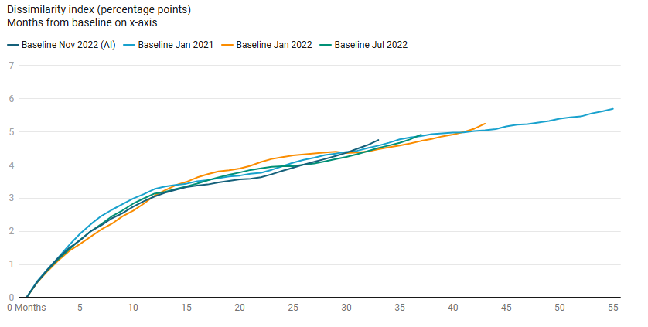
Figure 1: Changes in the Occupational Mix From Recent Baselines
(Source: Gimbel et al., 2025)

Strategic Implications for HRM
Technological improvements need major HRM strategy modifications.
First, organisations must plan skills-based workforces instead of jobs. Instead of selecting between humans and robots, HR managers should assess how AI might boost performance. In order to retain jobs and promote productivity, task-level analysis improves people planning. Enhancing AI rather than replacing it boosts operational efficiency and personnel happiness, research finds.
Second, learning and growth must evolve. PwC's Global Workforce Survey 2024 found that 45% of workers had studied new job-related technology and 6% trained more than 25% on AI (PricewaterhouseCoopers, 2024). These gaps are risky yet promising. AI boosts production and morale for upskilled and reskilled companies. The best AI literacy programs combine formal instruction with hands-on learning.
Third, HRM must study technology's psychological and cultural consequences. Innovative technologies might suffer from work instability, intensity, and oversight. Adaptation needs honest technology deployment communication, employee design involvement, and leadership commitment to helping people adjust. AI might automate tedious chores, improve workplace safety, and free up personnel for more fascinating tasks.

Implications for International Human Resource Management
Automation and digital platforms enable global talent platforms, distributed teams, and remote work. 40 countries provide digital nomad visas or remote work programs since 2024, suggesting the development of itinerant labour (Myskiv, 2025). These agreements have ambiguous employment legal, taxes, and social security ramifications for IHRM practitioners. Countries vary greatly in AI preparedness. The IMF's AI Preparedness Index shows significant differences in digital infrastructure, legal frameworks, and labour capacities. While there is variety, wealthier economies are typically more prepared. Global companies must adjust their AI deployment methods to local markets since what works in one may not work elsewhere. INHRM must balance local responsiveness and global consistency. Technological advances boost worldwide talent management. By connecting people to foreign jobs, AI-powered recruiting firms may enhance global labour allocation. One study demonstrated that poorly designed and supervised AI systems may increase recruiting biases. IHRM specialists need governance frameworks for AI-driven talent processes across cultures and locations. Algorithmic decision-making needs constant supervision.

2. What are the key demographic and geopolitical factors influencing employment markets today, and how do they create challenges for HR professionals?

The Demographic Transformation
2025 is a demographic turning point. After decades of growth, the OECD Employment Outlook 2025 predicts a working-age population decline. Most OECD countries have many retiring baby boomers. Working-age population decline will disrupt society until 2060. Record-high 65-year-olds outnumber workers. In 2024-2060, productivity growth will cut OECD GDP per capita growth by 40% from 1% in 2006-2019 to 0.6 percent (OECD, 2025). When the working-age population shrinks, employment falls, cutting growth. Populations vary by area. US and Irish job losses and growth are lower than Japan and Korea. The mismatch affects international labour mobility. The CBO reports rising immigration in low-fertility countries, reducing demographic pressures.

Workforce Ageing and Labour Market Dynamics
Working-age people age fast. Buckley and Bachman (2017) report that the number of US workers 65 or older has increased 96% over the past two decades and is anticipated to grow three times faster than those 25–54. Since 2000, 75-year-old women have worked over 100% more. Not like elderly workers quitting. Ageing workforces impact several aspects of business success. OECD study shows that 37% of 55–74-year-olds change employers or job status yearly, compared to 44% of 15–44-year olds (Fluchtmann et al., 2025). Reduced mobility may hamper personnel reallocation from less productive to more productive enterprises, lowering production. Retiring personnel concentrate organisational knowledge, complicating succession planning and risking knowledge loss. Women will grow from 46.8% to 47.2% despite a labour force participation drop. Women's 25-54 age group involvement will climb while men's decline (Figure 1). By 2024, fewer than 60% of workers will be "white non-Hispanic," 20% Hispanic, and modest African-American and Asian growth.

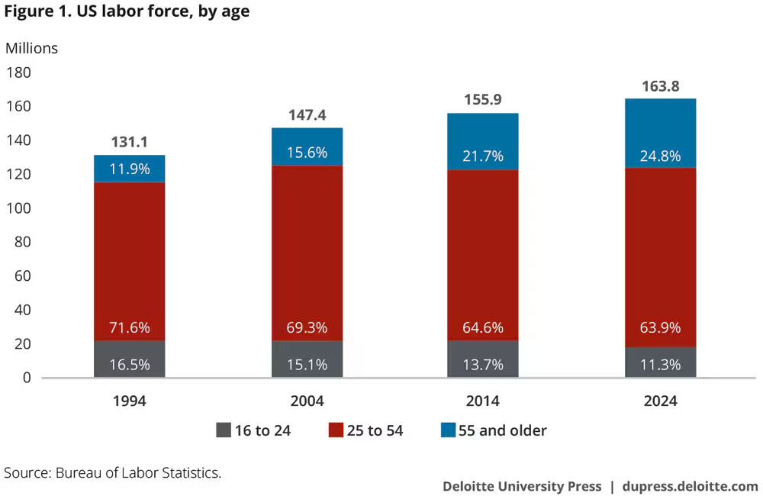
Figure 2: US Labor Force, by age
(Source: Buckley and Bachman, 2017)

Geopolitical Disruptions and Migration Patterns
Geopolitics affect global labour mobility. Political instability, humanitarian crises, and conflicts increased OECD asylum petitions 30% to 2.7 million in 2023 (OECD, 2024). Geopolitics can affect migration trends, as the EU recalled over four million Ukrainian migrants after Russia's invasion. Some nations recruit 50%–60% refugees, others 20%. Press release (2024) reports record 6.5 million OECD permanent migrants in 2023, up 10% from 2022. Family migration rose 16% and humanitarian migration 20% due to geopolitics. Employers recruited foreign workers, driving temporary labour migration up 16% to 2.4 million work permits in 2023. In order to address infrastructural, housing, and social service shortages, many destination nations tighten immigration regulations. Trade disagreements and economic fragmentation affect international employment. Instead of foreigners, firms are building local talent pools due to geopolitical competitiveness. As organisations overcome geopolitical obstacles and expand globally, Deloitte observed talent localisation rising. CEOs worry 71% about talent shortages, citing labour and mobility concerns.

PESTLE Analysis of Employment Market Factors (Check Appendix)

Challenges for HR Professionals
HR workers face various interconnected concerns from demographic and geopolitical changes. Human resources must leverage several worker pools to meet the structural talent deficit caused by population decrease, not economic booms. Recruiting, eliminating barriers for under-represented groups, and flexible work are examples. Geographical dispersion hampers workforce planning because political issues hinder talent transfers. Thus, organisations need contingency plans, flexible deployment methods, and HR to monitor global trends to transform macro patterns into actionable knowledge. An aging workforce requires knowledge management and succession planning. Tokarz and Rosiński (2024) suggest that structured tacit knowledge collection, mentorship programs, and incentives for older persons to contribute information are crucial to preserve organisational expertise beyond retirement. Last, companies must balance demographics and operations. However, aggressive contingent worker recruiting may reduce labour shortages but raise costs and hinder staff growth and retention. Short-term flexibility and long-term competence growth must be balanced in sustainable workforce planning.

Opportunities Amid Challenges
Demographics and geopolitics provide opportunities despite these issues. Leveraging underutilised talent pools increases staff diversity, which may raise innovation and market awareness. Housing elderly workers improves workplaces for everybody. In 2022, 17% of OECD self-employed were immigrants, boosting economic growth (Orderud, 2025). HR professionals who take advantage may have a demographic advantage.

3. How can organisations address persistent skills gaps and talent shortages in critical sectors through strategic HRM?

Understanding Sector-Specific Skills Challenges
Skills shortages threaten technology, healthcare, and hospitality's social influence. Technological advances, demographic shifts, and evolving service delivery methods provide HRM problems in each business. Jordan (2022) reports IT managers struggle to hire cybersecurity, software development, data analysis, and AI talent. Some corporations sacked personnel due to pandemic overinvestment, yet a skills deficit continues, showing that conventional education institutions cannot satisfy digital expectations. 195,000 nurses are needed by 2031 to fulfil demand (Roy, 2024). Ageing doctors and lab personnel lower patient expectations. Contract worker expenses have increased 250% in three years, showing a significant talent shortage but without addressing the core issues. Epidemic-related staffing concerns affect 65% of hotels. High housekeeping and front desk turnover means low pay and poor conditions. Workers are lost quicker than hired, making workforce stability and growth difficult. These sector-specific concerns must be addressed to preserve workforce growth in critical firms.

Strategic Approaches to Skills Development
Workforce issues require entire plans for internal talent development and external recruiting across the employment lifecycle. Many organisations have latent talent, therefore upskilling and reskilling them pays off immediately. Training CNAs to become RNs improves retention and proficiency. Structured and cross-trained IT and hospitality workers adapt better. Skills development is desired but rarely done. According to Milton and Al-Busaidi (2023), PwC states that few organisations have taught most people in AI despite many CEOs highlighting it. Cost, operational demands, and training uncertainties hinder success. Reducing turnover and increasing productivity via worker development can solve these issues. Effective L&D programs meet employee choices. Engagement and operations increase with microlearning and mentorship. Training helps businesses and individuals.

Expanding Talent Pipelines
Success requires companies to aggressively develop talent pipelines. Early high school and university recruitment is advised by the American Hospital Association. A proactive strategy impacts students' career and educational choices and builds connections. Tech corporations may support coding bootcamps, while hotels might design courses alongside vocational institutions. Skills are gained through apprenticeships. Tucker (2024) claims that the January 2025 Trump executive order sponsored over one million apprenticeships and skilled trades training. These programs use structured instruction and practical experience to let students earn while studying. Through apprenticeships, companies can customize personnel and spread training expenses. German dual education includes academic and practical learning. It allows skilled workers to enter the firm, increasing talent and diversity.

Enhancing Recruitment and Retention
Firms compete for people by understanding employee values and offering engaging solutions. 47% of hoteliers desire more pay, and healthcare institutions have boosted pay 25.6% since 2019, but not enough when employment markets are competitive. Insurance, retirement, education, and discounts should be included in pay. Sihite and Damanik (2025) observe that purpose-driven Gen Z and Millennial workers are using remote and hybrid work arrangements more. Genuine employer brands may attract like-minded workers. In order to retain staff, fairness, development, and inclusiveness must improve. In a competitive job market, constant praise may drive employees.

Technology and Alternative Staffing Models
Automation minimises healthcare and hospitality worker shortages. AI and automatic check-in kiosks increase visitor experiences and reduce staff. Telemedicine and automated technology boost service but must balance personnel experience to retain human touch (Israni and Chawla, 2023). Flexible part-time workers and contract doctors scale but raise expenses and service consistency. Flex-workers present categorisation and rights difficulties. Culture-upholding permanent and surge contingent staff are needed.

International Talent Mobility
Middle-skilled workers might be recruited abroad. From 2024 to 2029, Japan will welcome 820,000 Specified Skilled Workers, whereas Lithuania accepts 40,250 in-demand occupation labour migrants (Rehm, 2025). While promising, immigration compliance, cultural integration, and PR challenges persist. Research suggests Ukrainian migrants in Europe face integration issues due to different job rates. For relocated workers, housing, language, and family integration are essential. Ethical hiring is needed in skills-deficient countries.

4. Personal Reflection: Preparedness for the International Workplace

Technology: Digital Competence and Adaptability
Today's jobs require digital skills. I excel in spreadsheets, presentations, and word processing. MS Teams and Slack improve distant collaboration. Business intelligence visualisation and Excel data analysis allow me to use technology. I have a bit of understanding about business AI but not futuristic tech. AI might boost content, data, and process automation, preparing me for tech adoption. Academic and professional experiences show my adaptation to new digital technologies, suggesting I can learn more. Programming and coding abilities are increasingly important in non-technical areas, yet I lack them. Automation and large dataset analysis without scripting are difficult. Insufficient cybersecurity capabilities put critical data at risk (Markopoulou and Papakonstantinou, 2021). As cyberattacks increase and data protection laws tighten, this knowledge gap is crucial. HR information systems and industry-specific technology limit my HR process contributions. In order to solve these problems, I want to master Codecademy basic programming, cybersecurity, and AI. In order to stay up with a fast-changing industry, I will research new technology.

Communication: Cross-Cultural and Multilingual Effectiveness
Language, culture, and adaptability are needed for worldwide communication. My English abilities allow me to communicate complicated thoughts and participate in professional talks across backgrounds. Fluency reduces English-speaking international trade hurdles. Not communicating well hinders my efficiency. I struggle to communicate with multilingual coworkers and customers due to my language barriers. Monolingualism harms relationships and ignores culture. Westerners' forthright communication may not function in indirect, face-saving civilisations. Culture adaptability requires new surroundings, which I lack. I wish to study Mandarin Chinese to address these difficulties because of its worldwide relevance. Native speakers will teach me languages carefully. Volunteering, cultural interactions, and teamwork will teach me cross-cultural skills. I studied Hofstede's cultural dimensions and Meyer's Culture Map to reflect on my experiences and build cultural intelligence (Alqarni, 2022). I will develop intellectual humility, curiosity, and cultural openness to foster cross-cultural communication.

Teamwork: Collaboration in Diverse and Distributed Contexts
Modern businesses need professional teamwork to solve complex issues. Teammates trust my reliability and results. I build strong alliances as needed. My emotional intelligence helps me manage my own and others' emotions, making me a reliable teammate. In order to address challenges, I value variety and aggressively seek colleagues' perspectives. My remote cooperation skills are lacking. Interpersonal relations and time zone synchronisation challenge me despite my progress. Research suggests remote teams need different practices than co-located teams (Liska, 2022). I resolve petty disagreements. In order to prevent confrontation, collaboration may be challenging. I have little multicultural team experience because I have worked in homogenous teams. Professional teamwork, volunteering, and fun will strengthen my teamwork. Think about these events for answers and challenges. I will learn online team management and multicultural effectiveness. I improve my conflict management through training. Empathy and perspective-taking increase cross-context collaboration.

Leadership: Influence and Development of Others
Leadership is needed in all organisations because modern workers must influence and grow others without official authority. Leading by example, I create high standards and implicit expectations. I value team goals above accolades to build trust. Helping teammates achieve builds trust. I communicate a goal, simplify work, and track collaborative progress while adapting. Teams follow this organisational skill. I keep teams together by problem-solving and being calm. I lack decisiveness as a leader. I prolong decision-making because I require consensus, which annoys colleagues seeking guidance. Performance issues and constructive feedback are my weaknesses. Unmet expectations may result from indirect communication. My lack of cultural understanding may hinder my worldwide effectiveness since individualistic leadership may not operate in collectivist environments. I will develop my leadership skills by doing more professional and volunteer work and getting feedback. Leadership coaching emphasises determination and pain. I want direct communication and uncertainty-based decision-making. Learning about leadership across cultures and implementing theory will help me adjust.

Self-Directed Learning: Continuous Development and Adaptation
Successful careers need self-assessment, preparation, research, and skill application. Academic curiosity and ambition drive me to study without pressure. Career growth requires effort. Individualised learning requires self-assessment of strengths and weaknesses. Reading, seeing, acting, and reflecting teach me. My objective is to learn and improve. Solo learning challenges me. My theory-practice gap is tremendous. My tendency to absorb knowledge without applying it hinders my adult learning, which studies demonstrate required conscious practice. Overestimating my abilities in low-input areas may create blind spots. My self-directed learning increases with structure. Personal growth plans including goals, KPIs, and timelines are essential (Rajapakshe, 2024). Work and volunteering will help me apply my skills. I want to grow through mentorship and practice communities. A growth notebook and self-evaluation will help me grow.

Integration and Personal Development Plan
I found strengths and weaknesses in technology, communication, teamwork, leadership, and self-directed learning. My basic and interpersonal skills benefit me in professional settings. However, difficult tasks test my talent and aggressiveness. Practical application, unpleasant situations, and uncomfortable skills must close these gaps. Self-study and intellectual curiosity give me hope for this evolution, which takes years. I want to progress professionally.

Conclusion
The report reveals that employment market dynamics affect HRM and IHRM. Artificial intelligence and automation, an ageing workforce, and geopolitical worries influencing international mobility are important factors. Challenges offer strategic opportunities for HR professionals who adapt. Initial change is tolerable but ongoing. History shows that prepared companies can manage turmoil. Staff training, better recruiting, and global talent evaluation are needed to address skills shortages. Human capital is an organization's most precious resource, thus personnel planning must be strategic. HR professionals must change. Human resources needs strategic workforce planning, data analytics for evidence-based decisions, change management for adaptability, and IHRM cultural intelligence. Labour investments and human capital development must be justified. Research emphasises professional growth, technology, communication, and leadership. Strategy and self-evaluation fill success skill gaps. Careers will be uncertain. Lifelong, flexible, and responsive learners face future challenges better. Change-preparers win, but workforce-cost-seekers lose. In uncertain times, smart people win.

Reference List
Alqarni, A.M., (2022). Hofstede's cultural dimensions in relation to learning behaviours and learning styles: A critical analysis of studies under different cultural and language learning environments. Journal of Language and Linguistic Studies, 18.
Buckley, P. and Bachman, D. (2017) Meet the US workforce of the future: Older, more diverse, and more educated, Deloitte Insights. Deloitte. Available at: https://www.deloitte.com/us/en/insights/topics/talent/meet-the-us-workforce-of-the-future.html.
Fluchtmann, J., Hijzen, A. and Puymoyen, A. (2025) OECD Employment Outlook 2025: Reviving growth in a time of workforce ageing: The role of job mobility, OECD. Available at: https://www.oecd.org/en/publications/oecd-employment-outlook-2025_194a947b-en/full-report/component-9.html (Accessed: 3 November 2025).
Georgieva, K., (2024). AI will transform the global economy. Let’s make sure it benefits humanity. International Monetary Fund.
Gimbel, M. et al. (2025) Evaluating the Impact of AI on the Labor Market: Current State of Affairs, The Budget Lab at Yale. Available at: https://budgetlab.yale.edu/research/evaluating-impact-ai-labor-market-current-state-affairs.
Israni, D.K. and Chawla, N.S., (2023). Human‐Machine Interaction in Leveraging the Concept of Telemedicine. Human‐Machine Interface: Making Healthcare Digital, pp.211-245.
Jordan, C.A., 2022. Exploring the cybersecurity skills gap: A qualitative study of recruitment and retention from a human resource management perspective. Northcentral University.
Kinder, M. (2024) AI Replacing Entry-Level Jobs Could Break the Career Ladder, Bloomberg.com. Bloomberg. Available at: https://www.bloomberg.com/news/articles/2024-11-15/ai-replacing-entry-level-jobs-could-break-the-career-ladder.
Liska, R., (2022). Can performance of modern virtual teams measure up to co-located teams?. Team Performance Management: An International Journal, 28(3/4), pp.205-222.
Markopoulou, D. and Papakonstantinou, V., (2021). The regulatory framework for the protection of critical infrastructures against cyberthreats: Identifying shortcomings and addressing future challenges: The case of the health sector in particular. Computer law & security review, 41, p.105502.
Milton, J. and Al-Busaidi, A., (2023). New role of leadership in AI era: Educational sector. In SHS Web of Conferences (Vol. 156, p. 09005). EDP Sciences.
Myskiv, G., (2025). Digital Nomads as a Contemporary Trend in the Global Labor Market. Economics, Finance and Management Review, (2 (22)), pp.94-108.
OECD (2024) International Migration Outlook 2024, OECD. Available at: https://www.oecd.org/en/publications/international-migration-outlook-2024_50b0353e-en.html.
OECD (2025) OECD Employment Outlook 2025 Can We Get Through the Demographic Crunch? Available at: https://www.oecd.org/content/dam/oecd/en/publications/reports/2025/07/oecd-employment-outlook-2025_5345f034/194a947b-en.pdf.
Orderud, G.I., (2025). Reviewing immigrant self-employment and entrepreneurship.
Press release (2024) Migration to OECD countries hits new record, OECD. Available at: https://www.oecd.org/en/about/news/press-releases/2024/11/migration-to-oecd-countries-hits-new-record.html.
PricewaterhouseCoopers (2024) Workers are ready for change. Are leaders ready to engage them?, PwC. Available at: https://www.pwc.com/id/en/pwc-publications/services-publications/consulting/hopes-and-fears-2024-survey.html.
PricewaterhouseCoopers (2025) PwC 2025 Global AI Jobs Barometer | PwC, PwC. Available at: https://www.pwc.com/gx/en/news-room/press-releases/2025/ai-linked-to-a-fourfold-increase-in-productivity-growth.html.
Rajapakshe, W., (2024). Performance Management Process: Performance Planning and Monitoring. In Employee Performance Management for Improved Workplace Motivation (pp. 31-56). IGI Global.
Rehm, M.X., (2025), March. Abe’s incrementalism: an institutionalist analysis of immigration policy reform during the second Abe administration. In Japan Forum (Vol. 37, No. 2, pp. 178-203). Routledge.
Roy, L.A., (2024). Implementing a Nurse Mentor Program. University of Hartford.
Sihite, M. and Damanik, L.G.S., 2025. Exploring the Influence of Purpose-Driven Culture, Work-Life Integration, and Digital Competency on Gen Z Employee Retention. International Journal of Business, Law, and Education, 6(1), pp.823-833.
Tokarz, M. and Rosiński, J., (2024). Transfer of tacit knowledge: exploring effective methods and techniques of tacit knowledge across generations in cultural institutions: a case study.
Tucker, T., 2024. The New US Trade Agenda: Institutionalizing Middle-Out Economics in Foreign Commercial Policy.
World Economic Forum (2025) The Future of Jobs Report 2025, World Economic Forum. Available at: https://www.weforum.org/publications/the-future-of-jobs-report-2025/digest/.

Appendix
Table 1: PESTLE Analysis of Employment Market Factors
Factor | Key Influences | HR Implications
Political | Digital nomad visas, employment protection, immigration restrictions, and government skills programs | Maintain jurisdictional compliance, manage complex visa processes, and support effective migration policy.
Economic | Workforce shortages, economic fragmentation, cost-of-living restrictions, and sector-specific demand shifts cause wage inflation. | Competitive pay, talent diversity, and sectoral job changes
Social | Ageing workforce, diminishing fertility, Gen Z/Millennial worker values, diversity, social cohesion issues | Strong employer branding, inclusive workplaces, age-diverse workforce management, intergenerational knowledge transfer
Technological | HR technology adoption, remote work platforms, AI and automation, digital skills needs | Digital divide, automated workforce planning, technology-enabled recruiting, expanding digital capabilities
Legal | Data security, right-to-work verification, contract worker laws, worldwide employment law differences | Worker classification, ethical AI governance, legal audits, and jurisdictional compliance
Environmental | Migration due to climate change, green jobs, sustainable workplaces, bad weather | Green skills, business continuity, climate migration, and HR sustainability

