DISSERTATION DRAFT
A Critical Analysis of the Impact the Tesco Clubcard has on the Loyalty of its Customers.

Benjamin John (1707698)
Independent Project (BMBM6020)
BA Business Management
12th May 2021
Word Count - 8784

Covid -19
In light of the continued impact of the global pandemic, it was considered important for the researcher to include a statement that addresses the impacts and effects of COVID-19 on the research conducted in order to complete this dissertation for the successful completion of the researcher’s undergraduate degree.
The University of Wales Trinity Saint David recognises that the COVID-19 pandemic and the consequent closures of university campuses (18th March 2020) as well as national lockdowns, has directly or indirectly had an impact on the work of many of the undergraduate researchers. Despite periods in which campuses were re-opened throughout 2020 and 2021, some of the research conducted by researchers would have been disrupted and some personal circumstances difficult to manage. Teaching for students was arranged via suitable meeting software and all documents were shared electronically. Similarly, all research data collection was designed in order to utilise digital methods of data collection.
The inclusion of this statement is to facilitate the readers' awareness, both now and in the future, that the pandemic may have had an effect on the scope, direction and presentation of the research presented within this dissertation.
The academic standards and the quality threshold for the award presented to the researcher remains unchanged. I wish to reassure the readers that this statement is not evidencing a lack of original research or quality.

DECLARATION
This work has not previously been accepted in substance for any degree and is not being concurrently submitted in candidature for any degree.
Signed: Date: 04/05/2021

STATEMENT 1
This dissertation is being submitted in partial fulfilment of the requirements for the degree of BA.
Signed: Date: 04/05/2021

STATEMENT 2
This dissertation is the result of my own independent work/investigation, except where otherwise stated.
Other sources are acknowledged by footnotes giving explicit references. A bibliography is appended.
Signed: Date: 04/05/2021

STATEMENT 3
I hereby give consent for my dissertation, if accepted, to be available for photocopying and for interlibrary loan, and for the title and summary to be made available to outside organisations.
Signed: Date: 04/05/2021

STATEMENT 4
I hereby give consent for my dissertation, if accepted, to be available on the university’s IT system to those who have consent to use the system.
Signed: Date: 04/05/2021

Acknowledgements

Firstly, I would like to thank my dissertation supervisor Caroline Jawad for the teaching, support and guidance given throughout the process of creating this dissertation as it was vital for the successful completion of this dissertation.
Secondly, I would like to thank my family and friends who have supported me and helped me to remain motivated to achieve my best throughout my time in university and especially during the process of writing this dissertation.
Finally, I would like to thank all of the participants who took the time to participate within the questionnaire distributed, as without this participation the successful completion of this dissertation would have been impacted.

Abstract
The use of customer loyalty schemes within a supermarket is not a new concept, however, the increasing number of available supermarkets which offer greater convenience and lower prices in a crowded market is negatively impacting the loyalty of customers towards Tesco. This dissertation has critically analysed the impact of the Clubcard loyalty scheme provided by Tesco to understand how it impacts the loyalty of its customers towards Tesco. The researcher conducted an extensive literature review to understand the factors impacting customer loyalty towards a supermarket to understand the different factors which play a role in a customer’s decision to remain loyal to a specific supermarket as well as understanding how loyalty schemes impact the overall loyalty of customers towards a supermarket. The literature review findings indicated the need for further research into the impact of customer loyalty schemes within a supermarket setting and the findings within the available literature were utilised by the researcher to produce a questionnaire that would aid in the understanding of the research. An online questionnaire was produced and distributed via the researcher’s social media channels in order to collect a substantial data set which could be utilised within statistical testing for the analysis of the collected data. 101 participants participated in the research and the main findings from the data collected indicated that there was a significant link between being a Clubcard member and choosing to shop at a Tesco supermarket. Furthermore, the findings also indicated that the Clubcard loyalty scheme helps to increase the loyalty of customers to Tesco through the increased sense of value that Clubcard participants feel from being a Clubcard member. However, despite this, the findings also indicate that the Clubcard fails to increase the overall satisfaction of customers as well as failing to encourage customers to remain loyal to Tesco if there is a more convenient option for them.

Contents
Chapter 1 – Introduction 1
1.1 Introduction 1
1.2 Rationale & Background 1
1.3 Aim & Objectives 3
1.4 Structure 3
1.5 Chapter Summary 4
Chapter 2 – Literature Review 6
2.1 Chapter Introduction 6
2.2 Brand Loyalty 7
2.3 Customer Commitment and Loyalty Schemes 8
2.4 Consumer Behaviour 9
2.5 Price and Perceived Value 10
2.6 Customer Convenience 11
2.7 Chapter Summary 12
Chapter 3 – Methodology 14
3.1 Chapter Introduction 14
3.2 Research Onion 14
3.2.1 Research Philosophy 15
3.2.2 Research Approaches 15
3.2.3 Research Strategies 16
3.2.4 Research Choices 16
3.2.5 Time Horizons 17
3.2.6 Techniques and Procedures 17
3.2.6.1 Data Collection 17
3.2.6.2 Questionnaire Design 17
3.2.6.3 Data Analysis 20
3.3 Sample 20
3.4 Reliability and Validity 20
3.4.1 Reliability 20
3.4.2 Validity 20
3.4.3 Pilot Study 21
3.5 Ethical Considerations 21
3.6 Chapter Summary 21
Chapter 4 – Analysis 23
4.1 Chapter Introduction 23
4.2 Data Analysis 23
4.3 Demographics 24
4.3.1 Participants Gender 24
4.3.2 Participants Age 25
4.3.3 Greatest Benefit of the Clubcard 26
4.4 Clubcard & Encouragement to shop at Tesco 27
4.5 Clubcard & Perceived Value 28
4.6 Clubcard & Convenience 30
4.7 Clubcard & Customer Satisfaction 31
4.9 Chapter Summary 32
Chapter 5 – Discussion 33
5.1 Chapter Introduction 33
5.2 Achievement of Objectives 33
5.3 Main Findings 34
5.4 Limitations 35
5.5 Further Research 35
5.6 Conclusion 36
5.7 Recommendations 36
References 38
Appendix 43

Table of Figures
Figure 3.1 The Research Onion (Saunders et al. 2019). 22
Figure 4.1 Participant’s Gender. 31
Figure 4.2 Participant’s Age. 32
Figure 4.3 Participant’s Age groups. 33
Figure 4.4 Greatest benefit word cloud. 33

Table of Tables
Table 3.1 Questionnaire Literature Review Matrix 26
Table 4.2 Age & Clubcard encouragement Chi-square. 34
Table 4.3 Frequent Supermarkets and Clubcard encouragement Crosstabulation. 35
Table 4.4 Frequent supermarkets and Clubcard encouragement Chi-Square. 35
Table 4.5 Clubcard encouragement & Increased Value Correlation. 35
Table 4.6 Age and price encouragement Crosstabulation. 36
Table 4.7 Age & convenience encouragement crosstabulation. 37
Table 4.8 Age & convenience encouragement Chi-Square. 37
Table 4.9 Frequency table encouragement & convenience. 38
Table 4.10 Age & satisfaction Crosstabulation. 38
Table 4.11 Age & satisfaction Chi-square. 38

Abbreviations
SPSS- Statistical Package for Social Sciences
COVID-19 – Coronavirus
UK- United Kingdom
UWTSD – University of Wales Trinity Saint David

List of Appendices
Appendix. A – Walkers Loyalty Matrix
Appendix. B – List of Loyalty Schemes
Appendix. C – Engel Kollat Blackwell Model
Appendix. D – Gantt Chart
Appendix. E – UWTSD Ethics Form
Appendix. F – SPSS Codes
Appendix. G – Questionnaire Raw Data
Appendix. H – Further Statistical Testing considered insignificant to Chapter 4

Chapter 1 – Introduction

1.1 Introduction
This dissertation seeks to understand the impact supermarket loyalty schemes have on the overall loyalty of those who participate, using the Tesco Clubcard loyalty scheme as a focus for the research. The Tesco Clubcard loyalty scheme currently has an estimated 16.5 million users (Howarth, 2021) and is considered one of the most successful supermarket loyalty schemes within the United Kingdom, therefore, it was considered the best option for the researcher when choosing a supermarket loyalty scheme for the focus of this particular dissertation.
This dissertation will critically analyse how the Clubcard scheme within Tesco plays a role in the loyalty of its customers and whether or not it has an impact on where they choose to shop. The dissertation will analyse a range of different factors that could impact the loyalty of customers as well as investigating whether or not loyalty schemes play a role in the loyalty of customers. Finally, the dissertation will seek to understand whether or not loyalty schemes such as the Clubcard are still effective at retaining customer loyalty when operating in the current retail environment.

1.2 Rationale & Background
Customer loyalties towards supermarkets are changing, customers are now on the hunt for supermarkets that offer them the best value for money as well as the most convenient shopping experience (Statista, 2020). Despite revolutionising customer loyalty schemes within supermarkets with the launch of their Clubcard loyalty scheme, as well as launching new initiatives to keep the Clubcard scheme current as well as enticing Clubcard customers with exclusive deals (Tesco, 2020), the loyalty of Clubcard users is being questioned.
Loyalty schemes within supermarkets are not a new concept, with Tesco launching the Clubcard loyalty scheme in 1995 (Tesco, 2021). Loyalty schemes are considered an immense marketing tool that when used strategically can benefit almost any organisation that faces a business environment in which substantial competitive pressures are a factor in the running of the business (Srivastava and Rai, 2018). Within a year of the launch of the Clubcard which cost Tesco nearly £10 million, customers were spending 28% more in Tesco stores and 16% less than their closest rival at the time, Sainsbury's (Westbrook, 2018). Nastasoi and Vanderbosh (2018), found that the use of a loyalty scheme by a supermarket helps to increase the differentiation between brands for consumers which in turn allows for the business to sustain a competitive advantage against its competitors. However, the impact on customer loyalty is now being questioned as the environment in which supermarkets operate is becoming more crowded with an ever-increasing number of competitors resulting in customers having less loyalty to one particular supermarket (Chahal, 2017). Customer loyalty towards a particular supermarket has changed with a 2017 study finding that nearly 40% of people would not consider themselves as negatively impacted if their usual supermarket closed due to the ease of shopping in another available supermarket (ibid).
The shift in customer loyalty to supermarkets which offer better value for money and a more convenient experience is negatively impacting Tesco as their market share continues to gradually decline while the market share of their discount retailer competitors continue to grow in the crowded market in which supermarkets operate (Statista, 2020). A possible cause of this problem is the economic uncertainty being faced by many within the UK as well as the growing inflation which has a detrimental impact on the prices of products within supermarkets. This dissertation will utilise research amongst Clubcard users in the attempt to add knowledge and to allow for a deeper understanding into the factors that impact customer loyalty towards a supermarket as well as a deeper understanding of how the Tesco Clubcard impacts the loyalty of those customers who partake in the scheme.

1.3 Aim & Objectives
Dissertation Aim
This dissertation aims to critically analyse the impact that the Tesco Clubcard has on the loyalty of those who participate in the scheme and their loyalty towards Tesco.
Dissertation Objectives
- To conduct an extensive literature review that will discuss the key literature and theories produced by credible authors who have discussed and analysed the changes in consumers behaviour and the different factors that impact customer loyalty towards a supermarket.

- To undertake primary research through the use of a survey aimed towards those who possess a Clubcard.

- To better understand through the use of statistical testing and analysis, the extent to which the Clubcard plays a role in the loyalty of consumers when choosing a supermarket.

- To make recommendations based on the findings of the dissertation that will allow Tesco to better understand the impact their loyalty scheme has on the loyalty of those who participate in the scheme.

1.4 Structure
In order to complete the dissertation and to achieve the aim and objectives set out by the researcher, the dissertation will consist of five chapters. The chapters are as follows, chapter one, introduction, chapter two, literature review, chapter three, methodology, chapter four, data analysis and finally chapter five, discussion.
Chapter two will analyse a wide range of literature including journal articles and textbooks that have discussed loyalty schemes and the different factors which impact a customer’s loyalty towards a supermarket. This chapter will also analyse a range of similar studies available to the researcher to understand where there is a gap in the available literature to allow for this dissertation to add further knowledge and to allow for a deeper understanding of the impact that loyalty schemes and in particular the Tesco Clubcard, have on customer loyalty.
Chapter three will outline the design of the research and the methodology that was utilised to conduct successful primary research. Chapter three will allow for the researcher to conduct successful research and to answer any questions that were raised as a result of the literature review in the previous chapter. Furthermore, chapter three will also discuss the ethical considerations and the limitations faced by the researcher throughout the research process.
Chapter four will utilise the primary data collected from the research and will use SPSS software in order to statistically test the data set to produce meaningful data that will help with the understanding of how the Clubcard loyalty scheme impacts customer loyalty.
Chapter five will discuss the completion of the aim and objectives of the research and where each of the objectives was achieved within the dissertation. Finally, the chapter will discuss the main findings of the dissertation and will provide recommendations based on those findings.

1.5 Chapter Summary
To summarise, this chapter has discussed the need for this dissertation by providing a rationale and a background into the problems that are being faced by Tesco regarding the loyalty of their customers. Furthermore, this chapter has outlined the aim and objectives that this dissertation hopes to achieve as well as setting out the structure of the dissertation including a summary of each chapter.
The following chapter will perform a literature review and will review a wide range of different literature from journal articles and textbooks to gain a deeper understanding of the factors that impact customer loyalty towards a supermarket as well as allowing the researcher to understand where there is a gap in the available literature that requires further research.

Chapter 2 – Literature Review

2.1 Chapter Introduction
The previous chapter has introduced this dissertation and has discussed the reasoning behind why the topic is appropriate and relevant for this dissertation. The previous chapter also outlined the aim and objectives that this dissertation will achieve.
This chapter seeks to explore and review the vast amount of literature that has been made available regarding the different factors that have an impact on a customer’s loyalty towards a supermarket and how consumer behaviours have changed regarding shopping habits within a supermarket setting.
This literature review will analyse a range of literature that was made available to the researcher through the use of a wide range of scholarly sources including articles, textbooks and academic journals that have been made available to the researcher via sources including Google Scholar as well as the UWTSD online library. Furthermore, the literature review will analyse a selection of theoretical frameworks as well as concepts that will be used to aid in the understanding of some of the factors discussed.
Finally, this literature review will establish any gaps within the available literature to understand which areas require the most amount of further research moving forward to allow for the research to add further knowledge into the factors that impact a customer’s loyalty towards a supermarket as well as understanding and adding further knowledge to understand how the Clubcard impacts the loyalty of customers to Tesco.
The literature review will achieve the first objective of this dissertation:
- To conduct an extensive literature review that will discuss the key literature and theories produced by credible authors who have discussed and analysed the changes in consumers behaviour and the different factors that impact customer loyalty towards a supermarket.

2.2 Brand Loyalty
Brand loyalty has in the past, been considered as a customer’s continuous decision to purchase from a brand as well as their continued decision to purchase from the brand in the future (Chaudhuri and Holbrook, 2001). More recent definitions have described brand loyalty as the measurement of a customer’s unwillingness to purchase from another brand or a competing service (Doyle, 2016). Brand loyalty is characterised by higher levels of customer satisfaction as well as the continued purchase of goods by customers who are loyal towards the brand over a continued period (ibid).
There has been a range of different variables found within literature that discusses the different factors that contribute to a customer’s loyalty towards a supermarket with Gobiraj et.al (2010) analysing nine different key factors that they considered to play a role in the loyalty of customers towards supermarkets within the United Kingdom including the promotions and value of products as well as the innovation and management of the brand. A Similar study found that there is a range of variables that have an impact on the loyalty of customers within a supermarket setting including, customer commitment, customer present value, customers satisfaction, service quality, customer trust, and finally the customers experience with the brand (Araceli et.al, 2016 cited in Nisa, 2016).
Brand loyalty is said to develop through a series of different stages before the consumer becomes truly loyal to an organisation (Bowen and Shiang-Lih, 2015). Walker (2020), created the ‘Loyalty Matrix’ framework which can be seen in Appendix A. The loyalty matrix was created to allow organisations to measure customer loyalty as well as the stability of their customer base. The model understands customer loyalty towards a brand as having two dimensions that help in the understanding of customer loyalty. John and Lyimo (2019), discuss how the model splits customers into four segments based on their behaviour towards a brand. These four segments then make up two different dimensions as discussed by Walker (2020). The two dimensions as discussed within the model are the customers’ behaviour along with the attitudes which support such behaviour (ibid). The loyalty matrix model, when used from the perspective of a business allows for the increased understanding of what motivates the behaviour and loyalty of its customers (ibid).

2.3 Customer Commitment and Loyalty Schemes
The first factor that has been argued to impact customer loyalty and one of the variables that have been discussed by Araceli et al., (2016) cited in (Nisa, 2016) is customer commitment and how loyalty schemes impact a customer’s commitment to a supermarket. Muganda et al. (2014) argue that loyalty schemes are an important and effective factor that impacts the loyalty of customers within a supermarket setting with a study by Buckingham (2018) finding that a customer’s commitment towards a supermarket could be impacted based on the loyalty scheme provided as 85% of shopper would be more inclined to shop in a supermarket that offered them a loyalty scheme, whereas the same study found that 27% of shoppers would avoid a supermarket altogether if a loyalty scheme was not available to them. Nandal et al. (2020), describe loyalty schemes as the way in which supermarkets give back to consumers who are users of their brand to ensure the overall faithfulness of the consumers towards their brand in the future. Similarly, Srivastava and Rai (2018) mention that loyalty schemes allow organisations to provide benefits for customers who are repeat users of their business through the use of a loyalty scheme with McMullan and Gilmore (2008), indicating that a loyalty scheme determines the choices which are made by an organisation to attract customers through giving the customers an incentive of gaining a reward in return for being a loyal customer to a particular organisation. A report analysing customer loyalty produced by AIMIA (2015), found that organisations that offer customers unique offers which are customised towards their previous shopping behaviours are more likely to retain the loyalty and commitment of the customer towards their brand. Similarly, this was again mentioned in the same study by Buckingham (2018) when it is argued that loyalty schemes heavily influence the different decisions of the consumers when they are targeted with benefits and offers which are aimed towards their previous purchasing behaviours.
There is a range of different loyalty schemes offered to consumers in an attempt to increase customer commitment and loyalty towards a brand as discussed by Nandal et al. (2020) which can be seen in Appendix B.

2.4 Consumer Behaviour
The second factor that has been understood to have an impact on consumer loyalty is the changes in consumer behaviour (Brun et al., 2017). Consumer behaviour has been understood as the way that consumers choose to purchase and use goods and services that are available to them and how different external factors including the marketing and pricing of products impact the way in which a consumer reacts to the product or the organisation in which it is available (East et al., 2017). Similarly, it has been argued that consumer behaviour is related to the psychology of the way that consumers think, feel, reason, and select between a range of products and services that are made available to them when they are making decisions about where they shop and what they purchase (Perner, 2018).
Consumer behaviour towards supermarket shopping and the loyalty of consumers towards a particular store has changed. The wide range of choices available to consumers encourages consumers to plan and evaluate their different choices available to them before they make a final decision on where to shop (Bellini et al., 2020). Nageswari (2019), mentions how technological advancements have resulted in technological interference at each stage of the consumer buying decision-making process, indicating that shoppers are now more likely to check the range of alternatives that are available to themselves online, before deciding on where they shop, thus having an impact on their loyalty to a particular supermarket.
The Engel, Kollat and Blackwell model (EKB) originally developed in 1978 which can be seen as Appendix C is a theoretical framework that was developed to allow for a deeper knowledge and better understanding of the theory of consumer behaviour. Schiffman and Kanuk (2008), argue that the EKB is one of the most efficient, most effective, and most important models in the understanding of consumer behaviour. Engel et al. (1978) describe consumer behaviour as a decision-making process in which five key stages are utilised, the five stages are problem recognition, need recognition, information search, evaluation of alternatives and choice.
The EKB when utilised within a supermarket setting can be argued to allow for supermarkets to get a better understanding of their consumers, which in turn allows for techniques and tactics to be used to retain loyal customers. Kotler (2012) argued the importance of organisations understanding the different behaviours of their consumers including their buying, consumption, and disposal behaviours, in order to provide an environment in which is sought after by the consumers. Furthermore, further research conducted by Hansen, Jensen and Solgaard (2011), corresponds with that of Kotler when it indicated that the marketing decisions made by an organisation have an impact on the different behaviours of the consumers, therefore indicating that the decisions made by supermarkets to understand their consumers in order to provide a suitable environment has an impact on the overall behaviour of consumers including their loyalty.

2.5 Price and Perceived Value
As far as loyalty is concerned, the price of products and the perceived value that a consumer feels has been argued to be another of the factors that have an impact on a customer’s loyalty towards a supermarket (Gobiraj et.al (2010); Nisa (2019). It has been previously argued by Chapman (2014), that following the event of the 2008 United Kingdom recession, customers habits and consumer behaviour regarding shopping changed, with customers now being more reliant on offers, rewards and cheaper prices that are offered by some supermarkets. Loyalty schemes allow for customers to feel an increased sense of value from the supermarket in which it is offered (Hupfeld and Speed 2017) as well as findings by Ramanathan et al. (2017) which found that customised promotions increase the customers' overall sense of value and connection to the brand in which the scheme is offered, therefore indicating the prices and perceived value of shopping at a particular supermarket impact a customer’s loyalty. This was again argued in a study conducted by Rather (2017), who found that the perceived value that customers feel from a supermarket impacts their decision to remain loyal to a particular supermarket.
However, the prices and perceived loyalty that a customer feels towards a supermarket is not only made available through the offering of a loyalty card, with the prices of products having an increasing impact on customer loyalty with Khadka and Maharajan (2017) finding that customers purchase goods and shop at supermarkets based on their expectations of the prices of the products. Customers are always on the lookout to have the best shopping experience with the most efficient service at the most reasonable and affordable prices to themselves (Cakici et al. 2019). Therefore, customers measure their overall experience with a supermarket by evaluating what they get in return for the amount of money they are spending (Wantara and Tambrin, 2019) and it has been found that discount retailers within the UK such as Lidl and Aldi have gained a substantial amount of the market share from the big four retailers as the no-frills service and the cheaper products available to customers has caused a generational shift within the shopping behaviours of customers (Shadbolt, 2015), thus impacting customers decisions on where to shop and their loyalty to a particular supermarket.

2.6 Customer Convenience
In addition to the prices of products and the perceived value of shopping at a particular store, another significant factor that has been argued to have an impact on consumer behaviour and a customer’s loyalty towards a supermarket is the convenience provided to the customer from the supermarket including how the location of the store plays a role in its convenience for customers as argued by Wright (2020), who found that shoppers are choosing to shop in the most convenient outlets for themselves. Correspondingly, Roy et al. (2020), discuss how consumers are now more likely to be engaged with supermarkets that provide them with the greatest amount of convenience and recent data provided by Tesco indicates that there is an increased demand for express stores within the UK, with 50 new Tesco express stores opening within the first quarter of 2020 alone (Wells, 2020). Furthermore, an article by Shadbolt (2015) indicates that supermarkets such as Lidl and Aldi provide the greatest environment for shoppers who choose to shop in a store due to its convenience, however, despite this Walker and Altman (2020), found that customers who choose where to shop based on convenience are less likely to have a strong loyalty towards one particular supermarket and are more likely to shop where they consider to be the most convenient for them at the time.
As well as the location of the store and the convenience this plays for the consumer, customers need to consider their shopping trip as satisfying for it to be considered as convenient (Reimers and Chao, 2014). Similarly, Khadka and Maharjan (2017) argued that customers who are satisfied with their overall experience with an organisation are more likely to remain loyal to that particular organisation. Thus, it has been argued by Muganda et al. (2014) and Nguyen et al. (2020) that to ensure that a customer remains loyal to a supermarket, ensuring their satisfaction through increased convenience is of paramount importance to ensure they remain loyal within the current competitive business environment that supermarkets are facing.

2.7 Chapter Summary
This chapter has achieved the first objective of this dissertation:
- To conduct an extensive literature review that will discuss the key literature and theories produced by credible authors who have discussed and analysed the changes in consumers behaviour and the different factors that impact customer loyalty towards a supermarket.
In summary, this literature review has analysed a range of scholarly literature including journal articles, textbooks and reports that were available to the researcher via sources including the UWTSD online library and Google Scholar. The sources allowed for a deeper understanding and a better knowledge of the key factors that impact a customer’s loyalty towards a supermarket. The literature review has also analysed concepts and frameworks which were developed to allow for a deeper understanding of some of the key factors discussed.
The literature analysed indicates the need for further research into the different factors that impact a customer’s loyalty towards a supermarket as well as allowing for the influence of loyalty schemes to be better understood.
The following chapter will consider the research methodology utilised by the researcher to successfully conduct primary research to aid in the completion of this dissertation. The following chapter will also discuss the limitations encountered by the researcher as well as the ethical considerations taken into account when conducting the research.

Chapter 3 – Methodology

3.1 Chapter Introduction
The previous chapter discussed and analysed the literature available to the researcher to allow for the understanding of the different factors that have an impact on the loyalty of customers towards a supermarket. This chapter will analyse the research design and methodology implemented by the researcher to complete the proposed research.
This chapter will discuss the structure of the research conducted through the implementation of the ‘Research Onion’ model developed by Saunders et al. (2019). The chapter will analyse each stage of the model and will utilise academic sources to justify why each stage was chosen for the research for this particular dissertation. Finally, the chapter will discuss the limitations encountered by the researcher as well as the ethical considerations taken into account to ensure the success of the research.
This chapter will achieve the second objective of this dissertation:
- To undertake primary research through the use of a survey aimed towards those who possess a Clubcard.

3.2 Research Onion
To ensure successful and meaningful research, the researcher utilised the ‘Research Onion’ model as developed by Saunders et al. (2019) which outlines six stages that are required to be utilised when conducting research. Muranganwa (2016), states that the use of the research onion model ensures an appropriate research design as well as Raithatha (2017) discussing how the utilisation of the model allows for a suitable methodology for the research to be created to ensure the overall success of the research.
The stages of the model are as follows, Philosophies, Approaches, Strategies, Choices, Time Horizons, and Techniques and Procedures (Saunders et al. 2019). Figure 3.1 outlines the pathway followed by the researcher to conduct successful research.

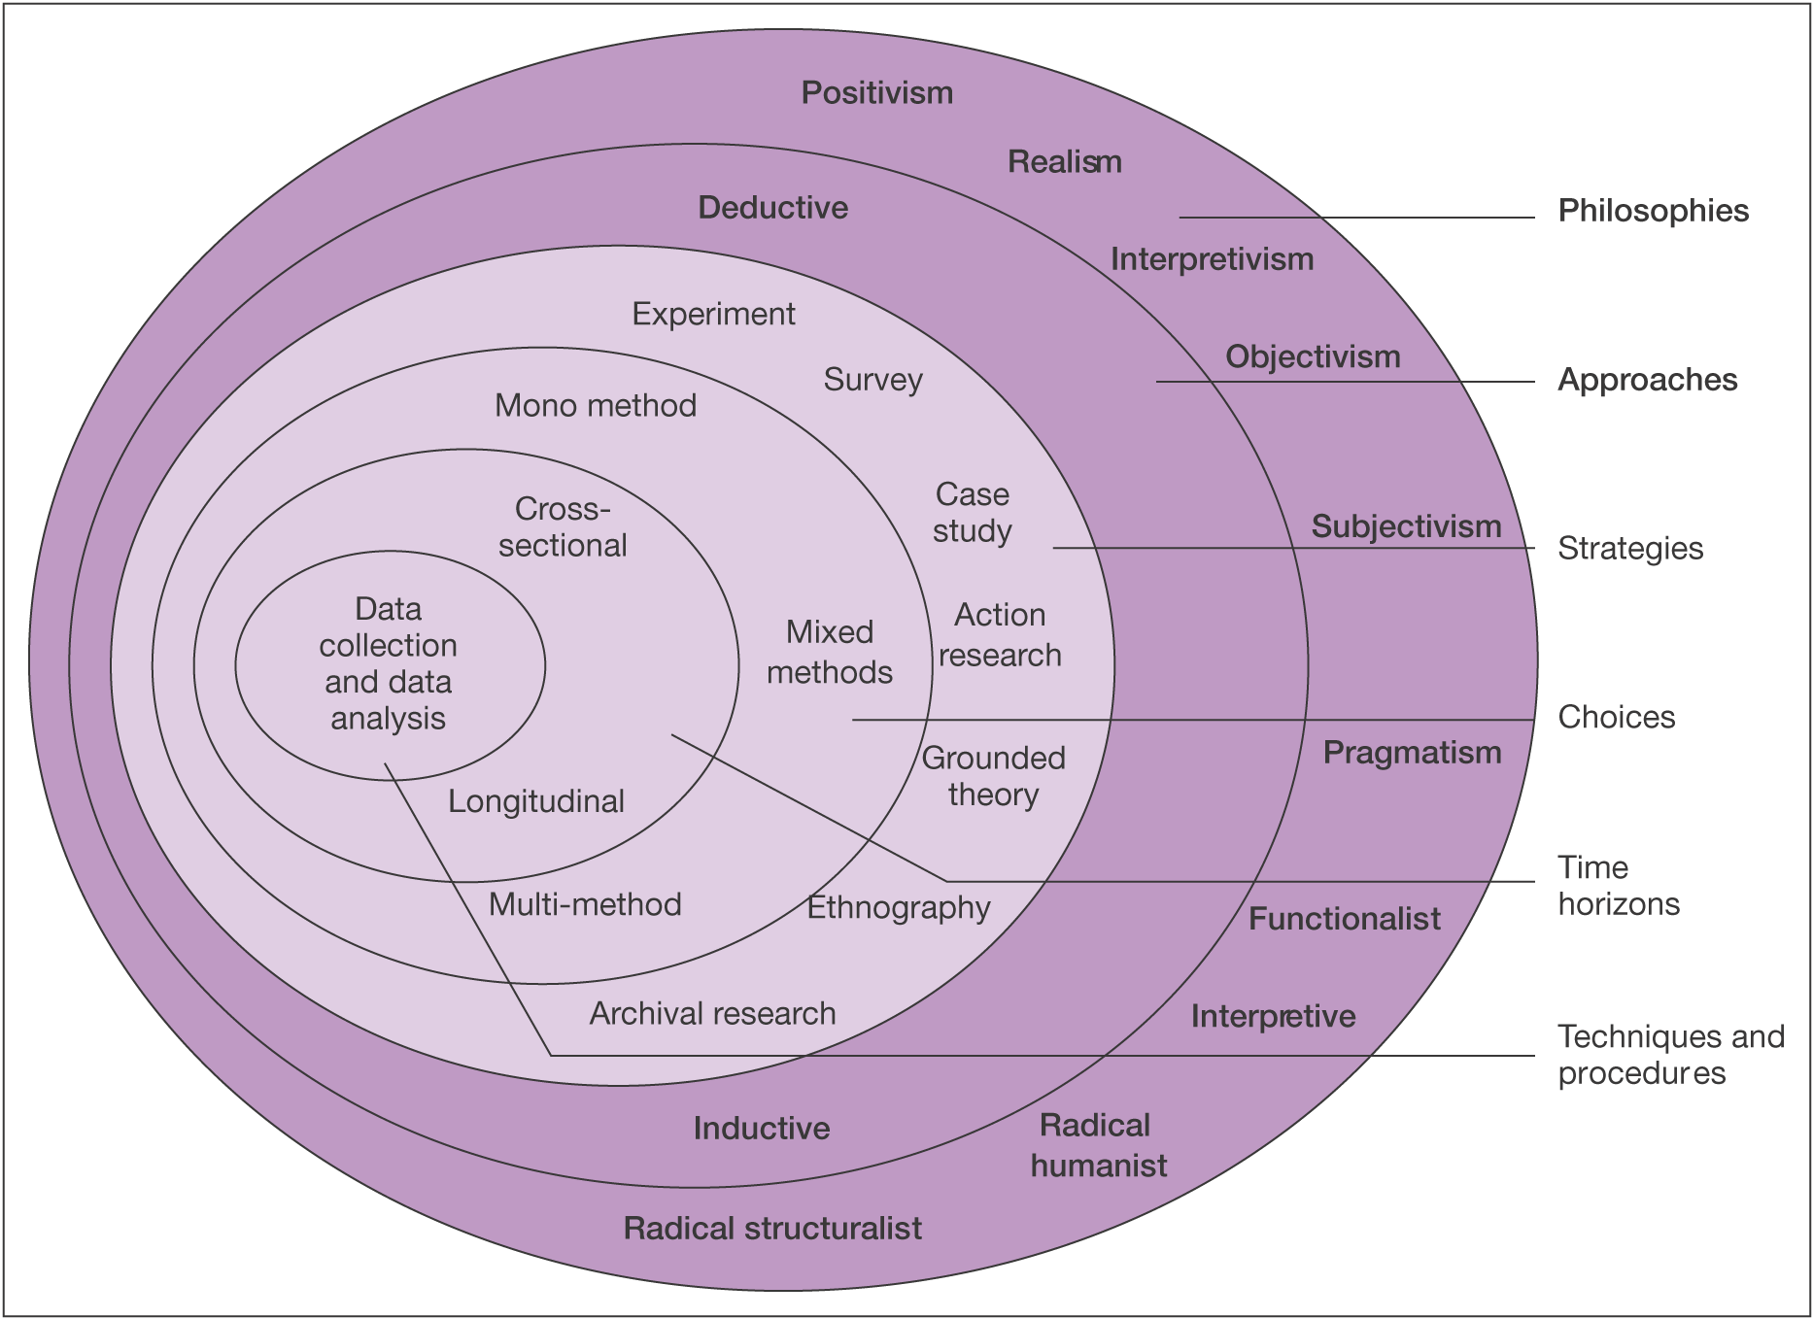

Figure 3.1 The Research Onion (Saunders et al. 2019).

3.2.1 Research Philosophy
The research philosophies are the first layer of the Research Onion model. Saunders et al. (2009) state that the philosophy which is utilised within the research will underpin the research strategy as well as the methods used within the research. Figure 3.1 indicates that ten possible philosophies can be utilised by the researcher when conducting research. The philosophical approach that this dissertation utilised was the positivism approach. According to Buchanan (2018), the positivism philosophy approach to research depends on the observations that lead to results from scientific analysis. As the research utilised the positivism philosophy, the research approach which is argued to complement this philosophy is the deductive approach (Crowther and Lancaster, 2008).

3.2.2 Research Approaches
As previously stated, the approach used for this research was the deductive approach. The deductive research approach allows for theory to be applied to a hypothesis and allows for that theory to be tested against existing theory (Wilson, 2010). Saunders et.al (2019), argue that the deductive research approach is seen as a more scientific approach as it allows for theory to be rigorously tested. Using this approach alongside the positivism philosophical approach is the most appropriate for this particular research as the researcher established a hypothesis before conducting the research.

3.2.3 Research Strategies
The data collection method adopted to ensure the successful completion of the aim and objectives of this dissertation was a survey in the form of a questionnaire. Questionnaires are a data collection method that allows for the collection of primary data (Harland, 2020) and according to Patten (2017), the use of a questionnaire allows for the most efficient collection of such data. The questionnaire was created using Google Forms and posted on the researchers' Facebook to allow for the collection of a substantial data set that could be later utilised for statistical testing to aid the research. Online surveys distributed through social media allows for the researcher to gather a large data set in an efficient and timely manner (Wright, 2017). Furthermore, the use of online surveys allow for easy access to participants as well as allowing the participant to remain anonymous at all times during their participation (Ball, 2019). For these reasons, online surveys were considered the most appropriate and beneficial strategy for data collection.

3.2.4 Research Choices
The selected research choice was the mono method. The mono method approach was the most suitable research choice as the researcher only utilised one method of data collection alongside one corresponding data analysis method (Saunders et al. 2019). A questionnaire was used to gather a primary quantitative dataset. The dataset collected was transformed into numerical form using statistical software in order for statistical tests to be conducted using quantitative data analysis techniques. The statistical testing allowed the raw data collected to be turned into meaningful data which could aid in the understanding of the responses collected as well as providing a better understanding of the research (BRM, 2021).

3.2.5 Time Horizons
The researcher had a limited time scale to complete the research, therefore, it was required that a cross-sectional time horizon was chosen. The use of the cross-sectional time horizon allows the researcher to collect data over one short period as appose to collecting data over a longer period (Sedgwick, 2014). As the data collection was conducted over four weeks during March 2021, the cross-sectional time horizon was the most appropriate.
To ensure that all tasks which were required for the research were completed on time, the researcher created and used a Gantt Chart. Geraldi and Lechter (2012), found that the use of a Gantt Chart allows for the practical and efficient way to plan activities and their intended durations to aid within the strategic planning of any project. The Gantt Chart created and utilised by the researcher can be seen as Appendix D.

3.2.6 Techniques and Procedures

3.2.6.1 Data Collection
As previously mentioned, the researcher used the mono method approach to collect quantitative data for the research and the method chosen was surveys in the form of a questionnaire. Questionnaires are considered the main tool used for data collection within quantitative research (Lavrakas, 2011). Questionnaires allow for a standardised set of questions to be asked to participants to gather data for specific questions (ibid). Questionnaires allow the researcher to analyse and compare the responses that were provided in order to have a deeper understanding and to help in the research (Ghauri et.al., 2020; Nardi, 2018).

3.2.6.2 Questionnaire Design
Kotler et al. (2020) discuss how questionnaires allow for great flexibility as they allow the researcher to ask both open and closed-ended questions to gather a substantial and effective data set. Brace (2018) argues that questionnaires are only effective if the questions asked to the participants are relevant as the responses from participants are only as good as the questions which are asked. To ensure the questions were relevant and effective at providing a data set that could be utilised by the researcher for analysis, the questionnaire was drafted upon the analysis of the literature review in the previous chapter. Table 3.1 below displays the questionnaire matrix that was produced by the researcher which demonstrates each question asked as well as their link to the literature discussed in the previous chapter.

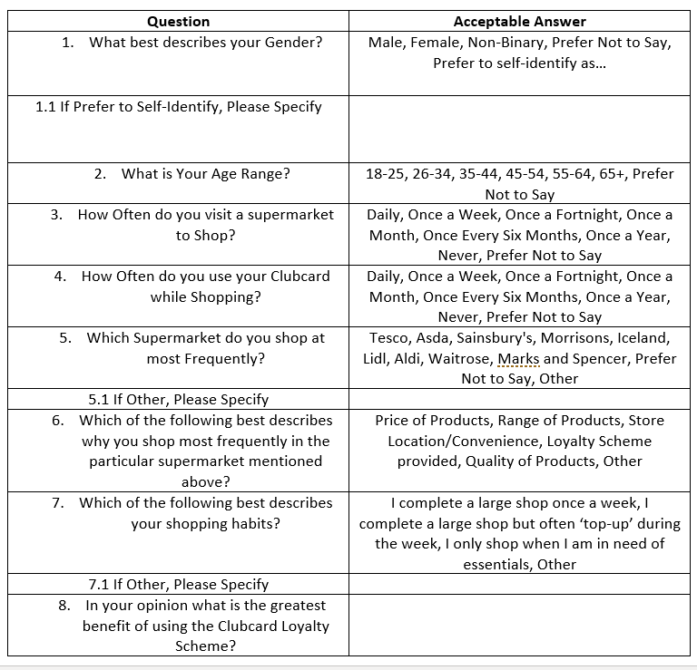
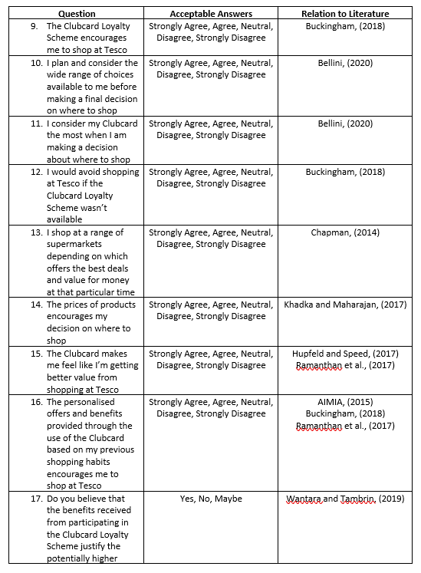

Table 3.1 Questionnaire Literature Review Matrix.

3.2.6.3 Data Analysis
The researcher used statistical software to analyse the responses that were gathered from the participants of the questionnaire. As the majority of the questions asked to the participants utilised a Likert scale which enabled the researcher to easily convert answers into numbers, SPSS software which allows for advanced statistical analysis for quantitative data (IBM, 2020) was used to ensure the most significant findings were outlined.

3.3 Sample
The researcher used a non-probability sample also known as a convenience sample to collect a data set for the research. A convenience sample allowed the researcher to collect data from those who were most convenient and most easily accessible to the researcher for data collection (Etikan, 2016). As the data was collected using the most convenient participants available to the researcher via social media channels this was considered a convenience sample (Dudovskiy, 2016).

3.4 Reliability and Validity

3.4.1 Reliability
The reliability of the research is an important factor that can be measured based on whether or not the results would be the same if the research was conducted on repeated occasions using the same research methods (Dudovskiy, 2016). Research reliability is seen as how reliable the chosen methods are at producing stable and consistent results (ibid).

3.4.2 Validity
Validity is a fundamental concept regarding the credibility of any research (Maxwell cited in Wyse et al. 2017). Validity has been defined as the extent to which the research accurately measures the concept in question (Heale and Twycross, 2015). The use of a well-designed questionnaire and the assurance of anonymity which increase the likelihood of honest responses from those who participate in the research (Murdoch et al. 2014) ensure the validity of the study.

3.4.3 Pilot Study
A pilot study was conducted before the distribution of the questionnaire to participants. By asking a small group of participants before distributing the questionnaire to a larger participant group, pilot studies allow for the feasibility of the research questions to be assessed as well as allowing for questions to be adapted if needed (Morin, 2013). The pilot study conducted was essential as it allowed for the understanding of the quality and efficiency of the questions asked within the questionnaire which allowed the researcher to ensure the highest quality and most relevant data could be collected (In, 2017).

3.5 Ethical Considerations
Before any data collection, ethical considerations for the research needed to be examined to ensure the participants and the researcher were protected at all times during the research process. Considering the ethical implications that could arise as a result of the research, the researcher was able to ensure that all steps were in place to ensure the protection for all involved against any potential risks that could arise as a result of their participation. The anonymity of the participants and the safe storage of collected data was ensured at all times to eliminate any potential risk of data misuse as well as ensuring that each participant gave full consent to be included in the research (Bryman & Bell, 2007).
The research was conducted upon approval by the ethics committee at UWTSD. A complete ethical assessment can be seen in Appendix E.

3.6 Chapter Summary
This chapter has achieved the second objective of this dissertation:
- To undertake primary research through the use of a survey aimed towards those who possess a Clubcard.
In summary, this chapter has identified and outlined the stages of the research design and methodology that was utilised for the successful data collection for this dissertation. This chapter has discussed and analysed each of the layers of the Research Onion and discussed the pathway followed to ensure successful research. This chapter has also identified the ethical considerations and limitations faced by the researcher while conducting the research.
The following chapter will utilise IBMs SPSS software to analyse and produce statistical data and findings from the primary data set collected from those who participated in the questionnaire.

Chapter 4 – Analysis

4.1 Chapter Introduction
The previous chapter has discussed the research design and methodology that was utilised for the primary research for this dissertation.
This chapter will achieve the third objective of this dissertation:
- To better understand through the use of statistical testing and analysis, the extent to which the Clubcard plays a role in the loyalty of consumers when choosing a supermarket.
This chapter will analyse the data collected from the one hundred and one participants who participated within the researcher’s questionnaire and will utilise a range of statistical methods using SPSS software to gain a better understanding of the data collected to aid in the understanding of the impact of the Tesco Clubcard on customer loyalty towards Tesco.
The chapter will use the following hypothesis when conducting tests:
H1- The Clubcard loyalty scheme has an impact on the loyalty of customers towards Tesco
H0- The Clubcard loyalty scheme does not have an impact on the loyalty of customers towards Tesco

4.2 Data Analysis
To analyse the data set collected to be able to better understand the responses of the participants, the researcher had to ensure that the data set was suitable for the SPSS software that was being used for the analysis of the data set. The researcher ensured that the data set was error-free to ensure it was suitable for the analysis. It was important to ensure that the data set was prepared correctly before the data analysis began to ensure the trustworthiness and meaningfulness of the analysis (Sheard, 2018). As well as this, before conducting the data analysis the researcher needed to code some of the responses that were collected to successfully analyse the data using the SPSS software. The codes utilised for each of the responses can be seen in Appendix F.

4.3 Demographics
The researcher used a range of demographic questions at the beginning of the questionnaire as this allowed for the researcher to have a clear understanding of the participants who took part in the questionnaire without the need for any personal information to be collected. As well as this, the demographic information collected could be utilised by the researcher to understand if demographics including the age or gender of the participants could impact the shopping habits and loyalties to a supermarket.
The researcher collected data from one hundred and one participants via their Facebook social media account and therefore, there is a chance that some of the data collected could be influenced by the researcher’s social media friendships, however, to try and avoid this, the researcher joined and utilised a range of private pages and groups on Facebook to ensure the data set was collected from a wide range of participants.

4.3.1 Participants Gender
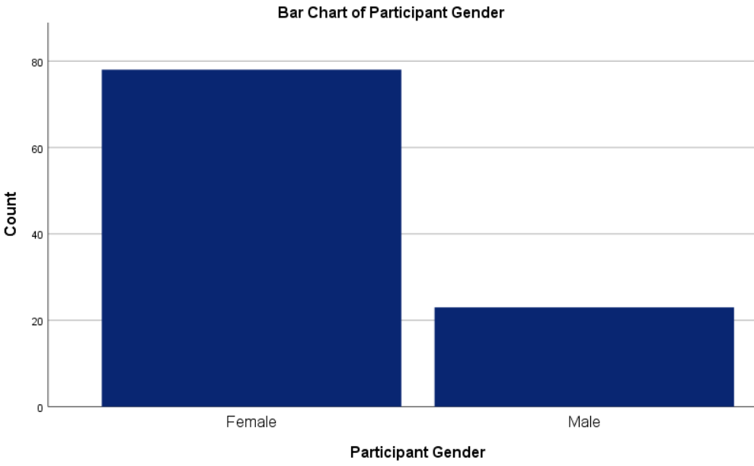
Figure 4.1 Participant’s Gender.
Figure 4.1 displays the frequency of the genders which were specified by those who participated in the research. The researcher gave a wide range of options for participants to ensure that all genders were considered, however, those who participated within the research only identified as male or female. The figure clearly shows that there was an increased number of female participants who participated in the research. As previously stated, this could be due to the social media friendships of the researcher, however, it could also be due to the nature of the research topic as it could be considered to be of more interest to female participants.

4.3.2 Participants Age
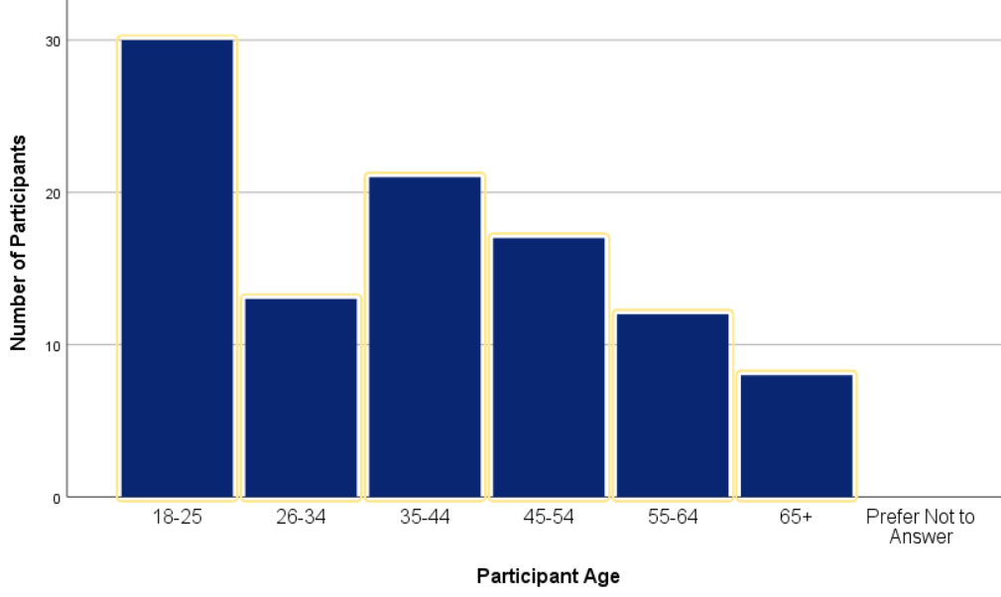
Figure 4.2 Participant’s Age.
Figure 4.2 displays a bar chart that shows the age of each participant. The bar chart clearly shows that the majority of participants were aged between 18-25. Again this could be due to the social media friendships of the researcher. However the bar chart also clearly shows that the remaining responses are spread out over the remaining age ranges and therefore the ages of the participants can be utilised by the researcher to conduct further analysis to understand how the participants’ age plays a role in their use of the Clubcard as well as their loyalty to a supermarket. To sustain more statistically accurate results, for some of the analysis, the researcher decided to separate the ages of participants into two age groups, under 45 and over 45 as seen in figure 4.3 below.
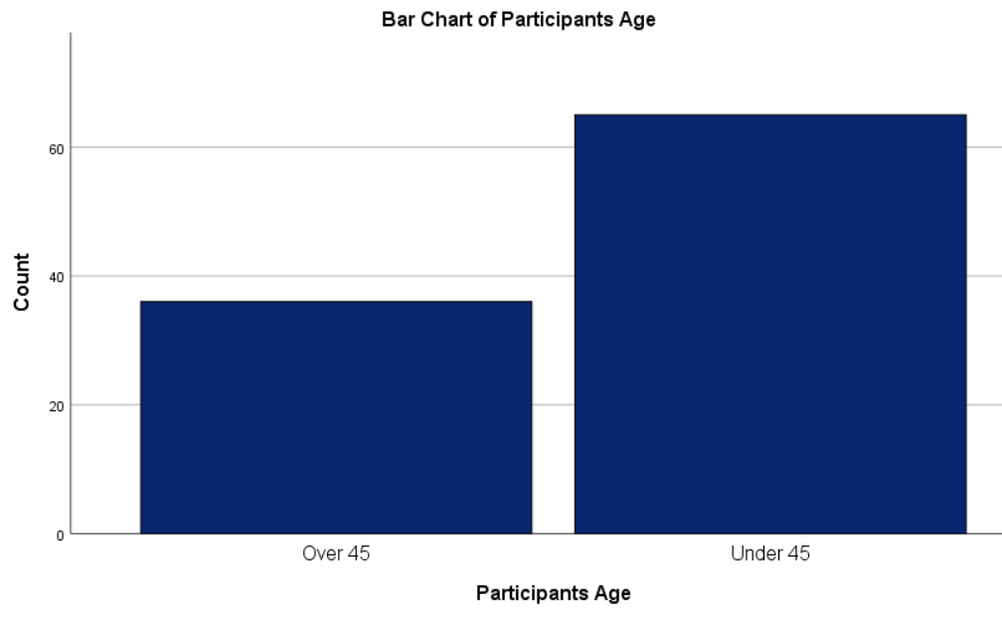
Figure 4.3 Participant’s Age groups.

4.3.3 Greatest Benefit of the Clubcard
Question 8 asked the participants what they believed was the greatest benefit to them of being part of the Clubcard loyalty scheme. This question allowed for the researcher to have a clear understanding of how the Clubcard is utilised by the participants and what factors may be a common theme throughout the responses received. The data collected for this question was analysed in a word cloud as seen in figure 4.4 below.
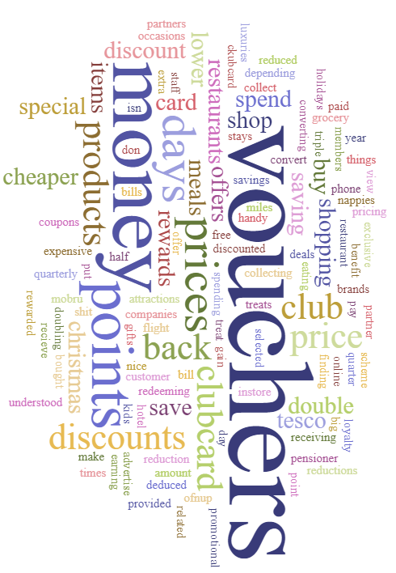
Figure 4.4 Greatest benefit word cloud.
The word cloud clearly shows that the vouchers provided as a result of utilising the Clubcard are considered as the greatest benefit to those who participate in the scheme. These findings correlate with those of Chapman (2014) as previously discussed in chapter two, who argued that customers are now more reliant on offers and rewards which are offered by supermarkets in the way of a loyalty scheme.

4.4 Clubcard & Encouragement to shop at Tesco
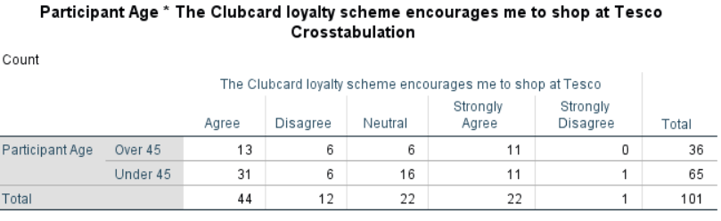
Table 4.1 Age & Clubcard encouragement Crosstabulation
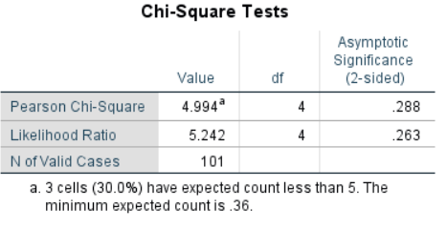
Table 4.2 Age & Clubcard encouragement Chi-square.
Question 9 of the questionnaire asked the participants whether or not the Clubcard loyalty scheme encourages them to shop at Tesco. The crosstabulation as seen in Table 4.1 above utilised the participates ages to understand if the age of the participant impacts how the Clubcard encourages them to shop. This was a useful analysis to aid in the understanding of the data collected as it will aid in the understanding of how the Clubcard impacts customer loyalty.
The crosstabulation analysis found that 66 of the 101 participants either strongly agreed or agreed that the Clubcard loyalty scheme provided by Tesco encouraged them to shop at the supermarket, with only 13 of the participants disagreeing or strongly disagreeing with the same statement. These findings correspond with the findings of Buckingham (2018) who found that 85% of shoppers are more inclined to shop in a supermarket that offers them a loyalty scheme.
A further crosstabulation and chi-square analysis were conducted to understand how the Clubcard encourages and influences the decisions of customers on where they shop as seen in table 4.3 and 4.4 below.
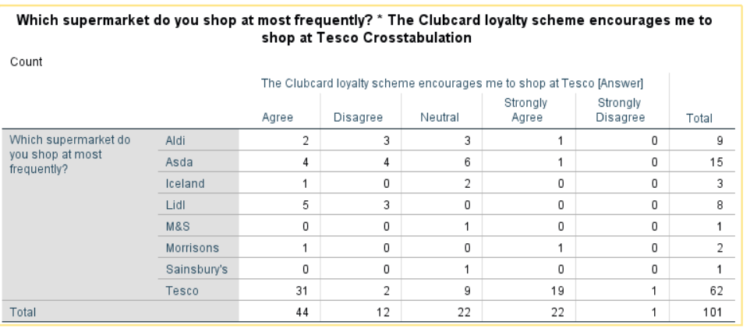
Table 4.3 Frequent Supermarkets and Clubcard encouragement Crosstabulation.
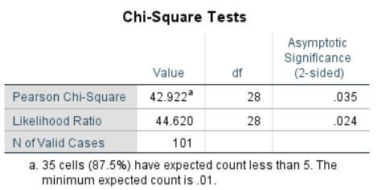
Table 4.4 Frequent supermarkets and Clubcard encouragement Chi-Square.
The chi-square analysis conducted in table 4.4 indicates that there is a significant link between the encouragement provided by the utilisation of the Clubcard and where the participants chose to shop. This once again corresponds with the findings by Buckingham (2018) which have been previously discussed in chapter two.

4.5 Clubcard & Perceived Value
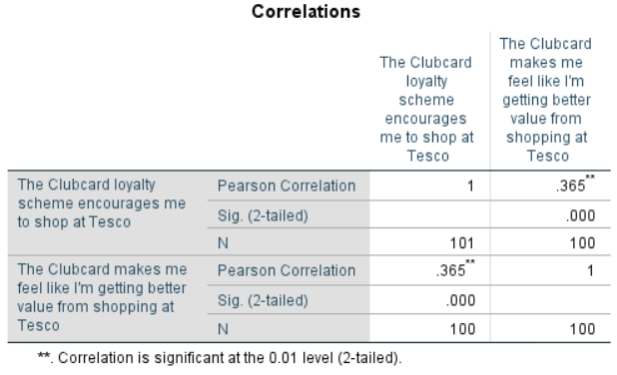
Table 4.5 Clubcard encouragement & Increased Value Correlation.
Table 4.5 above indicates that there is a statistically significant correlation between how the Clubcard scheme encourages customers to shop at Tesco and how the Clubcard impacts the perceived value of shopping at Tesco. This was an important statistical test as it allowed for the researcher to build a deeper understanding of how the Clubcard impacts customer loyalty and therefore the findings allow for the null hypothesis to be rejected. The findings correlate with those of Hupfeld and Speed (2017) who argued that the use of a loyalty scheme in a supermarket setting not only encourages customer loyalty but also increases the customers' perceived value in the supermarket in which the scheme is offered.

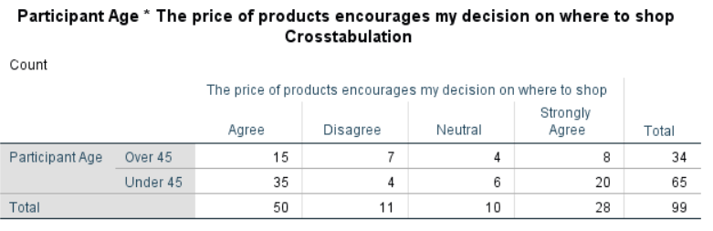
Table 4.6 Age and price encouragement Crosstabulation.
Further statistical testing as seen in the crosstabulation above found that the prices of products within a supermarket have an impact on where the participants chose to shop. The crosstabulation found that 78 of the 99 participants who answered the question either agreed or strongly agreed that they were encouraged where to shop based on the prices of the products available to them. These findings correlate with those of Khadka and Maharajan (2017) as previously discussed in chapter two when they discussed how customers choose a supermarket based on their expectations of the prices of the products. Therefore this indicates that the increased perceived value that customers feel from the use of the Clubcard as mentioned earlier in table 4.5 helps to ensure that the participants remain loyal to Tesco as they are getting a better value from shopping at Tesco as appose to visiting other supermarkets and therefore can be argued to increase the loyalty of customers and in turn once again allows for the null hypothesis to be rejected.

4.6 Clubcard & Convenience
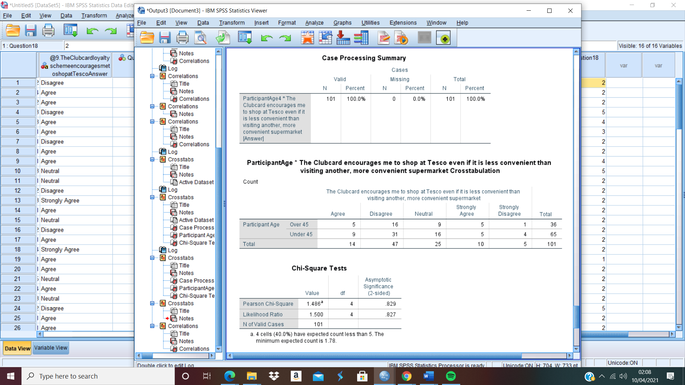
Table 4.7 Age & convenience encouragement crosstabulation.
Table 4.8 Age & convenience encouragement Chi-Square.
The researcher conducted a chi-square analysis to understand if the Clubcard plays a significant role in the loyalty of customers to Tesco even if it is less convenient for them to visit a Tesco supermarket. This allowed the researcher to understand to which extent the Clubcard plays a role in the overall loyalty of its users to Tesco. The analysis found that there was no statistically significant link between the participants and how the Clubcard encourages them to shop at Tesco even if it is less convenient for them to do so. These findings indicate that the participants are more likely to shop in a supermarket that offers them the greatest amount of convenience and therefore indicate that the Clubcard does not play a significant role in the loyalty of customers when there is a more convenient option available to them. Similar findings were discussed in chapter two by Wright (2020) and Roy et al. (2020) who discussed how customers are more likely to be engaged with supermarkets that provide them with the greatest amount of convenience. Furthermore, the findings also indicate that the participants are less likely to have a strong loyalty to a particular supermarket as they shop in supermarkets that are most convenient for them to do so at that particular moment. This was again discussed by Walker and Altman (2020) When they discussed that customers who choose where to shop based on convenience are less likely to have a strong loyalty to a particular supermarket.
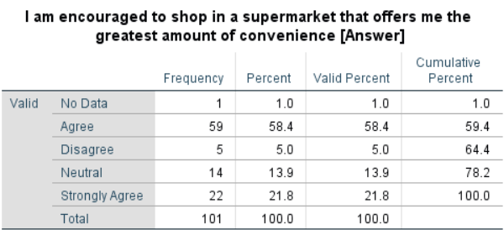
Table 4.9 Frequency table encouragement & convenience.
Further analysis and the use of a frequency table seen in table 4.9 above further solidified the findings as there is a significant number of participants who either strongly agreed or agreed that they are encouraged to shop in a supermarket that offered them the greatest amount of convenience.

4.7 Clubcard & Customer Satisfaction
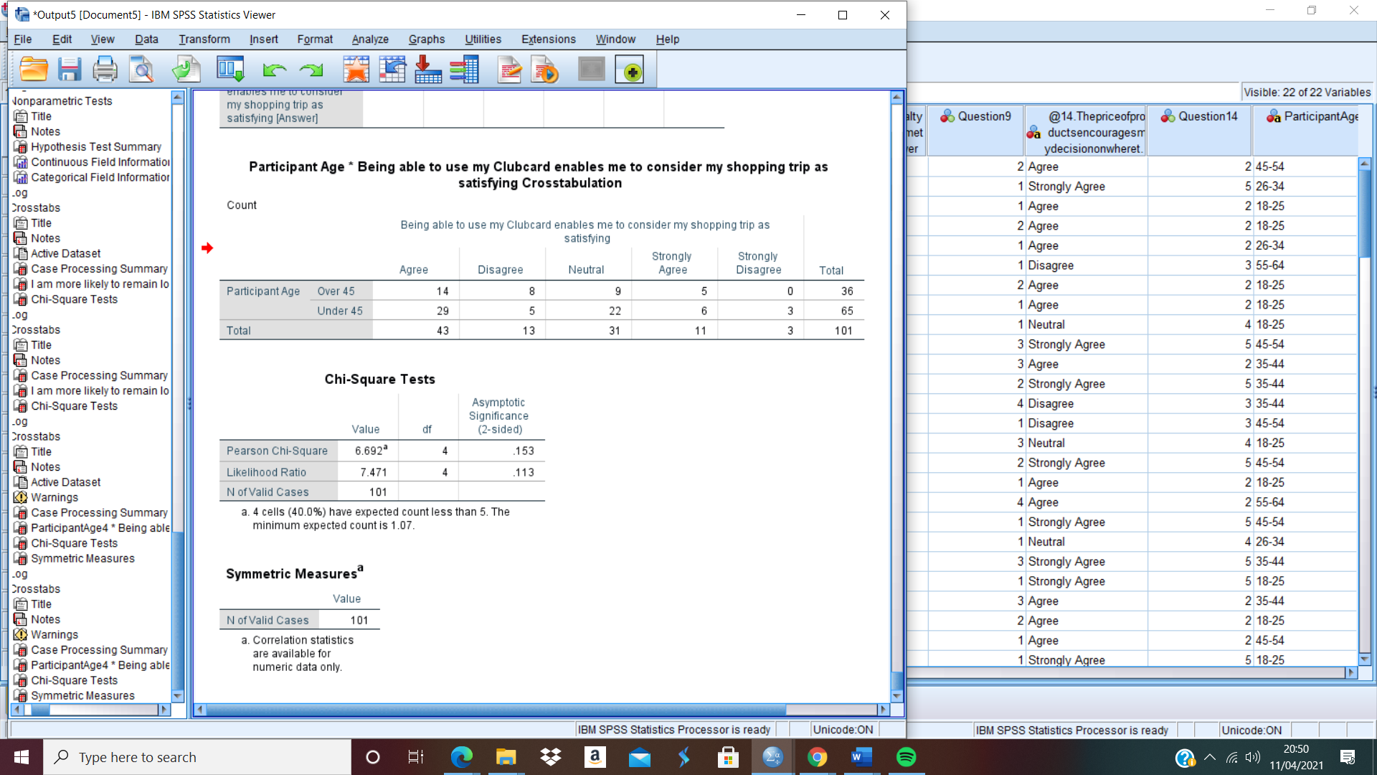
Table 4.10 Age & satisfaction Crosstabulation.
Table 4.11 Age & satisfaction Chi-square.
The researcher conducted further chi-square analysis to understand the impact that the Clubcard has on the overall satisfaction that is felt by the participants when shopping. This test was important to understand how the satisfaction that is felt by the participants when they use their Clubcard impacts their loyalty towards Tesco as it was previously mentioned by Khadka and Maharajan (2017) that the satisfaction of customers plays an important role in their continued loyalty to the organisation. The chi-square analysis conducted as seen in table 4.11 above indicated no statistical significance between the participants and their Clubcard impacting the satisfaction of their shopping trip. Therefore, in this case, the findings reject the alternate hypothesis as the satisfaction of the participants were not impacted by the use of the Clubcard then in this instance it can be argued that because of this, the Clubcard has no impact on the loyalty of its users towards Tesco.

4.9 Chapter Summary
This chapter has achieved the third objective of this dissertation:
- To better understand through the use of statistical testing and analysis, the extent to which the Clubcard plays a role in the loyalty of consumers when choosing a supermarket.
To summarise, this chapter has successfully utilised the primary data which was collected by the researcher from the participants who took part in the questionnaire which was earlier produced by the researcher. The data set collected was utilised to produce statistical results using SPSS which helped to better understand how the Clubcard loyalty scheme provided by Tesco has an impact on the loyalty of those who partake in the scheme.
The final chapter will discuss the findings of this dissertation as well as discussing the limitations and their implications on the research. Furthermore, the final chapter will achieve the final objective of this dissertation through the formation of recommendations based on the overall findings of the research as well as discussing where each of the dissertation objectives was achieved.

Chapter 5 – Discussion

5.1 Chapter Introduction
The previous chapter has analysed and discussed the data set collected from the primary research that was conducted by the researcher for this dissertation. This chapter is going to discuss the achievement of the dissertation aim and objectives followed by a discussion of the main findings which were outlined within the analysis of the data collected. Furthermore, the chapter will also provide recommendations based on those findings.
This chapter will achieve the fourth and final objective of this dissertation:
- To make recommendations based on the findings of the dissertation that will allow Tesco to better understand the impact their loyalty scheme has on the loyalty of those who participate in the scheme.

5.2 Achievement of Objectives
This dissertation has accomplished the aim and objectives that were established in chapter one:
- To conduct an extensive literature review that will discuss the key literature and theories produced by credible authors who have discussed and analysed the changes in consumers behaviour and the different factors that impact customer loyalty towards a supermarket.
The first objective was accomplished within chapter two of this dissertation where a thorough and extensive review of the available literature surrounding loyalty schemes and the factors which impact customer loyalty towards a supermarket were reviewed.
- To undertake primary research through the use of a survey aimed towards those who possess a Clubcard.
The second objective of this dissertation was achieved in chapter three where the primary research for the dissertation was outlined and a suitable survey was created utilising the literature discussed in chapter two to create a meaningful questionnaire that could aid in the understanding of the dissertation question.
- To better understand through the use of statistical testing and analysis, the extent to which the Clubcard plays a role in the loyalty of consumers when choosing a supermarket.
The third objective of this dissertation was accomplished within chapter four when the primary data set collected from participants of the researcher’s questionnaire was statistically tested using SPSS software to produce meaningful data that allowed for a deeper understanding of the research question.
- To make recommendations based on the findings of the dissertation that will allow Tesco to better understand the impact their loyalty scheme has on the loyalty of those who participate in the scheme.
The fourth and final objective of this dissertation was achieved within chapter five. This objective was achieved when the researcher produced a set of recommendations that were based on the findings of this dissertation that allowed for a deeper understanding of how the Clubcard loyalty scheme provided by Tesco impacts the loyalty of its users to the supermarket.

5.3 Main Findings
The main findings of this dissertation correspond with much of the literature that had been previously discussed within the literature review in chapter two. The main findings of this dissertation were discovered within chapter four when the data set collected was tested and statistically analysed. The main findings indicate there is a significant link between being a Clubcard participant and choosing to shop at a Tesco supermarket. The findings also indicate that the Clubcard helps to increase customer loyalty through the increased sense of value that those who participate in the scheme feel that they are getting by being a Clubcard member. However, despite this, the main findings found within chapter four also outlined the fact that the Clubcard fails to increase the satisfaction of the customer as well as failing to encourage customers to remain loyal to Tesco if there is a more easily accessible and more convenient supermarket available for them to visit.

5.4 Limitations
This dissertation encountered some limitations throughout the research process. One of the limitations encountered and a limitation that has been recognised within chapter four was how the data collection was conducted. As previously mentioned the researcher utilised their Facebook social media platform to gather the primary data. This presented a potential limitation regarding the participants of the research as the participates could have been limited by the social media friendships of the researcher.
Another limitation that was encountered was the time scale in which the research was conducted. As there was a limited amount of time to conduct the research it is possible that the number of participants who took part in the survey was less than what would be possible if the research had been conducted over a longer period. Furthermore, as the research was conducted in a period in which COVID-19 restrictions were present within the UK, it is possible that as many people had to shop online for their groceries that this could have impacted their responses to some of the questions which were asked.

5.5 Further Research
This dissertation has opportunities to be completed again at a later date to conduct further research into the Clubcard loyalty scheme and how this impacts the customers and their loyalty towards Tesco. The dissertation if completed again in the future could utilise a longer time scale to collect a larger data set as well as the data collection being conducted at a time where there are no COVID-19 restrictions which could impact the shopping behaviours of the participants and therefore allow for a greater understanding into the impact that the Clubcard has on customer loyalty. Furthermore, as the findings of this dissertation imply that the Clubcard only increases the loyalty and retention of customers in certain circumstances, then these circumstances could be observed in more detail to have a greater understanding of the factors that impact the customers' loyalty.

5.6 Conclusion
To conclude, this dissertation has successfully achieved its aim which was to critically analyse the impact that the Tesco Clubcard has on the loyalty of those who participate in the scheme and their loyalty towards Tesco. As well as this, this dissertation has also achieved each of its objectives that were set out to achieve the overall dissertation aim.
This dissertation has allowed the researcher to gain a deeper knowledge and better understanding of supermarket loyalty schemes and how these have an impact on the loyalty of those who participate in them. The findings of this dissertation indicate that despite the Clubcard loyalty scheme revolutionising loyalty schemes within a supermarket setting, in the current day, the scheme is only effective at retaining customer loyalty under certain circumstances. The dissertation found that the Clubcard loyalty scheme is effective in retaining the loyalty of customers in circumstances that allow the participant to feel an increased sense of value from the utilisation of their Clubcard, however, the dissertation findings also indicate that the Clubcard fails to impact the loyalty and retention of customers in circumstances where a more easily accessible or more convenient supermarket is available to them.

5.7 Recommendations
The following recommendations are being made based on the findings of this dissertation:
- Ensure the maximisation of convenience for Clubcard customers to ensure customer retention and increased customer loyalty towards Tesco.

- Ensure the continued maximisation of increased value through the continued offering of vouchers to Clubcard users to allow for the continued increased sense of value that Clubcard participants feel from the utilisation of their Clubcard to ensure increased customer loyalty.

References

AIMIA., (2015). AIMIA Global Loyalty Lens Report. [online] Available at: <https://silo.tips/download/2015-aimia-global-loyalty-lens-report#> [Accessed 10 January 2021].
Ball, H., (2019). Conducting Online Surveys. Journal of Human Location, 35(3), pp.413-417.
Bellini, S., Cardinali, M. and Grandi, B., (2016). Does Shopping Preparation Influence Consumer Buying Decisions? International Business Research, 9(10), pp.202-211.
Bowen, J. and Shiang-Lih, C. (2015). Transforming Loyalty Programs. International Journal of Contemporary Hospitality Management, 27(3), pp.415-430.
Brace, I., (2018). Questionnaire Design. 4th ed. Kogan Page, pp.1-6.
BRM., (2021). Quantitative Data Analysis. [online] Available at:< https://research-methodology.net/research-methods/data-analysis/quantitative-data-analysis/> [Accessed 11 February 2021].
Brun, I., Rajaobelina, L., Ricard, L. and Berthiaume, B., (2017). Impact of Customer Experience on Loyalty: A Multichannel Examination. The Service Industries Journal, 37(5-6), pp.317-340.
Bryman, A. and Bell, E., (2007). Business Research Methods. 2nd ed. Oxford University Press
Buchanan, I., (2018). A Dictionary of Critical Theory. 2nd ed. Oxford University Press.
Buckingham, D., (2018). The True Impact of Loyalty Schemes, Rewards and Personalisation on Consumer Behaviour. [online] Available at: <https://www.ecrebo.com/blog/true-impact-loyalty-schemes-rewards-personalisation#:~:text=The%20first%20is%20that%20loyalty,that%20didn't%20have%20one. [Accessed 30 November 2020].
Cakici, C., Akgunduz, Y. and Yildirim, O., (2019). The Impact of Perceived Price Justice and Satisfaction on Loyalty: The Mediating Effect of Revisit Intention. Tourism Review. https://doi.org/10.1108/TR-02-2018-0025.
Chahal, M., (2017). Can Loyalty Exist in the Grocery Sector? [online] Marketing Week. Available at: <https://www.marketingweek.com/grocery-loyalty/> [Accessed 21 April 2021].
Chapman, M., (2014). Consumers’ Recession Coping Mechanisms Have Become Entrenched Says Study. [online] Available at: <https://www.campaignlive.co.uk/article/consumers-recession-coping-mechanisms-become-entrenched-says-study/1291650> [Accessed 4 February 2021].
Chaudhuri, A. and Holbrook, M., (2001). The Chain Effects from Brand Trust and Brand Affect to Brand Performance: The Role of Brand Loyalty. Journal of Marketing, 65(2), pp.81-93.
Crowther, D. and Lancaster, G., (2008). Research Methods: A Concise Introduction to Research in Management and Business Consultancy. 2nd ed. Butterworth-Heinemann.
Doyle, C., (2016). Dictionary of Marketing. 4th ed. Oxford University Press
Dudovskiy, J., (2016). The Ultimate Guide to Writing a Dissertation in Business Studies: A Step-By-Step Assistance. 1st ed. Research-Methodolgy.net.
East, R., Singh, J., Wright, M. and Vanhuele, M., (2017). Consumer Behaviour: Applications in Marketing. 3rd ed. London: Sage, pp.3-4.
Engel, J. F, Kollat, D. and Blackwell, R., (1978). Consumer Behaviour. Dryden Press, NY.
Etikan, I., (2016). Comparison of Convenience Sampling and Purposive Sampling. American Journal of Theoretical and Applied Statistics, 5(1).
Geraldi, J. and Lechter, T., (2012). Gantt Charts Revisited. International Journal of Managing Projects in Business, 5(4), pp.578-594.
Ghauri, P., Gronhaug, K. and Strange, R., (2020). Research Methods in Business Studies. 5th ed. Cambridge. Cambridge University Press.
Gobiraj, V., Balasundaram, N. and Gandhi, R., (2010). Determinants of Customer Loyalty in Leading Supermarket in United Kingdom: An Exploratory Study. SRM Management Digest, 8.
Hansen, T., Jensen, M., and Solgaard, S. (2011). When Supermarket Consumers get Stocked in the Middle. International Journal of Retail, 39(11), pp.836-850. DOI:10.1108/09590551111177954.
Harland, B., (2020). How to Do a Quantitative Research Questionnaire. [online] Available at: https://sciencing.com/how-to-do-a-quantitative-research-questionnaire-12748929.html [Accessed 11 February 2021].
Heale, R. and Twycross, A., (2015). Validity and Reliability in Quantitative Research. Evidence-Based Nursing. 18(3). pp.66-68.
Howarth, R., (2021). Martin Lewis’ Urgent Warning to Tesco Clubcard Users as Major Changes Planned. [online] Available at: <https://www.lancs.live/whats-on/shopping/martin-lewis-urgent-warning-tesco-19620684> [Accessed 19 April 2021].
Hupfeld, A. and Speed, C., (2017). Getting Something for Nothing? Proceedings of the 2017 CHI Conference on Human Factors in Computing Systems. [online] Available at: <https://dl.acm.org/doi/abs/10.1145/3025453.3026017>.
IBM, (2020). IBM SPSS Software. [online] Available at: <https://www.ibm.com/analytics/spss-statistics-software> [Accessed 22 February 2021].
In, J., (2017). Introduction of Pilot Study. Korean Journal of Anesthesiology. [online] 70(6), pp.601-605. DOI: 10.4097/kjae.2017.70.6.601 [Accessed 23 February 2021].
John, D. and Lyimo, B., (2019). Contribution of External Marketing on Customer Loyalty in the Tanzania Tourism Industry. School of Researchers, 2(3).
Khadka, K. and Maharjan, S., (2017). Customer Satisfaction and Customer Loyalty. Centria University of Applied Sciences.
Kotler, P. (2012) Kotler on Marketing. New York: The Free Press.
Kotler, P., Armstrong, G., Harris, L. and He, H., (2020). Principles of Marketing. 8th ed. Pearson, pp.116-124.
Lavrakas, P., (2011). Questionnaire. Encyclopedia of Survey Research Methods. Sage. DOI: https://dx.doi.org/10.4135/9781412963947.n424 [Accessed 13 February 2021].
McMullan, R. and Gilmore, A., (2008). Customer Loyalty: An Empirical Study, European Journal of Marketing, 42(10).
Morin, K., (2013). Value of Pilot Study. Journal of Nursing Education. [online] 52(10), pp.547-548. DOI: https://doi.org/10.3928/01484834-20130920-10 [Accessed 23 February 2021].
Muganda, A. D., Otuya, R. and Waiganjo, M., (2014). Effect of Customer Loyalty Schemes on Competitiveness of Supermarkets in Kenya. European Journal of Business and Management. 6(16) pp.155-164.
Muranganwa, R., (2016). Design and Implementation of a Multi Agent Opportunistic Grid Computing Platform. University of Fort Hare.
Murdoch, M., Simon, A., Polusny, M., Bangerter, A., Grill, J., Noorbaloochi, S. and Partin, M. (2014). Impact of Different Privacy Conditions and Incentives on Survey Response Rate, Participant Representativeness, and Disclosure of Sensitive Information: A Randomised Controlled Trial. BMC Medical Research Methodology. 14(90). DOI: 10.1186/1471-2288-14-90.
Nageswari, R., (2019). The Evolution of Consumer Behaviour in the Digital Age. UGC Journal, 7(1), pp.245-250.
Nandal, N., Nadnal, N. and Malik, R., (2020). Is Loyalty Program as a Marketing Tool Effective. Journal of Critical Review, 7(6), pp.1079-1082.
Nardi, P., (2018). Doing Survey Research: A Guide to Quantitative Methods. 4th ed. New York. Routledge.
Nastasoiu, A. and Vandenbosch, M., (2018). Competing with Loyalty: How to Design a successful Customer Loyalty Reward Program. Business Horizons, [online] 62(2), pp.207-214. Available at: <https://www.sciencedirect.com/science/article/abs/pii/S0007681318301873> [Accessed 20 January 2021].
Nguyen, D., Pham, V., Tran, D. Pham, D., (2020). Impact of Service Quality, Customer Satisfaction and Switching Costs on Customer Loyalty. [online] Available at: <http://db.koreascholar.com/article?code=396903> [Accessed 19 January 2021].
Nisa, Y., (2019). Customer Loyalty – Does Pricing Matter? Lulea University of Technology
Patten, M., (2017). Research: A Practical Guide. 4th ed. New York: Routledge
Perner, L., (2018). Consumer Behaviour: The Psychology of Marketing. [online] Available at: https://www.consumerpsychologist.com/ [Accessed 18 December 2020].
Raithatha, Y., (2017). Understanding the Economic Impact Terrorism has on the Destination Decision Making: Northern Irish Tourists. Dublin Business School.
Ramanathan, U., Subramanian, N., Yu, W. and Vijaygopal, R., (2017). Impact of Customer Loyalty and Service Operations on Customer Behaviour and Firm Performance: Empirical Evidence for UK Retail Sector. Production Planning and Control, 28(6-8), pp.478-488.
Rather, R., (2017). Investigating the Impact of Customer Brand Identification on Hospitality Brand Loyalty: A Social Identity Perspective. Journal of Hospitality Marketing & Management, 27(5), pp.487-513.
Reimers, V. and Chao, F., (2014). The Role of Convenience in a Recreational Shopping Trip. European Journal of Marketing, 48 (11/12), pp.2213-2236.
Roy, S., Shekhar, V., Quazi, A., and Quaddus, M., (2020). Consumer Engagement Behaviours: Do Service Convenience and Organisational Characteristics Matter? Journal of Service Theory and Practice.
Saunders, M., Lewis, P. and Thornhill, A. (2019). Research Methods for Business Students. 8th ed. London: Pearson Education.
Saunders, M., Lewis, P. and Thornhill, A., (2009). Research Methods for Business Students. 5th ed. Harlow: Pearson Education, pp.100-125.
Schiffman, G. and Kanuk, L., (2008). Consumer Behaviour, 8th ed. Prentice Hall, New Jersey.
Sedgwick, P., (2014). Cross Sectional Studies: Advantages and Disadvantages. BMJ. [online] pp. g2276. Available at: https://www.researchgate.net/publication/275427950_Cross_sectional_studies_advantages_and_disadvantages [Accessed 12 February 2021].
Shadbolt, P., (2015). How the Discounters are Beating the Supermarkets. [online] Available at: <How the discounters are beating the supermarkets - BBC News> [Accessed 20 January 2021].
Sheard, J., (2018). Research Methods: Information, Systems, and Context. 2nd ed. Elsevier, pp.429-452.
Srivastava, M. and Rai, A., (2018). Mechanics of Engendering Customer Loyalty: A Conceptual Framework. IIMB Management Review, [online]. 30(3), pp.207-218. Available at: <https://www.sciencedirect.com/science/article/pii/S0970389618302416> [Accessed 20 January 2021].
Statista., (2020). Supermarkets in the United Kingdom – Statistics and Facts. [online] Available at: <https://www.statista.com/topics/1983/supermarkets-in-the-united-kingdom-uk/> [Accessed 27 October 2020].
Tesco PLC., (2020). Tesco Offer Hundreds of Exclusive Deals for Clubcard Customers. [online] Available at: <https://www.tescoplc.com/news/2020/tesco-offer-hundreds-of-exclusive-deals-for-clubcard-customers/> [Accessed 28 October 2020].
Tesco., (2021). Our History. [online] Tesco. Available at: <https://www.tescoplc.com/about/our-history/> [Accessed 21 April 2021].
Walker, H. and Altman, G., (2020). Changing in Behaviour of Grocery Shoppers. [online] Available at: <https://www.thinkwithgoogle.com/intl/en-gb/marketing-strategies/search/how-digitisation-changing-behaviour-convenience-grocery-shoppers/> [Accessed 16 January 2021].
Walker., (2020). Walker Loyalty Matrix. [online] Walkerinfo.com. Available at: <https://www.walkerinfo.com/loyalty-matrix> [Accessed 30 November 2020].
Wantara, P. and Tambrin, M., (2019). The Effect of Price and Product Quality Towards Customer Satisfaction and Customer Loyalty. International Tourism and Hospitality Journal, 2(1), pp.1-9.
Wells, L., (2020). Tesco Reports Growth in Convenience. [online] Available at:< https://www.talkingretail.com/news/industry-news/tesco-reports-convenience-growth-26-06-2020/> [Accessed 16 February 2021].
Westbrook, I., (2018). Tesco Clubcard Changes Anger Customers. [online] BBC News. Available at: <https://www.bbc.co.uk/news/business-42700758> [Accessed 21 April 2021].
Wilson, J., (2010). Essentials of Business Research: A Guide to Doing Your Research. Sage Publications, p.12.
Wright, A., (2020). The Changing Behaviour Series: A View on Grocery Shopping in the UK. [online] Available at: <https://blis.com/the-changing-behaviour-series-a-view-on-grocery-shopping-in-the-uk/> [Accessed 19 January 2021].
Wright, K. (2017). Researching Internet-Based Populations: Advantages and Disadvantages of Online Survey Research, Online Questionnaire Authoring Software Packages, and Web Survey Services. Journal of Computer-Medicated Communication. [online] 10(3). Available at: https://academic.oup.com/jcmc/article/10/3/JCMC1034/4614509 [Accessed 11 February 2021].
Wyse, D., Selwyn, N., Smith, E., and Suter, L., (2017). The BERA/SAGE Handbook of Educational Research. 1st ed. BERA/SAGE.

Appendix

Appendix A - Walkers Loyalty Matrix
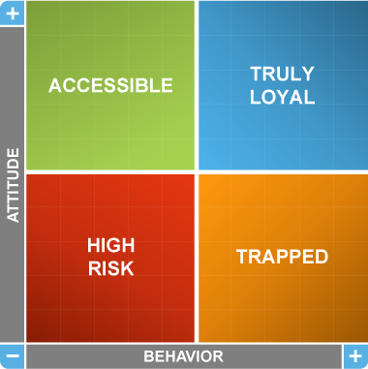

Appendix B – List of Loyalty Schemes (Nandal et al. 2020)
- Frequency Loyalty Reward Program
- Earn Points to get Rewards Program
- Cash Back Loyalty Program
- Points Program
- Spend Program
- Tiered Program
- Paid Program – VIP Members Club
- Value Based Program
- Partnered Program
- Game Program
- Hybrid Loyalty Program

Appendix C – Engel Kollat Blackwell Model (1978)
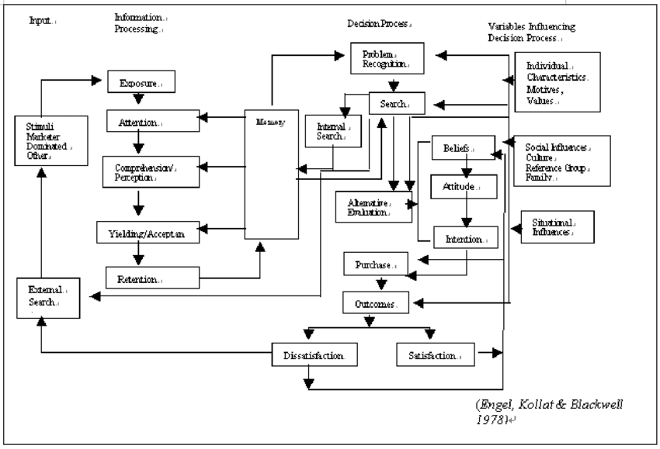

Appendix D – Gantt Chart
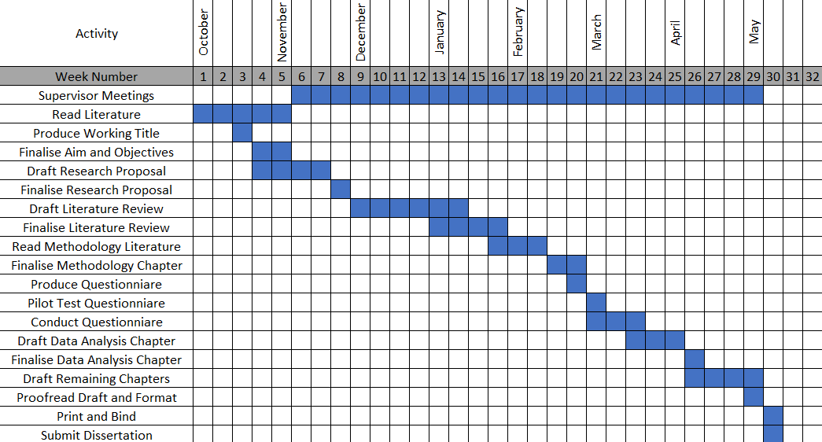

Appendix E – UWTSD Ethics Form
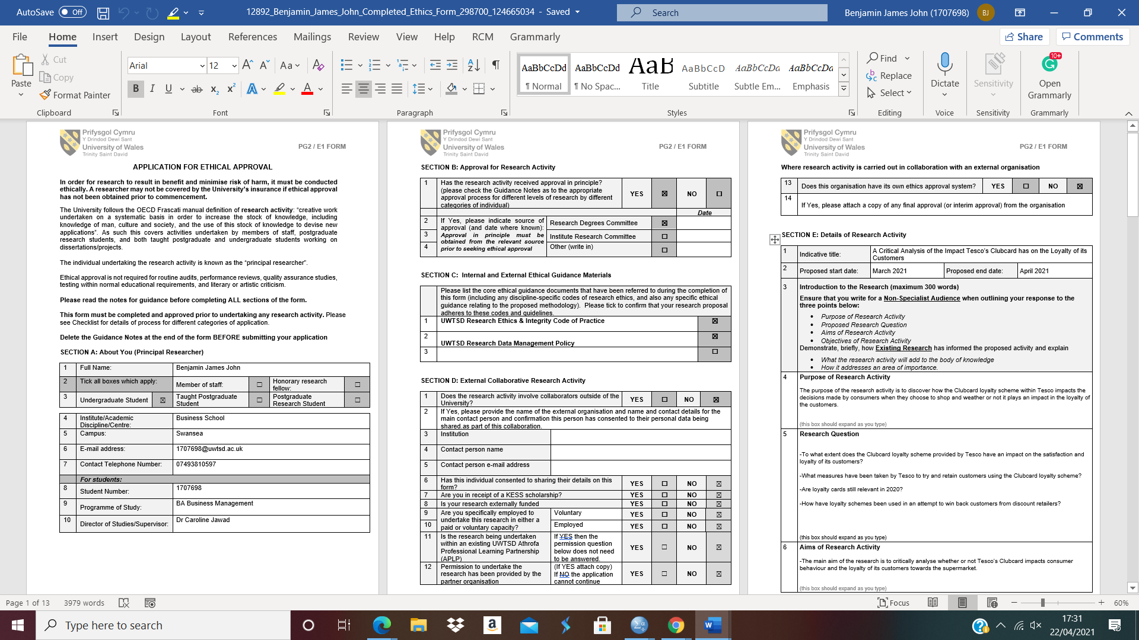
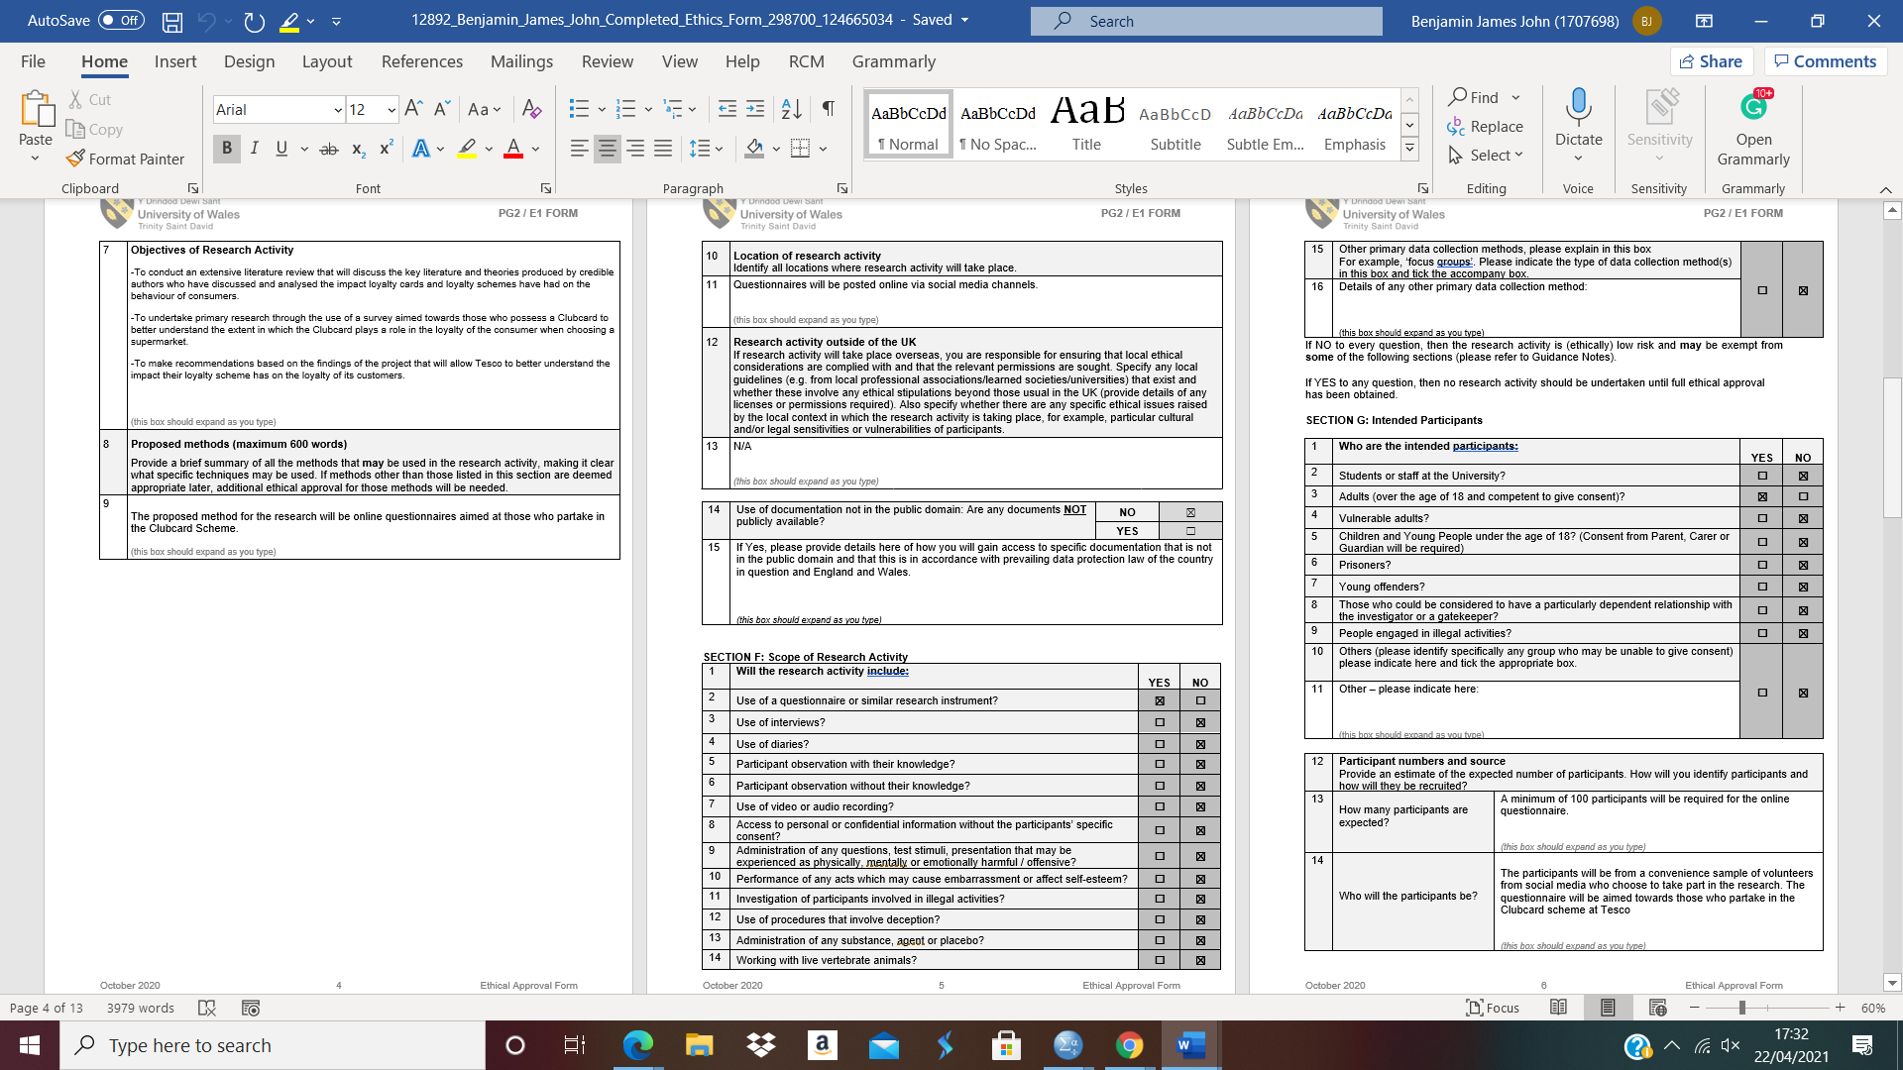
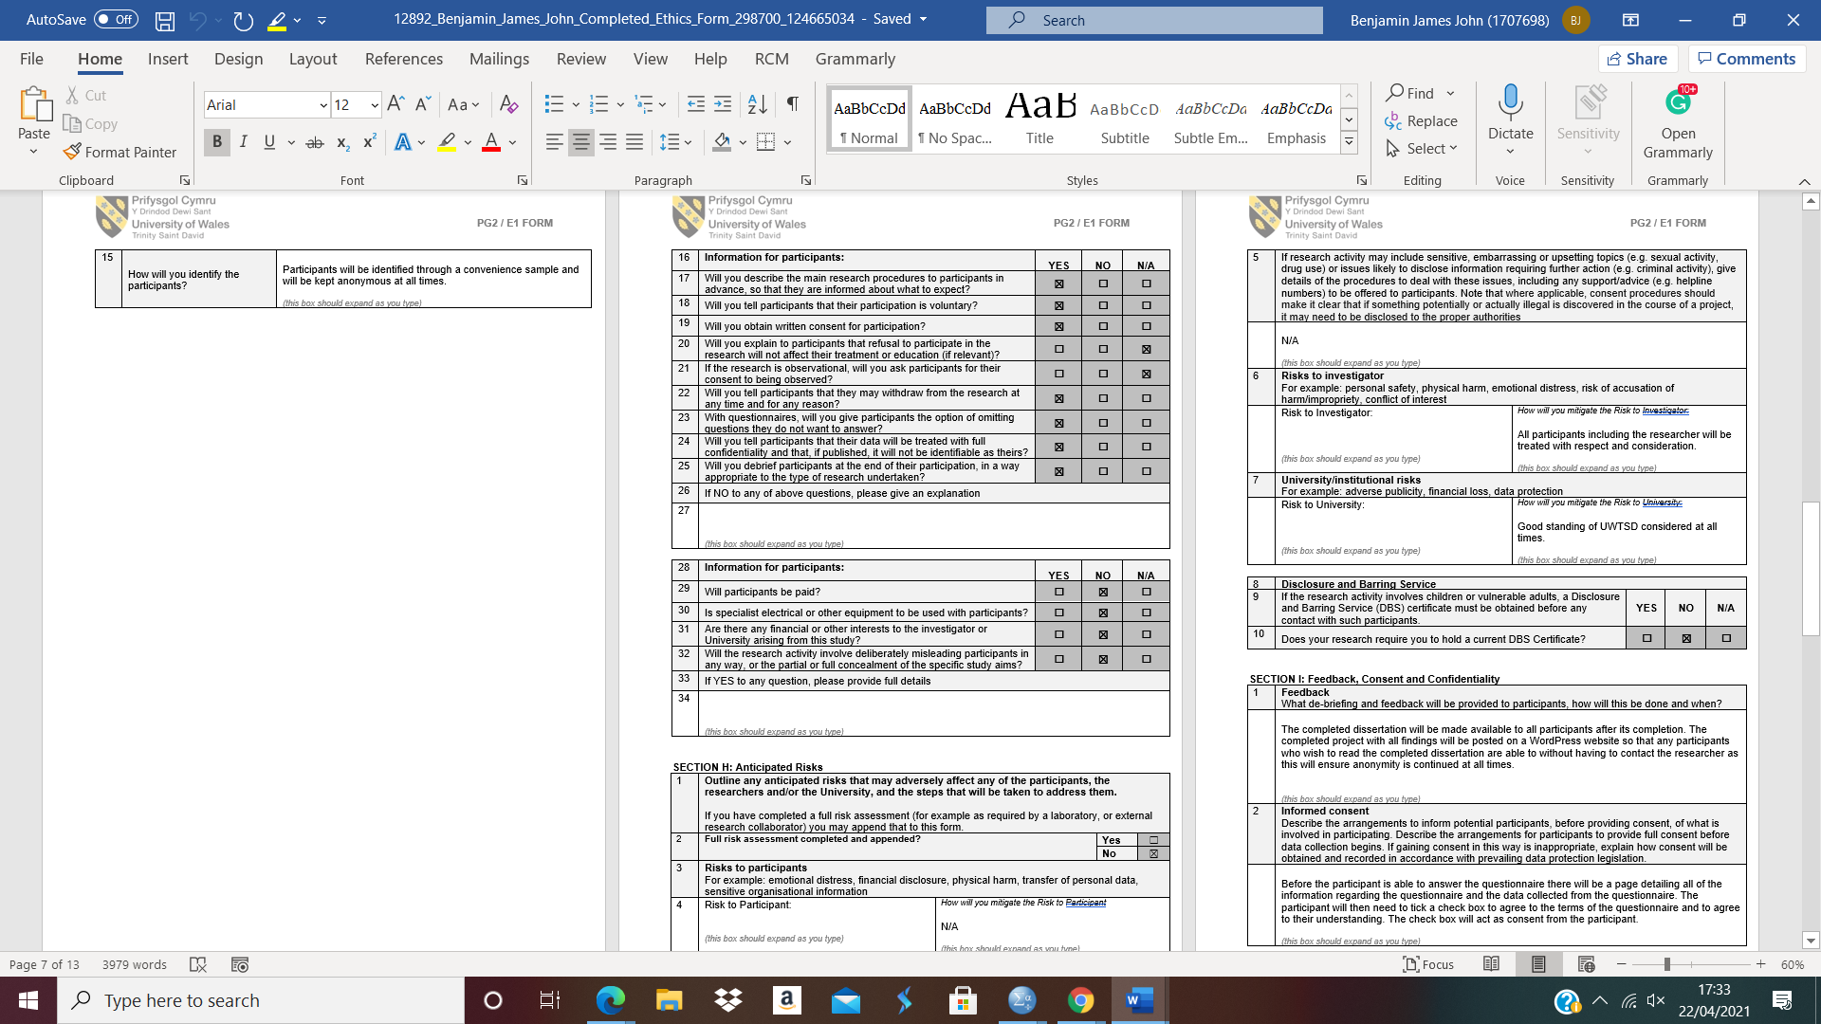
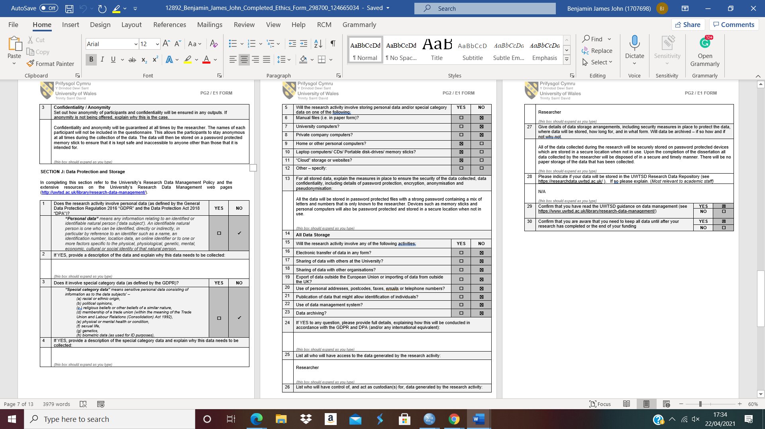
Appendix F – SPSS Codes
Participant Response | Code
Male | 1
Female | 2
18-25 | 1
26-34 | 2
35-44 | 3
45-54 | 4
55-64 | 5
65+ | 6
Strongly Agree | 1
Agree | 2
Neutral | 3
Disagree | 4
Strongly Disagree | 5

Appendix G – Questionnaire Raw Data
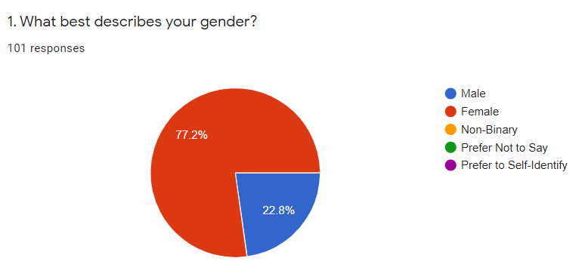
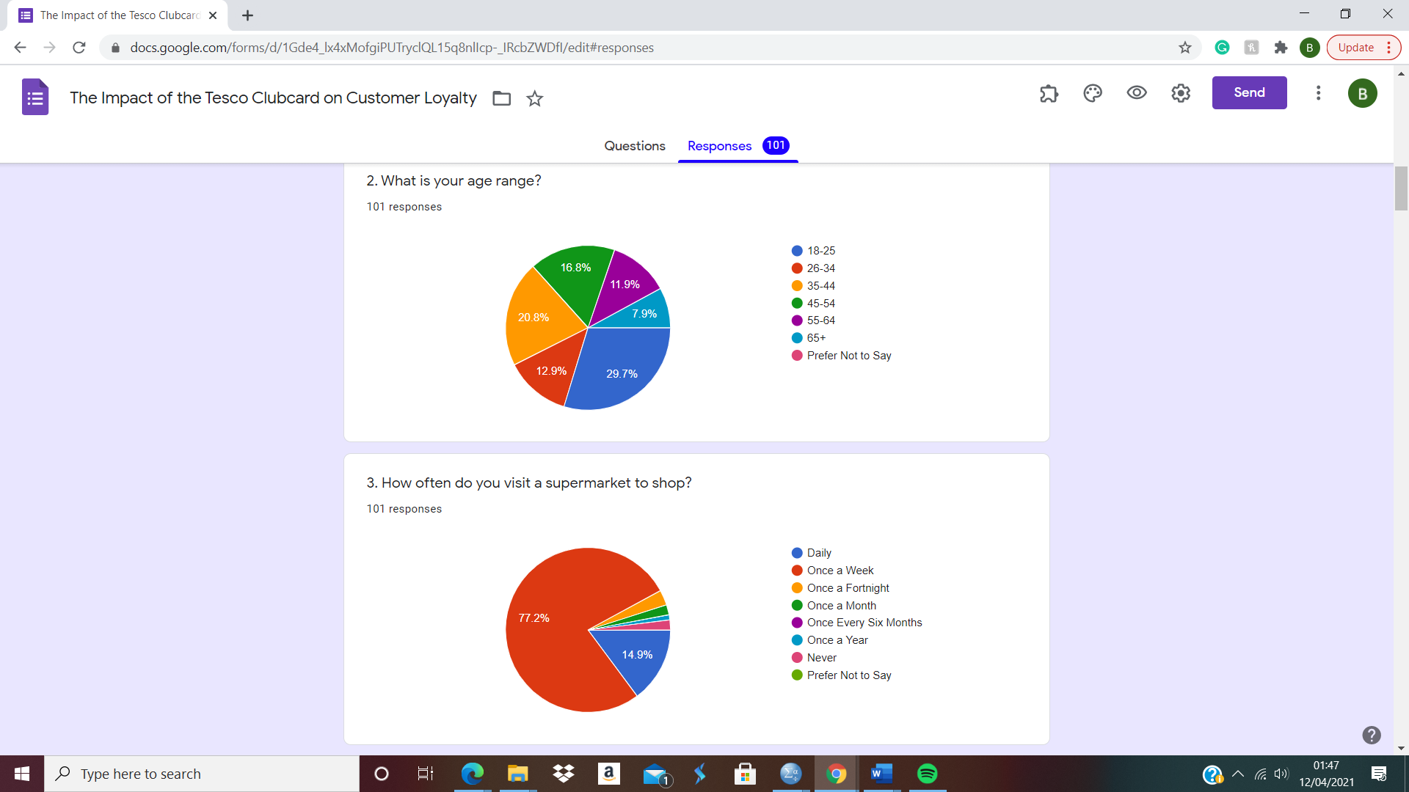
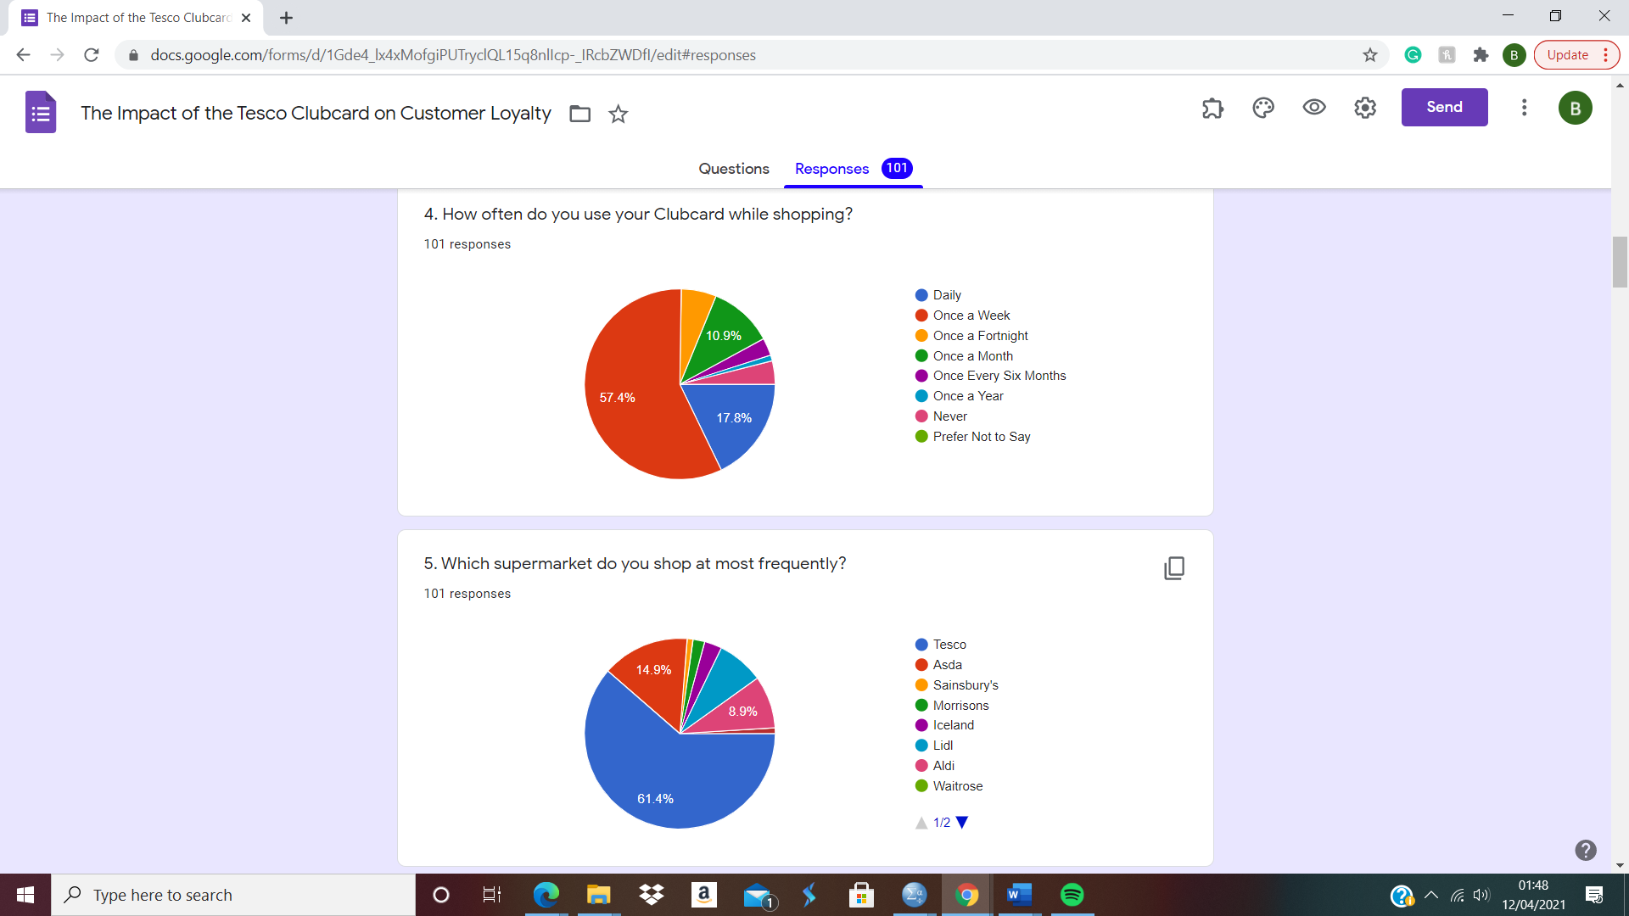
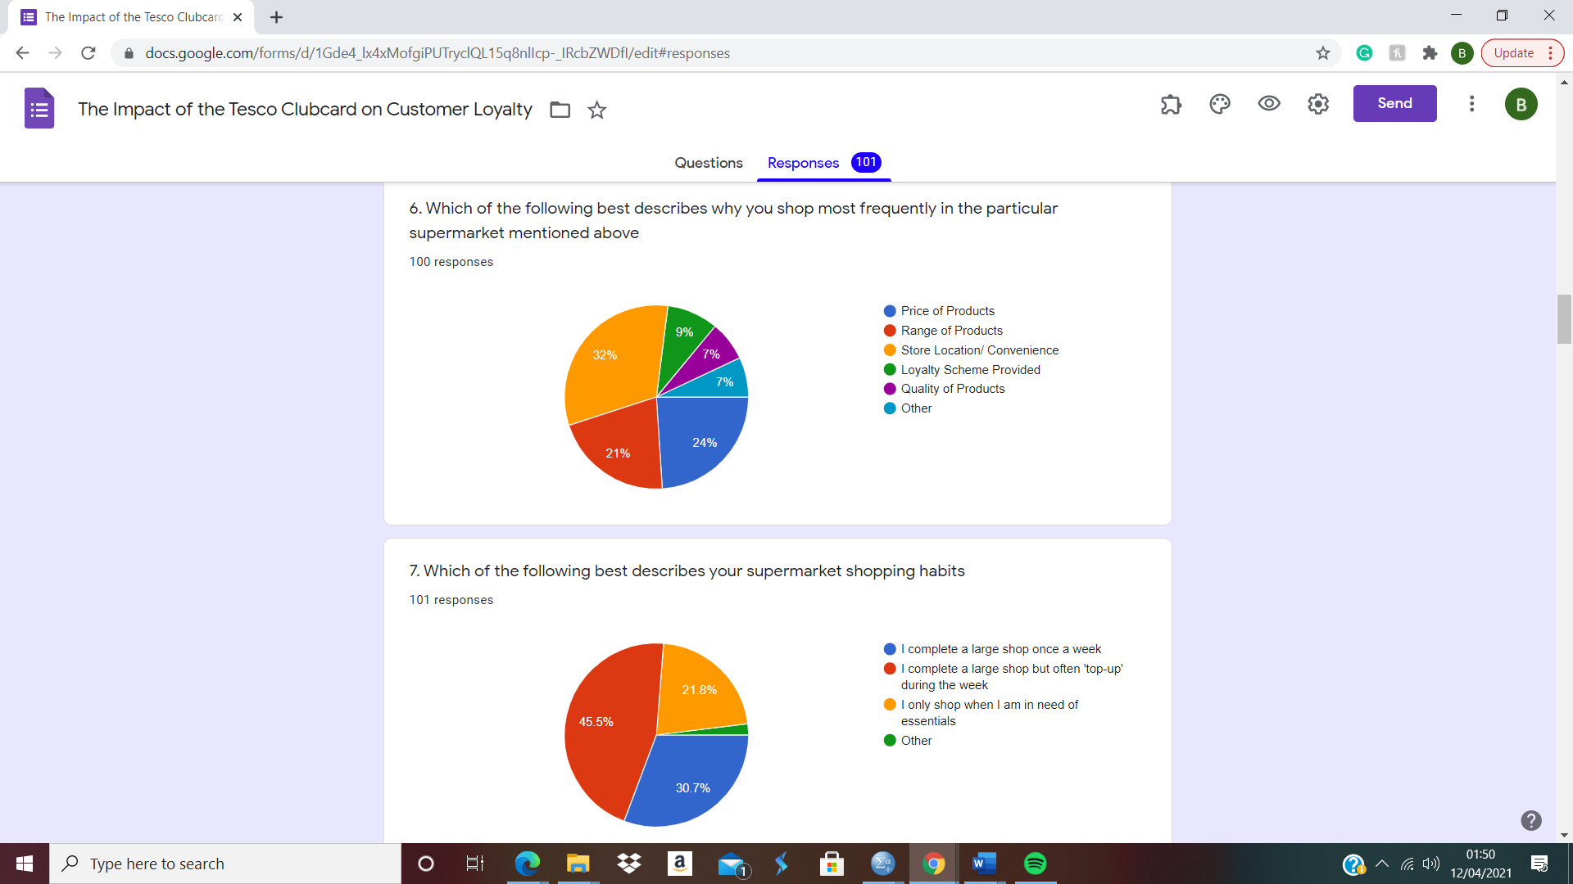
Question 8
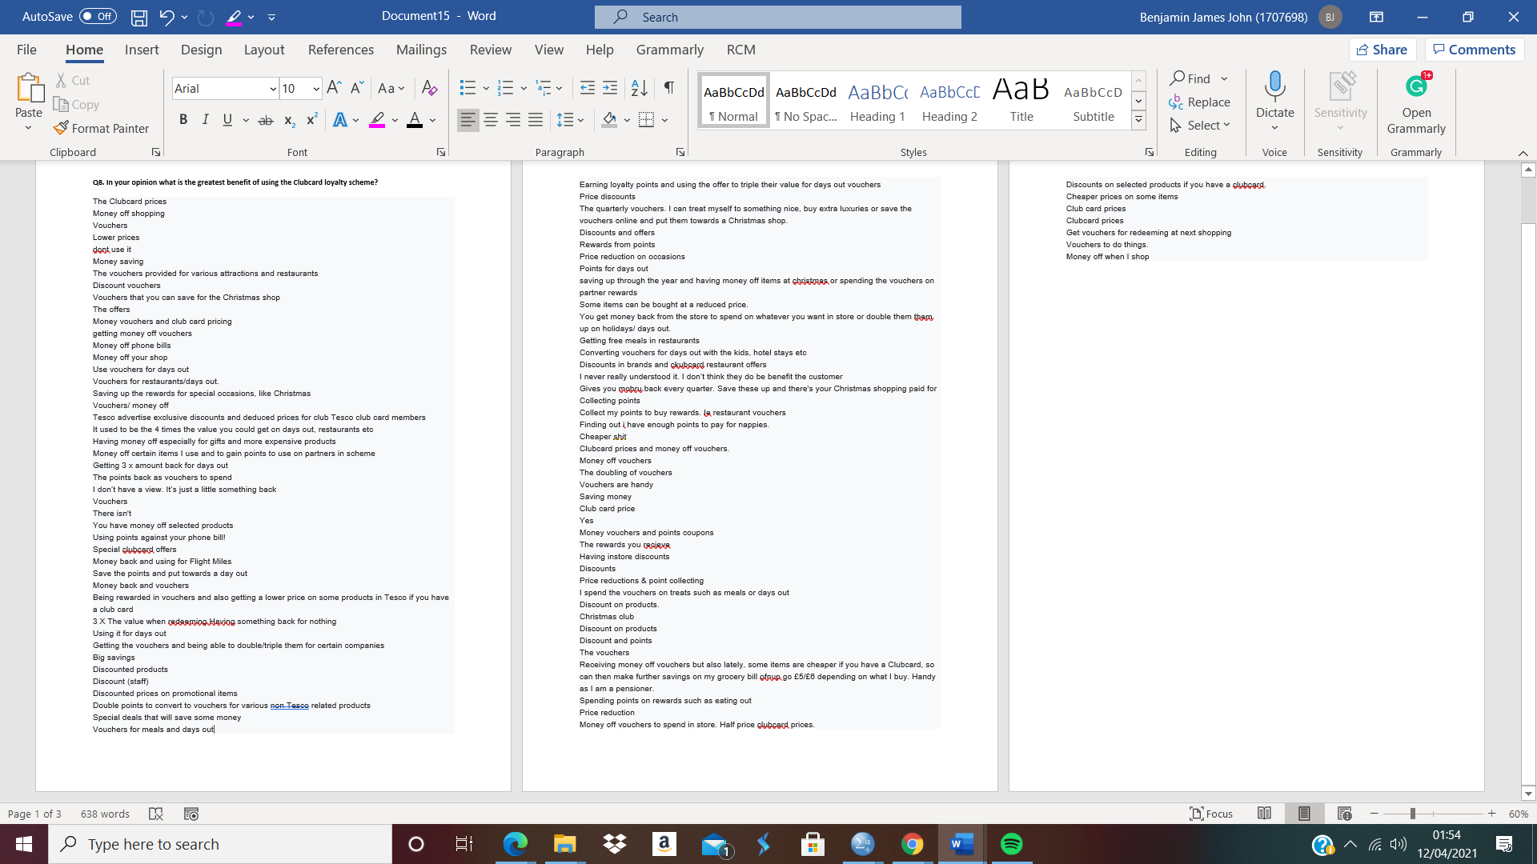
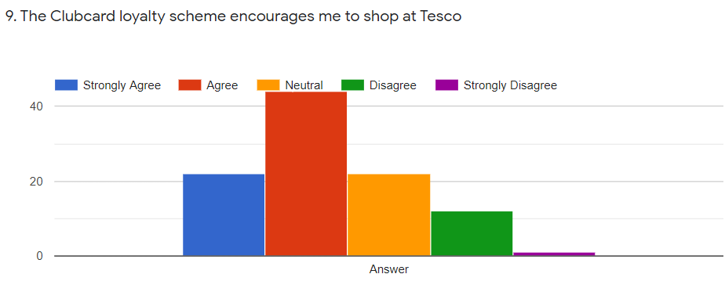
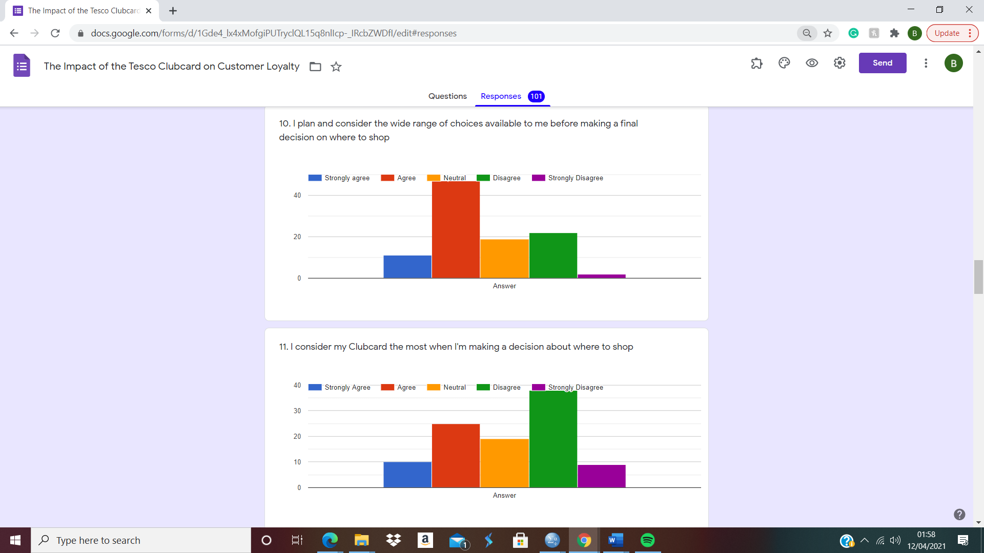
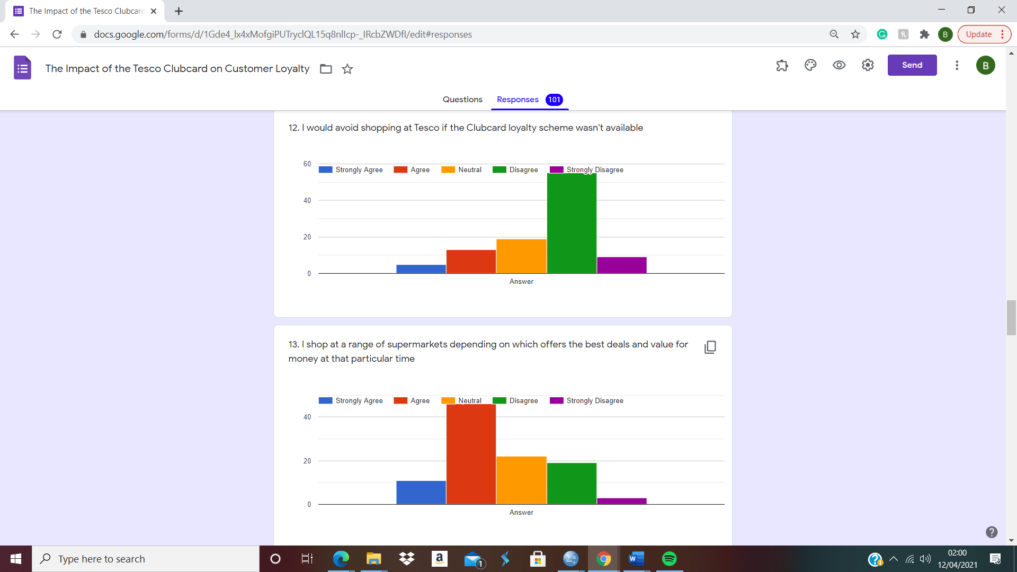

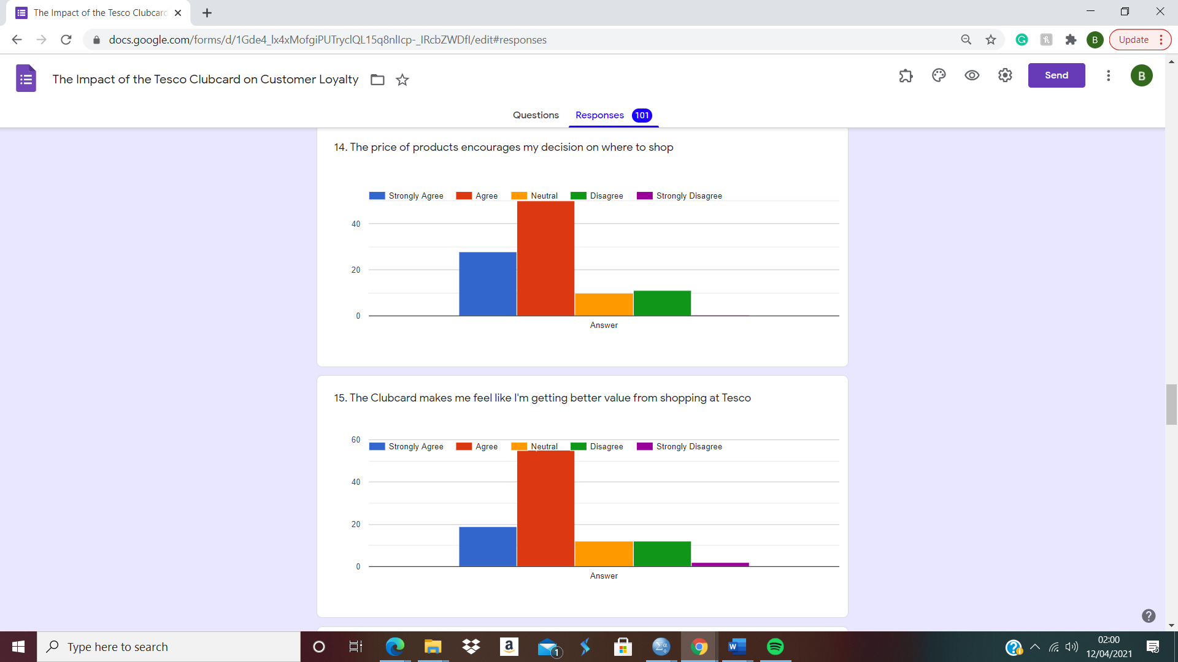
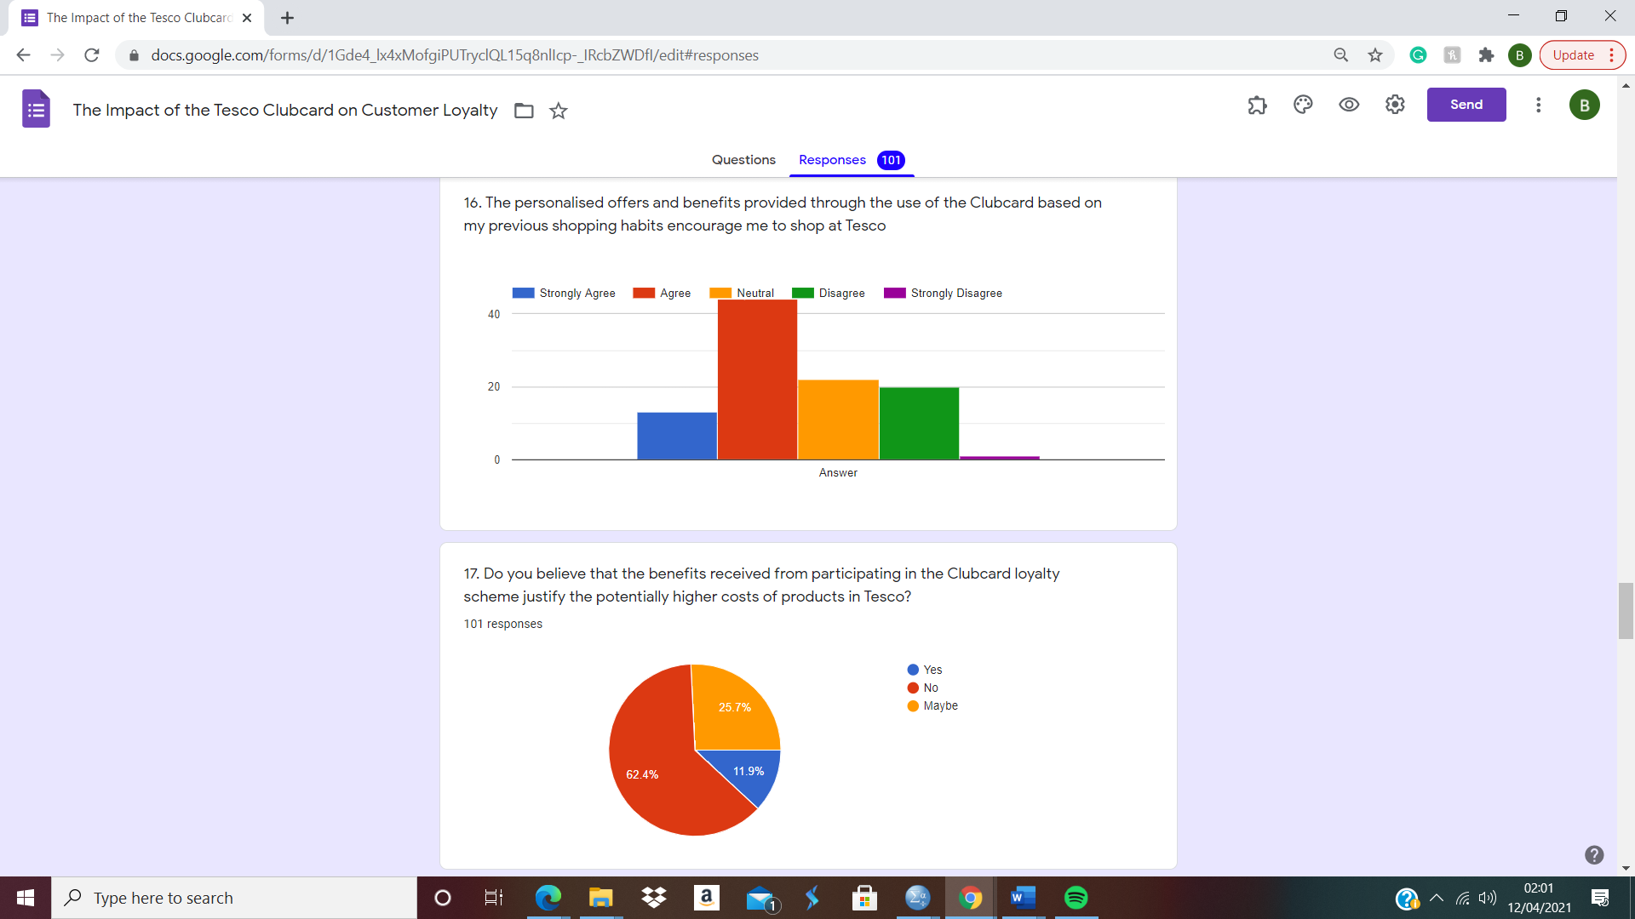

Question 17.1
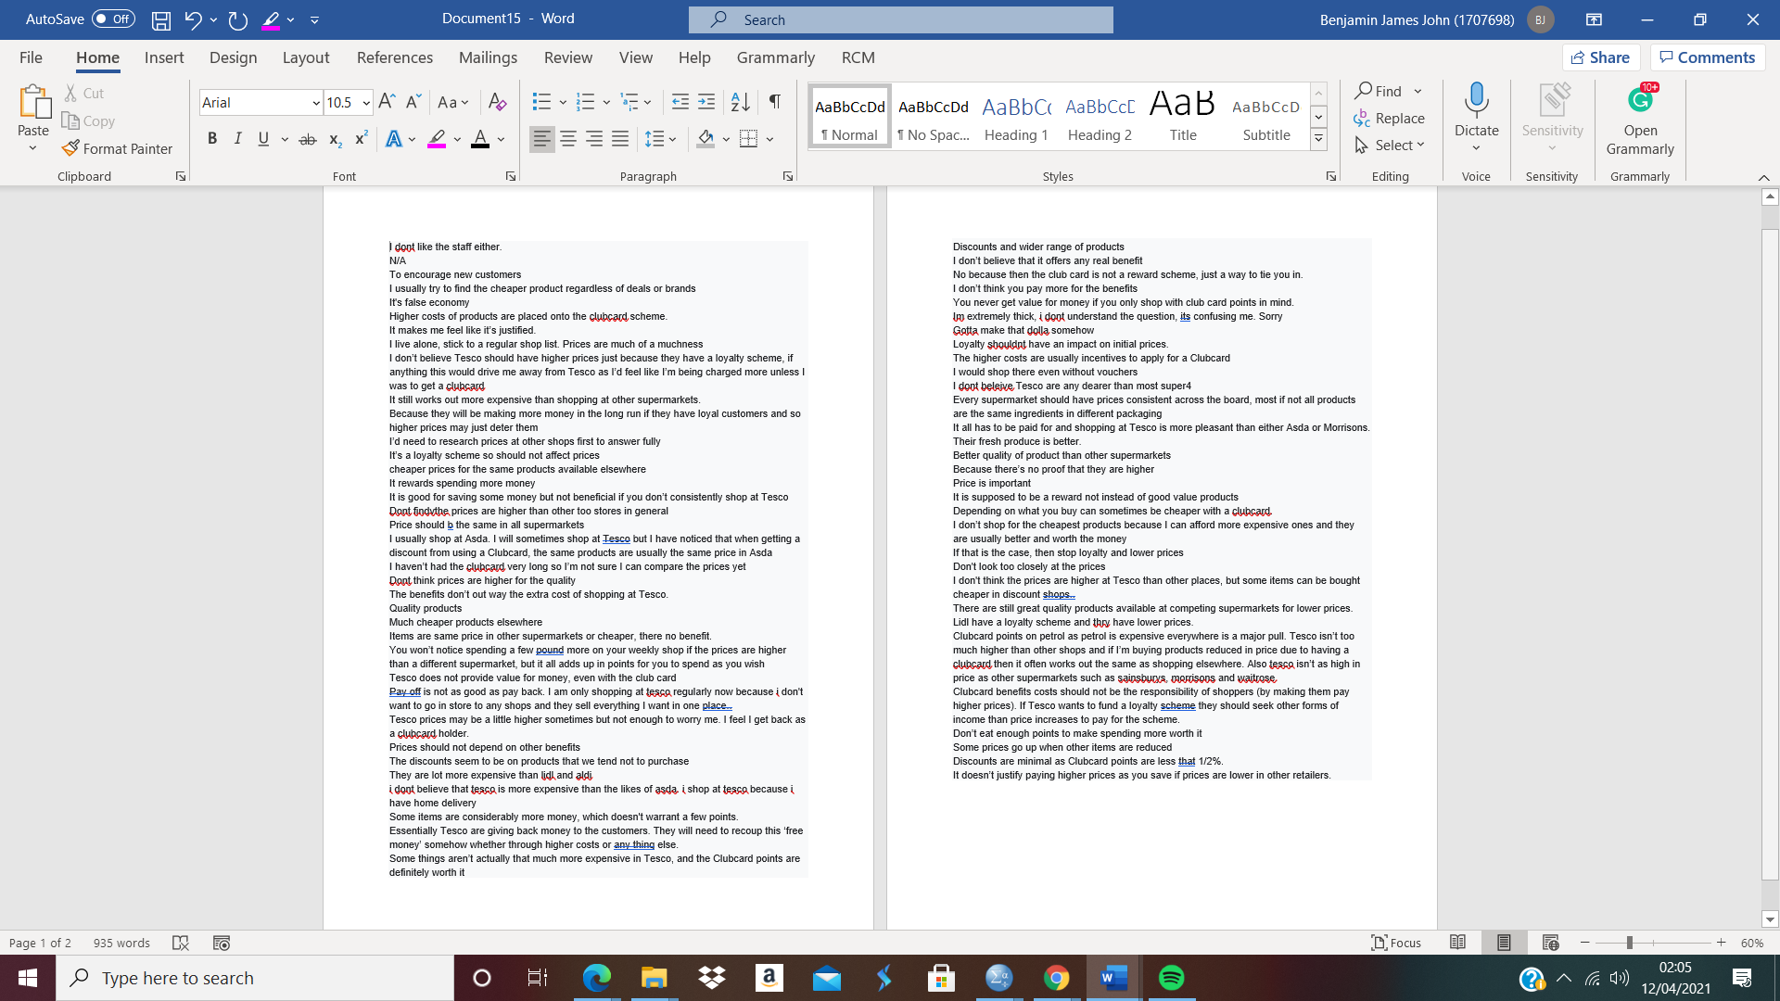
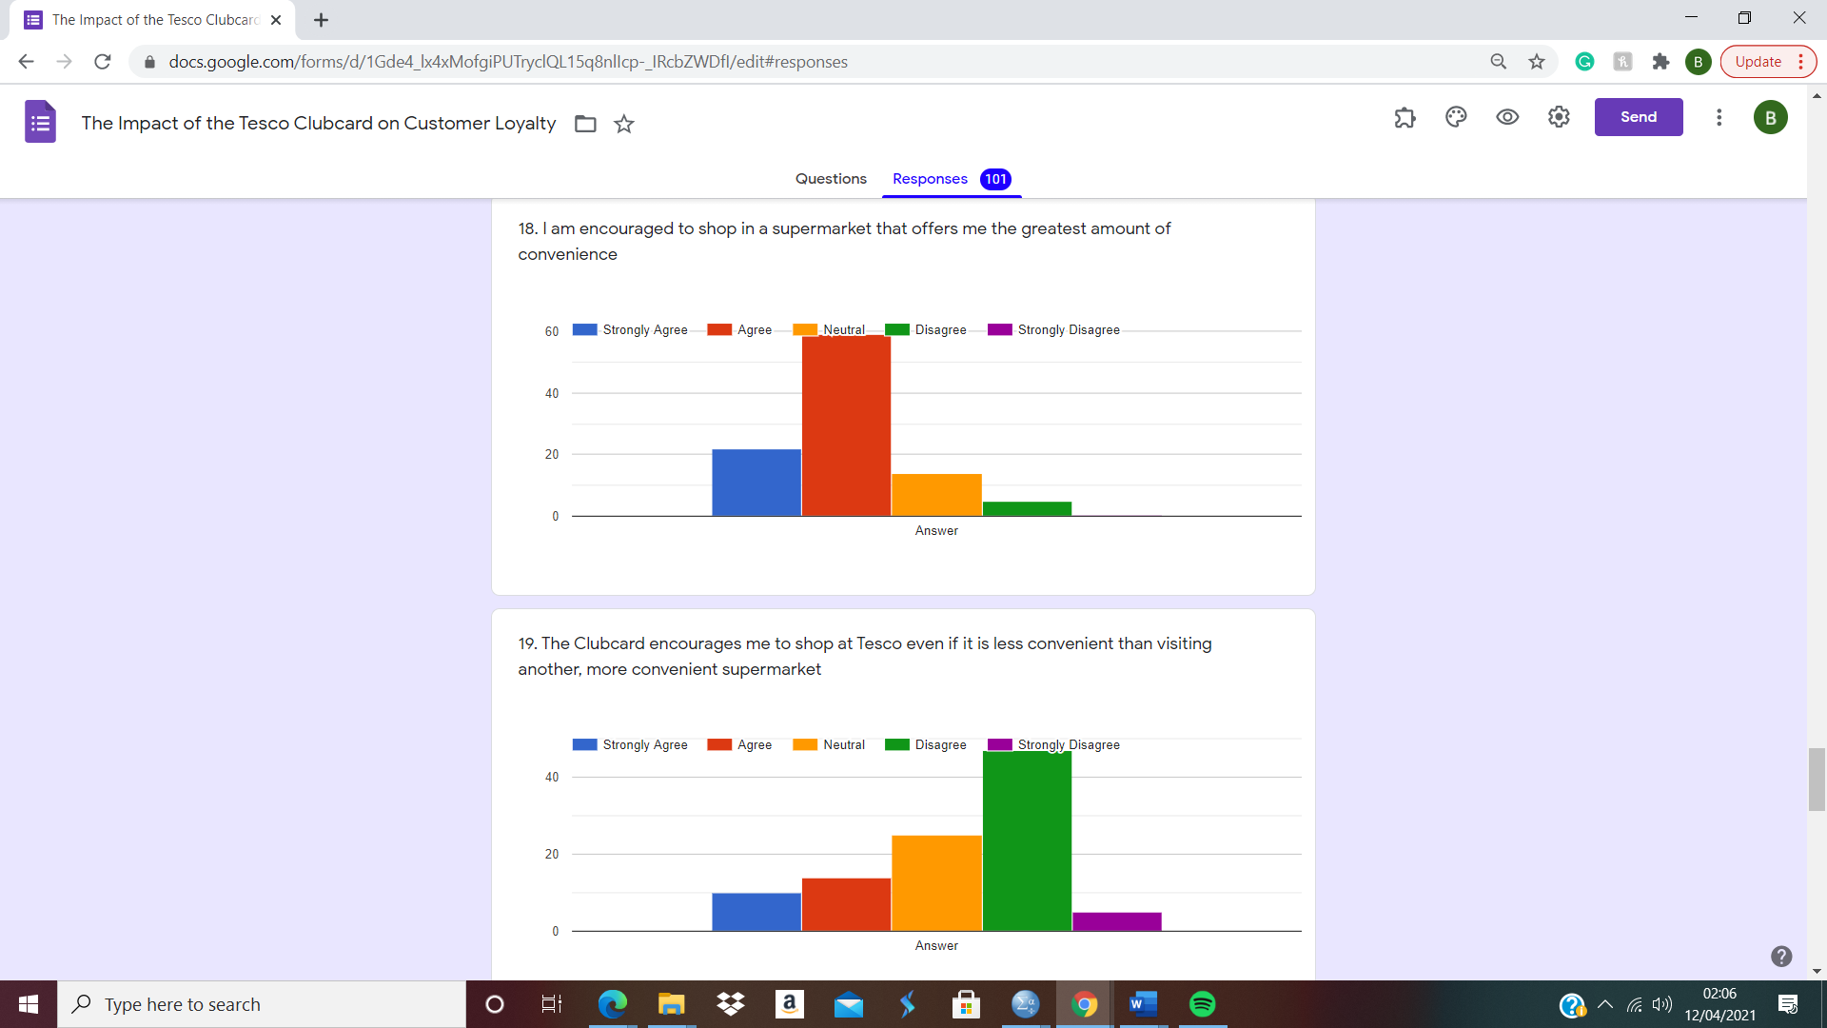
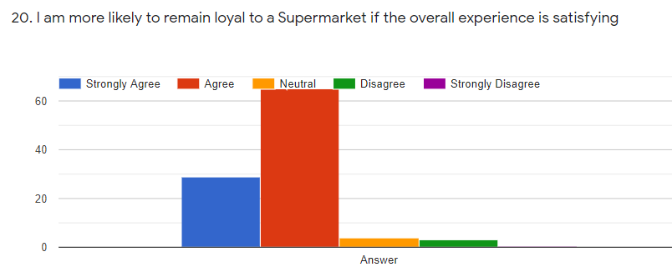
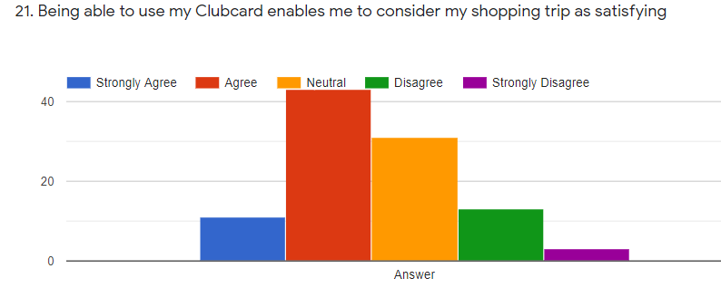

Appendix H – Further Tests which were considered insignificant to Chapter 4
Frequency Table of most frequently used supermarket by participant.
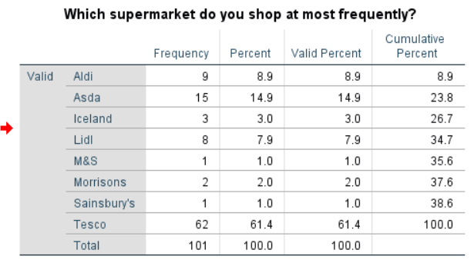

Crosstabulation & Chi-Square analysis for Q9 + Q10
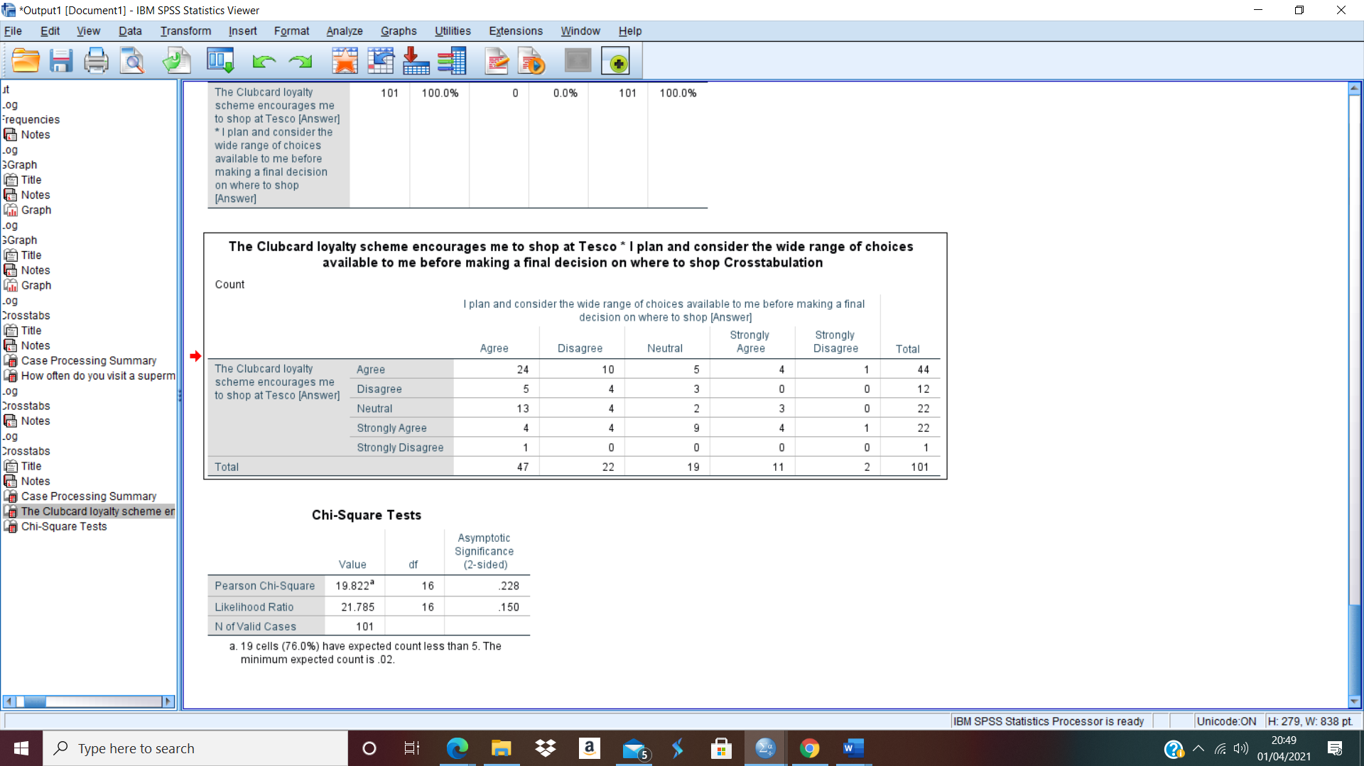

Crosstabulation for Q3 + Q4
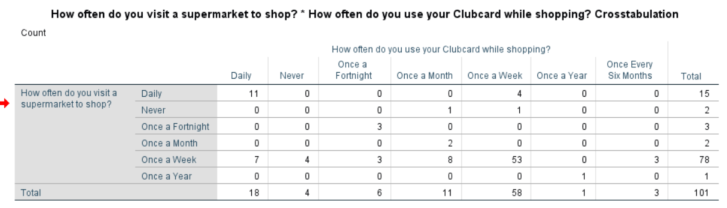

Crosstabulation & Chi-Square analysis for Q9 + Q12
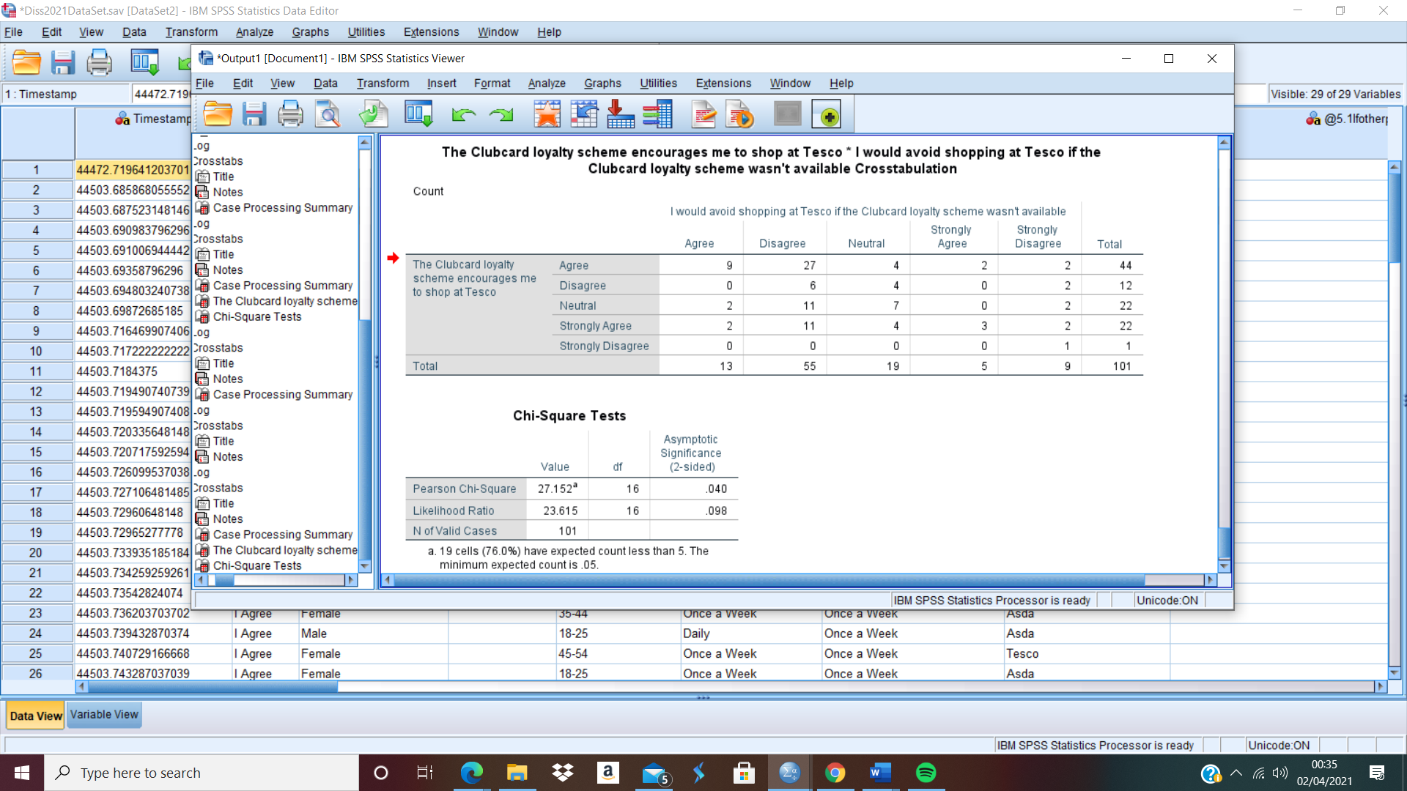

Question 22 Wordcloud
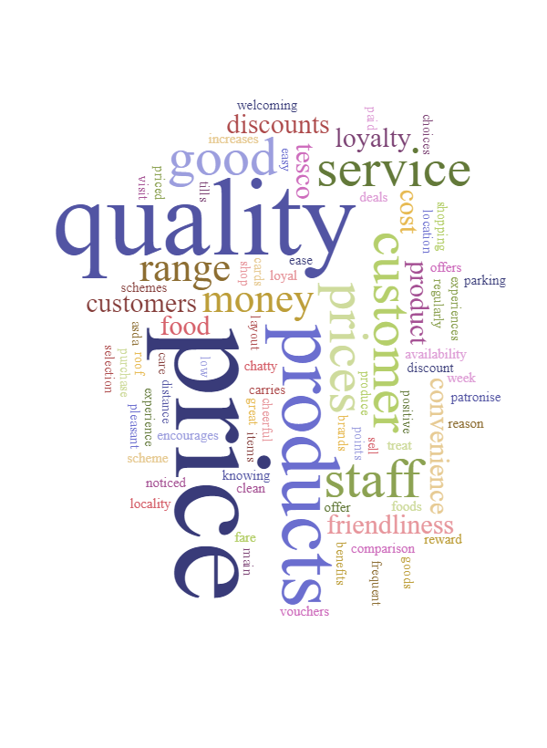

Crosstabulation & Chi-Square analysis for Q1 + Q9
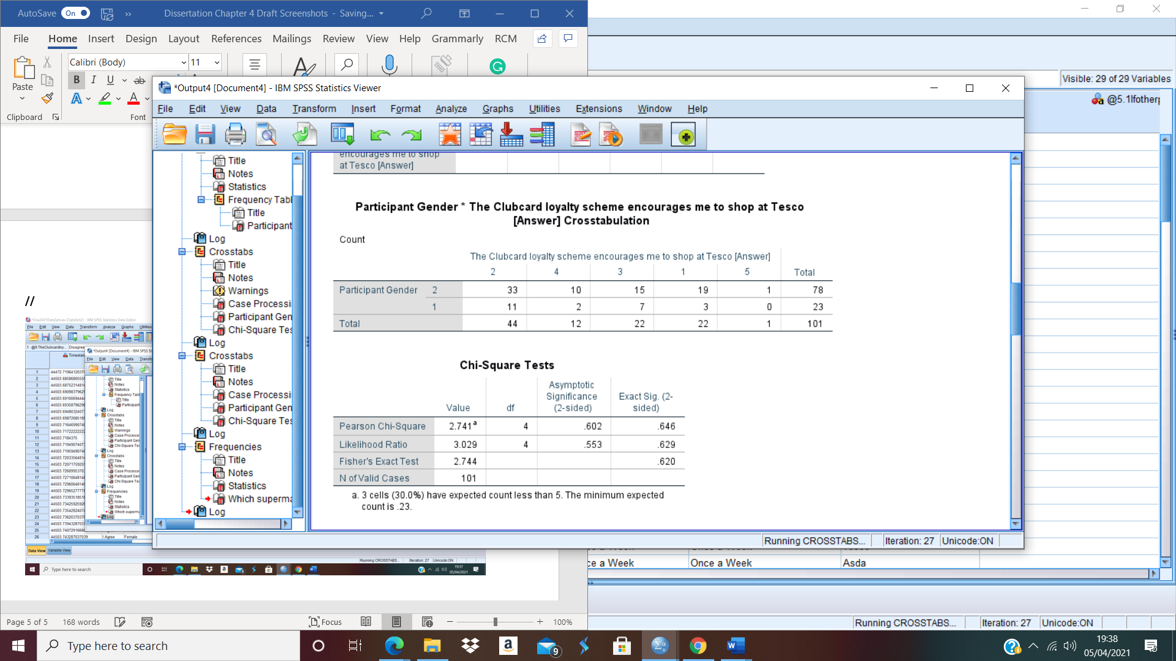

Pearson Correlation for Q2 + Q15
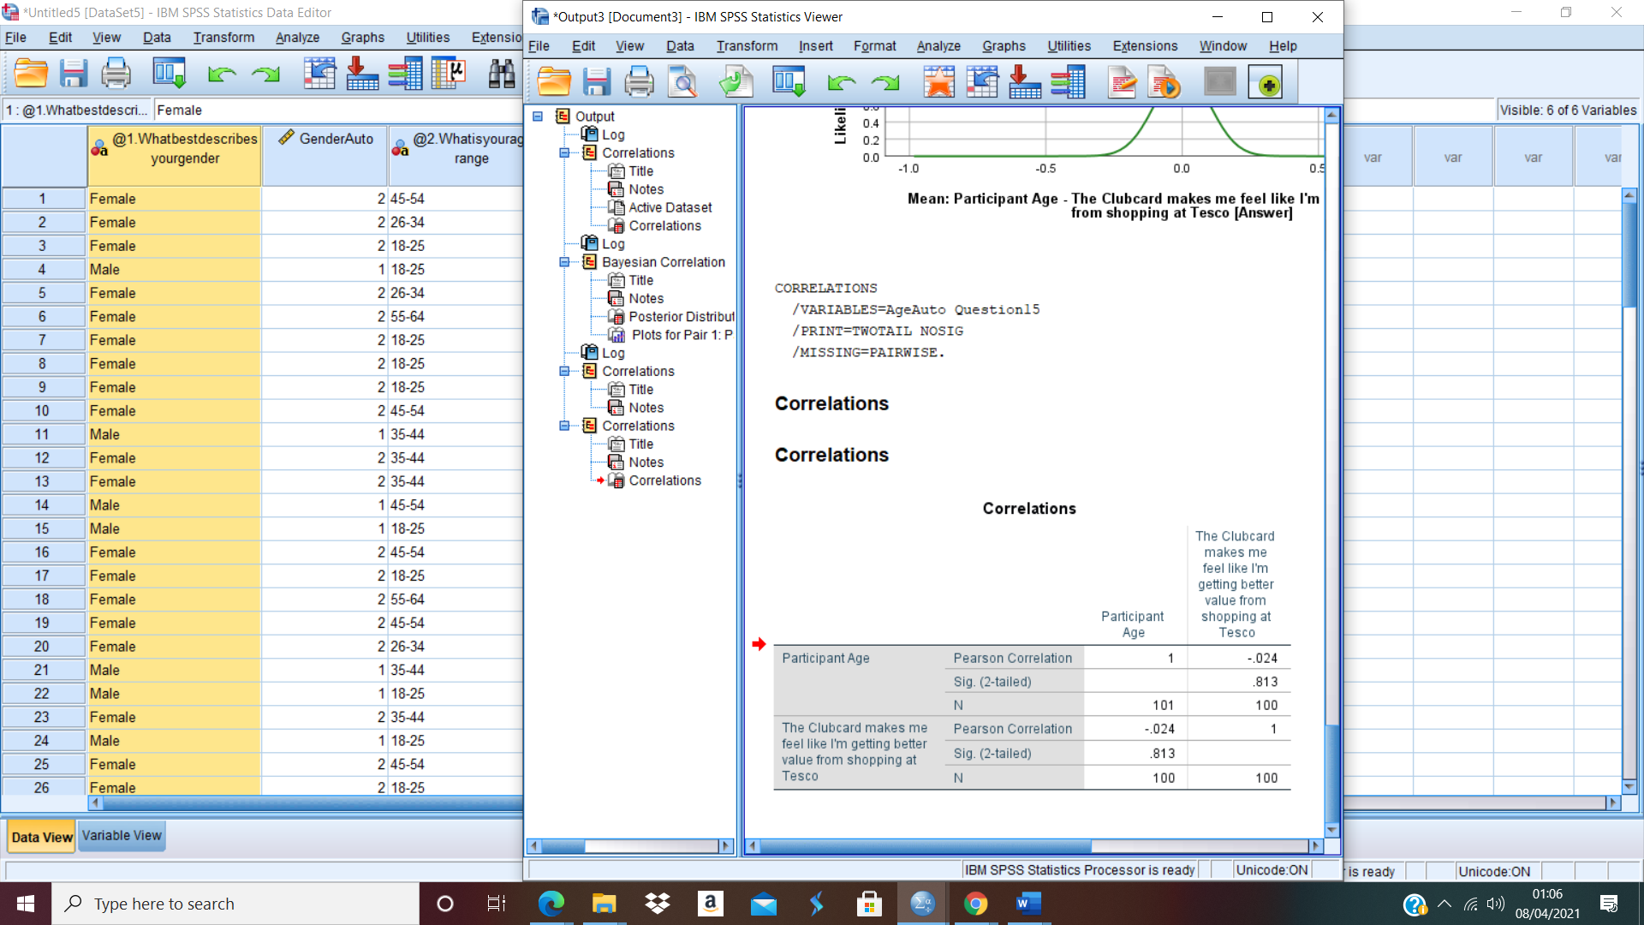

Pearson Correlation for Q14 + Q15


