An individual reflective response to the Professional Teaching Experience.
Reflection is “the way that we learn from an experience in order to understand and develop practice” (Jasper 2003). Reflection consists of thinking about what went well and what was disappointing about the experience. Reflection is also about thinking of how we can ensure that the experience improves next time. It is important to understand that reflection is positive not negative. Even though we are identifying disappointing elements we must do this to then identify ways to prevent it happening again.
For PTE 1 I was Nursery. There are morning and afternoon classes with each having 45-50 students. Initially, I was nervous but as soon as I was there I loved it. I was most nervous about not knowing which class I was going into. I was a bit disappointed going into nursery as it was not my Foundation Phase preference. Nevertheless, I went in with an open mind and it was as soon as the second day that I realised that I really liked it. My intentions for the first week were to observe the children and lead group activities.
In the first week, I got to know the Nursery classes. There was a lot of names to learn but I did well. In the first week I led 2 different group activities which gave me a chance to bond with the children and understand their abilities. I felt very comfortable doing this as I believe it came quite natural to me. I soon learnt that the morning class were more able than the afternoon class. During the observation week I discussed the additional needs with the teacher. The additional needs included Autism but there are some pupils who still haven’t been statemented. It’s often difficult for staff to know what strategies to use with these children as they have not been diagnosed. As a result of this, I was observing the way the teachers dealt with these children and continuing to use the strategy suited to that child.
The Nursery are not grouped but they have a routine for their day in Nursery which involves playing/activities, snack and playing in the garden. When I was getting children to do specific activities, I found it easier to call them individually as most of them needed support or 1:1. I found it difficult to let them get on with something as some of them found it difficult to follow instructions.
One of the targets I set myself was to explore assessment of pupil progress which relates to the QTS standard S3.2 Teaching: Monitoring and Assessment. Specifically looking at ‘evidence of the use of assessment to track pupils’ learning experience (Education Wales, 2009) I approached this target by using the Tracking record (C11a) to monitor how children performed in all activities I planned. (See Appendix 1 and 2). I used the RAG assessment in some tracking records but I also tried to adapt to a tracking method ‘Independent. With support or 1:1, which is what the school use. A reason for tracking pupil progress is that “It helps parents, carers and practitioners to recognise children’s progress, understand their needs, and to plan activities and support” (Children First Northamptonshire, 2019). Pupils progress must be monitored effectively to ensure that the school are then providing the best support for them to be able to reach their full potential. My placement has made me realise that it is just as important to monitor pupils progress in Nursery as it is in any other class. This is because in nursery they are being prepared to move into reception where they begin to complete a lot more work. Tracking children can help identify where support is needed as soon as possible. This will provide appropriate support for them before moving onto their next class. It is important to “analyse observations in order to make judgements which lead to action to support individual children”. It’s vital that children are supported when it is needed but also setting targets so these children to have a goal to work towards. During my time in Nursery, I was given opportunities to mark children’s work and monitor the progress. I also learnt ways in which I could provide appropriate support for the children which guided them to make progression in their work, this was explained in the ARC (See appendix 3).
It is with “hope that improvement in classroom assessment will make a strong contribution to the improvement of learning” (Black. P and William. D, 1998). I think it is so important that we track and monitor our pupils but if we cannot provide next steps for them in moving forward with their learning then it is not beneficial.
Bruner and Vygotsky both believe that “other people should help a child develop skills through the process of scaffolding” (McLeod, 2018). Scaffolding is when a more knowledgeable other interacts with the child to provide help for the child to complete a task. As you can see in appendix 3, I experienced providing scaffolding for some children in Nursery. They were struggling to do ticks on their worksheet, so I used a white board to show them how to do it, then they would try. If they were still unable to do it, I then used a highlighter on their worksheet to draw a tick and they would then have to go over it. “Vygotsky believed that when a student is in the ZPD for a particular task, providing the appropriate assistance will give the student enough of a ‘boost’ to achieve the task” (McLeod, 2018). I believe some children were in the ZPD. They knew what a tick looked like, but they couldn’t quite draw it and therefore the highlighter was helping them complete the task.
Another target that I chose towards the end of my time in Nursery was to look at behaviour and class management. However, I would like to continue to reach this target as I go into year 3. This relates to the QTS standard S3.3 Teaching and Class management, looking specifically at the standard ‘effective class management/ behaviour strategies’ (Education Wales, 2009). The way in which I approached this behaviour was by observing the nursery staff and how they manage the class. I managed to identify a couple of strategies used with the children. In Nursery, there were quite a lot of children who have additional needs, and this was where I really saw the behaviour strategies being used. The behaviour strategies that I saw being used were things such as stickers which were used as rewards. If a child was doing something particularly good such as good listening then they were able to have a sticker. One child who the school suspect to have behavioural issues had a little obsession with buses. In order to encourage good behaviour from him, the teacher would offer him a bus ticket as a reward for when he showed good behaviour. In the nursery classroom, they also have smiley face charts where children are awarded smiley faces for good behaviour. Another strategy that was used was the sun and the cloud. Each child in the class had a little image of them which is either placed on the sun or the cloud. If the children were behaving well then they would remain on the sun but if there was bad behaviour shown then the child would be put on the cloud. I saw that this had a real impact on the children as they really hated being put on the cloud. This would therefore encourage them to behave well so that they wouldn’t go onto the cloud.
In the first couple of days where I have observed in year 3 I have noticed ways they manage behaviour and praise children. The whole school uses ‘Dojo’ where points can be awarded for good behaviour. Parents and staff have access to this so they can see when points are awarded. In KS2, I have also seen reflection take place. Children who are involved in bad behaviour miss their play and have to reflect on the incident by filling out a form.
The use of rewards and punishments links to Skinner’s theory of operant conditioning. “through operant conditioning, an individual makes an association between a particular behaviour and a consequence” (Skinner, 1938). This theory suggests that if someone is rewarded for positive behaviour then they are more likely to repeat this behaviour. However, negative behaviour can lead to negative consequences and therefore hopefully learn not to repeat that behaviour. This can always be used in schools and I have seen in in practice during PTE. Children in nursery would be rewarded with stickers to positively reinforce the good behaviour that they have performed, and then they are likely to make the link between the behaviour and the reward. However, Skinner’s theory also discussed punishments. In Key stage 2 I have seen children who have to attend what they call reflection if they have behaved negatively. The children miss their play and spend the time filling out a reflection form about the incident that has led them to be in reflection. Negative reinforcement is “the removal of an adverse stimulus which is ‘rewarding’ to the animal or person” (McLeod, 2018). In nursery, some children who are not sitting on the carpet when they need to sometimes get told that they will have to be moved onto the cloud if they cannot sit on the carpet. Hopefully, this results in them sitting on the carpet as they want to avoid being put onto the cloud.
To conclude, I think its always good to reflect on things we have done, and its good to set targets to aim for in the future. Also, always think about the positives as well as the disappointing elements. Reflection can always help other people too as you can share your experiences and how you could do things differently.

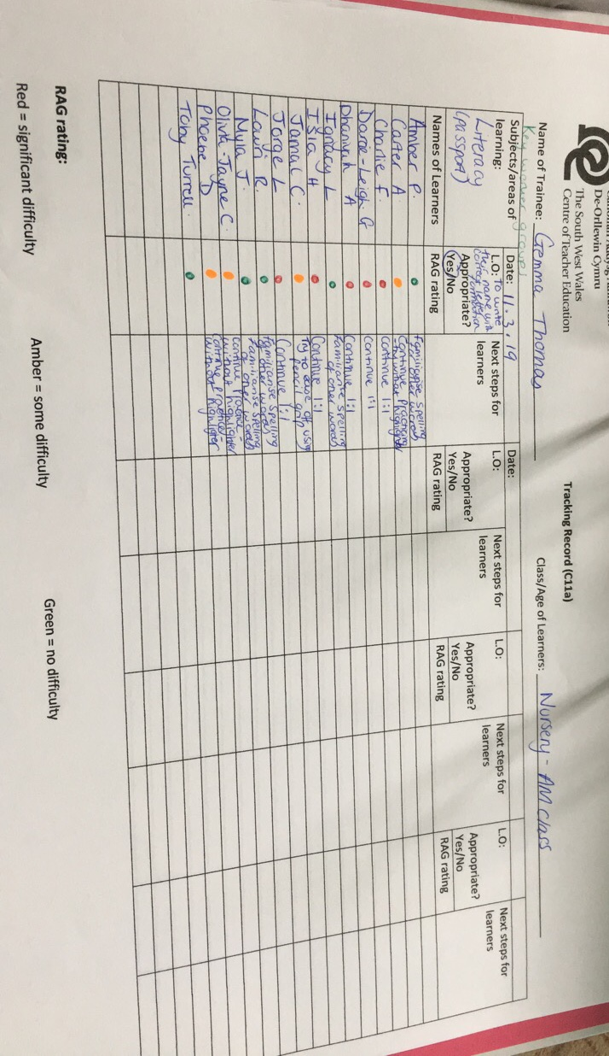
Appendix
Appendix 1

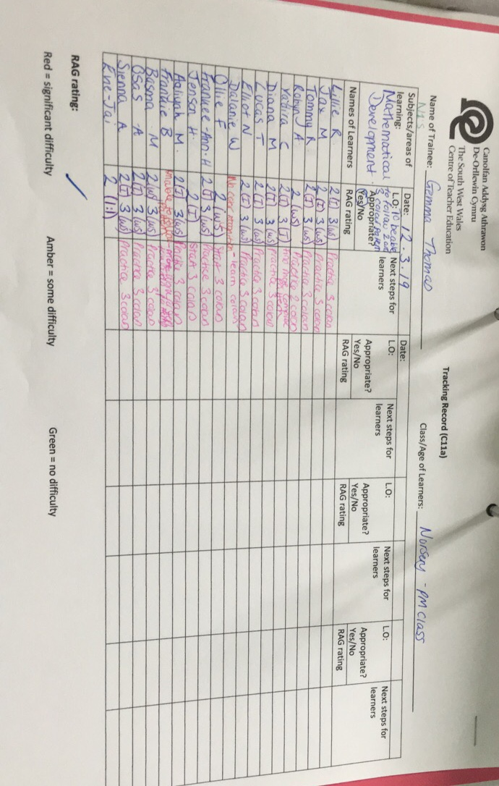
Appendix 2

Appendix 3

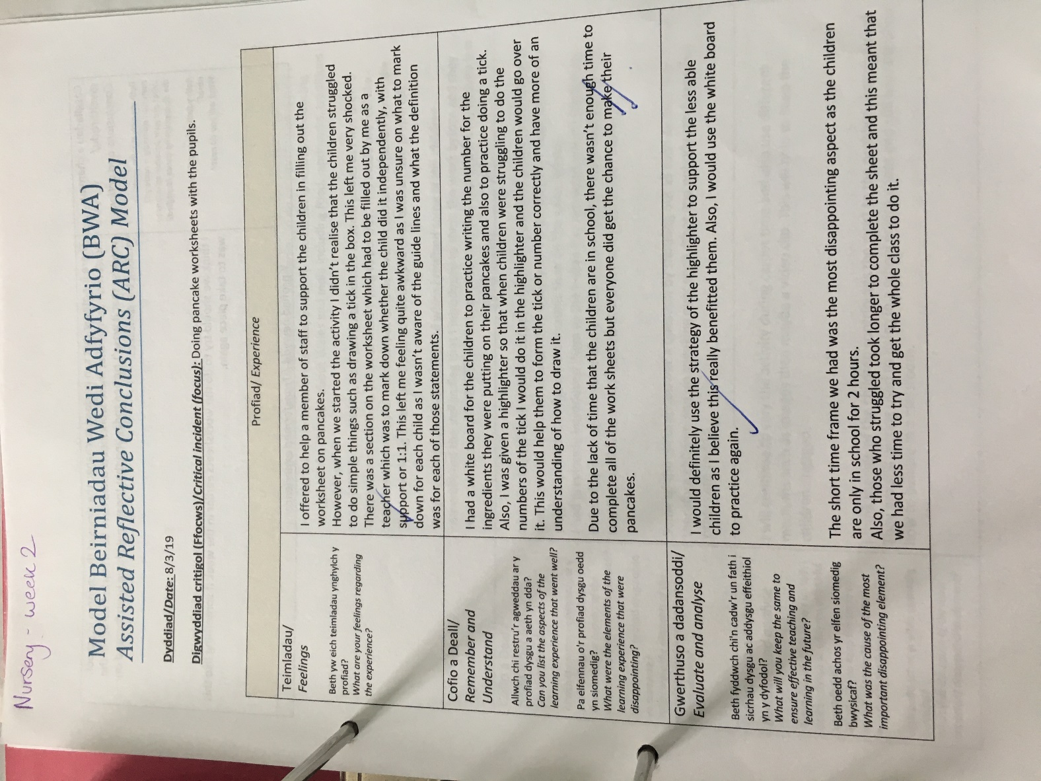

References
Children First Northamptonshire, Northamptonshire Council (2019) Learning and development with EYFS) Available at: https://www3.northamptonshire.gov.uk/councilservices/children-families-education/early-years/information-for-childcare-providers/the-early-years-curriculum/Pages/learning-and-development-within-the-early-years-foundation-stage.aspx (Accessed: 19th March 2019)
Education Wales. (2009) Qualified Teacher Standards Wales 2009. Cardiff: Welsh Government.
JASPER, M., 2003. Beginning reflective practice. Cheltenham: Nelson Thornes.
McLeod, S. A. (2012). Zone of proximal development. Available at: https://www.simplypsychology.org/Zone-of-Proximal-Development.html (Accessed: 21st March 2019)
McLeod, S. A. (2018, Feb 05). Bruner. Available at: https://www.simplypsychology.org/bruner.html (Accessed: 21st March 2019)
McLeod, S. A. (2018, Jan, 21). Skinner - Operant Conditioning. Available at: https://www.simplypsychology.org/operant-conditioning.html (Accessed: 21st March 2019).
Black. P & William. D (1998) Assessment and Classroom Learning, Assessment in Education: Principles, Policy & Practice. Available at: https://pdfs.semanticscholar.org/3906/9c5916d3cdf2cff6fd6d89fec9ff1f8e818f.pdf (Accessed 21st March 2019)

