Name: Kamran Khan
Student Number: 2246128
Module: Health, Wellbeing and Sustainable Development - BMHP6030
Assignment Title: Component 2: Written Assignment (Report)
Lecturer Name: Parese Ahmed

Table of Contents
Introduction 3
Section 1: SDG 3: Good Health and Wellbeing (NCDs and Mental Health) 3
WHO Global NCD Action Plan 3
England Tackling Obesity Strategy 5
Active Travel Initiatives 5
Recommendations 6
Section 2: SDG 11: Sustainable Cities and Communities 6
UN-Habitat New Urban Agenda 6
UK Clean Air Zones 7
Lahore Clean Air Initiatives 8
Recommendations 8
Conclusion 8
References 10

Introduction
Rapid urbanisation is reshaping how health and wellbeing are produced and distributed. Cities can enable access to jobs, education, healthcare and social networks, yet they also concentrate health risks through air pollution, overcrowded housing, traffic injury, sedentary lifestyles, heat exposure and widening inequalities. In this context, the Sustainable Development Goals (SDGs) matter because they provide a shared, globally recognised framework that links health outcomes to the social and environmental conditions that drive them shifting policy attention from healthcare alone to prevention, equity and sustainable development (Buse and Hawkes, 2015). This report therefore examines how SDG 3 (Good Health and Wellbeing) and SDG 11 (Sustainable Cities and Communities) interact to shape population health through urban environments.
The report aims to critically evaluate the effectiveness of selected global, national and local policies and initiatives aligned with these goals, and to develop evidence-informed recommendations for improvement. Analysis is structured in two main sections. Section 1 assesses SDG 3 with a focus on non-communicable diseases and mental health, examining how policies balance individual behaviour change with structural determinants. Section 2 evaluates SDG 11, focusing on housing, transport and green infrastructure as “health-producing” systems. Across both sections, evaluation is guided by the Social Ecological Model, Built Environment Theory, and Health Impact Assessment (HIA) to connect theory to real-world policy design, implementation and outcomes.

Section 1: SDG 3: Good Health and Wellbeing (NCDs + mental health)
SDG 3 aims to ensure healthy lives and promote wellbeing for all at all ages, explicitly covering non-communicable diseases (NCDs), mental health, environmental risks, and health systems (including universal health coverage) (United Nations, 2025). In urban settings, SDG 3 outcomes are strongly patterned by the built environment (land-use, transport, housing quality, green space) and by structural determinants (income, work, discrimination), meaning policy success depends on cross-sector governance rather than health services alone (Seelajaroen and Jitmaneeroj, 2025).

WHO Global NCD Action Plan
The WHO Global Action Plan for the Prevention and Control of NCDs (2013–2020; later extended toward 2030 alignment) sets targets and recommended best buys across tobacco, alcohol, diet and physical activity, and strengthens surveillance and health-system response (WHO, 2013). Its main advantage is that it makes NCD prevention a whole-of-government agenda (e.g., fiscal, marketing limits, primary care integration). But, practically, translation into national policy tends to lean toward individual-level solutions (education campaigns, apps, advice) since they are easier politically than control over commercial drivers (food marketing, ultra-processed products, car dependency) or revamping the city form. This policy lifestyle creep is a notoriously popular failure mode of NCD policy: the upstream drivers are recognized, but downstream interventions control delivery (Akhtar et al., 2025).
In the context of Social Cognitive Theory (SCT), a number of NCD programs, such as healthy swaps actvity challenges, focus on observational learning and behavioural capability, but lack investment in environmental facilitators that enable the behaviour to be realistic (safe pavements, safe cycle lanes, low-cost healthy food). SCT processes, including self-efficacy, are disrupted whenever the environments are obesogenic since repeated failure diminishes perceived control (Egele, Klopp and Stark, 2025). Likewise, campaigns may tend to raise perceived threat (threats of obesity, diabetes, CVD) but not as much perceived barriers (cost, time, unsafe streets, long commutes) or enduring cues to action after short campaigns using the Health Belief Model (HBM) thus limiting permanence (Razmara et al., 2018).
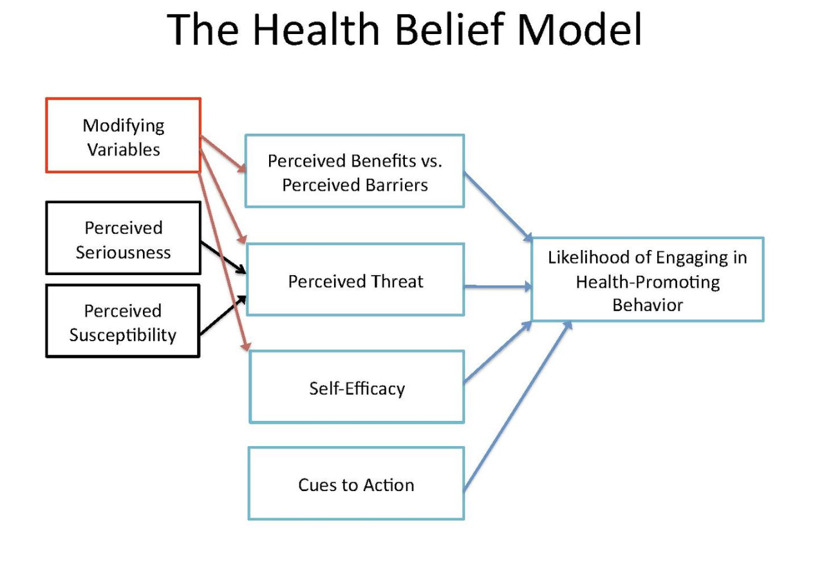
Figure 1: Health Belief Model
Mental health is also embedded in SDG 3 targets (e.g., 3.4). WHO’s Comprehensive Mental Health Action Plan (2013–2030) reinforces prevention and service coverage, but implementation is constrained by workforce gaps, stigma, and unequal access especially for low-income urban residents facing precarious housing and pollution stressors (Singh, 2021).

England Tackling Obesity Strategy
The 2020 strategy to tackle obesity in England expressly mentions their intention to modify the environment and promote healthier decisions through strategies like labelling and weight management assistance (Department of Health & Social Care, 2020). The strongest-supported national lever in this area is the fiscal/regulatory policy of sugar-sweetened beverages. The UK Soft Drinks Industry Levy (SDIL) has facilitated significant decreases in sugar content through reformulation (government reporting shows there are significant decreases in sugar content in the market), and modelling and empirical studies attribute these decreases to decreases in sugar purchases and estimated health benefits. It means that structural choice architecture can be more effective than information-only interventions due to the ability to change the defaults of the whole population, including less health-literate groups (Cobiac et al., 2024).
Limits do exist, obesity patterns are socially structured, and individual product interventions cannot be enough to offset a wider exposure to ultra-processed foods and poverty, as well as limited mobility. According to parliamentary and scholarly reviews, delivery has been unequal and under policy delay/rollback pressures, which demonstrates its susceptibility to political cycles and industry lobbyisms. National strategies, in HBM terms have enhanced cues to action (labels, campaigns) but not yet addressed barriers to action such as affordability, housing instability and time poverty particularly in deprived urban regions (Dicken and Batterham, 2024).

Active Travel Initiatives
Active interventions of travel (walking, wheeling, cycling infrastructure) are directly connected to SDG 3, as they address physical inactivity, physical air quality co-benefits, and mental health through exposure to green space. But it requires the quality of the system (linked networks, perceived safety) over single lanes (Ding et al., 2024). The National Audit Office of England came to the conclusion that the barriers to delivery (funding instability, fragmented governance, short-termism) threaten to miss ambitions, and the present monitoring guidance is based on the necessity to be more evaluated and data-driven. This is consistent with the Social Ecological Model: when individual motivation is balanced by positive community and policy conditions, the long-term behaviour change is possible, rather than when individual citizens are blamed (Ewald, Orsini and Strack, 2023).

Recommendations
- Integrate urban planning and health via “Health in All Policies” governance: embed SDG 3 targets into transport, housing and economic plans; align budgets across sectors (so prevention is not optional) (Ramirez-Rubio et al., 2019).
- Shift from lifestyle messaging to structural levers and scale best buys like pricing, marketing restrictions, procurement standards alongside targeted support for high-risk groups, to reduce inequalities (Razmara et al., 2018).
- Build evaluation into delivery for active travel and obesity initiatives and implement routine equity-focused monitoring (by deprivation, gender, disability) and long-term funding to sustain networks rather than one-off schemes (Razmara et al., 2018)

Section 2: SDG 11: Sustainable Cities and Communities
SDG 11 seeks to make cities inclusive, safe, resilient and sustainable, covering housing, transport, participatory planning, disaster risk reduction, and protection of cultural/natural assets. SDG 11 is therefore a health policy in disguise: it shapes exposure to pollution, injury risk, heat, social isolation, and access to green space which are core determinants of SDG 3 outcomes (United Nations, 2025).

UN-Habitat New Urban Agenda
The New Urban Agenda (Habitat III, 2016) sets a normative framework for integrated planning, sustainable mobility, and inclusive urbanisation. Its value lies in agenda-setting: it legitimises cross-sector approaches (planning–health–climate) and encourages participation (UN Habitat, 2020). The key constraint however is governance: it is mostly non-binding, dependent on national/local political goodwill, and it may be severely constrained by funding and capacity in swifter growing cities such as Lagos and Dhaka. UN-Habitat reports on progress show unbalanced implementation and resource disparities, which reflects structural difficulty in converting international obligations into local enforceable delivery. Practically, cities may embrace the vocabulary of sustainability without stopping car-driven development, neglecting informal settlements, and unequal service delivery that leads to policyimplementation disjunctures (UN Habitat, 2023).
In terms of Built Environment Theory, the implications of the New Urban Agenda are therefore correct: the form of cities determines behaviour and exposure (e.g. density, mixed use, street connectivity). However, in the absence of quantifiable responsibility (targets, enforcement instruments), it is unclear how the route between ambition and less pollution or better welfare is traversed (Nesmachnow and Callejo, 2025).

UK Clean Air Zones
SDG 11 is operationalised by Clean Air Zones (CAZ) and other low-emission actions that lower transport-based pollution, and direct SDG 3 co-benefits (respiratory and cardiovascular risk). According to national air quality reporting, NO 2 compliance has increased but not entirely achieved in certain areas, pointing to persistent urban hotspots and the possibility that a sustained effort is still necessary beyond individual cities (Longhurst et al., 2018). The article by Mebrahtu et al. (2025) discusses the clean air plan created by Bradford that includes a CAZ and explains that the scale and enforcement make possible measurable reductions in NOx, but the health effects may require more time to manifest. The major constraint is distributional: when substitutes are ineffective, charges may create a burden on lower income drivers. Environmental justice thus demands CAZ to be coupled with low-cost public transport options and scrappage/support plans and healthier networks of active travel options, lest the policy becomes seen as punitive instead of protective.
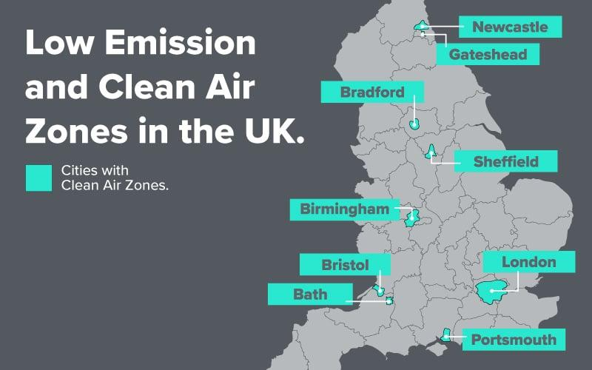
Figure 2: Clean Air Zones in UK (Brookes, 2021)
The Levelling Up agenda acknowledges geographical disparities in wellbeing and has missions based on local outcomes, and annual reporting of progress (Gov UK, 2025). This can assist in making cities healthier with investments in place, skills, and infrastructure in SDG terms. Nevertheless, critics outline instability of governance and policy turnover: should missions, metrics, or legislation be changed, long-term urban health planning becomes more difficult. In the perspective of Social Ecological Model, a long-term change cannot be made through a short funding cycle but through a stable upstream investment (housing quality, transport access, green space) (Vardoulakis et al., 2020).

Lahore Clean Air Initiatives
The smog and PM 2.5 load of Lahore makes SDG 11-SDG 3 connections urgent. The Smog Mitigation planning of Punjab and the Punjab Clean Air Program supported by the World Bank will reduce PM 2.5 in the long run, directly mentioning health benefits to residents of Lahore Division (World Bank, 2025). This is one big move to institutionalising cleaner transport, industry controls and monitoring capacity. However, barriers to implementation are high: the capacity to enforce, sectoral coordination (transport, industry, agriculture), and political pressures in high smog seasons. Another risk is equity: interventions increasing compliance costs may push additional burden on informal workers and low-income households unless compensated or coupled with substitute options (clean public transport, affordable energy options) (Hussain, 2024).

Recommendations
- Make Health Impact Assessments (HIA) routine/mandatory for major transport, housing and regeneration schemes to quantify health equity impacts and prevent unintended harms (e.g., displacement, exposure shifts) (Harris-Roxas et al., 2012).
- Institutionalise community participation (especially marginalised groups) as a delivery requirement, not consultation only improving legitimacy, uptake and local fit (SDG 11 participatory planning) (Ding et al., 2024).
- Prioritise affordable, healthy housing and mobility: align clean-air measures with affordable public transport and housing quality upgrades to avoid gentrification-driven displacement and to deliver environmental justice in both UK and Pakistan contexts (Longhurst et al., 2018).

Conclusion
This report has shown that SDG 3 and SDG 11 are mutually reinforcing: urban environments operate as health systems that shape exposure (pollution, heat, injury), behaviour (activity, diet), and psychosocial wellbeing (stress, connection). SDG 3 policies on NCDs and mental health are most effective when they move beyond lifestyle framing and address structural determinants through fiscal, regulatory and environmental change, as illustrated by evidence on reformulation-focused approaches and the need for robust active travel networks. The SDG 11 programmes like the New Urban Agenda, Clean Air Zones, and the clean-air programming of Lahore show that city-level policy could offer tangible benefits to the environment, but they also illustrate the same limitations: lack of enforcement, insufficient funding, and the possibility of disadvantaging the worst off with costs. The broader meaning is that development needs multi-sector control, long-term stable investment and systematic Health Impact Assessment such that gains of sustainability interventions provide health benefits in an equitable manner. In their absence, SDG commitments will remain aspirational accounts as opposed to population-health perspectives.

References
Akhtar, S. et al. (2025) ‘Non-communicable diseases prevention and control in Pakistan: recommendations from policy and public health experts’, BMC Proceedings, 19(S30), pp. 32–32. Available at: https://doi.org/10.1186/s12919-025-00350-4.
Brookes, H. (2021) Navigating Low Emission and Clean Air Zones: A Guide for UK Drivers | Vertu, Vertumotors.com. Available at: https://www.vertumotors.com/news/navigating-low-emission-and-clean-air-zones-a-guide-for-uk-drivers/ (Accessed: 23 February 2026).
Buse, K. and Hawkes, S. (2015) ‘Health in the sustainable development goals: ready for a paradigm shift?’, Globalization and Health, 11(1). Available at: https://doi.org/10.1186/s12992-015-0098-8.
Cobiac, L.J. et al. (2024) ‘Impact of the UK soft drinks industry levy on health and health inequalities in children and adolescents in England: An interrupted time series analysis and population health modelling study’, PLoS medicine, 21(3), pp. e1004371–e1004371. Available at: https://doi.org/10.1371/journal.pmed.1004371.
Department of Health & Social Care (2020) Tackling obesity: Empowering Adults and Children to Live Healthier Lives, gov.uk. Available at: https://www.gov.uk/government/publications/tackling-obesity-government-strategy/tackling-obesity-empowering-adults-and-children-to-live-healthier-lives (Accessed: 22 February 2026).
Dicken, S.J. and Batterham, R.L. (2024) ‘Ultra-processed Food and Obesity: What Is the Evidence?’, Current Nutrition Reports, 13(1). Available at: https://doi.org/10.1007/s13668-024-00517-z.
Ding, D. et al. (2024) ‘The co-benefits of active travel interventions beyond physical activity: a systematic review’, The Lancet Planetary Health, 8(10), pp. e790–e803. Available at: https://doi.org/10.1016/s2542-5196(24)00201-8.
Egele, V.S., Klopp, E. and Stark, R. (2025) ‘How Valid Is Bandura’s Social Cognitive Theory to Explain Physical Activity Behavior?’, European Journal of Investigation in Health, Psychology and Education, 15(2), p. 20. Available at: https://doi.org/10.3390/ejihpe15020020.
Ewald, D.R., Orsini, M.M. and Strack, R.W. (2023) ‘The path to good health: Shifting the dialogue and promoting social ecological thinking’, SSM - Population Health, 22. Available at: https://doi.org/10.1016/j.ssmph.2023.101378.
Gov UK (2025) Levelling-Up Missions annual report 2024 to 2025 (accessible version), GOV.UK. Available at: https://www.gov.uk/government/publications/levelling-up-missions-annual-report/levelling-up-missions-annual-report-2024-to-2025-accessible-version (Accessed: 22 February 2026).
Harris-Roxas, B. et al. (2012) ‘Health impact assessment: the state of the art’, Impact Assessment and Project Appraisal, 30(1), pp. 43–52. Available at: https://doi.org/10.1080/14615517.2012.666035.
Hussain, A.T. (2024) Analysis: Can Punjab’s new smog plan do the job?, Dialogue Earth. Available at: https://dialogue.earth/en/pollution/analysis-can-punjabs-new-smog-plan-do-the-job/ (Accessed: 22 February 2026).
Longhurst, J. et al. (2018) ‘Analysing air pollution and its management through the lens of the UN sustainable development goals: A review and assessment’, WIT Transactions on Ecology and the Environment, 230, pp. 3–14. Available at: https://doi.org/10.2495/air180011.
Mebrahtu, T.F. et al. (2025) ‘Impact of an urban city-wide Bradford clean air plan on health service use and nitrogen dioxide 24 months after implementation: An interrupted time series analysis’, Environmental Research, 270, p. 120988. Available at: https://doi.org/10.1016/j.envres.2025.120988.
Nesmachnow, S. and Callejo, L.H. (2025) ‘The Urban Agenda’, Urban Science, 9(12), p. 500. Available at: https://doi.org/10.3390/urbansci9120500.
Ramirez-Rubio, O. et al. (2019) ‘Urban health: an example of a “health in all policies” approach in the context of SDGs implementation’, Globalization and Health, 15(1). Available at: https://doi.org/10.1186/s12992-019-0529-z.
Razmara, A. et al. (2018) ‘Prediction of safe driving Behaviours based on health belief model: the case of taxi drivers in Bandar Abbas, Iran’, BMC Public Health, 18(1). Available at: https://doi.org/10.1186/s12889-018-5300-5.
Seelajaroen, R. and Jitmaneeroj, B. (2025) ‘Interdependencies among SDGs: evidence-based insights for sustainable development indicators and policy’, Environmental and Sustainability Indicators, 27, pp. 100762–100762. Available at: https://doi.org/10.1016/j.indic.2025.100762.
Singh, O. (2021) ‘Comprehensive Mental Health Action Plan 2013–2030: We must rise to the challenge’, Indian Journal of Psychiatry, 63(5), p. 415. Available at: https://doi.org/10.4103/indianjpsychiatry.indianjpsychiatry_811_21.
UN Habitat (2020) The New Urban Agenda Illustrated | UN-Habitat, unhabitat.org. Available at: https://unhabitat.org/the-new-urban-agenda-illustrated (Accessed: 22 February 2026).
UN Habitat (2023) Progress in the implementation of the New Urban Agenda and the 2030 Agenda for Sustainable Development. Available at: https://unhabitat.org/sites/default/files/2023/05/2306199e.pdf (Accessed: 22 February 2026).
United Nations (2025) Goal 3: Ensure healthy lives and promote well-being for all at all ages, United Nations. Available at: https://sdgs.un.org/goals/goal3 (Accessed: 22 February 2026).
Vardoulakis, S. et al. (2020) ‘Urban Environmental Health Interventions towards the Sustainable Development Goals’, Science of The Total Environment, 748, p. 141530. Available at: https://doi.org/10.1016/j.scitotenv.2020.141530.
WHO (2013) Global Action Plan for the Prevention and Control of NCDs 2013-2020, www.who.int. Available at: https://www.who.int/publications/i/item/9789241506236 (Accessed: 22 February 2026).
World Bank (2025) Pakistan: World Bank Supports Punjab’s Smog Mitigation Action Plan with $300 Million Concessional Loan, World Bank. World Bank Group. Available at: https://www.worldbank.org/en/news/press-release/2025/03/27/pakistan-world-bank-supports-punjab-s-smog-mitigation-action-plan-with-300-million-concessional-loan (Accessed: 22 February 2026).

