

Dissertation question: How does the different themes and art style impact horror games?

Supervisor: Richard Morgan

Name: Harry Hixson

Student number: 2005116

Project submitted as part of the requirements for the award of

Ba Computer Games Design

Intro
For my dissertation and final major project, I will look into how the different sub-genre found in horror games can impact the art style used in each of the sub-genre, I will do this by looking at 3 of the most popular sub-genres used in horror which are gothic, sci-fi and cartoon because these themes have been used throughout the years to bring a new light to the horror genre as a whole showing that the horror genre is not limited by one linear style of thinking, with that in mind for my final major project I decided to create three models using the three sub-genres I have just stated as a theme for each of my models to show the differences between each of the sub-genres art styles and how those art styles impact the way the model is made and textured to fit within their chosen styles.
Research
Horror genre
The horror genre as we know it has been around for over 200 years showing up in different forms of media ranging from literature, art, movies and even games but the horror genre can be found going back even when looking at different myths and legends found throughout history with different stories of the unknown most commonly themed around such things as death, devils, demons, evil spirits and the afterlife. With this in mind the common way originally heard these stories was through their religion this can be seen within the bible with stories of hell and Dontay's inferno but soon enough with all things the horror genre started to evolve into entertainment for people with books like Frankenstein by Mary Shelley in 1818 Dracula by Bram Stoker in 1897, and from this the horror genre became more diverse branching off into movies such as Friday the 13th but also being used as a theme for artist to use in their work and also a very popular theme to use for games. This makes the horror genre quite popular because it is full of great examples of different types of sub genres such as cartoon, gothic, psychological and sic-fi which makes the gerne very desirable to work within as an artist, writer, director and even a games designer because it is one of the few genres that gives people wide range of creative freedom because it is a world that is only limited by the imagination of the person exploring it and it is a genre that allows an induvial to make there subject whether that be a person reading a story, watching a movie, admiring a piece of art or just sitting down playing a game that person will be affected some way if it's through fear or just the anticipation of an act it will stimulate that subjects brain in turn that will pull the subject in deeper and deeper till that subject needs more of those mental and physical stimulus to keep their brain engaged either through a negative way if that would be anxiety or sometimes for some people it can bring a positive feeling like joy, this is why to this day the horror genre is still widely popular to this day.
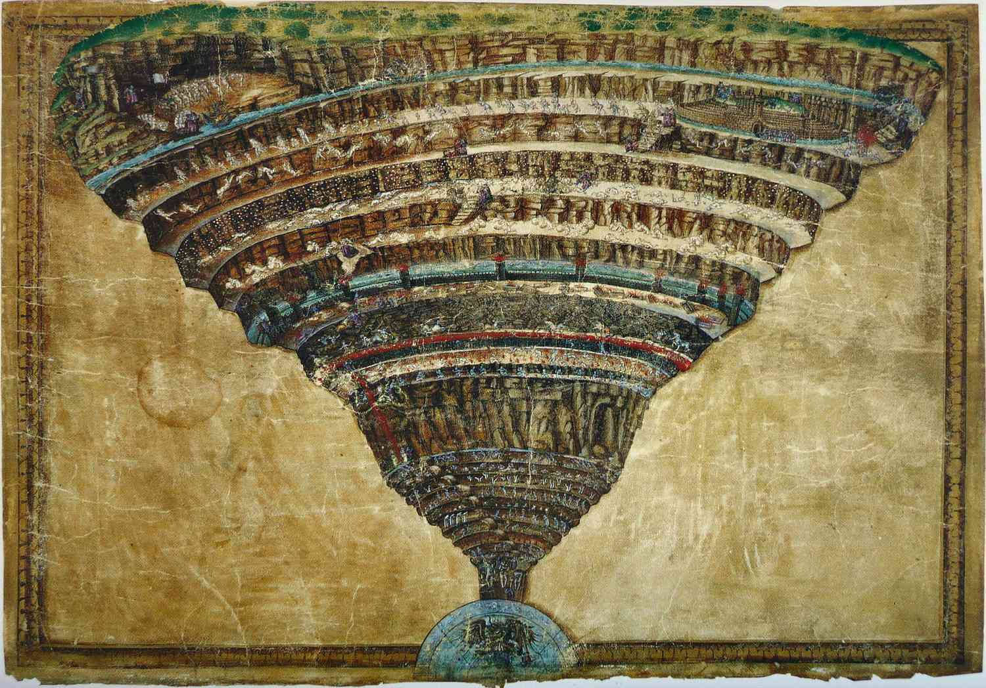

[1] Dante’s inferno by Sandro Botticelli in the mid 1480s or 1490s. The Map of Hell painting by Botticelli is one of the extant ninety-two drawings that were originally included in the illustrated manuscript of Dante's Divine Comedy.

Sub-genre Gothic Horror
As one of the oldest sub-genres of horror the gothic genre can actually trace its origins back to 1764 with the creation of the castle of otranto by Horace Walpole which help define the style that gothic has used for well over 200 years which its gloomy atmosphere and creep castle just as the book describes, the style can also be seen within medieval architecture such as cathedrals for example Notre dam in Paris but over time the gothic genre started to branch into media with the most popular being tv, art and games while style having a firm grip in literature with authors like H.P.Lovecraft and more recently Stephen King.
When it comes to gothic literature the two authors that stick out to me have always been H.P.Lovecraft with his creation of Catullo which came into the world through the condition that he suffered from called night terrors which have him these very vivid nightmares of the eldritch monsters he then felt compelled to write about, then on the other hand you have an author like Stephen King who took the psychological aspect of the gothic genre by writing about supernatural creatures such as evil spirits and demons his most popular book about the subject The Shining actually describes some of the events he experiences while staying at the hotel the book is based on the Stanlee hotel.
From these two authors we can see that the gothic genre does follow its original style of a gloomy atmosphere bus also that it has delved deeper int the territory of the psyche with people using the fear of the unknown to truly scare us, a great example of this is the tv series American horror story with its unique look at some of Americas most haunted places, using cutlers like witches to the stereotypes around freak shows and cults to show how the unknown can be truly frightening.
After looking at these I decided to also look into different games and artists that use the gothic style within their work so for the game I decided to look at the Dark souls franchise from 2011 with dark souls 1 to dark souls remaster in 2018 as a whole, the games were made by Japanese games studio called fromsoftware inc the games all follow a lone hollow there term for the player as they go off the save the land by linking the fire now within the games it becomes very clear early on that the developers took inspiration from western gothic medieval cutler from its environments to the armour and weapons and even the enemies you have to fight in order to survive.
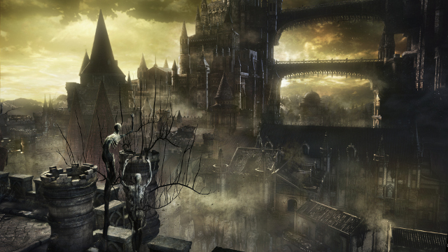
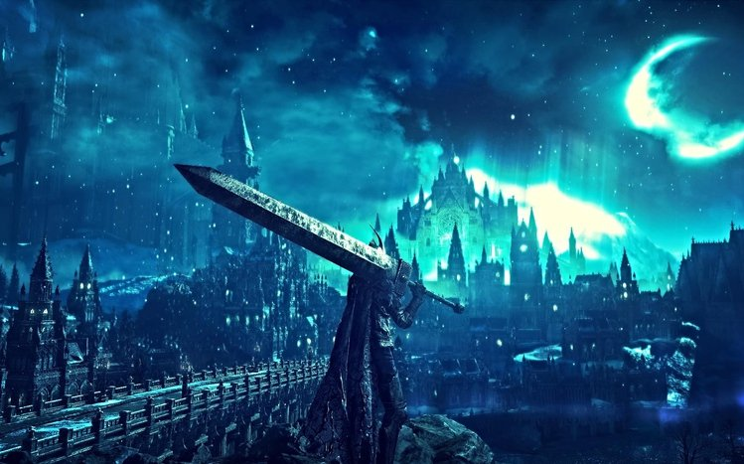 [2] [3] As we can see from these visuals, we can clearly see that the game developers were heavily inspired by the gothic architecture from the 18th to 19th centuries and with the colour pallet they decide to go with you can get an eery feeling just by looking at the images which also ties in with the gothic theme.

While looking into the game I also decided to look into an artist that was proficient in the gothic art stye, and I came across an artist called Keith Thompson who is a concept artist, creature designer and illustrator that has worked on multiple different projects such as the ones he has worked on with director Guillermo Del Toro the creator hell boy but he has worked with other directors to, to give the characters they come up with an actual form so they can also visualise what the character could look like, he has also has help create art work for games such as Skyrim which is a fantasy game that has a gothic medieval art style.
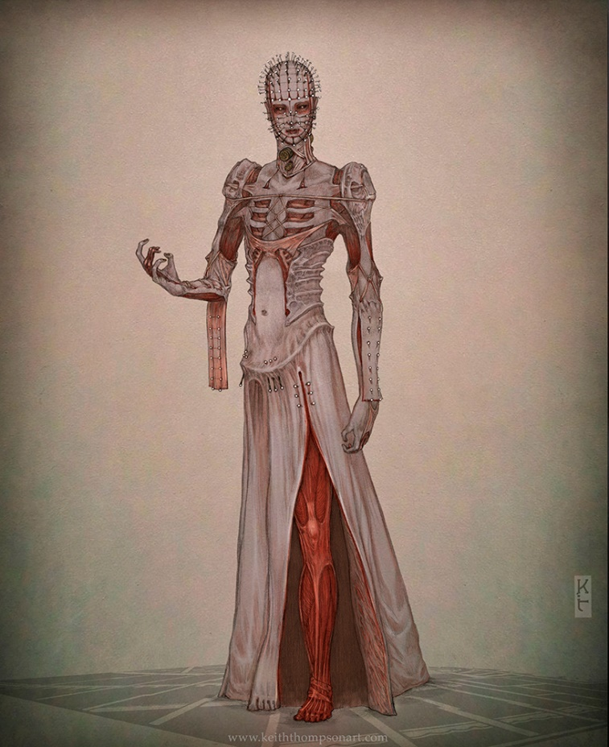 [4] As you can see Keith Thompsons work really does capture the essence of gothic horror with its striking visuals showing parts of the human body we don't often see in real life but it is also his use of colour that draws you in to look at the image more with the leg being the centre of focus of this piece of work as the red within the muscle stands out when next to the grey of the subjects skin, which in a way gives of a sense or morbidity which gothic horror id all about.
While looking at the art style the colour pallet became very clear as the style uses very cold colours such as greys, blues and blacks but they also use a small number of warm colours mainly reds to catch the attention of the person.

Sub-genre Sci-Fi Horror
Now sci-fi horror is a little different from the sub-genre I was just talking about because it as only been around for the past 92 years, but this doesn’t mean that is has had less of an impact than the other sub-genre have throughout the history of horror as it has been used to open a window into how science can create a monster such as Frankenstein which is an example of how an experiment can go wrong but it also looks into what an alien invasion would look like but that does not mean it is only limited to these ideas as it focuses on events that could happen meaning you only need to broadened your way of thinking to use this sub-genre. This can be seen in many different forms of media ranging from books, movies, art and games as it a wide range of themes it can be translated into different medias making it easier for people to understand how the mind of these creators work and experience what they feel when making their projects.
While actually looking into this sub-genre I came across many different pieces of work that follow the style of this sci-fi horror such as the book I am legend by Richard Matheson in 1954 which describes a post apocalyptic America with a virus that turns a large number of the world's populism into zombie vampire hybrids as a long doctor tries to find a cure for this virus with his own immunity, with this the book became very popular and was eventually adapted into multiple different movies other the years following the books original realise with the most popular being a movie of the same name in 2007 with the lead actor Will Smith playing the lone survivor. After finding this out I realise that sci-fi horror sub-genre was the easiest out of all the different sub-genres to adapt to diverse types of medias this was confirmed when I started to look into different artists, and I came across the artist H.R.Giger and his unique style of biomechanical.
When looking at the work of H.R.Gigers work he had a very unique way of seeing the world mainly when he was painting and creating portraits of people, he would turn them into biomechanical hybrids by merging them the wires and pipes to create what people would look like if they had a closer relationship with technology similar to that of cyborgs we see in different science fiction medias but also looking at his work you can see that he was a great inspiration for the style used in the Alien movies and even the imperium of man shown within the space marines.
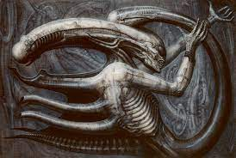[5] [6] This is H.R.Gigers Necronom IV 1976 which was as you can see has a lot of similarities to the xenomorphs found within the Alien movies with its overly large head from the back and an exoskeleton that mimics the human body structure most notably the rib cage of a person and overly extended spine that goes down to the tip of its tail.

As I have previously mentioned H.R.Gigers work also has many similarities to the imperium of man space marines found in the game franchise of 40k Warhammer that heavily uses the biomechanical art style so I decided to look into this game just to see how similar it is to H.R.Gigers art style. The 40k Warhammer franchise first started out as a table top game like D&D but in 1998 they came out with a video game called Warhammer 40k: chaos gate which used a version of the turn based combat seen on the original table top game and also using the same art style to create the figurines they used it to create the biomechanical art style we start to assonate with the game with human beings being used as objects such as computers, drones, locks and multiple forms of cyborg like creatures all most commonly found within the space marine part of the 40k Warhammer franchise.
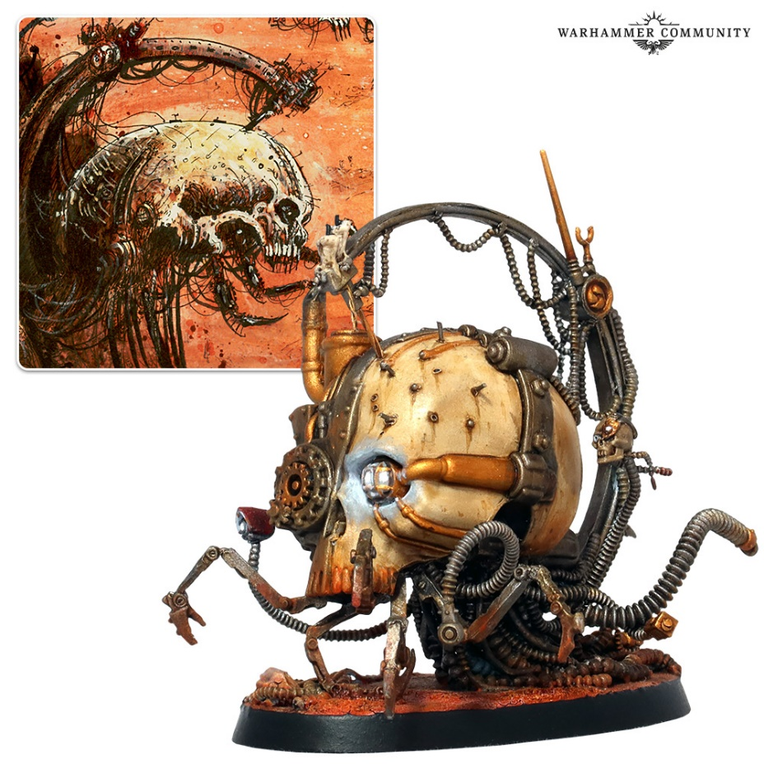
[7] you can clearly see the biomechanical art style being used on this figurine from 40k Warhammer as the mechanical parts have become one with the human element within the model this being the skull of the human it was taken from, this shows the relationship between technology and humans could possibly have at one point in the future this is one of the most common ways that the sci-fi horror sub-genre is used for.
The colour pallet that is commonly used for sci-fi horror are a mix of dark and warm tones with neon colours to help the main subject of the piece to pop from the rest of the work which works for either a building or a person who is being the main subject.

Sub-genre Cartoon horror
Now with the final sub-genre I decided to look into cartoon horror which like the other two sub-genres I have already talked about the cartoon horror genre mainly focuses on the comedic aspect that horror genre can create sometimes, its origins can be found in the creation of horror comics going back to the 1930s bringing a new light to the scary stories by using bright vibrant colours they were able to market the comics for children, after its successes its clear to see how over time horror comics evolved into movies, tv and games with this in mind we can see that the most popular version of cartoon horror of course is shown on tv with shows like scooby doo and Danny phantom taking evil spirits and monsters and given them a comedic view meaning the horror genre could be suitable for a young audience such as children.
This can also be said for movies and art with this in mind there was only one person who came to mind that would be Tim Burton the director and creator of movies such as nightmare before christmas, frankin weener and corpse bride which are all animated cartoon horror movies which use the unique style that Tim Burton created himself called goofy gothic which takes the dark and gloomy atmosphere and flipping it on its head by giving monsters and creatures giving them goofy designs to make them more appealing to children but also to adults alike.
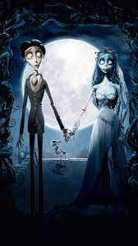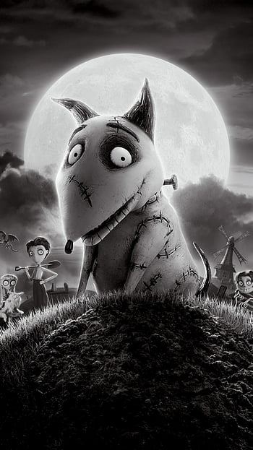[8] [9] as you can see even though these are two different movies created by Tim Burton you can see the similarities within the style use to create both animations most notably the eyes with the black rings around them given them the look of not sleeping for days but also with the corpse bride movie all the characters within it have oddly proportioned bodies which is also very common to see within Tim Burton's work.
I also looked into how cartoon horror has made its way into the world of games and the game I found that came the closest to the cartoon horror sub-genre which is the cuphead game made in 2017 that follow two cupheads after they lose a bet to the devil they must now chase down other debtors who have run away and they need to take their souls to make sure they won't lose their own they do this by going through many endless boss fights until they can face against the devil once again.

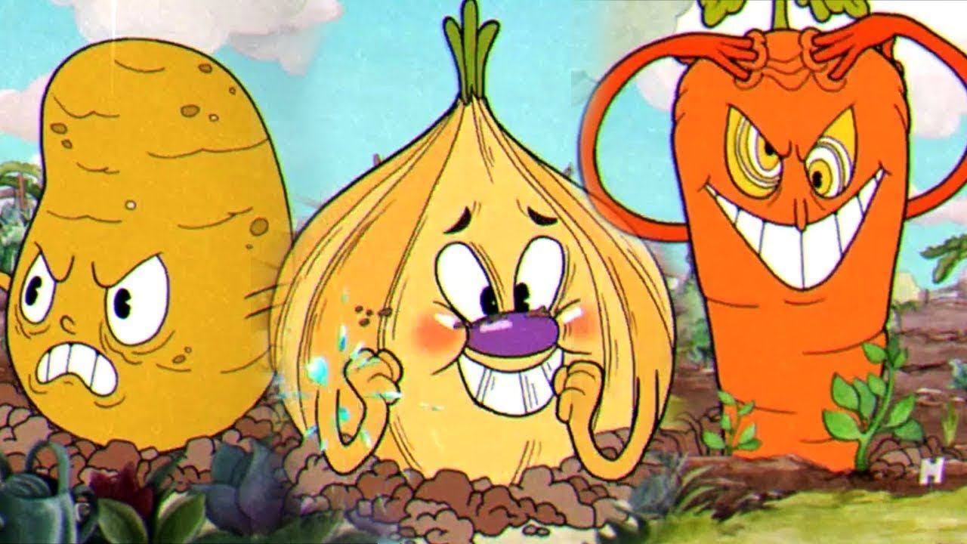[10]
While looking at the game I couldn’t help but notice the art style does seem quite innocent at first as shown with the onion but then gradually gets more intense as you move up the boss fights showing how it fits in with the style of the cartoon horror sub-genre as its not to intense that it would give the person a sense of fear instead the art style gives a person a sense of joy while looking at it because for an adult to play a game like this it would bring back a sense of nostalgia to when they were a child watching shows like scooby doo for the first time.
The colour pallet that is most commonly used for cartoon horror are bright vibrant warm colours to always keep your attention at all times and at the same time they still find a way for the colours to not overpower each other.
Final project
Firstly, after finishing my initial research I began preparations on my final project starting off by making a pdp also known as a personal development plan as I have had a hard time in the past using the standard gantt charts to keep track of my work especially with a project like this which is quite fluid at times when working on more than one model at a time it just came to reason that a pdp was my best option.
Goals | What will I do to achieve this? | What resources or support will I need? | What will my success criteria be? | Time skill to achieve goals
Create concepts in the style of my chosen sub-genres | I will create a wide range of concepts to show I have an understanding of each of the chosen sub-genres gothic, sci-fi and cartoon | I will used hand drawn concepts with a mix of models made in a program called hero forge or use zbrush to make prototypes of the models | I will have clear concepts when looked apon can clearly show the different sub-genres have been replicated. | 3 weeks
To find a way to use custom brushes in substants painter | I will watch youtube videos to see how other people have taken a custom brush and use it in substance painter | I will need accesses to a pc that has substances painter on it to test out whether or not custom brushes will work | I have successfully used a custom brush in substance to create the texture I want | 1 week
To make hard baked textures | I will use zbrush to practise making hard bake textures so I can add something more to my final models when it comes to final make them | I will need accesses to the pcs in the lab within uni to use the program zbrush to create the hard bake textures I am looking for | I have made the desired hard baked textured that fit with the sub-genre I am trying to replicate through my models | 3-4 weeks
To have all 3 if my models finished | I will set time each week leading up to the deadline to make sure I have my models ready form my final presentation | I will need accesses to the games lab within the university building to use the pcs that have zbrush on them to create my final models | By the deadline I will have 3 distinct models that represent the 3 sub- genres of horror gothic, sci-fi and cartoon | 1 week
To finish my dissertation on time | I will set between 2-3 hours a day to write up my dissertation making sure it falls under what I originally proposed to do at the beginning of the year | I will use a timer on my phone set to the same times each day to begin a retain of writing my dissertation till it is completed | I will have a fully written dissertation with relevant information, referencing and a bibliography | 3 months
To use turn tables in unreal to present my final pieces | I will watch youtube tutorials on how other people have made the turn tables in unreal before | I will use the pcs in uni to create the turntables for each of my models using the version of unreal they have accesses to keep my work consistent | I will have 3 fully functioning turn tables I could edit into one long video in premier to present as my final piece | 1-2 weeks

As you can see with the pdp I can set myself reasonable goals on how to do my work and keep track on how long each task will take me to complete using the resources I listed to complete my work but even with this system nothing is perfect, and some things do fall through.
Concepts and prototypes
After making my pdp I began to create hand draw concept pieces to show that I had an understanding of what made each style of horror sub-genre gothic, sci-fi and cartoon so unique in its own way so I decided to make 3 concepts for each of the sub-genre to get a wide range, but I didn’t realise till my last cartoon concept that my hand drawing each of that concepts was taking up to much of my time and went straight into creating hard baked texture model prototypes using the research I conducted at the beginning of this project as a base on what the hard bakes should look like and how they are differentiated between each of the sub-genres.
Hand drawn concepts.
Gothic concept 1 inspired by the art style used in the game series dark souls.
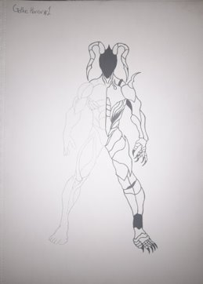
Gothic concept 2 inspired by old legends of demos and devils.
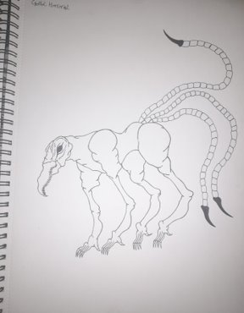

Gothic concept 3 inspired by the works of H.P. Lovecraft.
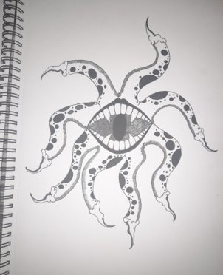
Cartoon concept 1 inspired by sally from Tim Burtons nightmare before christmas .
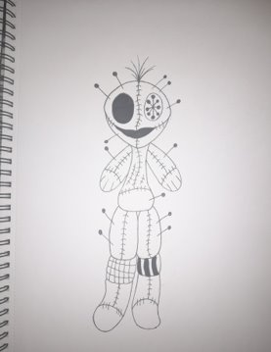

Cartoon concept 2 inspired by the art style within the game cuphead
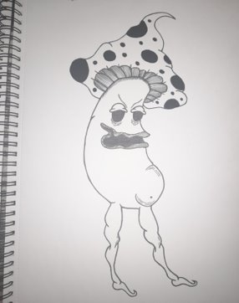
Prototypes
With my prototypes and final models all of them were made in zbrush using the preset male and female models because I wanted to focus more on the hard bake texture aspect than modelling a character from scratch as I felt the most important part for my project were the hard bake textures as they would express the style of the different sub-genres more than if I were to model a character from scratch.
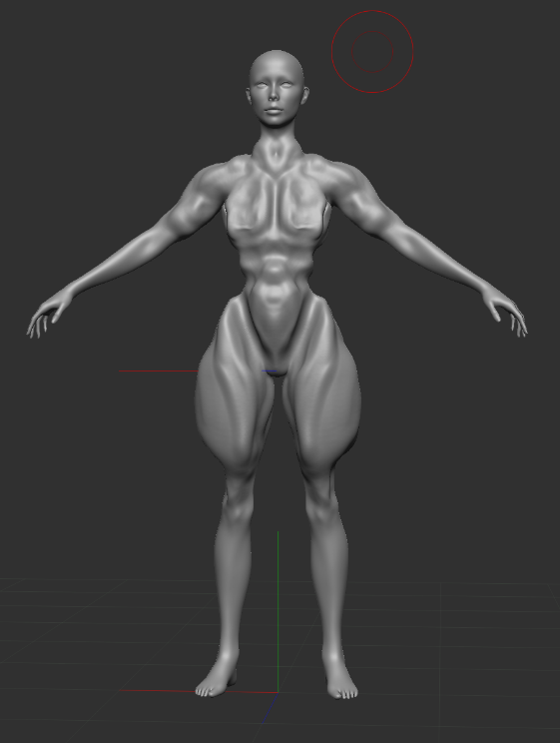
Gothic horror prototypes
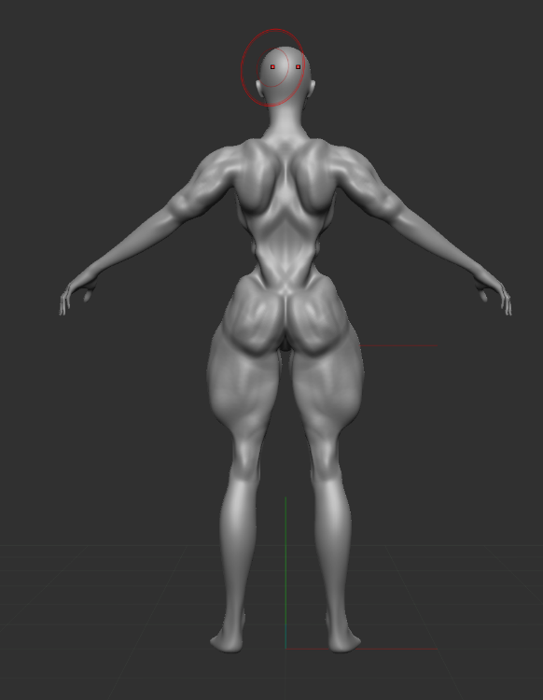

For my first gothic prototype I decided to carve in to the model to give it a more rotten body look but also wanted to look mutated to similar to the zombies found in resident evil or dying light I did this by making current pieces of the body look more robust like the thighs, parts if the back and the chest of this prototype.
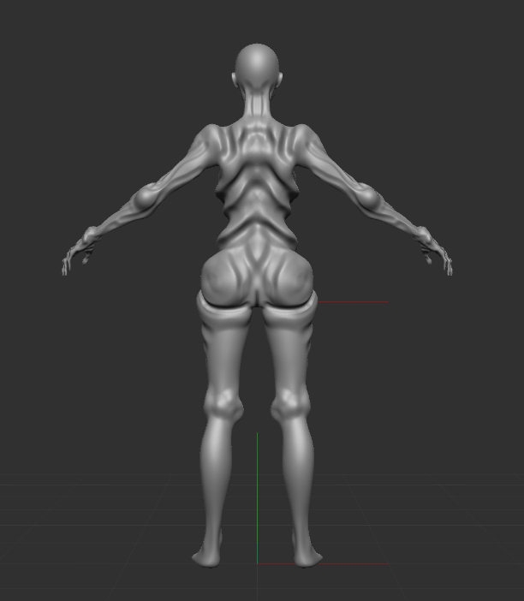
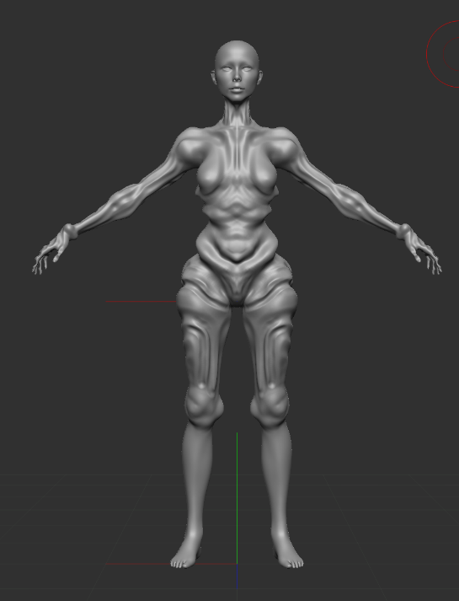

With the second prototype I decided to go for a more classic undead like body with much deeper grove marks I made by reversing the brush I was using in Zbrush so instead of it adding to the model it would take away from the model instead creating a more rotted body compared to the first one as it looked like parts of the skeleton could be seen through the rotted flesh just like it would on an actual undead body , this can bee seen at the arms, stomach to chest and the back of the second prototype model.
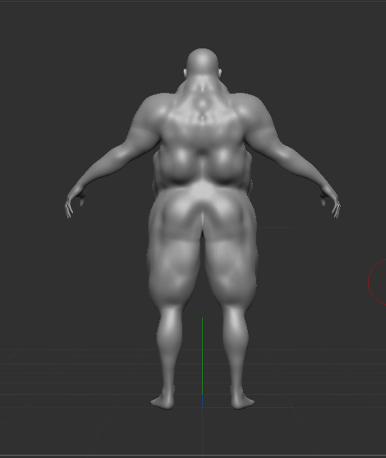
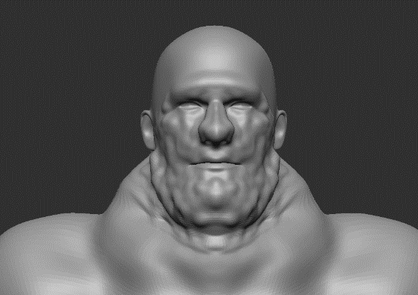
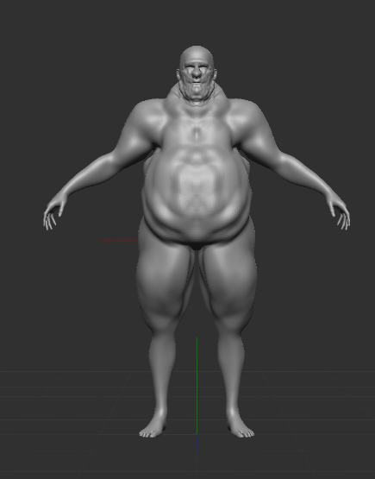
Cartoon horror prototypes

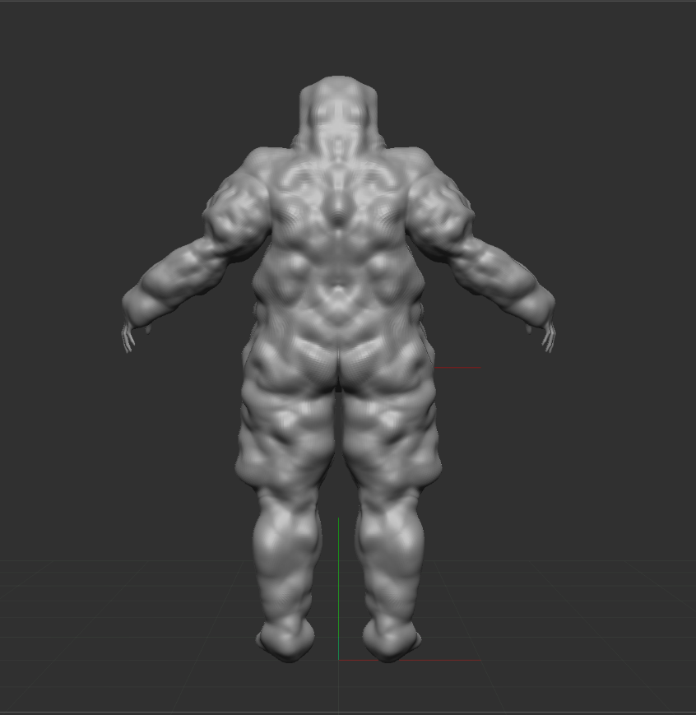
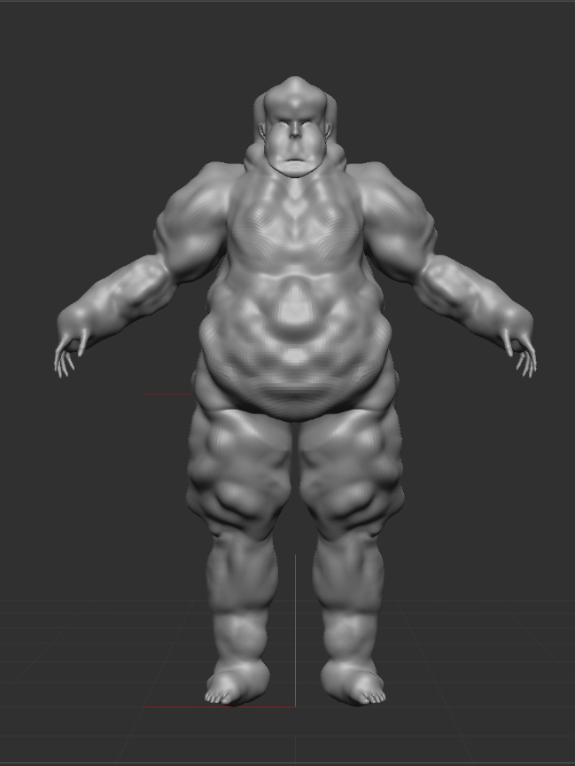
For the carton horror prototypes I was looking at enlarged human bodies as the cartoon style is very focused on they evil characters to big unbelievable sizes and this goes more so for cartoon horror, so as you can see I have tried to make my own version of those types of characters with this prototype by following the natural lines of the body model then inflating them one at a time to create layers of fat just like a person would in real life this is evident the stomach of the model, the thighs and arms of the model , the back of the model and the face of the model to make it seem in human in a slight way.

With my second prototype of cartoon horror I went the same rout of making the model quite large but I went a step further with this model to make it look mor inhuman as possible by building layers of small layers fat on top of big layers to create a lumpy texture I then repeated this prosses on the head if the model to give it that abnormal size and shape making it more unrealistic which in turn made it follow the cartoon horror art style.
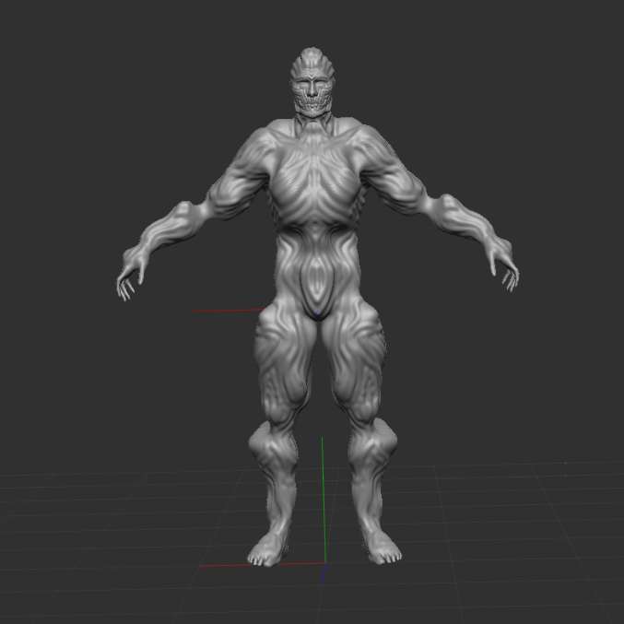
Sci-fi horror prototype

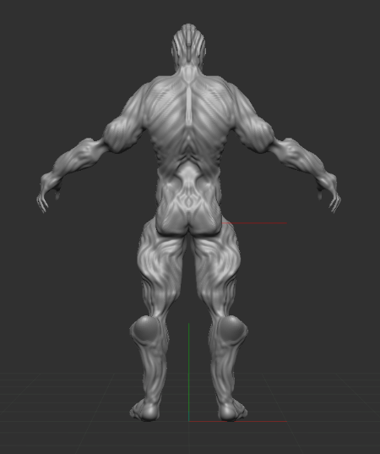

For my sci-fi horror prototype I decided to make my own version of H.R.Gigers biomechanical art style by first reducing the selected areas of his body this included the models knees, elbows, base of the spine and the hips of the model to make is seem that the models joins had been replaced by mechanical parts on top of doing that I also enlarged parts of the models body to make is seem that they were being enhanced some how this is also helped by the hard bake textures of the wires going over the body of the model by following the natural flow of the body using the standard brush to create the flow of wires I desired to make this prototype work.
After I finished the last of my prototypes I made a start on my final 3 models by taking aspects from the prototypes to create a new final product so use as my final piece but I also did carry on looking at outside sources of inspiration to help make my final pieces even better.
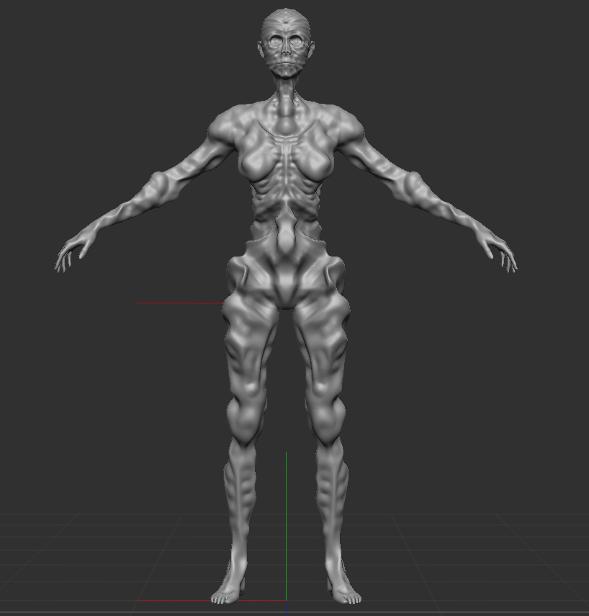
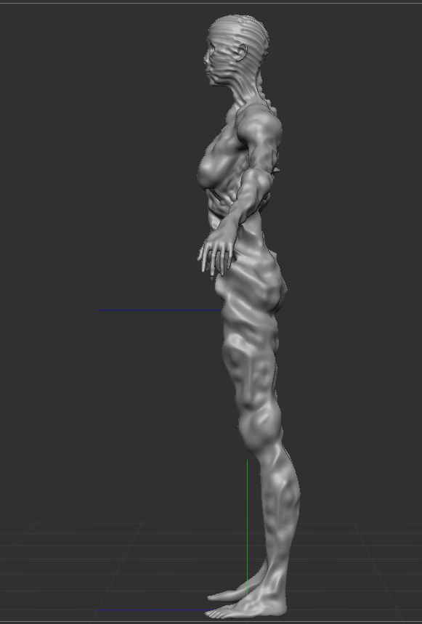
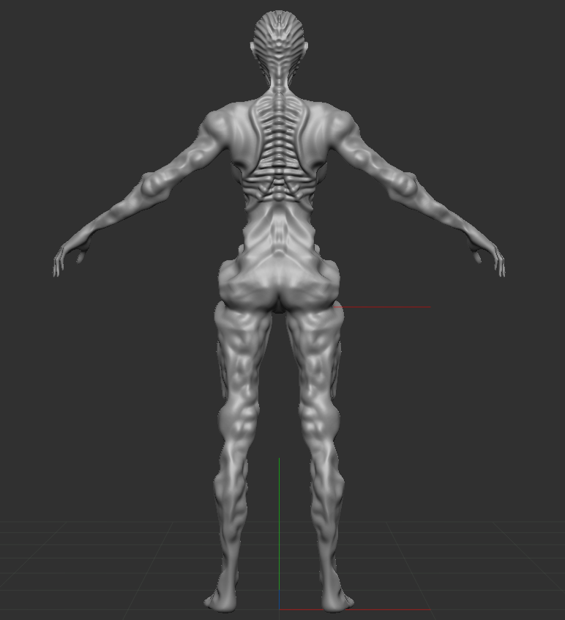
Gothic horror final piece

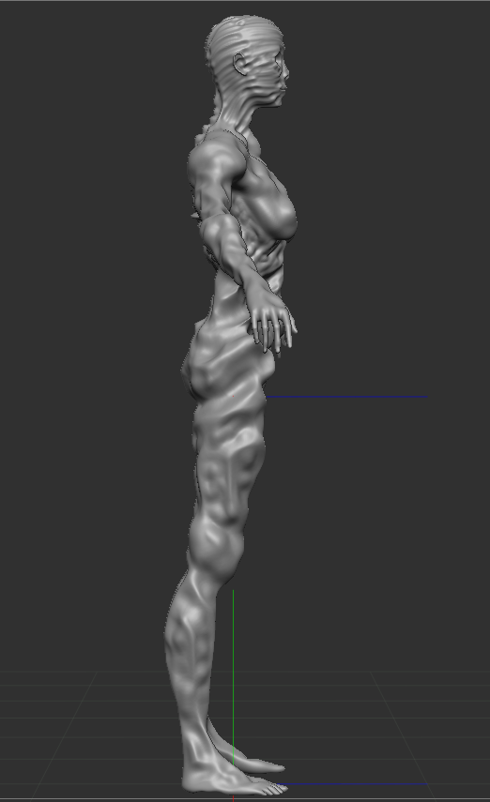

As you can see for my gothic horror final piece I created a heavily decayed undead body being able to see parts of the muscle, organs and even its bones just like a real human body would have to go through when I reached that point od decay. I was able to achieve this look using the hard brake textures in a why to decrease the mass of the body by reversing the brus so it would subtract instead of adding to the model this in turn helped me mark out a basic plan of what area of the models body I was editing first and I decided to start with the chest, hips and back because being the biggest sections on the body I knew the quicker I finalise the look on these areas the rest of the model would quickly take shape and look more towards the theme of gothic horror. When I was done with taking the bulk out of the model getting it to a nice base I started to go back and add details the most notable one being the ribs that show just under the chest then wrap around to the overly exposed spine giving the model distinctive features.
Honestly I am very happy on how this model came out and I think if I were to make it again I would hard break some more gore textures into it just to add another element that would catch a persons attention when first looking at it other than that there isn’t much else I would change to this model.
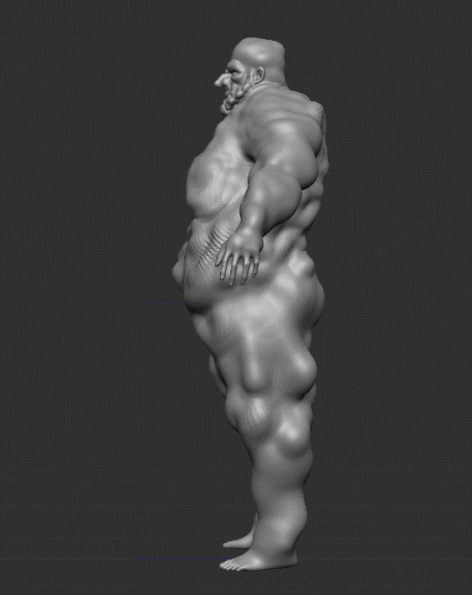
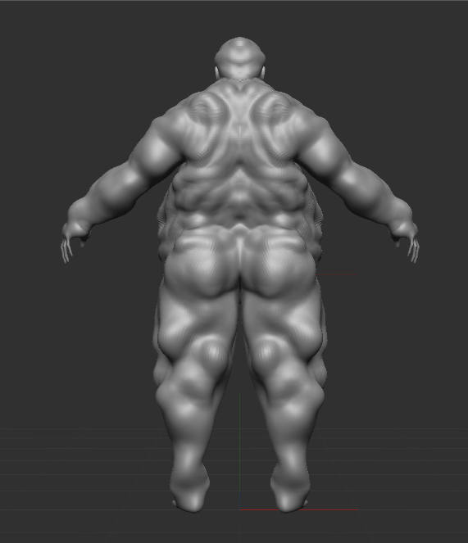
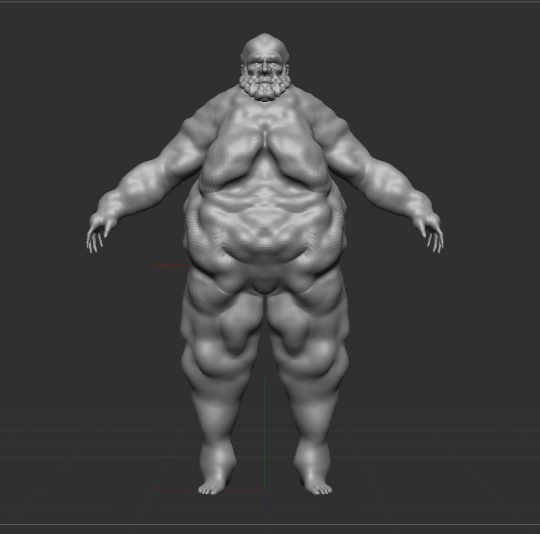
Cartoon horror final piece
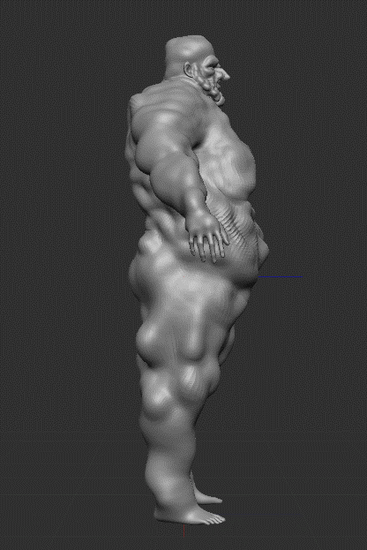

With the cartoon horror final piece there weren’t any sort of troubles that came along with it in reality it was the easiest models out of the three to get to where I needed it from beginning to end. I started off by inflating the main sections of the body being his stomach and while I was inflating that area I would also deflate the area in the low part of the models back to make it seem that it would have a very had time getting around on its own if it needed to walk, after finishing with back and stomach by adding the last of the details needed I moved towards the leges and the arms not like the stomach where I could move it in any way I needed, I needed to follow the natural flow of the leg and arm muscle to make actual believable fat legs before adding the small pockets of cat on the legs and arms to make the body inhuman just like a cartoon. Finally I moved on to the face and in order to make it seme impossible to have I started with nose the very centre of a persons face meaning it is the first thing you see when looking at a person so I made the models nose comically large which then helped me gage on how big I needed to make the brow and cheek bones this is because when drawing a face you always start with the nose then work up to the brows, cheeks and finally eyes.
This model was very enjoyable to make as it allowed me to just play around with the model to make it perfect but I do have one or two issues with the model I feel like because the model feels a bit to simple I feel like I could of added more to it like try to model clothes on top of the model I feel like that would the model seem a little more funny and creepy which is the essence of cartoon horror but I am still very happy on how this model came out.
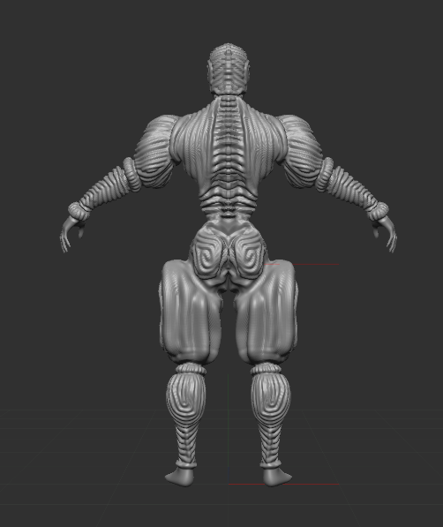
Sci-fi horror final model
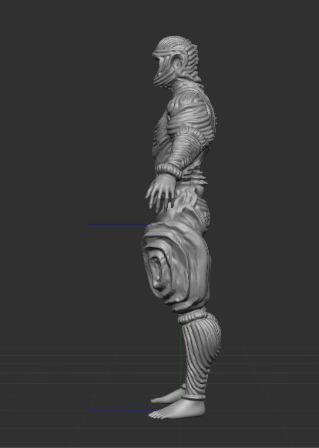
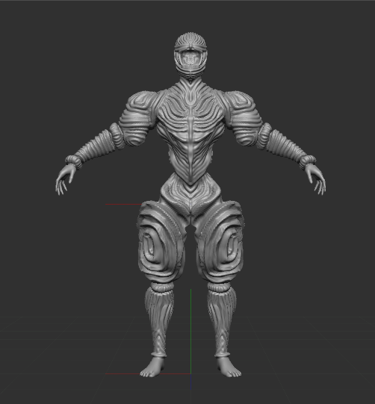
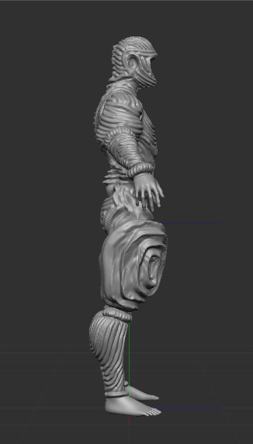

This is my final model out of the three I’ve done and out of the three of them this was the model that was the most technically challenging as I had to be so precise with every edit I made to make sure I got the desired biomechanical look I was trying to go for and this is how I did it. I first started by carving down the hip and the stomach to make it seem lie the model had fully given in on becoming a full machine no matter what so as I was carving away at the stomach I had to keep in mind that I couldn’t take to much away but at the same time I also could take to little away and this it where some of the technical challenges came into play with this model I realise that is I want this model to exactly what I vision I needed to patient an not rush any of the prosses I was using to create this model. After I was able to remove enough of the mass away I made a start on adding an exoskeleton and armor to the model first starting with the spine as it ran from the back of the models head all the way to the base of the spine it became the centre piece of the hard bake texter of the wires as each of the vertebrae were being made on the spine more wires began to form on the chest neck and head which also helped me mark out where to carve the face out to turn the model into a cyclops. When the upper body was completed including the arms where I sectioned off parts of the arms then then filed in that section with patterns made of the wire hard baked texture, I moved on to the legs staring with the things I wanted to create something similar to a knights leggings I inflated the leg following the flow of the muscle to keep it propionate to the rest of the body when I got the size I was looking for I began circling it in wire till I reached the centre then I carved between the wire to make the thighs more distinctive than the rest of the model.
Out of all three of the models I made this is by far my favourite because it was the model that challenged me the most and truly had to make me think about what is good and bad when it comes to making models such as these that have to follow such a sticked art style overwise you end up making something that doesn’t fit the theme you are trying to go for because of this I don’t think there is anything I would redo about this model.
Conclusion
In conclusion I have realised while researching the different sub-genre of horror and actually use them to create models in the specific art styles I can truly say that the answer to my question how does the art style and different themes impact horror games I can say that depending on what sub-genre if that be gothic horror, cartoon horror or even sci-fi horror you will experience a completely way of thinking from each and every one of them and as I’ve found out this is not just limited to games it can also be found in a multitude of different media from tv shows to moves to even different books and pieces of art so I think if I were to ever research this topic again some time in the future I would try to delve deeper into this question by looking at more than three sub-genres and truly see how deep this topic can go.

References
[1] | [1] Dante’s inferno by Sandro Botticelli
[2] | [2]Dark souls 3 [CD-ROM] Fromsoftware, Japan,  2016
[3] | [3] Dark souls 3 [CD-ROM] Fromsoftware, Japan,  2016
[4] | [4] unknown art by Keith Thompson
[5] | [5] Xenomorph from Alien by Dan O’Bannon 1979
[6] | [6] Necronom IV by H.R.Giger 1976
[7] | [7] The black iron by John Blanche
[8] | [8]Corpse Bride by Tim Burton 2005
[9] | [9]Frankin Weenie by Tim Burton 2012
[10] | [10] Cuphead [CD-ROM], Studio MDHR 2017

Bibliography
A Guide to Dante's 9 Circles of Hell (thoughtco.com)
https://hbr.org/2021/10/the-psychology-behind-why-we-love-or-hate-horror
https://www.nypl.org/blog/2018/10/03/brief-history-gothic-romance
https://www.nypl.org/blog/2018/10/03/brief-history-gothic-romance
https://www.creativebloq.com/digital-art/artists-changing-face-horror-101517417
https://gamerant.com/what-turns-sci-fi-into-sci-fi-horror/
https://www.gamerevolution.com/news/12364-dark-souls-3-launch-trailer-showcases-beautiful-environments-and-refined-gameplay
https://themepack.me/theme/dark-souls-environment/
https://www.google.com/url?sa=i&url=http%3A%2F%2Fblog.keiththompsonart.com%2F&psig=AOvVaw37j6YatB8oVw236X-NSaQ0&ust=1682593392826000&source=images&cd=vfe&ved=0CAQQjB1qFwoTCJC-6_-yx_4CFQAAAAAdAAAAABAD
https://www.warhammer-community.com/2021/05/11/classic-warhammer-art-comes-to-life-in-these-john-blanche-inspired-conversions/
https://www.wikiart.org/en/h-r-giger/necronom-iv-1976
https://www.vulture.com/2014/09/xenomorph-is-gone-forever-says-ridley-scott.html
https://unofficialcuphead.fandom.com/wiki/The_Root_Pack

