

Programme: | BSc Health and Social Care
Module: | Introduction to Independent Research Skills
Module code: | BMHP5019
Lecturer:  Student:  ID: | Philip Jones, Raheela Shaikh and Zakiyyah Ahmed  Musab Shah  2411894 | Internal Verifier: | Chloe Harries
Assignment Title: | Component 2:  Written Assignment (Research Report) | Word count (or equivalent):
Submission deadline: | Monday 20th July 2026  14:00 (2PM) - (Week 11) | Return date of provisional marks & written feedback: | Monday 24th August 2026

Contents
1. Introduction 3
1.1. Topic focus and rationale 3
1.2. Review question and objectives 3
2. Background 3
2.1. Clinical and service context 3
2.2. Digital health, access and professional work 4
3. Methods 5
3.1. Scoping review design 5
3.2. Data collection and eligibility 5
3.3. Selection, charting and analysis 5
3.4. Ethical considerations 6
4. Results 6
4.1. Search outcome and selected evidence 6
4.2. Theme 1: clinical benefit depends on active feedback 9
4.3. Theme 2: engagement and usability shape outcomes 10
4.4. Theme 3: implementation must address workload, cost and equity 11
5. Discussion 12
5.1. Critical interpretation of findings 12
5.2. Strengths and weaknesses of the evidence 12
5.3. Limitations of the review 13
5.4. Implications for UK primary care 13
6. Conclusion and Recommendations 13
6.1. Conclusion 13
6.2. Recommendations 14
References 15

Introduction

Topic focus and rationale
Type 2 diabetes is a chronic disease where glycaemic control, medicines optimisation and self-management support need to be maintained between visits. Remote patient monitoring (RPM) refers to the systematic gathering of patient-generated health data (PGHD) like blood glucose levels, weight, symptoms, lifestyle information, etc., via digital or telephone-based systems. This report is specific to adults with type 2 diabetes in primary care as most of the routine review, medication titration and the prevention of complications are arranged outside of hospital. The importance lies in its practical applications: if a device could be used remotely to detect deterioration, it would be done earlier, but at the same time it would be expected to add to workload and would also rule out those with poor access to digital devices. There is recent evidence that digital diabetes interventions can be effective at improving HbA1c, but this is highly dependent on the professional feedback and intervention design. Some evidence has emerged regarding the effectiveness of digital diabetes interventions at improving HbA1c, with effectiveness being highly dependent on professional feedback and intervention design (Moschonis et al., 2023).

Review question and objectives
The review question is: what does recent peer-reviewed evidence show about the effectiveness, acceptability and implementation of remote patient monitoring for adults with type 2 diabetes, and what are the implications for UK primary care?
The objectives are: Identify the key intervention characteristics described in the literature; review clinical and patient-centred outcomes; explore the barriers and facilitators to implementation; and draw conclusions for practice, policy and future research. A scoping review was the most suitable type of review for this field as there are several randomised trials, systematic reviews, and implementation studies available that have been conducted with varying terminology, populations, and outcomes.

Background

Clinical and service context
Diabetes care is an ongoing care process and requires a reliable monitoring process, behaviour change, timely professional decision making and patient confidence. In primary care, remote monitoring is appealing as it potentially could convert episodic visits to more responsive follow-up. Among adults who had persistently poor control, a comprehensive telehealth approach yielded better results than telemonitoring and care coordination alone (Crowley et al., 2022), suggesting that data collection alone is not likely to be enough. This is significant for UK practice given the pressures on appointments both for primary care teams and for the digital pathway to avoid unnecessary risk, rather than simply shifting hidden labour to nurses, pharmacists, general practitioners and/or patients.
The topic is discussed under four concepts. Effectiveness is defined as the impact of monitoring on outcomes like HbA1c, self-management or complication prevention. Acceptability is defined as the pathway's usability and value from the patient and staff's perspectives. Implementation involves the organisational work that is required to establish a monitoring routine. Equity is about how access to benefits is achieved for groups who have already poorer diabetes outcomes. It is crucial as a clinically effective digital tool can be unsuccessful if it is cumbersome to use, not well integrated, unsafe to staff, or inaccessible to marginalised patients.

Digital health, access and professional work
The evidence-based literature also indicates that remote monitoring is not a product, but a service redesign. Evidence from systematic review suggests that interventions with more healthcare provider involvement are more effective at reducing HbA1c than interventions that primarily use self-directed telehealth (Robson and Hosseinzadeh, 2021). Based on the mobile app reviews, self-care tools can be used to assist in glycaemic and blood pressure control, but this is done through communication and personalised advice and decision support, not just technology (Liu et al., 2020). This poses a challenge to implementation because while remote monitoring can benefit individuals who have trouble traveling, it can also harm individuals who are not digitally literate, have limited English proficiency, disability, or poor housing stability or internet access. Thus, evidence of implementation that focuses on the patient remains a critical factor in assessing acceptability, feasibility and equity (Mokaya et al., 2022) of interventions in mHealth.
When monitoring is remote, professional work changes, too. More frequent data may need to be interpreted by staff, decisions need to be made about when to act on a reading and what is urgent, and staff may need to communicate their decisions without the cues that are present when meeting the patient in person. The experiences of health professionals in relation to the support of care provided by digital health interventions is the subject of a systematic review which identified concerns about workflow, accountability and training needs (Ali, et al. 2023). This is a review of staff feasibility, and not a detail of implementation that can be ignored.

Methods

Scoping review design
The design and methods were secondary research which was carried out by scoping review design to map the scope of evidence and to find out the major themes relevant to practice. The review was facilitated by the current methodological literature that suggests that a scoping review may be helpful when the topic is conceptually complex, has a mix of concepts and is not ready for a narrowly focused effectiveness review (Peters et al., 2020). Reporting was guided by systematic review transparency guidelines including the transparent reporting of search decisions and eligibility criteria and the study flow (Page et al., 2021). The search strategy was also guided by PRISMA-S as transparent reporting of databases, terms and limits aids readers in assessing the reliability of a review (Rethlefsen et al., 2021).

Data collection and eligibility
The search terms used combinations of: type 2 diabetes, remote monitoring, telemonitoring, telehealth, digital health, mHealth, primary care, HbA1c, acceptability, implementation and equity in search engines PubMed, EBSCOhost and Google Scholar. The sources included were peer-reviewed primary and secondary journal articles published in English and related to adult type 2 or mixed diabetes samples in which the results of type 2 diabetes were clearly relevant. Studies were discarded if they were editorials, opinion pieces, conference abstracts, policy documents or were not related to diabetes management, or were device advertisements. The final in-depth sample consisted of five articles to satisfy the assessment requirement, but not to eliminate critical discussion and analysis, which would otherwise be superficial listing. Background, methods and discussion sections were supported by wider peer reviewed studies.
The search was not designed to determine effectiveness of all types of telehealth. Rather, it sought out evidence that would account for the usefulness or problematicness of certain features in the realm of remote monitoring. Articles were prioritised if they contained clinical outcomes, patient or practitioner experience, barriers to implementation, service utilisation, cost or primary-care relevance. This prevented the singular focus on HbA1c alone and helped to provide a more comprehensive evaluation of the potential for remote monitoring in the real world.

Selection, charting and analysis
Titles and abstracts were checked for the review question prior to the assessment of full-text. Key information was graphed for the study type, population, intervention, outcomes, implementation issues, strengths and limitations. As the goal was to map evidence, rather than calculating pooled effect sizes, there was no formal risk of bias score used. A thematic analysis approach was used; initial codes were identified based on clinical effect, engagement, professional feedback, access, workload, cost and equity, with these themes being further interpreted into three interpretive themes. Thematic analysis was effective because it allowed for the development of themes that were repeated, but also encouraged active interpretation and pattern building as opposed to just counting repeated words (Braun and Clarke, 2021). A worked example of this approach demonstrated the utility of being transparent in analytic decisions in relation to credibility (Byrne, 2022).
There were three stages in the thematic synthesis process. To preserve the level of detail at the study level, first the findings from each selected article was charted separately. Second, there was identification of similarities and contrasts across studies, particularly in relation to the intensity of feedback and engagement of patients and professionals' workload. Third, themes were further developed to address the review question as opposed to just summarizing the literature. This process was used to provide a critical but proportionate review appropriate for Level 5 secondary research.

Ethical considerations
Published peer-reviewed literature was used for the review without recruiting participants, and with no collection of personal data. However, moral interpretation was still significant. First, the report does not claim that digital monitoring is necessarily a good thing as inequalities can be exacerbated when access to digital technologies is unevenly distributed. Second, the studies were accurately represented in terms of its limitations, and evidence was not overstated. Third, patient autonomy, confidentiality and professional responsibility were taken into account when interpreting remote monitoring as patient-generated health data may raise expectations of constant monitoring. This is especially critical when there is not a clear agreement on alerts, thresholds and response times.

Results

Search outcome and selected evidence
A wide and growing literature was identified for telehealth, mobile apps, connected glucose devices and digital self-management. Five articles were chosen for detailed analysis after screening for relevance to adult type 2 diabetes, features of remote monitoring, and applicability to primary-care. The studies selected were one randomised trial, three systematic reviews/meta analyses and one review/economic service utilisation. This blend has been intentionally included because the question in the review is one of effectiveness, acceptability and implementation, as opposed to one of clinical efficacy. The selection also incorporates the assessment requirement to be selective in their choice of a limited number of peer-reviewed studies and use broader academic reading.
The literature search for the studies revealed that there is a wide and uneven literature of remote monitoring. Numerous articles were written about general telemedicine or general diabetes education without a monitoring element, and some articles reported on the performance of the devices without describing primary-care implementation. This was felt to be a reasonable approach to choosing five studies for detailed analysis with the use of further peer-reviewed literature to enhance context and discussion.
The study-selection process is summarised visually in Figure 1 to improve transparency in how the final five peer-reviewed studies were identified for detailed review.
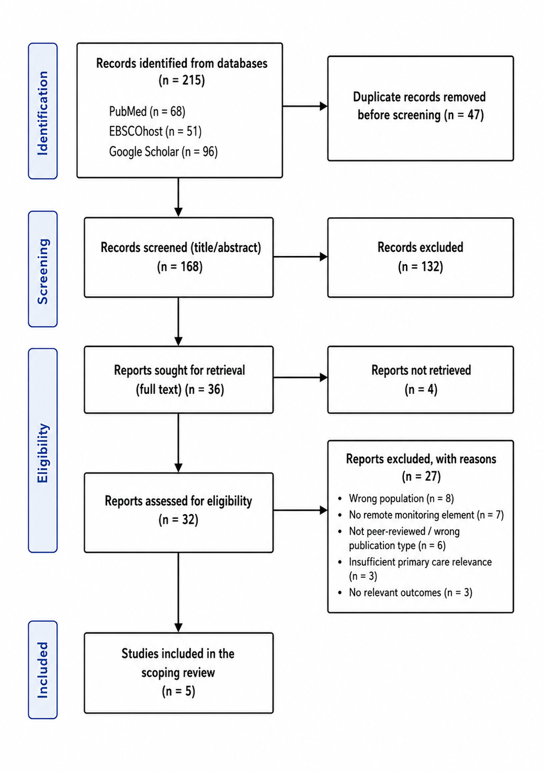
Figure 1: Flow diagram of the scoping review study-selection process.
Table 2: Summary and critical appraisal of the five studies selected for in-depth review.
Study | Design and focus | Main finding | Critical relevance to review question
Crowley et al. (2022) | Randomised clinical trial of comprehensive telehealth versus simpler telemonitoring/care coordination in adults with persistently poor control. | Comprehensive telehealth improved outcomes more than the simpler model. | Strong evidence that professional input and pathway design matter, although the United States setting limits direct transfer to UK primary care.
Chiaranai et al. (2024) | Systematic review and meta-analysis of randomised trials during the COVID-19 period. | Telehealth reduced HbA1c compared with usual care, but heterogeneity was substantial. | Useful for effectiveness, but pandemic context may overstate acceptability of remote care as routine practice.
Robson and Hosseinzadeh (2021) | Systematic review and meta-analysis of telehealth care for adults with type 2 diabetes in primary care. | Interventions with self-management support and provider engagement had stronger effects. | Highly relevant to the review question because it connects clinical benefit with professional involvement.
Moschonis et al. (2023) | Systematic review and meta-analysis comparing SMS, smartphone application and website-based interventions. | Digital interventions improved glycaemia, while reach, uptake and feasibility differed by mode. | Adds implementation depth by showing that effectiveness and adoption are not identical outcomes.
Morris et al. (2023) | Systematic review of digital health interventions, service utilisation and costs in type 2 diabetes management. | Evidence on utilisation and cost was mixed and not consistently reported. | Important for UK practice because sustainability depends on resources as well as clinical outcomes.

Theme 1: clinical benefit depends on active feedback
The most salient theme is that remote monitoring is more effective when combined with data that are coupled with professional feedback, medication review, and behavioural support. Crowley et al. showed that a full-fledged telehealth model is more valuable than a simpler telemonitoring model, indicating that human clinical input is essential to improvement, rather than incidental. A meaningful HbA1c benefit with the use of telehealth was reported during the COVID-19 era, but the review also revealed variation or heterogeneity, indicating that the type and intensity of intervention can impact the outcome (Chiaranai et al., 2024). Zhang et al. also reported that telemedicine in primary care had modest positive effects on blood glucose and self-management, although this effect was not necessarily seen after 6 months ( Zhang et al., 2022).
Additional meta-analytical support for this theme is available. The authors of this study reported variation in quality of studies and interventions, and they concluded that telemedicine had a positive impact on glycaemic control in adults with type 2 diabetes (De Groot et al., 2021). Ravi et al. subsequently reached the same conclusion that virtual care has the potential to lower HbA1c levels in people with type 2 diabetes, but because an umbrella review relies on the quality of the systematic reviews it includes, it is essential that the systematic reviews are of high quality (Ravi et al., 2025). This suggests that remote monitoring has potential, but effect sizes can be considered pathway dependent but not guaranteed.

Theme 2: engagement and usability shape outcomes
Patient engagement is a mechanism of effect and a potential source of exclusion is the second theme. Chawla et al. reported improvements that were statistically significant following a digital therapeutic intervention; and the data shown below are found in many digital diabetes studies, and depict type of outcome reporting (Chawla et al., 2022). But engagement should not just be limited to app usage or data uploads. Studies of digital health technologies reveal potential benefits for glycaemic control, but also reveal that the content of the intervention, its usability and support for patients differs widely (Stevens et al., 2022). The study by Lee et al. showed that an electronic medical record integrated app had the most positive impact on personalised diabetes self-care, indicating that digital tools are most effective when integrated into current clinical information systems (Lee et al., 2022).
The figures are helpful because they provide visual evidence of clinical improvement; they also highlight a drawback of a lot of digital health evidence. A pre-post graph cannot show, by itself, that the changes would have continued if the intervention had not ended, or that the changes would have stopped if the intervention was to be discontinued. That's why trial and implementation evidence should be used together. Therefore the effectiveness of remote monitoring needs to be evaluated not only in terms of data improvements, but also as to whether patients can participate without creating excessive burden.
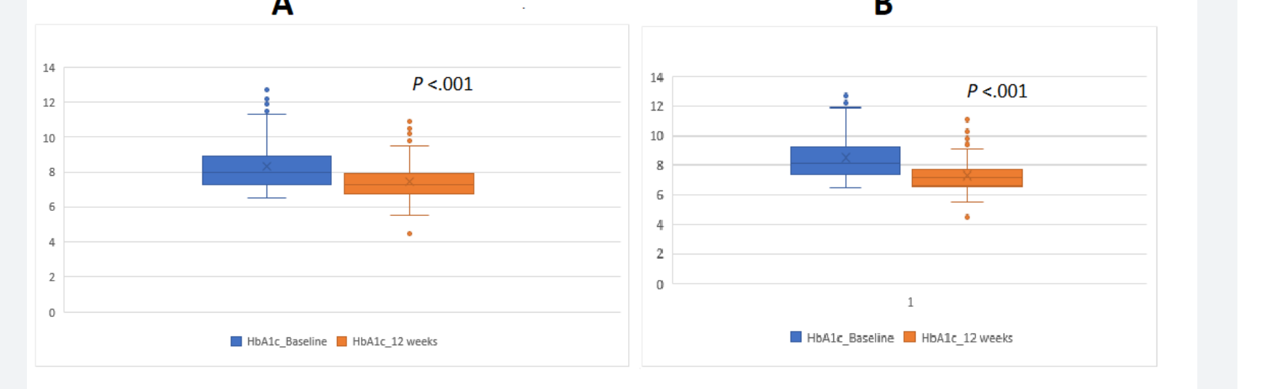
Figure 2: Online figure showing HbA1c comparison at baseline and 12 weeks (Chawla et al. 2022)
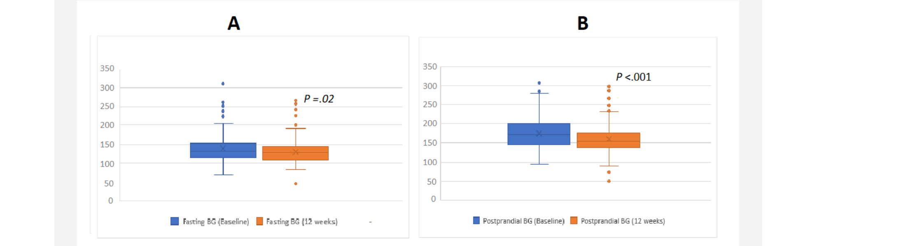
Figure 3: Online figure showing fasting and postprandial blood glucose comparison (Chawla et al. 2022)

Theme 3: implementation must address workload, cost and equity
The third theme is that service capacity, cost and equity are key to implementation success. Morris et al. identified that digital health interventions could have an impact on health and social care use, but there was mixed evidence on cost and resource use (Morris et al., 2023). Practitioner evidence also indicates that remote monitoring can generate new work, specifically in the areas of data review, alert management, documentation and patient troubleshooting (Serrano et al., 2023). A review of implementation barriers and facilitators identified that organizational readiness and staff training and integration with existing platforms are important factors that shape the sustainability of remote care (Oudbier et al., 2024).
Cost and workload are not a secondary consideration for a UK practice. Increased alerts can be a problem if the number is higher than what staff can safely review. Requiring smartphones and reliable internet or competent English-language app usage can exacerbate inequalities. If it is not integrated with electronic records, it can lead to duplication of records. These pragmatic issues are the reasons why a well-executed intervention can be challenging to scale without redesigning roles, training and governance.

Discussion

Critical interpretation of findings
Overall, the scoping review suggests that caution should be used when considering the use of remote monitoring for type 2 diabetes in UK primary care. There is the strongest evidence for targeted use in adults with poor glycaemic control, changes in medication or access barriers, and especially when combined with timely professional feedback and monitoring. Weaker for universal rollout due to the variety of studies in terms of intervention design, patient populations, duration of follow-up and comparator care. Eberle and Stichling (2021) found that telemetric interventions may have a positive effect on HbA1c, but the results of the meta-review were limited by the quality and similarity of the studies included. Telemonitoring was also identified as a promising option by Emonena and Ojo (2022) who pointed out education and patient attitudes and cost as barriers to application in primary care.
This discovery has implications for the way results are reported to decision makers. No one would be able to write a balanced interpretation that suggested a replacement for routine reviews with remote monitoring. It would say that remote monitoring might be a useful reinforcement of routine reviews if patients are picked appropriately and there is learning, escalation and professional response on the pathway. This separation will safeguard patients from unsupervised self-surveillance and services from implementing digital tools without the resources to do so safely.

Strengths and weaknesses of the evidence
One of the advantages of the literature is that there is some randomised and synthesised evidence, which means that there is greater confidence than in isolated descriptive studies. The Crowley et al. trial is particularly relevant as it compared two active remote-care models rather than technology alone versus usual care. The second is the increasing number of investigations of implementation and service effects, beyond HbA1c. Mannoubi et al. identified features of telehealth tools and reported that many telehealth interventions encompass glycaemic monitoring, diet, physical activity, medication monitoring, education and professional support (Mannoubi et al., 2024).

Limitations of the review
The review is subject to limitations. This was not a systematic review and therefore some eligible studies may not have been identified. The use of peer-reviewed journal articles in English language has enhanced academic reliability but has meant that grey literature was excluded that may reflect current service models in the UK. The five-study in-depth sample also results in an interpretive, rather than definitive, interpretation of findings. One weakness is the lack of consistency in the use of remote monitoring, telehealth, mHealth and digital therapeutics. This makes it challenging to develop interventions since a text message intervention, a connected glucometer, and a multidisciplinary virtual clinic can all be called digital diabetes care.

Implications for UK primary care
The UK primary care implication is that remote monitoring needs to be ordered as a supported clinical pathway. Agreed thresholds, named staff responsibility, escalation rules, documentation procedures and time for review need to be provided for patient readings. A digital health intervention was found to have a beneficial effect on glycaemic control in a retrospective study (Zimmermann et al., 2021), but there is a risk observational study designs may not find that same effect in other service settings. Majithia et al. demonstrated that virtual care with continuous glucose monitor can yield better glycaemic outcomes, but the model might require resources and patients' capabilities that varies among individuals (Majithia et al., 2020). Although a smartphone app trial produced metabolic benefits, it is possible that even trial-based app interventions aren't representative of the complexity of routine primary care (Lim et al., 2021).
The evidence also backs co-design, prior to implementation, with the patients and practitioners. Co-design is not just a matter of preference, it's about testing if the alerts, dashboards, appointment flows and educational messages are relevant to the actual service conditions. For instance, a pathway might be efficient when assessed from a clinical outcome perspective but become unsustainable if there are increased telephone calls or unplanned contacts and/or staff anxiety over missed readings. These risks need to be considered prior to procurement.

Conclusion and Recommendations

Conclusion
While the evidence suggests that remote patient monitoring could have significant implications for adults with type 2 diabetes, there is no simple answer that technology can augment care. The strongest evidence is that clinical interpretation, professional support and incorporation of remote monitoring into self-management education is the most effective means of implementing remote monitoring. The evidence also reveals significant boundaries – clinical outcomes are reported more consistently than workload, safety, cost and accessibility and long-term sustainability. This is important as interventions in primary care in the UK need to be effective in studies, but also practical in overstretched services, and acceptable to a variety of patient groups.
Thus, the importance of this review lies not only in its practical aspect, but also in its ethical aspect. In practice, it pinpoints situations for which remote monitoring is more likely to be successful. Ethically, it suggests that the digital diabetes care should support the professional care and the patient's autonomy, not leave them with unsupported responsibility. This is particularly relevant in primary care where continuity of care, trust and the judicious allocation of resources to manage LTCs are essential.
In summary, this highlights the importance of using evidence-based decision making to guide implementation with caution, documenting the impact of the services in an understandable way, maintaining a focus on equity, and specifically evaluating staffing needs in day-to-day diabetes service provision and governance planning.

Recommendations
First, it needs to be directed to those patients who are most likely to benefit, such as those who have persistent hyperglycaemia, have recently changed medications or have difficulties attending reviews. Secondly, thresholds and staff roles should be established in advance for services. Thirdly, support for digital inclusion, and non-digital support should be integrated into the path. Fourth, future studies should benchmark the various models of monitoring against outcomes other than HbA1c such as workload, cost, safety, patient experience and inequalities. Last, future research in the UK must include how data from a distance is translated into better, safer and equitable care as the primary evidence gap is not whether digital monitoring can gather data but how services turn that evidence into better, safer, and equitable care.

References
Braun, V., & Clarke, V. (2021). One size fits all? What counts as quality practice in (reflexive) thematic analysis?. Qualitative research in psychology, 18(3), 328-352. Available at: https://doi.org/10.1080/14780887.2020.1769238
Byrne, D. (2022). A worked example of Braun and Clarke’s approach to reflexive thematic analysis. Quality & quantity, 56(3), 1391-1412. Available at: https://doi.org/10.1007/s11135-021-01182-y
Chawla, R., Jaggi, S., Gupta, A., Bantwal, G., & Patil, S. (2022). Clinical utility of a digital therapeutic intervention in Indian patients with type 2 diabetes mellitus: 12-week prospective single-arm intervention study. JMIR diabetes, 7(4), e41401. Available at: https://doi.org/10.2196/41401
Chiaranai, C., Chularee, S., Saokaew, S., Bhatarasakoon, P., Umnuaypornlert, A., Chaomuang, N., ... & Nimkuntod, P. (2024). Effectiveness of telehealth on the glycemic control of patients with type 2 diabetes mellitus during the COVID-19 pandemic: a systematic review and meta-analysis of randomised controlled trials. International Journal of Nursing Studies Advances, 6, 100169. Available at: https://doi.org/10.1016/j.ijnsa.2023.100169
Crowley, M. J., Tarkington, P. E., Bosworth, H. B., Jeffreys, A. S., Coffman, C. J., Maciejewski, M. L., ... & Edelman, D. (2022). Effect of a comprehensive telehealth intervention vs telemonitoring and care coordination in patients with persistently poor type 2 diabetes control: a randomized clinical trial. JAMA internal medicine, 182(9), 943-952. Available at: https://doi.org/10.1001/jamainternmed.2022.2947
De Groot, J., Wu, D., Flynn, D., Robertson, D., Grant, G., & Sun, J. (2021). Efficacy of telemedicine on glycaemic control in patients with type 2 diabetes: a meta-analysis. World journal of diabetes, 12(2), 170. Available at: https://doi.org/10.4239/wjd.v12.i2.170
Ali, N., El Hamdaoui, S., Nefs, G., Walburgh Schmidt, J. W., Tack, C. J., & de Galan, B. E. (2023). High diabetes‐specific distress among adults with type 1 diabetes and impaired awareness of hypoglycaemia despite widespread use of sensor technology. Diabetic Medicine, 40(9), e15167. Available at: https://doi.org/10.1111/dme.15167
Eberle, C., & Stichling, S. (2021). Effect of telemetric interventions on glycated hemoglobin A1c and management of type 2 diabetes mellitus: systematic meta-review. Journal of medical Internet research, 23(2), e23252. Available at: https://doi.org/10.2196/23252
Emonena, H., & Ojo, O. (2022). The efficacy of tele-monitoring in maintaining glycated haemoglobin levels in patients with type 2 diabetes mellitus: a systematic review. International Journal of Environmental Research and Public Health, 19(24), 16722. Available at: https://doi.org/10.3390/ijerph192416722
Lee, E. Y., Cha, S. A., Yun, J. S., Lim, S. Y., Lee, J. H., Ahn, Y. B., ... & Ko, S. H. (2022). Efficacy of personalized diabetes self-care using an electronic medical record–integrated mobile app in patients with type 2 diabetes: 6-month randomized controlled trial. Journal of Medical Internet Research, 24(7), e37430. Available at: https://doi.org/10.2196/37430
Lim, S. L., Ong, K. W., Johal, J., Han, C. Y., Yap, Q. V., Chan, Y. H., ... & Khoo, C. M. (2021). Effect of a smartphone app on weight change and metabolic outcomes in Asian adults with type 2 diabetes: a randomized clinical trial. JAMA network open, 4(6), e2112417. Available at: https://doi.org/10.1001/jamanetworkopen.2021.12417
Liu, K., Xie, Z., & Or, C. K. (2020). Effectiveness of mobile app-assisted self-care interventions for improving patient outcomes in type 2 diabetes and/or hypertension: systematic review and meta-analysis of randomized controlled trials. JMIR mHealth and uHealth, 8(8), e15779. Available at: https://doi.org/10.2196/15779
Majithia, A. R., Kusiak, C. M., Armento Lee, A., Colangelo, F. R., Romanelli, R. J., Robertson, S., ... & Zisser, H. (2020). Glycemic outcomes in adults with type 2 diabetes participating in a continuous glucose monitor–driven virtual diabetes clinic: prospective trial. Journal of medical Internet research, 22(8), e21778. Available at: https://doi.org/10.2196/21778
Mannoubi, C., Kairy, D., Menezes, K. V., Desroches, S., Layani, G., & Vachon, B. (2024). The key digital tool features of complex telehealth interventions used for type 2 diabetes self-management and monitoring with health professional involvement: scoping review. JMIR Medical Informatics, 12, e46699. Available at: https://doi.org/10.2196/46699
Mokaya, M., Kyallo, F., Vangoitsenhoven, R., & Matthys, C. (2022). Clinical and patient-centered implementation outcomes of mHealth interventions for type 2 diabetes in low-and-middle income countries: a systematic review. International Journal of Behavioral Nutrition and Physical Activity, 19(1), 1. Available at: https://doi.org/10.1186/s12966-021-01238-0
Morris, T., Aspinal, F., Ledger, J., Li, K., & Gomes, M. (2023). The impact of digital health interventions for the management of type 2 diabetes on health and social care utilisation and costs: a systematic review. PharmacoEconomics-Open, 7(2), 163-173. Available at: https://doi.org/10.1007/s41669-022-00377-9
Moschonis, G., Siopis, G., Jung, J., Eweka, E., Willems, R., Kwasnicka, D., ... & Bruka, L. (2023). Effectiveness, reach, uptake, and feasibility of digital health interventions for adults with type 2 diabetes: a systematic review and meta-analysis of randomised controlled trials. The Lancet Digital Health, 5(3), e125-e143. Available at: https://doi.org/10.1016/S2589-7500(22)00233-3
Oudbier, S. J., Souget-Ruff, S. P., Chen, B. S., Ziesemer, K. A., Meij, H. J., & Smets, E. M. (2024). Implementation barriers and facilitators of remote monitoring, remote consultation and digital care platforms through the eyes of healthcare professionals: a review of reviews. BMJ open, 14(6), e075833. Available at: https://doi.org/10.1136/bmjopen-2023-075833
Page, M. J., McKenzie, J. E., Bossuyt, P. M., Boutron, I., Hoffmann, T. C., Mulrow, C. D., ... & Moher, D. (2021). The PRISMA 2020 statement: an updated guideline for reporting systematic reviews. bmj, 372. Available at: https://doi.org/10.1136/bmj.n71
Peters, M. D., Marnie, C., Tricco, A. C., Pollock, D., Munn, Z., Alexander, L., ... & Khalil, H. (2020). Updated methodological guidance for the conduct of scoping reviews. JBI evidence synthesis, 18(10), 2119-2126. Available at: https://doi.org/10.11124/JBIES-20-00167
Ravi, S., Meyerowitz-Katz, G., Yung, C., Ayre, J., McCaffery, K., Maberly, G., & Bonner, C. (2025). Effect of virtual care in type 2 diabetes management–a systematic umbrella review of systematic reviews and meta-analysis. BMC health services research, 25(1), 348. Available at: https://doi.org/10.1186/s12913-025-12496-0
Rethlefsen, M. L., Kirtley, S., Waffenschmidt, S., Ayala, A. P., Moher, D., Page, M. J., & Koffel, J. B. (2021). PRISMA-S: an extension to the PRISMA statement for reporting literature searches in systematic reviews. Systematic reviews, 10(1), 39. Available at: https://doi.org/10.5195/jmla.2021.962
Robson, N., & Hosseinzadeh, H. (2021). Impact of telehealth care among adults living with type 2 diabetes in primary care: a systematic review and meta-analysis of randomised controlled trials. International journal of environmental research and public health, 18(22), 12171. Available at: https://doi.org/10.3390/ijerph182212171
Serrano, L. P., Maita, K. C., Avila, F. R., Torres-Guzman, R. A., Garcia, J. P., Eldaly, A. S., ... & Forte, A. J. (2023). Benefits and challenges of remote patient monitoring as perceived by health care practitioners: a systematic review. The Permanente Journal, 27(4), 100. Available at: https://doi.org/10.7812/TPP/23.022
Stevens, S., Gallagher, S., Andrews, T., Ashall-Payne, L., Humphreys, L., & Leigh, S. (2022). The effectiveness of digital health technologies for patients with diabetes mellitus: a systematic review. Frontiers in Clinical Diabetes and Healthcare, 3, 936752. Available at: https://doi.org/10.3389/fcdhc.2022.936752
Zhang, A., Wang, J., Wan, X., Zhang, Z., Zhao, S., Guo, Z., & Wang, C. (2022). A meta-analysis of the effectiveness of telemedicine in glycemic management among patients with type 2 diabetes in primary care. International journal of environmental research and public health, 19(7), 4173.Available at: https://doi.org/10.3390/ijerph19074173
Zimmermann, G., Venkatesan, A., Rawlings, K., & Scahill, M. D. (2021). Improved glycemic control with a digital health intervention in adults with type 2 diabetes: retrospective study. JMIR diabetes, 6(2), e28033. Available at: https://doi.org/10.2196/28033

