
A critical evaluation on the effectiveness of self-regulatory codes in the accounting profession

By Kirsty Bevan
P152179
Dissertation submitted as part of the requirements for the award BA (Hons) Accounting
2019

DECLARATION
This work has not previously been accepted in substance for any degree and is not being concurrently submitted in candidature for any degree.
Signed……………………………………………
Date………………………………………………

STATEMENT 1
This dissertation is being submitted in partial fulfilment of the requirements for the degree of BA.
Signed…………………………………………….
Date………………………………………………

STATEMENT 2
This dissertation is the result of my own independent work/investigation, except where otherwise stated.
Other sources are acknowledged by footnotes giving explicit references. A bibliography is appended.
Signed……………………………………………
Date………………………………………………

STATEMENT 3
I hereby give consent for my dissertation, if accepted, to be available for photocopying and for interlibrary loan, and for the title and summary to be made available to outside organisations.
Signed………………………………………………
Date………………………………………………....

STATEMENT 4
I hereby give consent for my dissertation, if accepted, to be available on the university’s IT system to those who have consent to use the system.
Signed………………………………………………
Date…………………………………………………

Acknowledgements
I dedicate this dissertation to my beloved father, Christopher Carl Bevan, who sadly passed away on 16 March 2016.
I would firstly like to thank Ian Jackson for all his help and support he has given me throughout the dissertation. Another thanks to Maria Heffernan who stepped in at the last minute to give me further guidance and support.
Thank you to Sabina and Henning at ICAEW for taking the time in their busy lives and helping me share my online survey to chartered accountants.
Lastly, I would like to thank my partner and all my family for their support, guidance and for believing that I was capable to achieve great academic results throughout my entire time at university.

Abstract
The aim of this dissertation was to critically evaluate the effectiveness of self-regulatory codes in the accounting profession. Self-regulatory codes cover the key areas of this study and refers to regulation, codes of ethics, conduct and practice. Within these key areas it also includes ethical behaviour and decision-making within the accounting profession.
The researcher conducted a substantial review of academic literature on the rationale of self-regulatory codes to get a better understanding on the effectiveness it has within the profession. The findings and themes that emerged from the literature review were used to underpin survey questions.
An online questionnaire was created online and was distributed through professional online platforms such as LinkedIn as the survey was intended for professional accountants. There were 167 participants in total. The interviews got distributed potentially to 12 people however, only three responded. The findings support much of the literature and themes outlined in chapter two. The first being that all professional accountants are aware that ethics is a very important factor however, it is proving to be ineffective, this could be related to unethical practices that are wrongdoing. Theme two was identified and that being that there is a necessity for regular and robust audits due to the occurring fraudulent activity. Lastly, the findings support that stronger regulation and tougher penalties are needed as the current regulation is ineffective.

Contents
Chapter 1 - Introduction 1
1.1 Background 1
1.2 Rationale 3
1.3 Aims and Objectives 3
1.4 structure 4
1.5 Conclusion 4
Chapter 2 – Literature review 6
2.0 Introduction 6
2.1 Government Regulation 6
2.1.1 Self-Regulation in the accounting profession 8
2.1.2 General Codes 10
2.1.2.1 Professional Ethics 11
2.1.2.2 Professional codes of ethics 12
2.1.2.3 Ethics for professional accountants 12
2.1.2.4 Employee ethics in the accounting profession 13
2.1.3 Ethical behaviour of individuals 15
2.1.3.1 Ethical decision making 15
2.1.4 Importance of morality for accountants 17
2.1.5 Law and legislation 18
2.2 Accounting principles for professional accountants 19
2.2.1 Accounting scandals 22
2.3 Conclusion of the literature review 22
Chapter 3 - Methodology 24
3.0 Introduction 24
3.1 The Research Onion 25
3.1.1 Philosophy 26
3.1.2 Approach & strategy 26
3.1.3 Choice 27
3.1.4 Time horizon 27
3.1.5 Techniques: data collection and analysis 27
3.1.5.1 Data collection 27
3.1.5.2 Survey design 28
3.1.5.3 Pilot study 28
3.1.5.4 Question and literature review matrix 29
3.1.5.5 Interview design 31
3.1.5.6 Analysis 31
3.2 Sample 31
3.3 Reliability and validity 32
3.3.1 Triangulation 33
3.4 Limitations 33
3.5 Ethical considerations 34
3.5 Conclusion 35
Chapter 3 - Data analysis 36
4.0 Introduction 36
4.1 Data analysis 36
4.2 Methods 36
4.3 Demographics 37
4.4 Codes of conduct 40
4.5 Independent T Test 41
4.5.1 Gender and fraud in accounting 41
4.5.2 Gender and reasons that make the accounting profession liable to fraud 44
4.6 Crosstabulation analysis and Chi-square tests 46
4.6.1 Gender and pressure to falsify accounts 46
4.6.2 Gender and observation of unethical behaviour 47
4.7 Analysis of qualitative data collected from online surveys 48
4.7.1 Ways to reduce fraud 48
4.7.2 The most important principle 49
4.7.3 Reasons why the accounting profession are liable to fraud 50
4.7.4 Analysis of qualitative data collected in the online survey 52
4.8 Themes from the online questionnaire 55
4.9 Matrix analysis of qualitative data from interviews 57
4.10 Triangulation of findings 60
4.11 Conclusion 60
Chapter 5 – Conclusion and recommendations 61
5.1 Introduction 61
5.2 The achievement of objectives; 61
5.3 Main findings 62
5.4 Recommendations 62
5.5 Limitations 64
5.6 Further research 65
5.7 Conclusion 67
Self-reflection 68
Bibliography 69
Appendices 80

List of figures
Figure 2.1 Self-regulation model in the accounting profession adapted from: (Johnson, 2016). 9
Figure 2.2 The relationship of codes of ethics and codes of conduct source: (Global Alliance, 2018). 14
Figure 2.3 Framework for understanding ethical decision-making source: (Crane & Matten, 2016). 16
Figure 2.4 Model of the relationship of Ethics, Morality and Law source: (Jawad, 2018). 18
Figure 2.5 The conceptual Framework for professional accountants’ source: (IFAC, 2018). 19
Figure 2.6 Three-step approach source: (IFAC, 2018). 21
Figure 3.1 The Research Onion Source: (Saunders, et al., 2016) 25
Figure 4.1 Graph of gender identification 38
Figure 4.2 Age classification results 39
Figure 4.3 Graph of possible years of experience. 40
Figure 4.4 Graph defining if respondents have a code of conduct in their workplace. 41
Figure 4.5 Most frequent answer to reduce fraud (Online survey data, 2019). 49
Figure 4.6 High level word cloud of accounting principles (Online survey data 2019) 50
Figure 4.7 Text query analysis on reasons for fraud (Online survey data 2019). 51

List of tables
Table 3.1 Questions in the questionnaire relating to chapter two the literature review 31
Table 4.1 Crosstabulation analysis of age and importance of ethics. 39
Table 4.2 Independent T Test of gender and fraud in the accounting profession. 43
Table 4.3 Independent T Test of gender and reasons why accountants are liable to fraud. 45
Table 4.4 Crosstabulation analysis of gender and if they have been put under pressure to falsify account. 46
Table 4.5 Chi-Square test gender and pressure to falsify accounts 46
Table 4.6 Crosstabulation analysis of gender and unethical behaviour from clients. 47
Table 4.7 Chi-Square test gender and unethical clients. 47
Table 4.8 Thematic analysis of qualitative data 53
Table 4.9 Frequency analysis on the codes of ethics 55
Table 4.10 Frequency analysis of code of conduct 55
Table 4.11 Frequency analysis of code of practice 56
Table 4.12 Analysis of qualitative data collected from interviews 59

Abbreviations
FRC: The Financial Reporting Council
RSB: Recognised Supervisory Bodies
ACCA: Association of Chartered Certified Accountants
CAI: Chartered Accountants Ireland
CIMA: Chartered Institute of Management Accountants
CIPFA: Chartered Institute of Public Finance and Accountancy ICAEW: Institute of Chartered Accountants in England and Wales
ICAS: Institute of Chartered Accountants of Scotland

Chapter 1 - Introduction
The purpose of this dissertation is to evaluate if self-regulatory codes can be effective in minimising problems of malpractice or fraud in the accounting profession. It is noted that this subject area has a paucity of academic research on the everyday ethical behaviour of accountants. This chapter provides the rationale and the background of this study and highlighting issues as to why this study is one that is imperative. For the purpose of this dissertation the researcher will use the term self-regulatory codes which will cover the following key areas; regulation, codes of ethics, conduct and practice.

1.1 Background
Self-regulatory codes are the rationale for an effective system of discipline in relation to ethics and the behaviour of professionals (Vaagan, 2002). This dissertation seeks to analyse the rationale behind self-regulatory codes and what effect it has on accountants.
Accounting regulation is an important factor for accountants as it has the following principles, to promote consistency, fairness, simplicity, to be transparent and efficient, provide clarity and accountability (BIS, 2011). According to (Malhotra, 2013) lack of enforcement techniques within regulation can be ineffective within the accounting profession and suggests that self-regulators need to enforce better regulation whereas (Flanagan & Clarke, 2007) have concerns that rules, regulations and ethics are simply not efficient enough. The premise of the dissertation is that major accounting scandals have had a negative impact on the accounting profession’s reputation and the ethical behaviour of accountants. Steve Giles quoted in (ACCA, 2016, p. 30 ) explains that ‘fraud is a significant business risk that threatens both profits and reputation’.
One example of an accounting scandal in 2009 was Enron and the Arthur Andersen accounting firm who once was highly reputable, (Kannaiah & Kumar, 2009) claim that this case raised a huge ethical question on the appropriate behaviour of professional accountants. The BBC (2002) reported that Enron lied about its profits and hiding debts to falsify the company accounts. The Independent (2002) reported that this scandal resulted in serious consequences, a fine of £322,000 and a probation period of five years meaning that any if anything else occurred would result in a prison sentence. This scandal went above and beyond of breaking the code of conduct for professional accountants.
Another example is the WorldCom scandal who coincidently had the same accounting firm; Arthur Andersen. According to (The Guardian, 2002) that scandal resulted in the company’s chief financial officer and former controller being charged with fraud and conspiracy and was sentenced to 65 years in prison. There are several other accounting scandals such as Tyco international scandal with the accounting firm PricewaterhouseCoopers, Royal Ahold and accounting firm Deloitte & Touche and Parmalat with Grant Thornton SpA accounting firm. A more recent one was the singer James Arthur’s accountant who stole £599,000 from his company (BBC NEWS, 2018).
There were two scandals which took place in Swansea which raised concerns over the ethics and regulation in the profession, these are being explored due to the location being the same as the researcher. Firstly, Robert Davies the head of the homeless charity Cyrenians Cymru was caught forging invoices to his own bank account which amounted to £1.3m (BBC NEWS, 2017). The second scandal was boss Nasir Malik and the accountant Saquib Zia for the charity Awema who were found guilty of being unethical and using charity funds to buy themselves some rugby tickets, along with including but hiding personal pension payments in the accounts, issuing cheques for large amounts of money and hiding £100k in a bank account when the charity was mistakenly paid a grant twice, the prosecutor’s accused Malik of being dishonest (WalesOnline, 2014). These scandals are the fundamental reasons why the researcher wishes to explore the reasons why accountants are liable to fraud and how effective self-regulatory codes are.

1.2 Rationale
These scandals above underpin the rationale of this study which seeks to understand if codes and ethics within the accounting profession are effective, and if not why. According to (Onyebuchi, 2011) cited in (Payne, et al., 2018, p. 216) “ethics in accounting is in one of the most important, yet most misunderstood, concerns in the world of business today”, yet there is a gap in research regarding the effectiveness of codes in the accounting profession.
Ethics is an important factor within the accounting profession however, there needs to be more rigorous regulation as the current soft regulation seems to be ineffective.
The researcher has a personal interest in the study; accounting is the researchers degree pathway and undertook an internship in the profession (the internship led to a part-time post within the same accounting organisation). Further she hopes to secure employment in this sector, and therefore a rich understanding and knowledge of the research area will be beneficial.

1.3 Aims and Objectives
The aim of this dissertation is to critically evaluate the effectiveness of self-regulatory codes in the accounting profession. There are four objectives:
1. To critically analyse previous academic literature on the rationale of self-regulatory codes within the accounting profession.
2. To analyse the importance of self-regulatory codes on the ethical behaviour within the accounting profession.
3. To analyse the data collected to understand the effectiveness of self-regulatory codes on the ethical behaviour within the accounting profession.
4. To make recommendations to the accounting profession on the importance of self-regulatory codes to improve unethical behaviour.

1.4 structure
To successfully achieve the objectives of this study chapter two will analyse the available academic literature on the rationale of regulation, codes and ethics within the accounting profession this will identify if there are any gaps in current literature to explore in more detail when conducting primary research.
Chapter three seeks to identify the most suitable method and methodology that will be used to conduct primary research in relation to the gaps that have been recognised within the academic literature review of chapter two.
Chapter four will analyse the data collected through mixed methods using a sequential approach firstly, the online questionnaire will be analysed and present findings and then interviews, - which will allow triangulation to take place.
Chapter five will begin with the achievement of objectives. A discussion on the main findings including any implications that have arisen. Recommendations and limitations will also be stated within this chapter. Along with details for further research.

1.5 Conclusion
This chapter has successfully outlined the aim and objectives of this dissertation through discussing the background and rationale of this study which permits further investigation to gain a deeper understanding of the subject’s personal experience and first-hand knowledge on the research area.
Chapter two as previously mentioned, will critically analyse previous academic literature on the rationale for regulation, codes and ethics within the accounting profession which will identify relevant issues and themes which will allow the researcher to explore further and conduct primary research.

– Literature review

2.0 Introduction
The purpose of this chapter within the dissertation is to carry out a review of available literature concerning the effectiveness of self-regulatory codes in minimising problems of malpractice or fraud in the accounting profession as this area has a paucity of academic research on the everyday ethical behaviour of professional accountants. The purpose of this literature review will be to achieve the first research objective of the dissertation:
To critically analyse previous academic literature on the rationale of self-regulatory codes within the accounting profession. The premise of the dissertation is that major accounting scandals have had a negative impact on the accounting profession.
To meet the objective, this chapter will use several sources such as academic journals, relevant text books, government publications, accounting websites, professional accounting bodies and newspaper articles. Literature within this chapter will also be considered to enable and assist the researcher in the design of primary research and methodology for collecting data within chapter three.
The purpose of this literature review will be to identify the rationale of regulation, self-regulation and codes within current literature which is relevant within the accounting profession. Secondly, to analyse current theoretical concepts and frameworks available within the accounting profession. Lastly, the literature review seeks to evaluate limitations of current research and identify any gaps within the literature.

2.1 Government Regulation
Regulation has been identified to have a high relevance within the accounting profession and therefore, this dissertation must explore the rationale for regulation. The purpose of regulation is for the government to enforce rules to manage the behaviour of businesses (L'etang, 1992). There are two types of regulation there is hard regulation and soft regulation. Hard regulation refers to laws, acts, formal or informal rules, policies, goals, concepts and strategies that can impact, enable or encourage the behaviour of businesses (Crane & Matten, 2016). This type of regulation is also known as imperative regulation. The government form legislation and are backed up by Parliament, the police and courts who can grant penalties (OECD, 2002). However, other forms of regulation such as soft regulation are not always enforced by the government but by private regulator bodies which are formally known as private regulation where rules are produced by business associations and civil society actors which tries to promote and encourage ethical behaviour in businesses. In the UK The Financial Reporting Council (FRC) is an independent regulator funded by the government who are responsible on behalf of the government for the monitoring and enforcing actuarial, accounting and audit standards which were founded in 1990.
Carroll & Buchholtz (2009) suggest that It is important that accounting practices fully understand regulatory frameworks as it can help the development and implementation of strategies. Regulation is an important factor not only to businesses but for accountants as it has the following principles, to promote consistency, fairness, simplicity, to be transparent and efficient, provide clarity and accountability (BIS, 2011). However, Crane and Matten (2016) state that government regulation has not been widely accepted by companies. This is due to the government offering little persuasion or encouragement towards businesses and the government having a lack of funds. The lack of expertise in specific industries and how time consuming it can be to enforce rules and regulations. Therefore, professional accountants require professional bodies who are self-regulators and can propose further strategies and professional bodies are needed to impose higher ethical standards (Cise, 1966). According to Malhotra (2013) the lack of enforcement techniques within regulation can be ineffective within the accounting profession and suggests that self-regulators need to enforce better regulation.

2.1.1 Self-Regulation in the accounting profession
As identified above self-regulation is an important factor within the accounting profession. Self-regulation differs from regulation and referred to as soft which is based on guidelines and set standards for codes of practice, conduct or ethics (Maitland, 1985).
There has been an increase in self-regulation which is not enforced entirely by the government and is more industry focussed. OECD (2015) official definition of self-regulation is that;
Many professions adopt self-regulation, i.e., develop and self-enforce rules commonly arrived at for the mutual benefit of members. Self-regulation may be adopted in order to maintain professional reputation, education and ethical standards.
Self-regulation negotiates and enforces codes within industries and have statutory backing or some government involvement (Bartle & Vass, 2005).
Self-regulation aim to encourage financial industries with a proactive approach and encourage ethical behaviour to achieve objectives faster due to the major time constraint that government regulations face (Bartle & Vass, 2005) this is due to the commitment and professional knowledge that self-regulators have within professional sectors . Institutions of self-regulators can be the following; professional bodies, trade associations and public interest groups who usually are efficient and have expertise within different industries however, (Baldwin, et al., 2012) claim that there are concerns and worries from critics that self-regulators will have weaknesses in regards to who mandates the accountability and the fairness of procedures. According to the FRC’s website there are six Recognised Supervisory Bodies (RSB) who have been governed by FRC since 2003 (see appendix 1). A suitable model for professional self-regulation within accounting has been adapted and can be seen in figure 2.1, the original can be found in appendix 2.
Figure 2.1 Self-regulation model in the accounting profession adapted from: (Johnson, 2016).
However, Bartle and Vass (2005) identified in their study that several accountants were unsure of the meaning of self-regulation and negative about and noted that their perceptions on the topic claimed that self-regulation can result in anti-competitive behaviour by focussing on the private interest and not actually pursuing the public interest although concluded that there is a lack of understanding. Although (Thomas, 2018) identified that new research has suggested that regulation within the accounting profession by its members (otherwise known as self-regulation) has had a positive impact towards accountants and their professionalism. Payne et al (2018) reports that there is need for further development of a system of self-regulation that applies to all self-regulators, as this would help to maintain the reputation of accountants, education and ethical standards through having the same codes of ethics.

2.1.2 General Codes
Regulation, self-regulation and codes are the rationale for an effective system of discipline in relation to ethics and the behaviour of professionals (Vaagan, 2002) however, for the purpose of this dissertation it will focus only on the accounting profession. L’etang (1992) has simply categorised codes into three sections: codes of ethics, conduct and practice which are all vital to professionals such as accountants. CIMA, ICAEW and ACCA all have codes of ethics and conduct which applies to all members who are associated with these professional accounting bodies.
Dean (1992) has suggested that the implementation of codes are methods to regulate professional ethics that is if the codes have been developed correctly and concluded that codes a widely needed within professions although notes that codes alone are not enough to have a consistency within ethical behaviour. However, in agreement (Higgs-Kleyn & Kapelianis, 1999, p. 365) suggest that “codes should only be viewed as one part of a larger system intended to promote ethical conduct and codes should provide a supported environment for such professionals”.
Codes, however, can be perceived differently between accountant’s and their opinions of what is acceptable behaviour can have a major difference according to (Payne, et al., 2018), while (Green & Weber, 1997) argues that codes are beneficial and have a huge effect on the ethical behaviour in the accounting profession due to professional bodies such as ACCA, CIMMA and ICAEW all adopting the same codes published by the IFAC.

2.1.2.1 Professional Ethics
Ethics has become a major topic and concern for current issues for professional accountants. The perception of ethics can vary from cultures, individuals, society and professional moral values which can make it problematic to define (Malhotra, 2013). There are many definitions of ethics, but most of them conclude with what is right and what is wrong. One definition of ethics from (Onyebuchi, 2011) cited in (Payne, et al., 2018, p. 223) is “The systematic study of conduct based on moral principle, reflective choices, and standards or right and wrong”. Whereas (Johnson, et al., 2015) argued that ethics is based upon the behaviour and actions of people within an organisation. However, Crane and Matten (2016) explain that ethics is a study of morality and reasoning for rules and principles.
Gill (2009) claims that in the accounting profession ethics has developed into a technical term for professional accountants whereas (Flanagan & Clarke, 2007) have some concerns that rules, regulations and ethics are simply not efficient enough. According to (Onyebuchi, 2011) cited in (Payne, et al., 2018, p. 216) “ethics in accounting is in one of the most important, yet most misunderstood, concerns in the world of business today”. Gill (2009) concluded in his research that the concept of ethics varied between accountants and they all had their own opinions on ethics and suggests that there is a need for further development on the concept of ethics.

2.1.2.2 Professional codes of ethics
Codes of ethics are usually formed on a set of ethical principles defined by (L'etang, 1992), this is the same for all professions the only differences are the underpinning principles within the code. Codes of ethics within the accounting profession are based upon fundamental principles and guidelines in relation to improving professional ethics which its members must adopt and comply with (Higgs-Kleyn & Kapelianis, 1999).
Codes of ethics can vary slightly depending on the professional accounting body however, in the UK the six main professional accounting bodies adopt the same code of ethics (Payne, et al., 2018, p. 224) have identified that “codes of ethics provide a coherent articulation of the ideas, responsibilities, and limitations of the collective ethic of a profession’s members”. Flanagan and Clarke (2007) argue that codes of ethics will not solve the overall problem of malpractice, fraud or ethical and moral behaviour of individuals especially when it comes to the accounting profession as it would be hard to ensure all accountants are following the code of ethics correctly.

2.1.2.3 Ethics for professional accountants
Originally accountants were perceived as ethical professionals due to the nature of their role however, academics, the public and news have all doubted the ethics of professional accountants (Caglio & Cameran, 2017). All professional accounting bodies/institutes such as ICAEW, ACCA and CIMMA promote that ethics is a huge part in the accounting profession and claims that all members are required to be ethical in behaviour and when making judgements.
Adams et al (1995) have identified that Certified Public Accountants (CPA) have experienced several ethical conflicts between what CPA’s responsibility is to the public and the responsibility towards their clients due to the moral choices that the accountant needs to make on the bases of the rules within the code of ethics and conduct. Boylan (2011) has suggested that accountants are perceived to act as protectors when it comes to public trust due to the nature and sensitivity of the profession. According to (Payne, et al., 2018) accountants are under pressure and research concluded that due to a rise in ethical dilemmas it has forced accountants to act unethically.
Griffith (1986) cited in Bora and Saha (2016) research claims that all accountants for companies are fiddling its profits and that the books have been cooked in some way or another because it lets accountants to adjust figures to make accounts look better than what they are although reports that this is seen as perfectly normal and legitimate as it is ‘creative accounting’ this then defeats the principle in accounting to give a true and fair view. According to (Malhotra, 2013) creative accounting is a perfectly legal way to abuse accounting rules, principles and standards, it allows accountants to adjust figures to give a better overall picture of the company although this promotes inconsistency (Remenaric, et al., 2018) claims that it is a way to bend the rules to keep up with competition or the economic environment this however, is not illegal nor is it ethical in any way. Gill (2009) identified that accountants had claimed “that their actions are strongly influenced by factors which they believed to be out of their hands” however, this could just be an excuse for poor ethical behaviour, lacking in moral values and bad decision making.

2.1.2.4 Employee ethics in the accounting profession
Employee ethics differs from ethics as it refers to how individuals claim how their actions within the workplace are morally right or wrong (Gill, 2009). Trapp (2011) suggests that businesses must have codes of conduct in order to ensure that there is good ethical employee behaviour however, the question is that if superiors are unethical or do not comply with the code of conduct then this may impact the behaviour of employees within a business.
There is a relationship between code of ethics and code of conduct. Code of ethics is for decision making whereas code of conduct governs actions these both represent two ways commonly that companies use to self-regulate (Global Alliance, 2018).
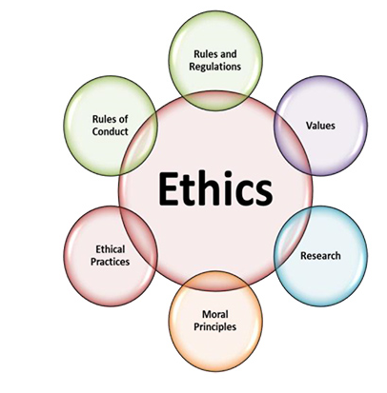

Figure 2.2 The relationship of codes of ethics and codes of conduct source: (Global Alliance, 2018).
Gill (2009) Identified that lower-level staff in accountancy felt that they are told what to do by staff higher than them and considered it a relief at times as it meant someone else was responsible for any mistakes and concluded that there was a lack of morality among the interviewees, the literature outlines that if ethical principles and behaviour have not been applied throughout their accounting careers then they could face ethical dilemmas and lack socially responsible when the time comes to becoming a senior accountant. The term ethical dilemma occurs in situations where a tough decision needs to be made which goes beyond moral principle of what is right or wrong (Trapp, 2011).

2.1.3 Ethical behaviour of individuals
The concept of ethical behaviour is perceived as what is good and what is right within the governing moral code, thus is usually driven by moral values. ICAEW (2019) suggest that all members should “demonstrate the highest of standards” and that “ethical behaviour plays a vital role in the reputation of the accounting profession” although Thomas (2018) notes that ethical behaviour of professional accountants cannot by any means be enforced based on ethical codes alone and claims that there is a demand for higher standards of behaviour from accountants and his research suggests that there should be more guidance available on ethical dilemmas through professional standards.
There are several factors that can hinder ethical behaviour of individuals, employees and businesses however, a major factor is time pressure to meet deadlines which can result in cutting corners especially in the accounting profession according to (Koh, et al., 2018) and which studies have then raised concerns on how it can impact ethical decision making.

2.1.3.1 Ethical decision making
Ethical decision making can be a complex process and can be influenced by individual factors or situational factors Crane and Matten (2016) have produced a framework for understanding the ethical decision-making process.
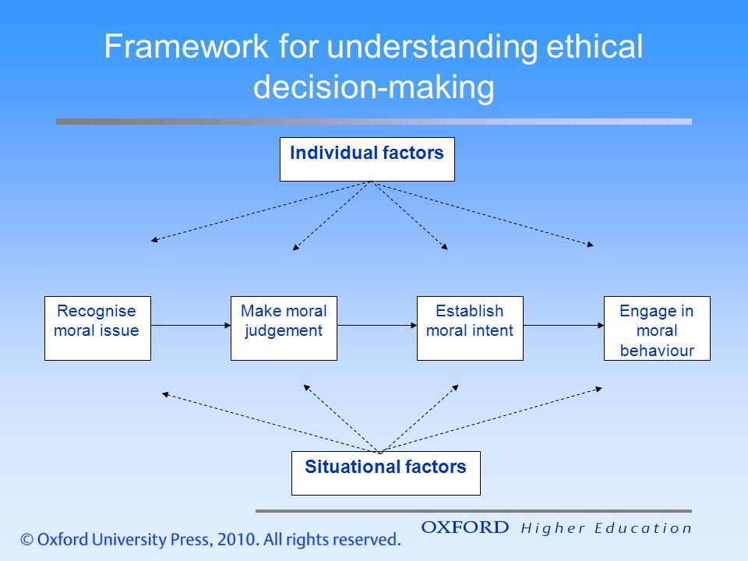

Figure 2.3 Framework for understanding ethical decision-making source: (Crane & Matten, 2016).
According to Crane and Matten (2016) framework individual factors that influence the ethical decision-making can be age, gender, experience or socialization whereas the situational factors such as reward systems, job role or the workplace culture are the most important to consider as it can result in making an unethical decision as in the accounting profession this may occur due to tight deadlines or pressure from clients. Although there seems to be a gap in current literature if there is any gender bias or if codes minimise bad practice.
Various research has outlined that in the accounting profession the application of ethical decision making has become a major social issue which has had an impact on the reputation of accountants (Flanagan & Clarke, 2007) however, Hall et al (2005) argues and has indicated that accountants should not need any sort of approval from others when it comes to making ethical decisions within the workplace due to their commitment and nature of their job within profession.
Although (Payne, et al., 2018) pointed out that accountants are pressurised constantly because of the lack of time. Kannaiah and Kumar (2009) found that accountants tend to have two decisions the first being to keep their clients and the second is to face losing them. However, for accountants or anyone for that matter to make better ethical decisions then there must be an element for some sort or morality or moral reasoning (Ghoshal, 2005). Decision-making for accountants can be difficult when facing ethical dilemmas with clients and can result in either pleasing clients or abiding to the professional code of ethics (Adams, et al., 1995). Whereas West (2017) suggests that accountants are applying Aristotle’s approach on ethics which lacks ethics of self-interest and morality.

2.1.4 Importance of morality for accountants
Morality and ethics are slightly different but are often perceived as the same thing however, this is not the case. According to Crane and Matten (2016, p. 8) “Morality is concerned with the norms, values, and beliefs embedded in social processes which define right and wrong for an individual or community”, whereas already identified that ethics is theory-based and focusses on rules and principles within professions.
Flanagan and Clarke (2007) recognised from literature that morality is very important as ethics would not be possible without morality as ethics is usually a reflection on morality, (Bostan, et al., 2011) in agreement suggest that accounting has a close relationship with ethics and morality and blames a lack of morality for bad ethical judgement, behaviour and decision making as seen in figure 2.3. Accountants must make moral choices based on the professional code of ethics and conduct and not on pleasing their clients and thus can cause conflict and ethical dilemmas as (Adams, et al., 1995) identified that accountants do not always make the right moral choice. The concept morality is formed on integrity, honesty and acting in good faith which is one of the fundamental principles related to accounting profession and thus is the reason why ethics and morals are an important factor in accounting (Yurt & Elitas, 2013).

2.1.5 Law and legislation
A substantial amount of literature has referred to the law and legislation having little effect on the accounting profession and the literature has identified that accountants are becoming increasingly unethical in judgement, behaviour and morality and have suggested that accountants bend the rules, commit fraud or cook the books which raises questions on the effectiveness of discipline procedures and the law.
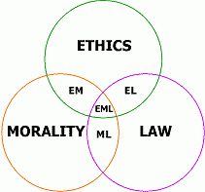
Ethics, morality and the law are all connected but differ from one another. To be unethical or unmoral is not illegal however if someone was to break the law that is illegal and will result in consequences. The law is a system of rules and regulations which governs the whole society and can enforce penalties to anyone who breaks the law.

Figure 2.4 Model of the relationship of Ethics, Morality and Law source: (Jawad, 2018).
Flanagan and Clarke (2007) have identified that morality, ethics and the law cannot be separated when it comes to such studies on the behaviour of professional accountants. Literature indicates that without the law being present or connected to morality and ethics then it would encourage bad ethical decisions, behaviour and judgement (Bostan, et al., 2011). The law is a big part within the accounting profession, accountants can face serious fines, lose their qualifications and or even imprisonment when it comes to financial fraud and that is why there is a Fraud Act in place in England and Wales (David, et al., 2018). However, several studies such as (Bora & Saha, 2016), (Caglio & Cameran, 2017), (Remenaric, et al., 2018) and (Thomas, 2018) suggest that professional bodies need to tighten disciplinary actions and procedures when accountants break the rules.

2.2 Accounting principles for professional accountants
The International Federation of Accountants (IFAC) report that they have “revamped” codes of ethics for professional accountants and became effective in December 2018 and further updates are effective in June 2019. The reason for doing this according to the IFAC is to serve the public interest and to promote high quality professional standards. There are five fundamental principles within the code of ethics for professional accountants and have a conceptual framework to ensure a better standard of ethical behaviour within the accounting profession (IFAC, 2018).
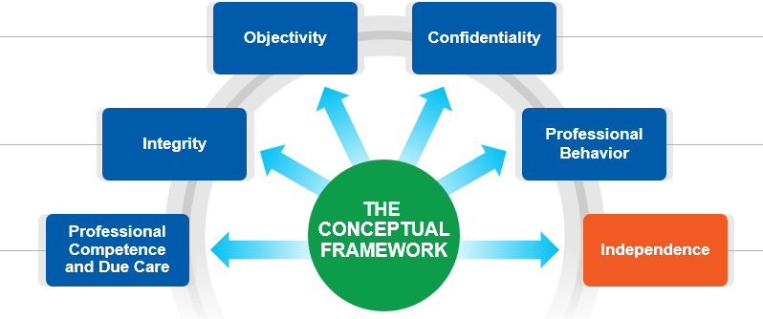

Figure 2.5 The conceptual Framework for professional accountants’ source: (IFAC, 2018).
The framework is a set of five principles that applies to all professional accountants who are members of this professional body with the addition of independence. The code of ethics and conduct for professional accountants within ACCA, CIMA, and ICAEW are all based upon IFAC code of ethics (see appendix 3).
However important the five key principles are within the code of ethics for accountants there seems to be a limited understanding and a lack of clarity on the effectiveness of principles within the codes of ethics or if accountants know what those principles are.
Payne et al (2018) and (Gill, 2009) all claim that no code of ethics no matter how strong or serious the penalties are will ever remove the pressure an accountant can face or to act unethically, this could be pressure from clients or bosses, greed or immorality. Furthermore, Flanagan and Clarke (2007) propose that such changes to codes of ethics from professional accounting bodies will not fix the problem as they realised that some accountants do not even know the code and unfortunately this will always attract criticism especially when the next accounting scandal occurs.
However, there is also a three-step approach which all accountants are required to apply when it comes to dealing with ethics and independence issues, The IFAC suggests that this approach helps to identify, evaluate and address any threats they may face in compliance with the fundamental principles within the code of ethics (IFAC, 2018) although there is no mention of training or practical support and suggest that if a threat cannot be addressed using the three-step approach then the only option for an accountant would be to decline or end the activity or service.
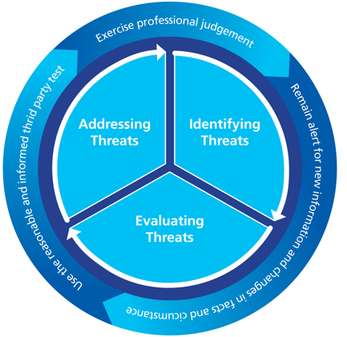

Figure 2.6 Three-step approach source: (IFAC, 2018).
Professional accounting institutes such as ICAEW, IFAC and IFA are trying to improve the code of ethics, frameworks to overcome ethical dilemmas and the behaviour of their accountants (Kannaiah & Kumar, 2009) although whether it will have an impact or not as it is evident than in previous years the code of ethics or ethical behaviour has been abused by professional accountants.
However, there seems to be no agreement on the effectiveness of codes between authors and researchers as (Flanagan & Clarke, 2007) argues that this implies that ethics is no longer seen as a positive but a negative hurdle to overcome especially when it comes to ethical decision making. Malhotra (2013) Indicates that it is more beneficial for accountants to be more ethically aware and claims this is “over and above” the rules, principles and regulation of accounting however many disagree with that (Thomas, 2018), (Payne, et al., 2018), (Bora & Saha, 2016) and (Adams, et al., 1995).

2.2.1 Accounting scandals
There have been many major accounting scandals, examples outlined in chapter 1 which have had a negative impression on the reputation of accountants and the profession itself (Gill, 2009). A large number of studies such as (Caglio & Cameran, 2017), (Gill, 2009), (Bora & Saha, 2016) and (Malhotra, 2013) have identified that accountants are facing huge ethical situations due to the number of accounting scandals that have risen in recent years and notes that the publics perceptions or trust of accountants have been majorly impacted. Gill (2009) suggests that accounting scandals are becoming the norm and that accountants who run the financial world cannot really be trusted. If such big companies can commit criminal and unethical activity it raises concerns on all accountants (Bora & Saha, 2016).
Research suggests that a way to reduce accounting scandals and help to improve the ethical behaviour, morals and ethical decisions of accountants would be to remove the concept of creative accounting due to accountants abusing the system which has impacted the reputation of accountants and their integrity and accountability within the finance world (Remenaric, et al., 2018), (Yurt & Elitas, 2013) and (Higgs-Kleyn & Kapelianis, 1999). Limitations that have been discovered within the current literature has concluded with a question of, do accountants even realise the importance of their responsibility in the profession or if they are breaking the accounting rules, standards and the code of ethics daily.

2.3 Conclusion of the literature review
This chapter has now achieved objective one:
To critically analyse previous academic literature on the rationale of self-regulatory codes within the accounting profession.
Also, in part of objective two:
To analyse the importance of self-regulatory codes on the ethical behaviour within the accounting profession.
In conclusion to this literature review, it is evident that there is a substantial amount of research on regulation, ethics and major principles within the accounting profession although having little effect on the behaviour of accountants (Payne, et al., 2018). Many studies focus solely on how accountants are responsible within the profession (Adams, et al., 1995) but there seems to be a lack of literature and studies on how ethical lower-level employees are within the accounting profession regarding a small business compared to how ethical senior staff such as managers or owners who work within the business.
Furthermore, there is a limited amount of research on the pressure employees in the accounting profession are currently facing when it comes to following accounting principles and professional codes of ethics whilst trying to please their managers or clients (Malhotra, 2013). Many studies such as (Caglio & Cameran, 2017), (Bora & Saha, 2016), (Malhotra, 2013) and (Gill, 2009) refer to major corporate accounting scandals and the lack of ethics for professional accountants whereas this dissertation has identified that there is a lack of studies that focus on the effectiveness of codes of ethics and the importance of ethical behaviour for accountants in smaller accounting practices. The next chapter seeks to identify the most suitable methodology that will be used to conduct primary research in relation to the gaps that have been recognised in the literature review.

Chapter 3 - Methodology

3.0 Introduction
The previous chapter achieved the first objective of this study and has demonstrated the importance of self-regulatory codes of ethics within the accounting profession. Also, the previous chapter identified and highlighted a gap in research on the effectiveness of codes of ethics and the importance of ethical behaviour of professional accountants. To provide a further understanding on these important but problematic key areas the purpose of this chapter aims to achieve the second objective of this dissertation:
To analyse the importance of self-regulatory codes on the ethical behaviour within the accounting profession.
To meet this objective the researcher identified the most suitable methods and methodology in order to conduct primary research. A mixed method approach was utilised with both an online questionnaire and interviews.
The method of primary research will be analysed using Saunders, et al (2016) Research Onion which provided guidance in understanding the importance of research and will aid the researcher in the process of identification and justification when choosing the research strategy, data collection methods and data analysis techniques best suited for this dissertation.
Research has been defined by Collis & Hussey (2014, p. 2) as ‘research is a systematic and methodical process of inquiry and investigation with a view to increasing knowledge’, another definition by Saunders et al (2016, p. 6) is research ‘a process that people undertake in a systematic way in order to find out things, thereby increasing their knowledge’. These definitions are both in agreement with one another as both have the same meaning when it comes research as it is an important factor to increasing knowledge or understanding and, in this study, contribute to a greater understanding of the effectives of self-regulatory codes in the accounting profession.

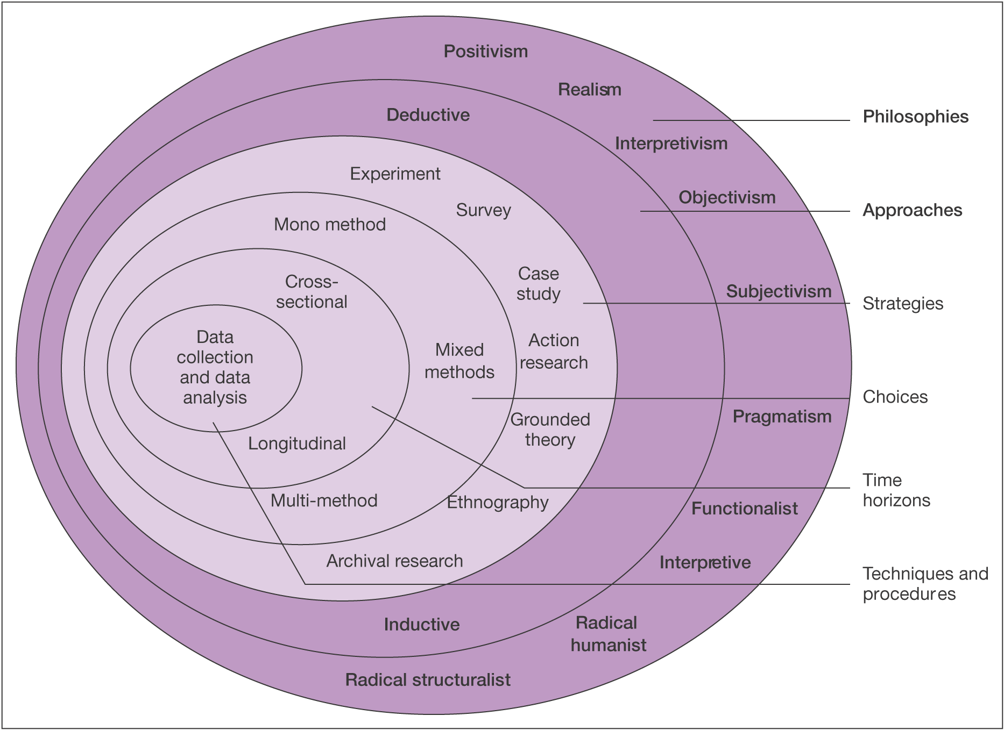
3.1 The Research Onion
Figure 3.1 The Research Onion Source: (Saunders, et al., 2016).
This research has identified a suitable methodology, which gives ground for the associated research paradigm required to collect and analyse primary data within the context of the effectiveness of codes of ethics for professional accountants. The primary data collected aims to gain a greater understanding on the codes of ethics for accountants and the perceptions of those who take part within the study (Saunders, et al., 2016). There is a paucity of academic research particular to the effectiveness of codes of ethics and the ethical behaviour of professional accounts. Based on this, further investigation is necessary to address the gap in current literature.

3.1.1 Philosophy
To create the research, the most suitable pragmatism view of philosophy has been selected upon (Collis & Hussey, 2014). To do so, the researcher used an analysis of paradigms carried out by Patel (2015) which has been formed by other sources such as Crotty (1998) and Scotland (2012) a long with Saunders et al (2009). The philosophies chosen for this research are positivism and interpretivism. A positivist approach will be used to analyse the closed questions in the questionnaire; interpretivism will be used to analyse the interviews and open-ended questions in the questionnaire.

3.1.2 Approach & strategy
There are two parts to data collection in this study. An online questionnaire was conducted and analysed first as this allows the results to then be used to explore in more detail with qualitative research therefore an explanatory sequential mixed method has been implemented. The results of the online questionnaire informed the interviews, which were undertaken in order to fill the gaps or uncertainties highlighted by the online questionnaire. First a questionnaire will be used as a primary data collection method as this will give a positivist approach which will enable the study to be replication to other researchers and there is not a need to be based on evidence (De Villers, 2012). This questionnaire a quantitative approach will allow the collection of data to effectively evaluate the research question posed (Sahay, 2016). Secondly, semi-structured interviews will take place with key participants who are involved in accounting practices as a means of purposive sampling and targeted at participants with a demographic and personal background within the research subject. This is an interpretive approach (Silverman, 2016)which has proven suitable for this dissertation as current problems have not yet been clearly specified. This approach adapts to an interpretivist theoretical perspective (Creswell, 2014) which enables the researcher to investigate and gain a perception into the subjective reality within the social phenomena (Dudovskiy, 2018). This has been recognised as an appropriate method of exploring and finding new information that can expand on previous research on this subject (De Villers, 2012).

3.1.3 Choice
The researcher has decided on a mixed method approach as this will allow to conduct both qualitative and quantitative research.
This research will require participants perspectives to be analysed using qualitative and quantitative research which the researcher will then triangulate as the strategy of combining a mixed method approach. (Grix, 2004, p. 135) defines triangulation as ‘a process in which the researcher uses two or more research methods to investigate the same phenomenon’.

3.1.4 Time horizon
The time horizon within the research onion indicates the time it can take to conduct research and data collection, as this is a short-term study the most appropriate time horizon would be cross sectional which would also enable further studies later if needed.

3.1.5 Techniques: data collection and analysis

3.1.5.1 Data collection
Saunders et al (2016) suggest that using multiple data collection methods enables to gather a wider understanding such as interviews can identify theme and any issues, and the questionnaires can address anything identified for further depth in the interviews. Using both qualitative and quantitative primary data collection methods then enables the researcher to triangulate the combination of methodologies in the study. The qualitative data will be collected using email interviews due to time constraints (Hawkins, 2018).

3.1.5.2 Survey design
A questionnaire is a predetermined set of questions used to collect data, which is a tool for collecting and recording information based on the objectives of the research and it is important to clearly define how the findings will be used (Denscombe, 2010). A questionnaire is the most used data collection tool in social science research as they are a method of collecting quantitative research in the form of numbers which can then be statistically tested (Saunders, et al., 2009).
The online questionnaire format consisted of fourteen closed questions and four open ended questions to ensure a rich depth of data could be collected, the reason for this is that (Creswell, 2014) suggests that survey results will be more successful if using mixed methods and can cut the time of completion which could attract more participants. Optional open-ended questions help to gather a deeper understanding and identify any themes which will help with the design of the questions for the interviews (Collis & Hussey, 2014). It was hoped that an online survey would be the most appropriate and valuable way to collect data on sensitive issues (Warren & Tweedale, 2002).

3.1.5.3 Pilot study
A pilot study was conducted in order to ensure that the primary research adopted the principles of reliability and validity, ensure it is ethically appropriate and demonstrated clarity to the user. This would allow questions to be amended or adapted (Saunders, et al., 2016). To test for clarity the pilot study consisted of a convenience sample to ensure that the online survey was appropriate for the intended participants.

3.1.5.4 Question and literature review matrix
Questions in survey | Relation to chapter two
Q1 Please tick the gender that best describes you?  Q2 How old are you?  Q3 What is your job role?  Q4 What is your length of experience in the accounting profession?  Q5 Please tick your qualifications | Questions 1-5 were all demographic which will help to gather relevant information on participants to then test using SPSS.
Q6 Do you have a code of conduct within your workplace? | Importance of codes L’etang (1992)  Perception of codes Payne et al (2018) Codes in the accounting professional bodies ACCA, CIMMA, ICAEW  Figure 2.2 relationship of code of ethics and conduct Global Alliance (2018)
Statement question Q7:  Voluntary codes reduce the incidence of fraud in the accounting profession,  Self-regulation is not enough | Codes, principles and regulation for professional accountants (ICAEW), (ACCA), (CIMA)
Statement question 7:  Accounting scandals have had a negative impact on the reputation of the accountancy profession | Accountants are facing ethical issues and poor reputation because of accounting scandals Caglio & Cameran (2017), Gill (2009), Bora & Saha (2016) and Malhotra (2013)
Q8 In your opinion, what measure or measures would reduce the incidence of fraud in the accounting profession? | Regulation for professional accountants Carroll and Buchholtz (2009)  Curbing creative accounting Malhotra (2013)
Statement question 8;  I have never faced an ethical dilemma,  I think I could behave more ethically in the accounting profession  I have observed unethical behaviour in the accounting profession | Ethical decision-making framework Crane and Matten (2016)  Accountants are unethical in decision making Flanagan and Clarke (2007), Hall et a (2005), Kannaiah and Kumar (2009), Adams et al (1995), West (2017)  A Model Code of Ethics for Decision Making in Accounting Professions Payne et al (2018)
Q9 Please select all the following reasons which you think make the accounting profession liable to fraud | Code of ethics for professional accountants IFAC (2018)
Q10 Which of the following principles do you know and understand in the code of ethics? | Code of ethics for professional accountants IFAC (2018)
Q11 In relation to Q10, which do you think is most important principle and why? | Morality and Ethics of Accounting Yurt & Elitas (2013)
Q12 Please tick your agreement with the following statements (5 principles within the code of ethics) | Curbing Creative Accounting: Role & Effectiveness of Ethics Malhotra (2013), Professional Responsibility and Ethics in Accounting Thomas (2018)
Q13 What do you think would keep accountants honest? | Beyond a Code of Professional Ethics: A Holistic Model of Ethical Decision-Making for Accountants Flanagan and Clarke (2007)
Q14 Have you ever observed unethical behaviour by others? | Three-step approach for accountants to apply when dealing with ethical issues IFAC (2018)
Q15 Being part of a professional accounting body provides me with the guidance I need | Self-regulation accounting bodies model appendix 2 adapted from Johnson (2016)
Q16 which do you think would help accountants to be more ethical? | Government regulation, education and training, guidance from self-regulating accounting bodies; ICAEW, CIMA, ACCA, IFAC, FRC
Q17 Can you match each term to the correct definition? (code of ethics, code of conduct, code of practice) | Codes Le’tang (1992) Regulation, self-regulation, law, codes of ethics for accountants
Q18 How important are ethics for you in the decision making in the accounting profession? | Ethical decision-making framework Crane and Matten (2016)  Accountants are unethical in decision making Flanagan and Clarke (2007), Hall et a (2005), Kannaiah and Kumar (2009), Adams et al (1995), West (2017)  A Model Code of Ethics for Decision Making in Accounting Professions Payne et al (2018)
Q19 Any questions or comments relating to the issues in this survey would be very welcome | This open-ended question will be analysed in relation to any themes that have arisen, and it is hoped that it will contain qualitative answers.
Table 3.1 Questions in the questionnaire relating to chapter two the literature review

3.1.5.5 Interview design
The researcher conducted three interviews, who have been purposively selected as expert participants with experience in the accounting profession. All three of them via email in order to provide a rich, interactive interview with respondents who are busy and would prefer to answer one question at a time (Hawkins, 2018).

3.1.5.6 Analysis
To analyse the quantitative data collected from the online questionnaire will be of a numerical form and the researcher will use SPSS version 25 and statistical analysis of the quantitative closed questions using a Likert scale. The open-ended questions will be analysed using a thematic approach to seek out any common themes, trends or patterns. The qualitative data will be collected using semi-structured interviews will firstly, be transcribed and then analysed to look for any common themes, current trends or patterns. The transcripts and full resources can be found in the appendix 4, 5 and 6. Using both qualitative and quantitative primary data then enables the researcher to triangulate the combination of methodologies in the study.

3.2 Sample
A purposive sample is one that is non-probability as the researcher uses their judgement to select participants who are involved with their topic (Saunders, et al., 2009). Due to the nature of the research project, to collect the most relevant and credible primary data the participants were purposively selected upon as professionals within the accounting industry through various social media platforms such as LinkedIn and contacting professional accounting bodies such as ICAEW. Collis and Hussey (2014) suggest that having a poor sample or one that is inaccurate can result in a measurement of data that can be misleading and therefore the research would not be valid. Therefore, the online questionnaire is hoped to have a larger sample size containing quantitative data compared to the smaller sample size of the semi-structured interviews with qualitative data. The total population of professionals working in the profession is globally large therefore, links to the online questionnaire were posted on the researchers professional LinkedIn account. Collis and Hussey (2014) suggest that due to time constraint of the study, the sample size needs to be feasible and therefore the sample chosen was a minimum of one hundred people which is more than adequate however, there were one hundred and sixty-seven participants.

3.3 Reliability and validity
Validity has been defined as ‘validity is an integrative, evaluative judgement of the degree to which empirical evidence and theoretical rationales support the adequacy and appropriateness of inferences and actions based on test scores and modes of assessment’ Invalid source specified.. Thus, is another reason for the pilot study with the online survey and, why the researcher decided to use a mixed method approach to ensure that primary data will be of great validity. Collis and Hussey (2014) suggest to get more validity when collecting data is to do more than one method and is the reason for the online surveys and semi-structured interviews.
Reliability refers to how reliable is the data and if the primary data was to be repeated then the outcomes should always be approximately the same and the results should be consistent (Lodico, et al., 2010). The reliability and validity of primary data has been selected by the researcher carefully which has a purposive sampling procedure and will only consist of professionals within the accounting industry and has assessed that the data collected will be of a creditable, valid and reliable source to ensure it is accurate with the aims and objectives of the research explains (Saunders, et al., 2009).

3.3.1 Triangulation
‘Triangulation involves the practice of viewing things from more than one perspective’, (Denscombe, 2010, p. 346).
Data Triangulation is also another technique chosen for this dissertation to ensure more validity and reliability in the primary data and can minimise the chances of any biased findings as the data can be observed from different angles and thus will give more accurate findings and conclusions (Grix, 2004).
Denscombe (2010) suggests that methodological triangulation allows the findings from mixed methods to be contrasted, compared, or even combined, findings from one method that being an online questionnaire could find something new or different to explore further in the other method of face-to-face interviews.

3.4 Limitations
Firstly, one major limitation within this dissertation is the amount of time needed to access essential resources and to collect primary research and analyse the data. To minimise this limitation, the researcher has provided a Gantt chart which will also improve the management of time.
Secondly, another limitation is the measurement of validity in evaluating secondary data as it might fail to provide any valid answers or meet any objectives within the research (Saunders, et al., 2009) and thus is why the researcher has decided upon a mixed method approach.
Thirdly another limitation the researcher could encounter is that the intended participants may not want to participant in the interviews or take part in an online questionnaire however, to reduce this limitation the researcher has decided to use a number of social media platforms such as LinkedIn to reach out to professionals In the accounting industry.
A limitation that the researcher came across was that a participant commented on the wording of one particular question, the question was please select all of the following reasons which you think make the accounting profession liable to fraud? their suggestion was that liable was not quite right and suspectable would have been a better suited word.

3.5 Ethical considerations
Ethics is a vital element that needs great consideration for anyone who is conducting research as it refers to the formation and rationale of the research topic, the design of research, data collection, process and the storage of data and research findings must be completed in a responsible and moral way (Saunders, et al., 2009).
Saunders et al (2009) explain that no research should cause harm or risks to participants intended or not and careful consideration should be taken to ensure interviews and questionnaires do not cause the participant to feel stressed nor should questions be intrusive. The UWTSD ethics forms required approval from the supervisor and co-ordinator and was approved. The online questionnaire clearly facilitated passing ethics protocols because of the anonymity and confidentiality provided by online questionnaires.
The research that will be conducted should not raise any concern with ethical risk due to all the participation being voluntary and over the age of eighteen. The surveys and interviews were intended for participants who have a professional career in accounting or involved within the accounting profession. Participants can withdraw at any stage if they wish too. However, all the data that does get collected will be confidential and all participants will be kept anonymous. The data collected will be saved correctly and password protected.

3.5 Conclusion
To conclude, this chapter has successfully identified and explained the research methodology and completed the second objective. The justification of the pragmatic mixed methods that will be used in this study have been clearly explained. Chapter four hopes to collect, analyse and present the findings from the data collection gathered by the methods that were identified in this chapter.

- Data analysis

4.0 Introduction
Chapter three consisted of the methodology for the primary research and was clearly defined. This chapter seeks to contribute towards fulfilling the aim of this dissertation which is to provide a critical analysis of the effectiveness of codes of ethics in the accounting profession.
The purpose of this chapter is to analyse the data that has been collected through mixed methods present the findings to achieve objective two:
To analyse the data collected to understand the effectiveness of self-regulatory codes on the ethical behaviour within the accounting profession.
Data collection was sequential and accordingly, this chapter will analyse and present findings from first the online questionnaires and second the interviews. The survey was distributed to approximately six hundred people however the total number of responses was one hundred and sixty-seven therefore the response rate was 28% which according to (Collis & Hussey, 2014) is a successful response rate. Whereas with the interviews there were three out of a possible of five participants.

4.1 Data analysis
Data analysis is referred to the organisation and sorting of the data that has been collected, in order that data can be categorised, so it becomes more manageable and patterns or themes will naturally arise (Collis & Hussey, 2014). The analysis was mindful of the aim and objectives of this dissertation.

4.2 Methods
Online questionnaires produce quantitative data and an appropriate method of analysis is to statistically test the data using SPSS. The analysis was grounded as a positivist approach using a mix of statistical tests; the independent samples t-test and crosstabulation using Pearson’s Chi-Square test of independence. The purpose of the independent samples t-test is to compare the means of two sets of values from one variable to see if there is a statistically significant difference in two unrelated groups (Griffith, 2010). Whereas the Pearson Chi-Square test is a nonparametric test which determines if there is an association between variables, results of this test will suggest that variables are independent or related (Owen & Jones, 1992).
The researcher was faced a challenge with the data to ensure that the quantitative data could produce purposeful information in the most appropriate way for the analysis and presentation and subjective decisions were made as the number of ‘non-binary’ (1) and ‘self-describe’ (3) in the gender demographic question were too small or diverse to be anything of meaningful, both were not used in the analysis of statistical testing however their responses will be used in analysing any qualitative data. DeCoster (2004) suggests that this is common for most in the analysis process to ensure that the presentation is clear. Doig and Groves (2006) explain that one of the requirements of research is to ensure the presentation of results are understandable, reliable and valid.

4.3 Demographics
This question was posed because the researcher was interested to see if gender had any impact on the perceived effectiveness of self-regulatory codes in the accounting profession. Due to gender research becoming more complex based on societal changes, this proved to be a difficult question (Runnels, et al., 2014). However, for the purpose of this chapter, there were 56% of participants were identified as female and 44% who identified themselves as male. The figures represent that in this study there are more females than males in the profession.

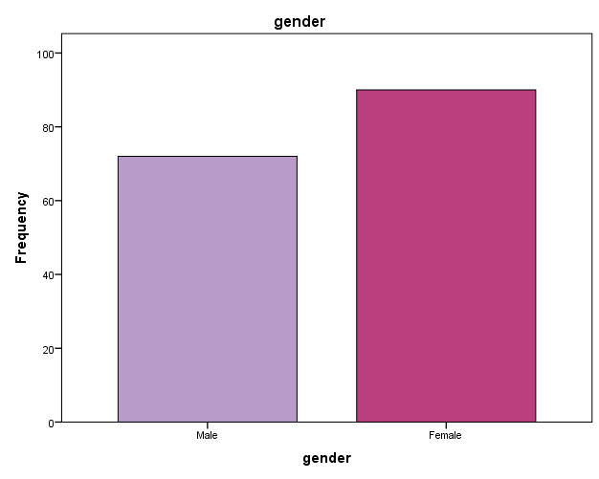
Figure 4.1 Graph of gender identification

To use SPSS, quantitative data needed to be coded into nominal categories such as male = 1, female = 2 (Stephen, 2015). There were lots of Likert scale questions and therefore the coding for these possible answers were strongly disagree = 1, disagree = 2, neither agree nor disagree = 4 and strongly agree = 5. Any questions which allowed multiple answers resulted in every possible answer to be split into variables, not chosen = 1, chosen =2 (Wuensch, 2002). Results before coding can be found in appendix 5.
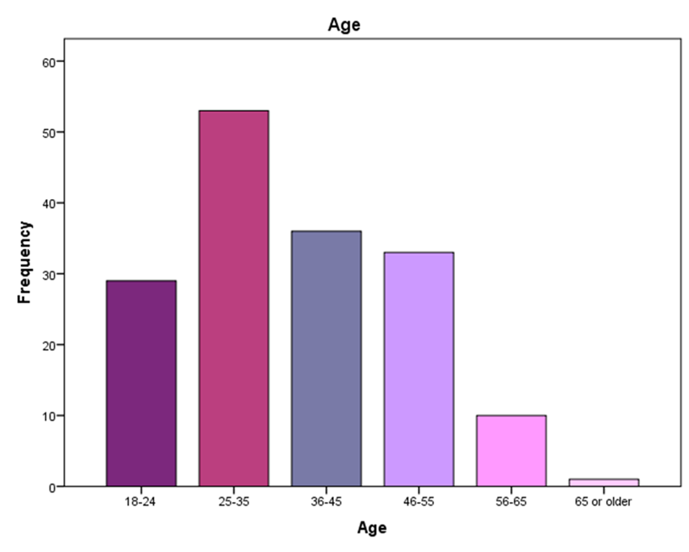
Question two asked respondents to specify which age bracket they belonged to. A crosstabulation analysis was conducted to see if that older participants have more of less agreement with the importance of ethics however, a crosstabulation analysis revealed that all ages agreed or strongly agreed (Crane & Matten, 2016). See table 4.1.

Figure 4.2 Age classification results

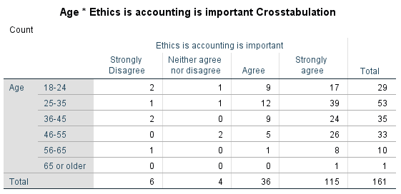

Table 4.1 Crosstabulation analysis of age and importance of ethics.

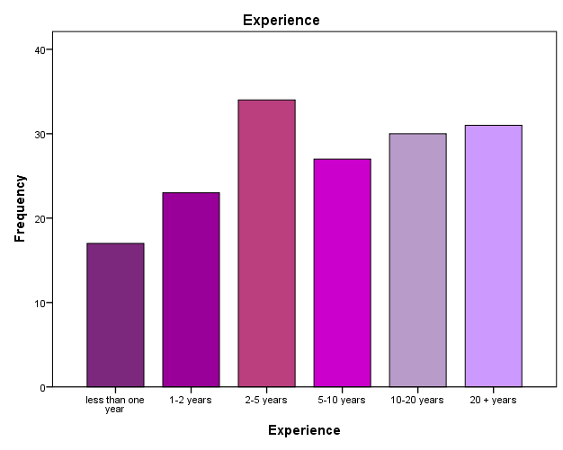
Question four was based on the respondent’s experience within the accounting profession see figure 4.3. The top three were 2-5 years, 10-20 years and 20+ years however, there was not much difference in frequency between all six possible categories.
Figure 4.3 Graph of possible years of experience.

4.4 Codes of conduct
Question six was significant because as discussed in chapter 2, codes have an effect on the ethical standards and behaviour that is required from professionals in the accounting profession (Green & Weber, 1997). Trapp (2011) suggested that codes of conduct are very important as they govern the behaviour of individuals. The question asked participants if they have a code of conduct within their workplace there was a total of 22% who picked no, unsure or other.
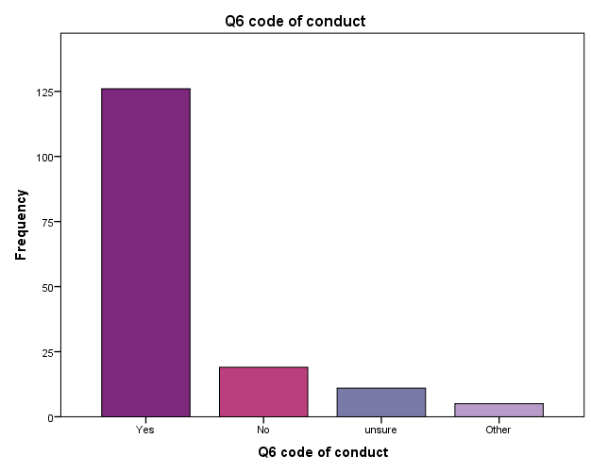
Figure 4.4 Graph defining if respondents have a code of conduct in their workplace.

4.5 Independent T Test

4.5.1 Gender and fraud in accounting
Question seven consisted of ten statements on a Likert scale based on ethical conduct of accountants however only the top five important were selected for testing regarding fraud and accountants abusing the creative accounting concept. The hypothesis for this test was;
- H1 accounting professionals regard ethical conduct in the accounting profession as important.
- H0 accounting professionals do not regard ethical conduct in the accounting profession as important.
The most appropriate test for this is the Independent Samples T Test. To find out if the results of the test are significant or not the researcher must calculate the p-value, 0.5% or lower would result in rejecting the null hypothesis because it would mean that there is a statistically significant difference has occurred if it is greater than 0.5% then there would be no significant difference between two variables (Griffith, 2010). The results in table 4.2 show that only one of the five were significantly different between genders the Sig. (2-tailed) or P-value was 0.026% which is less than 0.5% the therefore the hypothesis was rejected however, the other p-values were greater than 0.5% and therefore the test has proved that there is no significant difference, so all accounting professionals regard ethical conduct as important. 40 participants agreed or strongly agreed that creative accounting is acceptable whereas chapter 2 identified that accountants use creative accounting principles to abuse the code of ethics and fiddle the books (Malhotra, 2013), (Bora & Saha, 2016) and (Remenaric, et al., 2018). 71 selected that only serious penalties will reduce the incidence of fraud (Thomas, 2018).
108 participants agreed or strongly agreed that accounting scandals have had a negative impact on the reputation of the accounting profession, this was identified in chapter 2 (Higgs-Kleyn & Kapelianis, 1999), (Yurt & Elitas, 2013) and (Caglio & Cameran, 2017) . See appendix 7 for the frequencies of the answer.
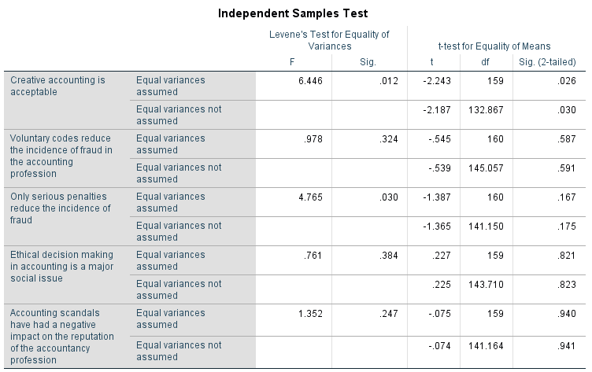

Table 4.2 Independent T Test of gender and fraud in the accounting profession.

4.5.2 Gender and reasons that make the accounting profession liable to fraud
This question was very interesting as there was no requirement to answer as all questions were optional. There was an option for other comments not one participant mentioned that the accounting profession is not liable to fraud, what was surprising is that each possible option had been picked at a minimum of 80 times. 110 out of 162 participants selected that the reason accountants are liable to fraud is the undue pressure from their superiors, 112 selected that it is down to bribes and 114 selected that it is due to conflict of interest which is principle 2 of the code of ethics for professional accountants (IFAC, 2018) which suggests that accountants are breaking their code of ethics and not following the rules and regulation (Flanagan & Clarke, 2007), (Payne, et al., 2018) and (Adams, et al., 1995).
Table 4.3 below has identified that there was only one significant difference between gender and reasons for the liability of fraud and that was manipulation of information the Sig.(2-sided) P-Value is 0.014% which is lower than 0.05% over double the amount of females chose that answer compared to males so in this instance the null hypothesis is correct however, there is no significant difference with the other variables and gender.

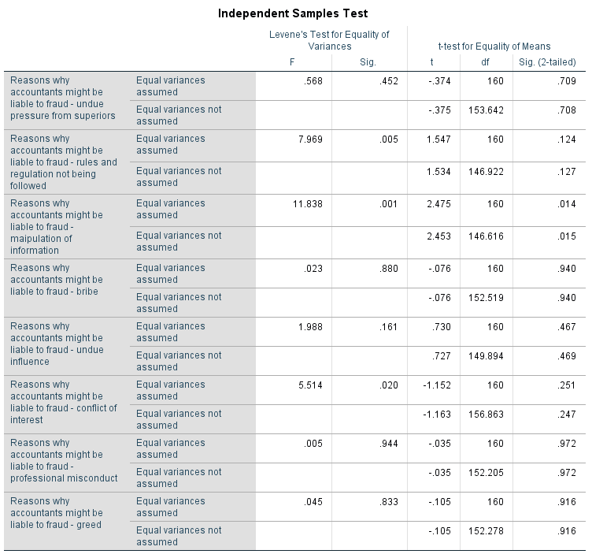

Table 4.3 Independent T Test of gender and reasons why accountants are liable to fraud.

4.6 Crosstabulation analysis and Chi-square tests

4.6.1 Gender and pressure to falsify accounts
The statistical results in table 4.2 shows that 20 agreed or strongly agreed that they have been put under pressure to falsify accounts.

Gender * I have been put under pressure to falsify accounts Crosstabulation
Count
 |  | I have been put under pressure to falsify accounts |  |  |  |  | Total
 |  | Strongly Disagree | Disagree | Neither agree nor disagree | Agree | Strongly agree | Total
Gender | Male | 27 | 22 | 10 | 9 | 2 | 70
Gender | Female | 43 | 27 | 10 | 5 | 4 | 89
Total |  | 70 | 49 | 20 | 14 | 6 | 159

Table 4.4 Crosstabulation analysis of gender and if they have been put under pressure to falsify account.

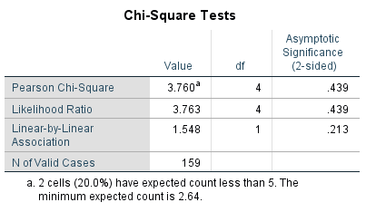

Table 4.5 Chi-Square test gender and pressure to falsify accounts
The test results for the Chi-Square test show that the Sig. is greater than 0.5% at therefore, the original hypothesis lies as there is no statistically significant difference.

4.6.2 Gender and observation of unethical behaviour
Question 14 asked if respondents had ever observed unethical behaviour by clients, colleagues, superiors, regulators and practitioners outside the organisation. Below are the most important results from the Crosstabulation and Chi-square test.
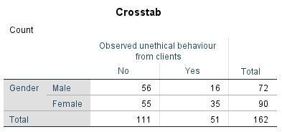

Table 4.6 Crosstabulation analysis of gender and unethical behaviour from clients.
In the table 4.3 above it shows that there were 19 more female who have observed unethical behaviour compared to males. Therefore, it is likely that the Pearson Chi-Square test will reject the original hypothesis.
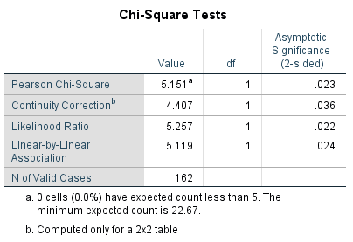

Table 4.7 Chi-Square test gender and unethical clients.
In table 4.6 the statistics show that the Sig.(2sided) is 0.023, which is lower than 0.05 therefore the researcher will reject hypothesis 1 as statistically there is a significant difference between genders. The statistical tests for the other possible answers all accept hypothesis 1 that being that there would be no significant difference in gender. The results can be found in appendix 7. What has been found is that the top three that were chosen was clients, colleagues and superiors who have been seen behaving unethically in the accounting profession this relates to (Gill, 2009) findings that lower-level or less experienced accountants will follow the unethical behaviour of superiors. Two females suggested that they have observed unethical behaviour from regulators such as HMRC, as HMRC are the ones who regulate the profession this is unacceptable.

4.7 Analysis of qualitative data collected from online surveys
To analyse the open-ended questions from the online survey the researcher decided to use NVivo as it provides several tools that can assist with the analysis of qualitative data and the interpretation of rich data to identify themes and patterns (Jackson & Bazeley, 2019).

4.7.1 Ways to reduce fraud
The use of NVivo text search query identified that the most common theme for a measure to reduce the incidence of fraud was penalties which can be seen in figure 4.5. This finding suggests that there is a need for tougher, harder, stronger and harsher penalties, laws and regulation from regulatory accounting bodies for those accountants who commit fraud or fiddle the books. This was outlined in chapter 2 so the finding is consistent with what the literature that was identified.
This is a factor which links in with objective 2 analysing the importance of ethical behaviour because all participants are professionals in the accounting profession and are all aware of the unethical behaviour within the profession. This also links in with several studies outlined in chapter 2 that professional accounting bodies need to tighten disciplinary actions and procedures (Caglio & Cameran, 2017), (Remenaric, et al., 2018) and (Thomas, 2018).
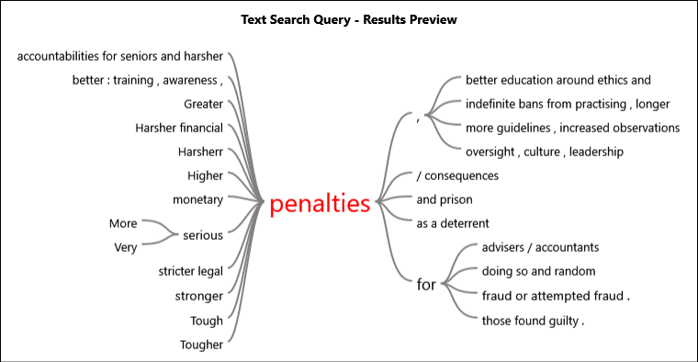

Figure 4.5 Most frequent answer to reduce fraud (Online survey data, 2019).

4.7.2 The most important principle
Using NVivo to run a high-level word cloud on question 11, what is the most important principle in the code of ethics identified integrity as being the most important principle and further comments suggested that this promotes honesty, morality, reputation and underpins the other principles within the official code. See figure 4.6.

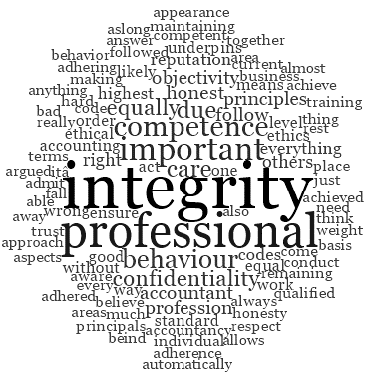

Figure 4.6 High level word cloud of accounting principles (Online survey data 2019).

4.7.3 Reasons why the accounting profession are liable to fraud
After running a text query analysis on the node reasons why accountants are liable to fraud (see figure 4.7) the most common theme was the undue pressure from superiors followed by rules and regulation are not being followed correctly this suggests that there is a lack of ethical behaviour from those who are higher up in the profession and accountants are pressurised into becoming liable to fraud. Although participants agree with the importance of ethical behaviour, 99% answered the question on the liability of fraud.

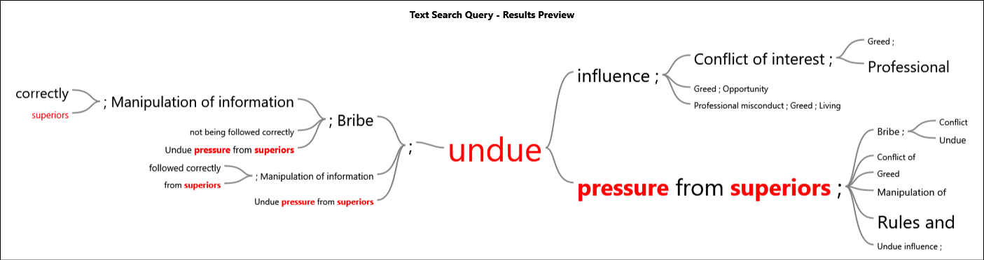

Figure 4.7 Text query analysis on reasons for fraud (Online survey data 2019).

4.7.4 Analysis of qualitative data collected in the online survey
Theme | Issue | Participant | Participant | Participant | Participant | Participant
Unethical behaviour | Targets, bonuses, pressure, fraud, Scandals | Participant 15 – “When I read about the sales scandal at Wells Fargo, I can’t help but think about the people who naively designed the incentive schemes that triggered this type of unethical behaviour”,  “In short, I see the strong connection between unethical business practices and accounting techniques” | Participant 19 – “It’s hard to maintain ethics when the real problem is discrimination” | Participant 47 – “unfortunately unethical behaviour in accounting will always exist when there are financial targets to be met and bonuses which are reliant upon them” | Participant 51 – “the number of fraudulent claims, which the accounting profession is growing, due to unethical behaviour” | Participant 120 – “Where this trust from the public has been wilfully broken by accountant’s intent on fraud then the punishments should be severe”.
Audits | Lack of audits, auditors aren’t liable, conflict of interest. | Participant 15 -” When I hear about the complex transfer pricing schemes at companies such as Amazon and Starbucks that enable them to avoid tax, I start wondering which accounting techniques they used” | Participant 17 – “Fraudsters don’t play on moral weaknesses, greed or fear; they play on weaknesses in the system of checks and balances – the audit processes that are meant to supplement an overall environment of trust” | Participant 40 – “If an accounting firm were to botch one audit or help insiders cook the books, that firm would jeopardize the dozens or hundreds of auditing assignments it got”, “conflict of interest created when they both audited and consulted to the same company” | Participant 47 – “A bigger worry to me personally is the audit profession. They exist to provide reasonable assurance to shareholders yet are not liable for combating fraud. Accountants are also not liable so there is a grey area which is often abused”
Codes of ethics | Lack of codes, need more than codes of ethics, lack of ethics. | Participant 15 – “. It is important to take that step back occasionally, to reflect on the ethics of the technics”. | Participant 43 – “Harris et al. summarize Stephen Unger's analysis of the possible functions of a code of ethics: "First, it can serve as a collective recognition by members of a profession of its responsibilities. Second, it can help create an environment in which ethical behaviour is the norm. Third, it can serve as a guide or reminder in specific situations…Fourth, the process of developing and modifying a code of ethics can be valuable for a profession. Fifth, a code can serve as an educational tool, providing a focal point for discussion in classes and professional meetings. Finally, a code can indicate to others that the profession is seriously concerned with responsible, professional conduct." (p. 35). So, to sum up - accountants should be proud of their work as a PROFESSION and secondly, we need law not just codes”. | Participant 70 – “I think ethics should play a bigger role in the accounting profession than it currently does. Too many of the big firms put profits ahead of thorough scrutiny and that is where much of the problems lie”. | Participant 82 – “Being an accountant is a privilege and carries obligations, you are expected to act in line with a code of ethics and remain completely independent throughout all assignments and never be compromised”. | Participant 148 – “Integrity is vital to keeping the good name of an individual accountant. A good name will keep existing clients and lead to more client recommendations”.

Table 4.8 Thematic analysis of qualitative data.

The themes in figure 4.8 were identified by occurring words analysed in NVivo.
Findings:
The first theme was unethical practices and wrongdoing, participants suggested that unethical behaviour will always occur in the accounting profession due being under pressure from clients and or superiors to meet targets (Kannaiah & Kumar, 2009) or to get their bonuses this can lead to cutting corners or produce misleading information (Payne, et al., 2018) and having a lack of morality (Bostan, et al., 2011).
The second theme is the necessity for regular and robust audits, participants suggested that there is a lack of audits on the accountants who are handling the accounts of others. One participant suggests that auditors and accountants are not liable and therefore this is a grey area which needs to be changed. Another comment was that there is too much conflict of interest which suggests that the code of ethics is not being followed correctly. One participant has questioned the accounting techniques used in order for scandals to avoid paying tax in relation to chapter 2 this supports other studies to remove creative accounting as it is a tool that allows accountants to fiddle the books (Bora & Saha, 2016), (Malhotra, 2013), (Remenaric, et al., 2018) and (Gill, 2009).
The last theme was the ineffectiveness of codes, although already identified that code of ethics are very important participants suggest that the profession need more than just codes perhaps better laws. One participant suggests that ethics should be playing a much bigger role than it already does and the importance of the code of ethics such as integrity which promotes the reputation of accountants and that accountants need to remain independent.

4.8 Themes from the online questionnaire
Three themes have emerged from the analysis of the online questionnaire. The first one is that the code of ethics is considered as an important factor within the accounting profession however, the findings support that ethics is not as effective as it should be as there seems to be a limited understanding on codes of ethics, conduct and practice. Some participants suggested that they did not or were unsure if they have a code of conduct which outlined in chapter 2 is important as this governs the behaviour of individuals also, question 17 of the online survey asked participants to match the correct definition to each three codes. As you can see below in figures 4.9, 4.10 and 4.11. Only 84 selected the correct answer for codes of ethics. 122 participants got the code of conduct and practice incorrect out of a total of 157 answers.
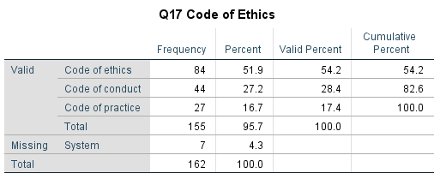

Table 4.9 Frequency analysis on the codes of ethics
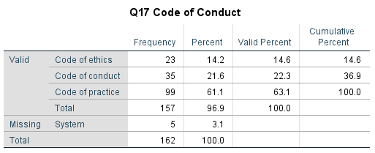

Table 4.10 Frequency analysis of code of conduct

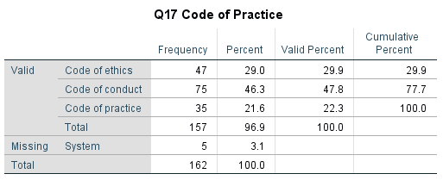

Table 4.11 Frequency analysis of code of practice
Another reason why ethics are ineffective is down to the unethical behaviour that accountants are observing from their clients, colleagues and superiors. The analysis identified that most accountants are under pressure to cut corners due to tight deadlines which would mean that the code of ethics is not being complied with.
The second theme that has been identified is that it is likely that unethical behaviour would lead to fraudulent activity which is ruining the reputation of any decent accountant. Findings suggest that this is down to the rules, regulation and accounting techniques such as creative accounting being abused in order to make information look more attractable and misleading. Along with undue pressure from superiors, greed and being bribed to commit fraud.
The third theme was identified as needing stronger regulation and laws. As already discussed, ethics has been identified as being very important but not effective, the findings suggest that there needs to be tougher and more penalties for those accountants who wish to act unethical and abuse the code of ethics. Participants suggest that there needs to be better ethical education, training and support from accounting regulation bodies to overcome the negative impact from accounting scandals and improve on the ethical situation within the profession.

4.9 Matrix analysis of qualitative data from interviews
Questions | Theme | Participant 1 | Participant 2 | Participant 3
Q1. Please state your gender |  | “Male” | “Male” | “Male”
Q2. The accounting profession have regulatory codes, in your opinion, what are the reasons for these codes? | Code of Ethics | “To ensure accountants abide by the rules” | “I believe these regulatory codes are put in place to ensure that accounting procedures are carried out as ethically as possible. Obviously not all abide by the regulatory codes, however the existence is somewhat a deterrent for unethical procedures”. | “These codes are designed to serve as guidance in ethical dilemmas any accounting professional might face. They form a basis of my ACCA studies and run through almost every exam I am taken. It helps to keep the accounting profession in high regards in the public eye and serve as measure to judge against in case of any misconduct. These codes should be followed by everyone working in the accounting profession”.
Q3. The profession has been impacted by several scandals, first why do you think these scandals happen and going forward how can the profession prevent such problems? | Poor regulation | “These scandals have happened as there is not enough checks done on the quality of the work, therefore more checks need to be implemented” | “I believe that the scandals that have happened have been mainly due to the laid-back nature in the monitoring of the codes. A closer eye should be kept upon accountancy firms and more stringent regulations should be put in place”. | “Scandals always happen because every human has flaws. Most of these happen because people saw opportunity for misconduct and had no ethical/ moral principles to stop themselves from exploiting these situations. It’s difficult to prevent such instances but the accounting profession itself needs to promote and instil these fundamental codes of conduct in its members. Especially of chartered accountants. Anyone found to breach these fundamental codes of conduct should face consequences- it most severe cases struck of as being chartered and criminal investigations should happen if found they have broken the law”.
Q4. There are 5 principles in the regulatory codes, Integrity, Objectivity, Professional competence and due care, Confidentiality, professional behaviour, in your opinion which principles do you think are most important and why? | Honestly and personal morality is very important. | “The most important are integrity, confidentiality and Professional Competence” | “I believe all of these principles are very important, however more emphasis should be put on integrity as it has not been exercised enough and has been the root cause of the scandals”. | “This is a difficult question as I see all 5 of them going hand in hand. If pushed, I would say integrity as the underlying basis of all. Acting with integrity would always ensure you try to do your best and the best for the people you work for”.
Q5. What types of regulation of the accounting profession do you think are needed going forward? | More observations and audits. | “Better checks on accountants” | “As mentioned previously the monitoring of the integrity of accounting firms is paramount”. | “This is hard to answer. Auditors have come under increasing pressure with the recent scandals like Carillion collapse. But I believe a higher emphasis needs to be put on corporate governance. If a company s not following proper corporate governance rules, then even the auditors can’t prevent it collapsing. Perhaps corporate governance could have adapted rules for smaller, non-listed companies to prevent power grabbing at the top that can easily happen in the smaller companies that are run by less directors or where the directors are also major shareholders”.
Q6. Regulatory codes come in the form of codes of conduct, codes of ethics and codes or practice - what do you think distinguishes each type of code from the other? | Lack of fully understanding codes. | “Code of conduct relates to the behaviour of the Person  Code of ethics is doing the right thing  Code of practice is abiding by the law” | “I believe they tend to deal with a different aspect of the profession. Codes of conduct tend to deal with social norms, whereas codes of ethics, tends to deal with rules regarding integrity and honesty. Finally, codes of practice are to do with the employers and employees’ responsibility to uphold a set of expected values”. | “Conduct would be more personal behaviour. Ethics would be underlying in a country’s culture and practice would be unique to the accounting profession”.
Q7. Why do you think the accounting profession is susceptible to unethical behaviour? | Undue pressure from superiors. Link between ethical behaviour and fraud | “Because that is the nature of people in general if they think they can get away with it” | “I believe that there is a great amount of leniency on accounting firms as they tend to be very helpful in profiting big corporations and therefore governments as well. Monetary gain of a large scale is always synonymous with unethical behaviour”. | “With accountants having access to systems like cash/ banks and accounting software, they can easily spot the weaknesses and work around control deficiencies. Unethical people would be able to exploit this especially if managers/ more senior staff are not checking correctly or are actually the ones doing it and then use their power and influence to intimidate people”.
Q8. If compliance with regulatory codes is judgement-based, how best can the profession ensure that accounting professionals are best equipped to make the best choices? | Better education and training, more observations and audits. Overall stronger regulation. | “You have to rely on the people involved to make the best choice” | “Seminars and different ways of education the employees within the profession would be the first step. It would also be beneficial to review certain choices to see if they comply with regulations. Giving feedback is also very beneficial”. | “This judgement-based approach needs to be instilled from the very beginning. IT needs to be taught in accountancy courses and the basis of judgement needs to be professional scepticism and confidence in one’s knowledge”.
Q9. In your opinion what are the ethical components of relationships between accountants and regulators and accountants and client? | Professional and transparent towards clients and regulators – referring to the principles within the code of ethics for professional accountants. | “My opinion is Clients will try to get away with as much as possible, while accountants must be seen to be supporting the Regulators” | “I believe the mainly ethical components linking all of the together is transparency”. | “The major ethical component should be honesty. Not trying to hide anything from regulators when non-compliant and likewise honest to clients when they ask us to do unethical behaviour of if there are going concern worries for a business.  Professionalism- Having a good relationship with a client without becoming overly friendly- that might cloud your judgement when dealing with the client. Likewise, professionalism in dealing with regulators will help to not take things too personal and good relationship with regulators can help deepen your knowledge as well”.
Table 4.12 Analysis of qualitative data collected from interviews.

4.10 Triangulation of findings
The themes that have emerged from the qualitative interviews are similar and agree with the findings that were identified from the quantitative online questionnaires and therefore triangulation can be used. Denscombe (2010) suggests that methodological triangulation allows the findings from mixed methods to be contrasted, compared, or even combined.
Theme one, as outlined already is that codes of ethics for professional accountants are important however are proving to be ineffective. Reasons for this is the lack of understanding on codes overall in the profession.
As previously identified in the quantitative data as theme two: unethical behaviour and fraud are closely linked this is due to rules and regulation not being followed correctly and undue pressure from superiors. The findings from the interviews also support this.
The most occurring theme between the findings in both methods support that regulation is lacking in the profession and there needs to be stronger regulation and laws as the current soft regulation is proving to be ineffective. There also needs to be tougher penalties in place to ensure that the rules are being followed. To overcome the ethical situation in the profession the findings suggest that there needs to be more ethical education, training and more support from accounting regulators.

4.11 Conclusion
The objective of this chapter has been successfully achieved by analysing the data collected from both methods and presenting the findings. There are three main findings that have emerged from the analysis from the qualitative and quantitative data. The next chapter which is the last will achieve the last objective which is to make recommendations, discuss any implications and reasons for further research.

Chapter 5 – Conclusion and recommendations

5.1 Introduction
The data collected from both methods was analysed in chapter 4 which was the achievement of objective three. The outcome of the findings emerged three themes those being, codes of ethics, fraud, regulation and law. This chapter will achieve the last objective of the dissertation;
To make recommendations to the accounting profession on the importance of self-regulatory codes to improve unethical behaviour.
Not only will this chapter offer several recommendations but also state the conclusions, limitations of this study and reference for future academic study. The recommendations will be based on the extremely thorough research that has been undertaken within this study and the findings from the data collected from accounting professionals.

5.2 The achievement of objectives;
1. To critically analyse previous academic literature on the rationale of self-regulatory codes within the accounting profession:
An extensive amount of research was conducted in chapter 2 to analyse previous academic research.
2. To analyse the importance of self-regulatory codes on the ethical behaviour within the accounting profession:
This was achieved in chapter three by identifying the correct methodology in relation to the findings in chapter two in order to conduct primary data to get a better understanding.
3. To analyse the data collected to understand the effectiveness of self-regulatory codes on the ethical behaviour within the accounting profession:
Chapter four achieved objective three by analysing the primary data collected using SPSS and NVivo and presenting the findings.

5.3 Main findings
The main findings support much of the literature contained in chapter two. Firstly, self-regulatory codes are very important in the accounting profession, however, are proving to be ineffective. The findings suggest that unethical behaviour is common within the profession and is linked with fraud. The analysis of data found that unethical behaviour occurs because of undue pressure from superiors, bribes and greed and rules, regulation and codes are not being followed as they should be.
The implications that have been discovered in this study is that overall the current soft regulation is ineffective, and the findings support that there needs to be stronger regulation with serious penalties to improve the ethical behaviour in the profession. Also, the profession needs better ethical education and training, regular observations and robust audits, along with more support from accounting regulatory bodies.

5.4 Recommendations
The following recommendations are being made firstly to accountants and then recommendations will follow for the accounting regulatory bodies.
Firstly, findings of this dissertation showed that accountants lack in knowledge on the differences between codes of ethics, conduct and practice. These codes are important no matter what the profession and it was quite a shock as to the high volume of participants who lacked in understanding them. The recommendation for this issue is that individuals need to be fully aware of these codes which should be available from their accounting regulatory body and within their workplace.
Secondly, to reduce the incidence of fraud accountants need to improve on their moral personality, responsibility and decision-making as it is not ok to be under undue pressure from superiors or clients to fiddle to books to please them, or from greed and bribes. If ever faced with an ethical dilemma like this you should get guidance from your accounting regulating body such as ATT, ACCA, ICAEW, CIMMA and HMRC.
Thirdly, this recommendation is that accountants really need to embed the integrity principle in all their work. This principle in the code of ethics underpins the other principles and findings have supported that this is seen as the most important. This ensures that you are honest, truthful and have moral principles.
Fourthly, a recommendation must be made to accountants to consider topping up their knowledge on rules, regulations and principles which can be achieved by simply referring to online guidance and seminars which take place quite frequently online. Also, to consider free online courses and learning such as Alison.com to ensure that you are up to date with the current requirements.
Fifthly, this recommendation is to accountants who are superiors to others, always consider and keep in mind that others are always observing your behaviour and most likely will follow in your footsteps. If anything, your behaviour should be of a highest ethical standard.
The first recommendation for the accounting regulatory bodies is that it is evident that the current soft regulation is not effective enough to ensure that all accountants are ethical. The profession seems to be crying out for stronger regulation and legislation and this is something that needs revising.
Secondly, the findings of this study suggest that there needs to be tougher and harsher penalties in place when accountants are guilty of fraudulent activity which again could be revised between the current accounting bodies.
Thirdly, there needs to be more regular unexpected observations and robust audits on the work of accountants and accounting practices from accounting regulatory bodies such as HMRC. Although this would be costly to do, this would overcome the current issues of accountants who cook the books.
Fourthly, there needs to be more encouragement from regulatory bodies to promote ethical behaviour, this could be done through better ethical education, training and guidance. Regulatory bodies such as ACCA, ICAEW and CIMMA need to consider conducting research or gathering yearly data to explore how ethical or unethical their members are and offer online top-up knowledge courses.
Fifthly, regulatory accounting bodies should encourage and show more awareness on the importance of codes within the profession and ethical behaviour. This can be done through online platforms, regular emails to members and students or even television advertisements and make it clear that it is not ok to be unethical or if observing unethical behaviour then it must be reported with an option of it being anonymous and investigations must be carried out.

5.5 Limitations
This dissertation was intended for professional accountants however, the researcher did not consider that the findings and opinions could be different between the public and private sector. In the analysis of the qualitative online survey the researcher found that accountants within the public sector who participated disagreed with much of the answers of those who are in the private sector. This is also referred to outliers identified within the observation and analysis of data and was inconsistent with most of the data collected (Salkind, 2010).
If this was considered or identified in chapter two then the findings could have been produced different information to what has emerged. The researcher could have ensured that the sample group consisted or was distributed equally between the public and private sector.
Another limitation the researcher has identified is that there was no consideration between unqualified accountants and chartered accountants in the design of both the online survey and the interviews. Question eight of the online survey asked participants what measures could be taken to reduce the incidence of fraud in the accounting profession and a significant amount of participants outlined that unqualified book keepers and accountants are legally allowed to offer their services and should not be able to practice in the profession as they believe this is one reason as to why unethical behaviour and fraud occurs. This was not identified in the review of current literature so again; this could also be another possible gap in current research.

5.6 Further research
As the data collected was quite substantial not all of it could be analysed although could have been more with a longer time scale or a different time of year as for accounting professionals March and April are one of the busiest. This study has the potential to be revisited at a later point.
Due to the researcher observing outliers within the analysis of the data collected suggests that there could potentially be another gap in research which would enable future research between accountants in the public and private sectors. The outliers disagreed with much of what was found from accountants in the private sector which can be seen below their comment suggests that it is the accountants who are ethical and are facing unethical behaviour from others.
Participant 158 disagrees “the tone of this survey seems to suggest you think there is a problem with ethics in the accounting profession and that there have been scandals caused by accountants. I find the opposite, it is usually the accountants that blow the whistle on unethical behaviour, for instance it was an accountant at Tesco that blew the whistle on the incorrect income recognition. Where I work, it is the accountants saying to Directors they shouldn't do certain things that they want to do as it doesn't comply with the standards or would be misleading. However, I am in the public sector, maybe it is different in the private sector where company survival plays a part.
Participant 120 who also works within the public sector suggests that “there also needs to be more understanding within the public that the accounting profession cannot stop all incidents of fraud through auditing. There will be individuals who will be intent on covering evidence and therefore as an accounting/auditing professional we could never provide 100% assurance on any organisation we are auditing.
Participant 130 suggested that “Whilst ethics are important, they are a given so rarely arise as an issue - ethical issues are exceptional. Depends on Industry though - more of a risk in financial services than in Government.
Further research could also explore the relationship between unethical behaviour and unchartered accountants who are possibly to blame for fraudulent activity occurring in the profession as they will lack in training, education, rules and self-regulatory codes than those who are qualified chartered accountants.

5.7 Conclusion
This study has not only achieved the aim and objectives which was to critically evaluate the effectiveness of self-regulatory codes but has also provided the researcher with greater knowledge on the areas that were explored. The researcher is confident that this study will help with her with her chosen career path and to ensure that the principles within the code of ethics shall be followed throughout her career in accounting.
This dissertation has identified the key issues as to why self-regulatory codes are proving to be ineffective and that unethical behaviour is occurring too often in the profession. This has been carried out through every chapter of this dissertation. Firstly, chapter one identified the rationale for the study, which explored recent accounting scandals. Chapter two consisted of a concise analysis of available literature on the areas in relation to the topic which revealed that there was a gap within current literature for further exploration. Chapter three identified the most suitable method and methodology in order to collect primary data which found that this study needed a mixed method approach. Chapter four was quite extensive and carried out the analysis of the data gathered and presented the findings in a sequential order.
In conclusion to this study overall is that there is a great need for changes for both accountants and accounting regulating bodies to ensure that there are high standards of ethical behaviour within the profession through better regulation and tougher penalties.

Self-reflection
As mentioned previously the researcher of this study wanted to gain a better understanding on the effectiveness of self-regulatory codes within the accounting profession, this was due to studying a BA in Accounting whilst getting first hand experience in her internship.
This dissertation has been somewhat difficult at times however, the researcher has developed knowledge in the use of SPSS and NVivo. The dissertation has been very rewarding and has taught her the independent process of self-learning.
On the completion of this dissertation the researcher has gained a rich understanding of the importance of codes of ethics, conduct and practice along with a better understanding on the ethical behaviour in the profession. Integrity; being honest and having moral responsibility has been outlined as the most important ethical principle within the profession however, she has realised that this principle is lacking in the profession due to unethical practices and the undue pressure from superiors.

Final summary
The dissertation has contributed to our current understanding on the effectiveness of self-regulatory codes; however, it has identified significant areas for further research such as motives for cooking the books in the first place as well as measurements for self-regulatory codes and finally the need for robust regulation.

Bibliography
ACCA, 2016. Accounting and Business. AB UK 04/2016, 01 April, pp. 30 - 31 .
ACCA, 2016. Accounting and Business Magazine. [Online]
Available at: https://www.accaglobal.com/content/dam/ACCA_Global/Members/AB/2016/April/AB-UK-April-16.pdf
[Accessed 04 Novemeber 2018].
ACCA, 2017. Accounting scandals are back in the big time. [Online]
Available at: http://www.accaglobal.com/uk/en/member/member/accounting-business/2017/03/in-focus/accounting-scandals.html
ACCA, 2018. ACCA GLOBAL. [Online]
Available at: http://www.accaglobal.com/uk/en/qualifications.html
ACCA, 2018. Business Finance. [Online]
Available at: https://www.accaglobal.com/uk/en/student/exam-support-resources/fundamentals-exams-study-resources/f9/technical-articles/business-finance0.html
[Accessed 26 November 2018].
Adams, B. L., Malone, F. L. & James, W., 1995. Confidentiality Decisions: The Reasoning Process of CPA's in Resolving Ethical Dilemmas. Journal of Business Ethics, Volume 14, pp. 1015 - 1020.
Arnold, G., 2012. Corporate Financial Management. 5th ed. Harlow: Pearson.
Baldwin, R., Cave, M. & Lodge, M., 2012. Understanding Regulation: Theory, Strategy and Practice. 2nd ed. Oxford: Oxford Univeristy Press.
Bartle, I. & Vass, P., 2005. Self-regulation and the Regulatory State, Bath : University of Bath .
BBC NEWS, 2017. Former Cyrenians Cymru Swansea Boss forged invoices. [Online]
Available at: https://www.bbc.co.uk/news/uk-wales-south-west-wales-39589957
[Accessed 20 March 2019].
BBC NEWS, 2018. James Arthur's accountant pleads guilty to fraud. [Online]
Available at: https://www.bbc.co.uk/news/uk-england-essex-46609916
[Accessed 19 January 2019].
BBC, 2002. Enron Scandal at-a-glance. [Online]
Available at: http://news.bbc.co.uk/1/hi/business/1780075.stm
[Accessed 05 Febuary 2018].
BIS, 2011. Principles for Economic Regulation. [Online]
Available at: https://assets.publishing.service.gov.uk/government/uploads/system/uploads/attachment_data/file/31623/11-795-principles-for-economic-regulation.pdf
[Accessed 08 Febuary 2019].
Bora, J. & Saha, A., 2016. Creative Accounting in Financial Reporting and its Ethical Perspective. International Journal of Applied Research, 2(3), pp. 735-737.
Bostan, I., Costuleanu, C., Horomnea, E. & Costuleanu, M., 2011. Morality, Ethics and True Image in Business Accounting. Theoretical and Applied Economics, 18(6), pp. 47-54.
Boylan, S., 2011. Credit Rating Agency Reform: Insight from the Accounting Profession: Certified Public Accounting. The CPA Journal, 81(11), pp. 40-43.
Brinkmann, S., 2017. Philosophies of qualitative research. New Yotk: Oxford University Press.
Bryman, A. & Bell, E., 2007. Business Research Methods. 2nd ed. Oxford: Oxford University Press.
Caglio, A. & Cameran, M., 2017. Is it Shameful to be an Accountant? GenMe Perception(s) of Accountants' Ethics. Journal of Accounting, Finance and Business Studies , 53(1), pp. 1 - 28.
Carroll, A. B. & Buchholtz, A. K., 2009. Business & Society: Ethics and Stakeholder Management. 7th ed. Mason : London: Cengage Learning Distributor.
CIMA, 2005. CIMA Offical Terminology. Oxford: CIMA.
Cise, J. G. V., 1966. Regulation - By Business or Government?. [Online]
Available at: https://hbr.org/1966/03/regulation-by-business-or-government
[Accessed 09 Febuary 2019].
Collis, J., 2010. Audit Exemption and the Demand for Voluntary Audit: A Comparative Study of the UK and Denmark. International Journal of Auditing, 12(2), pp. 211-231.
Collis, J. & Hussey, R., 2014. Business Research: a practical guide for undergraduate and postgraduate students. 4th ed. Basungstoke: Palgrae Macmillan higher education.
Commission, J. P., 2010. The Global Financial Crisis and International Investment Regimes.. Proceedings of the Annual Meeting (American Society of International Law), Volume 104, pp. 443 - 447.
Crane, A. & Matten, D., 2016. Business Ethics. 4th ed. Oxford: Oxford Univeristy Press .
Creswell, J. W., 2014. A Concise Introduction to Mixed Methods Research. 3rd ed. London: SAGE Publications.
Crotty, M., 1998. The Foundations of Social Research: Meaning and Perspective in the Research Process.. 1st ed. s.l.:SAGE.
Customs, H. R. &., 2017. Research and analysis Exploring small business and agent attitudes and engagement with Making Tax Digital. [Online]
Available at: https://www.gov.uk/government/publications/exploring-small-business-and-agent-attitudes-and-engagement-with-making-tax-digital
[Accessed 20 March 2019].
David, C. et al., 2018. Financial crime in the UK (England and Wales): overview. [Online]
Available at: https://uk.practicallaw.thomsonreuters.com/8-520-4390?transitionType=Default&contextData=(sc.Default)&firstPage=true&comp=pluk&bhcp=1
[Accessed 19 January 2019].
De Villers, R., 2012. Models for interpretive information systems research. [Online]
Available at: file:///C:/Users/kirst/AppData/Local/Packages/Microsoft.MicrosoftEdge_8wekyb3d8bbwe/TempState/Downloads/viewcomplimentaryCh121%20(1).pdf
[Accessed 10 10 2018].
Dean, P., 1992. Making Codes of Ethics "Real". Journal of Business Ethics, Volume 11, pp. 285-290.
DeCoster, J., 2004. Meta-analysis Notes. [Online]
Available at: https://www.researchgate.net/publication/239550494_Meta-Analysis_Notes
[Accessed 3 April 2019].
Denscombe, M., 2010. The Good Research Guide: for small-scale social research projects. 4th ed. Berkshire: McGraw-Hill Education .
Doig, B. & Groves, S., 2006. Easier analysis and better reporting: Modelling ordinal data in mathematics education research. Mathematics Education Research Journal, 18(2), pp. 56-76.
Dudovskiy, J., 2018. The Ultimate Guide to Writing a Dissertation in Business Studies: A Step-by-step Assistance, s.l.: Research-Methodology.net.
European Commission , 2018. What is an SME?. [Online]
Available at: http://ec.europa.eu/growth/smes/business-friendly-environment/sme-definition_en
Flanagan, J. & Clarke, K., 2007. Beyond a Code of Professional Ethics: A Holistic Model of Ethical Decision-Making for Accountants. Abacus, 43(4), pp. 488-519.
Ghoshal, S., 2005. Bad Management Theories Are Destroying Good Management Practices. Acadamy of Managment Learning & Education, 4(1), pp. 75-91.
Gill, M., 2009. Accountants' Truth: Knowledge and Ethics in the Financial World. Oxford: Oxford Scholarship Online.
Global Alliance, 2018. Global Alliance Code of Ethics. [Online]
Available at: https://www.globalalliancepr.org/code-of-ethics
[Accessed 25 Febuary 2019].
Green, S. & Weber, J., 1997. Influencing Ethcal Development: Exposing Students to the AICPA Code of Conduct. Journal of Business Ethics, 16(8), pp. 770-790.
Griffith, A., 2010. SPSS for Dummies. 2nd ed. Indianapolis : Wiley Publishing, Inc..
Grix, J., 2004. The Foundations of Research. Basingstoke: Macmillan Publishers Limited.
Hall, M., Smith, D. & Langfield-Smith, K., 2005. Accountants' Commitment to their Profession: Multiple dimensions of proffesional commitment and opportunities for future research. Behavioral Research in Accounting, Volume 17, pp. 89 - 109.
Hawkins, J. E., 2018. The Practical Utility and Suitability of Email Interviews in Qualitative Research. The Qualitative Report, 23(2), pp. 1 - 11.
Higgs-Kleyn, N. & Kapelianis, D., 1999. The Role of Professional Codes in Regulating Ethical Conduct. Journal of Business Ethics, 19(4 ), pp. 363 -375.
Higgs-Kleyn, N. & Kapelianis, D., 1999. The Role of Professional Codes in regulationg Ethical Conduct. Journal of Business Ethics, 19(4), pp. 363-374.
Hopwood, A. C., 1976. Accounting and Human Behaviour. London: Prentice Hall International .
Horn, R., 2012. Researching and Writing Dissertations: a complete guide for business and management students. 2nd ed. London: CIPD.
House of Commons, 2018. Company audits: problems and solutions. [Online]
Available at: http://researchbriefings.files.parliament.uk/documents/CBP-8385/CBP-8385.pdf
[Accessed 20 October 2018].
Humphrey, C., Moizer, P. & Turkley, S., 1993. The Audit Expectations Gap in Britain: An Empirical Investigation. Journal of Accounting and Business Research, 1 January, 23(1), pp. 395-411.
ICAEW, 2006. Fundamentals- Audit purpose. [Online]
Available at: https://www.icaew.com/-/media/corporate/files/technical/audit-and-assurance/audit-quality/audit-quality-forum/meeting-notes-2006/july-2006-audit-purpose.ashx
[Accessed 3 April 2019].
ICAEW, 2019. ICAEW > Code of Ethics. [Online]
Available at: https://www.icaew.com/membership/regulations-standards-and-guidance/ethics
[Accessed 03 Febuary 2019].
IFAC, 2018. The International Code of Ethics for Professional Accountants: Key Areas of Focus for SMEs and SMPs. [Online]
[Accessed 15 Febuary 2018].
Independent, 2002. Anderson Gets Maximum Punishment Over Enron. [Online]
Available at: https://www.independent.co.uk/news/business/news/andersen-gets-maximum-punishment-over-enron-140338.html
[Accessed 19 Febuary 2019].
Jackson, K. & Bazeley, P., 2019. Qualitative Data Analysis with NVivo. 3rd ed. s.l.:SAGE.
Jawad, D. C., 2018. ethics, Morality and Law. Swansea: Online.
Johnson G, Whittingtion R, Scholes K, Angwin D, Regner P, 2014. Exploring Strategy. England: Pearson Education Limited.
Johnson, B., 2016. FA1 Concepts & Conventions. Regulation Self-Regulation National Law EU Law. [Online]
Available at: https://slideplayer.com/slide/7873501/
[Accessed 01 March 2019].
Johnson, G., Scholes, K. & Whittington, R., 2015. Exploring Corporate Strategy: Text and Cases. London: Prentice Hall.
Kannaiah, D. & Kumar, N., 2009. An Urgent Need for Ethics Education for Accountants. Issues in Social and Environmental Accounting , 3(1), pp. 88-94.
Koh, H. P., Scully, G. & Woodliff, D. R., 2018. Can Anticipating Time Pressure Reduce the Likelihood of Unethical Behaviour Occurring?. Journal of Business Ethics, 153(1), pp. 197-214.
L'etang, J., 1992. A Kantian Approach to Codes of Ethics. Journal of Business Ethics, Volume 11, pp. 737-744.
Lodico, M. G., Spaulding, D. T. & Voegtle, K. H., 2010. Methods in Educational Research: from Theory to Practice. 2nd ed. San Francisco: Jossey-Bass.
Maitland, I., 1985. The Limits of Business Self-Regulation. California Management Revoew, 27(3), pp. 132-148.
Malhotra, A. K., 2013. Curbing Creative Accounting: Role & Effectiveness of Ethics. International Journal of Finance & Policy Analysis, 5(2), pp. 15-27.
McLaney, E. J., 2011. Business Finance Theory and Practice. 9th ed. Harlow: Financial Times Prentice Hall.
McNeill, P. & Chapman, S., 2005. Research Methods. 3rd ed. Abingdon: Routledge.
Mitchell, T. R., 1982. Motivation: New Directions for Theory, Research, and Practice. Academy of Management Review, 7(1), pp. 80-8.
Niece, J. & Trompeter, G., 2004. The Demise of Athur Andersen's One-Firm Concept: A Case Study in Corporate Governance. Business & Society Review, 109(2), pp. 183-207.
Nobes, C. & Paker, R., 2008. Comparative International Accounting. 10th ed. harlow: Peason Education.
OECD, 2002. OECD Glossary of Statistical Terms - Regulation Definition. [Online]
Available at: https://stats.oecd.org/glossary/detail.asp?ID=3295
OECD, 2015. Industry Self Regulation: Role and Use in Supporting Consumer Interests, OECD Digital Economy Papers, No. 247, Paris: OECD Publishing.
Onyebuchi, V., 2011. Ethics in Accounting. International Journal of Business and Social Science, 2(10), pp. 275-276.
Owen, F. & Jones, R., 1992. Statistics. 3rd ed. London: Pitman Publishing.
Parliament UK, 2016. Small Companies Audit Exemption Thresholds:Written statement - HCWS491. [Online]
[Accessed 10 Novemeber 2018].
Parliament UK, 2018. Business Statistics. Briefing Paper Number 06152, 12 December, pp. 1 - 15.
Patel, S., 2015. The Research Paradigm – methodology, epistemology and ontology – explained in simple language. [Online]
Available at: http://salmapatel.co.uk/academia/the-research-paradigm-methodology-epistemology-and-ontology-explained-in-simple-language
[Accessed 10 October 2018].
Payne, D. M., Corey, C. M. & Raiborn, C., 2018. A Model Code of Ethics for Decision Making in Accounting Professions. Albuquerque, NM, SWAM 2018 Proceedings.
Remenaric, B., Kenfeja, I. & Mijoc, I., 2018. CREATIVE ACCOUNTING – MOTIVES, TECHNIQUES AND POSSIBILITIES OF PREVENTION. UDK: 657.3:343.537 , 19 January, pp. 1-7.
Rexhepi, G. & Ramadani, N., 2017. Ethics and Social Responsibility in Islamic Finance. In: Entrepreneurship and Management in an Islamic Context. Springer : Cham, pp. 133-142.
Robson, C., 2007. How to do a Research Project, Oxford: Blackwell.
Ruddick, G. & Kollewe, J., 2017. Tesco to pay £129m fine over accounting scandal. [Online]
Available at: https://www.theguardian.com/business/2017/mar/28/tesco-agrees-fine-serious-fraud-office-accounting-scandal
Runnels, V., Tudiver, S., Doull, M. & Boscoe, M., 2014. The challenges of including sex/gender analysis in systematic reviews: a qualitative survey. Systematic Review, 3(33).
Sahay, A., 2016. Peeling Saunder's Research Onion. Birla Institute of Management Technology, 01 July, 3(2), pp. 1-4.
Salkind, N. J., 2010. Encyclopedia of Research Design, s.l.: Sage publications.
Saunders, M., Lewis, P. & Thornhill, A., 2009. Research Methods for Business Students. 5th ed. Essex: Pearson Education Limited.
Saunders, M., Lewis, P. & Thornhill, A., 2016. Research Methods for Business Students. 7th ed. Essex: Pearson Education Limited .
Scotland, J., 2012. Exploring the Philosophical Underpinnings of Research: Relating Ontology and Epistemology to the Methodology and Methods of the Scientific, Interpretive and Critical Research Paradigms. English Lauguage Teaching , 5(9-16).
Shao, X.-F., 2015. Product Differentiation Design Under Sequential Consumer Choice Process. International Journal of Production Research, 53(8), pp. 2342 - 2365.
Silverman, D., 2016. Qualitative Research. 4th ed. London: Sage Publications.
Soubry, A., 2016. Small Companies Audit Exemption Thresholds: Written Statement - HCWS491. [Online]
Available at: https://www.parliament.uk/business/publications/written-questions-answers-statements/written-statement/Commons/2016-01-26/HCWS491/
[Accessed 08 November 2018].
Stephen, D., 2015. Multiple Responses Analysis using SPSS: A Beginner's Guide. [Online]
Available at: https://www.academia.edu/13232497/Multiple_Responses_Analysis_using_SPSS_Dichotomies_Method_A_Beginner_s_Guide
[Accessed 10 March 2019].
Taylor, C. S., 2013. Validity and Validation. 1 ed. Oxford: Oxford University Press .
The Guardian, 2002. WorldCom Accounting Scandal. [Online]
Available at: https://www.theguardian.com/business/2002/aug/09/corporatefraud.worldcom2
[Accessed 25 Febuary 2019].
Thody, A., 2006. Writing and Presenting Research, London: Sage.
Thomas, S., 2018. Research on Professional Responsibility and Ethics in Accounting. Management Accountants' Professionalism and Ethics, pp. 169-192.
Trapp, N. L., 2011. Staff Attitudes to Talking Openly About Ethical Dilemmas: The Role of Business Ethics Conceptions and Trust. Journal of Business Ethics, 103(4), pp. 543-553.
Trochim, W. M., 2006. The Research Knowledge Base. [Online]
Available at: https://socialresearchmethods.net/kb/index.php
[Accessed 30 October 2018].
Uncles, M., 1998. A Structured Approach to the Presentation of Research. Australian Marketing Journal, 6(1), pp. 87-98.
Vaagan, R., 2002. The Ethics of Libarianship: An International Survey, Munich: K.G. Saur .
WalesOnline, 2014. Naz Malik fraud trial: Charity boss 'gave back £100k following funding error', court told. [Online]
Available at: https://www.walesonline.co.uk/news/wales-news/naz-malik-fraud-trial-charity-7644083
[Accessed 20 March 2019].
Wallace, T., 2018. Auditors could face £10m fines under tougher punishments for 'poor work'. [Online]
Available at: https://www.telegraph.co.uk/business/2018/04/09/auditors-could-face-10m-fines-tougher-punishments-poor-work/
Warren, R. & Tweedale, G., 2002. Business Ethics and Business History: Neglected Dimensions in Management. British , 13(3), pp. 209-219.
West, A., 2017. The Ethics of Professional Accountants: an Aristotelian perspective. Acconting, Auditing & Accountability Journal, 30(2), pp. 328-251.
Wuensch, K. L., 2002. Creating a Coding Variable in SPSS. [Online]
Available at: https://www.google.co.uk/url?sa=t&rct=j&q=&esrc=s&source=web&cd=24&ved=2ahUKEwjugojPyfzhAhXuTxUIHUEYDcgQFjAXegQIARAC&url=http%3A%2F%2Fcore.ecu.edu%2Fpsyc%2Fwuenschk%2FSPSS%2FCoding-SPSS.doc&usg=AOvVaw2IfZRv3L-uxVShMp3-w-Rl
[Accessed 18 March 2019].
Young, S. D. & Cohen, J., 2013. Corportate Financial Reporting and Analysis. West Sussex: John Wiley & Sons Ltd.
Yurt, C. & Elitas, C., 2013. Morality and Ethics of Accounting. International Conference on Economic and Social Studies, pp. 1-10.

Appendices
Appendix 1; The six recognised supervisory bodies in the accounting profession.
Association of Chartered Certified Accountants (ACCA), Chartered Accountants Ireland (CAI), Chartered Institute of Management Accountants (CIMA), Chartered Institute of Public Finance and Accountancy (CIPFA), Institute of Chartered Accountants in England and Wales (ICAEW) and Institute of Chartered Accountants of Scotland (ICAS). All the above except CIMA is governed by FRC since 2003

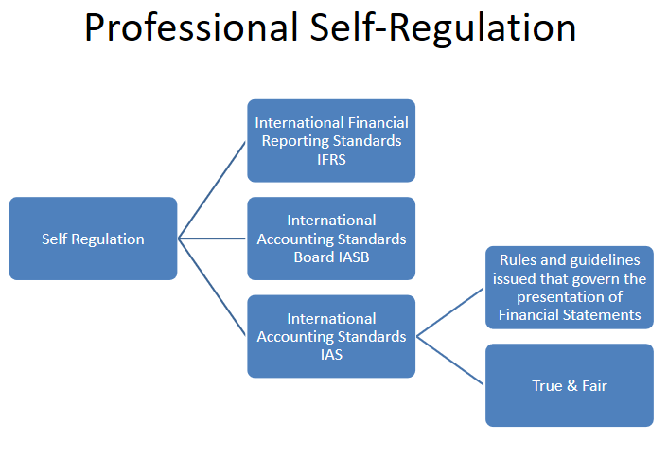
Appendix 2; Self-regulation model in accounting adapted from: (Johnson, 2016)

Appendix 3; Code of ethics for professional accountants;
Firstly, there is integrity – accountants should be straightforward and honest in all professional business relationships.
Secondly, there is objectivity – should not allow bias, conflict of interest or undue influence of others to override professional or business judgements.
Thirdly, there is professional competence and due care – to maintain professional knowledge and skill at the level required to ensure that a client or employer receives competent professional service based on current developments in practice, legislation and techniques and act diligently and in accordance with applicable technical and professional standards.
Fourthly, is confidentiality – to respect the confidentiality of information acquired as a result of professional and business relationships and therefore, not disclose any such information to third parties without proper and specific authority, unless there is a legal or professional right or duty to disclose, nor use the information for the personal advantage of the professional accountant or third parties.
Lastly, is professional behaviour - to comply with relevant laws and regulations and avoid any conduct that can discredit the profession in any way.

Appendix 4;
Copy of questionnaire
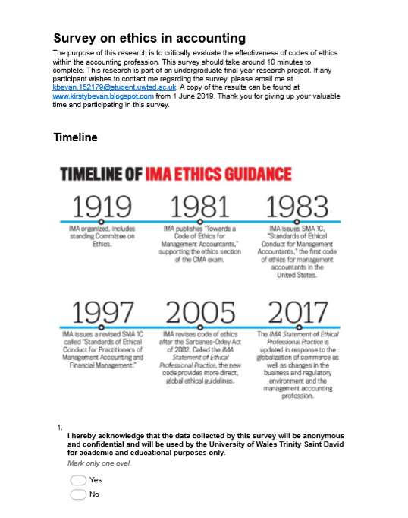

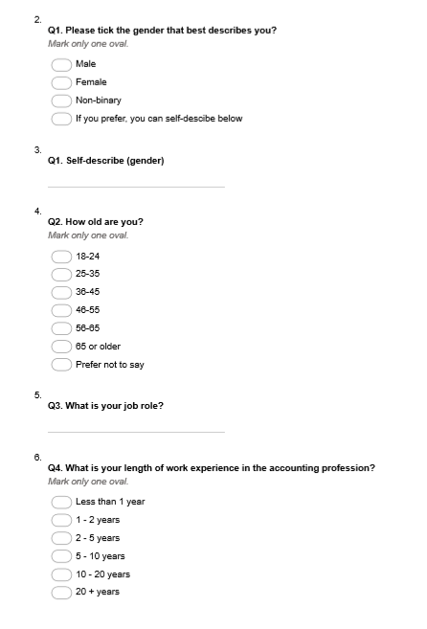

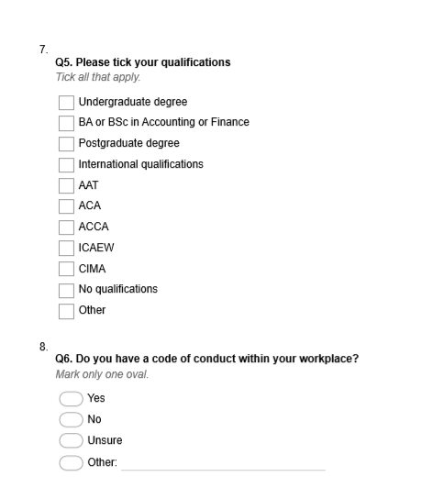

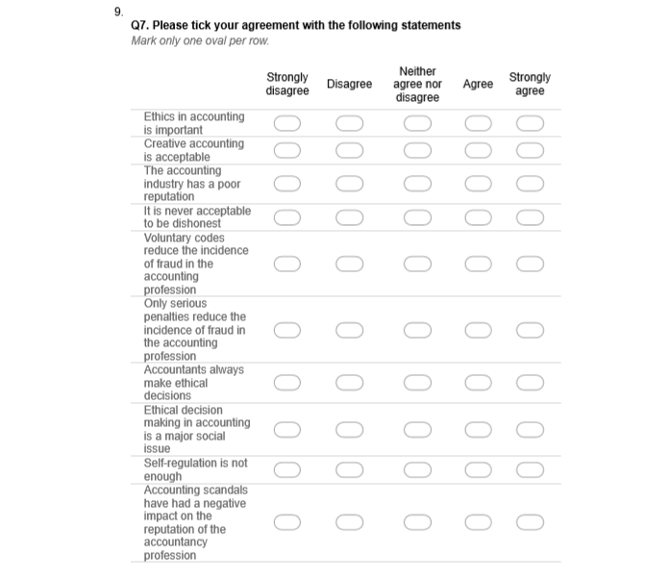

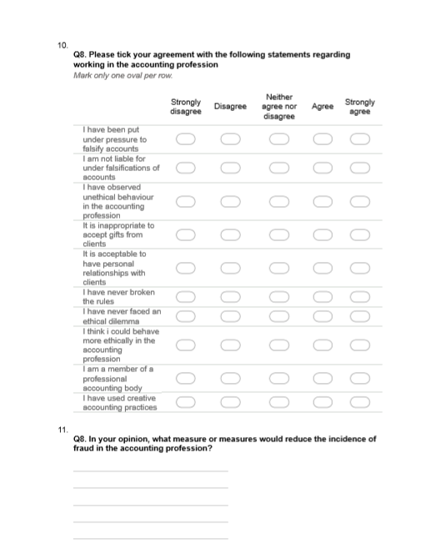

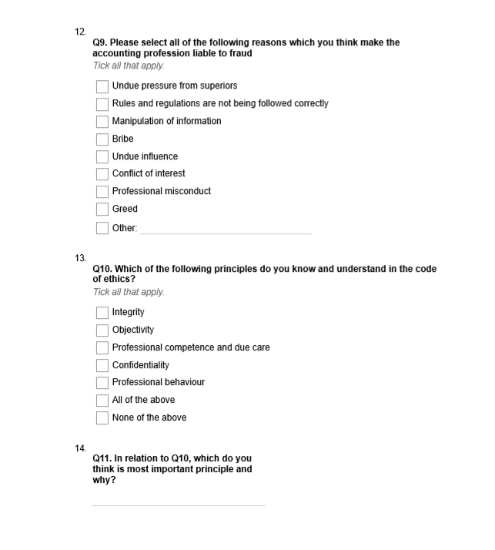

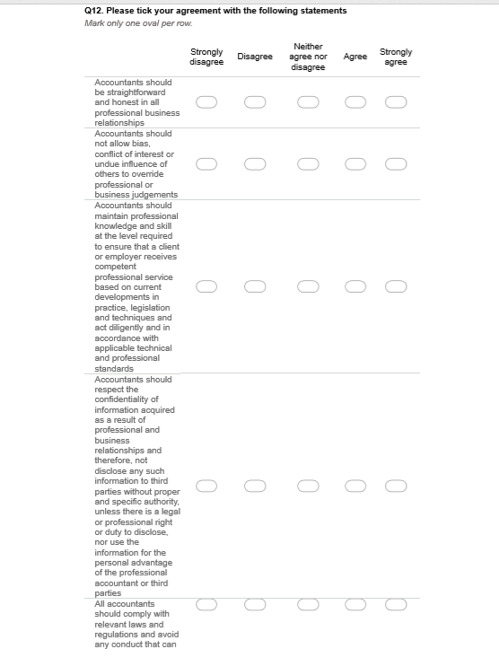
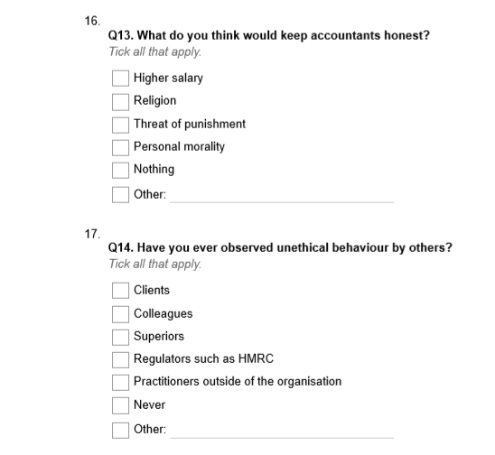

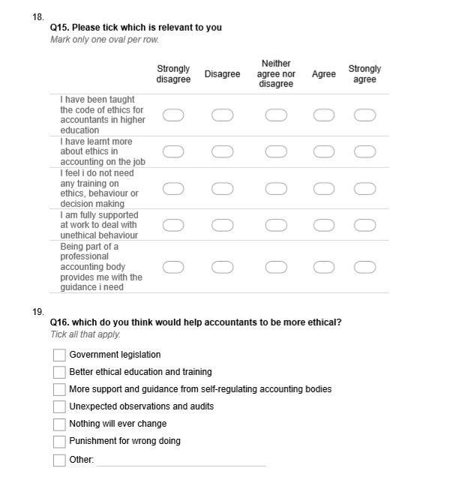

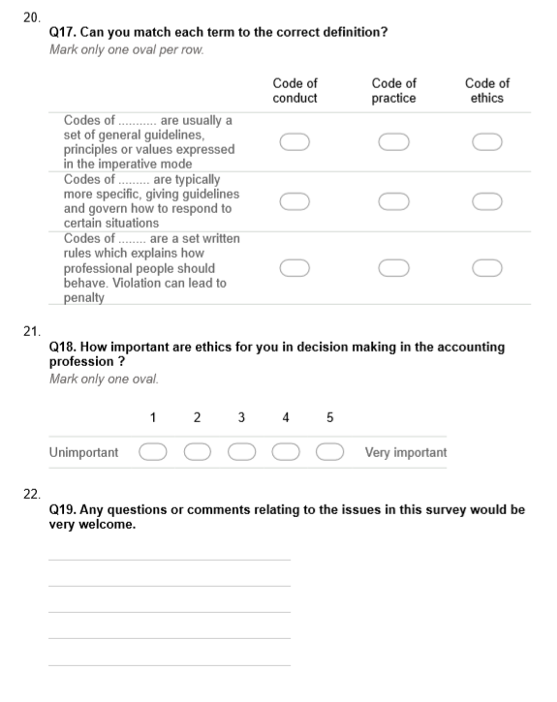

Appendix 5;
Copy of raw data results
Survey on ethics in accounti 
168
responses
Not accepting responses
QUESTIONS
RESPONSES
168
Message for respondents
This form is no longer accepting responses
SUMMARY
INDIVIDUAL
I hereby acknowledge that the data collected by this survey will be anonymous and confidential and will be used by the University of Wales Trinity Saint David for academic and educational purposes only.
166 responses
Yes
100
%
No
Q1. Please tick the gender that best describes you.
168 responses
54.2
%
42.9
%

Q1. Self-describe (gender)
20 responses
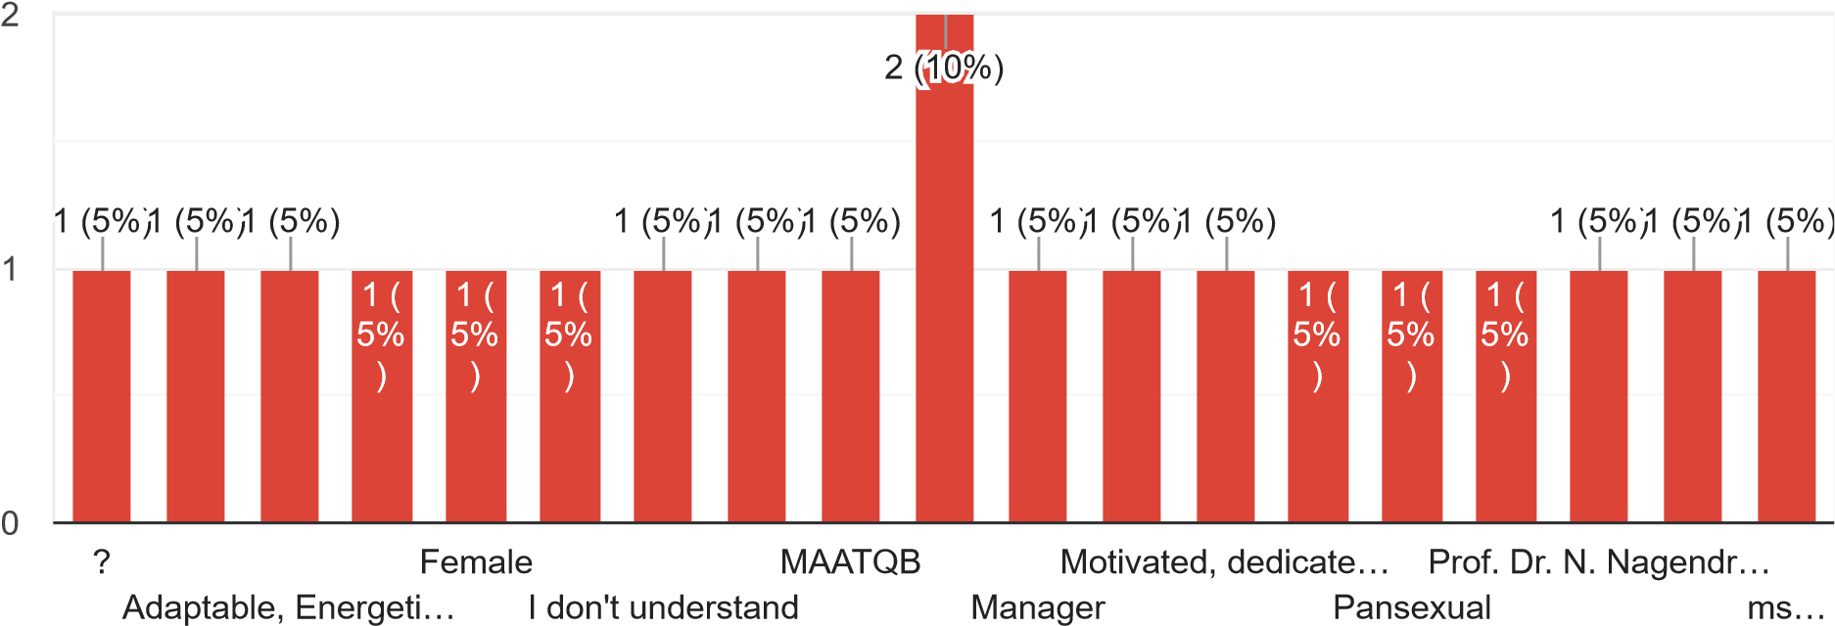
Q2. How old are you? 168 responses
17.3
%
20.2
%
21.4
%
33.9
%

Q3. What is your job role?
163 responses
Accountant
Trainee
Accountant
Student
Financial
Accountant
Accountant
Chartered
Accountant
Assistant
Accountant
Director
Business
Adviser ACCA
Accounts
Assistant
Head of Finance
Management
Accountant
Trainee
Accountant
Trainee accountant
Finance
Business Partner
Lecturer
Director of Finance
Sales assistant Accounts assistant Director
Finance officer
Professional Bookkeeper
Accountant assistant
Consultant
For the moment I am a full-time mom
Senior
Lecturer
Accounts manager
Trainee
Assistant accountant
Student
BA Hons Accounting
Finance assistant Auditor
Customer Assistant
Tax
Advisor
Accounts
Administrator
I
own my own practice
Senior accountant
Tax
Preparer
Manager
Football
chartered accountant student
Audit
Finance Manager
Professor
Accountant - charity
General services manager
Administrator/Property Management
Accounts officer Intern
Financial consultant students
Document control

I used to work as accountant of a student newspaper
Patient and Transport liaison manager
Assurance Manager
Full-time student/part-time playworker
Technical
Manager at ICAEW
ACA
Accounts
Receivable Manager
Bookkeeper
Senior Accountant
senior accountant nhs
Finance
Analyst
Head of Finance and Business Services
Office
Manager
Expense Accountant
retired public sector accountant
Senior manager
Assistant accountant ACCA
Financial accountant
Accounts senior
Management accountant academic
Book-keeper
Trainee accounting
Audit assistant manager
Finance
Analyst
Associate auditor
Senior
Financial Business Partner
Finance
Control Manager
Assistant
Management Accountant
Head of Financial Control
Accountant partner
Professor of accounting and finance Project
Accountant
Management Accountant
Senior
Management Accountant and Finance Business Partner
Group
Accountant
Principle
Accountant
Branch head
Head of financial accounting
Office
manager
Senior
Financial Control Manager
Account manager
Trainee
management accountant
Chartered accountant
Financial controller
Assistant management accountant
Senior auditor and accountant

OTHER
(17)
Q4. What is your length of work experience in the accounting profession?
168 responses
Q5. Please tick your qualifications
167 responses
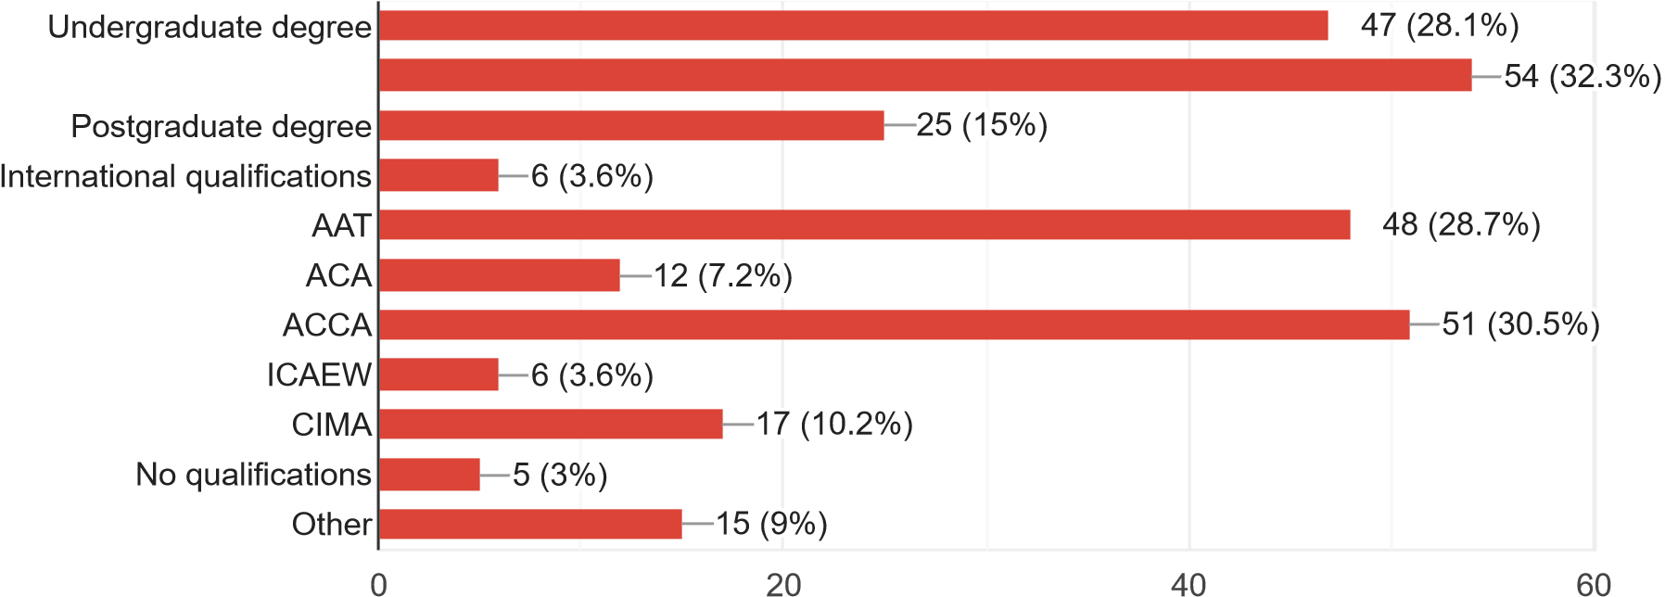
Q6. Do you have a code of conduct within your workplace?
167 responses
Yes
8.4
%
11.4
%
77.2
%
No
Unsure
Not applicable not working at moment
Yes, but also moral conduct for charity
When working, yes
Yes, the university has one No employees
Q7. Please tick your agreement with the following statements
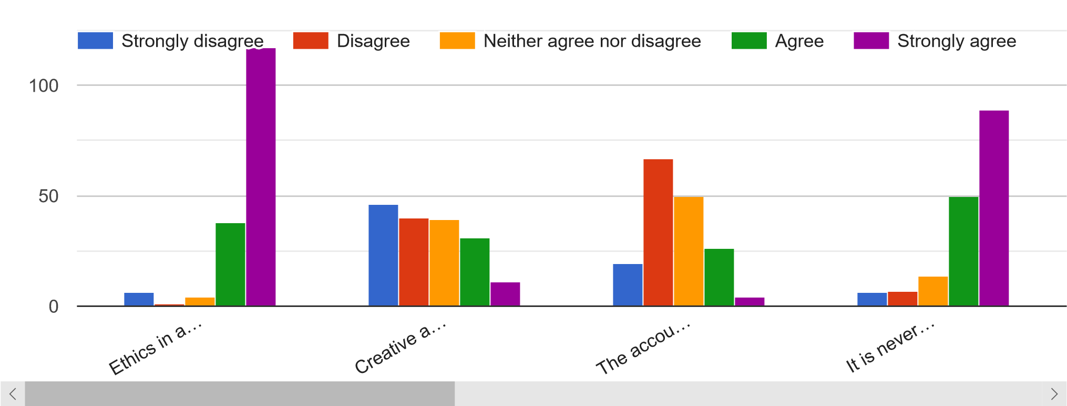
Q8. Please tick your agreement with the following statements regarding working in the accounting profession
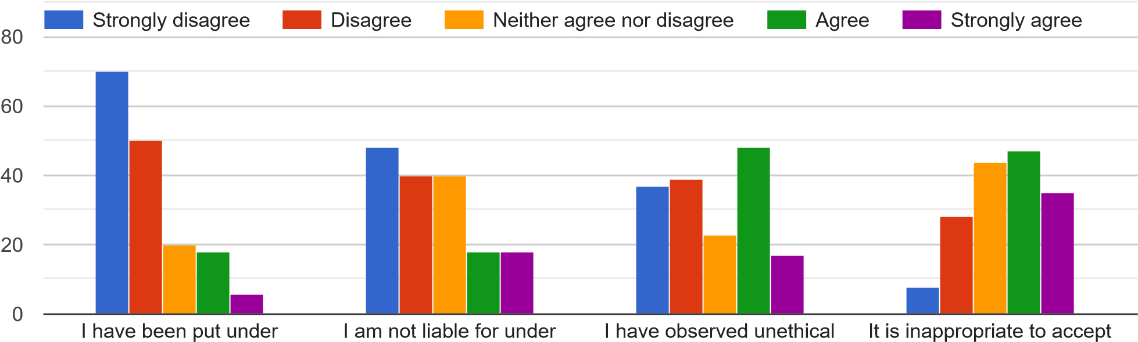
pressure to falsify accounts |  | falsifications of accounts |  | behaviour in the accounting profession | gifts from clients
 |  |  |  |  | 
Q8. In your opinion, what measure or measures would reduce the incidence of fraud in the accounting profession?
130 responses
Independent audit for accountants
Unsure
More investigations
Better regulation Unsure
Strong
CPD requirements and publicity of punishment for transgressions
Stricter
Regulations
Monitoring receipts don't get duplicate/ passed around book keepers
Unexpected observations/ audits from professional bodies
Independent
(External) internal audit - obviously cost willing
More
robust regulation from governing bodies. Audits are fundamentally at risk of fraud as accountancy firms have to tender for the work. There will then always be the risk that pressure from the client will influence the audit as the firm wants to maintain the fee.
More overt regulation especially of auditors
By
making the titles 'Accountant' and 'Bookkeeper' protected titles only to be used by qualified professionals. By HMRC disallowing those who have committed fraud to continue working in the industry in any capacity.
A qualified accountant
Penalties and prison
Less pressures from bosses and clients to cheat. It is all about cheating the tax man and keeping as much money for themselves. It is one of those things - where everyone is looking out for themselves.
Legal regulation and communication and transparency
The
nature of fraud is that it works outside your field of vision, subverting the normal checks and balances so that the world changes while the picture stays the same. People in financial markets have been missing the wood for the trees for as long as there have been markets.
Being honest in every situation you face.
Financial motivation
More stringent government regulation and the breakup of the big 4 firms
Probably nothing. It happens everyday
Training
Making
tax digital
Monitoring
Clearer guidance around ethical issues
More oversight and stronger confidence within employees to speak out.
Higher penalties/consequences
Penalties
Not
sure, maybe peer reviews or compulsory change of auditors after a certain length of time
depends om personality
A robust governing body
Not allowing people who are unqualified to do any sort of accounting or bookkeeping
Regular checks
CEO listening to my recommendations. As he didn’t, I have resigned.
An auditor’s concern for its own reputation should deter it from signing off on cooked books. But the experience of Arthur Andersen, which presided over a series of accounting debacles before Enron without major client defections, shows that deterrence doesn’t happen in practice. Either companies were too lazy to change accountants, or they were simply oblivious to Andersen’s failures, or they may have wanted the lax treatment for themselves. The key to real accounting reform is to remove the economic incentive for accountants to be half-hearted in their audits. One way would be to make the audit of public companies a federal function. That would guarantee independence, to be sure. But the government’s inability to hire low-skilled airport screeners in a timely
fashion doesn’t exactly instil confidence that it could assemble a crack team of accountants.
Hard
to say perhaps digital accounting or being cashless otherwise it is going to be hard to avoid
We
need either a tax police, going after the fraudsters, including accountants or we need to just accept it, that if people can get away with it, they will look to keep as much money as possible for themselves and not the tax man. The pressure I have been under from clients and bosses over the years has affected my nerves and I have suffered from stress because I have been caught in between being honest and keeping my clients and bosses happy.
Some kind of tracking - who did what etc
Strong
internal audit. Having rewards for internal audit management dependent on process improvement instead of financial results.
Severe punishment to the members
No personal relationships with clients, accounts should be double checked by another member.
Keep
Tracking
Frequent
internal and external audit, hands on management, clear understanding of company’s policies and procedures
Audited financial statement
Ethical
accounting and auditing practices, checking and investigations through numerous techniques of auditing.
Strong
ethical code of conduct and embedding ethical controls across organisation
double check
monetary penalties for fraud
Good accounting practices and control.
Periodic audits
better enforcement of guidelines No
Continuous
Controls Monitoring in organisations where accountants work including focus on controls design and controls operating Effectiveness; Greater Board oversight - sound policies including whistle-blower policy; agreed Values, Code of Ethics, Code of Conduct, independent Ethics Audit with unaltered report to CEO and Audit and Risk Committee
Change in mindset of old school accountants
I
think the right mix of voluntary code and sanctions is key. Ultimately most accountants are proud of their profession and want it to be seen as honest. Therefore, building up a culture of good behaviour in the industry will be the biggest single success factor in reducing fraud. Integrity breeds integrity. However, there will always be individuals who do wrong, for these, heavy sanctions are required to try and act as a deterrent to others.
Fines and prison sentence
Regular third-party audits
More training/courses
Tighter regulations/ rule based
Robust procedures, ad hoc sample auditing, consequences of actions
Tough penalties
stricter legal penalties
Digitize taxation, link businesses and employers to one single system.
I don’t think
fraud will ever be reduced, once a solution is found to stop it one way, they will find another.
Suitable
controls within the workplace, independent internal audit and extreme consequences if found guilty of fraud.
Nothing
- it is human incentive. There are already regulations in place, but this does not deter some people.
Harsher
financial penalties, indefinite bans from practising, longer prison sentences and stripping of all licenses.
Very serious penalties for doing so and random inspections.
Improvement in external audits
Drop in audits by professional body and hot file reviews/ visits
Training
in ethics, protection of the term "Accountant" to members of CCAB members, refusing membership to those found guilty of fraud.
Moral guidance rather than hard rules
More government regulation
Better laws
Stricter internal controls and review
Controls
& Procedures
I
have no opinion about it. The only Fraud I read about or know about are due to untrained staff making mistakes or big companies influencing the accountant making a report and by giving their opinion. It should not be an opinion. But a reasonable qualification of the accounts is a true and fair representation of the business activities and has been following all financial standard and that no evidence or Fraud has been detected to reflect any different. Big companies should have more than one firm and or accountant working for them reviewing their accounts and should never be the same working together each year and together. and no more than twice every five years in a row.
Internal ethic practices and training
Increased scrutiny of accounts
Following procedures as gospel
better: training, awareness, penalties, oversight, culture, leadership
Don’t know
More definitive standards
Change
perceptions and mindsets to alter behaviour. I believe unethical behaviour arises because those carrying out unethical practices do not consider wider repercussions
Na
With
Principles accounting there will always be disagreement in the treatment of certain items in accounts whereas Prescribed rules do not cover all eventualities especially in evolving financial markets. The simpler the rules the harder they are to try and defraud, but better independent auditing and compelled to rotate companies periodically would help identify fraud.
fines
Harsher penalties
Penalties for advisers/accountants
More
emphasis on ethics in accounting exams; creating an anti-fraud culture in a population as a whole
Making examples of those found guilty to deter others. Stricter rules on CPD.
Stronger penalties, better education around ethics and impact of fraud
Rules that remove judgement. Policing of the rules by relevant parties
Greater penalties for those found guilty.
Tougher penalties
Know
Your Business Partners
Internal controls and audits.
More staff training
More consistency

Q9. Please select all the following reasons which you think make the accounting profession liable to fraud
166 responses
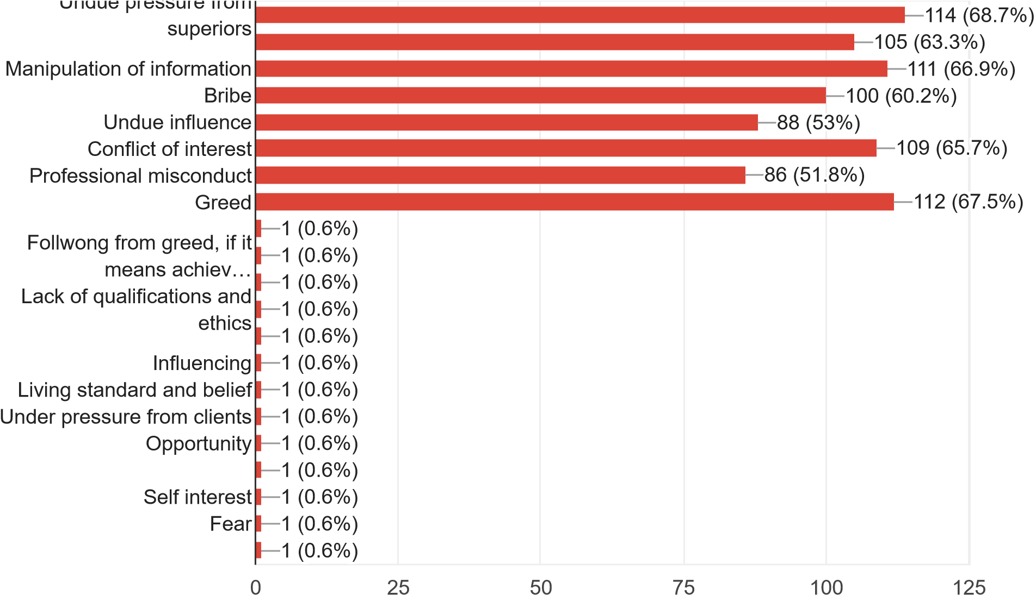
Q10. Which of the following principles do you know and understand in the code of ethics?
166 responses
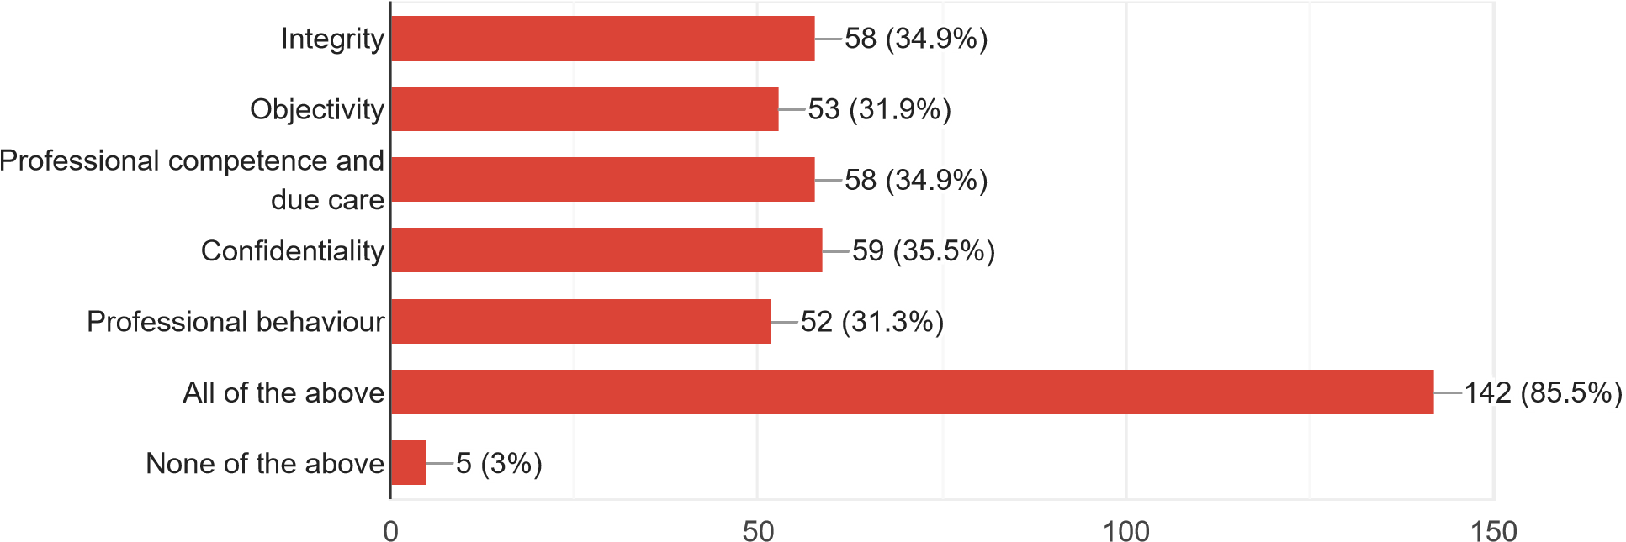
Q11. In relation to Q10, which do you think is most important principle and why?
Integrity
Integrity
Confidentiality
Professional competence and due care
Professional behaviour
Integrity,
highest standard Objectivity integrity
All of them are important.
All
of them
Confidentiality because information should be kept in privacy.
Professional
behaviour, if you can follow this, it is highly likely your adhering to the other principals in the work place too
Professional competence and due care. This should feed into the other principles
Integrity.
Ultimately everyone must decide what is right or wrong. If an individual has a high level of integrity, they would find it v difficult to live with themselves if they knowingly committed fraud, manipulated info etc in an inappropriate way.
Professional
competence and due care because if you have the correct training in order to be competent then the rest automatically come with that.
Professional competence
To be fair, this is not uppermost for the profession. It is cosmetic to say there is a code, but I am not really aware of what is in it. It is worthless really.
Integrity
because encompasses all honesty and good behaviour
They
are all important but they are equally meaningless. If I break a confidentiality, so what? Who cares? Who will catch me?
Integrity, without it you will compromise in the other areas.
Professional behaviour- respect your job...is the one how feed you
Objectivity as it should ensure independence
All
of them are vital
Integrity-
we must be professional and act with integrity to raise levels of trust in our profession
Professional behaviour
Unsure
Integrity.
It’s the platform for every other principle
Professional behaviour, it underpins everything
Integrity
because you need to be honest
professional competence and due care as it’s important for me
They are all equally important.
All
of them
Confidentiality
- so that the other person is not harmed/exposed in this way
Integrity as it come down to my own ethics on how the other 4 principles are achieved.
Whilst they
are all important, they mean nothing. These terms are almost buzzwords.
Being professional
Business men
I am aware of the terms, but I am unaware of their real meaning or if they have any
weight. I think codes of ethics in their current state are pointless and unnecessary.
Competence
as it ties all the other together
Integrity as without it you are likely to not follow the others.
Integrity.
Having respect for the work you submit will help distinguish between right and wrong.
1
Confidentiality, private business
Integrity,
honesty and morals are very important qualities every Accountant should have
All
principals are important in order to follow ethical conduct
Integrity and confidentiality
All
of them are equally important. Professional accountant should be independent on factual grounds as well as appearance
Integrity
- it underpins all the other principles
Objectively
Integrity-it’s always doing the right thing
objectivity
- there should be no bias
Integrity.
It goes to the heart of Trust and community expectations
They
all count obviously but for me personally it is integrity. As that is doing the right thing even when no one is looking.
Integrity,
Hard to choose one but along as you honest it should cover all other aspects
Professional
confidence and due care. If this is adhered to, it could be argued that all other headings are behind achieved.
Professional
Behaviour, because it ensures you stay on message
All
of the above. They all have their place in the workplace and all need to be followed equally.
Professional
behaviour, if you are being professional you should be making the right decisions
Professional behaviour to ensure the accounting profession is not degraded.
All
are equally important I believe
Professional
behaviour. The way I interpret this code is that it very much covers all the other codes of ethic. This is because it involves maintaining the good reputation of the accounting profession. In order to achieve this, it is important to follow the rules and regulations, be non-biased, act in a morally positive manner and uphold the highest level of confidentiality.
Professional behaviour as this underpins all the principles
Professional competence ensuring up to date
Integrity
/ professional competence
They are all equal importance
Integrity
- overarching
Objectivity
sets you as a neutral party for reporting and minimises any threats to independence
All
of the above are important and integral to the profession
They are all equally as important
All
equal
integrity, it contains the foundation for the others
Professional competency
Integrity as this is your own personal standing and reputation at risk
Integrity
because a unionist accountant will be more likely to act unethically. An honest accountant will always consider unethical behaviour before making a decision.
All
equally as important
All
equally
All
of the above are relevant
Integrity
as I feel it is the basis of all the other codes, without integrity you cannot follow the remaining codes
They carry weight together as a cohesive set of principles
All
equally important
Equally important
All
are important but having integrity has an impact on all others so for example if you have integrity then you will admit when you don't have enough professional competence in a specific area.
Integrity, it is good to be honest in all walks not just at professional level.
Integrity.
By being straightforward, honest and truthful in all professional and business relationships, the other principles are followed too
Professional competences. I’m qualified for a reason and I expect all qualified accountant to follow the same professional ways
Integrity as it underpins the rest
I think all the principles should have equal consideration as adherence to each of them should ensure a rounded and robust ethical approach
3
All
Integrity as all the others stem from it.
Objectivity
Integrity as it allows moral guidance
Professional competence and due care
Competence
Professional behaviour, as the remaining fall within this scope.
All
of that are important. I just prefer to mention professional competence and due care because whether it is missing, everything wrong can occur.
I believe
that they are all so important and accountancy would not be able to be ethical without one or the other
Integrity, as it is most important to do the important things.
Hard to answer. Integrity probably as everything else builds upon this
Objectivity
- professional scepticism is important in not believing everything a client tells you.

OTHER
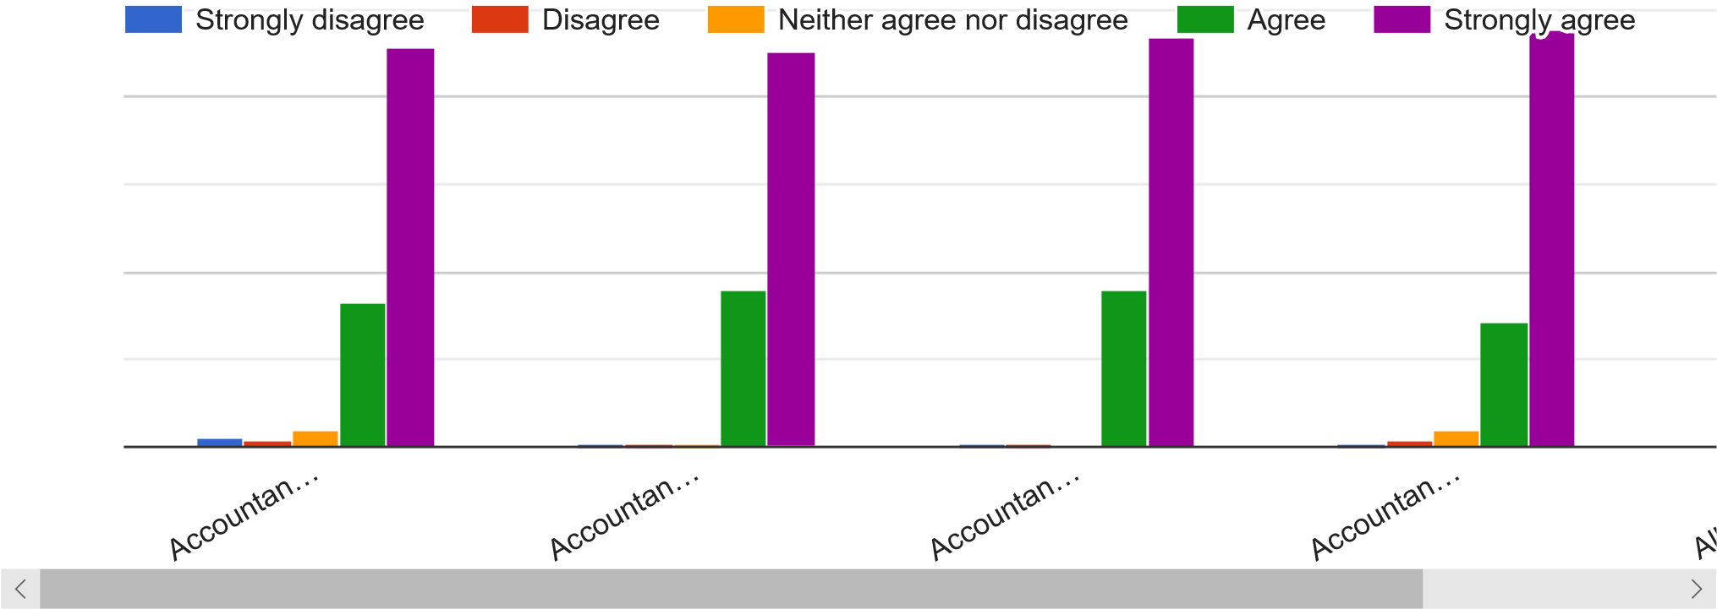
(8)
Q12. Please tick your agreement with the following statements

Q13. What do you think would keep accountants honest?
164 responses
Q14. Have you ever observed unethical behaviour by others?
153 responses
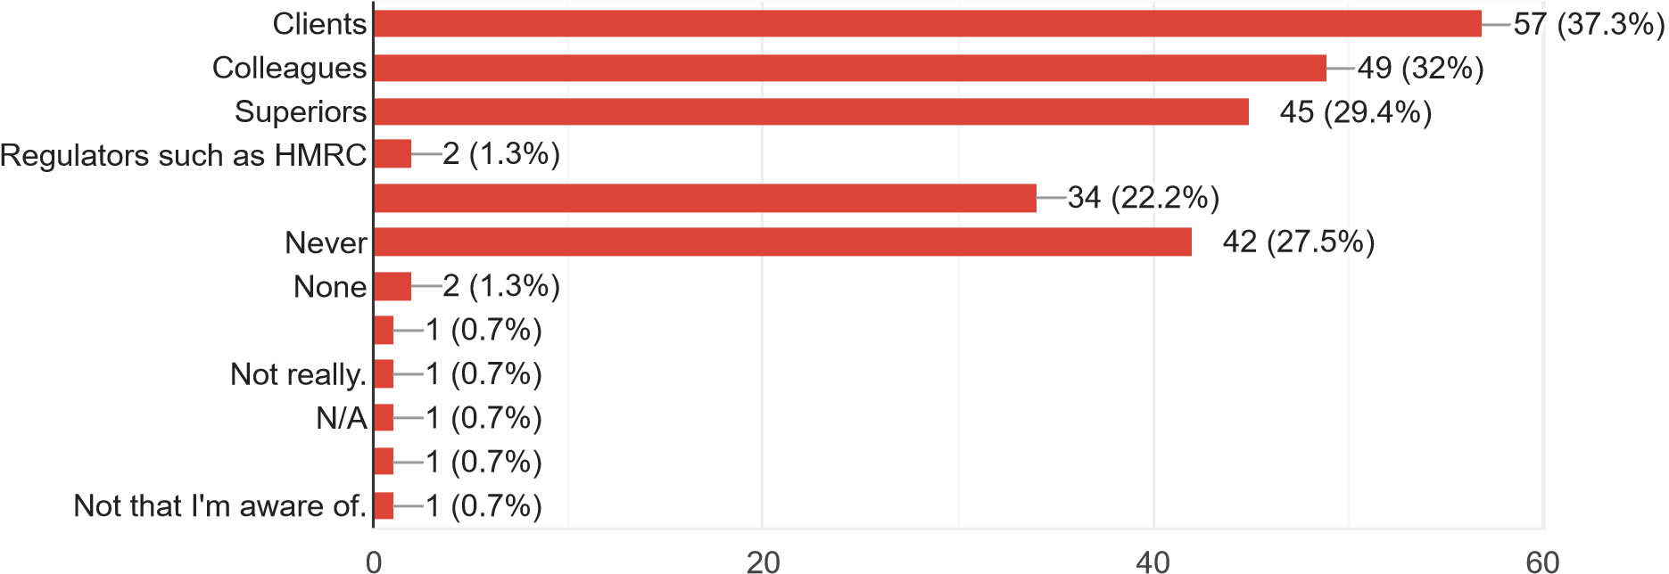
Q16. which do you think would help accountants to be more ethical?
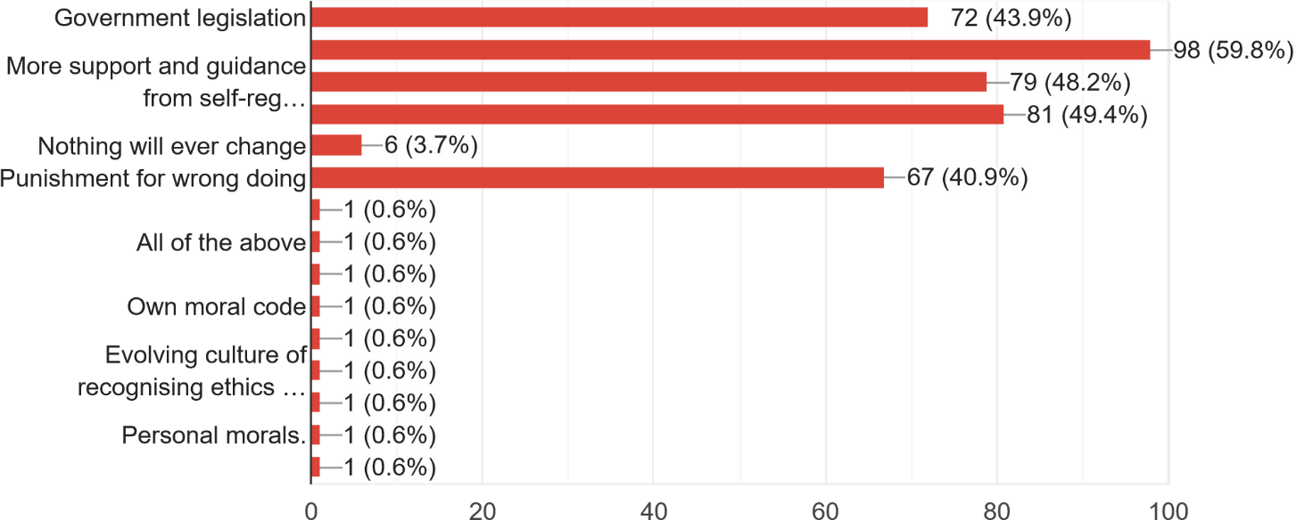
- responses

Q17. Can you match each term to the correct definition?
0
25
50
75
100
Code of conduct
Code of practice
Code of ethics
Codes of ........... are usually a set of general guidelines, … Codes of ........ is a set written rule…?
Codes of ......... are typically more specific, giving guidelines and govern how…
Q18. How important are ethics for you in decision making in the accounting profession?
- responses
1
2
3
4
5
0
50
100
150
0
(0%
)
1
(0
.
6%
)
12
.
3%
)
(7
50
(30.3%
)
102 (61.8%)
Q19. Any questions or comments relating to the issues in this survey would be very welcome.
35 responses
Unsure
whether Q13 was asking whether accountants should or whether accountants do. I have answered as accountants do
I
think this is a good topic which needs to be explored further. When I read about the sales scandal at Wells Fargo, I can’t help but think about the people who naively designed the incentive schemes that triggered this type of unethical behaviour. When I hear about the complex transfer pricing schemes at companies such as Amazon and Starbucks that enable them to avoid tax, I start wondering which accounting techniques they used. In short, I see the strong connection between unethical business practices and accounting techniques. In the film Jurassic Park, Dr Ian Malcolm says: “Scientists were so preoccupied with whether or not they could, they didn’t stop to think if they should.” I would say students, managers and accountants – to not make that mistake. It is important to take that step back every once in a while, to reflect on the ethics of the technics.
In some countries, there are "low-trust societies". The political institutions are fragile and corrupt, business practices are dodgy, debts are rarely repaid and people rightly fear being ripped off on any transaction. In the “high-trust societies”, conversely, businesses are honest, laws are fair and consistently enforced, and the majority of people can go about their day in the knowledge that the overall level of integrity in economic life is very high. It is much more difficult to be a fraudster in a society in which people only do business with relatives, or where commerce is based on family networks going back centuries. It is much easier to carry out a securities fraud in a market where dishonesty is the rare exception rather than the everyday rule. so, I think we need to change the big picture. Fraudsters don’t play on moral weaknesses, greed or fear; they play on weaknesses in the system of checks and balances – the audit processes that are meant to supplement an overall environment of trust. One point that comes up again and again when looking at famous and large-scale frauds is that, in many cases, everything could have been brought to a halt at a very early stage if anyone had taken care to confirm all the facts. But nobody does confirm all the facts. There are just too bloody many of them. Even after the financial rubble has settled and the arrests been made, this is a huge problem.
It’s hard to maintain ethics when the real. problem is discrimination
What is your values n/a?
Immaterial
gifts can be accepted. Although I do not socialise with clients, the relationship is one of friendship.
But there is a way to use the power of the marketplace—which until now has conspired against good auditing and accounting—to bring accountants to heel. We should require publicly held companies to purchase accounting insurance. Accounting firms, as a condition of doing business, should be required to buy accounting insurance. Accounting insurance would cover all, or a portion, of damages suffered by investors because of accounting fraud or earnings misstatements, with a certain deductible and a cap. In order to assess the risk of insuring a company’s books, insurance companies would hire accountants and pay them to conduct annual audits. Since the auditors would be representing their new customers—insurers—not the audited companies, they would have both the freedom and the incentive to be tough and thorough. Meanwhile, accountants could continue to offer their consulting services to companies, because the conflict of interest created when they both audited and consulted to the same company would disappear. Signing off on faulty books would be devastating for an accounting firm. Insurance companies are nothing if not risk-averse; mitigating risk is their business. If an accounting firm were to botch one audit or help insiders cook the books, that firm would jeopardize the dozens or hundreds of auditing assignments it got from insurance companies. The insurance companies would charge premiums based on the perceived risk. That risk would be dictated not simply by the audits but also by the past actions of the company and its executives—the way accident-prone drivers pay higher rates or smokers with a history of accidental fires shell out more for home insurance. For companies with honest, clean, and transparent books, accounting insurance will be a relatively minor cost of doing business. A company run by the Pope (perhaps) would pay a low premium. For companies or executives with a history of earnings exaggeration, insurance would be more expensive. A company headed by Jeff Skilling would find it very difficult to obtain accounting insurance. Premiums and ratings would be disclosed to investors in financial statements, so they could draw their own conclusions about the accounting risk inherent in a given company. It would be a challenge for insurers to price the audit coverage at first, but insurers have shown an ability and eagerness to insure everything from the knees of football players to priceless works of art. And this is a market with sufficient history and sufficient size to quickly develop an orderly pricing regime.
Too many questions
I am very interested in this topic and have conducted some reading in this area prior to today and completing your survey. debate surrounding codes of ethics. At one end of the spectrum, John Ladd has argued that codes of ethics serve no good purpose whatever. Ladd argues that ethics should be open-ended and reflective, and that relying on a code of ethics is to confuse ethics with law. He further asserts that it is mistaken to assume that there is a special ethics for professionals which is separate from the ethics of ordinary human beings within a moral society. Professionals, he suggests, have no special rights or duties separate from their rights and duties as moral persons, and therefore codes of ethics are pointless and possibly pernicious. A different sort of attack on the usefulness of codes of ethics comes from Heinz Luginbuhl.
Luginbuhl acknowledges that codes of ethics do have some sociological value. Luginbuhl writes, "The adoption of a code is significant for the professionalization of an occupational group, because it is one of the external hallmarks testifying to the claim that the group recognizes an obligation to society that transcends mere economic self-interest" (p. 138). But he believes that ultimately codes of ethics create moral problems rather than helping to resolve them. Luginbuhl notes that practicing professionals rarely turn to their codes of ethics for guidance, and that the guidelines within the codes sometimes seem internally inconsistent. He also voices a concern similar to Ladd’s -- namely, that implementation of a code of ethics may be in conflict with the moral autonomy we expect of individuals. In response, Harris et al. argue that all three of Luginbuhl’s criticisms can be surmounted. They suggest that though most practicing professionals do not routinely consult their codes of ethics, it does not follow that they do not know about or care about the contents of their codes. Further, the fact that codes of ethics sometimes seem internally inconsistent can be addressed by understanding codes of ethics not as recipes for decision-making, but as expressions of ethical considerations to bear in mind. We should view them as an ethical framework rather than as specific solutions to problems. Finally, the authors argue that moral autonomy is not really compromised by codes of ethics. "If a code's provision can be supported with good reasons, why should a profession not include an affirmation of those provisions as part of what it professes? This does not preclude individual members from autonomously accepting those provisions and jointly committing themselves to their support." (p. 34). Michael Davis makes a strong positive case for professional codes of ethics. Davis argues that codes of ethics should be understood as conventions between professionals. Davis writes, the code is to protect each professional from certain pressures (for example, the pressure to cut corners to save money) by making it reasonably likely...that most other members of the profession will not take advantage of her good conduct. A code protects members of a profession from certain consequences of competition. A code is a solution to a coordination problem." (p. 154). Davis goes on to suggest that having a code of ethics allows an engineer to object to pressure to produce substandard work not merely as an ordinary moral agent, but as a professional. Engineers (or doctors, or clergy, etc.) can say "As a professional, I cannot ethically put business concerns ahead of professional ethics." Davis give four reasons why professionals should support their profession’s code: "First…supporting it will help protect them and those they care about from being injured by what other engineers do. Second, supporting the code will also help assure each engineer a working environment in which it will be easier than it would otherwise be to resist pressure to do much that the engineers would rather not do. Third, engineers should support their profession’s code because supporting it helps make their profession a practice of which they need not feel…embarrassment, shame, or guilt. And fourth, one has an obligation of fairness to do his part…in generating these benefits for all engineers." (p. 166) Harris et al. summarize Stephen Unger's analysis of the possible functions of a code of ethics: "First, it can serve as a collective recognition by members of a profession of its responsibilities. Second, it can help create an environment in which ethical behaviour is the norm. Third, it can serve as a guide or reminder in specific situations…Fourth, the process of developing and modifying a code of ethics can be valuable for a profession. Fifth, a code can serve as an educational tool, providing a focal point for discussion in classes and professional meetings. Finally, a code can indicate to others that the profession is seriously concerned with responsible, professional conduct." (p. 35). so, to sum up - accountants should be proud of their work as a PROFESSION and secondly, we need law not just codes.
Unfortunately
unethical behaviour in accounting will always exist when there are financial targets to be met and bonuses which are reliant upon them. Companies often focus
on short term rewards, failing to see that this will promote unethical behaviour. However, steps are being taken in the right direction and as more case studies arise (Enron, Wire card etc). A bigger worry to me personally is the audit profession. They exist to provide reasonable assurance to shareholders yet are not liable for combating fraud. Accountants are also not liable so there is a grey area which is often abused. The argument of materiality also worries me. If £200k's worth of Receivables are not attributable to any clients, but was a combination of accrued revenue would it be correct to ignore it because the value fell outside of the sample threshold? £200k is a lot of money should that 1 person decide to transfer it to their own account as it never belonged to a real customer, it was never going to be receivable. I understand the workload implications, but this is how fraudulent activities are done. I digress, I hope this commentary helps your essay. Good luck with your course.

it's really a nice topic.

The number of fraudulent claims, which the accounting profession is growing, due to unethical behaviour.
Accountants should have always executive.
I have not answered questions that are either too personal, not sufficiently defined egg Q7 Creative Accounting or too loose for legal ramifications. Hope this helps. Well done.

I think ethics should play a bigger role in the accounting profession than it currently does. Too many of the big firms put profits ahead of thorough scrutiny and that is where much of the problems lie. Good luck.

My belief if that integrity is paramount for any accountant and it is something you are taught from an early age and will stay with you for a lifetime and is something that becomes so embedded in your make-up and which cannot be and should not ever be compromised no matter what the circumstances. Being an accountant is a privilege and carries obligations, you are expected to act in line with a code of ethics and remain completely independent throughout all assignments and never be compromised.
I
am retired but have responded in the spirit of my last role as a Head of Finance, as a Chair of an ACCA regional panel and as a member of a CIPFA Accounting panel.
Nothing
is mentioned about a great spirit behind the ethics or of a professional accountant. Why?
Q9
I think you should change "liable" to "susceptible". Overall a very thought-provoking survey which I enjoyed answering
Very
good survey I was not sure what you wanted in Q1. Self-describe, so my answer was brief.
Good Luck!
For reference, I currently work within a Government agency and as such work in a stricter environment for accounting. I would suggest that in this not-for-profit environment there would be less threats to my ethical behaviour than someone who would be working in the private sector. All accountants have a due to the public to ensure financial information available from all sectors is true and fair. Where this trust from the public has been wilfully broken by accountant’s intent on fraud then the punishments should be severe. There also needs to be more understanding within the public that the accounting profession cannot stop all incidents of fraud through auditing. There will be individuals who will be intent on covering evidence and therefore as an accounting/auditing professional we could never provide 100% assurance on any organisation we are auditing.
Good luck for your unit work.
Whilst
ethics are important they are a given so rarely arise as an issue - ethical issues are exceptional. Depends on Industry though - more of a risk in financial services than in Government.
Consider publicity as a deterrent.
Integrity
is vital to keeping the good name of an individual accountant. A good name will keep existing clients and lead to more client recommendations. Good survey. Best wishes with your career.
The tone of this survey seems to suggest you think there is a problem with ethics in the accounting profession and that there have been scandals caused by accountants. I find the opposite, it is usually the accountants that blow the whistle on unethical behaviour, for instance it was an accountant at Tesco that blew the whistle on the incorrect income recognition. Where I work, it is the accountants saying to Directors they shouldn't do certain things that they want to do as it doesn’t comply with the standards or would be misleading. However, I am in the public sector, maybe it is different in the private sector where company survival plays a part.
Good luck with your research! Would be interested to read your discussion.

Appendix 6; Interview evidence
Participant 1 –
Please can you fill in the following and email back when convenient for yourself.
Please state your agreement;
I hereby acknowledge that the data collected by this survey will be anonymous and confidential and will be used by the University of Wales Trinity Saint David for academic and educational purposes only. I hereby agree to taking part
Q1. Please state your gender Male

Q2. The accounting profession have regulatory codes, in your opinion, what are the reasons for these codes? To ensure accountants abide by the rules

Q3. The profession has been impacted by several scandals, first why do you think these scandals happen and going forward how can the profession prevent such problems?
These scandals have happened as there is not enough checks done on the quality of the work, therefore more checks need to be implemented

Q4. There are 5 principles in the regulatory codes, Integrity, Objectivity, Professional competence and due care, Confidentiality, professional behaviour, in your opinion which principles do you think are most important and why?
The most important are integrity, confidentiality and Professional Competence

Due to the nature of the work being carried out then clients must have faith in the accountant’s ability to carry out their work with due care and attention while abiding by the law

Q5. What types of regulation of the accounting profession do you think are needed going forward?
Better checks on accountants

Q6. Regulatory codes come in the form of codes of conduct, codes of ethics and codes or practice - what do you think distinguishes each type of code from the other?
Code of conduct relates to the behaviour of the Person
Code of ethics is doing the right thing
Code of practice is abiding by the law

Q7. Why do you think the accounting profession is susceptible to unethical behaviour?
Because that is the nature of people in general if they think they can get away with it

Q8. If compliance with regulatory codes is judgement-based, how best can the profession ensure that accounting professionals are best equipped to make the best choices?
You must rely on the people involved to make the best choice

Q9. In your opinion what are the ethical components of relationships between accountants and regulators and accountants and client?
Clients will try to get away with as much as possible, while accountants must be seen to be supporting the Regulators

Participant 2;
I Agree to the opening statement and I am willing to participate in this survey.
Q1. Please state your gender.
Male

Q2. The accounting profession have regulatory codes, in your opinion, what are the reasons for these codes?
I believe these regulatory codes are put in place to ensure that accounting procedures are carried out as ethically as possible. Obviously not all abide by the regulatory codes, however the existence is somewhat a deterrent for unethical procedures.
Q3. The profession has been impacted by several scandals, first why do you think these scandals happen and going forward how can the profession prevent such problems?
I believe that the scandals that have happened have been mainly due to the laid-back nature in the monitoring of the codes. A closer eye should be kept upon accountancy firms and more stringent regulations should be put in place.

Q4. There are 5 principles in the regulatory codes, Integrity, Objectivity, Professional competence and due care, Confidentiality, professional behaviour, in your opinion which principles do you think are most important and why?
I believe all these principles are very important, however more emphasis should be put on integrity as it has not been exercised enough and has been the root cause of the scandals.

Q5. What types of regulation of the accounting profession do you think are needed going forward?
As mentioned previously the monitoring of the integrity of accounting firms is paramount.

Q6. Regulatory codes come in the form of codes of conduct, codes of ethics and codes or practice - what do you think distinguishes each type of code from the other?
I believe they tend to deal with a different aspect of the profession. Codes of conduct tend to deal with social norms, whereas codes of ethics, tends to deal with rules regarding integrity and honesty. Finally, codes of practice are to do with the employers and employees’ responsibility to uphold a set of expected values.

Q7. Why do you think the accounting profession is susceptible to unethical behaviour?
I believe that there is a great amount of leniency on accounting firms as they tend to be very helpful in profiting big corporations and therefore governments as well. Monetary gain of a large scale is always synonymous with unethical behaviour.

Q8. If compliance with regulatory codes is judgement-based, how best can the profession ensure that accounting professionals are best equipped to make the best choices?
Seminars and different ways of education the employees within the profession would be the first step. It would also be beneficial to review certain choices to see if they comply with regulations. Giving feedback is also very beneficial.

Q9. In your opinion what are the ethical components of relationships between accountants and regulators and accountants and client?
I believe the mainly ethical components linking all the together is transparency.

Participant 3;
I hereby acknowledge that the data collected by this survey will be anonymous and confidential and will be used by the University of Wales Trinity Saint David for academic and educational purposes only.

Q1. Please state your gender
Male - 33
Q2. The accounting profession have regulatory codes, in your opinion, what are the reasons for these codes?
These codes are designed to serve as guidance in ethical dilemmas any accounting professional might face. They form a basis of my ACCA studies and run through almost every exam I am taken. It helps to keep the accounting profession in high regards in the public eye and serve as measure to judge against in case of any misconduct. These codes should be followed by everyone working in the accounting profession

Q3. The profession has been impacted by several scandals, first why do you think these scandals happen and going forward how can the profession prevent such problems?
Scandals always happen because every human has flaws. Most of these happen because people saw opportunity for misconduct and had no ethical/ moral principles to stop themselves from exploiting these situations. It’s difficult to prevent such instances but the accounting profession itself needs to promote and instil these fundamental codes of conduct in its members. Especially of chartered accountants. Anyone found to breach these fundamental codes of conduct should face consequences- it most severe cases struck of as being chartered and criminal investigations should happen if found they have broken the law.

Q4. There are 5 principles in the regulatory codes, Integrity, Objectivity, Professional competence and due care, Confidentiality, professional behaviour, in your opinion which principles do you think are most important and why?
This is a difficult question as I see all 5 of them going hand in hand. If pushed, I would say integrity as the underlying basis of all. Acting with integrity would always ensure you try to do your best and the best for the people you work for.

Q5. What types of regulation of the accounting profession do you think are needed going forward?
This is hard to answer. Auditors have come under increasing pressure with the recent scandals like Carillion collapse. But I believe a higher emphasis needs to be put on corporate governance. If a company s not following proper corporate governance rules, then even the auditors can’t prevent it collapsing. Perhaps corporate governance could have adapted rules for smaller, non-listed companies to prevent power grabbing at the top that can easily happen in the smaller companies that are run by less directors or where the directors are also major shareholders.

Q6. Regulatory codes come in the form of codes of conduct, codes of ethics and codes or practice - what do you think distinguishes each type of code from the other?
Conduct would be more personal behaviour. Ethics would be underlying in a country’s culture and practice would be unique to the accounting profession.

Q7. Why do you think the accounting profession is susceptible to unethical behaviour?
With accountants having access to systems like cash/ banks and accounting software, they can easily spot the weaknesses and work around control deficiencies. Unethical people would be able to exploit this especially if managers/ more senior staff are not checking correctly or are the ones doing it and then use their power and influence to intimidate people.

Q8. If compliance with regulatory codes is judgement-based, how best can the profession ensure that accounting professionals are best equipped to make the best choices?
This judgement-based approach needs to be instilled from the very beginning.
IT needs to be taught in accountancy courses and the basis of judgement needs to be professional scepticism and confidence in one’s knowledge.

Q9. In your opinion what are the ethical components of relationships between accountants and regulators and accountants and client?
The major ethical component should be honesty. Not trying to hide anything from regulators when non-compliant and likewise honest to clients when they ask us to do unethical behaviour of if there are going concern worries for a business.
Professionalism- Having a good relationship with a client without becoming overly friendly- that might cloud your judgement when dealing with the client. Likewise, professionalism in dealing with regulators will help to not take things too personal and good relationship with regulators can help deepen your knowledge as well.

Appendix 7; Chi-square tests on gender and observation of unethical behaviour
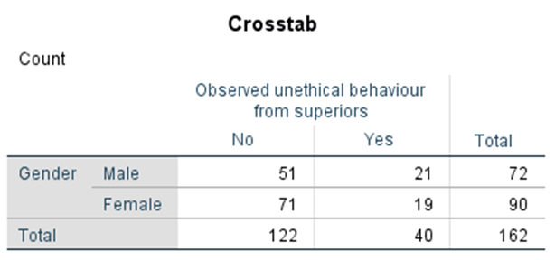
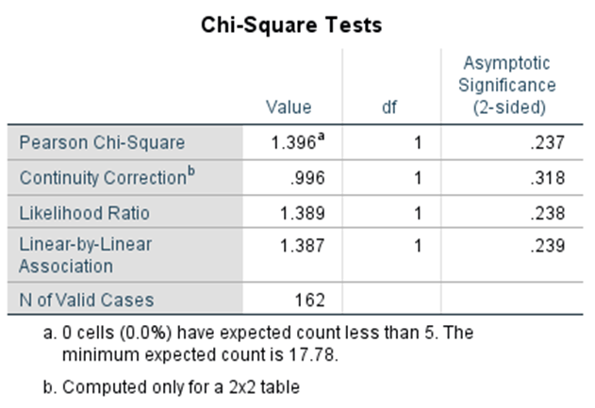
Crosstabulation analysis of gender and unethical behaviour of superiors

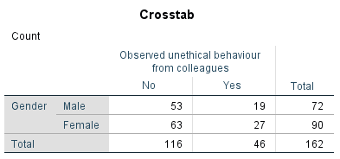
Chi-Square test for gender and unethical behaviour of superiors

Crosstabulation analysis of gender and unethical behaviour of colleagues.

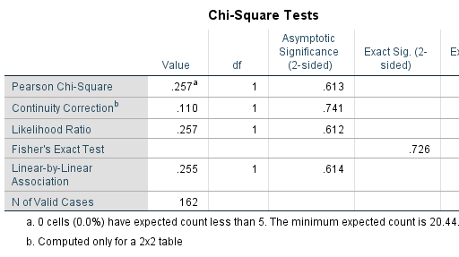

Chi-Square test for gender and unethical behaviour of colleagues
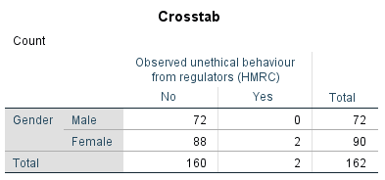

Crosstabulation analysis of gender and unethical behaviour from regulators.
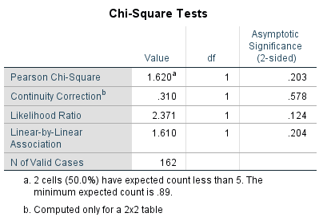

Chi-Square test of gender and unethical behaviour from regulators.

Appendix 8:
Number of answers in relation to question 7 independent t test


