
Assignment 2

Name: Sanya Suneja
Student id: 2234449
Module code: LCBB4004
Module name: Marketing Fundamentals
Lecturer name: Tushara Balendran

Table of contents Page.no.
1. Introduction…………………………………………………. 3.
2. External analysis: Pestel ……………………………………………………………………. 3.
3. Porter’s 5 forces ……………………………………………. 7.
4. Strategies for Apple using Ansoff matrix………………. 10.
5. Conclusion …………………………………………………….12.
6. References ……………………………………………………. 14.

1. Introduction
Due to the dynamic evolvement of business environment, companies tend to face myriad of challenges and opportunities which is driven by powerful external forces. As a marketing executive of Apple.inc, a pioneering technology organization having innovative products with global influence all over the world.
This report will evaluate the external environment of Apple. Inc including effective strategies which can be helpful.
Apple has displayed a remarkable journey by being the market leader and symbolizing leading-edge technology. The report will analyze the external forces which are affecting the company through the application of PESTEL and Porters 5 Forces Model. It will also suggest strategies that can be adopted by Apple through the application of Ansoff Matrix.
These strategies will provide insights into how Apple can position itself to maintain its leadership in the Tech-market. It will encompass strategies to capitalize emerging opportunities and address the vulnerabilities exposed by the external environment.
2. External Analysis: Pestel
The name PESTEL is derived from six external macroeconomic factors: Political, Economic, Socio- Cultural, Technological, Legal and Environmental. It is a valuable tool to identify opportunities and threats for business. By incorporating these variables, it allows conceptualizing the scenarios, which enables better future prediction, persistent decision making in the present along with long term goals in mind for the company. (Alanzi, 2018)
Consideration of all the macroenvironment factors for Apple. Inc:
2.1 Political:
To attain the main objective of profit maximization, political factors such as bureaucracy, corruption, government stability, tax imposition, lobbying are necessary to be contemplated.
1. Tax impositions: Taxation policies of different countries affect the profitability of the company. Intricate legal methods are used by Apple to reduce the global tax obligations, mainly in the US and Ireland. For instance, to prevent any financial loss to the company, Apple hold major funds offshore which results in saving corporate income taxes (Hoxie, 2018).
Moreover, an example of tax policies impact was faced by Apple when the European Commission demanded tax for 10 years which was from 2004-2014. The tax amount was USD 16.2 billion, however, changes in tax policies as well as government led to change of decisions. Thus, this illustrates that political factors impact the external environment of a company (Sullivan, 2020).
2. Apple has grappled with ramifications of political factors on a global factor on a global scale as well. An illustration to show how politics can intersect with business operations was when the Kremlin made a demand to cease the use of iPhone and iPad to safeguard against Foreign Intelligence Services (Evan, 2023). Similarly, the trade conflict between China and US made implications on Apple’s revenue and growth.
The political factor is unfavorable for the company as Apple operates in different countries and all of them has distinctive rules and regulations including tax impositions which might pose challenges.
2.2. Economic:
There are a wide range of economic factors which can affect Apple’s overall performance. One of them is Currency Exchange Rate, according to the latest financial report the total net sales from other countries except from the US is still higher by USD 11,031, which negatively affects the current tendency of strengthening USD (Apple, 2023)
Another factor which influences the economic factor of Apple is the cost of labor. Apple opted to establish its manufacturing plants in China because of the overall cost effectiveness of resources and availability of inexpensive labor.
The figure below indicates that the cost of labor in China per hour has increased to $6.5. Therefore, the upward trajectory labor costs stands a noteworthy economic factor that directly impacts the company’s profitability (Statista, 2023).
There are various other factors which influence the external environment of Apple economically such as the interest rates and inflation rates.
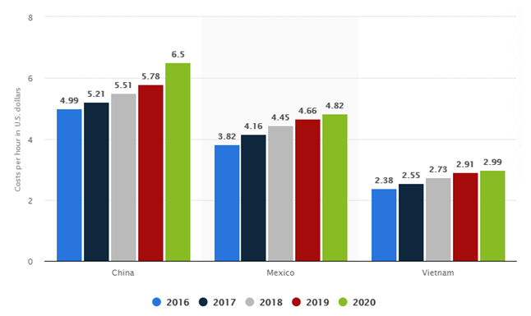
Source: (Statista,2023)
Inflation Rate: “The increase of prices over time is called inflation, the rate of inflation determines the purchasing power of money” (Brooks, 2010).
Increase in inflation rate in the US has affected apple in the past due to having cash reserves. One of the instances which happened in 2013 was when David Einhorn, one of Apple’s many investors, threatened to sue the company demanding a dividend of $ 137 Billion (Neate, 2013). This addresses that inflation rate impacts the organization.
The economic factor is unfavorable according to the above situation as fluctuation of currency affects the net sales, and rising labor costs impacts profitability.

2.3 Socio- Cultural:
The changing lifestyle trends of society impacts the success of the company. These aspects are changing demographics, healthy lifestyle, eco friendly and different products which are designed to fulfil the needs of the consumers. The demonstration of one such product launched by Apple is the latest Apple watch Ultra which is specially designed for sports, is perfect for athletes and adventurous people (Apple, 2023). Hence, this shows that the product is designed according to the needs of society and changing cultures.
The organization also pace up with cultural values as it operates in different countries, which directly affects how the products are accepted which is why the marketing, communication and product strategies are tailored accordingly. Moreover, the rate of urbanization is rapidly increasing which calls for the need of technology in society therefore, it impacts appeal of Apple’s product in the market. Therefore, the changing demographic and societal trends are considered by Apple while making strategies (iLounge, 2022).
The Socio- Cultural factor is both unfavorable and favorable according to the situation as it gives Apple an advantage to adapt its product according to the changing consumer preferences which is favorable. Additionally, the products and strategies to various cultural values can be favorable and unfavorable both as it allows to cater diverse markets, however, misalignment with cultural values can lead to challenges.
2.4 Technological:
The technological environment can influence the product, including the value chain, by improving the manufacturing methods, distribution channels and communication which gives a competitive advantage to the company (Jeffs, 2008).
The need of Technology has imposed direct impact on the environment of Apple as the continuous investment in Research and development by the company anticipates changing trends which leads to innovation and advancement for meeting the needs of the consumers. In July 2023 the R & D investment made by the company was $7442 which demonstrates the step towards advancement (Apple. Inc, 2023).
Moreover, Apple has introduced special student discounts noticing the need for technology in the learning environment. This directly impacts on the sales of the company as it creates a competitive advantage along with promotion of the brand. According to the latest discount offer provided, students are getting discounts on Mac and iPad along with gift card up to £130 (Apple. Inc, 2023).
The above illustrations discuss the changes made by technology for Apple in recent years which helped the company to develop further and consider it as a major factor of the external environment.
The technological factor is favorable in this case as investment in R&D reflects the commitment to innovation and providing student discounts promotes brand loyalty among the youth.
2.5. Environmental:
Natural resources such as minerals, climate and land can affect the business environment. The most dangerous among them is the climate change as it enforces implications on the organization which needs to be considered by them (Boddy, 2016).
Apple also takes care of the environmental factors to ensure smooth working throughout. One of the instances where environmental factors affected the company in 2011 is mentioned by The Financial Times which discusses the allegations made by non-governmental Chinese organizations. The argument was regarding the violation by Apple suppliers for polluting the environment. This accusation led to the tension between the company and environmental activists which impacted the performance of Apple. Hence, this highlights the challenges of managing environmental issues in global supply chains changing attitudes of China towards pollution issues. Apple has also faced controversies before related to suppliers and working conditions. Climate change created global warming, which tends to disrupt transoceanic shipping and supply chain. (Hook and Hille, 2011).
The environmental factor is favorable and unfavorable both as discussed in the above case the emission of pollution is causing global problems, although, stepping towards sustainability in future is favorable.
2.6. Legal:
The final element of PESTEL analysis, refers to the legal aspects which analyses topic like labor, taxation, rules on ownership, and corporate governance (Jhonson et.al, 2016).
Apple’s entry into the financial services industry is a lucrative choice. Apple pay is used by most apple users mostly US and China for making transactions, this makes the company fall under oversight of financial regulators, like consumer financial protection bureau. This means regulations addresses concerns about data privacy and security related to these services (The Christian Science Monitor ,2023).
The legal factor is favorable and unfavorable as entering new business have both opportunities and threats however, adapting the legal laws is favorable for the long run.
3. Porter’s five forces:
Michael E. Porter has represented the Five Forces model as a systematic instrument for assessing the competitive dynamics and attractiveness of an industry. This framework assists in understanding the factors that influence how profitable an industry can be and the competitive strengths of its participants. The five forces model comprises five essential components that together shape the competitive environment within an industry (Porter, 1998)
3.1. Threat of new entrants: This factor assess the potential for new entrants to join the industry. It considers barriers like economic scale, entry requirements, distribution access, government regulations, and existing brand loyalty to gauge their impact on industry profitability (Porter, 1998).
Companies which intend to enter the computing or smartphone market require substantial capital for research and development and manufacturing before they can even launch products and generate revenue. Apple as a well-established brand can be a high competition and companies such as Google and Samsung can be a threat (Maverick, 2022). Moreover, Apple’s strong brand loyalty and ecosystem, including App store and iCloud services, act as a barrier to new players.
The threat of new entrants is medium as Apple’s brand reputation and services safeguards it. However, potential players with substantial resources could pose a moderate threat.
3.2. Bargaining power of suppliers: Supplier power denotes the capacity of suppliers to sway industry participants by managing variables like input accessibility, expenses, and input quality. Suppliers possessing significant bargaining influence can exert stress on industry actors, potentially impacting their capacity for profitability (Porter, 1998).
Apple requires more than 50 countries to make their production possible thus, Apple care about their suppliers (Apple, 2023). Moreover, supplier bargaining power holds limited sway within Apple’s product market and ample supply weakens supplier clout. According to the last fiscal year supplier list, Apple possess ample options to select component part suppliers including competitive industries like computer manufacturers (Apple, 2023).
Switching suppliers is relatively uncomplicated for Apple, with minimal barriers. Additionally, Apple is a significant buyer fostering supplier reluctance to jeopardize the business relationship. This dynamic empowers Apple in negotiation while diminishing supplier leverage. The impact of component part suppliers’ bargaining power holds minimal significance for Apple and the rivals.
The bargaining power of suppliers is low as Apple have numerous suppliers.
3.3. Bargaining power of buyers: According to Porter buyer power gauges the control customers wield over industry participants. Elevated buyer influence can rigger requests for reduced prices, enhanced quality, or improved terms, consequently impacting industry profitability (Porter, 1998).
In the technology se tor, customers hold significant power due to their array of choices and ease of switching. For instance, in 2011 Samsung surpassed Apple. Inc as the world’s largest smartphone vendor. Samsung shipped 27.8 million smartphones, accounting for 23.8% of the market, according to a statement from strategy analytics based in Milton Keynes, UK. Apple, on the other hand, secured second place with 17.1 million shipments, representing 14.6% of the market. Therefore, this shows that buyers have distinctive options in the market which can be a threat to Apple if it does not make changes according to the demand of the consumers (Culpan, 2023).
The bargaining power of buyers is high as there are plenty of options in the market for consumers.
3.4. Threat of substitutes: Substitutes refer to options that can replace a sector’s products or services. The potential of substitutes is influenced by factors like the presence of comparable alternatives, their cost- effectiveness, and the expenses customers incur when switching (Porter, 1998).
According to Ferguson, substitutes products hold a weak competitive threat to Apple’s computing, electronics, and online services. This aspect gauges how easily alternatives attract customers. Substitutes have less impact on Apple due to lower buyer propensity to change, less available substitutes and weak substitute performance.
Substitutes like digital cameras or landline phones are accessible but lack advanced features, making Apple products more appealing (Ferguson, 2023).
The threat of substitutes for Apple is low.
3.5. Industry rivalry: competitive rivalry assesses the extent of competition within current industry players. Elements like competitor count, diversity, pricing battles, advertising, differentiation approaches, and marketing endeavors collectively shape the intensity of industry rivalry (Porter, 1998).
Apple contends with a robust competitive rivalry, factors which influence this rivalry are strong competition due to aggressive strategies of rivals, similarities in product, and ease of switching brands. Apple’s industry landscape is shaped by vigorous innovation and marketing by competitors like Microsoft, Google, Amazon, Samsung, and others (Ferguson, 2023).
The threat of industry rivalry is high because product likeness and low switching costs make it easy for customers to switch, amplifying competitive rivalry.
4. Strategies for Apple using Ansoff matrix:
The Ansoff Matrix, created by H. Igor Ansoff, is a model for analyzing growth strategies based on new or existing products and markets. It comprises four quadrants: market penetration, new product development, market development, and diversification. It helps formulate product strategies for different market growth approaches, especially in well-defined markets and tangible products (Doyle, 2016).
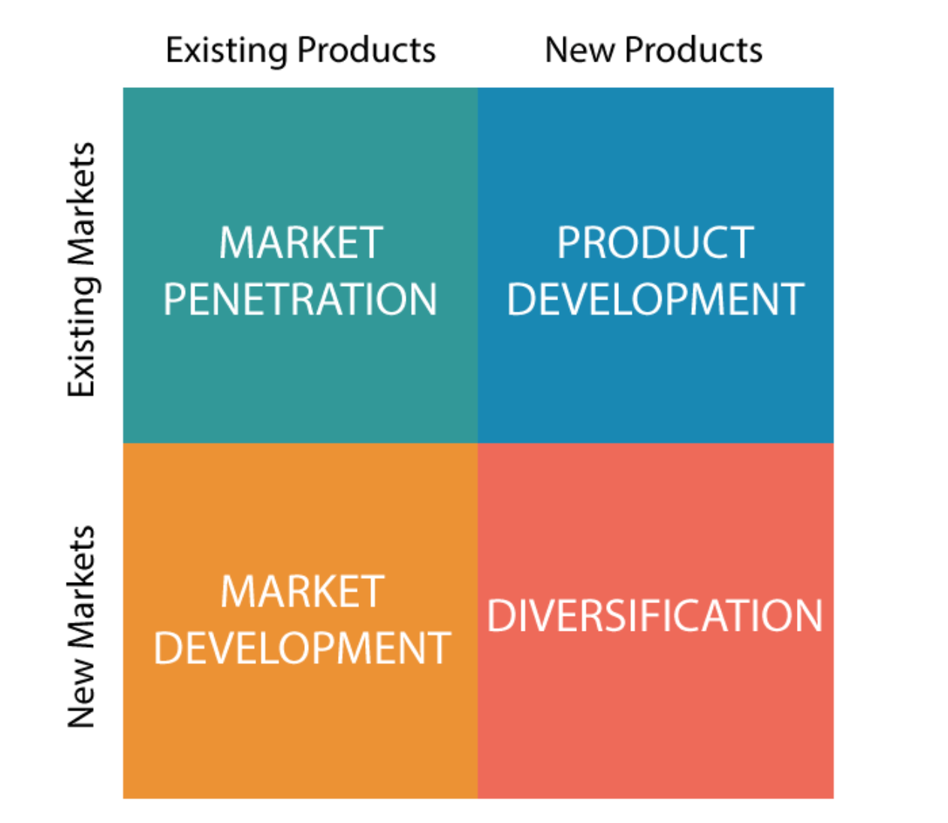

4.1. Market Penetration: Market penetration is the least risky strategy involving existing products in the current market. It encompasses intensified marketing, attractive pricing, customer research, and competitor customer acquisition to drive growth (Doyle, 2016).
Apple encompasses its global operations divided into five segments: American, Europe, Greater China, Japan, and rest of Asia Pacif. Apple’s presence spans over 518 retail stores across 25 countries and regions. The company adeptly employs marketing strategies to drive this market penetration approach, leveraging its product ecosystem effectively (Dudovskiy, 2023).
Apple can focus on increasing sales of its existing products in its current markets. This can involve intensifying marketing efforts, improving distribution channels, and enhancing customer loyalty through loyalty programs and incentives.
4.2. New product development: Creating novel products for current markets can demand significant investment due to the expenses tied to producing and marketing such innovations. This undertaking can encompass product development driven by untested technologies (Doyle, 2016).
Apple engages in new product development as their fundamental growth tactic. They unveil upgraded iteration of current offerings while also introducing novel products. Notably, Apple’s commitment to research and development for new products has surged, escalating from $0.78 billion in 2007 to $25.3 billion in 2023 (Dudovskiy, 2023).
Apple should continue to innovate and introduce new or improved products to its existing markets. This might involve launching upgraded versions of existing devices or introducing complementary products that enhance the user experience.
4.3. Market Development: Venturing into new markets using existing products involves increased risk. This strategy targets untapped or less price- sensitive market segments. It might require new distribution channels, retail spaces, or geographic expansion through licensing or partnerships (Doyle, 2016).
Despite the strong commitment to market development, Apple’s large revenue source remains the Americas segment encompassing north and South AMERICA. In 2022, over 43% of the company’s revenue was generated from the Americas segment. Thus, the company tailors marketing strategies to resonate with local culture and sentiments (Dudovskiy, 2023).
Apple can expand its Apple music service into new regions and countries, tapping into markets with growing demand for digital music streaming. This strategy capitalizes on existing expertise and brand recognition.
4.4. Diversification: Exploring new markets with new products represents the highest- risk strategy, involving unfamiliar territories and potential acquisitions or mergers for market or product assets (Doyle, 2016).
For example, Apple TV+ ranks lower than competitors like Netflix, Amazon Prime Video, Hulu, and Peacock. Due to iPhone market saturation and its revenue importance, Apple is likely to prioritize diversification in the near to medium term (Dudovskiy, 2023).
Apple can diversify into augmented reality (AR) technology. By developing AR glasses or enhancing AR capabilities in its devices, in its devices, Apple can enter the growing AR market and create new revenue streams.
5. Conclusion:
In the ever-evolving realm of business, where challenges and opportunities are shaped by external forces, Apple Inc. stands as a beacon of innovation and global influence. This report delves into the intricacies of Apple's external environment, while also outlining strategic pathways to navigate these dynamic factors. As a trailblazing technology giant and a symbol of cutting-edge advancement, Apple's journey has been both remarkable and transformative.
The analysis commenced with a comprehensive exploration of the PESTEL framework, unveiling the multifaceted impact of political, economic, socio-cultural, technological, environmental, and legal factors. Tax impositions, economic fluctuations, changing societal preferences, technological innovation, environmental concerns, and legal regulations all play pivotal roles in shaping Apple's operational landscape.
Subsequently, the report delved into Porter's Five Forces model, which highlighted the intricacies of competitive rivalry, supplier power, buyer power, threat of substitutes, and the potential for new entrants. These forces collectively contribute to the complex dynamics of the technology industry, emphasizing the need for strategic maneuvers to maintain Apple's position.
The Ansoff Matrix, a tool for growth strategies, provided insights into Apple's potential expansion avenues: market penetration, new product development, market development, and diversification. Each quadrant presented unique challenges and opportunities, offering strategic directions that align with Apple's commitment to innovation and brand loyalty.
In conclusion, Apple's unparalleled journey has been shaped by its ability to harness innovation, adapt to changing landscapes, and capitalize on emerging trends. To sustain its leadership position, Apple must continually evaluate and respond to the intricate interplay of external forces. The dynamic blend of PESTEL analysis, Porter's Five Forces model, and the Ansoff Matrix equips Apple with a roadmap to navigate the future successfully. By employing these strategies, Apple can not only secure its market leadership but also continue to redefine the boundaries of technology innovation on a global scale. The path ahead is challenging, yet with its legacy of innovation, Apple remains poised to shape the future of the tech industry.

6. References
Alanzi, S. (2018) Research Gate. Available at: (PDF) Pestle Analysis Introduction (researchgate.net) (Accessed: 3 August 2023).
Apple (2023) Apple Watch Ultra. Available at: Apple Watch Ultra - Apple (Accessed: 4th August 2023).
Apple (2023) Supplier responsibility. Available at: Supplier Responsibility - Apple (Accessed: 30th August 2023).
Apple. Inc (2023) Education store room. Available at: Back to School - Education Discounts - Apple - Education - Apple (UK) (Accessed: 6th August 2023).
Apple. Inc (2023) News and Results. Available at: 23-08-03 Apple reports third quarter results (Accessed: 4th August 2023).
Apple. Inc (2023) Newsroom. Available at: 23-08-03 Apple reports third quarter results (Accessed: 6th August 2023).
Apple. Inc (2023) Supplier list. Available at: Apple Supplier List FY22 (Accessed: 30th August 2023).
Boddy, D. (2016) Management An Introduction. Ed. 7th. United Kingdom: Pearson Publications.
Brooks, I. (2010) The International Business Environment Challenges and Changes. 2nd ed. England: Pearson Prentice Hall.
Culpan, T. (2023) Samsung overtakes Apple as world's biggest smartphone seller. Available at: Samsung overtakes Apple as world's biggest smartphone seller | Financial Post(Accessed: 30th August 2023).
Doyle, J. (2016) A Dictionary of marketing. Ed (4). Oxford University Press
Dudovskiy, J. (2023) Apple Ansoff Matrix. Available at: Apple Ansoff Matrix - Research-Methodology (Accessed: 30th August 2023).
Evans, J. (2023) Russia's iPhone Ban and the Digital Supply chain Available at: Russia’s iPhone ban and the digital supply chain | Computerworld (Accessed: 4 August 2013).
Ferguson, E. (2023) Apple's five forces analysis (Porter's model). Available at: Apple Five Forces Analysis (Porter’s Model) - Panmore Institute (Accessed: 30th August 2023). (Accessed: date).
Hook and Hille (2011) Apple attacked over pollution in China. Available at: Apple attacked over pollution in China | Financial Times (ft.com) (Accessed: 6th August 2023).
Hoxie, J. (2018) Commentary: Apple Avoided $40 Billion in Taxes. Now It Wants a Gold Star?” Fortune. Available at: Commentary: How Apple Avoided Paying $40 Billion in Taxes | Fortune(Accessed: 4 August 2013).
iLounge (2022) The impact Apple has on technology and society. Available at: The impact Apple has on technology and society | iLounge (Accessed: 4th August 2023).
Jeffs,C.(2008) StrategicManagement.London:SagePublications. DOI: https://doi.org/10.4135/9781446216446
Johnsons et. al. (2016) Exploring Strategies text and cases. Edition 11. United Kingdom: Pearson Publications.
Maverick, J. (2022) Analyzing Porter's 5 forces Apple (AAPL). Available at: Analyzing Porter's 5 Forces on Apple (AAPL) (investopedia.com) (Accessed: 30th August 2023).
Neate, R. (2013) 'David Einhorn suing Apple over Share holder Cash', Available at: David Einhorn suing Apple over shareholder cash | Apple | The Guardian
Porter, M. (1998) Competitive Strategy: Techniques for analyzing industries and competitors. Ed(2nd). The Free Press.
Statista (2023) Changes in cost of labor in China, Mexico and Vietnam. Available at: Manufacturing labor costs per hour: China, Vietnam, Mexico 2016-2020 | Statista (Accessed: 4th August 2023).
Sullivan, A. (2020) Apple tax ruling for Ireland shines light on global tax avoidance” DW. Available at: Apple Irish tax case shows global problem – DW – 07/23/2020 | Fortune (Accessed: 4 August 2013).
The Christian Science Monitor (2023) Why apple pay, and other mobile wallet services could be regulated links banks. Available at: Why Apple Pay and other mobile wallet services could be regulated like banks - CSMonitor.com (Accessed: 6th August 2023).

